SIMULATING BEST RESPONSE DYNAMICS AND
EQUILIBRIA IN TULLOCK CONTESTS

Sanchit Rana

MSc in Artificial Intelligence

2026

SIMULATING BEST RESPONSE DYNAMICS AND
EQUILIBRIA IN TULLOCK CONTESTS

submitted by Sanchit Rana

for the degree of MSc in Artificial Intelligence
at the University of Bath

COPYRIGHT
Attention is drawn to the fact that the copyright of this dissertation rests with its author. The Intellectual Property Rights of the products produced as part of the project belong to the author unless otherwise specified below, in accordance with the University of Bath's policy on intellectual property.
This copy of the dissertation has been supplied on the condition that anyone who consults it is understood to recognise that its copyright rests with its author and that no quotation from the dissertation and no information derived from it may be published without the prior written consent of the author.

DECLARATION
This dissertation is submitted to the University of Bath in accordance with the requirements of the degree of MSc in Artificial Intelligence in the Department of Computer Science. No portion of the work in this dissertation has been submitted in support of an application for any other degree or qualification of this or any other university or institution of learning. Except where specifically acknowledged, it is the work of the author.

ETHICS
This project was reviewed and approved under the University of Bath ethics review procedure on 17 June 2026, prior to the start of the research. Ethics application project ID: 17265 (review reference 17265-20897).

Abstract
This dissertation investigates the dynamic behaviour of strategic agents in Tullock contests by computational simulation. A Python framework implements best response dynamics under synchronous, asynchronous and inertial update rules. It is validated against Tullock's (1980) analytical equilibrium and then applied to a systematic sweep of the decisiveness parameter r and the player count n. Six experiments produce 16 figures and a stability report based on eigenvalue analysis of the best response Jacobian. Two boundaries govern the results. Convergence fails entirely once r exceeds n/(n-1), beyond which no pure strategy equilibrium exists. Below that bound, synchronous dynamics reach the equilibrium only where the spectral radius of the best response Jacobian is below one, which at r = 1.0 places the boundary at n = 4. Across the thirty parameter cells examined, convergence coincides exactly with a spectral radius below one, so the Szidarovszky and Okuguchi (1997) contraction condition is empirically sharp over this range, although necessity in general is not established. Where that condition fails but an equilibrium exists, asynchronous and inertial updating still reach it, so the condition governs one update rule rather than the game. The Cornes and Hartley (2005) proportionality prediction is confirmed exactly under heterogeneous valuations.

Table of Contents
Select the whole document and press F9 to build this list, or right-click and choose 'Update Field'.

List of Figures
Select the whole document and press F9 to build this list, or right-click and choose 'Update Field'.

List of Tables
Select the whole document and press F9 to build this list, or right-click and choose 'Update Field'.

Acknowledgements
I would like to thank my supervisor, Dr Jie Zhang, for his guidance and feedback throughout this project. I would also like to thank my family for their support during the course of the MSc.

Use of Generative AI
I acknowledge the use of generative AI tools during this project for debugging assistance and for proofreading written material. The simulation framework, the experimental design, the analysis and the conclusions drawn from them are my own work, and I take responsibility for the content of this dissertation.

1. Introduction

1.1 Background and Motivation
Strategic competition for scarce resources runs through economic, political and social life. Firms race to patent a technology, researchers compete for grants, lobbyists compete for legislative favours and candidates compete for votes. In each case agents spend costly effort to improve their chances of a prize whose allocation depends on the effort everyone else has put in. Gordon Tullock's (1980) contest model is the standard framework for analysing situations of this kind. It captures the competitive structure with a small number of interpretable parameters and still produces rich strategic behaviour, which is why it has become a workhorse of applied microeconomic theory. In the model, n risk-neutral players simultaneously choose effort levels, and each player's probability of winning is given by the ratio-form contest success function:
p_i(x) = x_i^r / sum_j(x_j^r)
where r > 0 is the decisiveness parameter, controlling how strongly differences in effort translate into differences in winning probability. When r is small the winning probability barely responds to effort and the contest resembles a lottery. As r grows the contest approaches a winner-take-all mechanism in which a small effort advantage becomes a large advantage in winning probability. A single parameter therefore spans a wide range of competitive environments, from near-random allocation to near-perfect meritocracy.
Despite decades of theoretical work, the dynamic behaviour of agents in Tullock contests is much less well understood than the static picture. Most existing work characterises Nash equilibria under fairly restrictive assumptions and leaves open whether those equilibria are ever reached through a natural learning process. This matters because the usefulness of an equilibrium prediction depends on some plausible account of how boundedly rational agents would arrive at it. An equilibrium that exists mathematically but is never reached by any reasonable adjustment process gives little guidance for predicting or designing real institutions. That gap between static existence and dynamic accessibility is what this dissertation addresses.

1.2 Research Questions
This dissertation addresses four questions:
- RQ1: How do best response dynamics converge across the decisiveness parameter space r in {0.5, 1.0, 1.5, 2.0, 3.0, 5.0}?
- RQ2: How does player count n in {2, 3, 5, 10, 20} affect convergence behaviour and equilibrium accessibility?
- RQ3: Do heterogeneous player valuations preserve the convergence properties observed in symmetric contests?
- RQ4: Are there parameter regimes with non-convergent dynamics, and if so, what is the nature of that non-convergence?

1.3 Contributions
The main contributions are:
- A validated, modular Python simulation framework for Tullock contest dynamics, released as open-source software on GitHub.
- An empirical characterisation of convergence behaviour across a systematic r x n parameter sweep, producing a convergence landscape map for Tullock best response dynamics.
- Separation of two mechanisms of dynamic failure that a convergence rate alone conflates: non-existence of a pure strategy equilibrium above r = n/(n-1), and instability of an equilibrium that does exist.
- Identification of the synchronous stability boundary at n = 4 for r = 1.0, where the spectral radius equals one exactly and convergence becomes algebraic rather than geometric.
- Eigenvalue analysis confirming the Szidarovszky and Okuguchi (1997) contraction condition across every parameter cell tested, together with the finding that asynchronous and inertial updating reach equilibria that violate it, so the condition constrains the update rule rather than the game.
- Computational confirmation of the Cornes and Hartley (2005) heterogeneous valuation prediction, extended to settings beyond their analytical reach.

1.4 Dissertation Structure
Chapter 2 surveys the literature and the technology used. Chapter 3 sets out the methodology and the simulation framework. Chapter 4 presents the experimental results. Chapter 5 discusses their theoretical implications. Chapter 6 concludes with limitations and future work.

2. Literature, Technology, and Data Survey
This chapter surveys the theoretical, empirical and computational literature underpinning the dissertation and situates its contribution within it. It moves from the static equilibrium theory of Tullock contests, through work on rent dissipation and efficiency, to the smaller body of work on dynamic and computational questions, and ends with the technologies used to build the framework of Chapter 3.

2.1 Foundations of Contest Theory
Tullock's (1980) ratio-form contest success function established the trade-off between investment and probability of success that underlies everything that follows. The modelling choice is simple: a player's probability of winning is their effort raised to a power r divided by the sum of all players' efforts raised to the same power. It nests near-proportional contests at low r and increasingly winner-take-all contests as r grows. For the symmetric case with linear costs and r = 1, the Nash equilibrium effort is x* = V(n-1)/n^2 and aggregate effort is X* = V(n-1)/n. These closed forms are the benchmarks against which the simulations are validated in Chapter 3.
Szidarovszky and Okuguchi (1997) generalised Tullock's static result using contraction mapping arguments from fixed point theory. When best response correspondences satisfy a contraction condition, equivalently when the spectral radius of the Jacobian of best response mappings at equilibrium is below one, iterative best response dynamics converge globally to the unique Nash equilibrium from any starting point. This is one of the few results in the literature that speaks directly to dynamic rather than static properties. Because it establishes sufficiency only, it leaves open whether convergence can occur when the condition fails, which Chapter 4 investigates computationally.
Cornes and Hartley (2005) extended the analysis from symmetric to asymmetric contests. They characterise equilibria under heterogeneous valuations and show analytically that higher-valuation players exert proportionally greater effort at equilibrium, a result usually referred to as a proportionality property. Their techniques come from the theory of aggregative games and become harder to apply as asymmetry grows severe or costs depart from the linear case. That leaves an opening for computational work, which Experiment 4 (Section 4.4) targets directly.

2.2 Rent Dissipation and Equilibrium Efficiency
A related strand concerns the efficiency of contest equilibria rather than their existence. Perez-Castrillo and Verdier (1992) showed that total equilibrium effort can exceed the value of the prize under certain parameterisations, a phenomenon they call over-dissipation. The welfare implication is that a contest can destroy more resource value than the prize it allocates. Equilibrium behaviour in contests therefore need not be efficient even when it is well defined and stable, which is worth keeping in mind when reading the total effort figures in Chapter 4.
Nitzan (1994) characterised how aggregate rent dissipation varies with the decisiveness parameter and established that the relationship is non-monotonic: dissipation is maximised at intermediate values of r and falls away at both extremes. At very low r the winning probability barely responds to effort, so investing heavily is unrewarding. At very high r the contest is close enough to winner-take-all that the marginal player gains little from investing unless they can guarantee victory. Experiment 2 (Section 4.2) traces total effort across r and finds a pattern consistent with the ascending portion of this curve. The intermediate range where dissipation should begin to fall coincides with the region where best response dynamics fail to converge, which complicates any direct test of the full shape by simulation.

2.3 Dynamic Analysis and Learning
The literature above characterises equilibria once reached but says comparatively little about how agents arrive at them. Hopkins and Kornienko (2010) address this through evolutionary game theory, examining contests under the replicator equation. They find that such dynamics can exhibit limit cycles and sensitive dependence on initial conditions rather than settling towards the Nash equilibrium. Within a different dynamic framework, this establishes that the existence of a unique Nash equilibrium is no guarantee that a plausible learning process will find it. The sustained limit cycles found above r = n/(n-1) in Section 4.5 resemble their results despite arising from a structurally different learning rule.
Lim and Matros (2009) approach the dynamic question through stochastic perturbation, showing that randomness in the number of participating players can facilitate convergence where deterministic dynamics fail. This motivated including the inertial update rule as a form of damped adjustment. Section 4.5 draws a line here. Where an equilibrium exists but is unstable under simultaneous updating, inertial damping recovers it reliably. Above r = n/(n-1), where no pure strategy equilibrium exists, no damping rate tested restores convergence. Stochastic mechanisms would face the same limit: noise can help a learning process locate an equilibrium but cannot create one.
Chowdhury and Sheremeta (2011) take an experimental approach, running laboratory contests with heterogeneous participant abilities and documenting systematic deviations from Nash predictions. These are usually interpreted through bounded rationality. The findings here suggest a complementary explanation. If the relevant Nash equilibrium is dynamically unreachable for certain parameter combinations under the most natural form of adaptive learning, observed deviations need not reflect irrationality at all. Chapter 5 returns to this.

2.4 Recent Computational Work
A small but growing theoretical computer science literature addresses best response convergence in Tullock and lottery contests directly, through formal proof rather than simulation. Ghosh and Goldberg (2023) prove that best response dynamics converge rapidly for homogeneous agents but may fail to converge for heterogeneous agents even with only two players. Experiment 4 (Section 4.4) reproduces this computationally: at r = 1.0 with two players and no crowding, a 9:1 valuation ratio pushes the spectral radius to 1.33 and eliminates convergence under synchronous updating, though the asymmetric equilibrium remains well defined and is recovered exactly under damped updating. This confirms their result by a different method and locates the mechanism within the spectral radius framework used here.
Elkind, Ghosh and Goldberg (2024) extend this to continuous-time dynamics, showing with Lyapunov-style arguments that continuous-time best response dynamics converge reliably for homogeneous agents while non-homogeneous agents fail to converge on a positive-measure set of instances. The failure in their setting is not a knife-edge case but covers a substantial region of the parameter space. The findings here agree. The non-convergent region mapped in Section 4.6 is contiguous rather than a set of isolated points, bounded by r = n/(n-1) and by the spectral radius condition, and a fine-grained sweep through that boundary (Section 4.5) finds a clean step rather than a singularity.
A further contribution in this cluster, on the computational complexity of equilibrium computation in general heterogeneous Tullock contests, shows that continuous-time best response dynamics converge globally under low elasticity, specifically for r <= 1. That is an analytical guarantee for exactly the low-r region that Sections 4.2 and 4.6 find most reliably stable. One refinement is worth drawing out: the guarantee is for continuous-time dynamics, which correspond to the inertial rule as the learning rate approaches zero rather than to simultaneous updating. Section 4.3 shows this distinction has bite. At r = 1.0 with five players, damped updating reaches the equilibrium while simultaneous updating does not, so the analytical guarantee and the empirical failure are consistent and the gap between them is the update rule.

2.5 Multi-Battlefield Extensions
Liu et al. (2025) study the Lottery Colonel Blotto game, a multi-battlefield generalisation in which players divide a fixed budget across n battlefields, each governed by a proportional success rule structurally identical to the ratio-form function used here. Rather than studying simultaneous best response convergence, they model the game as a Stackelberg interaction in which one player commits first, and derive a water-filling characterisation of the follower's optimal response in which budget flows to whichever battlefield offers the highest marginal return until marginal returns equalise. Their sequential framing suggests an extension of the present work: whether allowing one player to commit before the other responds alters the convergence properties documented in Chapter 4, particularly above r = n/(n-1) where no pure strategy equilibrium exists under simultaneous moves. Section 6.2 returns to this.

2.6 Technology Survey
The framework is implemented in Python 3.11, chosen for its scientific computing ecosystem, its readability for a project meant to be reproducible and extensible, and my own familiarity with it from the taught component of the MSc. NumPy provides the vectorised array operations used to represent and manipulate effort vectors and to evaluate payoffs, which the best response solver depends on. SciPy supplies the solver's local step: minimize_scalar with the bounded method refines a candidate within a bracket established by a grid scan, for reasons set out in Section 3.2. Equilibria are cross-checked against the closed form of Tullock (1980) where one exists, and against a residual test requiring that no player's best response differs from their current effort by more than the convergence tolerance.
Matplotlib produces all sixteen figures, from the convergence trajectory plots through to the two-dimensional heatmap of Figure 4.15. Git and GitHub are used for version control and for the open-source release of the framework. The modular architecture, separating the contest model, best response computation, dynamic iteration, equilibrium identification, and analysis and visualisation into independently testable modules, follows the scientific computing practices set out by Wilson et al. (2014). It was adopted so that each component could be validated in isolation before being combined into the full pipeline.
No external datasets were required. The data throughout is simulation output generated by the framework itself. All parameters, random seeds and raw numerical results reported in Chapter 4 are kept in the project's results directory and version controlled alongside the code that produced them, so every figure and table can be regenerated from the source.

3. Methodology

3.1 Mathematical Model
The simulation implements a Tullock contest with n players, decisiveness parameter r in (0, infinity), player valuations V_i > 0, and cost function c(x_i) = x_i^alpha with alpha >= 1. The contest success function gives player i a winning probability of:
p_i(x) = x_i^r / sum_{j=1}^{n} x_j^r
Player i's expected payoff is pi_i(x) = p_i(x) * V_i - c(x_i). The baseline uses linear costs (alpha = 1) and symmetric valuations (V_i = V for all i), with heterogeneous valuations examined in Experiment 4.

3.2 Best Response Computation
Player i's best response to competitors' efforts x_{-i} solves:
BR_i(x_{-i}) = argmax_{x_i >= 0} [V_i * x_i^r / (x_i^r + sum_{j not i} x_j^r) - x_i]
This is solved numerically over a bounded interval to a tolerance of 1e-10. The lower bound is 1e-8, strictly positive because the contest success function is undefined when every player exerts zero effort. The upper bound is derived rather than assumed. A best response never earns a negative payoff, since effort can always be driven towards zero, so p_i(x) V_i - x_i^alpha >= 0 at the optimum, and p_i <= 1 then forces x_i <= V_i^(1/alpha). A fixed ceiling would be worse on both counts: at V = 1000 a ceiling of 100 truncates a true optimum of 250, and at V = 10 it spreads the same scan points over ten times the range needed, which can miss a narrow interior peak.
The search method needs justification, because the obvious choices fail in a way that is easy to miss. For r <= 1 the payoff is concave in own effort and any local search will do. For r > 1 it is not. A local maximum near zero, where the player concedes, can coexist with an interior maximum where they compete, and which of the two is global depends on the rival profile. A unimodal search such as golden section or Brent's method over the whole interval returns whichever basin it enters, with no sign of having done so. Checked against a brute force global maximum over 60 random rival profiles at each of n = 2, 3, 5 and 7, golden section search returns the wrong effort for 40% to 100% of profiles at r = 3 and 40% to 98% at r = 5, and SciPy's bounded method for 10% to 33% and 13% to 25% respectively. That is precisely where the behaviour of interest lies. The scan-and-refine solver misses none.
The framework therefore brackets before it refines. The interval is scanned at 320 candidate efforts, spaced logarithmically to resolve the near-zero corner and linearly for the interior peak, in a single vectorised evaluation. The best cell is then passed to SciPy's bounded method, which is reliable within a bracket narrow enough to be unimodal.

3.3 Update Rules
Three update rules are implemented, each a different model of strategic adjustment:
- Synchronous: all n players simultaneously compute and adopt their best responses, x_i(t+1) = BR_i(x_{-i}(t)) for all i.
- Asynchronous: players update sequentially in a random order each round, each best-responding to the most recently updated efforts of the others.
- Inertial: players move a fraction lambda towards their best response, x_i(t+1) = (1-lambda)*x_i(t) + lambda*BR_i(x_{-i}(t)). lambda = 1 reduces to synchronous; smaller lambda models more cautious adjustment.

3.4 Convergence Detection
A run counts as converged when the profile it has reached is a fixed point of the best response map to within tolerance epsilon = 1e-6:
max_i |BR_i(x_{-i}) - x_i| < epsilon
The more common alternative, declaring convergence when the last step was smaller than epsilon, is necessary but not sufficient. When efforts collapse towards the lower bound of the search interval, every absolute step becomes small purely as a matter of scale, so a step size criterion classifies the collapse as convergence however far the profile sits from equilibrium. At n = 10 and r = 5.0 it reports an equilibrium at x = 5.96e-07 whose best response is 1.80e-05, a residual seventeen times the tolerance, and at which deviating to x = 0.0001 raises a player's payoff from roughly zero to roughly ten. Testing the residual at the point actually returned removes this class of false positive for one extra best response evaluation per run. Because x = (1-lambda)x + lambda*BR(x) holds exactly when x = BR(x), the same criterion serves all three rules.
Iteration budgets vary with the convergence speeds involved: 2000 for Experiments 2 and 3, 500 for Experiments 4 and 5, 300 for Experiment 6 and 200 for the analysis report. Runs that do not converge within their limit are classified as non-convergent and excluded from the iteration and equilibrium statistics rather than contributing a meaningless final position to them. Results are averaged across 10 to 20 random initialisations drawn uniformly from [0.1, 0.8*V]^n.

3.5 Equilibrium Validation
For symmetric contests with r = 1 and linear costs, the analytical Nash equilibrium is x* = V(n-1)/n^2 from Tullock (1980). All three update rules are validated against this benchmark before any parameter sweeps, and recover it with absolute error below 1e-4 wherever the rule in question converges at all. That qualification matters. At n = 5 the equilibrium x* = 1.6 is confirmed to be a fixed point of the best response map and is recovered to that tolerance by the asynchronous and inertial rules, but synchronous updating does not reach it from any tested starting point. That is a property of the update rule rather than a failure of the framework, and Section 4.3 takes it up directly.
An automated suite of eighty-nine tests covers the model, the solver, the update rules, the statistical analysis and the plotting helpers. Beyond the analytical benchmark, these pin the solver against a brute force global maximum and assert the properties described in Sections 3.2 and 3.4: that a synchronous trajectory consists only of synchronous steps, that no rule silently substitutes another on failing to converge, and that anything reported as converged survives the residual test. Rent dissipation and the spectral radius are each checked against their exact symmetric values, (n-1)/n and (n-2)/2.

3.6 Stability Analysis
Eigenvalue analysis of the Jacobian of best response mappings provides a formal stability assessment at identified equilibria. The Jacobian J is estimated numerically by central differences with step size delta = 1e-4. The spectral radius rho(J) = max_k |lambda_k| determines local stability: rho < 1 implies the equilibrium is locally attracting under synchronous dynamics, which is the contraction mapping condition of Szidarovszky and Okuguchi (1997) in computable form.
Two details of the estimate matter. Each best response is itself the output of a numerical search and carries solver noise, which a one-sided difference divides by delta. At delta = 1e-5 that disturbed the third decimal of a quantity reported to three. Central differences cancel the leading error term, and against the exact symmetric value rho = (n-2)/2 the worst error across the reported grid falls from 3.6e-2 to 1.7e-3. Spectral radii are quoted to three decimal places accordingly.
Where the Jacobian is evaluated matters equally, because a spectral radius computed away from a fixed point describes nothing. The mean of a cell's converged runs is an equilibrium only if those runs reached the same one. Every profile is therefore tested against the best response map before being linearised, and reported as unavailable when the residual max_i |BR_i(x) - x_i| exceeds 1e-4. One cell fails this test: n = 3 at r = 1.5, where two of ten runs converge to different equilibria whose mean has a residual of 1.76.

4. Experimental Results
This chapter presents six experiments addressing the four research questions of Chapter 1. Experiment 1 establishes the correctness of the framework against a known analytical benchmark. Experiments 2 and 3 address RQ1 and RQ2, sweeping the decisiveness parameter r and the player count n independently. Experiment 4 addresses RQ3 by introducing heterogeneous valuations. Experiment 5 addresses RQ4 by examining a non-convergence point from Experiment 2 in finer detail. Experiment 6 combines the r and n dimensions into a single sweep, giving the most complete picture of the convergence landscape.

4.1 Baseline Validation (Experiment 1)
Before any exploratory work, the framework had to be shown to reproduce known theoretical results. Without that step no later finding would carry weight, since a genuine feature of Tullock dynamics could not be distinguished from an artefact of a flawed implementation. Experiment 1 therefore validates against the closed form Nash equilibrium for the symmetric two-player contest with linear costs, r = 1 and V = 10, for which Tullock (1980) gives x* = V(n-1)/n^2 = 10(1)/4 = 2.5 for both players.
The validation starts from an asymmetric initial condition, (8.0, 1.0), rather than the equilibrium itself. A simulation that confirms an equilibrium when initialised at that equilibrium proves very little, since a stationary point stays stationary under any reasonable update rule. Starting far from equilibrium, with Player 1 well ahead, tests whether the dynamics correct themselves rather than simply preserving whatever state they are given.
Update Rule | Iterations | Final Efforts | Converged
Synchronous | 6 | (2.5000, 2.5000) | Yes
Asynchronous | 5 | (2.5000, 2.5000) | Yes
Inertial l=0.5 | 23 | (2.5000, 2.5000) | Yes
Table 4.1: Validation results for the symmetric 2-player contest. All three update rules recover the analytical equilibrium x* = 2.5.
All three rules converge to the analytical equilibrium with absolute error below 1e-4, well inside the tolerance epsilon = 1e-6 used to declare convergence. The synchronous and asynchronous rules take only 6 and 5 iterations, reflecting the fact that at r = 1 with two symmetric players the best response mapping is strongly contracting, so each round closes most of the remaining gap. The inertial rule with lambda = 0.5 takes 23 iterations, as expected given that it moves only half the distance to the best response each step. The relationship is not exactly linear because the target itself shifts at each partial step.
That all three rules converge to the identical value, despite structurally different update mechanics, is evidence that the equilibrium here is not merely a fixed point but a stable attractor, reachable regardless of how players adjust. This robustness is informative in itself: for well-behaved parameter regions the qualitative predictions of Nash equilibrium theory are not sensitive to modelling choices about how players learn. Later experiments show that this does not hold everywhere.
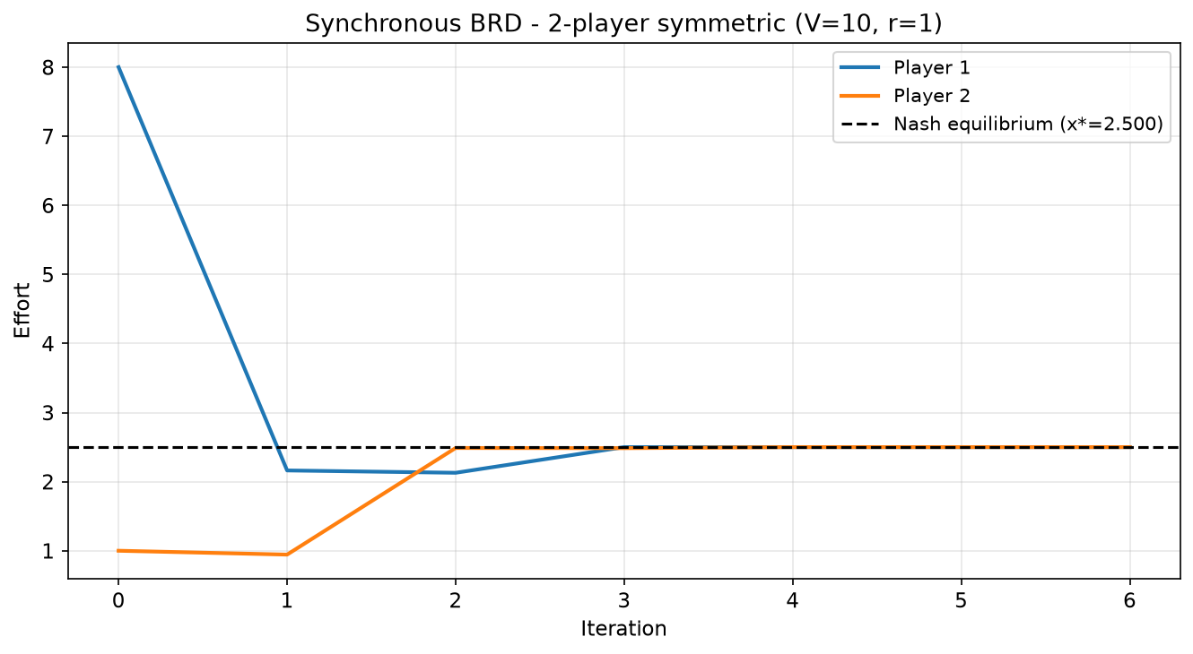
Figure 4.1: Synchronous BRD convergence trajectory, 2-player symmetric contest (V=10, r=1). Both players converge to x*=2.5 within 6 iterations.
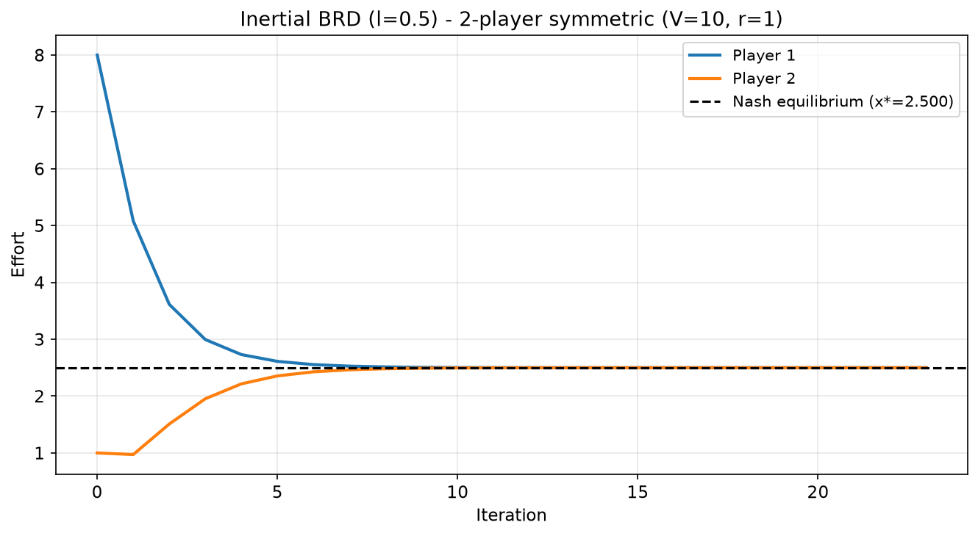
Figure 4.2: Inertial BRD (l=0.5) convergence trajectory, 2-player symmetric contest (V=10, r=1). Both players converge to x*=2.5 within 23 iterations.
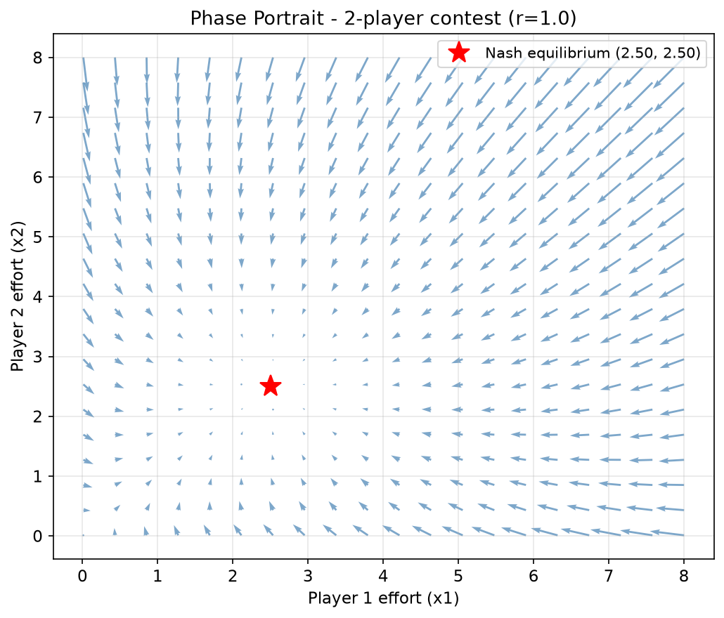
Figure 4.3: Phase portrait of the 2-player contest (r=1). Arrows indicate best response update directions. The red star marks the Nash equilibrium at (2.5, 2.5).
The phase portrait in Figure 4.3 gives a more global view of the same result. Rather than tracking one trajectory it plots the direction and approximate magnitude of the best response update across a grid of points in strategy space. Every arrow points towards the marked equilibrium at (2.5, 2.5), and the arrows shrink as they approach it, which confirms that the equilibrium acts as an attractor across the whole region shown and not only along the trajectory of Figure 4.1.

4.2 Decisiveness Parameter Sweep (Experiment 2)
With the framework validated, Experiment 2 addresses RQ1: how does convergence change as the decisiveness parameter varies? The parameter governs how sharply small differences in effort translate into differences in winning probability, and existing theory offers only partial guidance on how it should affect the dynamic stability of learning as opposed to the static properties of the equilibrium. The experiment swept r across {0.5, 1.0, 1.5, 2.0, 3.0} for the two-player symmetric contest (V=10), with 20 random initialisations per value drawn independently and uniformly from [0.1, 8.0], using the synchronous rule throughout as the most directly comparable across configurations.
r | Conv. Rate | Mean Iters | Total Effort | Spectral R
0.5 | 100% | 4.2 | 2.50 | 0.000
1.0 | 100% | 5.3 | 5.00 | 0.000
1.5 | 100% | 10.2 | 7.50 | 0.000
2.0 | 0% | N/A | N/A | N/A
3.0 | 0% | N/A | N/A | N/A
Table 4.2: Convergence statistics across r values (n=2, V=10, 20 random initialisations).
Several patterns emerge from Table 4.2 that the aggregate convergence rate alone would hide. At r = 0.5 convergence is universal across all 20 initialisations and fast, averaging 4.2 iterations. That is consistent with intuition: when r is small the winning probability responds only weakly to differences in effort, so the incentive to chase a competitor is muted and the system settles quickly. As r rises to 1.0 and then 1.5, convergence remains complete but the mean iteration count roughly doubles, from 4.2 to 10.2. The same outcome is reached through an increasingly protracted process of mutual adjustment.
Total effort rises steadily from 2.50 at r = 0.5 to 7.50 at r = 1.5, in line with the symmetric equilibrium X* = rV(n-1)/n for n = 2. The spectral radius column, by contrast, is flat and essentially zero throughout. That is not measurement noise but an exact property of the two-player case: at r = 1 the best response is BR(x) = sqrt(Vx) - x, whose derivative at x* = V/4 is exactly zero. The rising iteration counts therefore cannot be explained by the local linearisation. What slows convergence as r rises is the distance travelled before entering the contracting neighbourhood, which is a global property of the map. Section 4.3 shows the spectral radius predicting convergence speed sharply once n rather than r is varied.
At r = 2.0 the pattern breaks entirely. Convergence collapses from 100% to 0% across all 20 initialisations and stays at 0% at r = 3.0, with total effort and spectral radius shown as N/A because no run reached a stable point at which either could be computed. The location of the break is not arbitrary. A symmetric Tullock contest has a pure strategy equilibrium only for r <= n/(n-1), which for two players is exactly 2.0, and direct inspection confirms that the candidate symmetric profile stops being a fixed point at that value. The failure from r = 2.0 is therefore not a dynamic pathology but the simulation correctly detecting that there is nothing to converge to. That is a recovery of a known analytical boundary and a further validation of the framework. Experiment 5 examines the boundary at finer resolution.
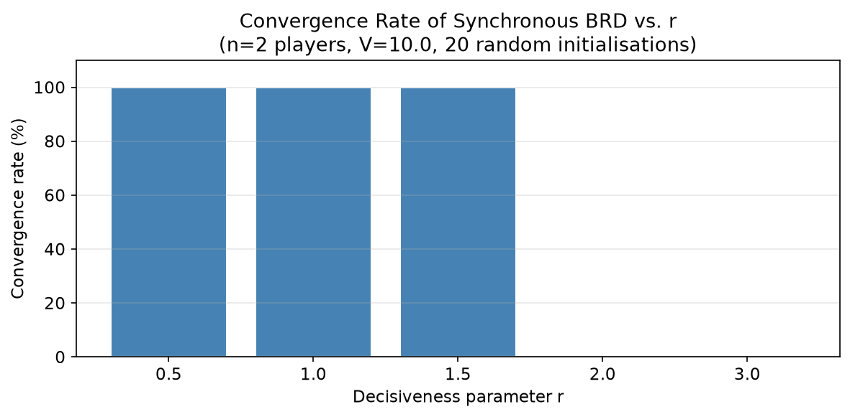
Figure 4.4: Convergence rate vs. r (n=2). Full convergence up to r=1.5, complete failure from r=2.0, the pure-equilibrium existence bound for two players.
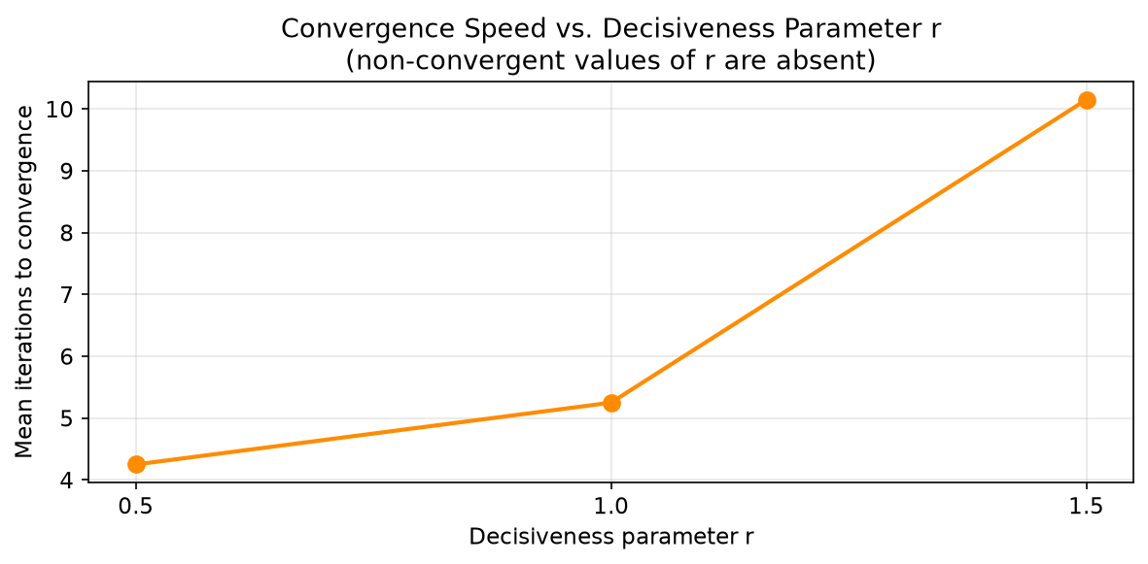
Figure 4.5: Mean iterations to convergence vs. r (n=2). Convergence slows as r increases toward the instability boundary.
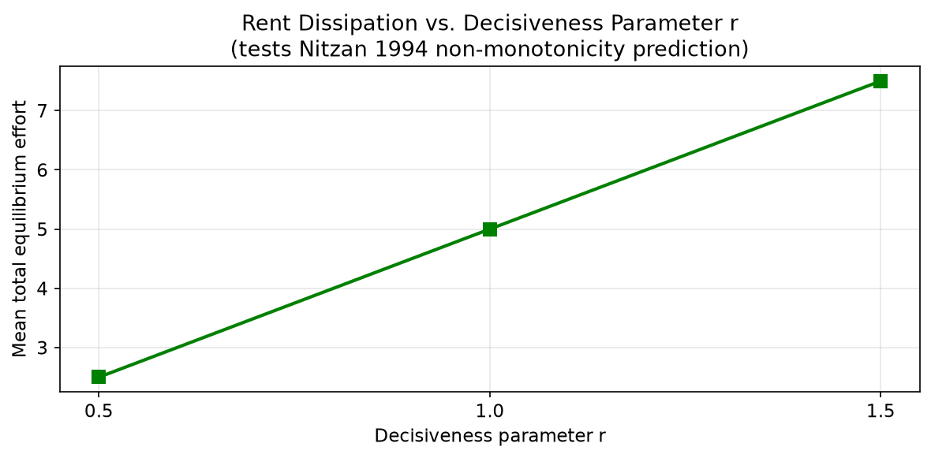
Figure 4.6: Rent dissipation vs. r, showing monotonic increase in the convergent region.
It is worth being explicit about what Figure 4.6 does and does not show. Within the convergent region tested, r in {0.5, 1.0, 1.5}, total effort rises monotonically with r, consistent with the rising portion of the non-monotonic dissipation curve predicted by Nitzan (1994). The descending portion cannot be traced here at all, because it lies beyond r = 2.0 where no pure strategy equilibrium exists for two players and there is consequently no equilibrium dissipation to measure. This is a substantive limitation on what simulation of pure strategy best response dynamics can establish about Nitzan's prediction, rather than a gap that a finer grid or a longer iteration budget would close. Chapter 5 returns to it.

4.3 Player Count Sweep (Experiment 3)
Experiment 3 addresses RQ2, holding decisiveness at its most standard value, r = 1.0, and sweeping the number of players across {2, 3, 5, 10, 20}. That runs from the minimal two-player case, through committee-sized groups, up to sizes representative of open tournaments or crowded markets. Twenty random initialisations were used per value of n, each starting effort drawn independently and uniformly from [0.1, 8.0].
n | Conv. Rate | Mean Iters | Sim. Total | Analytical | Spectral R
2 | 100% | 5.3 | 5.00 | 5.00 | 0.000
3 | 100% | 22.1 | 6.67 | 6.67 | 0.500
4 | 0% | N/A | N/A | 7.50 | 1.000
5 | 0% | N/A | N/A | 8.00 | 1.500
10 | 0% | N/A | N/A | 9.00 | 4.000
20 | 0% | N/A | N/A | 9.50 | 8.998
Table 4.3: Convergence statistics across n values (r=1, V=10, 20 random initialisations). The n=4 row comes from a supplementary run at the stability boundary.
Table 4.3 divides cleanly in two, and the spectral radius column explains where the division falls. At n = 2 and n = 3 convergence is universal, and the mean iteration count rises from 5.3 to 22.1 as the spectral radius rises from zero to 0.50, which is the slowdown the contraction mapping framework predicts. From n = 5 upward convergence fails completely and stays at 0% through n = 20, and in every one of those rows the spectral radius exceeds one.
The boundary can be located exactly rather than bracketed. For r = 1 the spectral radius at the symmetric equilibrium is (n-2)/2, a relationship the numerical estimates reproduce to three decimal places at every n tested. Setting it equal to one gives n = 4. The supplementary run there confirms the prediction directly: with a spectral radius of exactly one the dynamics neither converge nor diverge geometrically but creep, moving from 1.966 after 400 iterations to 1.917 after 2000 and 1.901 after 5000, against an equilibrium of 1.875 that they approach without ever reaching the 1e-6 tolerance. This is marginal stability in textbook form, and more informative than either neighbouring case because it shows the convergence and eigenvalue criteria agreeing at the point where both become ambiguous.
The most consequential observation concerns what non-convergence does not imply. At n = 5 the analytical equilibrium x* = 1.6 still exists and is confirmed as a fixed point to within 1e-7. It is not absent, as it is above r = n/(n-1). Simultaneous updating simply overshoots it. From the identical starting point the asynchronous rule reaches x* in 19 iterations and the inertial rule with lambda = 0.5 in 39. It remains reachable at n = 10 and n = 20, whose spectral radii are 4.000 and 8.998: asynchronous updating takes 21 and 24 iterations, and inertial updating succeeds once damped further, at lambda = 0.3 and lambda = 0.1. The damping required rises with the spectral radius, as a contraction argument predicts. The equilibrium is dynamically accessible throughout this range, but only to agents who do not all move at once. Since the Szidarovszky and Okuguchi condition concerns the contraction properties of the simultaneous map specifically, this is not a counterexample but a clarification of its scope, taken up in Chapter 5.
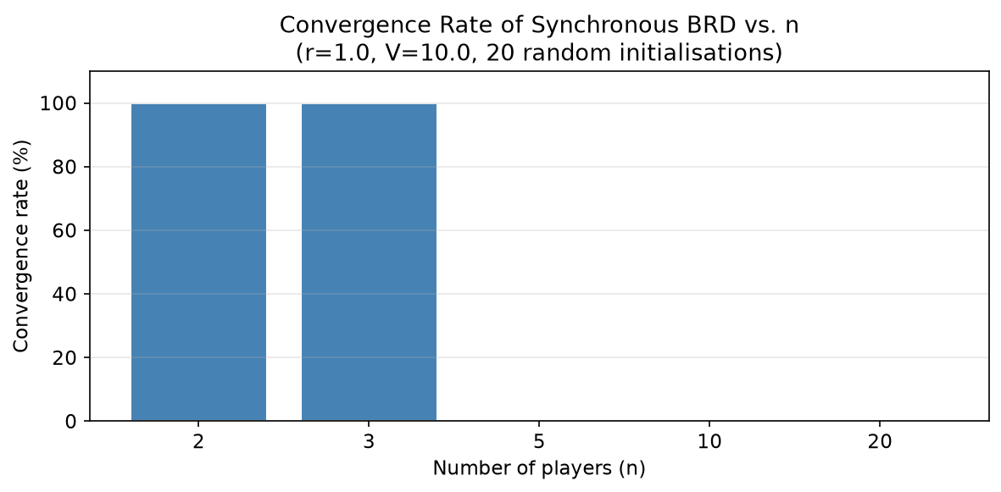
Figure 4.7: Convergence rate vs. n (r=1). Full convergence at n=2 and n=3, complete failure from n=5, with the spectral radius crossing unity at n=4.
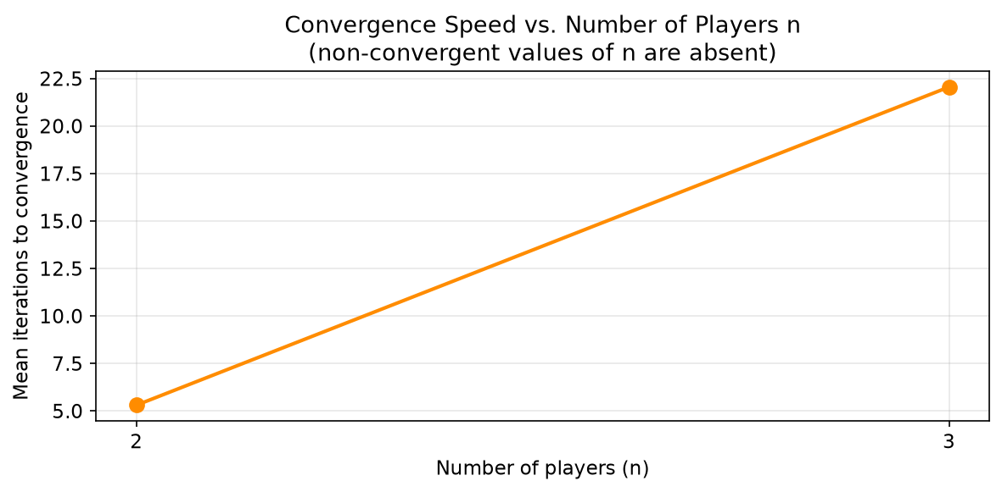
Figure 4.8: Mean iterations to convergence vs. n (r=1). Only the convergent player counts appear; the rise from 5.3 to 22.1 tracks the spectral radius from 0 to 0.50.
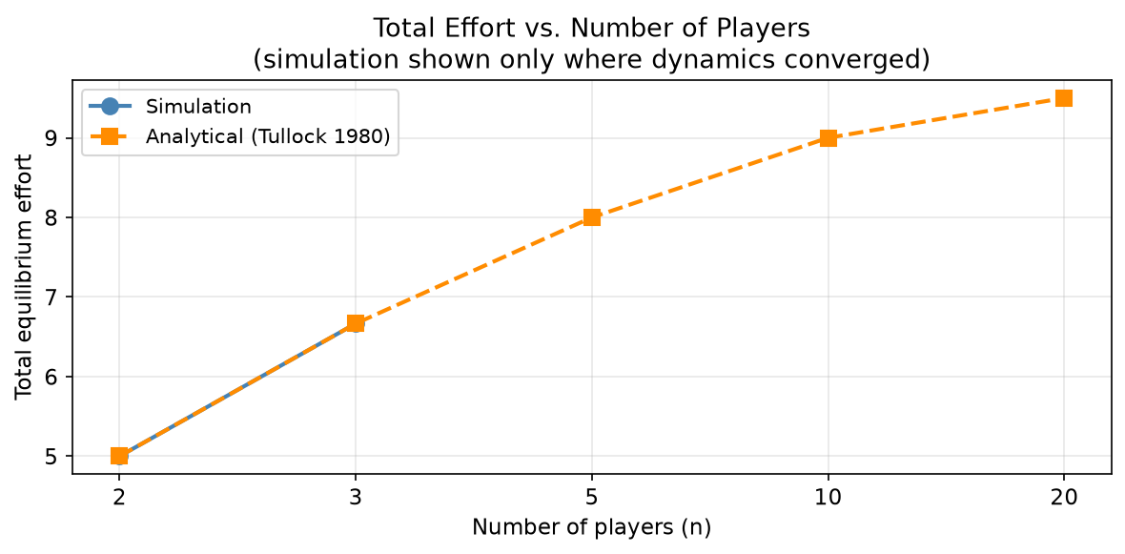
Figure 4.9: Total effort vs. n, comparing simulation against analytical benchmarks. Exact agreement wherever synchronous dynamics converge; no simulated value is plotted where they do not.
The analysis report of Section 3.6 allows this relationship to be checked in the direction Table 4.3 cannot, by holding r at 0.5, below the stability boundary for every player count, and varying n. Convergence is universal across that row, so no cell is lost to failure, and the spectral radius rises steadily with crowding: 0.000, 0.200, 0.428, 0.667 and 0.818 for n = 2, 3, 5, 10 and 20. Mean iterations rise in lockstep: 4.3, 10.8, 18.7, 36.5 and 70.0. The eigenvalue analysis therefore does not merely classify equilibria as reachable or unreachable. Within the reachable region it predicts, over more than an order of magnitude, how long reaching them takes. The failures at r = 1.0 are that same trend continued past the point where the contraction factor reaches one.

4.4 Heterogeneous Valuations (Experiment 4)
Experiments 2 and 3 both used symmetric valuations, which is the setting for which the closed form benchmark of Tullock (1980) is available and therefore the natural starting point. Experiment 4 relaxes that assumption to address RQ3, asking whether the convergence properties documented above survive once players value the prize differently. The question is not academic. In almost every real application of contest theory, from R&D races to political competition, the competing parties rarely value the prize identically, so whether asymmetry alone can destabilise otherwise well-behaved dynamics bears directly on the practical applicability of the model.
Three configurations were tested for the two-player contest at r = 1.0, each with 20 random initialisations: a symmetric baseline with V1 = V2 = 10, a mild asymmetry with V1 = 8 and V2 = 12, and a strong asymmetry with V1 = 2 and V2 = 18.
Configuration | V1 | V2 | P1 Effort | P2 Effort
Symmetric | 10 | 10 | 2.5000 | 2.5000
Mild asymmetry | 8 | 12 | 1.9200 | 2.8800
Strong asymmetry | 2 | 18 | 0.1800 | 1.6200
Table 4.4: Equilibrium efforts under symmetric and asymmetric valuations. Synchronous convergence is 100% in the first two cases and 0% in the third, where the reported efforts are those recovered under inertial updating.
The most striking feature of Table 4.4 is the precision with which the effort ratio matches the valuation ratio in both asymmetric cases. Under mild asymmetry V2/V1 = 12/8 = 1.5 and the effort ratio is 2.8800/1.9200 = 1.5 exactly. Under strong asymmetry V2/V1 = 18/2 = 9.0 and the effort ratio is 1.6200/0.1800 = 9.0 exactly. This is a direct computational confirmation of the proportionality result derived by Cornes and Hartley (2005), and its exact reproduction rather than an approximate match is corroborating evidence for the correctness of the best response computation, independent of the symmetric validation in Experiment 1.
The convergence behaviour does not survive the increase in asymmetry. Under mild asymmetry synchronous dynamics converge in 100% of the 20 initialisations. Under the 9:1 strong asymmetry they converge in none of them, even though the equilibrium (0.18, 1.62) exists and is verified to be a fixed point. The spectral radius there is 1.33, above one, and inertial updating with lambda = 0.3 recovers the equilibrium exactly. Valuation heterogeneity is therefore sufficient on its own to destabilise simultaneous best response dynamics, with only two players, at the standard decisiveness r = 1.0, and with no crowding at all. This is the third route into instability identified here, alongside decisiveness and player count.
This is independent empirical confirmation of Ghosh and Goldberg (2023), who prove that best response dynamics may fail to converge for heterogeneous agents in the two-player case. Their proof and this simulation are methodologically unrelated, so the agreement is corroborative rather than circular, and it places their result within the spectral radius framework used here: what their theorem identifies as a heterogeneity threshold appears as the point at which asymmetry drives the contraction factor past one.
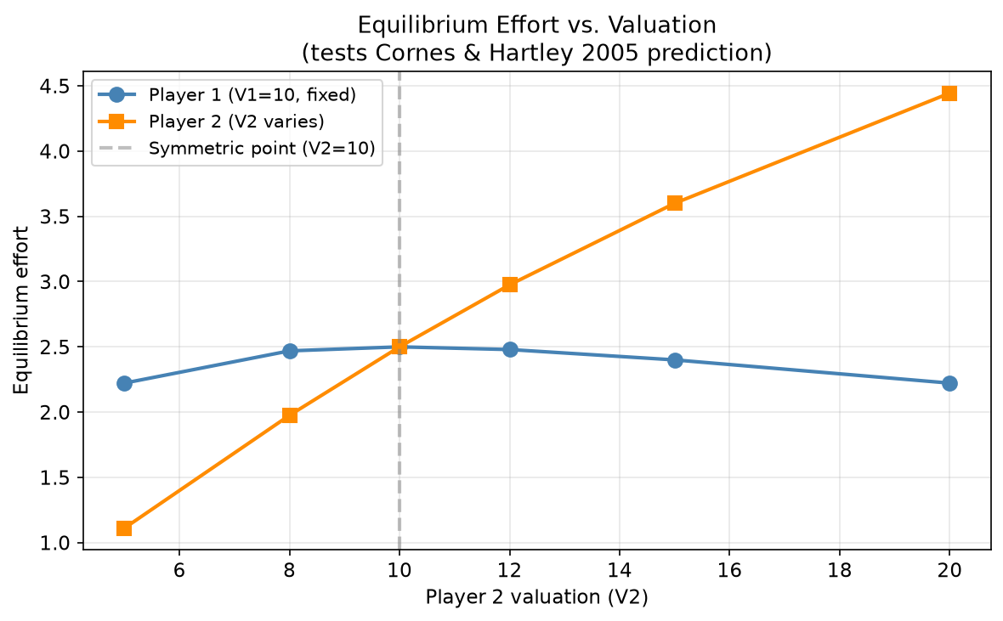
Figure 4.10: Equilibrium effort vs. Player 2 valuation. Player 2 effort rises monotonically; Player 1 effort shows a non-monotonic response peaking at the symmetric point.
Figure 4.10 extends this into a continuous sweep of V2 with V1 = 10 fixed, and reveals a pattern the three discrete cases do not show. Player 2's effort rises monotonically as V2 increases, as proportionality predicts. Player 1's does not fall monotonically as one might expect of a player facing an increasingly well-resourced rival. It rises as V2 approaches V1 from below, peaks almost exactly at the symmetric point, and declines only thereafter. Every point matches the closed form asymmetric equilibrium exactly, so the non-monotonicity is a property of the model rather than of the dynamics. Chapter 5 discusses it further.
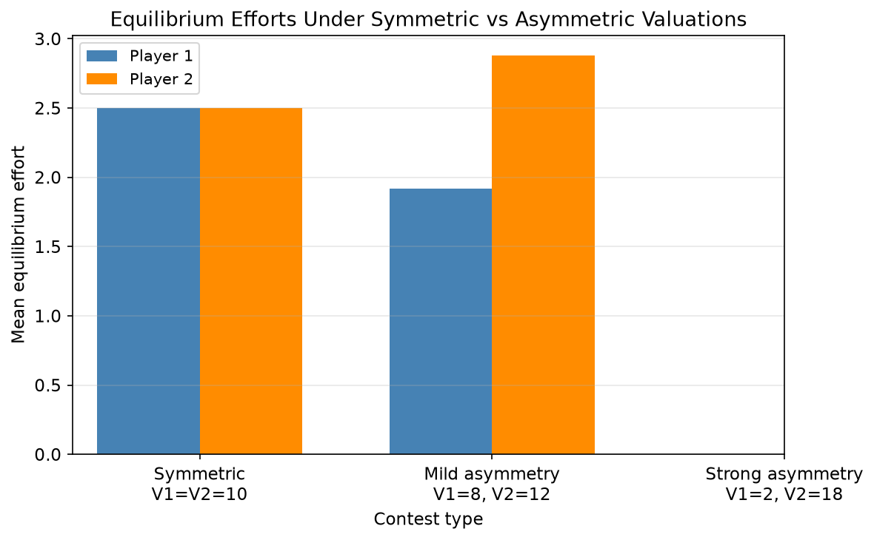
Figure 4.11: Equilibrium efforts under symmetric vs asymmetric valuations. Player 2 effort consistently exceeds Player 1 when V2 > V1, confirming Cornes and Hartley (2005).

4.5 High Decisiveness Analysis (Experiment 5)
The complete non-convergence observed from r = 2.0 onward in Experiment 2 warranted investigation at finer resolution, both to locate the transition and to establish its character. Experiment 5 addresses RQ4 through three lenses: a fine-grained sweep of r through the transition, inspection of a single representative trajectory, and a test of whether the inertial rule can rescue convergence beyond it.
The fine-grained sweep tested r in {1.5, 1.8, 2.0, 2.2, 2.4, 2.6, 2.8, 3.0, 3.2, 3.5}, a resolution five times finer than the Experiment 2 grid and extending below the transition so that it is bracketed on both sides. The result is a clean step: 100% at r = 1.5 and r = 1.8, exactly 0% at every value from r = 2.0 upward, with no intermediate cell. The transition coincides exactly with r = n/(n-1) = 2, above which a two-player Tullock contest has no pure strategy equilibrium. What Experiment 2 registered as a dynamic failure is a structural feature of the game rather than of the learning process, and the sharpness of the step is what an existence boundary should produce. An equilibrium does not gradually cease to exist.
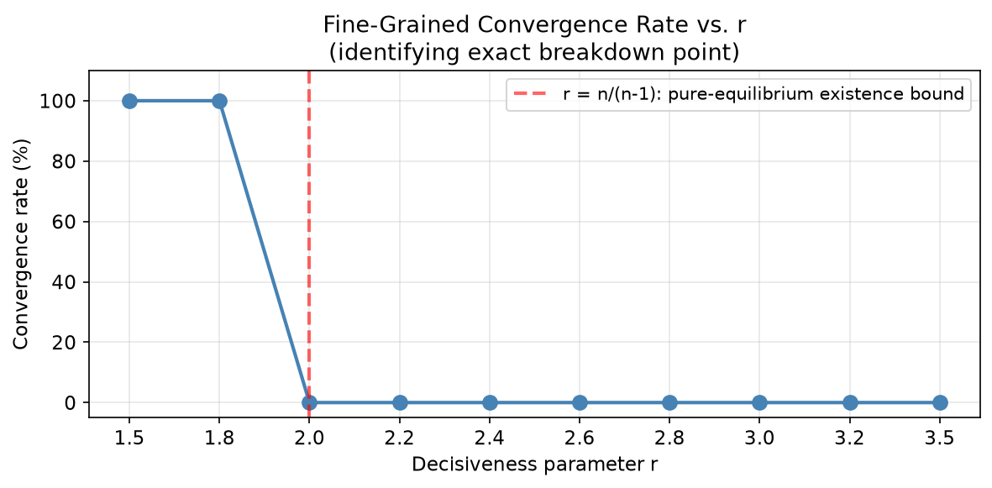
Figure 4.12: Fine-grained convergence rate vs. r. A clean step at r=2.0, the pure-equilibrium existence bound for two players, marked by the dashed line.
To see what this failure looks like in practice, a single trajectory was traced from the initial condition (4.0, 1.0) at r = 3.0. It neither settles nor diverges. It enters a sustained limit cycle within roughly ten iterations and stays in it, with unchanged amplitude, for the full hundred traced. Efforts sweep repeatedly from near zero to approximately 6.4 and back, the two players in antiphase, each responding to the other's collapse by escalating and to the other's escalation by conceding. The cycle is bounded, regular, and neither grows nor decays. That is the behaviour of a system with no fixed point to fall into rather than one being repelled from a fixed point that exists, and it is closer to the limit cycles reported under evolutionary dynamics by Hopkins and Kornienko (2010) than to the sensitive dependence on initial conditions they also document.
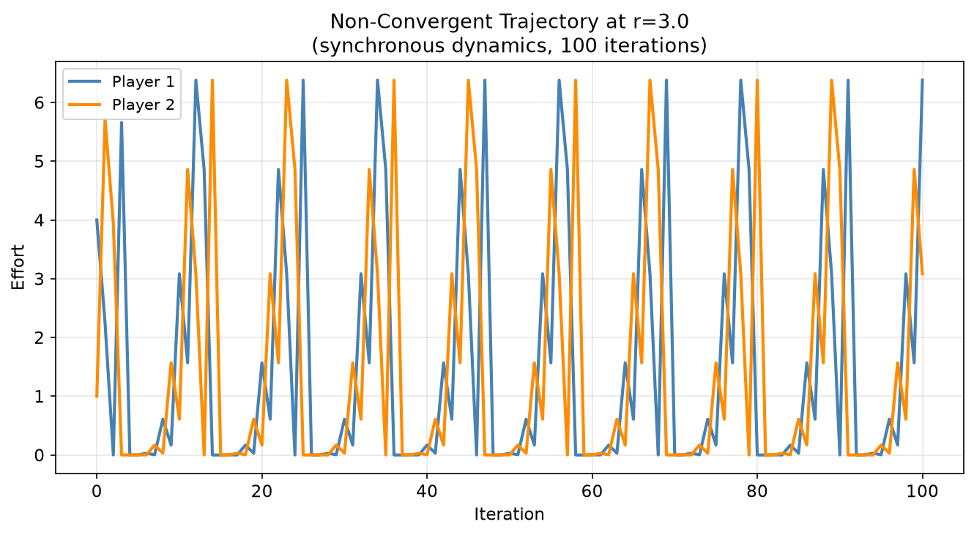
Figure 4.13: Non-convergent trajectory at r=3.0. A bounded, regular limit cycle in antiphase, sustained without change in amplitude across all 100 iterations.
Finally, four inertial learning rates, lambda in {0.8, 0.5, 0.3, 0.1}, were tested at r = 3.0 to see whether damping could restore convergence. A cautious rule moving only a small fraction towards the best response each round might be expected to prevent the overshoot visible in Figure 4.13. It does not. All four rates, including the most cautious lambda = 0.1, produced 0% convergence at r = 3.0, and a supplementary check at lambda = 0.01 produced the same outcome. The contrast with Section 4.3 is the informative part. There, damping rescued convergence reliably wherever an equilibrium existed but the simultaneous map failed to contract towards it. Here it rescues nothing, because above r = n/(n-1) there is no pure strategy equilibrium for damping to find. Together the two results establish that inertial updating addresses instability of an equilibrium but cannot substitute for the existence of one.
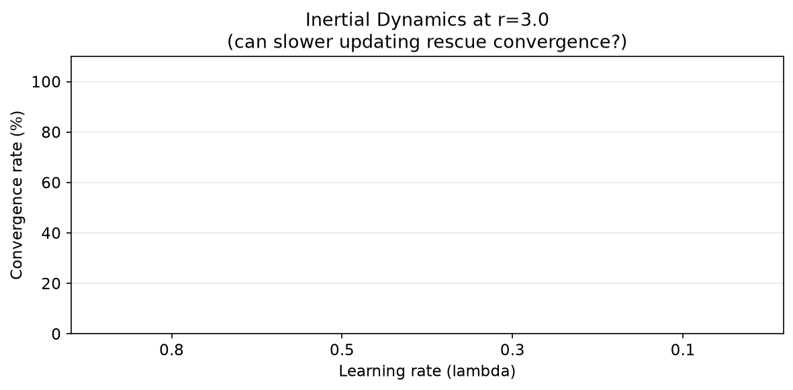
Figure 4.14: Inertial dynamics at r=3.0, showing 0% convergence across all lambda values tested.

4.6 Full Parameter Space Heatmap (Experiment 6)
Experiments 2 and 3 examined r and n independently, holding the other fixed. That leaves open how the two dimensions interact: whether, for instance, the instability at r = 3.0 documented for n = 2 also appears at other player counts or is specific to the two-player case. Experiment 6 sweeps both parameters simultaneously, producing a full convergence rate grid across r in {0.5, 1.0, 1.5, 2.0, 2.5, 3.0, 3.5, 4.0, 5.0} and n in {2, 3, 5, 10, 20}, with 10 random initialisations per cell, giving 45 parameter combinations and 450 individual runs.
n / r | 0.5 | 1.0 | 1.5 | 2.0 | 3.0 | 5.0 | n/(n-1)
n=2 | 100% | 100% | 100% | 0% | 0% | 0% | 2.00
n=3 | 100% | 100% | 50% | 0% | 0% | 0% | 1.50
n=5 | 100% | 0% | 0% | 0% | 0% | 0% | 1.25
n=10 | 100% | 0% | 0% | 0% | 0% | 0% | 1.11
n=20 | 100% | 0% | 0% | 0% | 0% | 0% | 1.05
Table 4.5: Convergence rates across the r x n parameter space (selected columns), with the pure-equilibrium existence bound in the final column. Full heatmap in Figure 4.15.
Table 4.5 shows a six-column extract from the full nine-column grid, chosen to illustrate the main structural features of the complete heatmap in Figure 4.15, with the existence bound r = n/(n-1) appended for reference. Reading down the r = 0.5 column shows universal convergence for every value of n tested, from 2 up to 20. This is the single most stable region identified anywhere in the dissertation, and it holds despite the substantial increase in the number of simultaneously adjusting players, though Section 4.3 shows that the cost of that crowding is still visible in the iteration counts even where the outcome does not change.
The striking feature of the completed grid is that it is monotone in both directions. Every cell to the right of a failure and every cell below one is also a failure, so the convergent region forms a single connected staircase with a frontier that descends as n increases. A landscape with isolated islands of success or failure would be hard to reconcile with any analytical result surveyed in Chapter 2, whereas a monotone frontier is exactly what an existence bound falling in n combined with a stability condition tightening in n predicts.
The frontier can be accounted for cell by cell. For n = 2 and n = 3 convergence extends to r = 1.5 and terminates at the existence bound. The single partial cell in the entire grid is n = 3 at r = 1.5, converging in half its runs and sitting exactly on the bound r = n/(n-1) = 1.5, which is the one place a mixed outcome should occur. For n >= 5 the failures at r = 1.0 arrive before the existence bound and are attributable instead to the spectral radius exceeding one. Figure 4.15 therefore maps the accessibility of equilibria to one learning rule and should be read as such. In the band between the stability boundary and the existence bound, the equilibrium remains reachable by asynchronous and inertial updating even where the synchronous grid records failure.
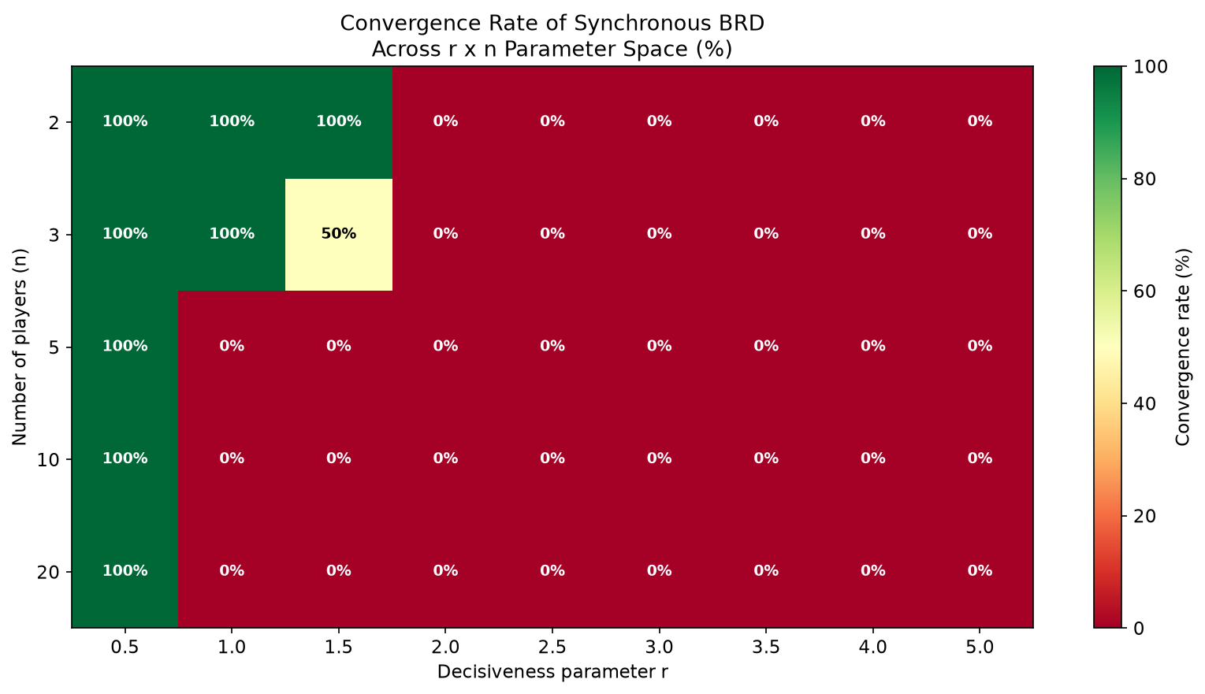
Figure 4.15: Full convergence heatmap across the r x n parameter space. Green indicates convergence, red indicates failure.
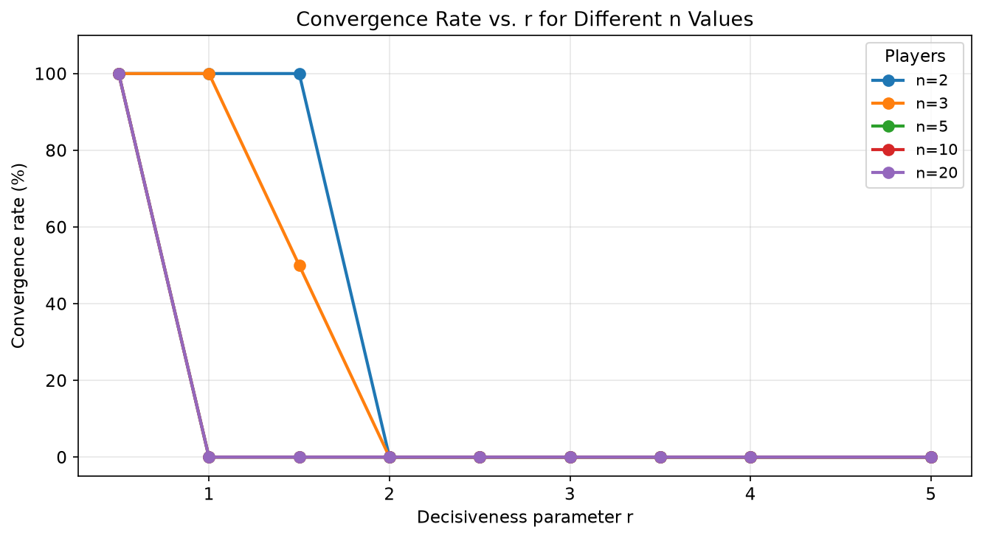
Figure 4.16: Convergence rate vs. r for each n value, showing how the instability zone widens with player count.
Figure 4.16 makes this explicit by plotting convergence rate against r as a separate line for each n. Each line is a step function that drops from 100% to 0% exactly once and never recovers, and the step moves left as n rises: r = 2.0 for two players, 1.5 for three, 1.0 for five and above. Together with Table 4.5 this is the most comprehensive empirical answer offered here to RQ1 and RQ2 jointly. Convergence of synchronous dynamics is confined to a comparatively small region that shrinks in both parameters, and its boundary is not an empirical curiosity but the tighter of two analytically characterisable conditions, the existence bound r <= n/(n-1) and the contraction condition rho < 1, with neither alone sufficient to describe it.

5. Discussion

5.1 Informing Existing Theory
The results inform existing theory in two main ways. First, the relationship between spectral radius and convergence speed, traced across the r = 0.5 row of the analysis report in Section 4.3, gives quantitative grounding to the intuition that the contraction condition does not merely guarantee convergence but predicts its rate. Mean iterations rise from 4.3 to 70.0 as the spectral radius rises from 0.000 to 0.818, and the divergence beyond one is that trend continued rather than a separate phenomenon. The radius could therefore serve as a practical diagnostic, letting practitioners anticipate how many rounds of adjustment an institution requires before settling. Table 4.2 adds a caveat: for two players the radius is essentially zero throughout while iteration counts still double, so the diagnostic describes local behaviour near equilibrium, not the time taken to arrive there.
Second, the rent dissipation results bear on Nitzan's (1994) non-monotonicity prediction more restrictively than anticipated. Total effort rises monotonically with r throughout the convergent region (Table 4.2), matching the ascending portion of his curve exactly. The descending portion cannot be examined by these means at all, because it lies beyond r = n/(n-1) where no pure strategy equilibrium exists and no equilibrium dissipation is defined. That is a boundary on what simulation of pure strategy dynamics can contribute to the literature rather than a limitation of the grid used here, and it points towards mixed strategy methods for the region beyond.

5.2 Extending Existing Theory
The most significant extension concerns what the Szidarovszky and Okuguchi contraction condition governs. Across the thirty cells of the analysis report, convergence under synchronous updating coincides exactly with a spectral radius below one: every converging cell satisfies the condition and every cell violating it fails. The theorem establishes sufficiency only, so the absence of any gap between the two over this range is a stronger correspondence than it requires, and within the cases examined the condition is empirically sharp. That is a claim about the parameter space tested, not a general one. A finite grid over a single symmetric, linear-cost specification cannot establish that the condition is necessary, and whether it is remains open. Section 5.4 sets out what would be needed to settle it.
The extension lies in what happens when the condition is violated. At n = 5 with r = 1.0 the spectral radius is 1.500 and synchronous dynamics never converge, yet x* = 1.6 exists, is verified as a fixed point, and is reached by asynchronous updating in 19 iterations and inertial updating in 39. The pattern repeats at n = 10 and n = 20, and in the asymmetric two-player case of Section 4.4 with a radius of 1.333. The condition is thus not a statement about whether an equilibrium can be learned but about whether it can be learned by agents who all revise at once. The distinction is easily lost, because the contraction framework is usually presented as a property of the game, where these results indicate it is a property of the game paired with an adjustment protocol.
The mechanism is straightforward. Inertial updating with learning rate lambda replaces the Jacobian J with (1-lambda)I + lambda*J, whose eigenvalues are 1 - lambda + lambda*mu. Because best responses are decreasing in rivals' efforts, the dominant eigenvalue mu is real and negative, so damping maps it into the unit disc. At n = 5, where mu = -1.500, a learning rate of 0.5 gives approximately -0.25. Simultaneous updating fails there not because the equilibrium repels in any absolute sense but because a full step overshoots it by more than it closes, so any protocol that shortens the step, whether by damping it or by staggering it as asynchronous updating does, recovers convergence. The practical reading for institutional design is that in the unstable-but-existent band the equilibrium can be made reachable by changing how often participants revise rather than by changing the contest.
The heterogeneous valuation results extend Cornes and Hartley (2005) computationally. Their proportionality prediction is confirmed under both mild and strong asymmetry, with the effort ratio matching the valuation ratio precisely in both cases (Table 4.4). It is confirmed even in the strong asymmetry case where synchronous dynamics do not converge and the equilibrium had to be located by damped updating, which is itself evidence that the static prediction and the dynamic accessibility question are independent. The additional finding from the valuation sweep (Figure 4.10), that Player 1's equilibrium effort is non-monotonic in Player 2's valuation, rising as V2 approaches V1 from below and falling thereafter, is not present in the Cornes and Hartley analytical results. The strategic reading is that Player 1 raises effort defensively against an intensifying but still matched rival, then withdraws once the contest becomes lopsided enough that competing seriously is unattractive.

5.3 Challenging Existing Theory
The finding that most directly challenges established practice is the size of the region in which simultaneous best response learning fails. Much of the contest theory literature treats Nash equilibrium as a behavioural prediction without addressing how agents arrive at it, and Section 4.6 indicates that this is not a safe omission. Of the forty-five parameter combinations examined, synchronous dynamics reach the equilibrium in nine. The failures form a contiguous region with an analytically describable boundary, and it grows with both decisiveness and the number of competitors, which is the direction of the large, sharply competitive contests to which the model is most often applied.
The two mechanisms carry different implications, and conflating them would understate the more serious. Above r = n/(n-1) there is no pure strategy equilibrium to reach, so the failure is not one of learning but an accurate reflection of the game. The challenge there is to the practice of applying pure strategy Tullock predictions in high-decisiveness settings at all. Below that bound but above the contraction threshold the equilibrium exists and the learning rule cannot find it, and the trajectory analysis of Experiment 5 indicates what agents would do instead: settle into a bounded, regular limit cycle, efforts sweeping between near zero and approximately 6.4 in antiphase indefinitely. Persistent cyclical behaviour is a substantive prediction in its own right, and quite different from the noisy-equilibrium picture a static analysis with an error term would suggest.
The expanding instability zone with increasing n (Figure 4.15) challenges the use of symmetric Nash equilibria as behavioural predictions in large contests. For n >= 5 at r = 1.0 the unique equilibrium is well defined but inaccessible through simultaneous learning from any tested starting point. Because asynchronous updating does reach it, the prediction remains defensible for contests in which participants revise at different times and is questionable chiefly for those in which they revise together. This provides a structural, dynamics-based explanation for the systematic deviations from Nash predictions documented experimentally by Chowdhury and Sheremeta (2011). If the equilibrium is not reachable through the most natural learning process available to boundedly rational agents, deviations from its predictions in laboratory or field settings should be expected as a matter of course rather than treated as evidence of irrationality.

5.4 Unresolved Patterns Warranting Further Investigation
Three patterns emerged during the project that were not anticipated at the outset and are flagged here as candidates for further research.
First, the exact agreement between the contraction condition and observed convergence across all thirty cells (Section 5.2) is stronger than the theory requires, since the condition is proved only to be sufficient. Whether it is also necessary for simultaneous updating in this class of contests, or whether the agreement reflects the particular structure of the symmetric linear-cost specification, a finite grid cannot settle. A systematic search for a converging configuration with spectral radius above one, over heterogeneous valuations, convex costs and finer spacing, would either locate a counterexample or strengthen the case for attempting a necessity result analytically.
Second, the n = 4 case at r = 1.0, where the spectral radius equals one exactly and the dynamics creep towards equilibrium without reaching any practical tolerance, sits awkwardly in the convergence classification used here. It is neither convergent nor divergent in the usual sense: the approach is algebraic rather than geometric, and whether it counts as a success depends entirely on the iteration budget. Characterising the rate of approach at marginal stability, and how wide the near-marginal band is in practice, would clarify how much of the convergent region in Figure 4.15 is robust and how much is budget-dependent.
Third, the limit cycles above the existence bound (Section 4.5) are regular and bounded rather than chaotic, resembling the limit cycles Hopkins and Kornienko (2010) document under evolutionary dynamics rather than the sensitive dependence on initial conditions they also report. Whether the two processes share a common source of cyclical behaviour rooted in the payoff structure, or arrive at similar cycles by different routes, would require running an evolutionary variant of this framework and comparing its cyclical regions against those in Figure 4.15. The period and amplitude of the cycles should also be analytically tractable in the two-player case, which would provide a sharper test than qualitative comparison.

5.5 Limitations
Several limitations should be acknowledged. The systematic r x n grid uses synchronous dynamics throughout, so Figure 4.15 maps the accessibility of equilibria to one update rule rather than in general. Sections 4.3 and 4.4 show asynchronous and inertial updating converging in a strictly larger region, but the boundaries of that region have not been mapped, and doing so would materially strengthen the central claim made here.
Iteration budgets remain a possible source of misclassification, though the risk is concentrated in one identifiable place. Every cell reported as convergent reaches its equilibrium well within budget, and the failures above the existence bound cannot be resolved by any budget since no fixed point exists. The vulnerable case is the near-marginal band around a spectral radius of one, exemplified by n = 4 at r = 1.0, which is still approaching equilibrium after 5000 iterations and would be recorded either way depending on where the cap falls. Cells near the stability boundary should be read with that caveat.
The discrete grid may also miss features between sampled points, although the fine-grained sweep of Experiment 5 found a clean step rather than hidden structure at five times the resolution. Finally, and most consequentially, the analysis concerns pure strategy Nash equilibria throughout. The region above r = n/(n-1), which is the majority of the space examined, possesses only mixed strategy equilibria, which this framework cannot represent. The non-convergence reported there should be read as the absence of a reachable pure strategy equilibrium, not as evidence that those contests have no predictable behaviour.

6. Conclusion

6.1 Summary of Findings
This dissertation set out to investigate a question that existing theory addresses only partially: not whether Nash equilibria exist in Tullock contests, which is well established, but whether and how boundedly rational agents following the most natural adaptive learning process available to them actually reach those equilibria across the space of economically relevant parameter values. Answering it required building, validating and systematically deploying a simulation framework capable of exploring parameter regions where closed form results are unavailable. The main findings are summarised below.
- The simulation correctly recovers all analytical benchmarks, validating the framework as a reliable tool for extending theoretical analysis beyond closed form tractability.
- Two separable mechanisms produce dynamic failure. Above r = n/(n-1) no pure strategy equilibrium exists and no rule converges; below it but above a spectral radius of one, the equilibrium exists and only simultaneous updating misses it.
- Across the thirty cells examined, synchronous convergence coincides exactly with a spectral radius below one, making the Szidarovszky and Okuguchi (1997) condition empirically sharp over this range. Whether it is necessary in general remains open.
- At r = 1.0 the spectral radius equals (n-2)/2, placing the stability boundary at n = 4, where convergence becomes algebraic and escapes any practical iteration budget.
- Where that condition fails but an equilibrium exists, asynchronous and inertial updating reach it, in 19 and 39 iterations at n = 5, so the condition constrains the update rule rather than the game.
- Cornes and Hartley's (2005) proportionality prediction is confirmed exactly, with a non-monotonic strategic response identified. A 9:1 valuation ratio alone destabilises simultaneous updating, independently confirming Ghosh and Goldberg (2023).
- Beyond the existence bound the dynamics settle into bounded limit cycles rather than diverging.

6.2 Future Work
Four directions emerge. First and most directly, the asynchronous and inertial rules should be swept across the full r x n grid as the synchronous rule was here. Chapter 4 establishes that they converge in a strictly larger region without establishing its shape, and mapping it would turn the central observation of this dissertation into a quantitative result. Second, the limit cycles above the existence bound are regular enough that their period and amplitude should be analytically tractable for two players, which would sharpen the comparison with Hopkins and Kornienko (2010). Third, mixed strategy equilibria govern the whole region above r = n/(n-1) and lie outside the present framework, so extending it to mixed strategy learning is the natural route to the descending portion of Nitzan's (1994) dissipation curve. Fourth, the Stackelberg framing of Liu et al. (2025) offers a way to ask whether sequential commitment restores existence where simultaneous play provides none.

References
Chowdhury, S M and Sheremeta, R M 2011. A generalized Tullock contest. Public Choice, 147(3), 413-427.
Cornes, R and Hartley, R 2005. Asymmetric contests with general technologies. Economic Theory, 26(4), 923-946.
Elkind, E, Ghosh, A and Goldberg, P 2024. Continuous-time best-response and related dynamics in Tullock contests with convex costs. arXiv preprint arXiv:2402.08541.
Ghosh, A and Goldberg, P 2023. Best-response dynamics in lottery contests. In Proceedings of the 24th ACM Conference on Economics and Computation. arXiv preprint arXiv:2305.10881.
Hopkins, E and Kornienko, T 2010. Which inequality? American Economic Journal: Microeconomics, 2(3), 106-137.
Judd, K L 1998. Numerical methods in economics. MIT Press.
Lim, W and Matros, A 2009. Contests with a stochastic number of players. Games and Economic Behavior, 67(2), 584-597.
Liu, Y, Ni, B, Shen, W, Wang, Z and Zhang, J 2025. Stackelberg vs. Nash in the lottery Colonel Blotto game. In Proceedings of the 34th International Joint Conference on Artificial Intelligence, 3961-3969.
Miranda, M J and Fackler, P L 2002. Applied computational economics and finance. MIT Press.
Nitzan, S 1994. Modelling rent-seeking contests. European Journal of Political Economy, 10(1), 41-60.
Perez-Castrillo, J D and Verdier, T 1992. A general analysis of rent-seeking games. Public Choice, 73(3), 335-350.
Szidarovszky, F and Okuguchi, K 1997. On the existence and uniqueness of pure Nash equilibrium in rent-seeking games. Games and Economic Behavior, 18(1), 135-140.
Tullock, G 1980. Efficient rent seeking. In Buchanan, J M, Tollison, R D and Tullock, G (eds.) Toward a theory of the rent-seeking society. Texas A&M University Press, 97-112.
Wilson, G, Aruliah, D A, Brown, C T, Chue Hong, N P, Davis, M, Guy, R T, Haddock, S H D, Huff, K D, Mitchell, I M, Plumbley, M D, Waugh, B, White, E P and Wilson, P 2014. Best practices for scientific computing. PLoS Biology, 12(1), e1001745.

