NAME | ALDREN LOUIE L REYES
PROJECT TITLE | ClientSphere: Customer Relationship Management System
SUBJECT:  CODE:  TIME: | IT15/L Integrative Programming and Technologies  8441  10:00 am - 12:00 nn
TOPIC (Type of Business Process) | #5 - Customer Relationship Management (CRM)
Products/Services | Accounting Firm
Deployed Link / Website link | http://clientsphereph.runasp.net
2nd Deliverables-1st Hands-on Exam (Deployed Protype/Design)
Log in-Page | 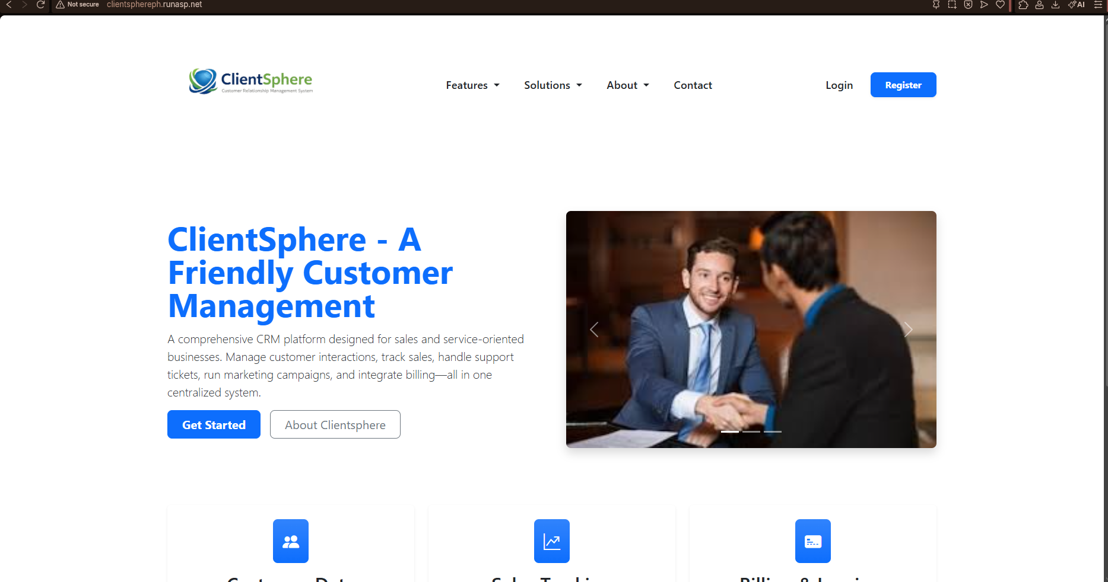
Dashboard (Admin) | 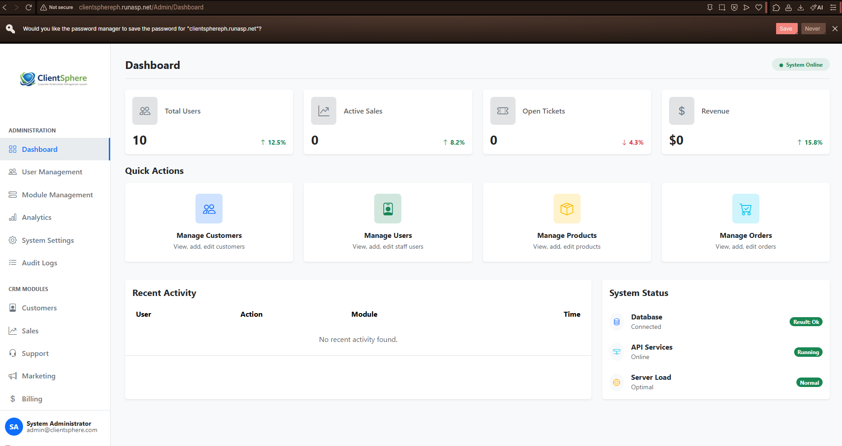
Dashboard (Client/End-User) | 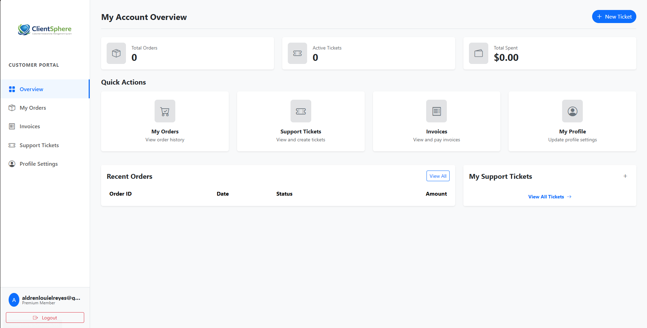
Add / Create Page | 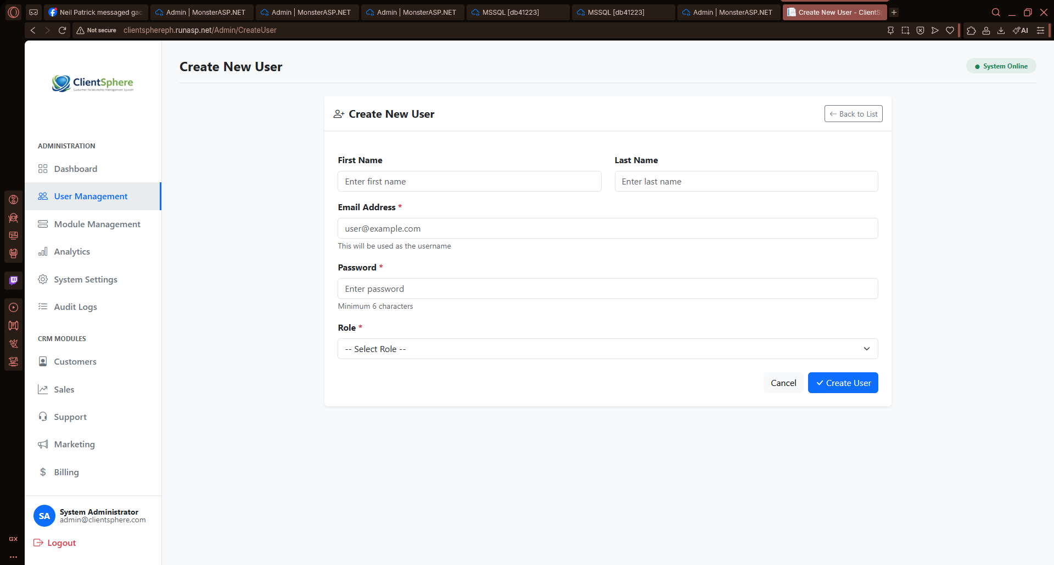  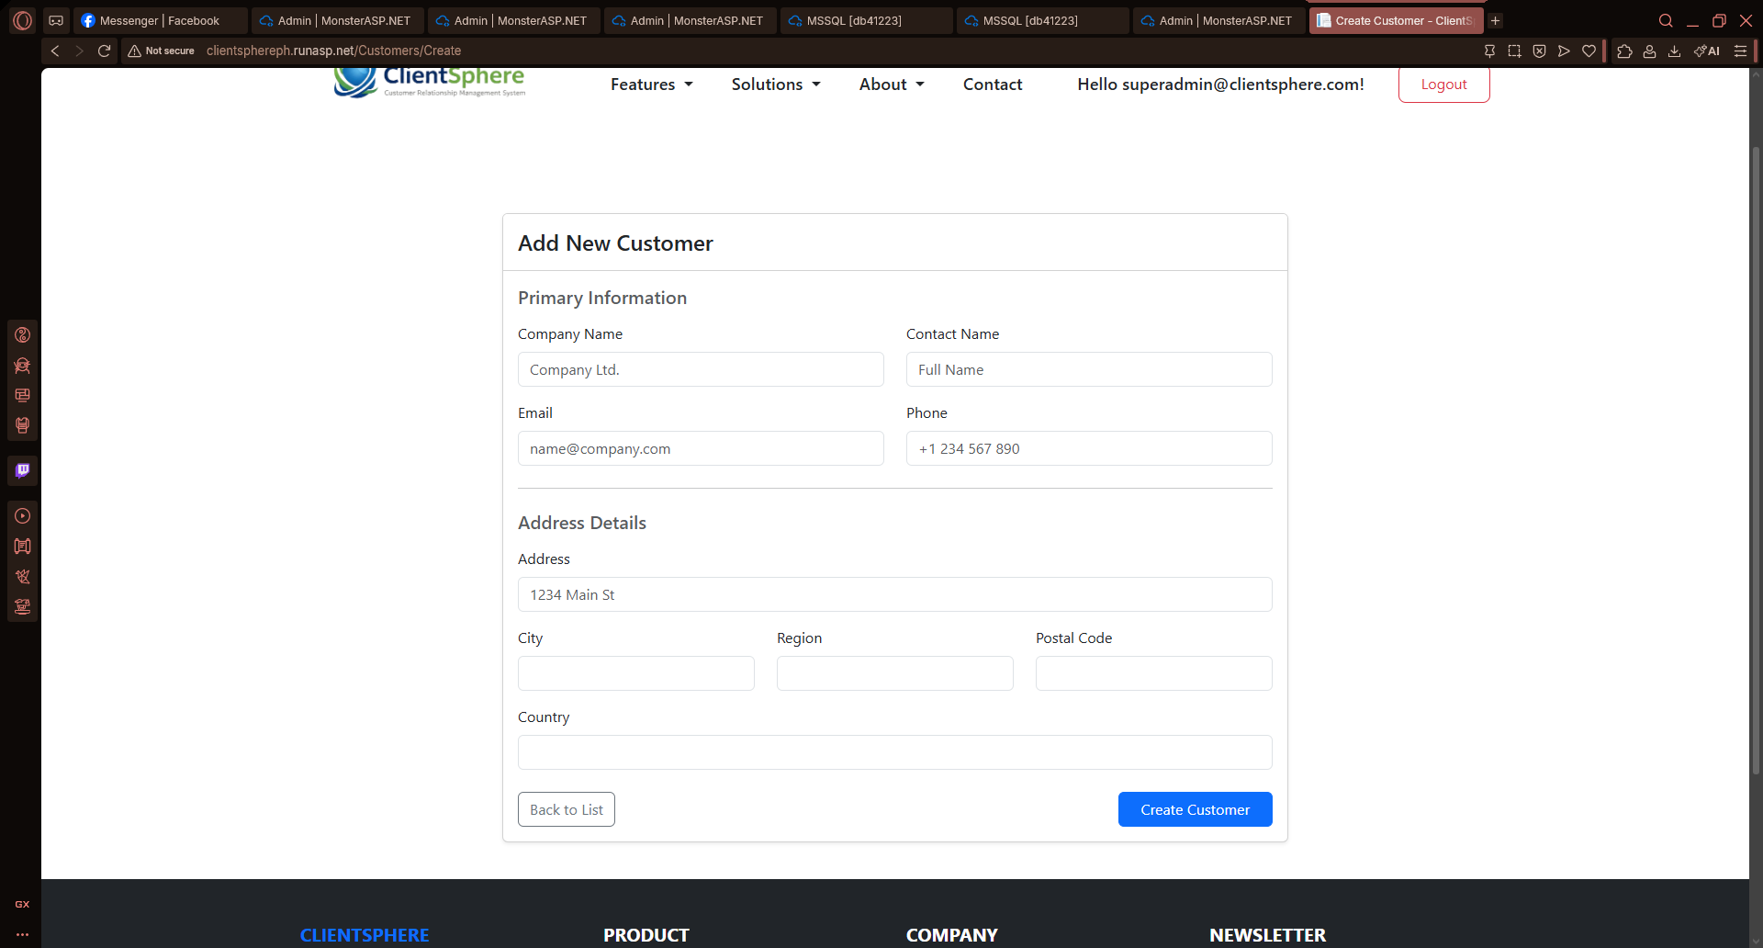  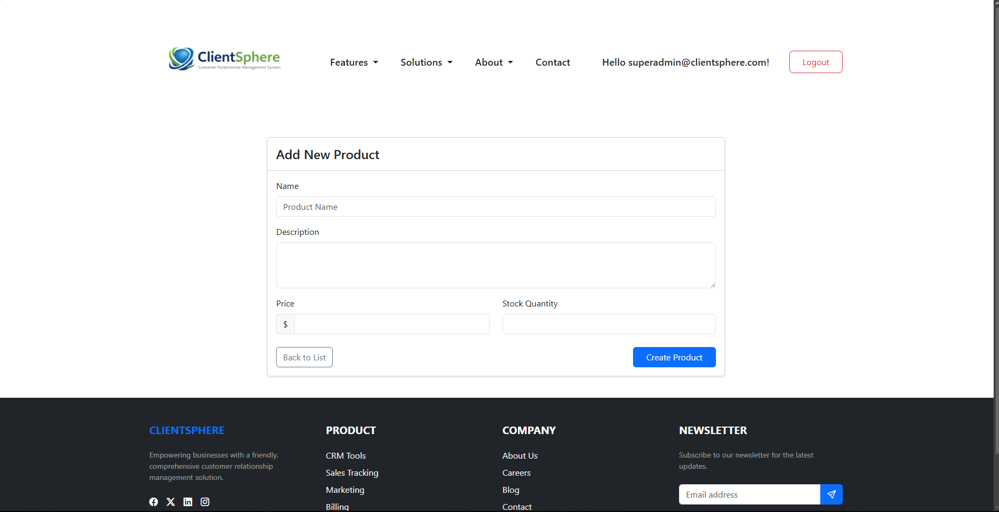  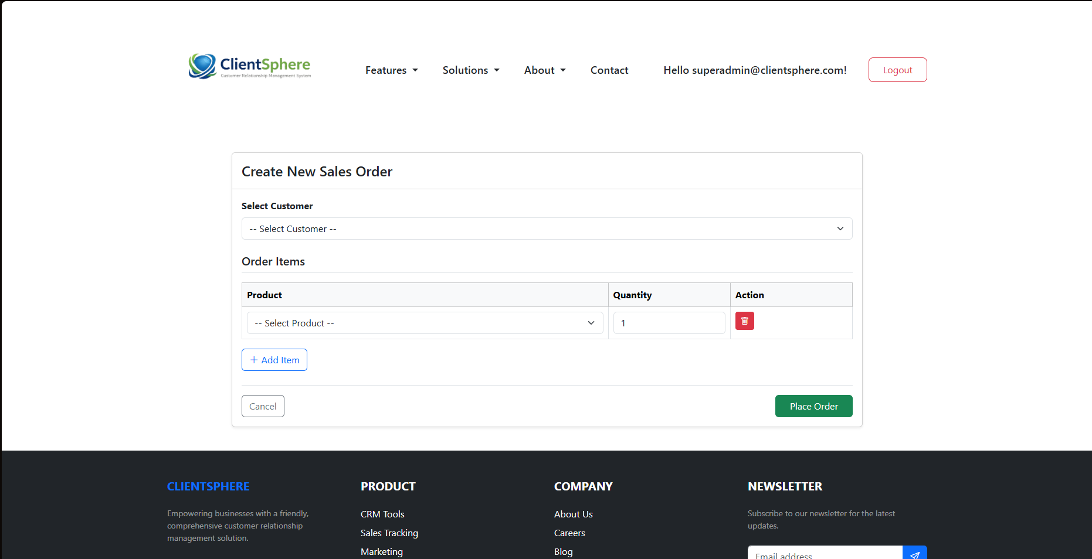  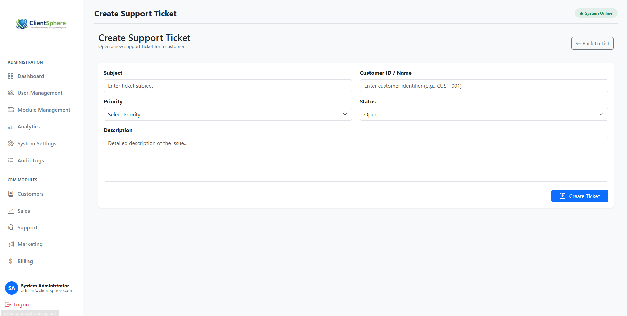  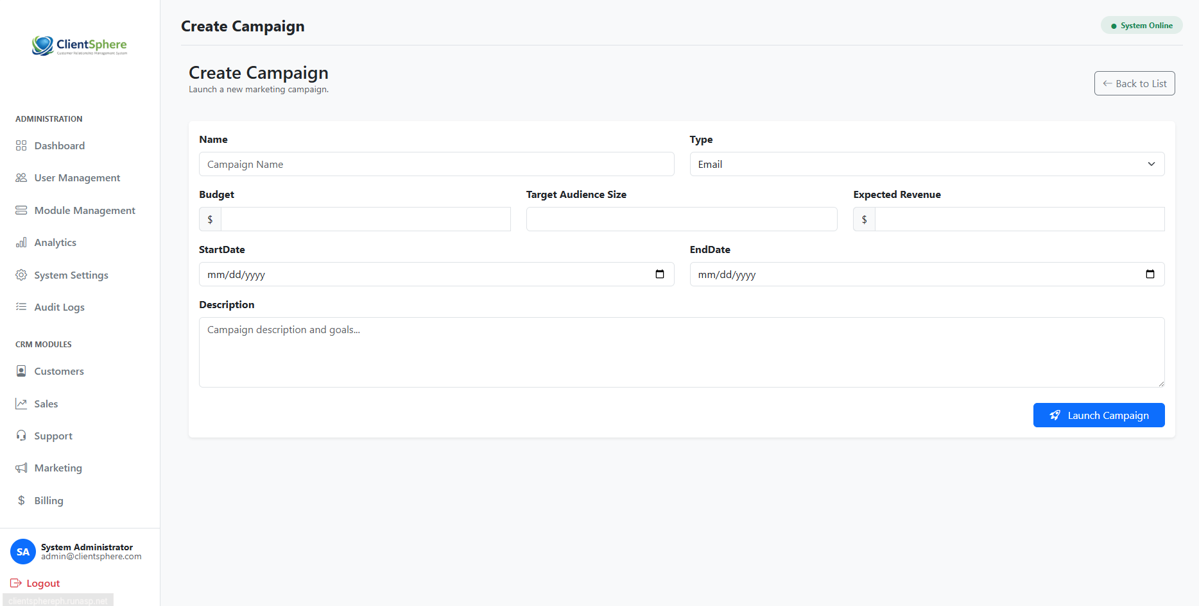  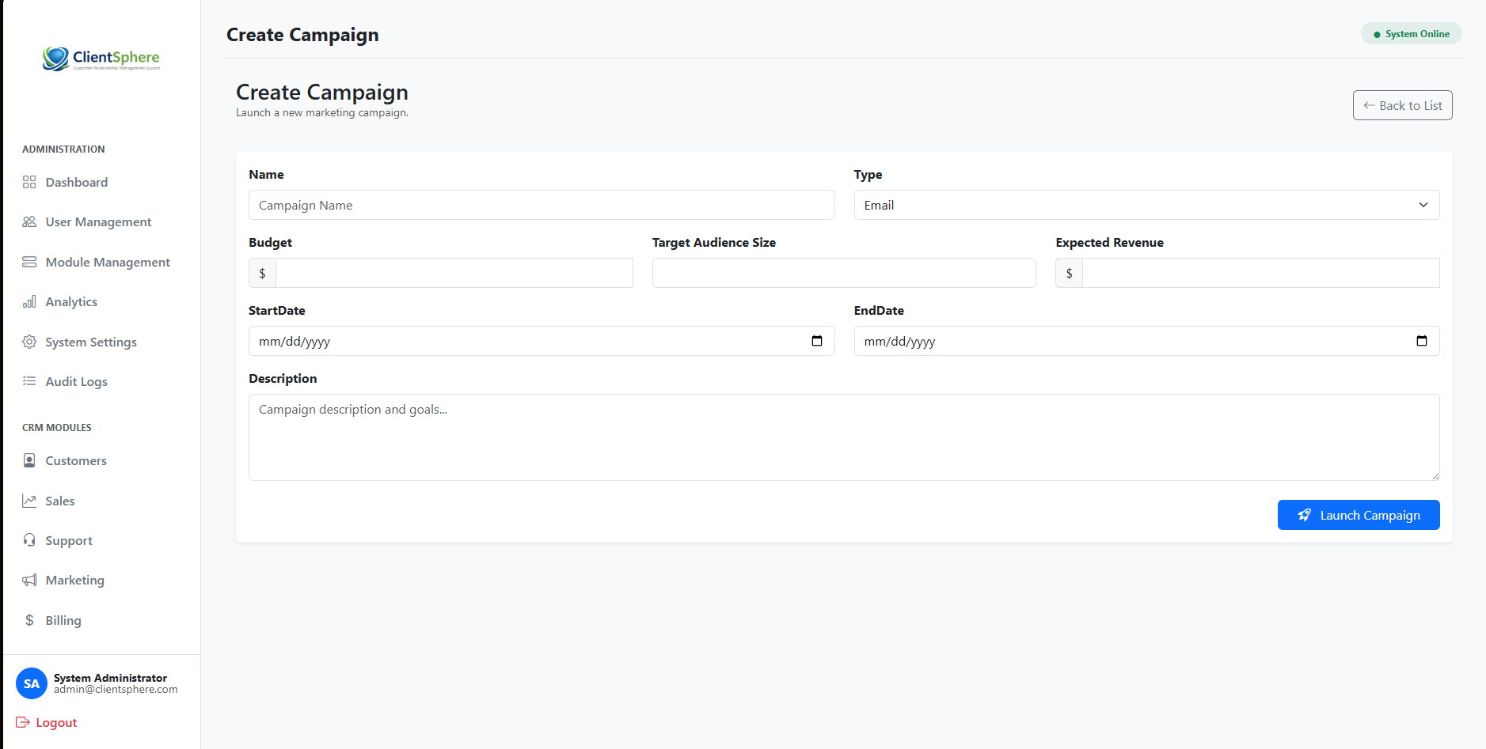  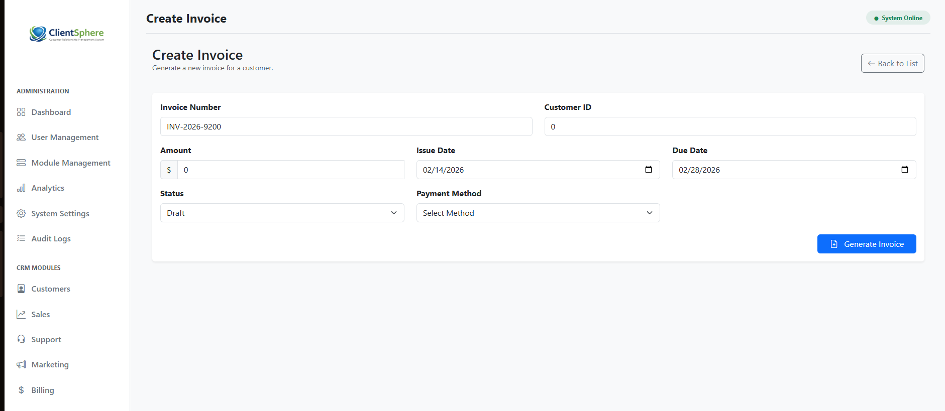
Update/Edit Page | 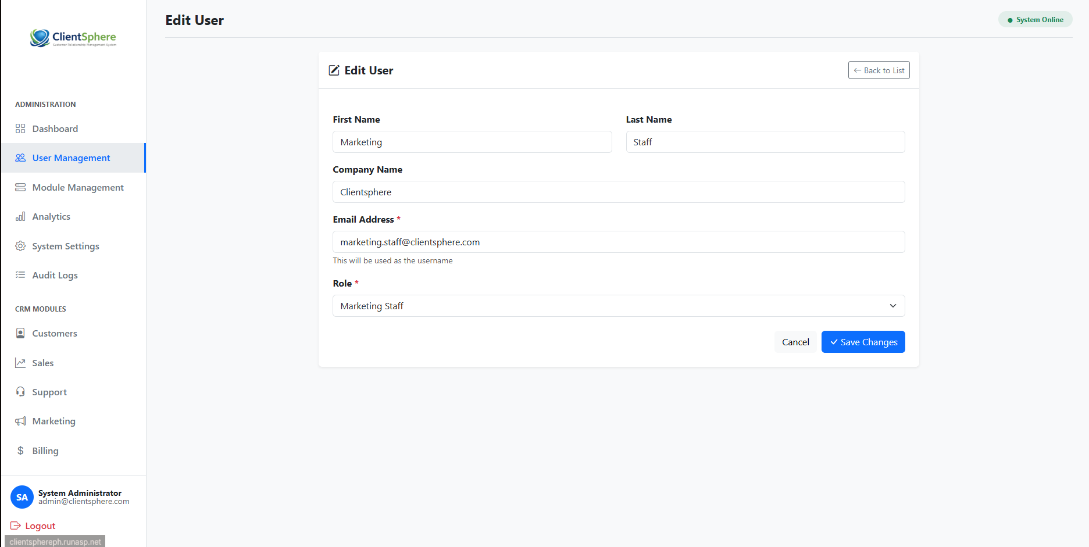
Display Records | 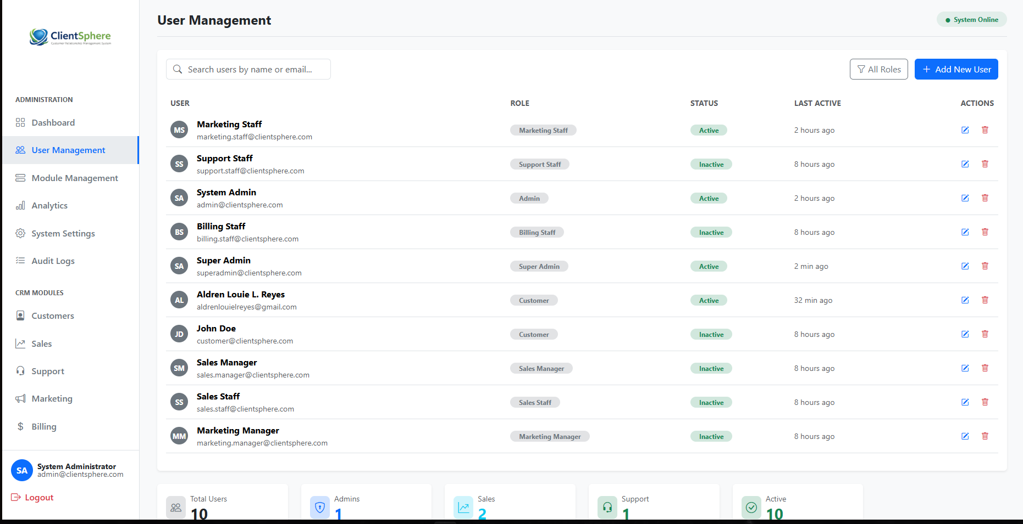
Date Submitted:
Teacher’s Feedback | _________________________________________________________________  _________________________________________________________________  _________________________________________________________________  _________________________________________________________________  _________________________________________________________________  _________________________________________________________________  ________________________________ __________________________  Student’s Signature (after feedbacking) Teacher’s Signature

-Submit on time. -FEB 13, 2026 SOFTCOPY-UPLOAD using BBL
-Use this template. (A4 Size) save as PDF FILE

