NAME | ROCKY BANTILAN ADAYA
PROJECT TITLE | Adaya IT Solution: Corporate Project Lifecycle & Workflow Management System
SUBJECT:  CODE:  TIME: | IT15/L Integrative Programming and Technologies  8441  10:00 AM – 12:00 PM
TOPIC (Type of Business Process) | #37 Collaborative and Workflow Transactions System
Products/Services | Corporate Enterprises, Project-Based Organizations, and HR/Project Management Services
Deployed Link / Website link | http://adaya-101.runasp.net
2nd Deliverables-1st Hands-on Exam (Deployed Protype/Design)
Log in-Page | 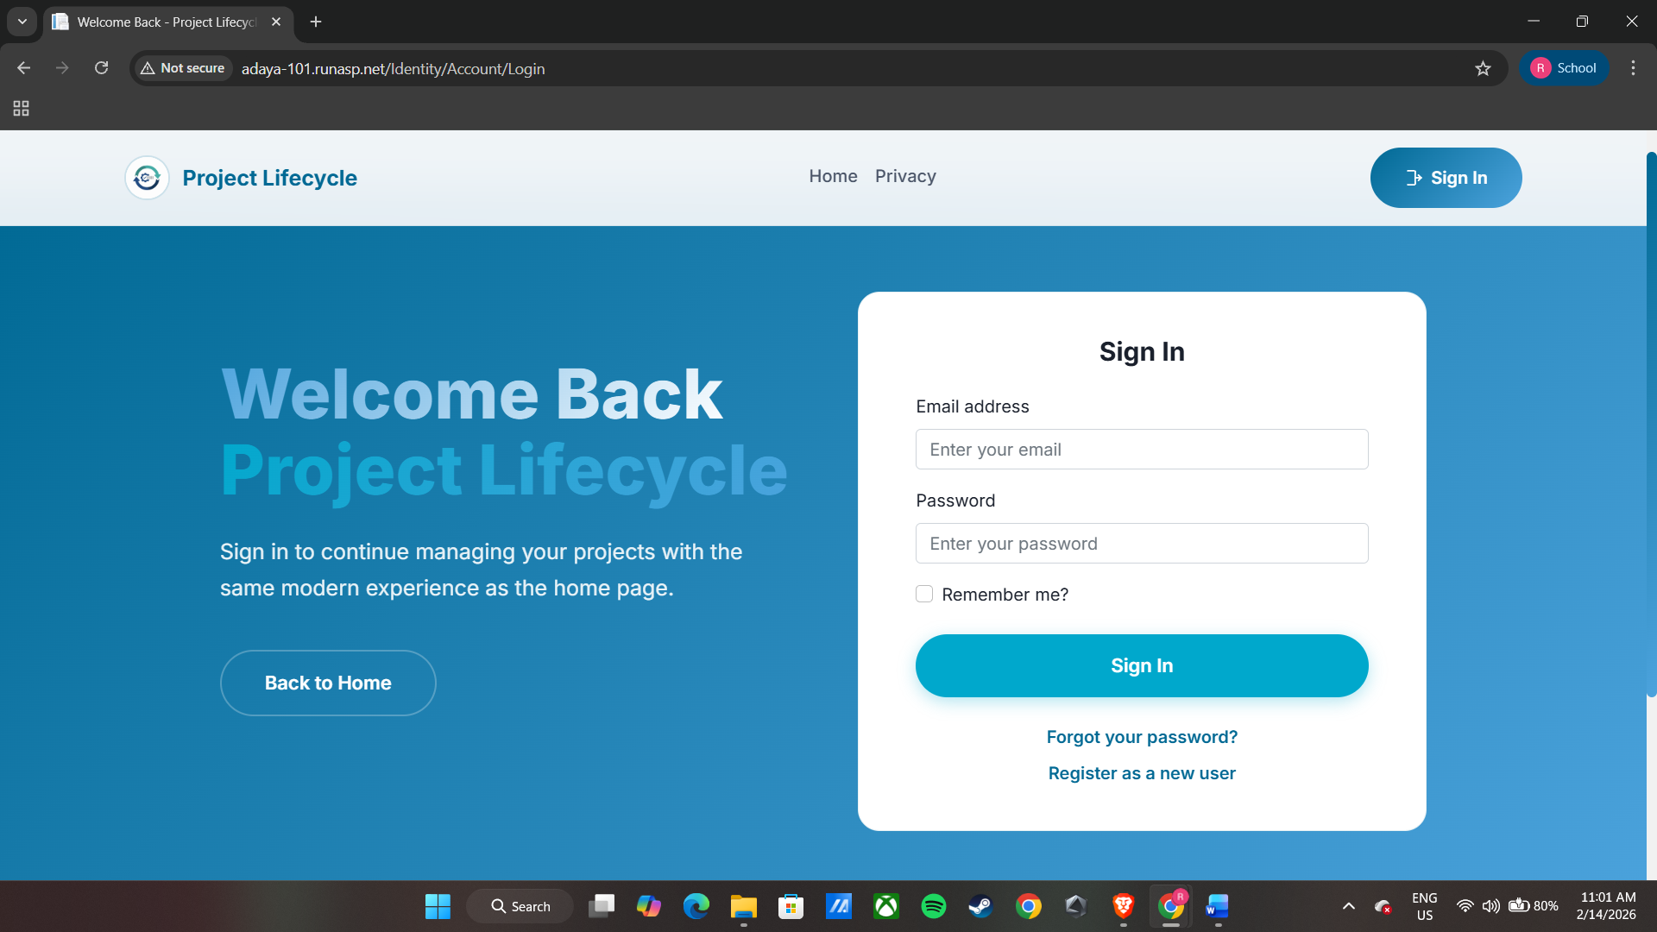  The Login Page enables internal corporate personnel to securely access the system using their assigned account credentials. Employee accounts are pre-registered and managed by the Super Administrator or HR/Admin, ensuring that only authorized users can log in to the platform. Upon entering a valid username and password, the system authenticates the user’s identity and grants access based on their designated role within the organization, such as Employee, Project Manager, Department Head, HR/Admin, Executive, or Super Admin. This role-based authentication ensures that users are directed to the appropriate dashboard and are only able to access features and data relevant to their responsibilities. In cases of invalid login credentials, the system displays an error message prompting the user to provide correct login information.
Dashboard (Admin) | 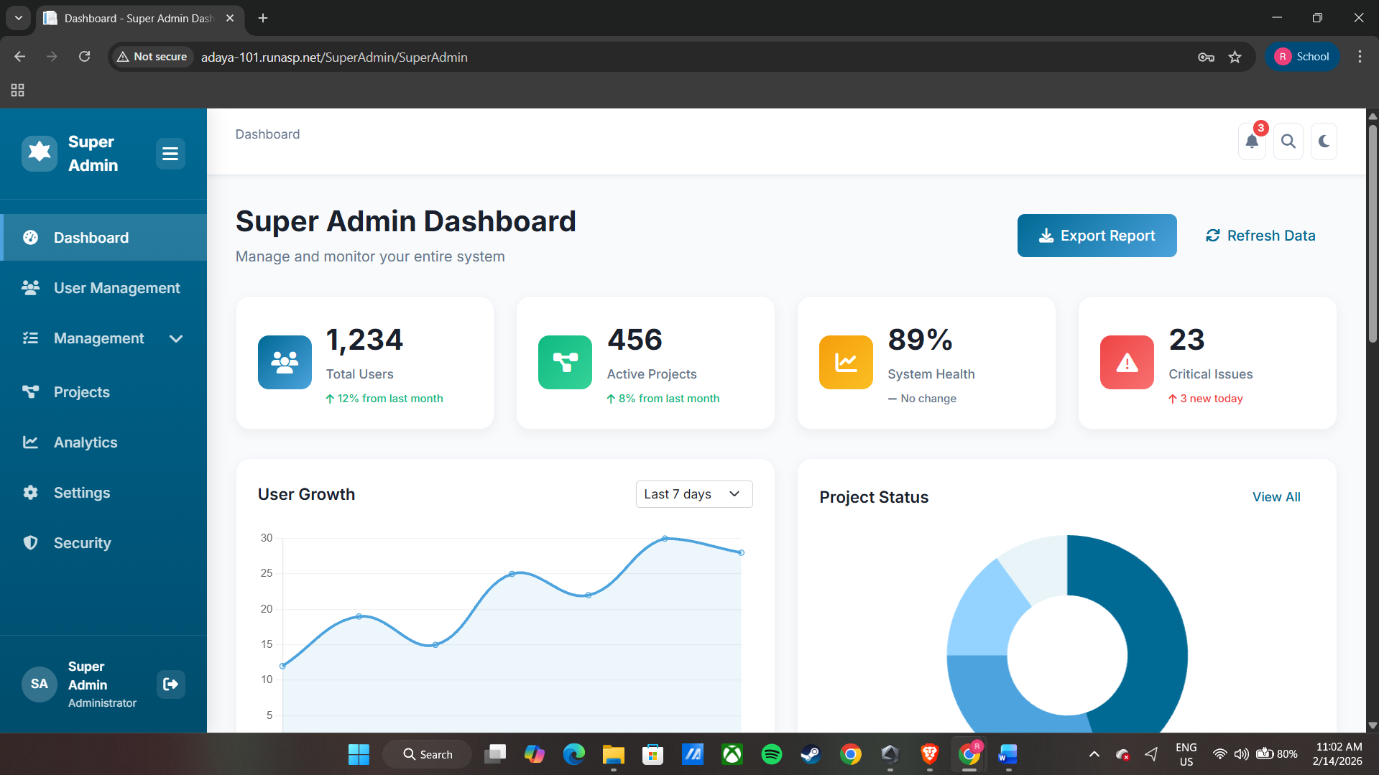  The Super Admin Dashboard serves as the central control panel for managing and monitoring the overall system operations. It provides the Super Administrator with a comprehensive overview of organizational activities, including user account management, project workflows, departmental assignments, and system-wide performance metrics. Through this dashboard, the Super Admin can create, update, and manage employee accounts, assign roles and access privileges, and oversee project and task progress across different departments. Additionally, it enables the administrator to monitor system usage and ensure that all modules are functioning efficiently. This centralized interface supports effective decision-making by presenting summarized data and real-time updates relevant to the organization’s project lifecycle and workflow management processes.
Dashboard (Client/End-User) | 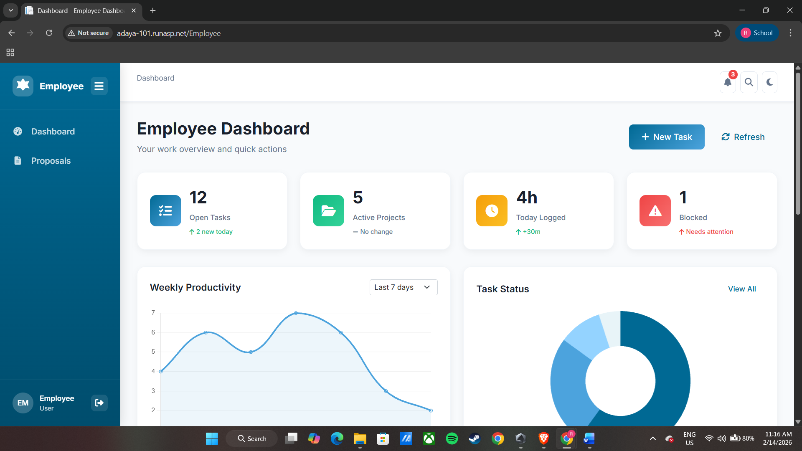  The Employee Dashboard serves as the primary interface for employees to access and manage their assigned tasks and project-related responsibilities within the system. It provides an overview of ongoing projects, assigned tasks, deadlines, and project updates relevant to the employee’s role. Through this dashboard, employees can track the progress of their tasks, view project details, and stay informed about notifications such as new assignments, task updates, or project announcements. Additionally, it allows employees to collaborate within project workflows by participating in assigned activities and monitoring their individual contributions to the overall project lifecycle. This feature ensures that employees remain updated and actively engaged in project execution and organizational workflow processes.
Add / Create Page | The Add / Create Account feature allows the Super Administrator to register new internal users into the system through a guided modal form with a stepper interface. This step-by-step process ensures accurate and complete user information before account creation.  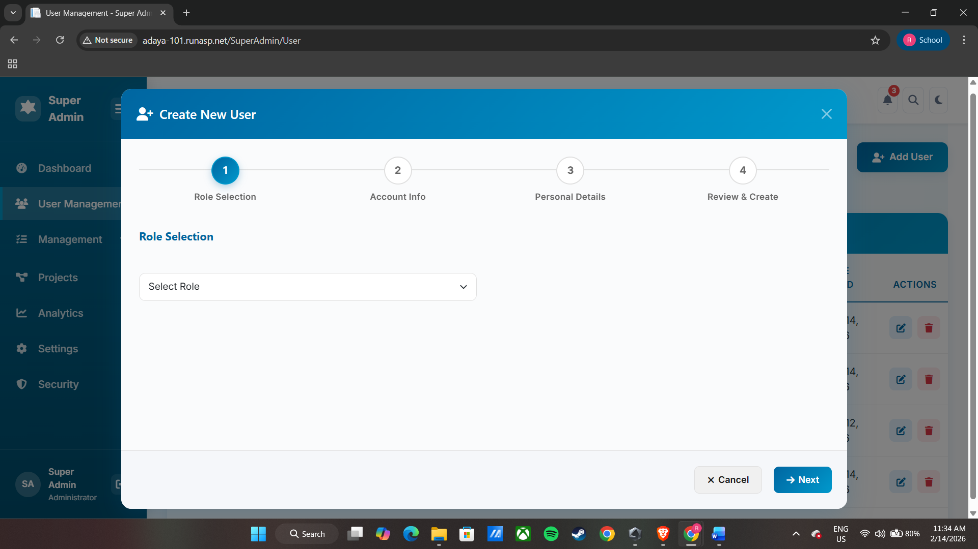  In the Role Selection step, the Super Admin assigns the appropriate system role for the new user, such as Employee, Project Manager, Department Head, Human Resource, or Executive, which determines the user’s access level and permissions within the platform.  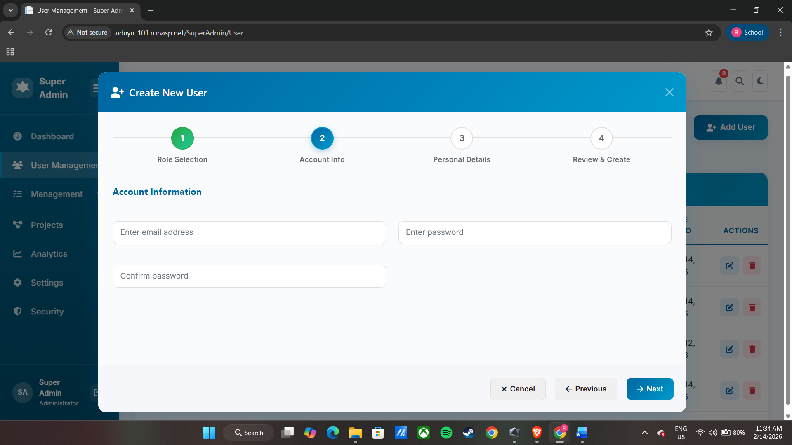  The Account Information step enables the administrator to input the user’s login credentials, including email address and password, along with password confirmation to validate consistency and ensure secure authentication.  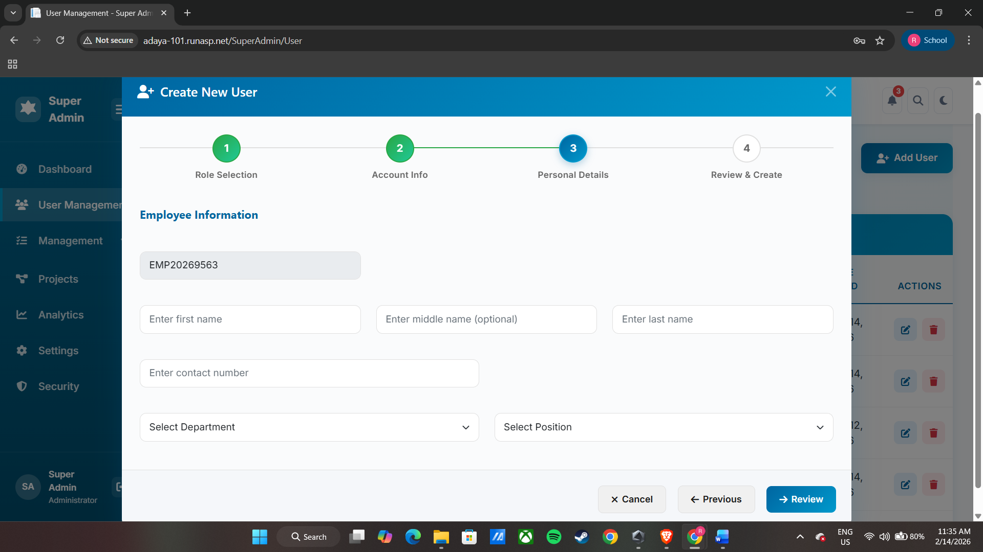  In the Personal Details step, the administrator provides the employee’s personal and organizational information, including full name (first name, middle name, and last name), contact number, department assignment, and job position through dropdown selections. The system automatically generates a unique employee number for identification purposes.  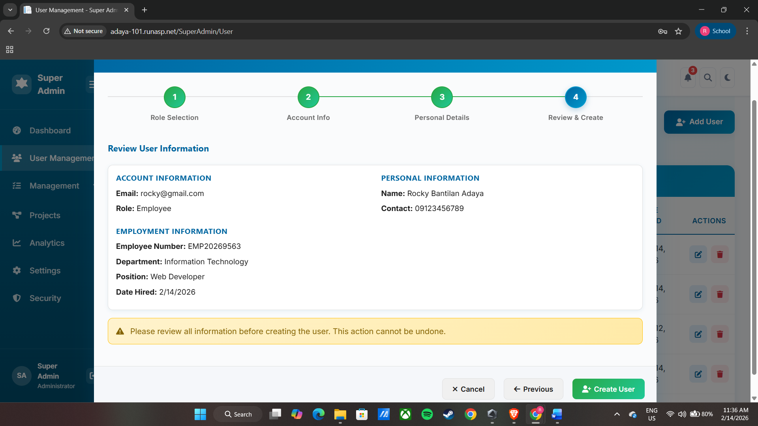  Lastly, the Review and Create step presents a summary of all entered information, allowing the Super Admin to verify the accuracy of the details before finalizing and creating the user account within the system.  Note: The address field is not yet included. An address API will be integrated to provide automatic dropdown selections for address fields, allowing the Super Admin or HR to select the user’s location without manually typing it, improving accuracy and speeding up data entry.
Update/Edit Page | The Update/Edit Account feature allows the Super Administrator to modify existing internal user accounts through a guided modal form with a stepper interface. This step-by-step process ensures that all user information is accurately reviewed and updated as needed.  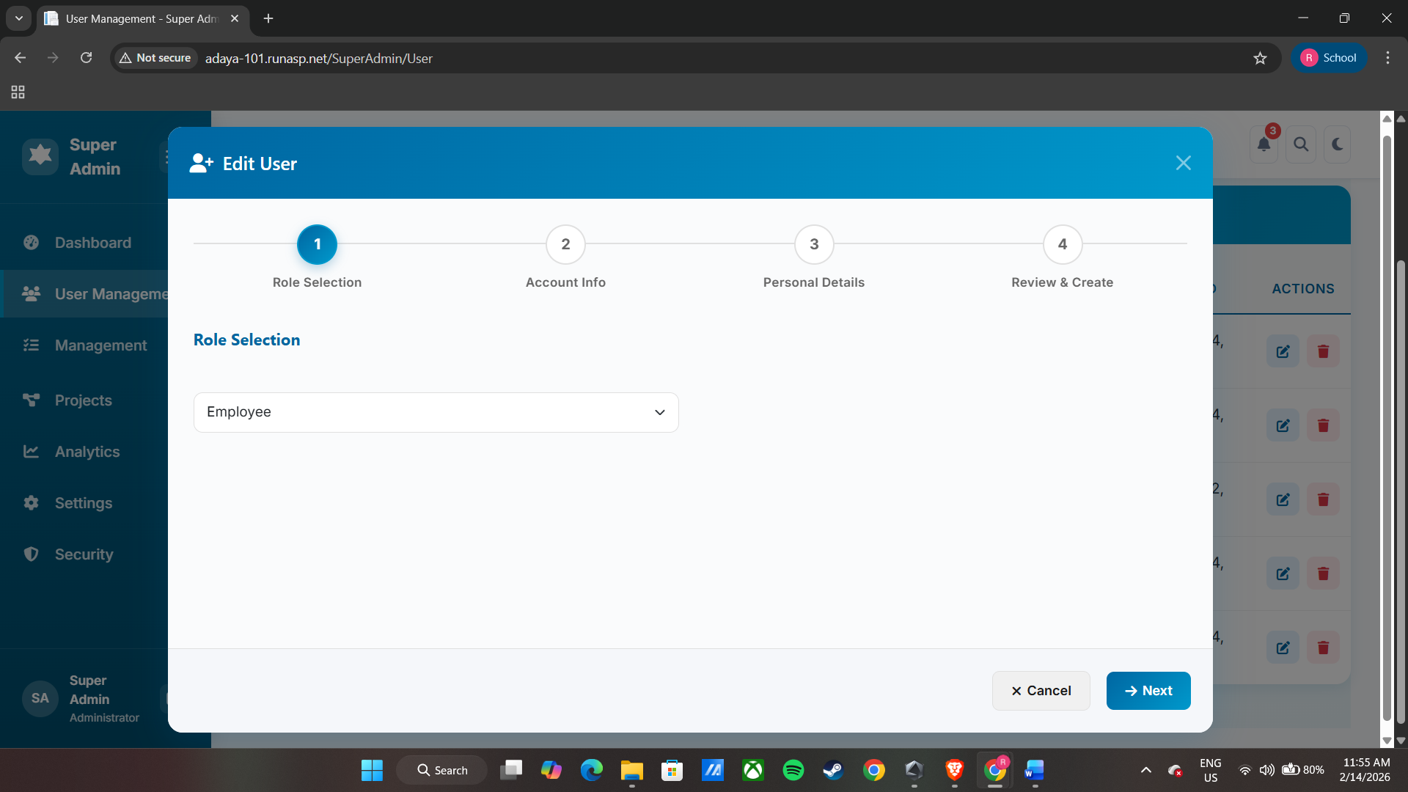  In the Role Selection step, the Super Admin can change or confirm the user’s system role, such as Employee, Project Manager, Department Head, Human Resource, or Executive, which determines the user’s access level and permissions within the platform.  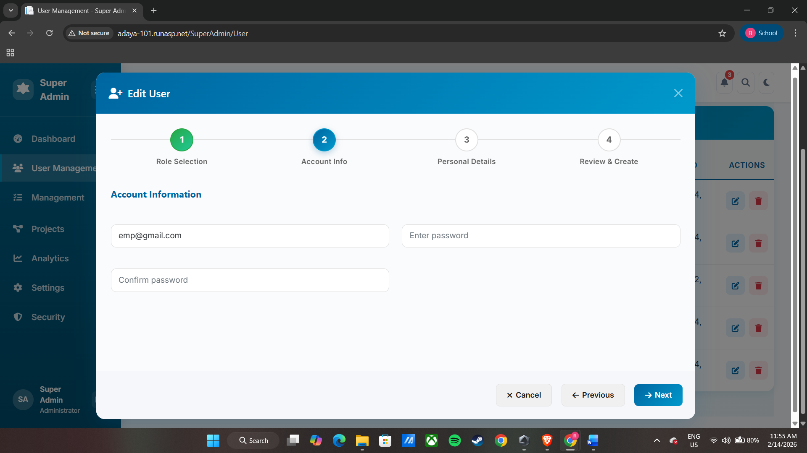  The Account Information step enables the administrator to update the user’s login credentials, including email address and password, with password confirmation to ensure consistency and secure authentication.  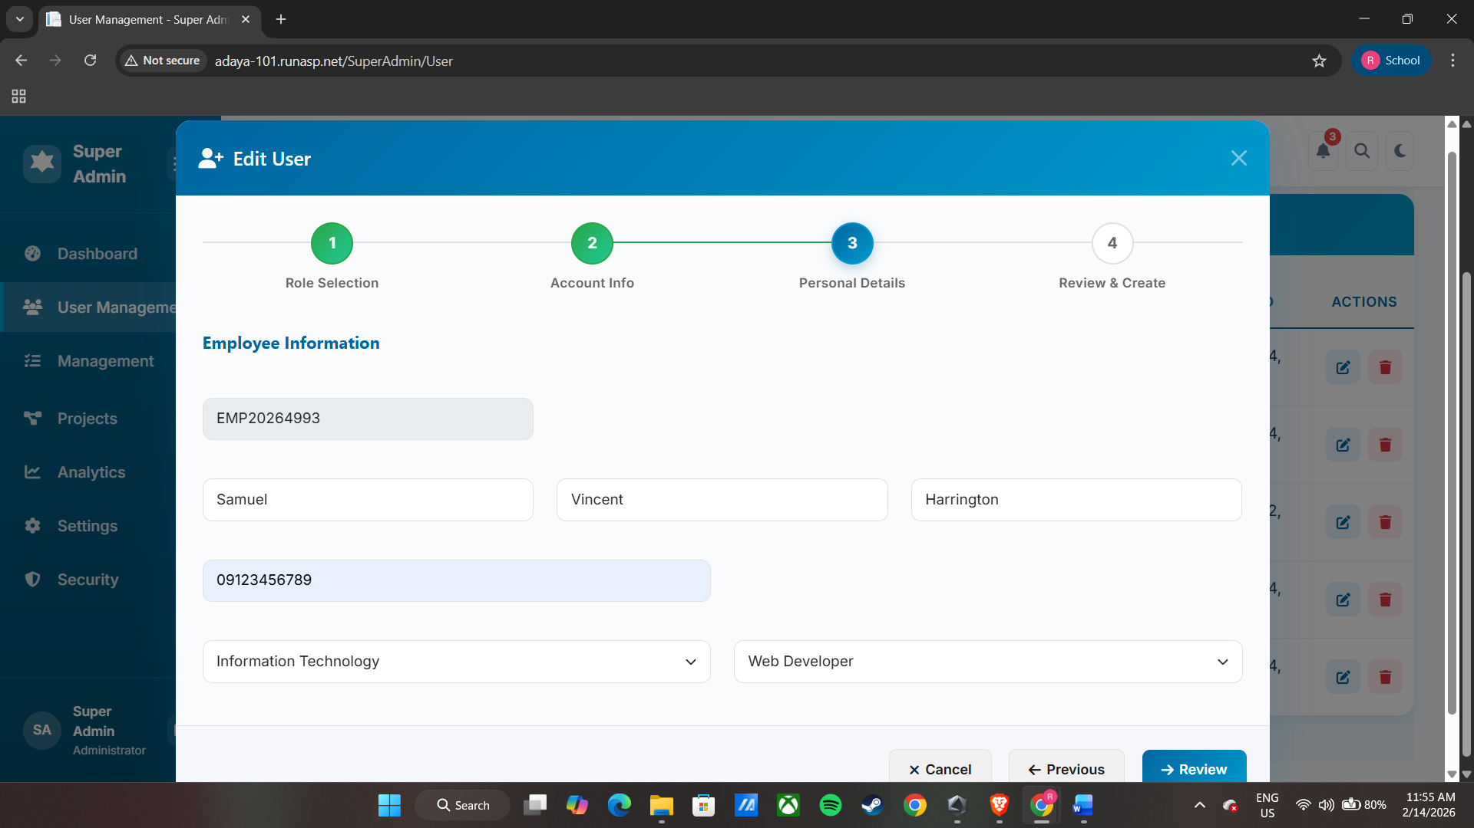  In the Personal Details step, the administrator can modify the employee’s personal and organizational information, including full name (first, middle, and last name), contact number, department assignment, and job position through dropdown selections. The employee number remains fixed for identification purposes.  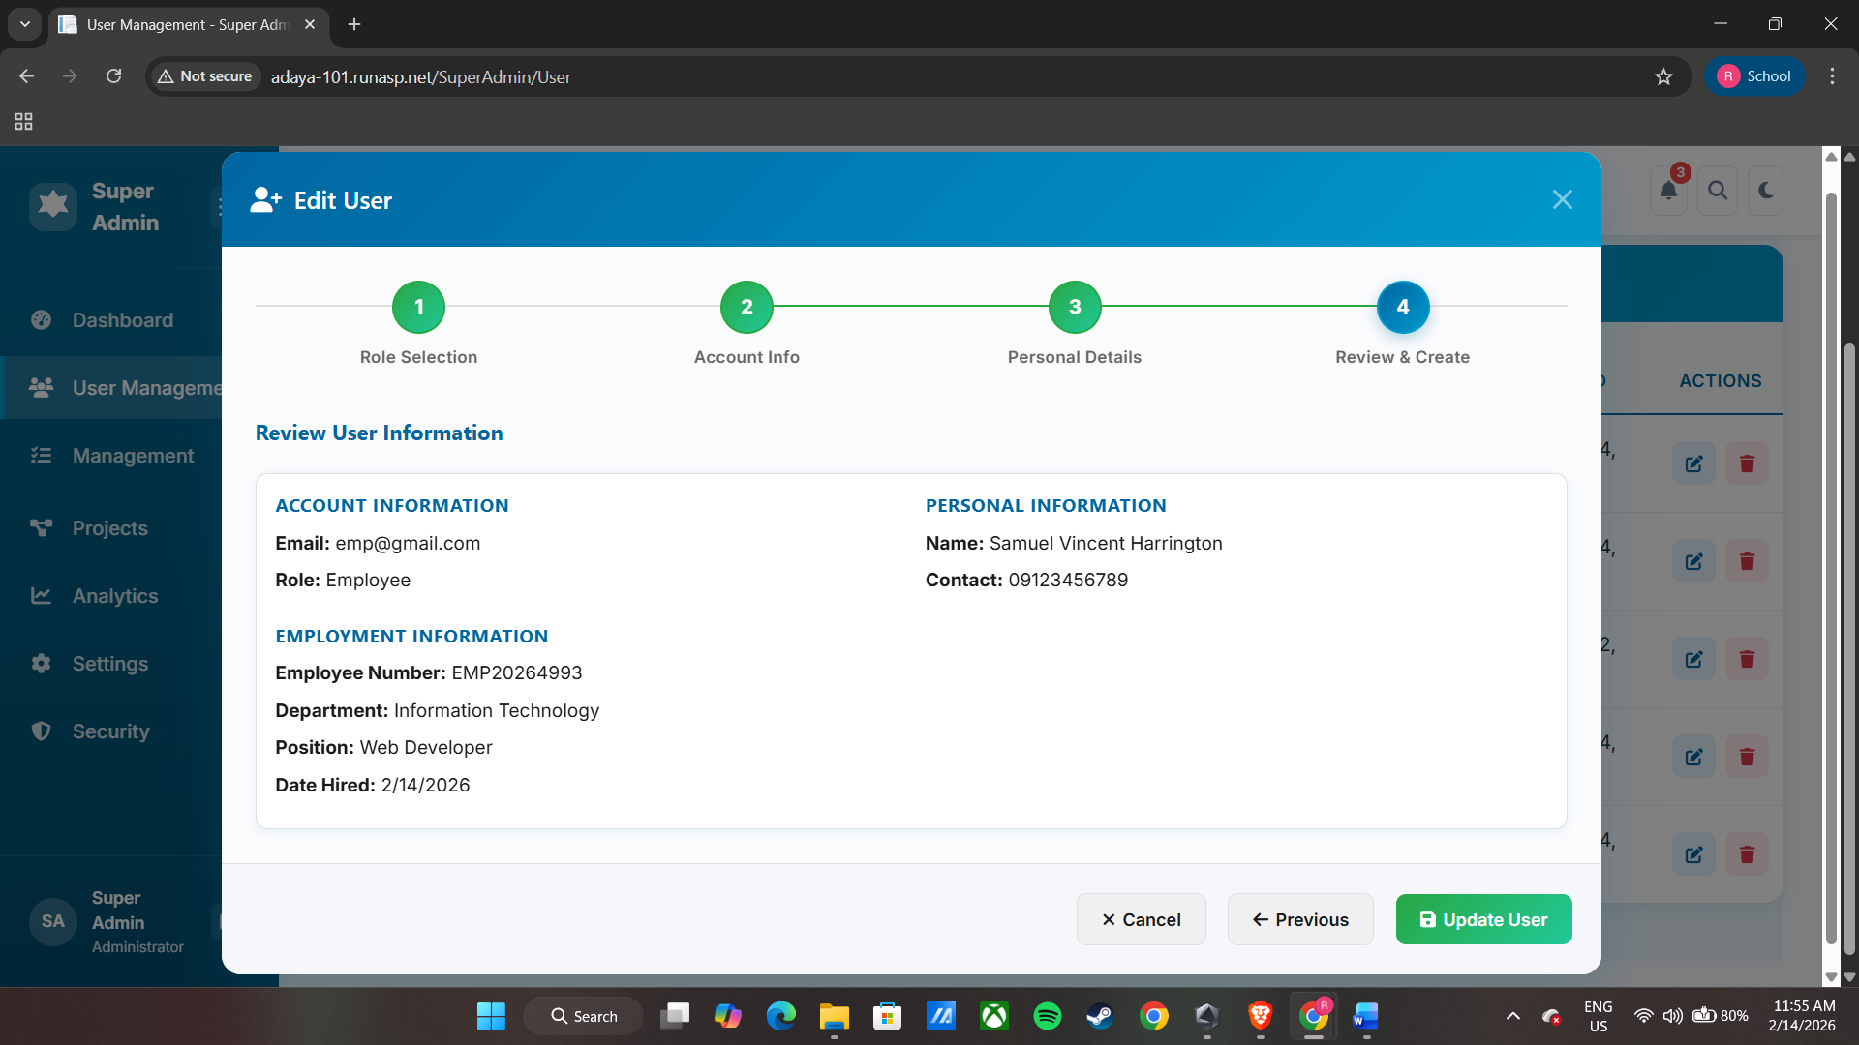  Lastly, the Review and Update step presents a summary of all changes, allowing the Super Admin to verify the accuracy of the information before finalizing and saving the updated account details within the system.  Note: The address field is not yet included. An address API will be integrated to provide automatic dropdown selections for address fields, allowing the Super Admin or HR to select the user’s location without manually typing it, improving accuracy and speeding up data entry.
Display Records | 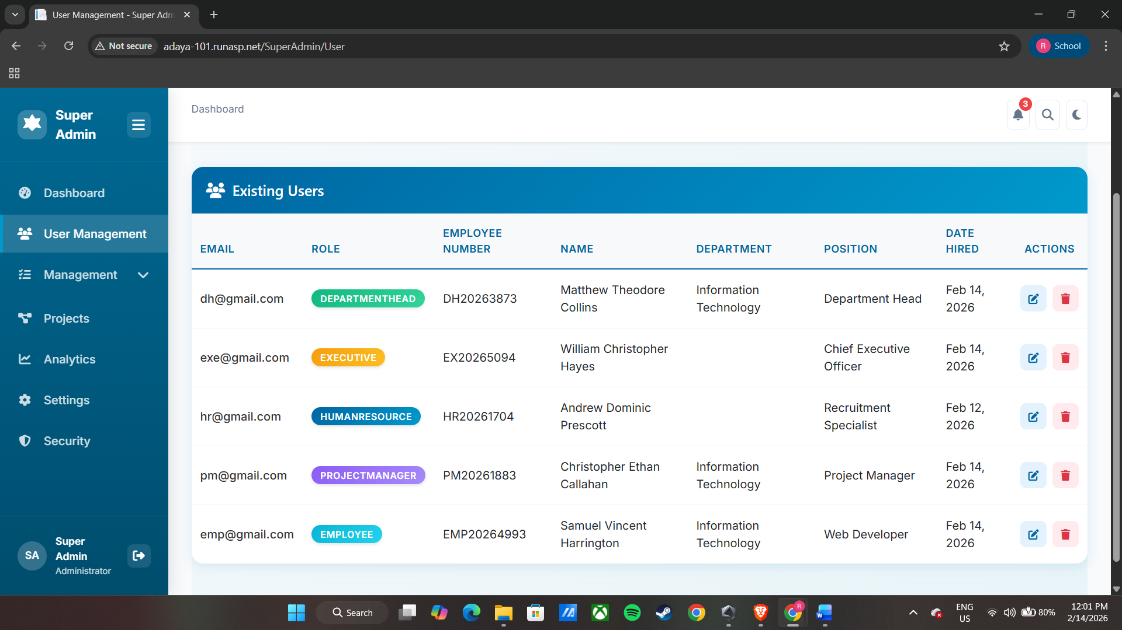  The Display Records page presents a comprehensive table of all registered internal users within the system. Each record displays key information, including the user’s email address, system role, employee number, full name, department, position, and date hired. This organized tabular view allows the Super Admin to quickly review and monitor user accounts at a glance.  The Actions column provides interactive buttons for editing or deleting a user’s account. The Edit button opens the Update/Edit Account modal, enabling the Super Admin to modify user information as needed, while the Delete button allows the Super Admin to remove an account from the system after confirmation.  This table is designed to ensure efficient user management, providing a clear overview of all employees and streamlining administrative tasks such as updating account details or maintaining accurate records.
Date Submitted: | February 14, 2026
Teacher’s Feedback | _________________________________________________________________  _________________________________________________________________  _________________________________________________________________  _________________________________________________________________  _________________________________________________________________  _________________________________________________________________  ________________________________ __________________________  Student’s Signature (after feedbacking) Teacher’s Signature

