1. Coding question

Given array type data like below:

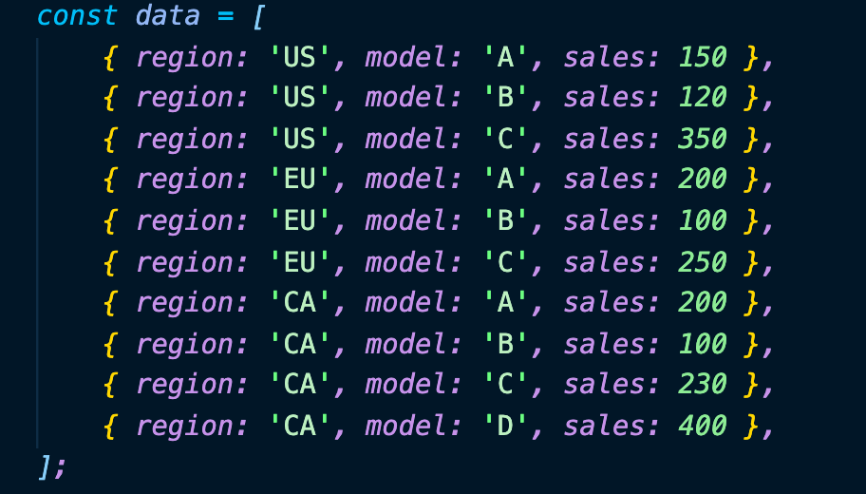

const data = [

{region: 'US', model: 'A', sales: 150},

{region: 'US', model: 'B', sales: 120},

{region: 'US', model: 'C', sales: 350},

{region: 'EU', model: 'A', sales: 200},

{region: 'EU', model: 'B', sales: 100},

{region: 'EU', model: 'C', sales: 250},

{region: 'CA', model: 'A', sales: 200},

{region: 'CA', model: 'B', sales: 100},

{region: 'CA', model: 'C', sales: 230},

{region: 'CA', model: 'D', sales: 400},

];

Build a table displaying each element of the data,

Add additional rows for the sums of sales number for each country, like:

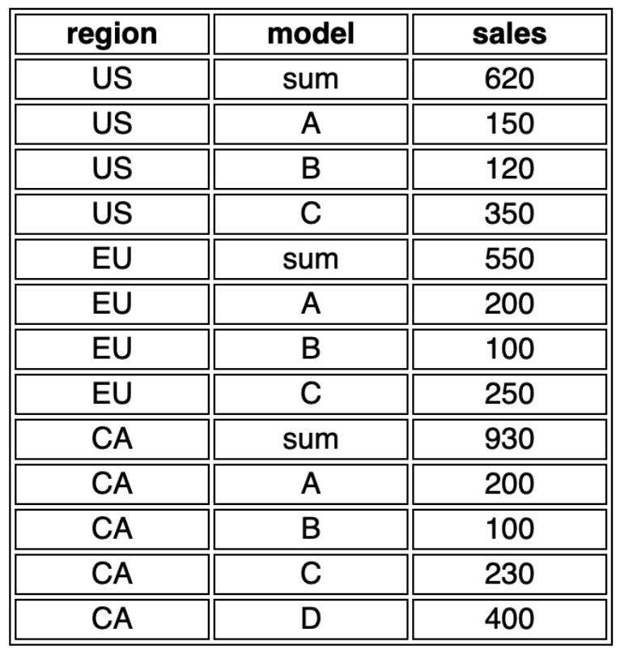

1. Coding question 2:

Given same data as the last question.

Build a table displaying each element of the data.

Apply two filters to table based on types of country and types of models of the data, like:

