# **DL-Lab02- IT20643836**

1. Upload the Backprop.ipynb to Jupyter notebook (or google colab) and see if you can understand the code. Increase the number of iterations (epochs) and see whether it improves the prediction accuracy.

Note: You may have to copy the image.png file to the home directory

No of Iterations = 500

No of Iterations = 100

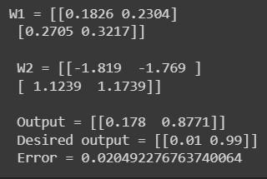

No of Iterations = 5000

No of Iterations = 1000

* **When increasing the number of iterations –**
* Output – becomes closer to the desired output
* Error – reduced
* Accuracy - increased

1. Upload the NN_sample.ipynb to Jupyter notebook (or google colab) and see if you can understand the code. Add the following text cell and the code cell to the notebook and run it again.
   1. 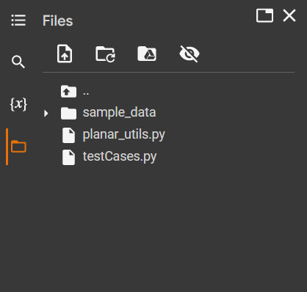What happens when the number of hidden nodes increase?

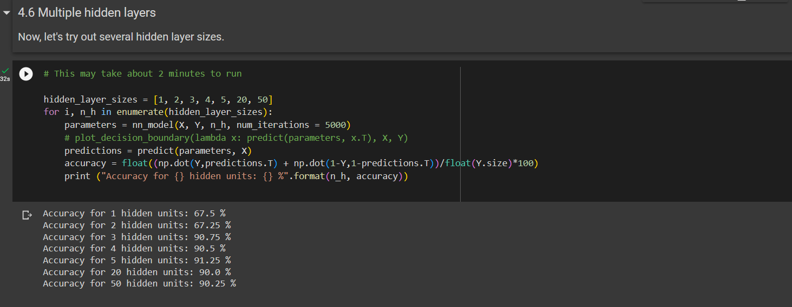

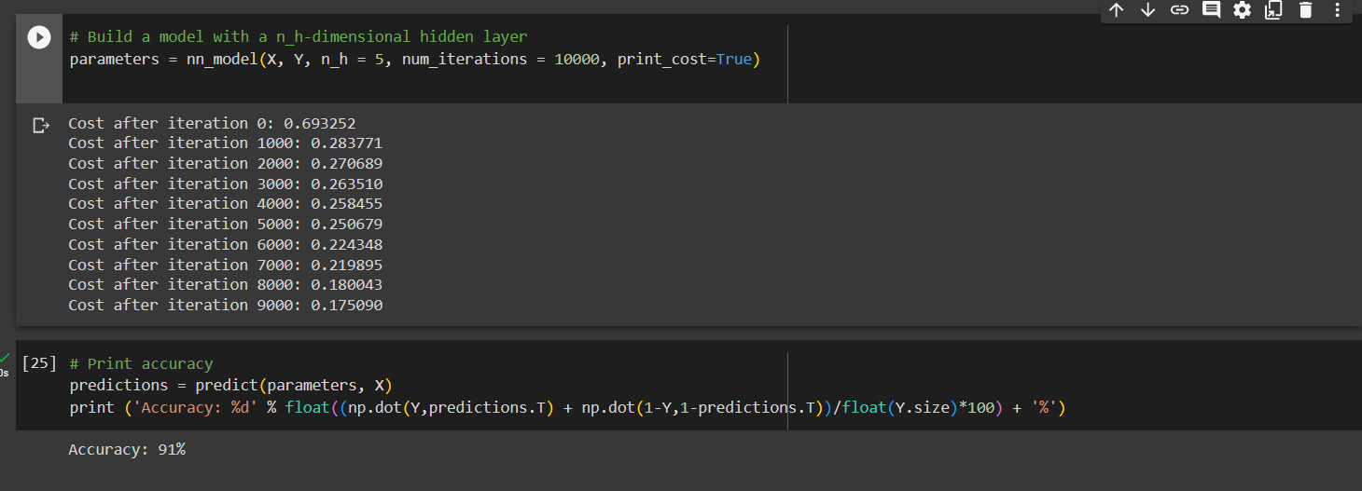

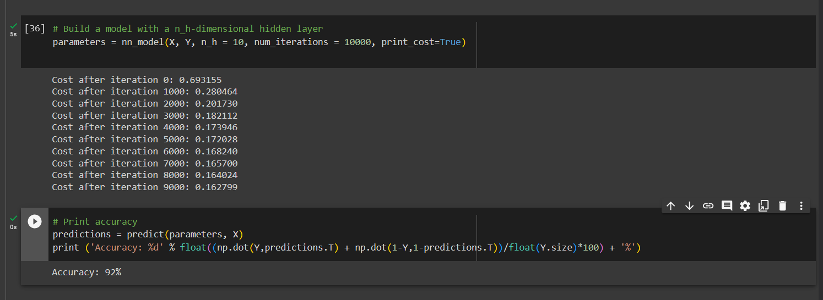

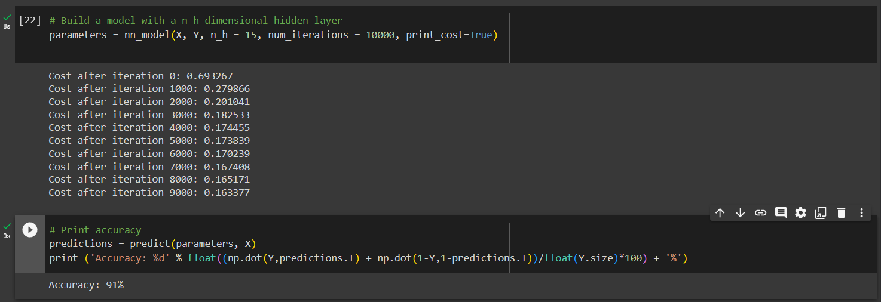

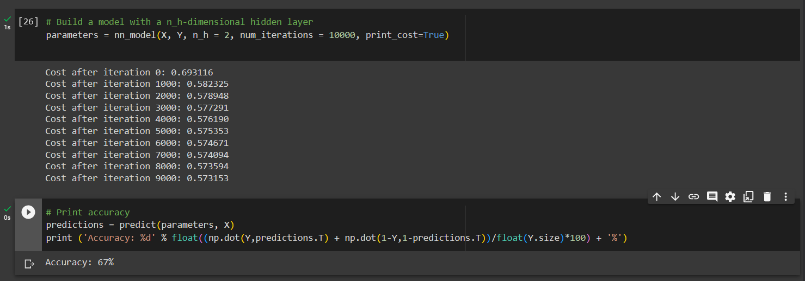

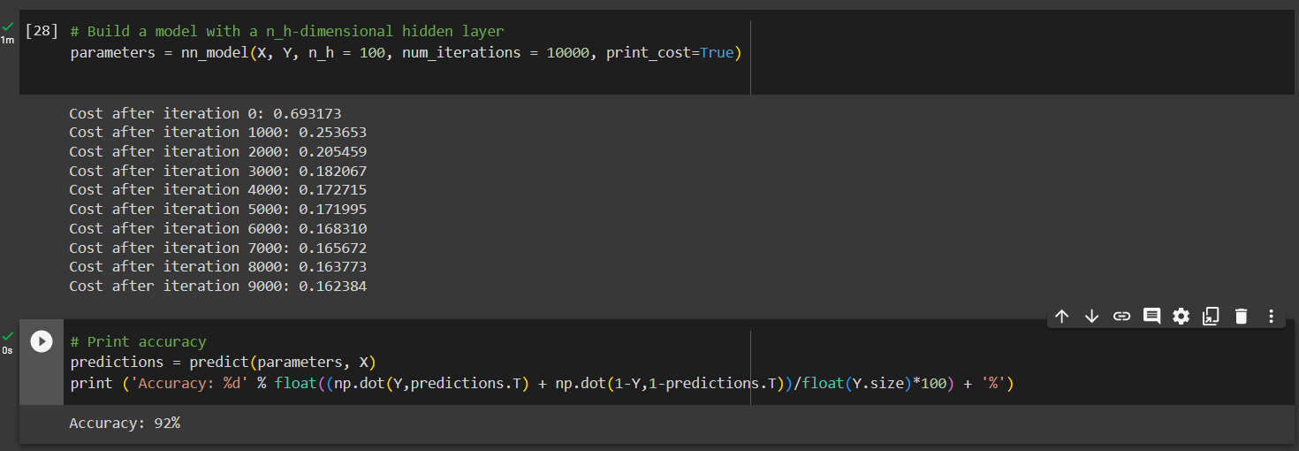

* 1. Can you explain the pattern of the accuracy when the hidden nodes increase?

Note: Copy the planar_utils.py and testCases.py files to the home directory.

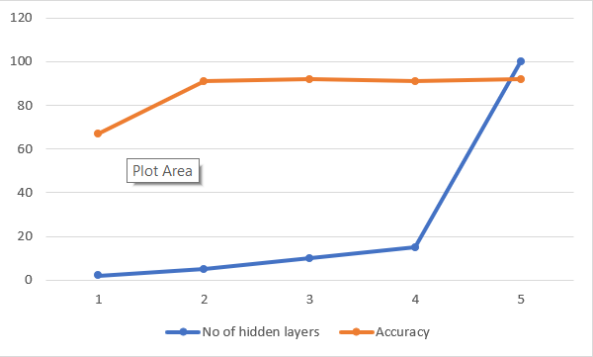

When the number of hidden layers is reduced , the accuracy drops .However, when the number of hidden layers is steadily increased, it shows high accuracy rate.

1. Run the MLP_with_MNIST_dataset.ipynb using Jupiter notebook (or google colab) and see if you can understand the code.
   1. Improve the test accuracy of the model by changing the hyperparameters.

* **Changing epoch size**

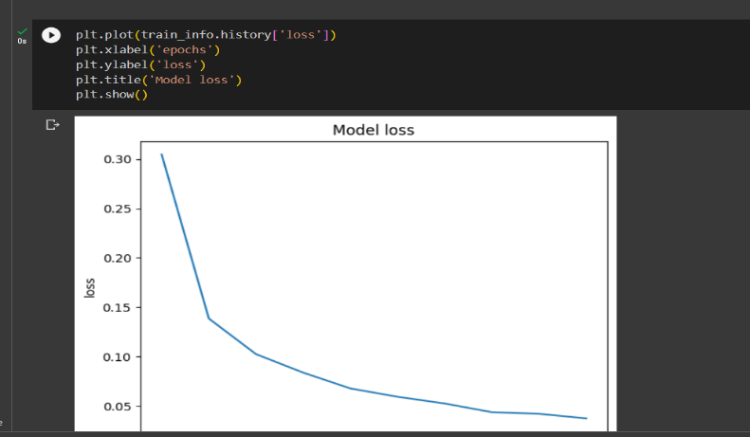

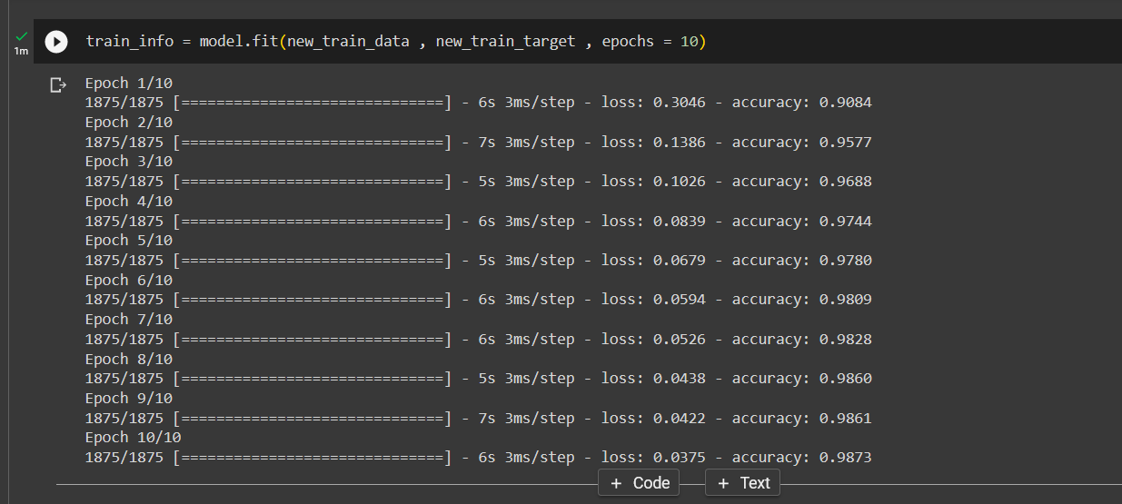

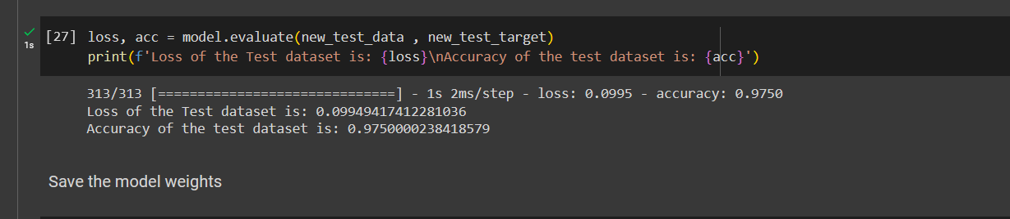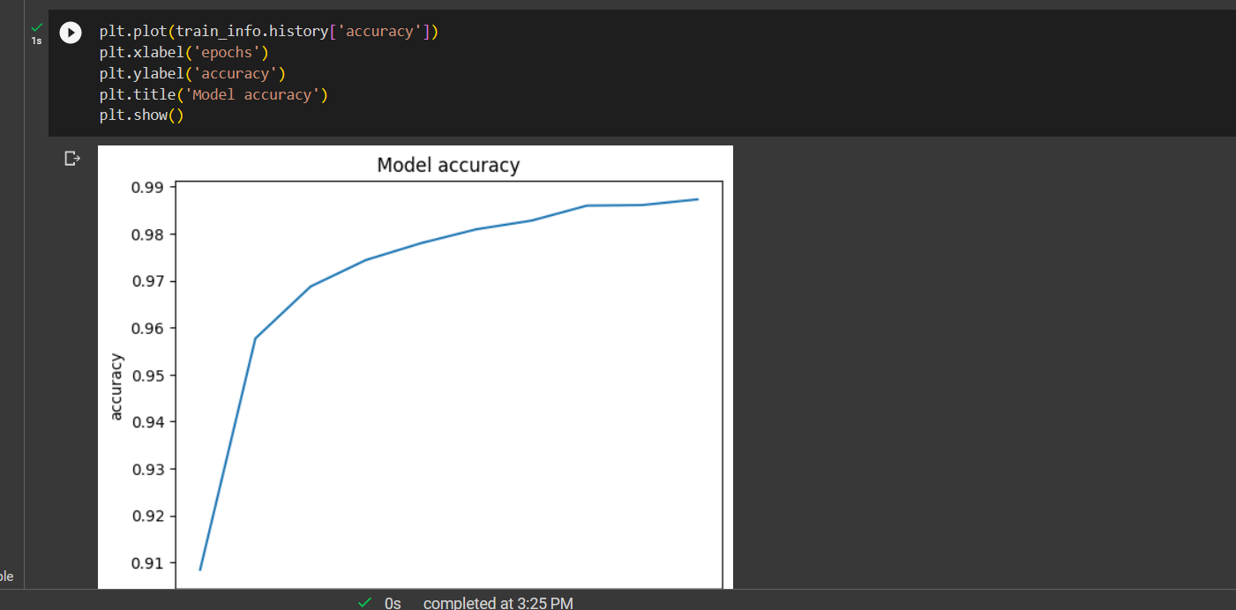

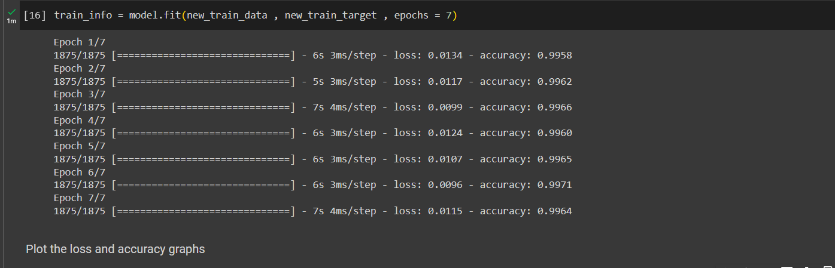**No of Epochs = 7**

**No of Epochs = 11**

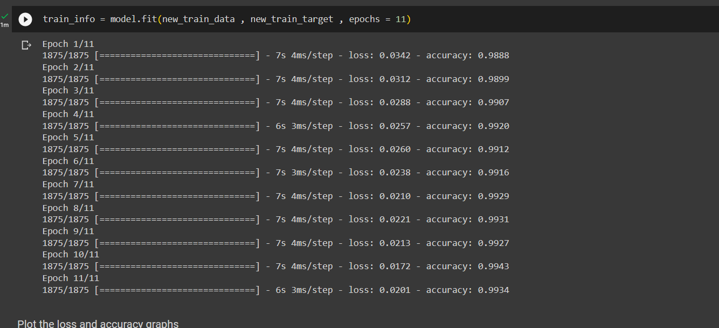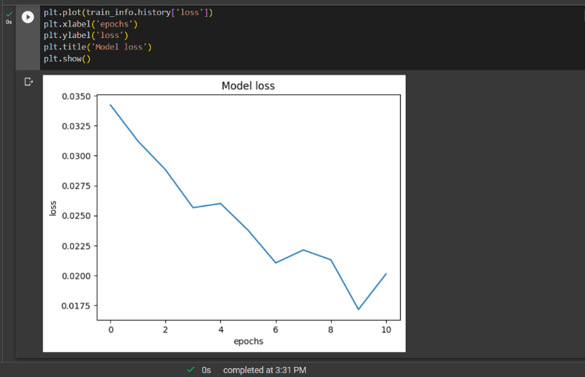

**No of Epochs = 12**

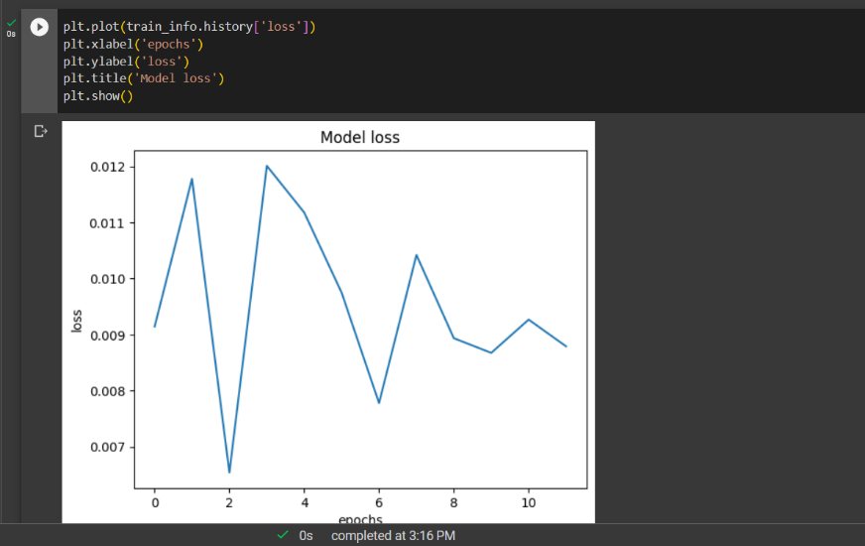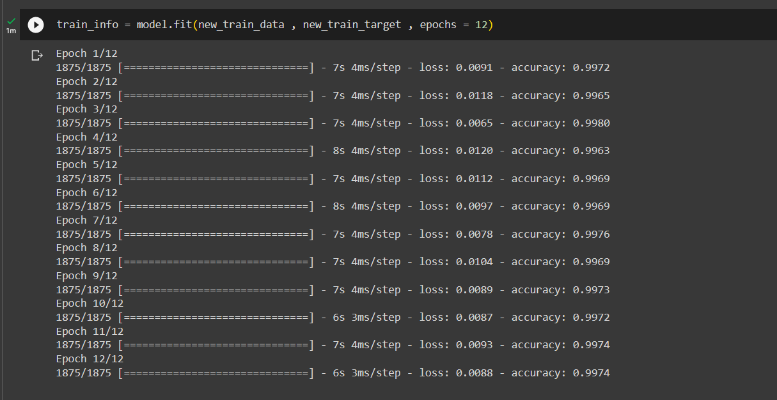

* Changing No of perceptron in dense layer

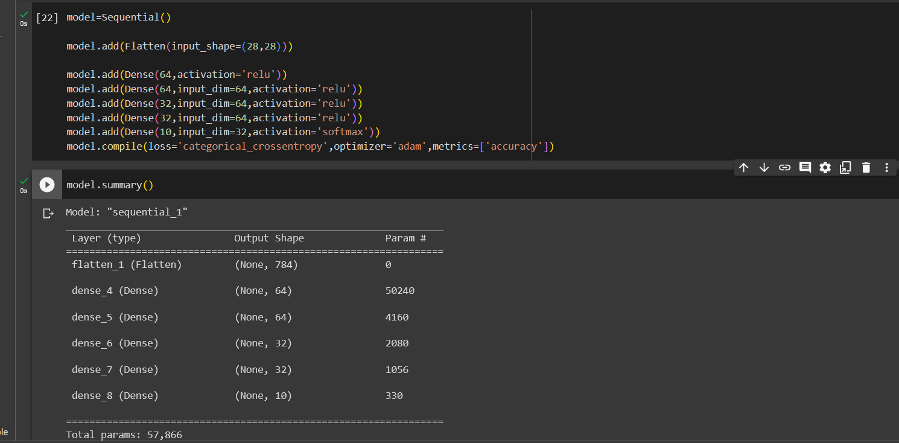

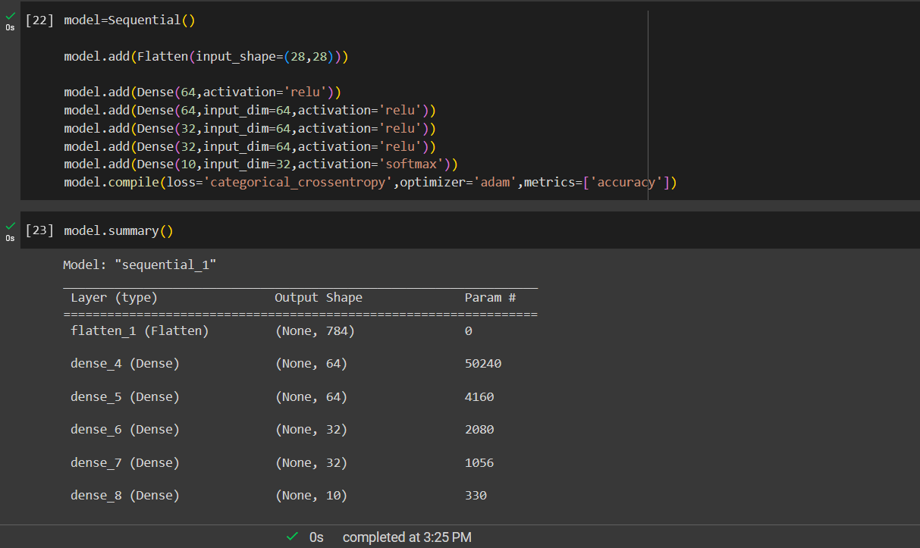

* 1. Add L1 and L2 regularization terms to the model and retrain the model.

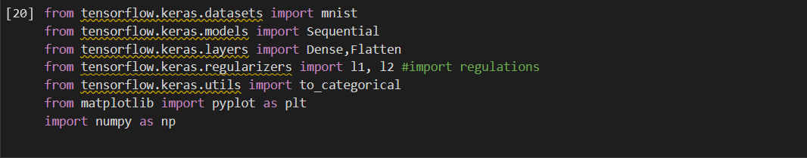

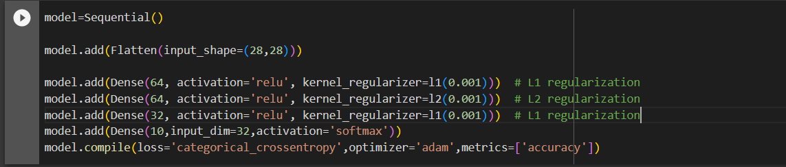

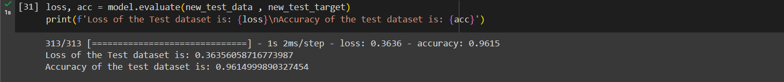

* 1. Visualize class-wise test dataset performance using a confusion matrix.

