**Lab-06-Deep Learning-IT20643836**

**Markov Decision Process (MDP)**

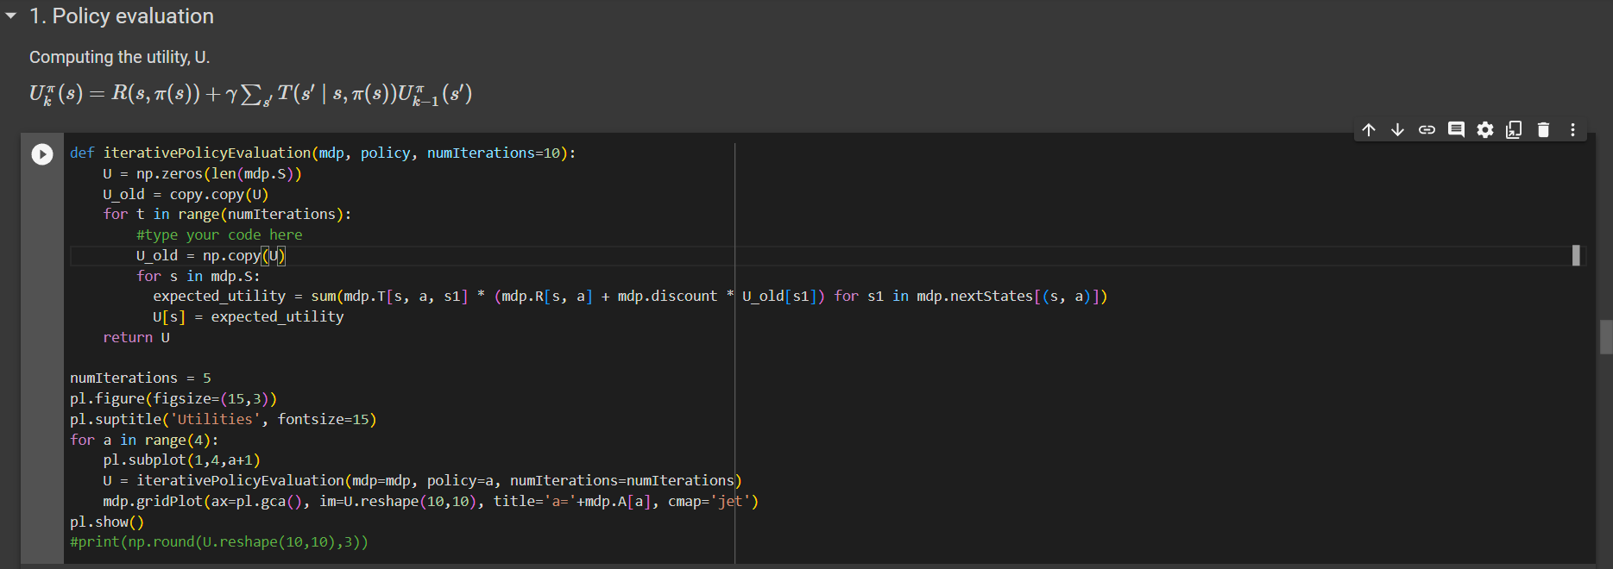

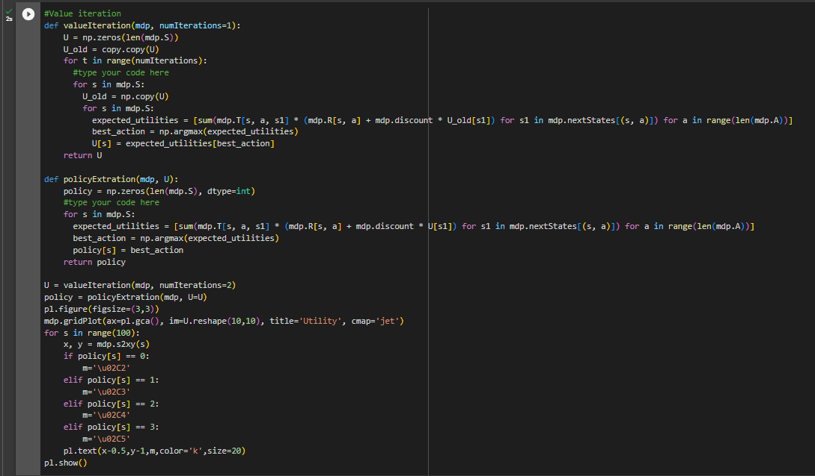

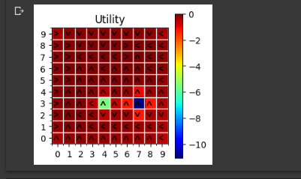

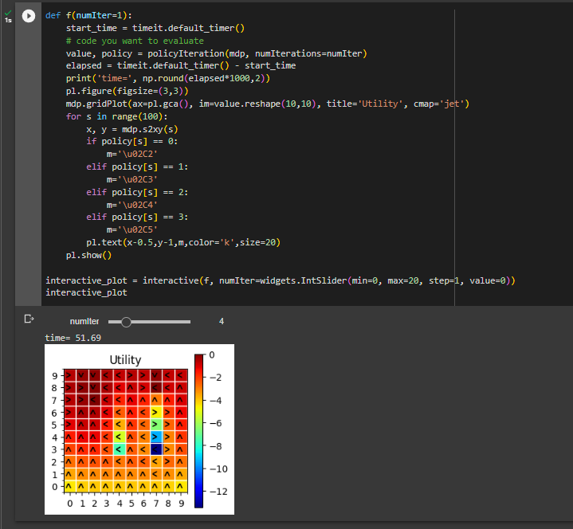

**The agent-environment interaction**

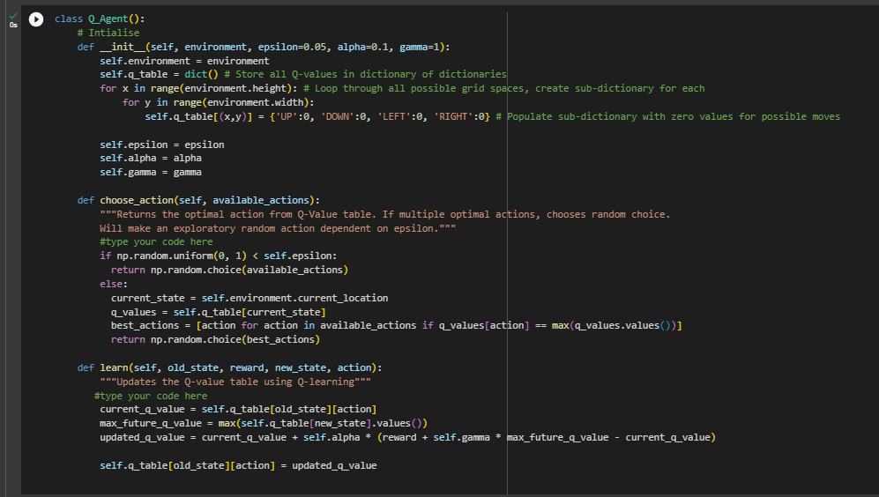

|  |  |  |
| --- | --- | --- |
|  | **before changing grid size** | **After changing grid size** |
| **Random Agent** |  |  |
|  |  |  |
| **Q-Agent** |  |  |