DL-Lab-07

1. Upload the Autoencoder (AE) jupyter notebook file (i.e., lab_7_AE_FFNN.ipynb) to google colab root directory.
   1. 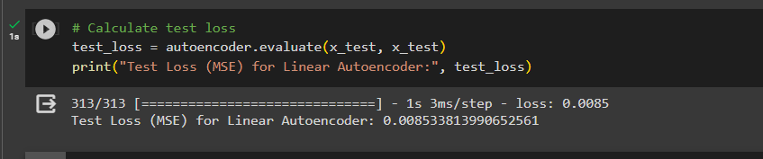Write the code implementation to calculate the loss (Mean Squared Error) for the test dataset.
   2. 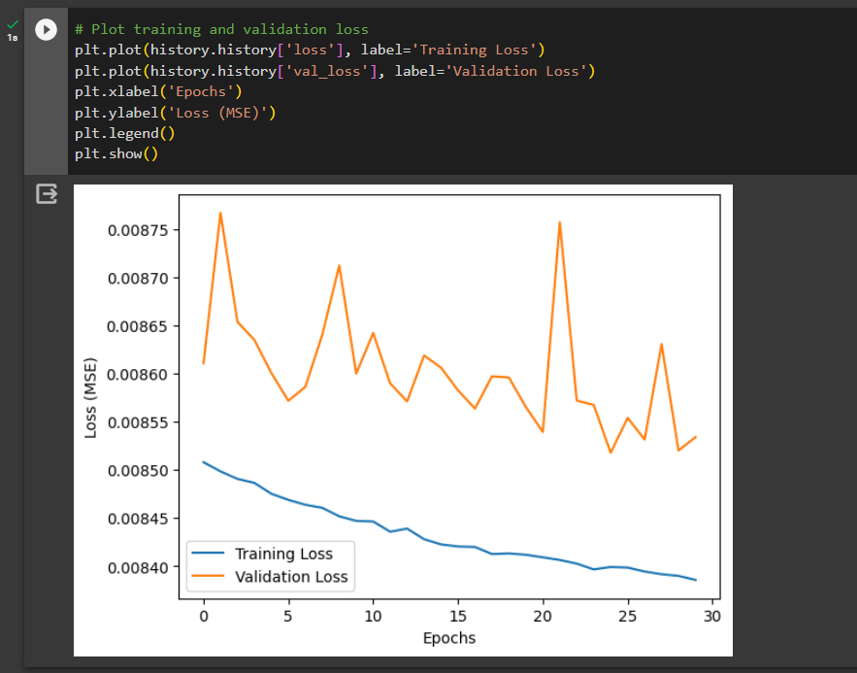Write the code implementation to plot the train and validation loss against number of epochs.
2. When above AE is used without activation functions, it is called a linear AE. Explain the relationship between linear AE and principal component analysis (PCA). Write the answer in a word file.

* **A linear autoencoder without activation functions and principal component analysis (PCA) both aim to reduce the dimensionality of data while maintaining important information. They both use linear transformations and aim to reduce variance . The fundamental difference is that although linear autoencoders learn from data through training and offer more flexibility, PCA is a statistical method that indirectly computes principal components from data.**

1. Upload the Vanilla CNN AE jupyter notebook file (i.e., lab_7_AE_Vanilla_CNN.ipynb) to google colab root directory.
   1. 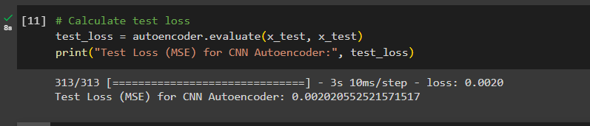Write the code implementation to calculate the loss (Mean Squared Error) for the test dataset.
   2. 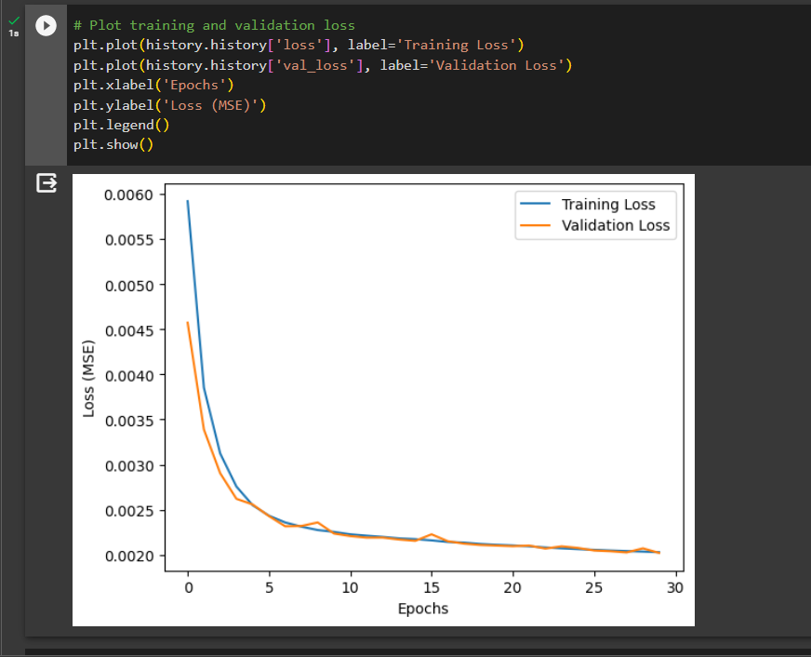Write the code implementation to plot the train and validation loss against number of epochs.
2. Observe the model performance improvements between the above two models and give reasons for the observed improvements.

* **The CNN-based autoencoder performs better than the linear autoencoder for image data like Fashion MNIST because CNNs are superior at gathering intricate spatial patterns, hierarchical features, and non-linear correlations, all of which are crucial for image analysis. The linear autoencoder has problems capturing these complicated features even though it is simple to grasp resulting in performance variations.**

1. Upload the Image De-noising AE jupyter notebook file (i.e., lab_7_AE_CNN_Image_Denoising.ipynb) to google colab root directory.
   1. 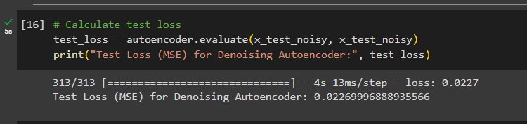Write the code implementation to calculate the loss (Mean Squared Error) for the test dataset.
   2. 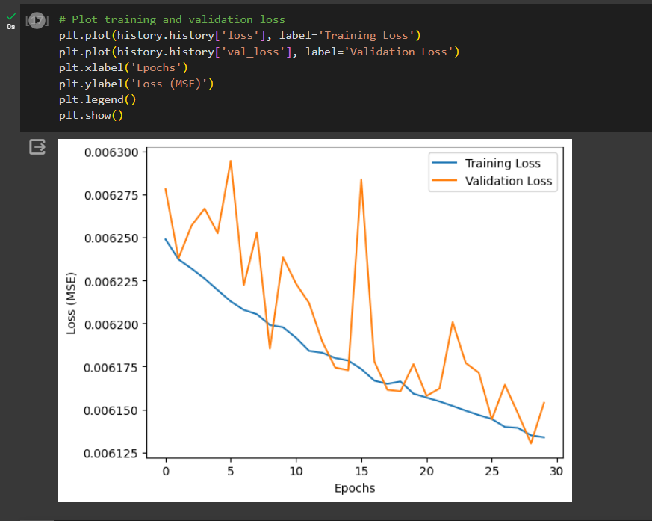Write the code implementation to plot the train and validation loss against number of epochs.
   3. Experiment with “noise_factor” value and use the best value you find in the final implementation. (Pay attention to how this value affect the images by observing the noise added images in the code.)

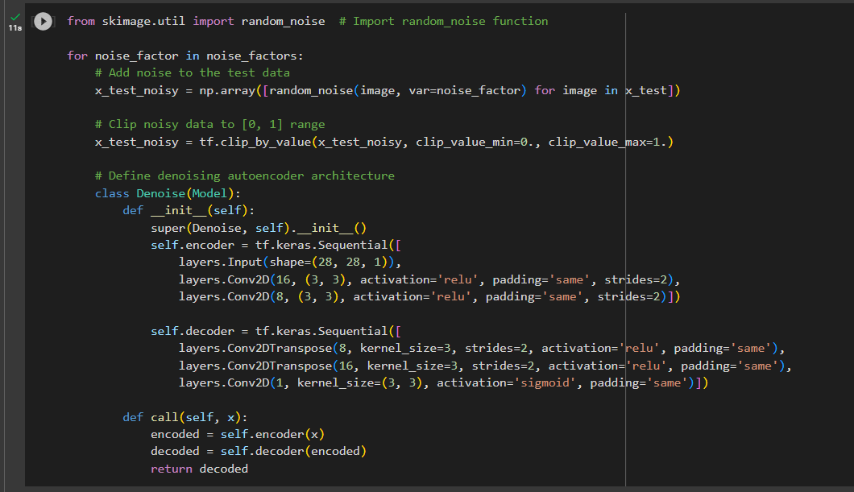

1. Observe the model performance improvements between the Image De-noising AE and the Vanilla CNN AE.
   1. Explain the reasons for the observed improvements.

When comparing the performance of the Image De-noising Autoencoder (AE) with the Vanilla CNN AE, it's important to keep in mind that the Image De-noising AE is designed to do more than just compress and reconstruct images; it also removes noise from them. The following are the performance enhancements and their underlying causes:

**Improvements to the Image De-noising AE's performance:**

* The most evident advantage is the Image De-noising AE's ability to successfully eliminate noise from input images. Contrarily, the reconstruction without noise removal is the core feature of the Vanilla CNN AE.
* Better visual quality and less artifacts are often seen in images that are reconstructed using the Image De-noising AE because noise is reduced. The Vanilla CNN AE, in comparison, could duplicate noisy patterns, leading to lower image quality.
* Image Reduction In terms of noise resistance, AE is more resilient to noisy input data. It is better able to control the alterations brought about by different levels of noise in the input images.

**Reasons for the Seen Improvements:**

* Image de-noising using noise modeling to model and minimize image noise, AE uses explicit training. During training, it learns to distinguish noise patterns and suppress them while preserving essential image features. This specialist training results in greater noise reduction.
* Loss Function: The Image De-noising AE usually uses a loss function that penalizes the difference between the cleaned image (i.e., one that is noise-free) and the rebuilt picture. This loss drives the model to produce output that closely resembles spotless photographs, producing images of greater quality.
* Regularization: The Image De-noising AE is encouraged to acquire trustworthy representations by introducing noise during training. Effective regularization makes the model less prone to overfitting and better equipped to handle noisy input during inference.
* Application Focus: The Image De-noising AE was created specifically with the intention of reducing noise from photos. It can perform remarkably well in circumstances where noise reduction is crucial, such as when taking pictures or denoising images for medical imaging, because of its narrow focus.
* Data Augmentation: The Image De-Noising By adding controlled noise to the training data, AE grows tolerant of noise. This may lead to better generalization to noisy images in the actual world.

1. Explain the differences between AE and Variational AE (VAE).

* **Autoencoders (AE) focus on learning a deterministic representation while learning a compressed representation of the input data for reconstruction, whereas variational autoencoders (VAE) attempt to model a probabilistic latent space distribution. VAEs are a strong fit for probabilistic generative modelling because they add stochasticity, regularization through KL divergence, and the ability to generate new data samples.**