User Document

Login Page

Enter the Correct email address and  correct password.

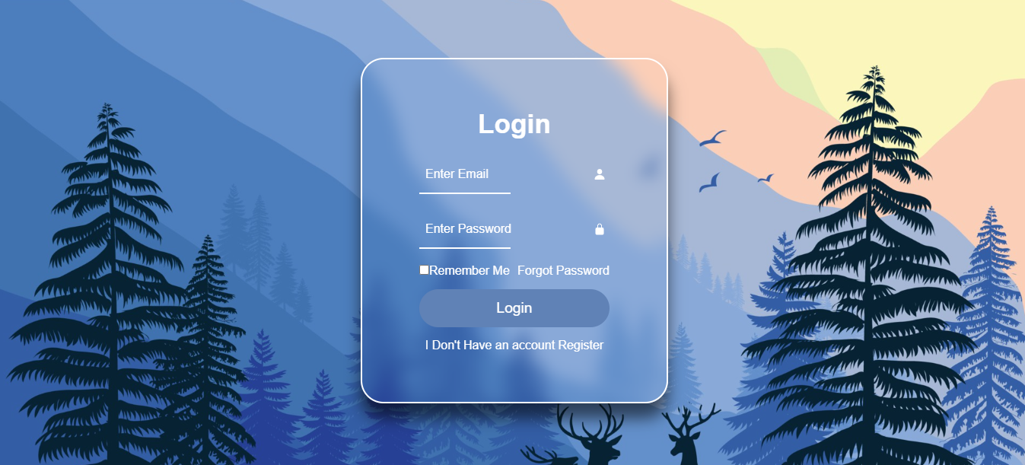

Username is - “admin”

Password is - “admin”