### Project: ****Task Management System****

A task management system where users can add, view, and update tasks in a MySQL database. This will involve creating a small database, integrating it with Python, and performing basic CRUD (Create, Read, Update, Delete) operations.

### Steps:

#### 1. ****Set up MySQL Database:****

* Open **MySQL Workbench** and create a database for this project, e.g., task_management.
* Create a table to store tasks with the following schema:

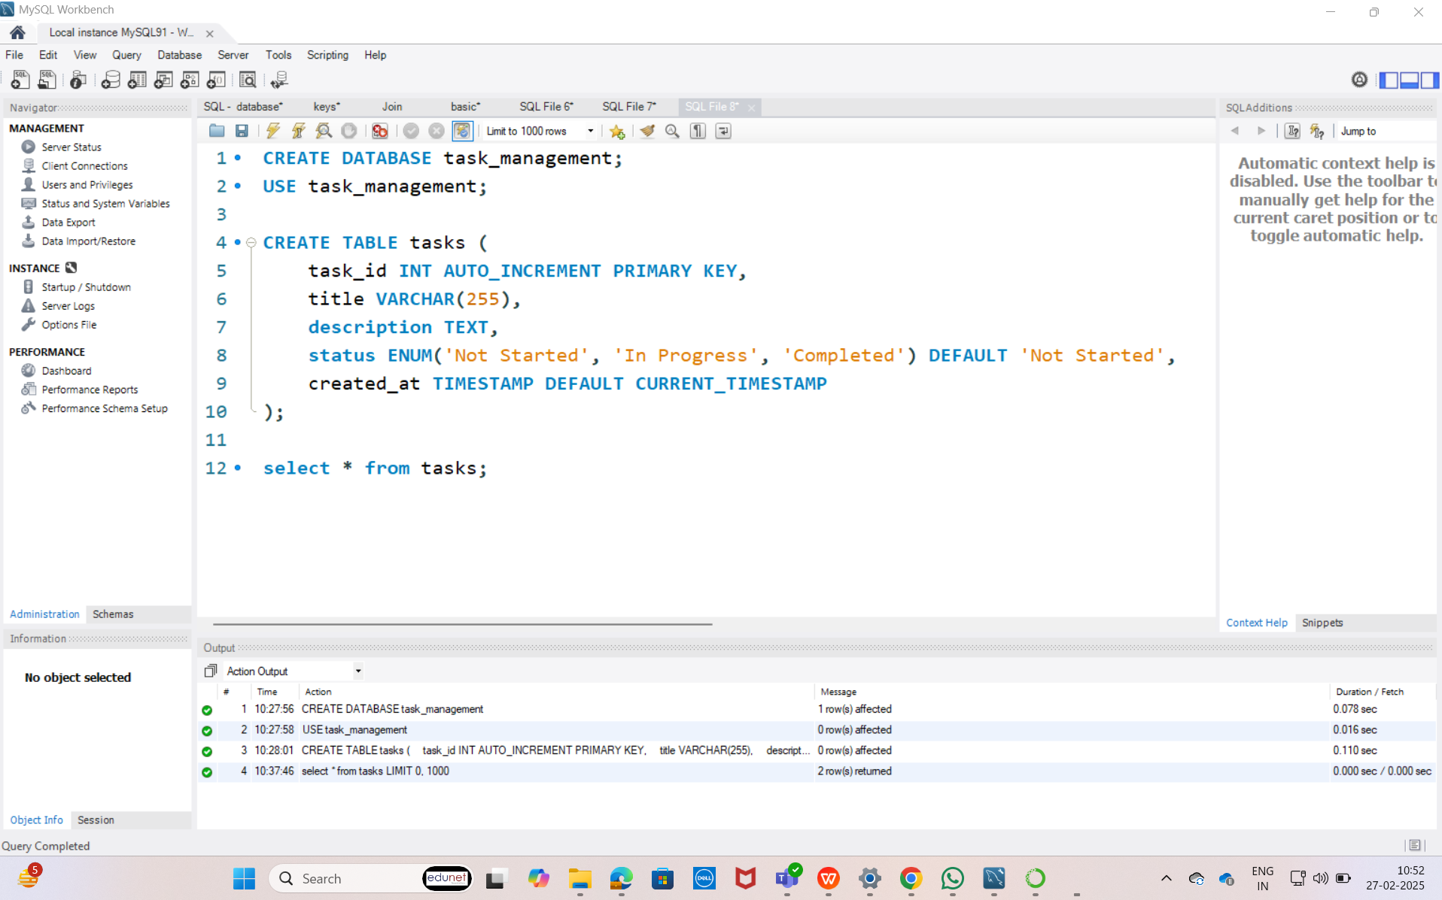

2. **Install MySQL Connector for Python:**

Install the MySQL connector to allow Python to interact with the database:

pip install mysql-connector-python

#### 3. ****Create a Python Script for the Application:****

Create a Python script to interact with the MySQL database. Below is a basic example that connects to MySQL and allows users to perform CRUD operations.

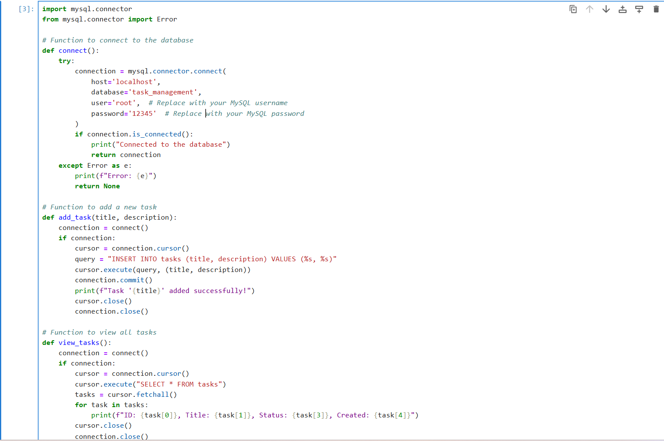

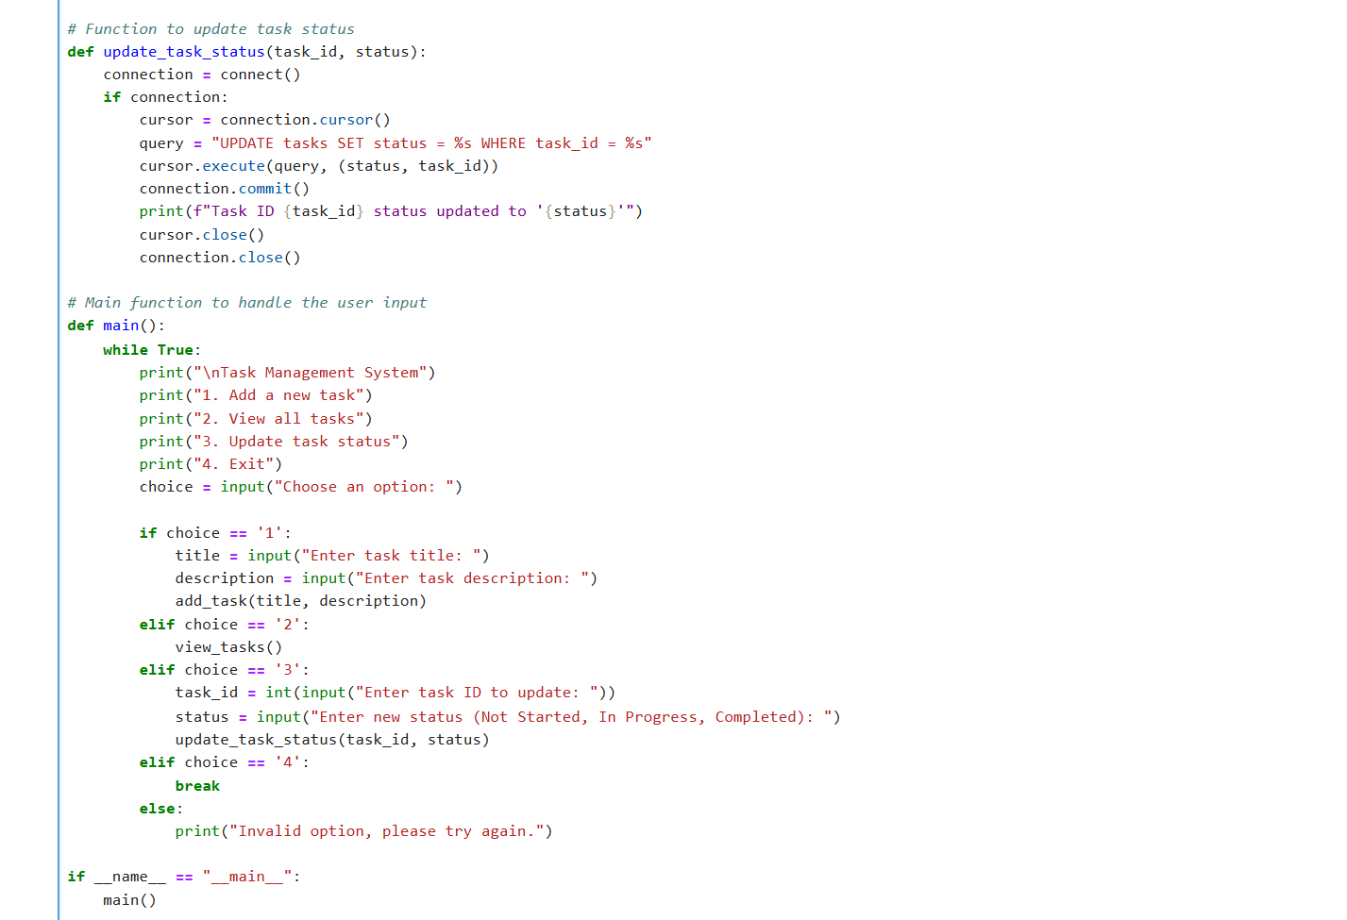

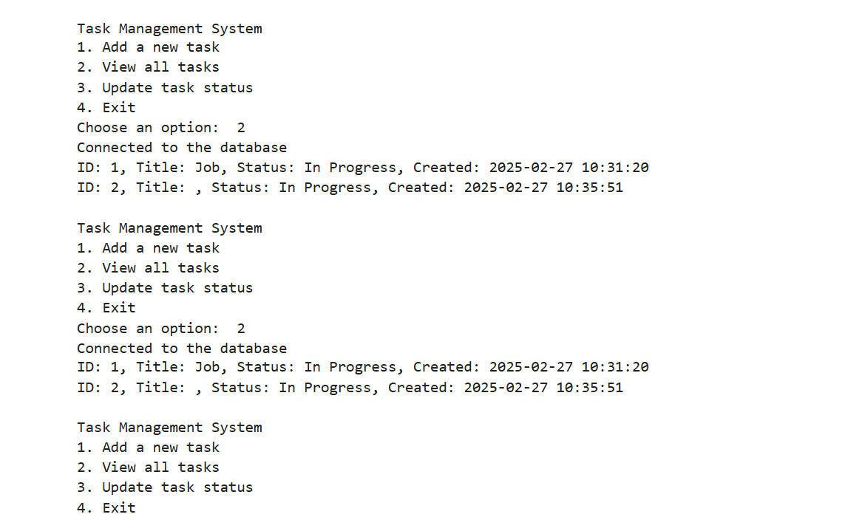

### Example Workflow:

1. Run the Python script.
2. Choose option 1 to add a task:
   1. Enter task title: "Buy groceries"
   2. Enter task description: "Milk, eggs, bread"
3. Choose option 2 to view all tasks.
4. Choose option 3 to update task status:
   1. Enter task ID: 1
   2. Enter status: "In Progress"
5. Exit the application by choosing option 4.

### Optional Enhancements:

* Add the ability to delete tasks.
* Create a GUI using Tkinter or PyQt5 for a more user-friendly interface.
* Implement user authentication (e.g., login system).
* Allow users to specify deadlines for tasks and set reminders.

GUI : 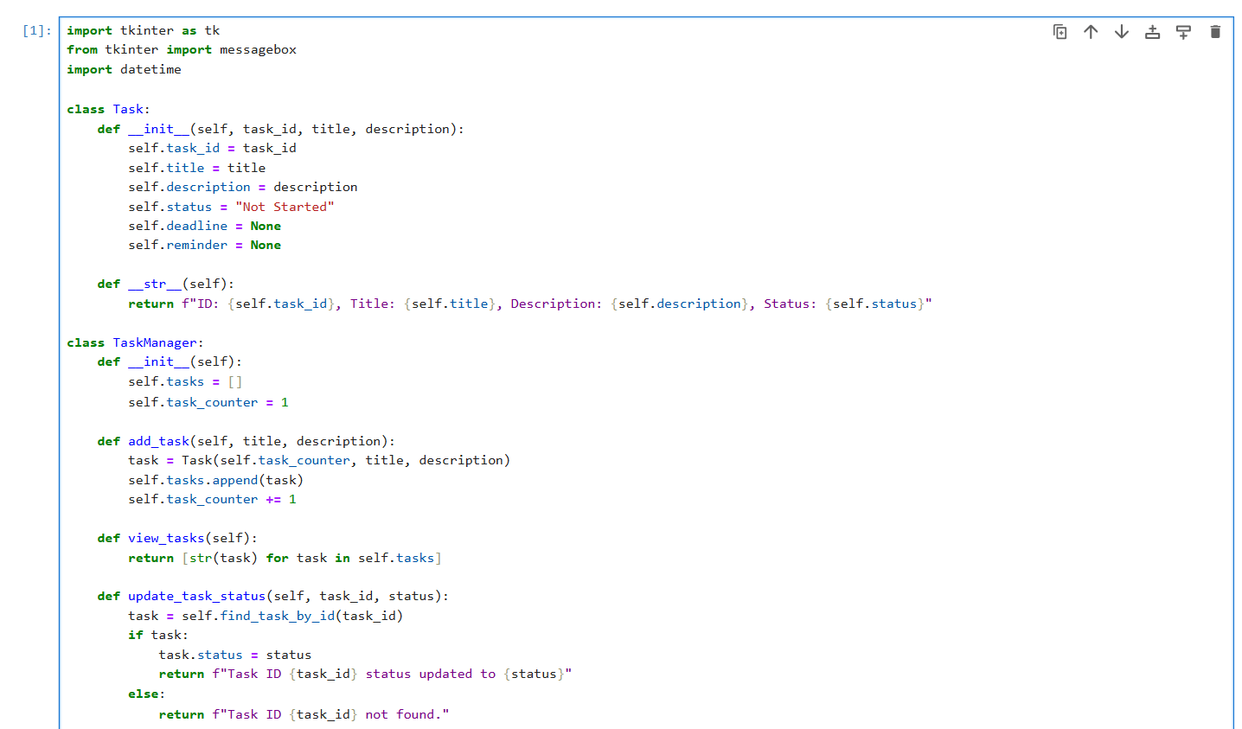

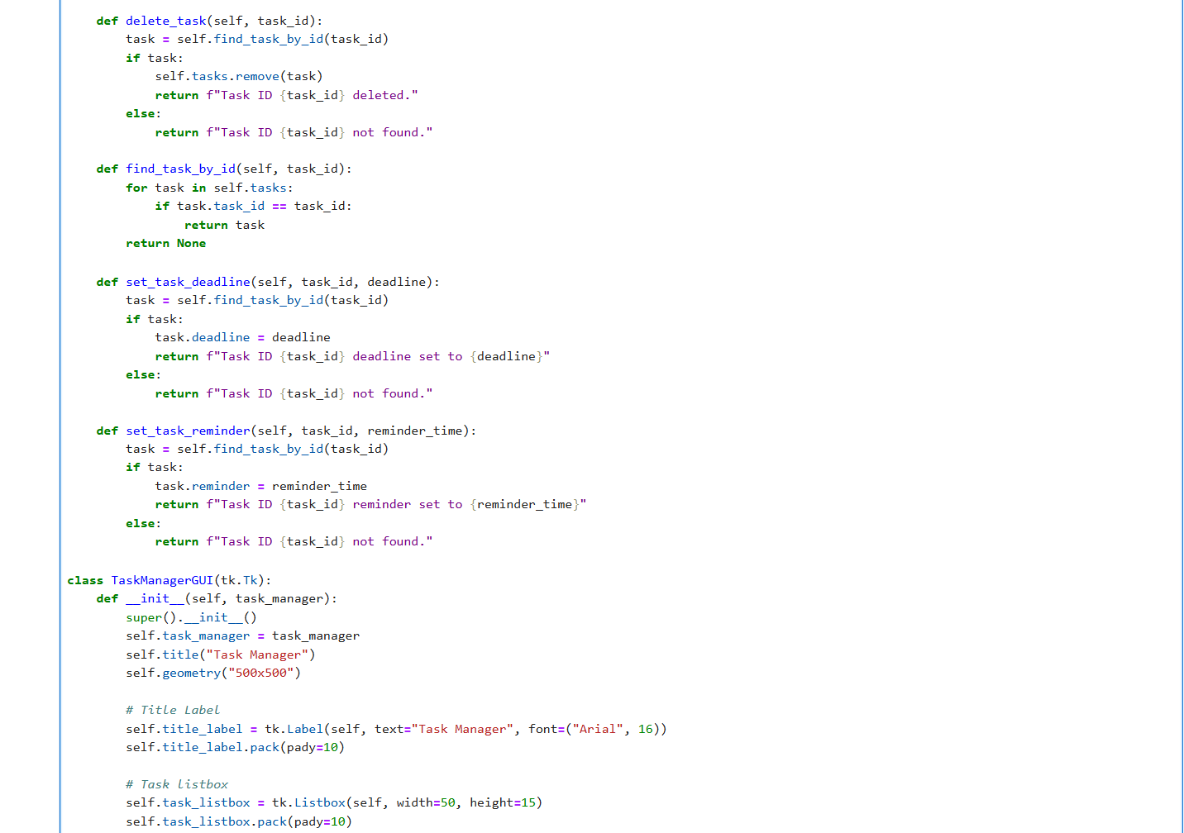

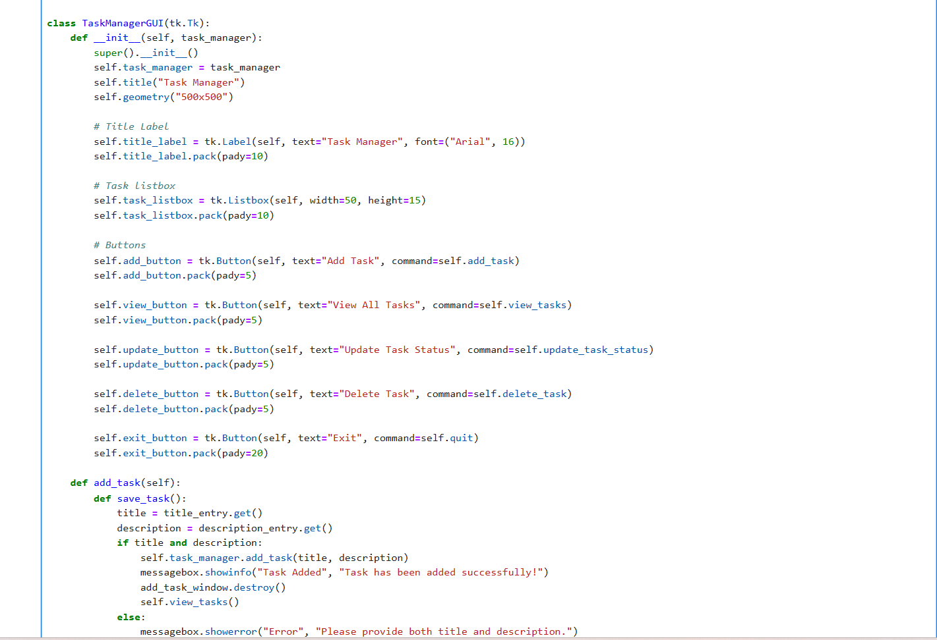

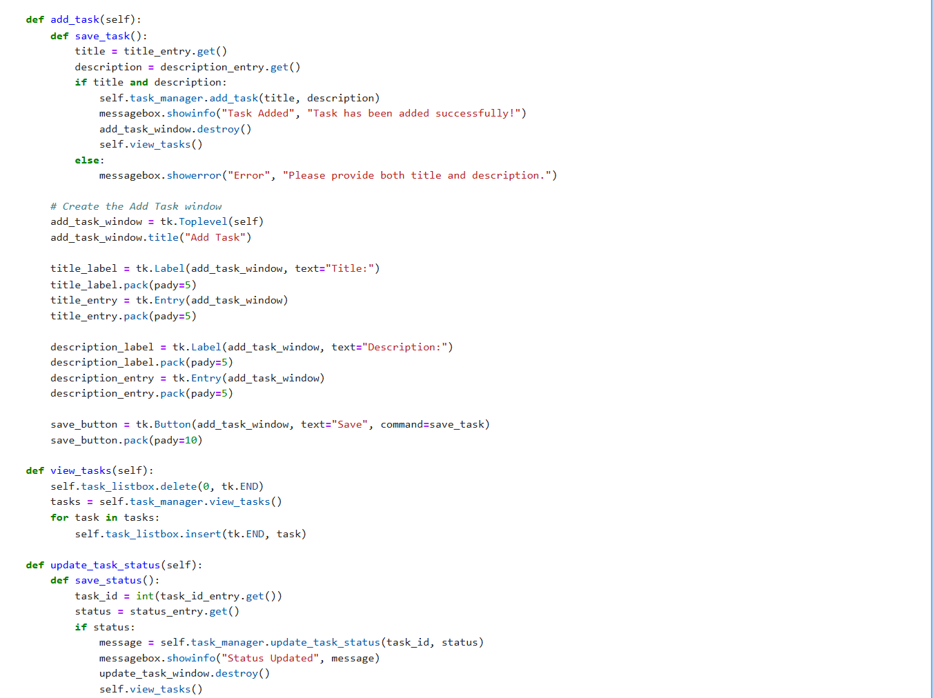

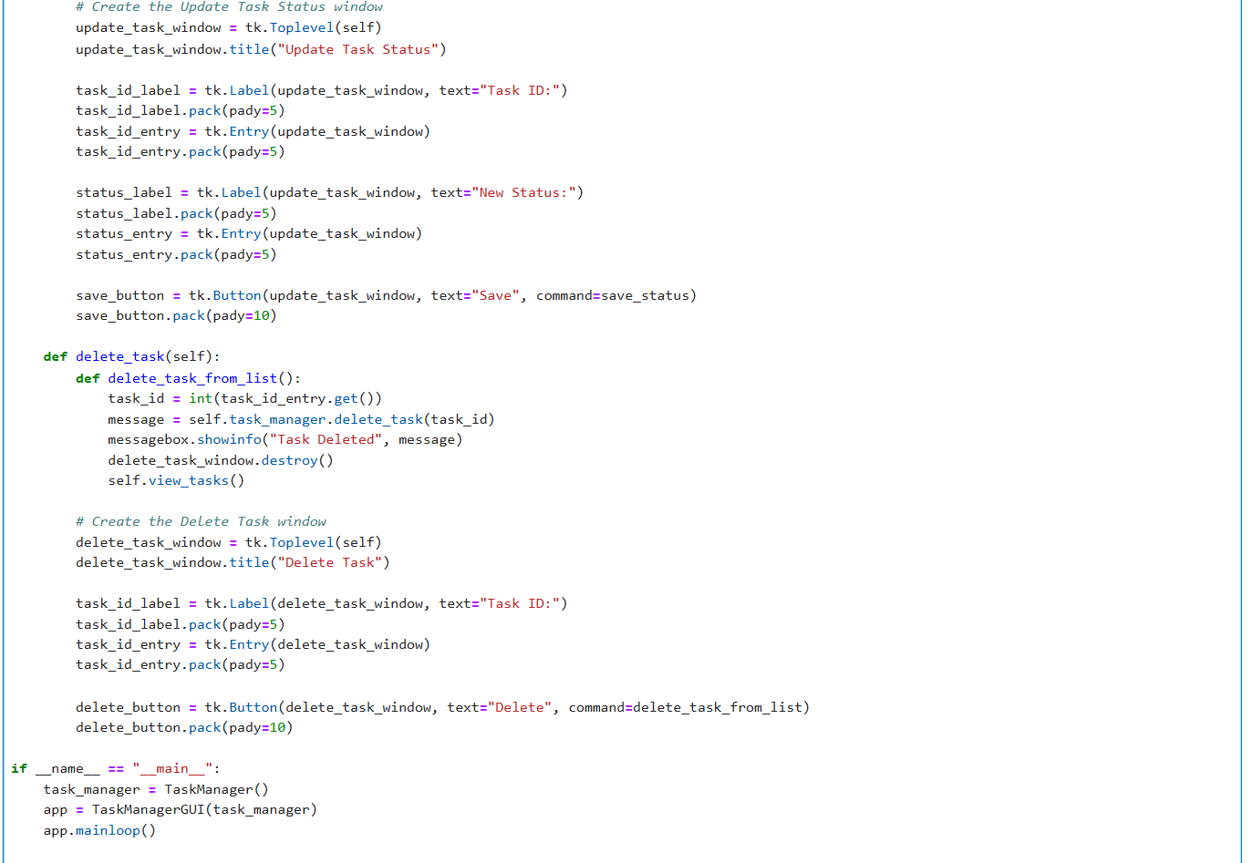

OUTPUT:

