Subject Line: Invitation: Join Intel for Drinks and Demos at MWC (RSVP)

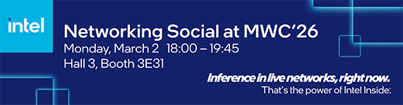
Together, we’re already running the future of networks.

Hosted by Greg Ernst, Corporate Vice President, Chief Revenue Officer, and General Manager of the Sales and Marketing Group, Intel cordially invites you to a private reception during Mobile World Congress. This exclusive event will provide an excellent opportunity for customers and partners to network in a welcoming atmosphere at the Intel booth, featuring refreshments, appetizers, technology demonstrations, and meaningful discussions with industry peers.

- Engage with colleagues and Intel executives
- Explore what’s live in networks today – discover the latest advancements in network technology—including AI-optimized Radio Access Networks, edge inference solutions, zero-trust architectures, and innovations designed to drive greater efficiency.

We look forward to sharing valuable insights and fostering connections in a relaxed setting amid the busy week at MWC.

Please RSVP by Monday, February 9 to confirm your attendance. Space is limited for this invitation-only event.
[RSVP Link]

This invitation is intended for the recipient only. We look forward to seeing you at MWC.

The best part of progress is who you build it with.
That’s the power of Intel Inside®.

