

4COSC006C-Web Design & Development

Coursework 01

Module Leader**: Aloka Fernando**

* Tutorial Group – Group D
* UOW ID: w16984211
* IIT ID:2017453
* Student Name: Susith Hemathilaka

|  |  |  |
| --- | --- | --- |
| Name | IIT Number | UOW ID |
| Susith Hemathilaka | 2017453 | W1698421 |
| Sandusha Marasinghe | 2017820 | W1699682 |
| Shehan Liyanage | 2017460 | W1698513 |
| Mininidu Hewawasam | 2017414 | W1698509 |

**Contents**

1.Introduction

1.1Discussion

1.1.1.Work Load

2.Site

Home Page

Feedback page

Cv

3.Code

3.1.Html

3.2.Java Script

3.3. Css

4.Individual Statement

**1.Introduction**

Our Website is related to movies under the Entertainment topic .I’ve done the Homepage ,Feedback page and Basic Styling in Website.

**1.1.Discussion**

**Creating Homepage**

**Creating Comment Form**

**1.1.1.Workload**

|  |  |  |  |  |
| --- | --- | --- | --- | --- |
| : **Task** | **Student 1** | **Student 2** | **Student 3** | **Student 4** |
| 1 - Presentation Page | * |  |  |  |
| 2 - Main Page |  | * |  |  |
| 3 - Font Size Change | * |  |  |  |
| 4 - Comments Form |  | * |  |  |
| 5 - Buy products | * |  |  |  |
| 6 – Diagrams |  |  |  | * |
| 7 – Quiz |  |  | * |  |
| 8 - View images |  |  |  | * |
| 9 - Student details |  |  | * |  |
| 10a - External CSS (created) |  | * |  |  |
| 10b - External CSS (10a reused | * | * | * | * |
| 11 – CV | * | * | * | * |
| 12 – Anchors | * | * | * | * |
| 13 - Logo/Page Editor | * | * | * | * |
| 14 - Additional Interactivity | * | * | * | * |
| Demo | * | * | * | * |
| Report | * | * | * | * |

**Homepage**

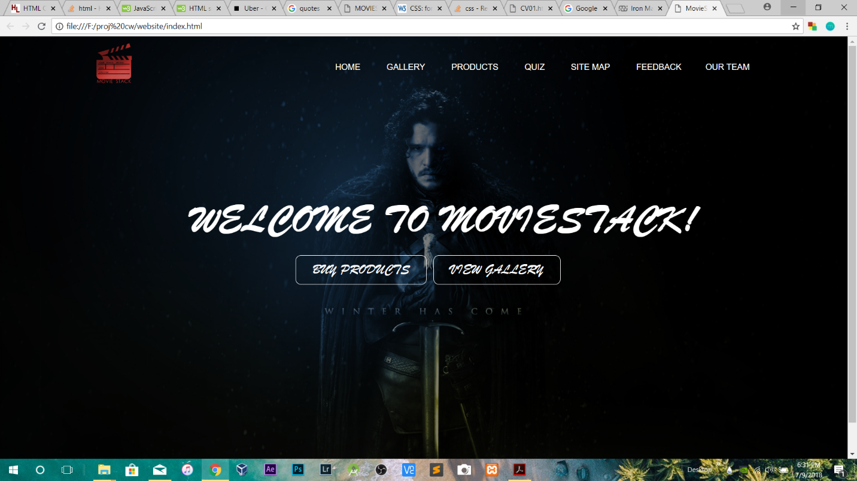

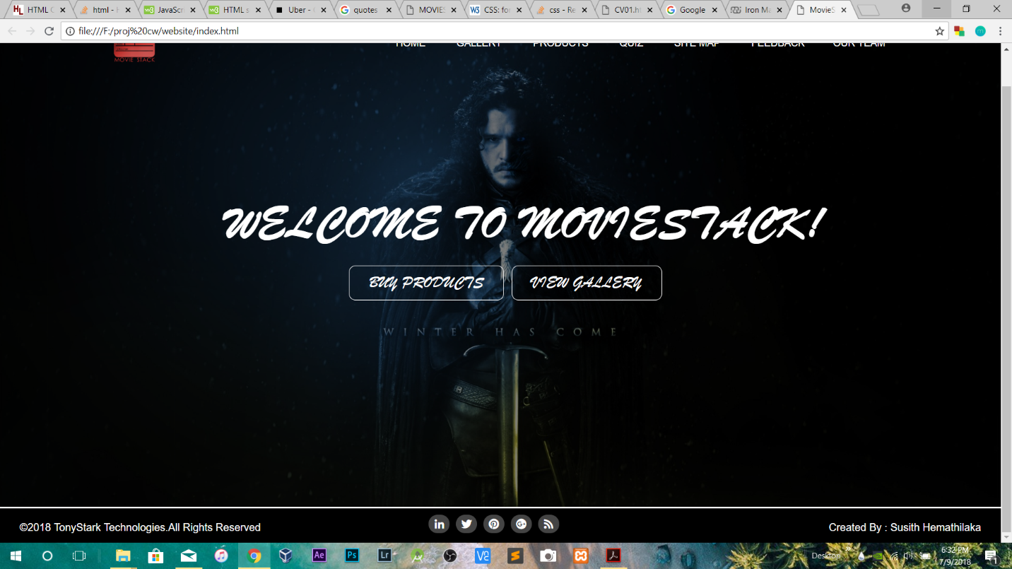

**Feedback page**

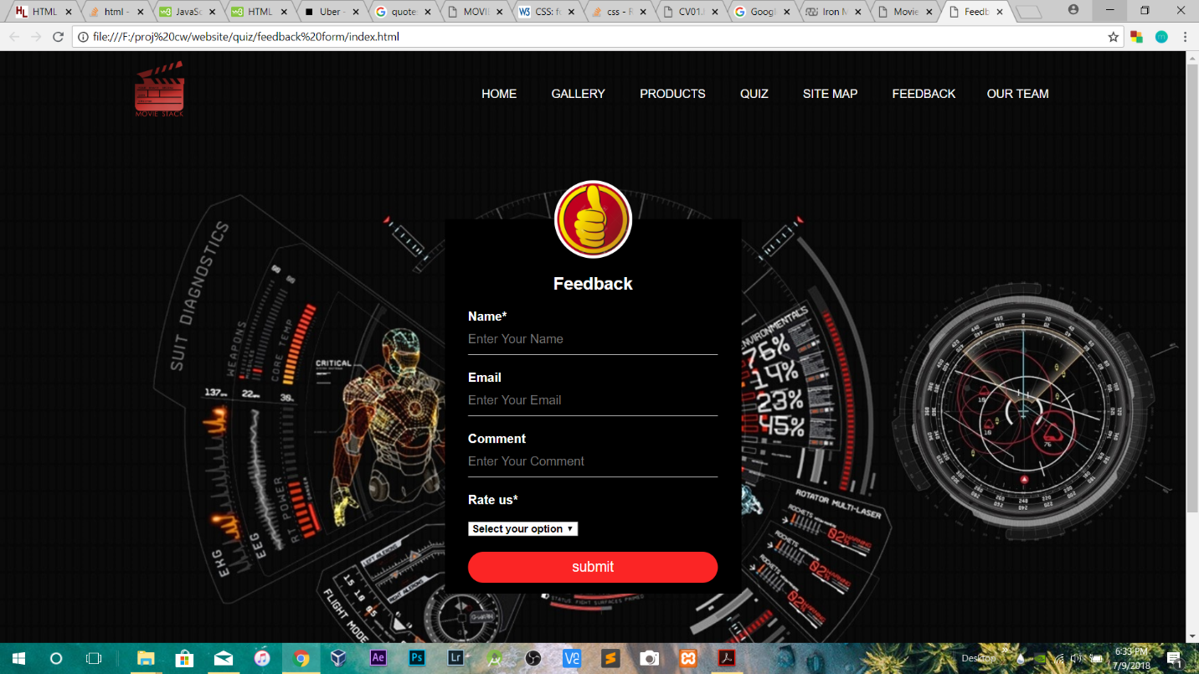

**CV**

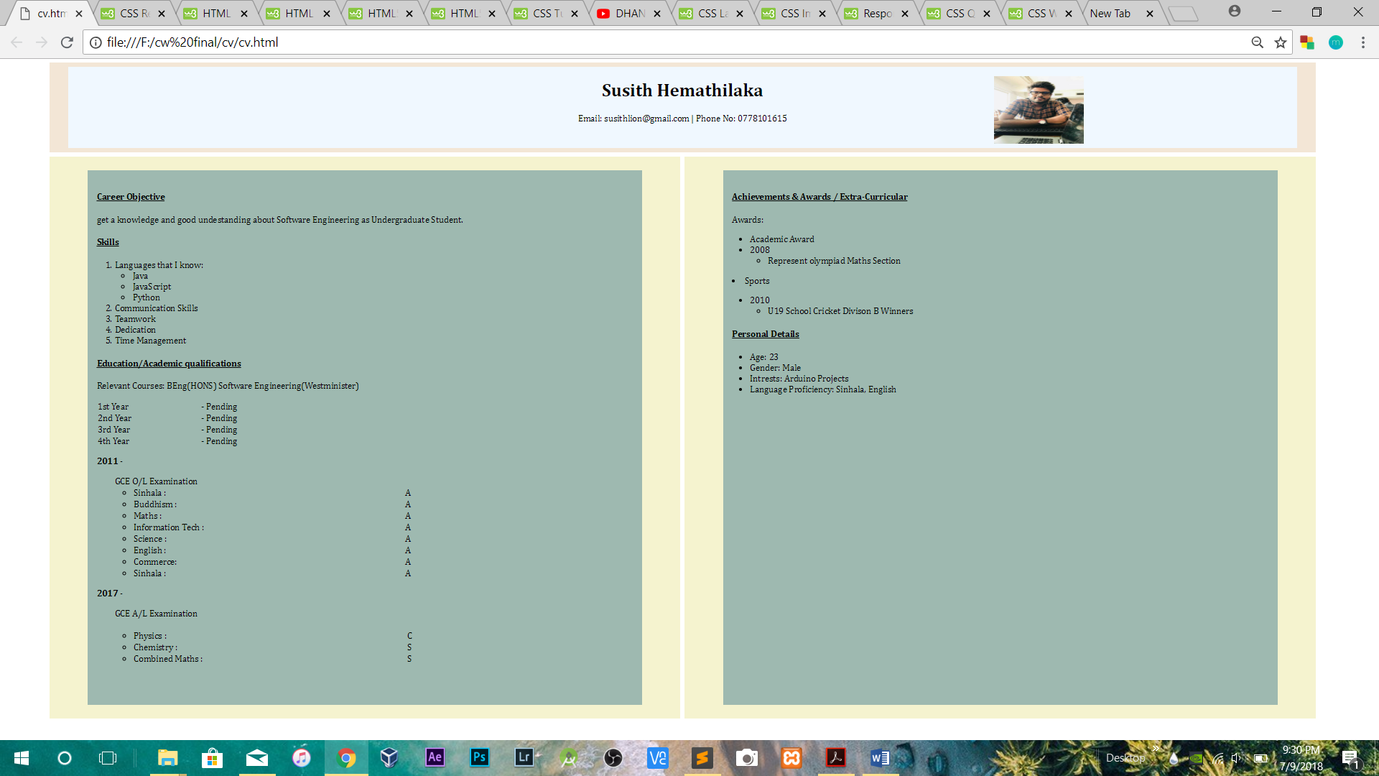

**Code**

**Homepage**

**Html**

<html>

<head>

<!-- page titile goes here -->

<title>MovieStack</title>

<!-- link to the font awesome plugin to use later in social links class -->

<link rel="stylesheet" href="https://use.fontawesome.com/releases/v5.0.13/css/all.css" integrity="sha384-DNOHZ68U8hZfKXOrtjWvjxusGo9WQnrNx2sqG0tfsghAvtVlRW3tvkXWZh58N9jp" crossorigin="anonymous">

<!-- links to external css -->

<link href="style.css" rel="stylesheet" type="text/css">

</head>

<body>

<header>

<!-- in this class includes logo,navigation menu and dropdown -->

<div class="row">

<div class="logo">

<img src="mov.png"

</div>

<ul class="main-nav">

<li><a href=""> HOME </a></li>

<li><a href=""> GALLERY </a></li>

<li><a href=""> PRODUCTS</a></li>

<li><a href=""> QUIZ</a></li>

<li><a href=""> SITE MAP</a></li>

<li><a href="">FEEDBACK </a></li>

<!-- in this class includes dropdown button -->

<div class="dropdown">

<button class="dropbtn">OUR TEAM</button>

<!-- in this class includes dropdown button -->

<div class="dropdown-content">

<a href="#">Student 1</a>

<a href="#">Student 2</a>

<a href="#">Student 3</a>

<a href="#">Student 4</a>

</div><!-- dropdown-content -->

</ul> <!-- main-nav -->

</div><!-- row -->

<!-- this class includes welcome text and the buttons -->

<div class="hero">

<h1>Welcome to MovieStack!</h1>

<!-- link to product page and gallery page -->

<div class="button">

<a href="#" class="btn btn-one">Buy Products</a>

<a href="#" class="btn btn-two">View Gallery</a>

</div><!-- button -->

</div><!-- hero -->

</header>

<footer>

<!-- this class includes copyright text -->

<div class="left">

&copy;2018 TonyStark Technologies.All Rights Reserved

</div><!-- left -->

<!-- social media icons using font awesome plugin -->

<div class="socialmedia">

<ul>

<li> <a href="#"><i class="fab fa-linkedin-in fa-fw"></i></a></li>

<li> <a href="#"><i class="fab fa-twitter fa-fw"></i></a></li>

<li> <a href="#"><i class="fab fa-pinterest fa-fw"></i></a></li>

<li> <a href="#"><i class="fab fa-google-plus fa-fw"></i></a></li>

<li> <a href="#"><i class="fas fa-rss fa-fw"></i></a></li>

</ul>

</div><!-- socialmedia -->

<!-- link to page creators cv page -->

<div class="right">

Created By : <a href="#">Susith Hemathilaka</a>

</div><!-- right -->

</footer>

</body>

</html>

**Homepage-CSS**

*

{

margin: 0;

padding: 0;

}

/*set margin, padding properties to all elements*/

.row

{

max-width: 1200px;

margin: auto;

}

/*styling navigation menu, dropdown button and list*/

.main-nav

{

float: right;

list-style: none;

margin-top: 30px;

}

.main-nav li

{

display: inline-block;

}

/*style the action when cursor on it*/

.main-nav li a:hover

{

border: 1px solid white;

border-radius: 10px;

background-color: darkorange;

}

.main-nav li a

{

color: white;

text-decoration: none;

padding: 5px 20px;

font-family: "Roboto", sans-serif;

font-size: 15px;

}

.dropbtn {

font-family: "Roboto", sans-serif;

text-decoration: none;

font-size: 15px;

background: none;

color: white;

border: none;

padding: 16px;

cursor: pointer;

}

/* The container <div> - needed to position the dropdown content */

.dropdown {

position: relative;

display: inline-block;

}

/* Dropdown Content styling */

.dropdown-content {

display: none;

position: absolute;

background-color: black;

min-width: 110px;

box-shadow: 0px 8px 16px 0px rgba(0,0,0,0.2);

z-index: 1;

}

/* Links inside the dropdown */

.dropdown-content a {

font-family: Impact, Charcoal, sans-serif;

color: white;

padding: 12px 16px;

text-decoration: none;

display: block;

}

/* Change color of dropdown links on hover */

.dropdown-content a:hover {

background-color: darkorange;

border: 1px solid white;

border-radius: 10px;

}

/* Show the dropdown menu on hover */

.dropdown:hover .dropdown-content {

display: block;

}

/* Change the background color of the dropdown button when the dropdown content is shown */

.dropdown:hover .dropbtn {

background-color: darkorange;

border: 1px solid white;

border-radius: 10px;

}

.hero

{

position: absolute;

width: 1200px;

margin-left: 0px;

margin-top: 0px;

}

/*styling welcome text*/

h1

{

color: white;

text-transform: uppercase;

font-size: 70px;

text-align: center;

font-family: Brush Script MT, Brush Script Std, cursive;

margin-left: 70px;

margin-top: 200px;

}

header

{

background-image:linear-gradient(rgba(0,0,0,0.5),rgba(0,0,0,0.5)),url(intro2.jpg);

height: 100vh;

background-size: cover;

background-position: center;

}

/*styling header */

.button

{

margin-top: 30px;

margin-left: 370px;

}

.btn

{

border: 1px solid white;

border-radius: 10px;

padding: 10px 30px;

color: white;

text-decoration: none;

margin-right: 5px;

font-size: 25px;

text-transform: uppercase;

}

.btn-one

{

font-family: Brush Script MT, Brush Script Std, cursive;

}

.btn-two

{

font-family: Brush Script MT, Brush Script Std, cursive;

}

/*style the action when cursor on it*/

.btn-one:hover

{

background-color: darkorange;

transition: all 0.5s ease-in;

}

/*style the action when cursor on it*/

.btn-two:hover

{

background-color: darkorange;

transition: all 0.5s ease-in;

}

/*stylig logo */

.logo img

{

margin-top: 12px;

width: 150px;

height: auto;

}

/*Set properties to footer class*/

footer

{

border-top: 3px solid white;

border-top: 2px solid white;

font-family: "Roboto", sans-serif;

color: white;

height: 7vh;

background-size: cover;

background-position: center;

background-color: black;

}

/*style copyright text*/

div.left{

margin-top: 20px;

float: left;

margin-left: 30px;

}

/*style create by text*/

div.right {

margin-top: 20px;

margin-right: 30px;

float:right;

}

/*style create by link*/

div.right a {

color: white;

text-decoration: none;

}

/*div.quoate img {

height: 140vh;

}

*/

/*style social media icons and links*/

div.socialmedia{

margin-top: 10px;

float: left;

margin-left: 250px;

}

div.socialmedia ul {

list-style: none;

}

div.socialmedia ul li{

display: inline;

}

div.socialmedia ul li a{

margin-left: 5px;

padding: 6px;

background: #444;

color: #fff;

display: inline-block;

border-radius: 20px;

}

/*style the action when cursor on it*/

div.socialmedia ul li a:hover {

background: orange;

}

**Feedback Page**

**Html + JavaScript**

<html>

<head>

<title>Feedback Form</title>

<script type="text/javascript">

/*this function work on onclick action of submit button*/

function val(){

/*declare and assign input values*/

var nam= document.form1.name.value;

var cmnt = document.forms["form1"]["comment"].value;

var r = document.getElementById('rating');

var rate = r.options[r.selectedIndex].value;

/*name or rating feild is empty enter to this loop*/

if(nam=="" || rate=="0" ){

/*name feild is empty then display alert enter a name*/

if (nam =="")

{

alert("enter a name");

return false;

}

/*rating feild is empty then display alert enter a name */

if(rate=="0")

{

alert("Please select Rating");

}

}

/*name or rating feild is filled enter to this loop and display the Thankyou message*/

else {

alert("Dear "+nam+", Thank you very much for your feedback.You have rated our site as "+rate+" and your comment was "+cmnt+".");

}

}

</script>

<!-- links to fontawesome plugin -->

<link rel="stylesheet" href="https://use.fontawesome.com/releases/v5.0.13/css/all.css" integrity="sha384-DNOHZ68U8hZfKXOrtjWvjxusGo9WQnrNx2sqG0tfsghAvtVlRW3tvkXWZh58N9jp" crossorigin="anonymous">

<!-- links to css file -->

<link rel="stylesheet" type="text/css" href="style.css">

<body>

<header>

<!-- in this class includes logo,navigation menu and dropdown -->

<div class="row">

<div class="logo">

<img src="mov.png"

</div>

<ul class="main-nav">

<li><a href=""> HOME </a></li>

<li><a href=""> GALLERY </a></li>

<li><a href=""> PRODUCTS</a></li>

<li><a href=""> QUIZ</a></li>

<li><a href=""> SITE MAP</a></li>

<li><a href="">FEEDBACK </a></li>

<!-- in this class includes dropdown button -->

<div class="dropdown">

<button class="dropbtn">OUR TEAM</button>

<!-- in this class includes dropdown button -->

<div class="dropdown-content">

<a href="#">Student 1</a>

<a href="#">Student 2</a>

<a href="#">Student 3</a>

<a href="#">Student 4</a>

</div>

</ul>

</div>

</header>

<!-- comment box starts here -->

<div class="feedbox">

<!-- comment box logo goes here -->

<img src="avatar1.jpg" class="avatar">

<h1>Feedback</h1>

<!-- form with input feilds, select list box and submit button -->

<form name="form1" onsubmit="return val();">

<p>Name*</p>

<input type="text" name="name" placeholder="Enter Your Name">

<p>Email</p>

<input type="text" name="" placeholder="Enter Your Email">

<p>Comment</p>

<input type="text" name="comment" placeholder="Enter Your Comment">

<!-- list box default select your option -->

<p>Rate us*</p><br>

<select id="rating">

<option value="0" disabled selected>Select your option</option>

<option value="Good">Good</option>

<option value="Bad">Bad</option>

<option value="Other">Other</option>

</select>

<!-- Submit button -->

<input type="submit" name="" value="submit">

</form>

</div>

<footer>

<!-- this class includes copyright text -->

<div class="left">

&copy;2018 TonyStark Technologies.All Rights Reserved

</div>

<!-- social media icons using font awesome plugin -->

<div class="socialmedia">

<ul>

<li> <a href="#"><i class="fab fa-linkedin-in fa-fw"></i></a></li>

<li> <a href="#"><i class="fab fa-twitter fa-fw"></i></a></li>

<li> <a href="#"><i class="fab fa-pinterest fa-fw"></i></a></li>

<li> <a href="#"><i class="fab fa-google-plus fa-fw"></i></a></li>

<li> <a href="#"><i class="fas fa-rss fa-fw"></i></a></li>

</ul>

</div><!-- socialmedia -->

<!-- link to page creators cv page -->

<div class="right">

Created By : <a href="">Susith Hemathilaka</a>

</div>

</footer>

</body>

</head>

</html>

**Feedback Page-CSS**

/*set properties to body elements*/

body{

margin: 0;

padding: 0;

background: url(pic2.jpg);

background-size: cover;

background-position: center;

height: 100vh;

font-family: sans-serif;

}

.row

{

max-width: 1200px;

margin: auto;

}

/*styling navigtion menu, dropdown button, logo and list*/

.logo img

{

margin-top: 12px;

width: 150px;

height: auto;

}

.main-nav

{

float: right;

list-style: none;

margin-top: 30px;

}

.main-nav li

{

display: inline-block;

}

/*style the action when cursor on it*/

.main-nav li a:hover

{

border: 1px solid white;

border-radius: 10px;

background-color: darkorange;

}

.main-nav li a

{

color: white;

text-decoration: none;

padding: 5px 20px;

font-family: "Roboto", sans-serif;

font-size: 15px;

}

.dropbtn {

font-family: "Roboto", sans-serif;

text-decoration: none;

font-size: 15px;

background: none;

color: white;

border: none;

padding: 16px;

cursor: pointer;

}

/* The container <div> - needed to position the dropdown content */

.dropdown {

position: relative;

display: inline-block;

}

/* Style Dropdown Content */

.dropdown-content {

display: none;

position: absolute;

background-color: black;

min-width: 110px;

box-shadow: 0px 8px 16px 0px rgba(0,0,0,0.2);

z-index: 1;

}

/* Links inside the dropdown */

.dropdown-content a {

font-family: Impact, Charcoal, sans-serif;

color: white;

padding: 12px 16px;

text-decoration: none;

display: block;

}

/* Change color of dropdown links on hover */

.dropdown-content a:hover {

background-color: darkorange;

border: 1px solid white;

border-radius: 10px;

}

/* Show the dropdown menu on hover */

.dropdown:hover .dropdown-content {

display: block;

}

/* Change the background color of the dropdown button when the dropdown content is shown */

.dropdown:hover .dropbtn {

background-color: darkorange;

border: 1px solid white;

border-radius: 10px;

}

/*style commentbox here*/

.feedbox{

width: 380px;

height: 480px;

background: #000;

color: #fff;

top: 60%;

left: 50%;

position: absolute;

transform: translate(-50%,-50%);

box-sizing: border-box;

padding: 70px 30px;

}

/*style commentbox logo*/

.avatar{

width: 100px;

height: 100px;

border-radius: 50%;

position: absolute;

top: -50px;

left: calc(50% - 50px);

}

h1{

margin: 0;

padding: 0 0 20px;

text-align: center;

font-size: 22px;

}

.feedbox p{

margin: 0;

padding: 0;

font-weight: bold;

}

/*style input fields*/

.feedbox input{

width: 100%;

margin-bottom: 20px;

}

/*style select list*/

.feedbox select{

margin-bottom: 20px;

font-weight: bold;

}

/*style input feilds*/

.feedbox input[type="text"]

{

border: none;

border-bottom: 1px solid #fff;

background: transparent;

outline: none;

height: 40px;

color: #fff;

font-size: 16px;

}

.feedbox input[type="submit"]

{

border: none;

outline: none;

height: 40px;

background: #fb2525;

color: #fff;

font-size: 18px;

border-radius: 20px;

}

.feedbox input[type="submit"]:hover

{

cursor: pointer;

background: #ffc107;

color: #000;

}

/*Set properties to footer class*/

footer

{

margin-top: 800px;

border-top: 3px solid white;

border-top: 2px solid white;

font-family: "Roboto", sans-serif;

color: white;

height: 7vh;

background-size: cover;

background-position: center;

background-color: black;

}

/*style copyright text*/

div.left{

margin-top: 20px;

float: left;

margin-left: 30px;

}

/*style create by text*/

div.right {

margin-top: 20px;

margin-right: 30px;

float:right;

}

/*style create by text*/

div.right a {

color: white;

text-decoration: none;

}

/*style social media icons and links*/

div.socialmedia{

margin-top: 10px;

float: left;

margin-left: 250px;

}

div.socialmedia ul {

list-style: none;

}

div.socialmedia ul li{

display: inline;

}

div.socialmedia ul li a{

margin-left: 5px;

padding: 6px;

background: #444;

color: #fff;

display: inline-block;

border-radius: 20px;

}

/*change background when cursor on it*/

div.socialmedia ul li a:hover {

background: orange;

}

**Individual Statement**

|  |  |
| --- | --- |
| Student Name:Susith Hemathilaka | Student ID:2017453 |
| State what tasks you carried out in the project. | |
| Design Home page , Comment Form and Main layout for Website. | |
| State what you enjoyed and did not enjoy about teamwork. | |
| Enjoyed, because I like Web Designing. | |
| State what you learnt about teamwork. | |
| Time management and Cordination. | |
| State what skills you gained/learnt from undertaking the project. | |
| Team work skills  Skill to inspire team members | |
| State any strengths about yourself that emerged whilst undertaking the project. | |
| Inspiring others | |
| State any weaknesses about yourself that emerged whilst undertaking the  project. | |
| Not noticed. | |
| State how you would do things better if you were to undertake the project again. | |
| Do Planning and Design phase much better | |
| Additional general or project specific comments: | |
| Great job | |
| Student Signature: | Date: |