# 

**Department of Computing**

Module: 4COSC006C – **Programming Principles 01**

Degree Program – **BScCS**

Tutorial Group - **Group D**

Module Leader:  Mr.  Guganathan Poravi

Date of submission: 07th Jan 2018

UOW ID : w1673745

Student ID: 2017184

Student Name: Sandeepa Sewwandi Perera

# **Introductions**

The University of Gugsi, No where in Particular (UGNiP) recognizes. The program store user names and passwords in Login database. University software has user Login. Student who logged then he enter the menu. This includes request asset entering, request to move, maintain request, get building plans, and get FMO reports. The program should always request university departments.

Problem – The problem was a create GUI application to Facility management office for the University of Gugsi which is located in no where particular.

Solution – create the GUI applications for the requests.

**2. Content**

* Login Details
* Menu
* Move Details
* Entering Menu
* Chair Details
* Desk Details
* Filling Cabinets Details
* Book Case Details
* Maintains
* Building Planes
* FMO Report

1. **Login Details**

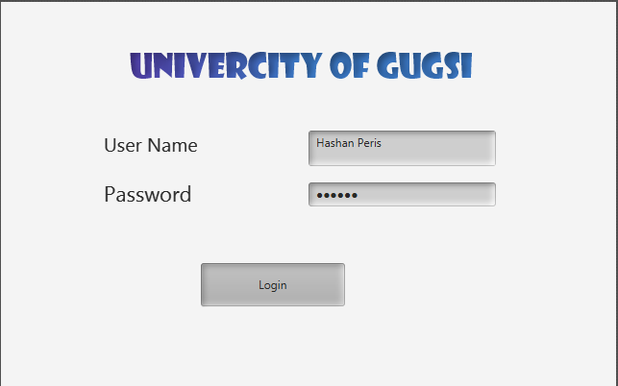

1. **Menu**



1. **Move Details**

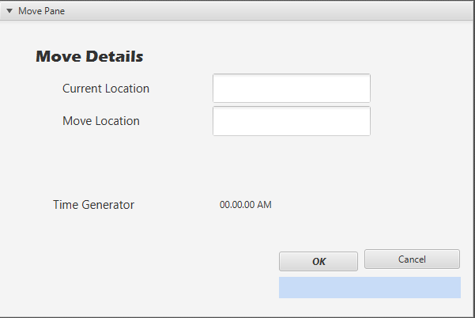

1. **Entering Menu**

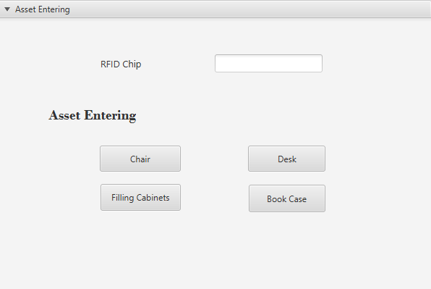

**4.1 Chair Type & Details**

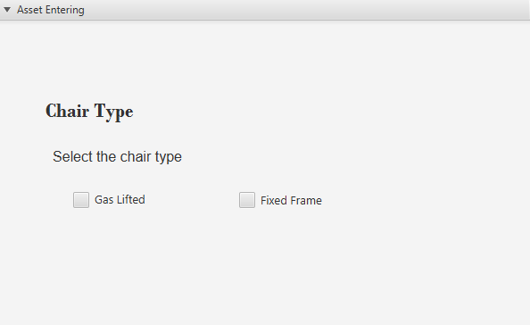

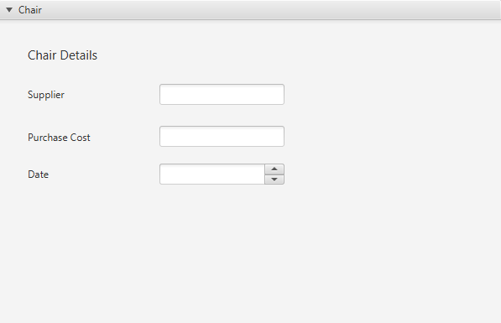

**4.2 Desk Details**

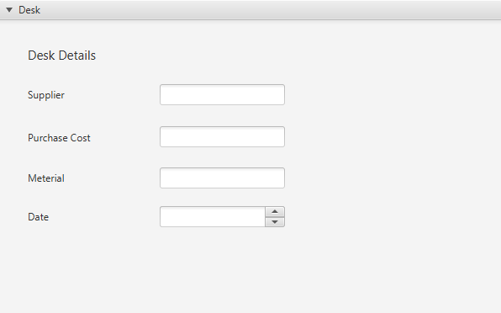

1. **Maintenance**

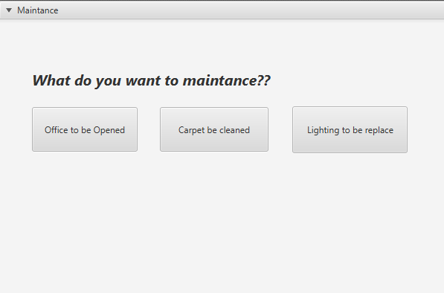

1. **Building Plans**

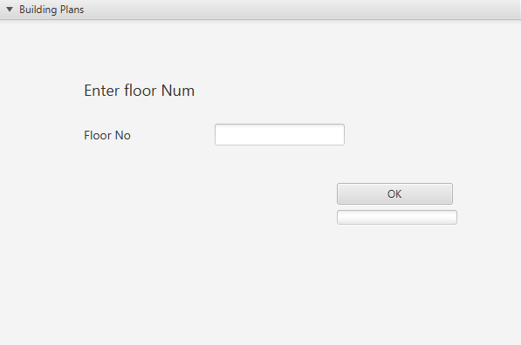

1. **FMO Report Details**

