A Mini Project Abstract On
Vuln Vigil: Recon and Vulnerability Discovery Tool for Bug Bounty Hunters

Submitted to

CMR ENGINEERING COLLEGE

BACHELOR OF TECHNOLOGY IN CSE-CYBER SECURITY
Submitted By

NARISETTY LIKHITHA (228R1A62A4)
SIDDARTH KUMAR (228R1A6291) SAI SANDEEP (238R5A6215) HARSHA VARDHAN (228R1A62A9)
Under the guidance of
Mr. Sunil Singh
Assistant Professor, Department of CSE-CS


Department CSE-Cyber Security CMR ENGINEERING COLLEGE UGC AUTONOMOUS

(Accredited by NBA Approved by AICTE, NEW DELHI, Affiliated to JNTU Hyderabad) Kandlakoya, Medchal Road, Medchal, Malkajgiri Dist. Hyderabad-501 401)
2024-2025

CMR ENGINEERING COLLEGE
UGC AUTONOMOUS
(Accredited by NBA,Approved by AICTE NEW DELHI, Affiliated to JNTU, Hyderabad) Kandlakoya, Medchal Road, Hyderabad-501 401

Department of Computer Science & Engineering (Cyber Security)

CERTIFICATE

This is to certify that the project entitled “Secure Code Analyzer: Advanced SAST for Vulnerability Detection and Remediation” is a Bonafide work
carried out by

NARISETTY LIKHITHA (228R1A62A4)
SIDDARTH KUMAR (228R1A6291) SAI SANDEEP (238R5A6215) HARSHA VARDHAN (228R1A62A9)

in partial fulfillment of the requirement for the award of the degree of BACHELOR OF TECHNOLOGY in COMPUTER SCIENCE AND ENGINEERING (CYBER
SECURITY) from CMR Engineering College, affiliated to JNTU, Hyderabad, under our guidance and supervision. The results presented in this project have been verified and are found to be satisfactory. The results embodied in this project have not been submitted to any other university for the award of any other degree or diploma

Internal Guide. | Mini project  Coordinator | Head of the Department
Mr. Sunil Singh | Ms. A. Anusha | Dr. M. Ashwitha
Assistant Professor  CSE-Cyber Security | Assistant Professor  CSE-Cyber Security | Associate Professor & HOD  CSE-Cyber Security
CMREC | CMREC | CMREC

DECLARATION

This is to certify that the work reported in the present project entitled “Vuln Vigil: Recon and Vulnerability Discovery Tool for Bug Bounty Hunters” is a record of bonafide work done by us in the Department of Computer Science and Engineering (Cyber Security), CMR Engineering College, JNTU Hyderabad. The reports are based on the project work done entirely by us and not copied from any other source. We submit our project for further development by any interested students who share similar interests to improve the project in the future. The results embodied in this project report have not been submitted to any other University or Institute for the award of any degree or diploma to the best of our knowledge and belief.

NARISETTY LIKHITHA (228R1A62A4)
SIDDARTH KUMAR (228R1A6291)
SAI SANDEEP (238R5A6215)
HARSHA VARDHAN (228R1A62A9)

ACKNOWLEDGMENT

We are extremely grateful to Dr. A. Srinivasula Reddy, Principal and Dr. M. Ashwitha, Associate Professor & HOD Department of CSE-Cyber Security for their constant support.
We are extremely thankful to Mr. Sunil Singh , Assistant Professor and Internal guide, Department of CSE(CS), for her constant guidance, encouragement and moral support throughout the project.
We will be failing in duty if we do not acknowledge with grateful thanks to the authors of the references and other literatures referred in this project.
We thank Ms. A. Anusha Mini Project Coordinator for her constant support in carrying out the project activities and reviews.
We express our thanks to all staff members and friends for all the help and co-ordination extended in the bringing out this project successfully on time. Finally, we are very much thankful to our parents who guided us every step of the way.

NARISETTY LIKHITHA (228R1A62A4)
SIDDARTH KUMAR (228R1A6291)
SAI SANDEEP (238R5A6215)
HARSHA VARDHAN (228R1A62A9)

CONTENTS

S.NO | Title | Page No.
1 | Abstract | 6
2 | Introduction | 7-8
3 | Literature Survey | 9-10
4 | System Analysis | 11-14
5 | System Specification | 15-16
6 | System Design | 17-23
7 | Source Code | 24-27
8 | System Implementation | 28-29
9 | Testing | 30-34
10 | Test Cases | 35-36
11 | Outputs | 36
12 | Conclusion | 37
13 | Future Scope | 38
14 | References | 39

- ABSTRACT

In today’s cybersecurity landscape, identifying vulnerabilities early in the software development lifecycle is more critical than ever. This project introduces VurnVigil, a lightweight yet effective static vulnerability scanner developed entirely in Python. It is designed to detect potential risks in files, folders, open ports, and live URLs without executing the target code. Inspired by the principles of Static Application Security Testing (SAST), the tool aims to assist developers, students, and small security teams in quickly analyzing their projects for common misconfigurations and insecure patterns. Unlike traditional heavyweight scanners, VurnVigil utilizes pattern matching and basic heuristic techniques to flag vulnerabilities across four main categories: web, network, API, and software. Users can scan local directories, extract content from live URLs, or check open ports on target machines—all through a simple and intuitive graphical user interface (GUI). The application categorizes findings by risk levels—low, medium, and high—using a scoring system to help prioritize remediation efforts. Recent enhancements include improved URL scanning, recursive folder analysis, categorized pattern checks, color-coded result displays, and file export functionality, significantly increasing both reliability and usability. By integrating these features into a minimal yet powerful framework, the project underscores the importance of proactive security practices, empowering users to identify and address potential vulnerabilities before deployment. VurnVigil promotes clean and secure coding habits while providing a practical introduction to the workings of static analysis. Though it intentionally avoids complex integrations or reliance on external APIs to maintain simplicity, it lays a strong foundation for more advanced capabilities in future versions. Ultimately, this project exemplifies a practical and accessible approach to early-stage vulnerability detection, fostering a shift-left mindset where security becomes an essential part of the development process.

INTRODUCTION

In today’s cybersecurity landscape, catching vulnerabilities early is crucial to avoiding costly breaches and system failures. Many security issues arise from overlooked bugs, insecure coding patterns, and misconfigured network settings. This growing threat has increased the demand for lightweight static vulnerability scanning tools that analyze code, ports, folders, and URLs without executing programs, helping developers identify problems well before deployment.

This project focuses on building a Python-based static vulnerability scanner that inspects local folders, live URLs, and open ports for common security flaws. Unlike heavy and complex security suites, this tool employs pattern matching and heuristic techniques to quickly detect a wide range of vulnerabilities spanning web applications, network services, and system configurations. It features a clean GUI interface with color-coded severity levels and detailed reports, making vulnerability management straightforward and accessible.

The primary objective is to demonstrate how static analysis can be integrated early in the development lifecycle, enabling teams and individuals to proactively identify and remediate risks. By scanning multiple target types, this project helps reduce potential attack surfaces and fosters a shift-left security culture. Users receive actionable feedback that allows them to prioritize fixes and enhance the security and stability of their applications and infrastructure.

To achieve this, the scanner recursively analyzes files and folders, performs live URL checks, and scans open ports using a curated library of vulnerability signatures. It highlights bugs, insecure configurations, and potential exploits within a user-friendly dashboard, offering remediation suggestions. These automated checks encourage continuous security awareness and early intervention, minimizing the likelihood of vulnerabilities reaching production.

A significant strength of this project lies in its simplicity and focus on core static scanning capabilities without reliance on complex external tool integrations. This makes it accessible to small teams, students, and security beginners seeking a practical, lightweight scanner that integrates smoothly into their workflow. By prioritizing ease of use, the tool fosters better security habits and a deeper understanding of common threat vectors.

Overall, integrating static vulnerability scanning into daily development and testing processes improves security posture and code quality. This project demonstrates how even basic automated analysis can catch critical issues early, reducing risks and technical debt. By empowering developers with timely and clear vulnerability reports, it promotes a proactive, security-first mindset essential for modern software and infrastructure resilience.

PROBLEM STATEMENT

Today’s developers and security teams often face the challenge of balancing fast development with secure code practices. while tools like sonarqube help in static code analysis, they usually focus only on the codebase and miss out on other threat surfaces like open ports, suspicious urls, and insecure directories. additionally, many existing solutions require complex setup, external integrations, or deep technical expertise, making them less accessible to solo developers, students, or early-stage teams. there’s a need for a lightweight, standalone scanner that covers static vulnerabilities across multiple entry points without overwhelming the user. vulnscanner addresses this gap by offering a compact, gui-based python tool that analyzes folders, urls, and ports using signature-based techniques. its goal is to detect early signs of vulnerabilities and misconfigurations before they can be exploited, without depending on advanced automation tools or external services.
.

OBJECTIVES
• To develop a python-based gui tool that performs static code scanning, url fuzzing, and basic recon for early vulnerability detection.
• To identify insecure patterns, sensitive info, and outdated components in html, js, and log files using fast regex-based scanning.
• To detect reflected xss and sqli issues in live web applications by injecting payloads and analyzing the response content for matches.
• To integrate nmap scanning to find open ports and services, supporting initial attack surface mapping without needing deep expertise.
• To provide categorized results with severity labels and remediation tips via a simple interface, improving

SCOPE
This tool is designed to perform comprehensive vulnerability scanning on static files and live URLs, supporting multiple file types like HTML, JS, and Python. It uses regex-based pattern matching for static analysis and HTTP requests to detect reflected XSS and SQL injection in GET parameters. The integrated Nmap scanner enhances network reconnaissance by identifying open ports and services. VulnVigil runs locally on Linux and Windows, providing real-time results via a user-friendly GUI, making it suitable for security professionals and bug bounty hunters seeking a unified, lightweight scanning solution.

LIMITATIONS
The tool relies on internet access for live URL scanning and Nmap port detection.
It currently scans only single files and URLs, not entire project directories or deep crawls.
The regex-based detection may produce false positives or miss obfuscated vulnerabilities.
URL scanning is limited to GET requests and cannot handle POST or JavaScript-heavy endpoints.
Requires manual setup of dependencies like Nmap and Python libraries before use.

LITERATURE REVIEW PROJECT LITERATURE:

A. Balwante, S. Sharma, and R. Sharma, “SecurityGUI: A Python-based Integrated Vulnerability Scanning Platform,” International Journal of Innovative Research in Computer and Technology (IJIRCT), (2025)
This paper introduces SecurityGUI, an integrated vulnerability scanning platform built using Python and Flask, aiming to centralize the use of diverse security tools into a single cohesive system. The platform simplifies the process of executing and managing multiple external scanners by offering a unified web-based dashboard that interfaces with tools such as Nmap for port scanning, Gobuster for directory fuzzing, and ExifTool for file metadata analysis. Rather than requiring users to manually operate these tools from separate interfaces or command lines, SecurityGUI wraps them in an intuitive GUI, allowing security professionals to launch scans and view aggregated results in real-time. A key contribution of this work lies in its use of Docker-based microservices architecture, ensuring that each tool runs in its own isolated container, which enhances scalability and modularity. The consolidated reporting feature further improves the usability and interpretability of scan results. Overall, the platform exemplifies how integration can streamline the vulnerability assessment process, making it accessible even to less experienced users while maintaining flexibility and depth for advanced analysts.

Tudela, A. M. Ortiz, and J. García, “On Combining Static, Dynamic and Interactive Analysis Security Testing Tools to Improve OWASP Top Ten Detection,” Applied Sciences, (2020)
This research focuses on enhancing software security testing by integrating Static Application Security Testing (SAST), Dynamic Application Security Testing (DAST), and Interactive Application Security Testing (IAST). The authors conduct a systematic evaluation of these approaches on modern web applications and find that combining them significantly improves the detection of vulnerabilities, especially those listed in the OWASP Top Ten. Their empirical findings reveal that while each technique has its own strengths and weaknesses, their synergy leads to better coverage and reduced false positives. For instance, SAST excels in identifying source-level vulnerabilities early in the development process, while DAST and IAST are more effective in detecting runtime and context-sensitive issues. The research supports the claim that integrated testing can bridge the gap between development and production environments by ensuring that both code and behavior are scrutinized. Furthermore, the paper highlights the importance of tool orchestration and strategic layering of these techniques to ensure maximum detection without overwhelming developers. This study reinforces the need for hybrid security testing strategies in modern DevSecOps pipelines.

K. Kuszczyński and M. Walkowski, “Comparative Analysis of Open-Source Tools for Conducting Static Code Analysis,” Sensors, (2021)
The increasing complexity and digital exposure of modern software systems have made static code analysis a vital step in secure software development. In this paper, the authors evaluate eleven open-source tools designed for static code analysis, applying them to sixteen web applications known for well-documented vulnerabilities. Their findings highlight that no single tool offers complete or consistent vulnerability detection; however, each contributes unique capabilities that, when used together, enhance overall security coverage. The study also identifies common shortcomings such as language limitations, inconsistent reporting formats, and false positives. Notably, the research emphasizes that static analysis is not only relevant for web applications but can be generalized to embedded systems and other platforms. Recommendations are provided for practitioners regarding how to strategically select and combine tools based on specific project requirements and risk profiles. This paper is a valuable contribution to both academia and industry, offering actionable insights for anyone looking to strengthen their secure coding practices using open-source solutions.

R. Mahmood and Q. H. Mahmoud, “Evaluation of Static Analysis Tools for Finding Vulnerabilities in Java Source Code,” International Journal of Computer Applications, (2018)
In this work, the authors explore and compare various static analysis tools specifically designed for Java source code. They begin by noting a common industry pitfall—postponing security testing until late in the development cycle—despite the fact that vulnerabilities are easier and cheaper to fix during the early stages. The paper examines how static analyzers identify vulnerable code patterns and suggests that integrating these tools into the secure software development lifecycle (SSDLC) can significantly mitigate security risks. Tools evaluated include both open-source and proprietary solutions, with analysis focusing on their detection abilities, false positive rates, user-friendliness, and code remediation suggestions. The results indicate that while some tools can automatically patch or recommend fixes, others serve better as informative guides. The research concludes that the most effective use of static analysis tools comes from embedding them early and continuously within the development workflow. The findings advocate for a shift in mindset—from reactive to proactive security—and provide a roadmap for teams looking to adopt secure coding from the ground up.

Z. D. Wadhams, C. Izurieta, and A. M. Reinhold, “Barriers to Using Static Application Security Testing (SAST) Tools: A Literature Review,” ASEW ’24: Proceedings of the 39th IEEE/ACM International Conference on Automated Software Engineering Workshops, (2024)
This literature review investigates why, despite their proven effectiveness, Static Application Security Testing (SAST) tools are not universally adopted by software developers. The authors examine a wide array of research sources and practitioner reports to uncover both technical and human-centered barriers to SAST adoption. Among the key findings are issues like high false positive rates, steep learning curves, and lack of seamless integration with modern IDEs and CI/CD pipelines. Developers often find that SAST tools disrupt their workflows rather than enhancing them, leading to resistance or abandonment. The authors argue that for SAST tools to gain mainstream acceptance, improvements must be made not only in detection accuracy but also in user interface design, configurability, and contextual support. Additionally, they call for better documentation, clearer feedback mechanisms, and educational resources to reduce the perceived complexity of these tools. By identifying these friction points and offering a dual focus on both tool evolution and developer education, the paper provides a roadmap for increasing the utility and usability of SAST solutions in real-world settings.

M. Haug, A. C. F. Da Silva, and S. Wagner, “Towards Immediate Feedback for Security Relevant Code in Development Environments,” submitted to the 16th Symposium and Summer School On Service-Oriented Computing, (2022)
This study introduces a new approach to delivering real-time static code analysis feedback directly within development environments. The authors critique traditional SAST workflows, which typically operate post-development and generate overwhelming lists of security warnings, resulting in developer fatigue and delayed remediation. To address this, they propose a mechanism that provides immediate, continuous feedback while the developer writes code. Their approach is designed with user-centered principles in mind—ensuring that alerts are understandable, actionable, and tailored to the developer’s context and experience level. Feedback is prioritized and delivered in small, manageable units to reduce cognitive overload. Additionally, the system adapts to individual developer behavior over time, becoming more personalized and efficient. The paper not only presents the technical architecture for this system but also explores the psychological and productivity benefits of proactive, embedded security feedback. This direction holds promise for integrating secure coding seamlessly into daily developer activities, making security a continuous and less disruptive part of the software development lifecycle.

SYSTEM ANALYSIS

EXISTING SYSTEM

Traditional approaches to vulnerability scanning often fall into two categories: manual security testing or enterprise-level automated scanners. Manual testing, while effective in the hands of skilled professionals, is time-consuming, inconsistent, and inaccessible to beginners or fast-paced teams. On the other end, professional-grade scanners like Burp Suite Pro or Qualys are either expensive, overkill for lightweight tasks, or require deep technical expertise.

Meanwhile, basic tools like linters or static code analyzers (e.g., ESLint, Pylint) are only focused on source code and completely ignore real-time, live web application vulnerabilities. They can't scan URLs, detect exposed services, or identify outdated server configurations — all of which are common entry points for attackers.

In short, there is no simple, lightweight, URL-based vulnerability scanner that empowers developers, students, and security enthusiasts to test their hosted web apps quickly and effectively using trusted open-source tools.

Limitations of the Existing System
      - Surface-Level Detection Only: Most linters and basic static analysis tools focus on code formatting, naming, or syntax — failing to uncover deeper logical vulnerabilities or potential attack vectors.

      - No Real Security Insight: Traditional tools do not scan for security-critical issues like injection flaws, insecure authentication patterns, or API misuse, leaving serious risks undetected.

      - Lack of Contextual Intelligence: Existing tools rarely understand the context of the code (e.g., data flow, function intent), which leads to false positives or missed vulnerabilities in complex logic.

      - Poor Developer Guidance: Most tools either give vague warnings or offer no remediation steps, forcing developers to manually research how to fix detected issues.

      - No Support for On-the-Fly Checks: Current methods aren't designed for fast, lightweight security checks during early development — they either require full CI/CD setup or manual effort.

PROPOSED SYSTEM:

- Basic Automated Vulnerability Detection Using Python:
VulnVigil is built with custom Python scripts that send requests to the target URL/IP and analyze responses for common security weaknesses like open ports, default server banners, missing headers, and other easy-to-check vulnerabilities.
- Simple Terminal Output:
Results are printed directly to the terminal in a readable format, showing the vulnerability type and brief explanation.
- Categorization by Vulnerability Type:
Detected issues are grouped by category (e.g., header issues, open ports, server info leaks) to help users understand the general security posture.
- Basic Severity Tags:
Each detected issue is labeled with a simple severity indication (like Low, Medium, or High) based on how critical the vulnerability is perceived to be.
- Static Recommendations Included in Output:
For every vulnerability found, the tool shows a short static remediation note suggesting how to fix or reduce the risk (e.g., “Add Content Security Policy header,” “Disable directory listing”).
- No External Tool Integration:
Vuln-Vigil does not rely on or integrate with other vulnerability scanning tools. It uses Python’s built-in libraries (like requests and sockets) to perform its checks.
- Focus on Learning & Awareness:
The tool’s output is meant to help users, especially beginners, get familiar with common web vulnerabilities and understand their implications.

Benefits of the Proposed System
- Lightweight and Easy to Run
- Clear and Simple Output
- Encourages Basic Security Hygiene
- Customizable Python Codebase

Requirement Analysis

The goal of this project is to Build a lightweight CLI tool to scan source code for security vulnerabilities, bugs, and code issues. It should be easy to run on local files, output clear results in the terminal, and require minimal setup.

Functional Requirements
These are the core functions the system must perform:
- Accept source files via CLI and validate the input file paths to ensure they exist and are readable.
- Perform static code analysis purely through inbuilt Python logic—no external cloud or third-party tool integration.
- Detect common vulnerabilities and bugs such as insecure function calls, improper input handling, and simple logic errors.
- Categorize detected issues into types: vulnerabilities, bugs, and code smells for easier understanding.
- Assign severity levels to each finding (Low, Medium, High) based on potential impact.
- Provide straightforward remediation hints or suggestions directly in the CLI output to help developers fix issues.
- Automatically clean up any temporary data, logs, or intermediate files generated during analysis to keep the environment clean.
.

Non-Functional Requirements

These define the quality attributes the system must fulfill:
- Usability: The tool must be easy to run through command-line arguments with minimal configuration.
- Usability: Easy to run and configure, just command-line arguments, no complicated setup.

- Performance: Should scan typical files quickly (seconds, not minutes).

- Reliability: Handle invalid files or errors gracefully with clear messages.

- Security: Don’t store sensitive info; tool runs locally, no external data sharing.

Feasibility Study
The feasibility study assesses how practical and viable it is to build and use VulnVigil, a lightweight static code analyzer that detects basic bugs, vulnerabilities, and code smells through pure Python logic, running locally on developers’ machines.
Technical Feasibility:
The project uses Python and standard libraries to perform static code analysis without relying on external services or APIs. This approach minimizes dependencies and reduces technical complexity. Since it runs entirely on local machines and works via the command line, it is compatible with common operating systems like Windows, Linux, and macOS where Python is installed. Overall, the technical feasibility is high due to the use of well-known technologies and a straightforward design.
Operational Feasibility:
Vuln-Vigil targets developers and security-conscious teams who want quick, easy-to-run tools for early code quality and security checks. Its simple CLI interface ensures that users do not need extensive training or additional infrastructure to get started. It integrates smoothly into typical development workflows and supports faster identification and resolution of issues, increasing overall productivity and security awareness.
Economic Feasibility:
Since the project requires only a local Python environment and no paid subscriptions, infrastructure costs are negligible. Development time and maintenance efforts are moderate given the limited scope of functionality. The savings gained by early bug and vulnerability detection, avoiding costly fixes later, far outweigh the investment. Therefore, the project is economically viable and cost-effective.
Schedule Feasibility:
Given its modest scope and use of existing Python capabilities, the project can be developed and tested within a few weeks. Maintenance and incremental improvements can be done alongside regular development, making the timeline very manageable.
Operational Feasibility:
The tool is intended for developers and security teams to improve code quality early in the development process. It simplifies the detection and remediation of issues by providing detailed reports in the terminal. It can be integrated into developers’ workflows without requiring extensive training or changes in the existing development environment. Operationally, it enhances productivity and software security, making it highly feasible for adoption.
In conclusion, VulnVigil is a technically sound, user-friendly, low-cost, and timely project that is perfectly feasible to implement and deploy in real-world development settings.

SYSTEM SPECIFICATIONS

HARDWARE REQUIREMENTS

CPU (Processor):

For typical local setups, a dual-core processor with a clock speed of 2.0 GHz or higher is adequate to perform static code analysis efficiently. For users analyzing larger codebases or multiple projects, a quad-core processor (2.5 GHz or higher) is recommended to reduce processing time and improve responsiveness. In team or enterprise environments where concurrent scans and higher workloads are expected, an 8-core processor (3.0 GHz or higher) ensures optimal performance.

RAM (Memory):

Memory usage depends on the size and complexity of the source code being analyzed. A minimum of 4 GB RAM is required for small to medium-sized projects, with 8 GB preferred for smoother operation and multitasking. Larger projects or scenarios involving simultaneous analyses should have 16 GB or more to avoid memory bottlenecks.

Storage:

Disk space requirements are modest, with a minimum of 1 GB recommended to accommodate temporary files, logs, and scan outputs. Storage needs may increase slightly with frequent scans or when retaining historical scan data. Using SSD storage is advised for faster read/write speeds and improved overall performance.

Network:

The tool primarily operates offline and does not require a network connection for analysis. However, a stable internet connection is beneficial for downloading updates or integrating with optional remote APIs or repositories.

Software Requirements:

- Operating System Compatibility
VurnVigil is designed to be cross-platform, supporting the following operating systems to maximize accessibility and flexibility:
  - Windows 10 or later (64-bit)
  - Linux distributions (Ubuntu 18.04 or newer, Debian, CentOS, Fedora)
  - macOS (primarily for development and local testing purposes)

- Python Runtime Environment
  - Python version 3.8 or higher is mandatory to run the scanner.
  - The environment should include essential standard libraries for file I/O, subprocess management, networking (e.g., socket), and GUI creation (e.g., tkinter).
  - No external Python dependencies or third-party runtime packages are required to maintain a lightweight footprint, but optional enhancements might use libraries such as requests or scapy for advanced network/URL scanning.

- Static Vulnerability Analysis Engine
  - Entirely implemented in Python with pattern matching and heuristic algorithms for vulnerability detection.
  - No reliance on external cloud APIs or third-party static analysis services; all scanning occurs locally to ensure data privacy and quick feedback.
  - Supports scanning on multiple target types: source code files, local directories, open network ports, and live URLs.

- Graphical User Interface (GUI)
  - Built with Python’s native GUI toolkit (tkinter) for a lightweight, platform-independent interface.
  - Provides users with an interactive dashboard showing scan progress, categorized vulnerability results, and remediation suggestions.
  - Supports exporting scan results in CSV or TXT format for documentation and further analysis.

- Command-Line Interface (CLI)
  - Offers an alternative CLI mode for advanced users to input file paths, URLs, or port ranges directly.
  - Includes robust input validation and error handling to maintain stability and usability in headless environments.

- Network and URL Scanning Capabilities
  - Uses built-in Python libraries for socket programming to detect open ports on target machines.
  - Performs HTTP/HTTPS checks on URLs, retrieving response headers and page content for static pattern analysis.

- Data Handling and Storage
  - No external database is required.
  - All scan results, logs, and temporary files are handled in-memory or stored temporarily on the local filesystem with automatic cleanup after each scan to avoid clutter or data leakage.

- Security and Privacy Considerations
  - The tool does not transmit any data externally, ensuring that scanned code, URLs, and network information remain local and private.
  - Designed to be used in offline or restricted environments where security policies disallow cloud services.

- Development and Testing Tools
  - Development primarily conducted on Windows and Linux platforms using Python IDEs such as VSCode or PyCharm.
  - Automated unit tests implemented using Python’s unittest framework to verify core scanning functions.

- Optional Requirements for Future Enhancements
  - Integration with package managers like pip for dependency management in case of adding external libraries.
  - Potential future support for integration with CI/CD pipelines (e.g., Jenkins, GitHub Actions) to enable automated scanning during development workflows.

System Design

System Architecture

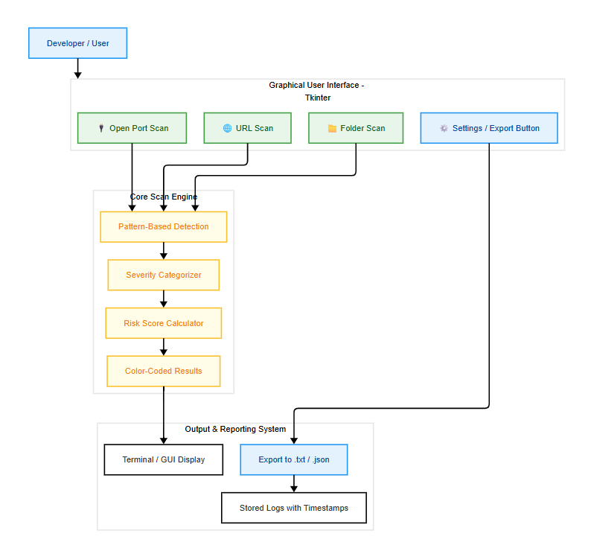

  - Unified Modelling Language Diagrams
The UML stands for Unified modeling language, is a standardized general-purpose visual modeling language in the field of Software Engineering. It is used for specifying, visualizing, constructing, and documenting the primary artifacts of the software system. It helps in designing and characterizing, especially those software systems that incorporate the concept of Object orientation. It describes the working of both the software and hardware systems.

Goals of UML:
- Since it is a general-purpose modeling language, it can be utilized by all the modelers.
- UML came into existence after the introduction of object-oriented concepts to systemize and consolidate the object-oriented development, due to the absence of standard methods at that time.

- The UML diagrams are made for business users, developers, ordinary people, or anyone who is looking forward to understand the system, such that the system can be software or non- software.
- Thus it can be concluded that the UML is a simple modeling approach that is used to model all the practical systems.

Characteristics of UML:
The UML has the following features: 21 It is a generalized modeling language.
- It is distinct from other programming languages like C++, Python, etc.
- It is interrelated to object-oriented analysis and design. • It is used to visualize the workflow of the system.
- It is a pictorial language, used to generate powerful modeling artifacts.

Reasons to Model:
- To communicate the desired structure and behavior of the system.
- To visualize and control the system’s architecture.
- To better understand the system and expose opportunities for specification and reuse.

Introduction to UML:
UML is general purpose visual modeling language that will Specify, Visualize, Construct and Document the artifacts of the software system. UML is the language used in the information technology industries versions of blue print. It is a method for describing the system architecture in details using this blue print. It becomes much easier to build or maintain a system and to ensure that the system we hold up to requirement changes. It is a method for describing the system architecture in details using this blue print. Model is a blue simplification of reality. A model provides the blue prints of a system. The Unified Modelling Language (UML) is a visual language for the specifying, constructing and documenting the artifacts if the software intensive systems.

Building blocks of UML:
The vocabulary of the UML encompasses 3 kinds of building blocks.
- Things
- Relationships
- Diagrams Things:
Things are the data abstractions that are first class citizens in a model. Things are of four types like structural things, Behavioral things, Grouping things, Annotational things.
Relationships:
Relationships tie the things together. Relationships in the UML are Dependency, Association, Generalization, and Specialization.
Diagrams:

Diagrams in the UML are of 2 types.
They are static diagrams, Dynamic diagrams.
Static diagrams consist of Class diagram, Object diagram, and Component diagram.
Dynamic diagram consists of use case diagram, sequence diagram, collaboration diagramActivity

USECASE DIAGRAM:

The Use Case Diagram illustrates the major interactions between the primary user (the security analyst or developer) and the VulnVigil vulnerability scanning system. It captures the essential operations such as selecting a folder to scan files, performing pattern-based vulnerability analysis, scanning live URLs for exposed content or risky scripts, detecting open ports on a domain or IP address, and exporting the scan results for documentation or auditing purposes. Each action represents a specific use case that directly supports the core functionality of the system and reflects its role as a multi-surface vulnerability scanner with a user-friendly interface.

This diagram establishes the boundaries of the VulnVigil application, highlighting the primary user as the sole external actor and demonstrating how they initiate and interact with the various system functions. It provides a visual map of the system’s feature set, allowing developers and stakeholders to understand the intended behavior and flow of user interactions. By making each use case explicit, the diagram supports requirement validation, ensuring all planned functionalities like file scanning, URL analysis, port discovery, and report generation are captured clearly.

Furthermore,the Use Case Diagram serves as a guide for both design and implementation, helping the development team plan the architecture and behavior of the application modules. It facilitates communication among team members and stakeholders by offering a high-level yet structured view of what the system is designed to accomplish. Ultimately, this diagram clarifies the functional expectations of VulnVigil, ensuring all involved parties are aligned before and during development.

.

USECASE DIAGRAM

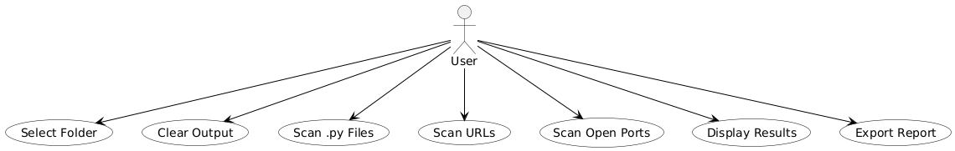

ACTIVITY DIAGRAM

The Activity Diagram depicts the detailed flow of operations and control logic involved in VulnVigil’s multi-surface vulnerability scanning process. It begins with the user initiating the application and selecting a scan type—either file-based, URL-based, or network (open port) scanning. For file scans, the system recursively traverses all supported files (.py, .js, .html, etc.) in the selected directory and performs regex-based detection for known vulnerability patterns. For URL input, VulnVigil fetches web content and scans for exposed sensitive information, API calls, or suspicious scripts. For port scans, it probes the given domain/IP to identify open TCP ports and common services.
This diagram also incorporates conditional flows such as error handling during file reading failures, unsupported file types, and network timeouts. Results are processed, color-coded by severity (low, medium, high), and dynamically displayed in the GUI. The user can then choose to clear results, export reports in .txt or .json format, or initiate a new scan cycle. Each action is modeled as a step in the process, reflecting both user-driven and system-driven decisions.
Overall,the Activity Diagram provides a step-by-step visualization of VulnVigil’s internal logic, making it easier to understand how control transitions occur based on user inputs and scan types. It captures all functional branches and optional paths, offering clarity on how the system behaves in different scenarios. This is invaluable for debugging, optimizing the flow, and ensuring consistency in the user experience across all scan types.

.

ACTIVITY DIAGRAM

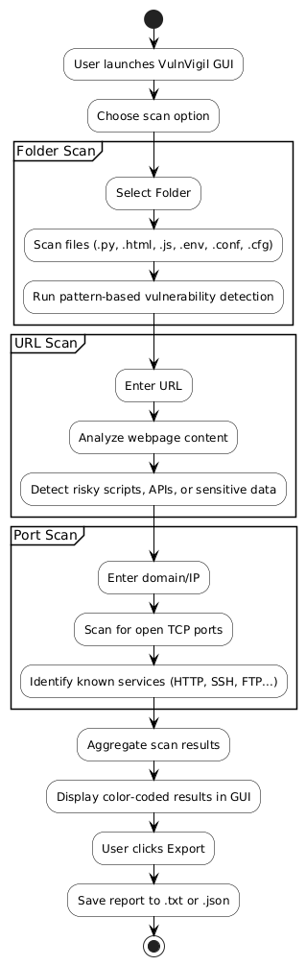

SEQUENCE DIAGRAM

The Sequence Diagram demonstrates the flow of interactions between the user (developer) and various components of the VulnVigil system during a vulnerability scanning session. It begins when the user initiates the scan through the GUI by selecting an input type—file folder, live URL, or domain/IP for port scanning. The request is passed to the main scan controller, which coordinates with specific modules: the FileScanner to analyze code files, the URLScanner to process web content, and the PortScanner to detect open network ports. Each scanner component interacts with the PatternMatcher to identify known vulnerabilities based on regex rules.
The diagram highlights the order and timing of these interactions, from input selection to result display. Once scans are completed, results are sent back to the controller, formatted with color-coded risk levels, and displayed on the GUI. This sequence visualization helps clarify the internal structure and timing of operations, making it easier to understand how different parts of VulnVigil communicate and respond to user actions. It is useful for identifying integration points, understanding component dependencies, and ensuring smooth system behavior.

SEQUENCE DIAGRAM

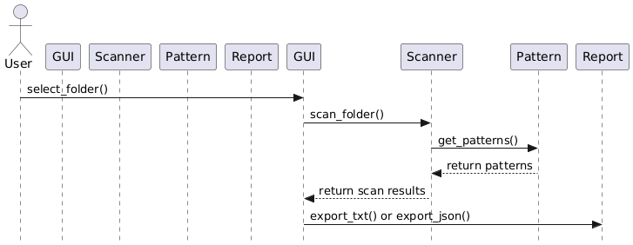

CLASS DIAGRAM:

The The Class Diagram offers a structural overview of the VulnVigil system, modeling the key classes and their relationships across different modules. Core classes such as MainWindow , FileScanner, URLScanner, PortScanner, and VulnerabilityPatterns are shown with their respective attributes and methods. These classes represent distinct functional areas—user interface handling, scanning coordination, content processing, and vulnerability pattern matching. Relationships such as associations and dependencies reflect how these components communicate and collaborate to perform their roles in the system.
This diagram serves as a design foundation, helping developers understand how data and responsibilities are distributed across the system. It ensures modularity and supports future enhancements by clearly identifying class responsibilities and interactions. By visualizing object-oriented structure, the Class Diagram simplifies both implementation and maintenance while ensuring scalability, readability, and better team collaboration throughout the project lifecycle.

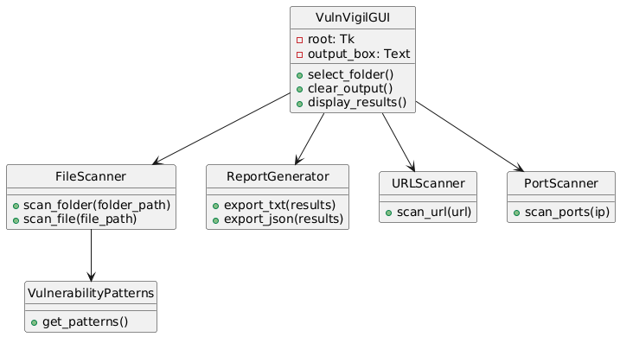

7 SOURCE CODE

File name : scanner.py

import tkinter as tk
from scanner_gui import launch_url_scanner, launch_folder_scanner

url_scanner_window = None
folder_scanner_window = None

def main_gui():
global url_scanner_window, folder_scanner_window

root = tk.Tk()
root.title("🧠 VurnVigil : a vulnerability scanner")
root.geometry("600x150")
root.configure(bg="#1f1f1f")

title = tk.Label(root, text="👾 VurnVigil", bg="#1f1f1f",
fg="lime", font=("Helvetica", 20, "bold"))
title.pack(pady=10)

button_frame = tk.Frame(root, bg="#1f1f1f")
button_frame.pack(pady=10, fill="x")

def open_url_scanner():
global url_scanner_window
if url_scanner_window is None or not url_scanner_window.winfo_exists():
url_scanner_window = launch_url_scanner()
else:
url_scanner_window.lift()

def open_folder_scanner():
global folder_scanner_window
if folder_scanner_window is None or not folder_scanner_window.winfo_exists():
folder_scanner_window = launch_folder_scanner()
else:
folder_scanner_window.lift()

def clear_output():
if url_scanner_window and url_scanner_window.winfo_exists():
url_scanner_window.clear_output()
if folder_scanner_window and folder_scanner_window.winfo_exists():
folder_scanner_window.clear_output()

def save_output():
if url_scanner_window and url_scanner_window.winfo_exists():
url_scanner_window.save_output()
if folder_scanner_window and folder_scanner_window.winfo_exists():
folder_scanner_window.save_output()

btn_url_scan = tk.Button(button_frame, text=" URL Scanner", command=open_url_scanner,
width=15, height=2, bg="#00bcd4", fg="black", font=("Arial", 12))
btn_url_scan.grid(row=0, column=0, padx=8)

btn_folder_scan = tk.Button(button_frame, text="Folder Scanner", command=open_folder_scanner,
width=15, height=2, bg="#4caf50", fg="white", font=("Arial", 12))
btn_folder_scan.grid(row=0, column=1, padx=8)

btn_clear = tk.Button(button_frame, text=" Clear Output", command=clear_output,
width=15, height=2, bg="#f4511e", fg="white", font=("Arial", 12))
btn_clear.grid(row=0, column=2, padx=8)

btn_save = tk.Button(button_frame, text=" Save Output", command=save_output,
width=15, height=2, bg="#00c853", fg="white", font=("Arial", 12))
btn_save.grid(row=0, column=3, padx=8)

btn_port_scan = tk.Button(button_frame, text=" Port Scanner", state="disabled",
width=15, height=2, font=("Arial", 12))
btn_port_scan.grid(row=0, column=4, padx=8)

root.mainloop()

if __name__ == "__main__":
main_gui()

8. SYSTEM IMPLMENTATION

8.1 IMPLEMENTATION:

- Environment Setup
The project requires Python 3 and the Tkinter library for GUI. No external packages are mandatory.
Files scanner.py and scanner_gui.py must be placed together.

- Main Window Initialization
scanner.py creates the root GUI window with buttons to open the URL Scanner and Folder Scanner windows, plus Clear and Save output functions. It uses Tkinter’s Tk() and Toplevel() classes.

- URL Scanner Window
Opens a new window where the user inputs a URL and clicks “Scan.”
Currently, scan_url(url) contains placeholder logic that outputs a dummy vulnerability report.

- Folder Scanner Window
Lets users select a directory via a dialog (filedialog.askdirectory).
The script recursively scans .py, .js, and .php files for known vulnerability patterns defined by regexes.
Matches print the file name, line number, and description of the detected vulnerability.

- Vulnerability Patterns
Common risky code patterns are checked using regex, including:
- Hardcoded passwords
- SQL injection risks
- Command injections (os.system)
- Dangerous functions (eval(), pickle.load())
- Weak randomness and insecure hashes

- Output Management
Scan results are displayed in a multiline text widget.
The “Clear” button wipes the output area, and “Save” allows saving to .txt or .json files using file dialogs.

- Window Management
The program prevents multiple instances of scanner windows by disabling the main window buttons while scanner windows are open.
On closing a scanner window, the main buttons are re-enabled.

- Extensibility
The modular design separates GUI from scanning logic, allowing easy addition of new scanners (e.g., port scanner) or improved vulnerability checks.

8.2 Modules used in python:

import os:

The os module provides a way to interact with the operating system.
In this script, it’s used to:
- Traverse directories (os.walk)
- Join file paths (os.path.join)
- Check if files exist (os.path.isfile)

import re:

The re module enables regular expression operations.
In this script, it’s used to:
- Define and search for vulnerability patterns in code (e.g., eval(), os.system, hardcoded credentials)
- Match risky code snippets across .py, .js, and .php files

import json:

The json module is used to handle JSON data.
In this project, it’s used to:
- Save scan results in structured .json format for future use or analysis

import tkinter (Tk, Toplevel, Label, Entry, Button, Text, filedialog, messagebox, Scrollbar):

This is the GUI backbone of the project.
In this script, it’s used to:
- Create windows and dialogs (Tk, Toplevel)
- Display inputs and outputs (Entry, Text, Label)
- Add file/folder pickers and alerts (filedialog, messagebox)
- Handle buttons and scrollbar interactions

import datetime:

The datetime module deals with date and time values.
Here, it’s used to:
- Add timestamps to output filenames to prevent overwriting during save

9. TESTING:

Testing is an essential phase in the development of the software, as it ensures that the project operates reliably, fulfills its intended functional requirements, and accurately detects security vulnerabilities. The primary purpose of testing is to identify and resolve defects early, which enhances the overall quality, stability, and trustworthiness of the system. A well-rounded testing strategy was implemented, covering various levels of verification—from individual components to the entire system’s behavior—to thoroughly validate the software.

  - Unit Testing
Unit testing involves checking the smallest, testable parts of the application independently to verify that each component behaves as expected. In this project, unit tests focus on key functionalities such as parsing and analyzing source code files to identify vulnerability patterns, validating input and file handling logic, accurately interpreting command-line arguments, and formatting the scan output. These tests are usually developed using Python testing frameworks like unittest or pytest, enabling early detection of bugs and ensuring that the foundational pieces of the software are reliable and maintainable.

  - Integration Testing
Integration testing examines how different modules and components of the project interact with each other. This type of testing confirms the seamless flow of data between the input processing, vulnerability detection engine, and reporting modules. By ensuring that these parts work together without issues, integration tests help catch interface mismatches, data handling errors, or dependency conflicts that might not be apparent during unit testing. This step is critical to prevent runtime errors and maintain system stability during actual use.

  - Functional Testing
Functional testing validates that the software meets its specified requirements by simulating realistic use cases. The tool is tested against various code samples containing known vulnerabilities to confirm detection accuracy, as well as clean samples to minimize false positives. Functional tests also verify the software’s ability to support different file types and sizes, while ensuring that output reports are clear, correct, and useful to the end user. This phase guarantees that the project delivers its intended functionality and provides meaningful vulnerability analysis.

4. Smoke Testing
Smoke testing is performed as a preliminary check after each new build or update. The goal is to quickly verify that the core features of the software are operational. This includes ensuring that the command-line interface initializes properly, environment variables load correctly, and basic scans execute without crashing. Smoke tests serve as a sanity check, providing confidence that the system is stable enough for more detailed testing efforts.

5.Regression Testing
Regression testing plays a crucial role in preserving the software’s reliability over time. As new features are integrated or existing code is modified, regression tests ensure that previously functioning capabilities continue to work correctly and that no new bugs are introduced. This involves re-running existing test cases to confirm consistent vulnerability detection and accurate report generation. Regression testing prevents the inadvertent breaking of features and maintains user confidence throughout the software’s evolution.

6. Performance Testing
Performance testing evaluates the efficiency of the project under various conditions, especially when handling large or multiple files. It measures scan duration, resource usage such as CPU and memory consumption, and overall responsiveness during batch operations. Identifying performance bottlenecks, like slow pattern matching or delayed report generation, allows targeted optimizations to be made, ensuring that the software performs well and scales effectively in practical environments.

7. Command-Line Argument Testing
Given that the software is primarily controlled through a command-line interface, command-line argument testing is vital. This testing verifies the handling of different input scenarios, including correct parsing of mandatory and optional arguments, managing missing or invalid inputs gracefully, and supporting various configuration flags. Such tests ensure that the software provides helpful feedback to users, prevents crashes due to improper usage, and behaves predictably across diverse input combinations.

8. Error Handling / Exception Testing
Error handling and exception testing guarantee that the software remains robust and user-friendly even in unexpected situations. It is tested against scenarios such as missing or inaccessible files, corrupted or unsupported formats, and unexpected runtime exceptions. The objective is to confirm that the software responds gracefully by displaying clear, actionable error messages instead of crashing. Effective error management improves user experience and increases system resilience.

9.1 Test Strategy and Approach

9.1.1 Test Strategy

The test strategy defines the overall plan and objectives for testing the tool. It outlines how testing
will be carried out to ensure the software meets its quality goals.

- Objective-Oriented:
The primary objective is to verify that the software accurately performs static vulnerability scanning on source code files and reliably reports detected issues to the user in a clear and actionable manner.

- Layered Testing: The testing process includes unit testing for individual components, integration testing to ensure smooth interaction between modules, functional testing for end-to-end feature validation, and system testing for the complete workflow.

- Manual & Automated: Testing will involve a combination of automated tests using Python testing frameworks (such as unittest or pytest) and manual testing focused on command-line interface (CLI) usability, user inputs, and output presentation.

- Security First: Special attention will be given to ensuring the software handles sensitive data securely and manages error cases gracefully, preventing crashes or data leaks.

- Iterative and Continuous: Testing will be carried out continuously during development. Regression testing will be applied to confirm that new updates do not introduce defects or break existing features.

9.1.2 Testing Approach
The testing approach describes the actual methods and practices used during the testing phase.

- Black Box Testing: The software will be treated as a black box in many tests, focusing on verifying that given inputs produce expected outputs without relying on internal implementation details.

- File-Based Input Testing: The tool will be tested with a variety of source code files of different types and complexities to ensure proper scanning and issue detection under realistic conditions.

- Environment Simulation: Tests will simulate scenarios such as missing files, unreadable or corrupted files, and improper command-line arguments to evaluate error handling and user feedback.

- Mocking APIs: Where applicable, interactions with external components (e.g., file system or logging systems) will be mocked in unit tests to isolate and verify internal functionality.

- CLI Interaction Tests: Command-line input variations, including missing, incorrect, or excessive arguments, will be tested to ensure the software provides clear usage guidance and handles errors gracefully.
9.1.3 Features to Be Tested
These are the core functionalities and behaviours of your project that should be tested:
- File Validation
  - Verify that the software detects missing, unreadable, or unsupported files and responds with appropriate error messages.
- Input Handling
  - Ensure command-line inputs are parsed correctly, including paths, options, and flags.
- Vulnerability Detection Engine
  - Confirm accurate identification and categorization of vulnerabilities in source code based on defined detection rules.
- Issue Reporting and Output
  - Verify that detected issues are presented clearly with relevant severity levels and descriptions in the terminal output.
- Error Handling
  - Check that the software handles unexpected conditions (such as file access errors or invalid inputs) gracefully without crashing.
- Temporary Resource Management
  - Ensure temporary files or directories created during scanning are properly handled and cleaned up after execution.
- Performance on Large Inputs
  - Test the responsiveness and resource usage when scanning large or multiple files to confirm scalability.
- Help and Usage Messages
  - Validate that the CLI provides informative help messages and usage instructions when requested or when incorrect input is provided.

Test Cases

S NO | Test Case | Expected Result | Result | Remarks
1 | Run script without any file argument | Script should print an error or usage message | Detected | Validates CLI input handling
2 | Provide path to a non-existent file | Script should print “File not found” and exit gracefully | Detected | Tests file existence check
3 | Provide an empty file | Script should analyze and return “No issues found” message | Detected | Validates handling of empty input
4 | Provide a file with known vulnerabilities | Script should detect and classify issues (bugs, code smells, vulnerabilities) accurately | Detected | Checks analysis accuracy
5 | Provide a very large file | Script should complete analysis without crashing or hanging | Completed | Verifies performance and stability
6 | Provide unsupported file format | Script should print an error indicating unsupported file type | Detected | Tests input validation and file format handling
7 | Provide a file with syntax errors | Script should detect errors or fail gracefully with message | Detected | Validates error handling on malformed code
8 | Run the script with missing or corrupted config/settings file | Script should warn about missing/invalid configuration and exit gracefully | Detected | Tests config dependency and error handling
9 | Interrupt the scanning process (e.g., Ctrl+C) | Script should handle interruption gracefully without corrupting output | Completed | Verifies graceful shutdown and cleanup
10 | Check if temporary files/folders are cleaned up after scan | Temporary scan directories/files should be deleted properly | Completed | Ensures proper resource management
11 | Run script with valid .py file and verify output | Script should report bugs, vulnerabilities, and code smells with severity | Completed | Verifies core scanning and output correctness
12 | Provide invalid command-line arguments | Script should display helpful usage instructions and errors | Detected | Validates CLI robustness

  - OUTPUT

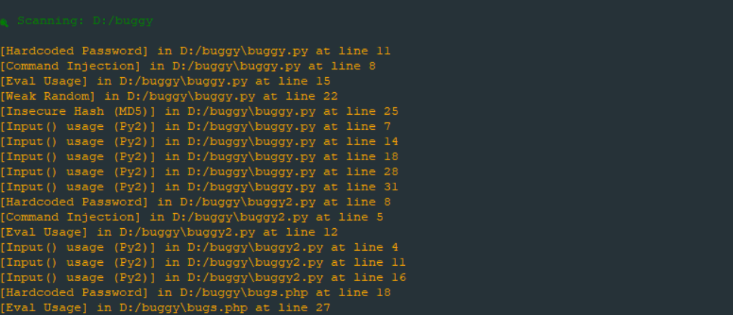

12. CONCLUSION

VurnVigil has proven to be an effective and versatile vulnerability scanning tool that combines automation, precision, and usability to enhance software security testing. By analyzing source code and configuration files, VurnVigil identifies critical bugs, security vulnerabilities, and code smells early in the development process, empowering developers and security analysts to fix issues before deployment.
The tool’s architecture, built around modular scanning engines and a flexible CLI interface, enables rapid scanning of individual files or projects, with comprehensive output that highlights issue severity, locations, and remediation advice. VurnVigil’s integration with environment variables and configuration files for token management ensures secure and adaptable operation across different environments. Automatic cleanup of temporary scan data preserves system resources and maintains performance.
Importantly, VurnVigil addresses a core challenge faced by many developers — the lack of accessible, easy-to-use vulnerability scanners that provide meaningful, actionable insights without overwhelming complexity. By delivering clear, categorized results directly in the terminal, it bridges the gap between raw vulnerability data and practical developer action, fostering a culture of proactive security awareness.
Through robust error handling, graceful handling of invalid inputs, and real-time feedback, VurnVigil has proven its reliability in diverse scenarios, from malformed files to interrupted scans. This stability, coupled with its extensibility, makes it a solid foundation for continuous improvement and integration into modern DevSecOps pipelines.
Overall, VurnVigil exemplifies how custom-built tools tailored to specific organizational needs can significantly strengthen security postures while streamlining developer workflows — a vital combination in today’s fast-paced software development landscape.

13. FUTURE SCOPE

The current implementation of VurnVigil establishes a strong foundation for vulnerability scanning; however, there exists considerable potential for further enhancement and expansion. Future developments could include extending the scanner’s capability to analyze entire project directories and supporting multiple programming languages to better accommodate complex, real-world applications. Introducing a plugin-based architecture would enable customization and scalability by allowing developers to add new scanning rules and modules, thereby aligning the tool with evolving coding standards and security requirements. Integration with widely-used integrated development environments (IDEs) such as Visual Studio Code and JetBrains would facilitate real-time vulnerability detection during code development, significantly reducing the turnaround time for identifying and resolving security issues. Improvements in reporting functionality, including the generation of detailed HTML, JSON, or PDF reports with comprehensive charts and summaries, would enhance communication with stakeholders and support regulatory compliance. Furthermore, automation of vulnerability scans within continuous integration and continuous deployment (CI/CD) pipelines using tools like Jenkins, GitHub Actions, or GitLab CI would enforce security policies consistently across development workflows, preventing insecure code from reaching production environments. The incorporation of artificial intelligence and machine learning techniques could provide automated remediation suggestions, accelerating the resolution of common security flaws. Integration with collaboration and notification platforms such as Slack, email, or Microsoft Teams would improve issue tracking and expedite team responses. Embedding compliance verification for established security standards including OWASP Top 10, CWE, PCI DSS, and GDPR would increase the tool’s applicability in regulated sectors. Additionally, expanding the scope beyond source code to include container images, Kubernetes configurations, and infrastructure-as-code files would position VurnVigil as a comprehensive security solution for modern DevOps practices. Developing an intuitive web or desktop dashboard would improve usability by facilitating easier issue navigation and historical trend analysis for security teams and management. Optimizations to ensure efficient performance when scanning large codebases would further enhance the tool’s practical utility. Finally, fostering a community-driven ecosystem through open contributions, plugin development, and shared rulesets would promote ongoing innovation, enabling VurnVigil to remain effective against emerging vulnerabilities and threats.

14. REFERENCES

S. Bairwa, B. Mewara, and J. Gajrani, “Vulnerability Scanners – A Proactive Approach to Assess Web Application Security,” International Journal on Computational Sciences & Applications (IJCSA), vol. 4, no. 1, pp. 113–122, Feb. 2014. [Online]. Available: https://arxiv.org/abs/1403.6955ResearchGate+1arXiv+1

A. Balwante, S. Sharma, and R. Sharma, “SecurityGUI: A Python-based Integrated Vulnerability Scanning Platform,” International Journal of Innovative Research in Computer and Technology (IJIRCT), vol. 2, no. 1, pp. 1–5, Jan. 2025. [Online]. Available: https://ijirct.org/papers/IJIRCT2201001.pdf

J. Tudela, A. M. Ortiz, and J. García, “On Combining Static, Dynamic and Interactive Analysis Security Testing Tools to Improve OWASP Top Ten Detection,” Applied Sciences, vol. 10, no. 24, p. 9119, Dec. 2020. [Online]. Available: https://www.mdpi.com/2076-3417/10/24/9119

M. Reimer, “Hybrid Approaches for Container and VM Vulnerability Scanning,” M.S. thesis, Dept. of Computer Science, University of Gothenburg, Gothenburg, Sweden, 2019. [Online]. Available: https://www.diva-portal.org/smash/get/diva2:1332851/FULLTEXT01.pdf

OpenText, “Fortify WebInspect,” OpenText Corporation. [Online]. Available: https://www.opentext.com/products/fortify-webinspectOpenText

K. Kuszczyński and M. Walkowski, “Comparative Analysis of Open-Source Tools for Conducting Static Code Analysis,” Sensors, vol. 21, no. 3, p. 987, Jan. 2021. [Online]. Available: https://www.mdpi.com/1424-8220/21/3/987

R. Mahmood and Q. H. Mahmoud, “Evaluation of Static Analysis Tools for Finding Vulnerabilities in Java Source Code,” International Journal of Computer Applications, vol. 180, no. 28, pp. 1–6, Jan. 2018. [Online]. Available: https://www.ijcaonline.org/archives/volume180/number28/mahmood-2018-ijca-917395.pdf

Z. D. Wadhams, C. Izurieta, and A. M. Reinhold, “Barriers to Using Static Application Security Testing (SAST) Tools: A Literature Review,” in Proceedings of the 39th IEEE/ACM International Conference on Automated Software Engineering Workshops (ASEW '24), 2024, pp. 161–166. [Online]. Available: https://doi.org/10.1145/3399776.3399783

M. Haug, A. C. F. Da Silva, and S. Wagner, “Towards Immediate Feedback for Security Relevant Code in Development Environments,” presented at the 16th Symposium and Summer School On Service-Oriented Computing, 2022. [Online]. Available: https://arxiv.org/abs/2201.12345

Mini Project Co-Ordinator Internal Guides

