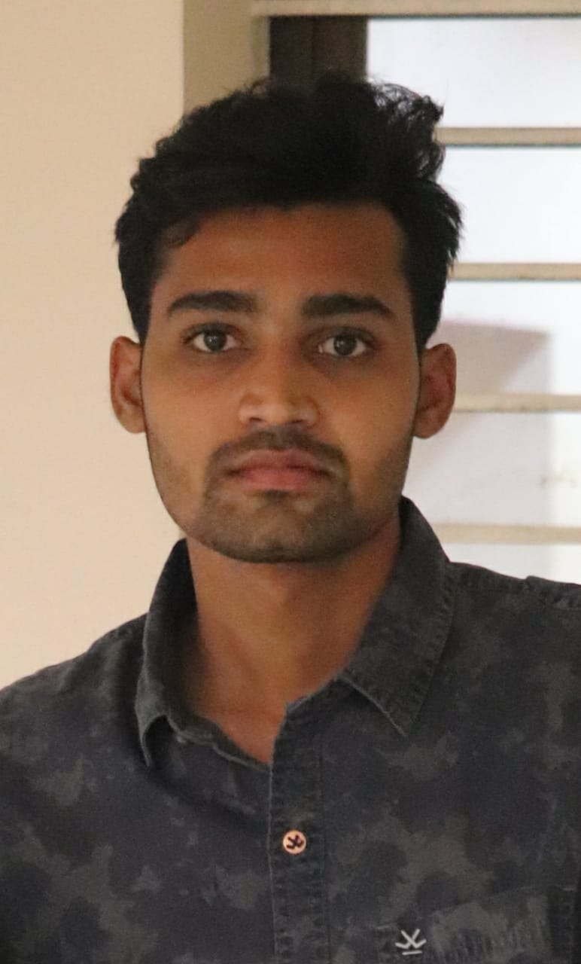

**Sandeep P**

**DIPLOMAS Y HOBBIES**

**Formaciones :** Diplomados, Congresos, xxxxxxxxxx xxxxxx xxxxxxxxx xxxxxxxxxxxxxxxxx

**Hobbies:** xxxxxxxxxxxxxxxxxxxxxxxxxxxxxx



**ABOUT ME**

**City:** Madanapalle

**Phone:** 9347678538

sandeepp1a0247@gmail.com

Detail-oriented individual with a BTech degree searching for a suitable role at an established IT organisation to utilise my knowledge and skills while contributing to the growth of the company.And I've trained in jspiders training Institute , Bangalore.

**EDUCATION**

Years  2017-2021

College*Aditya College of Engineering, Madanapalle*

Years  2015-2017

College *Siddartha Junior College, Madanapalle*

**LANGUAGES**

* Java
* Python (Entry-Level)
* MYSQL
* J2EE
* Eclipse IDE
* SQL (Basics)
* Html5
* CSS
* Web technology
* JavaScript
* SQL

**SKILLS**

**Quiz - Application**

Developing a quiz application that let users to login and find a quick set of questions to play around by answering them and get results.

**Tools & Languages**: Python and PyCharm

**Certified by Udemy – JAVA Course**

Spent 17.5Hrs of time to learn and grow skills in **Java** and certified by Udemy as a proof of learning.

2021

2021

**Extra-Curricular Activities**

English

Hindi

Telugu



**HOBBIES**

Badminton

Cricket

Socializing

