Steps to create project in JIRA tool

Step-1: create a project with scrum template

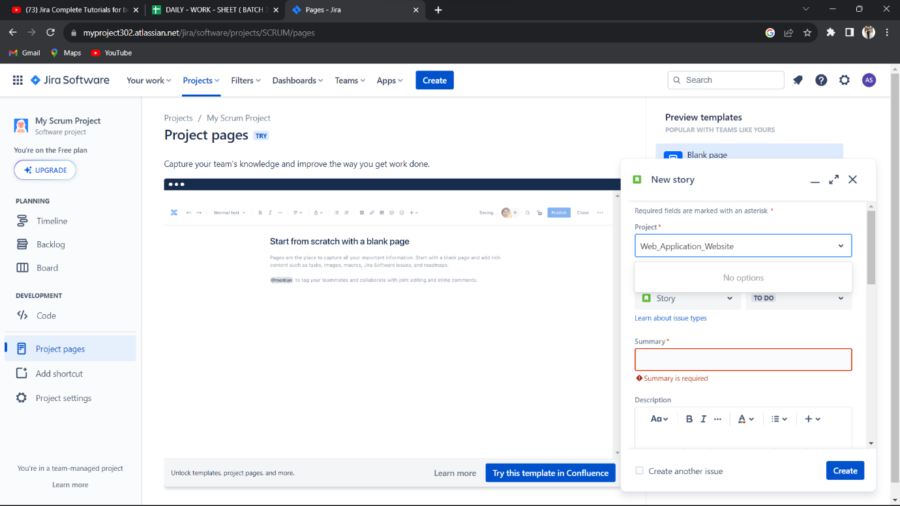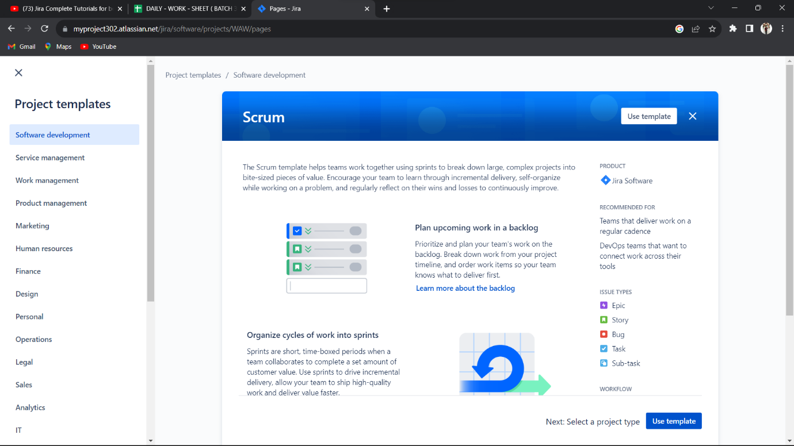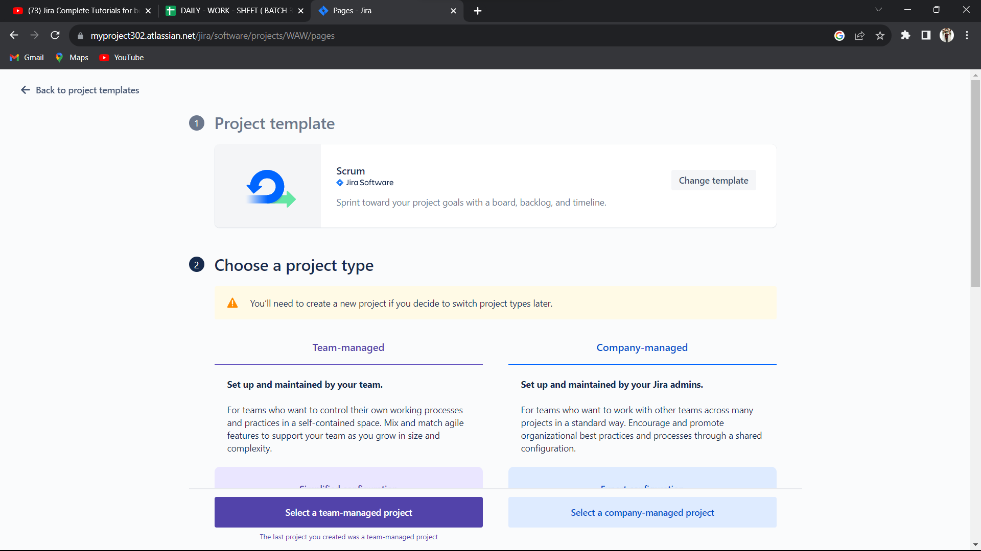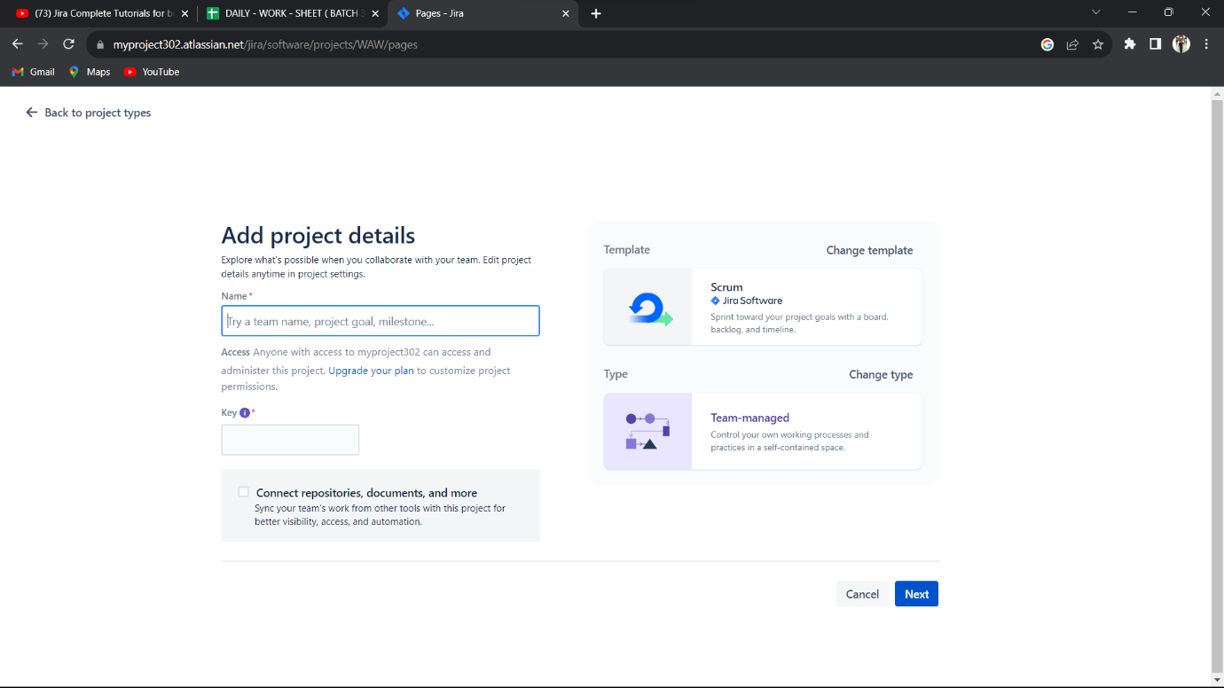

Step-2: create a sprint and add the story or Tasks

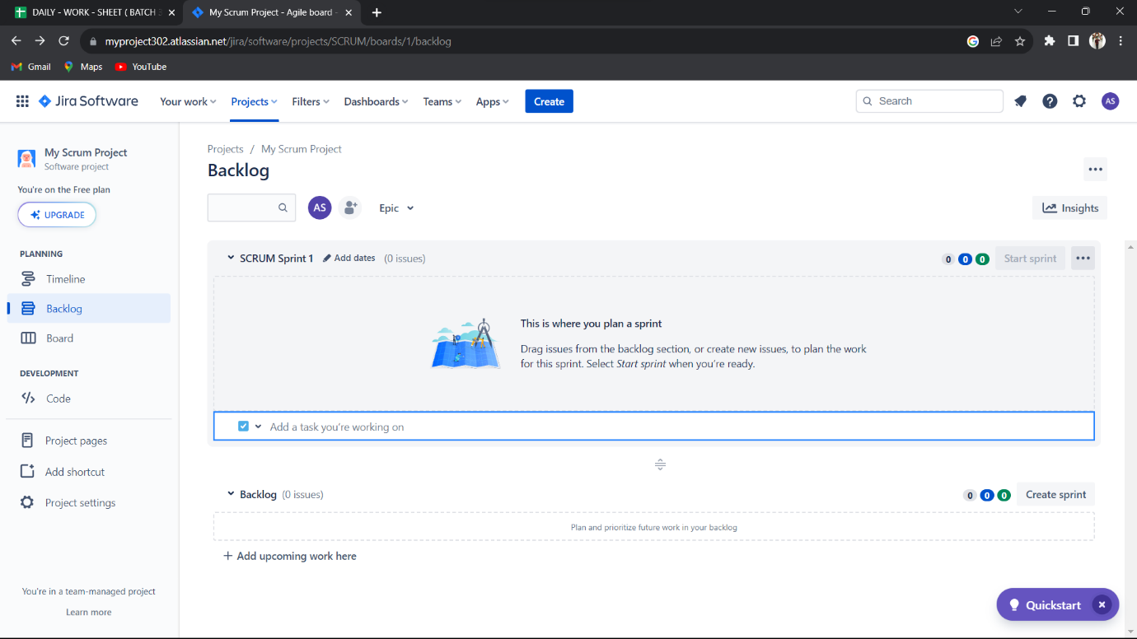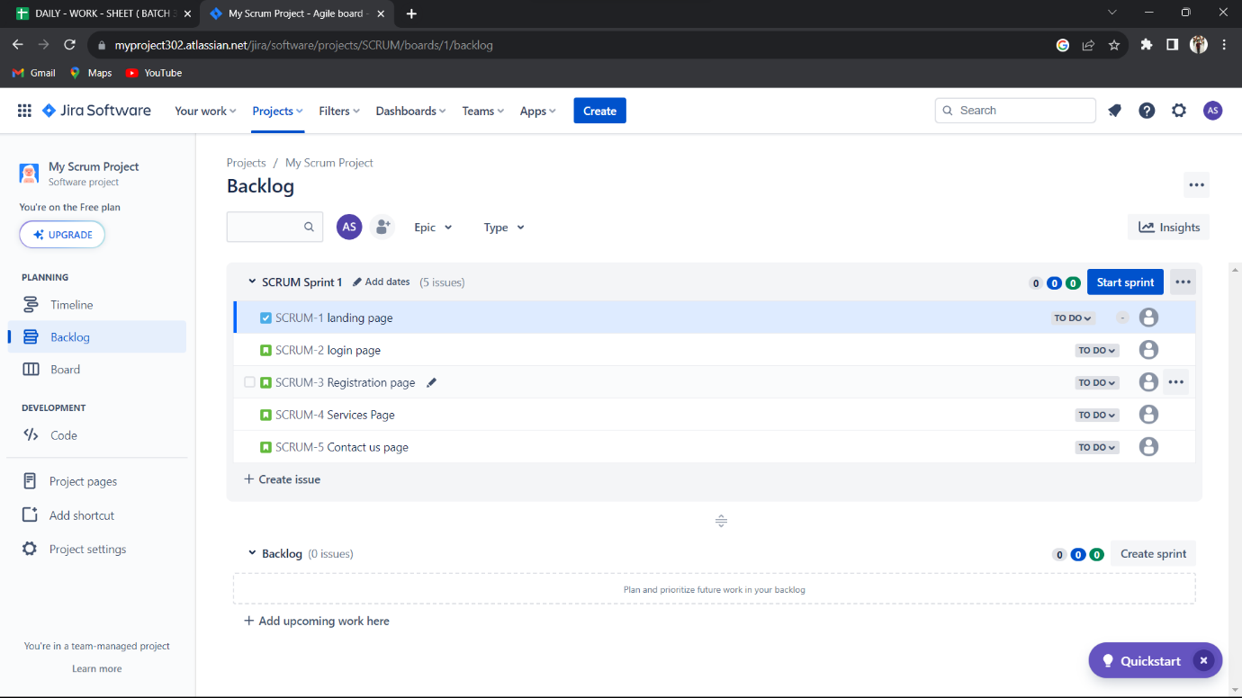

Step-3: Add people in the project

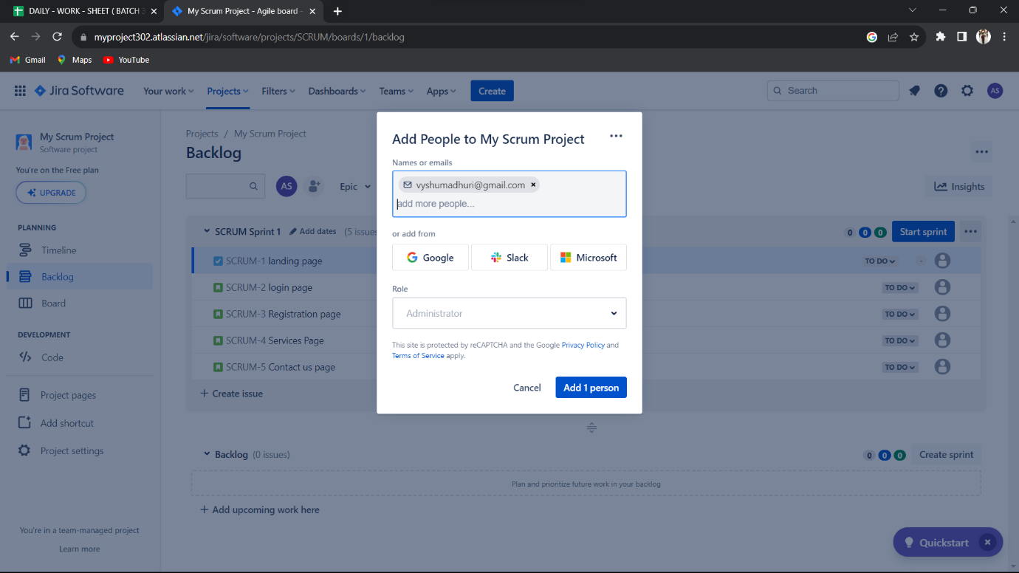

Step-4: edit workflow of the sprint

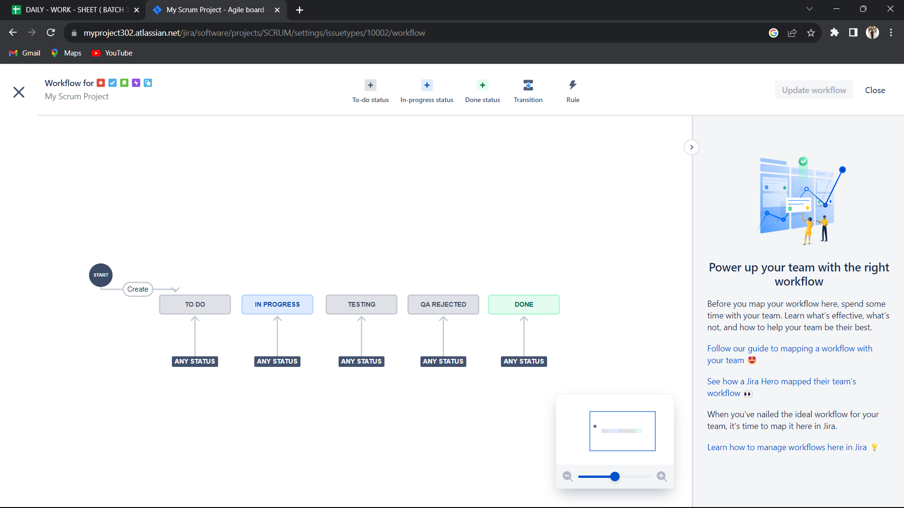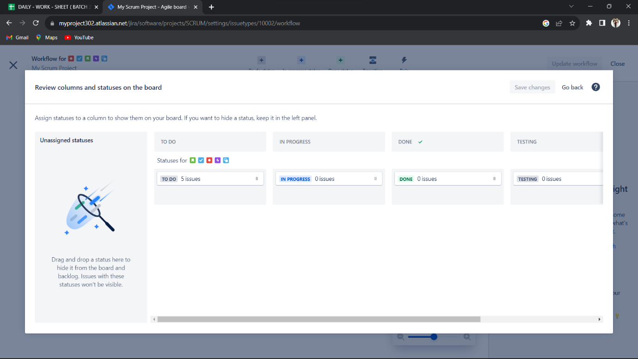

Step-5: Assign the task and Start the sprint

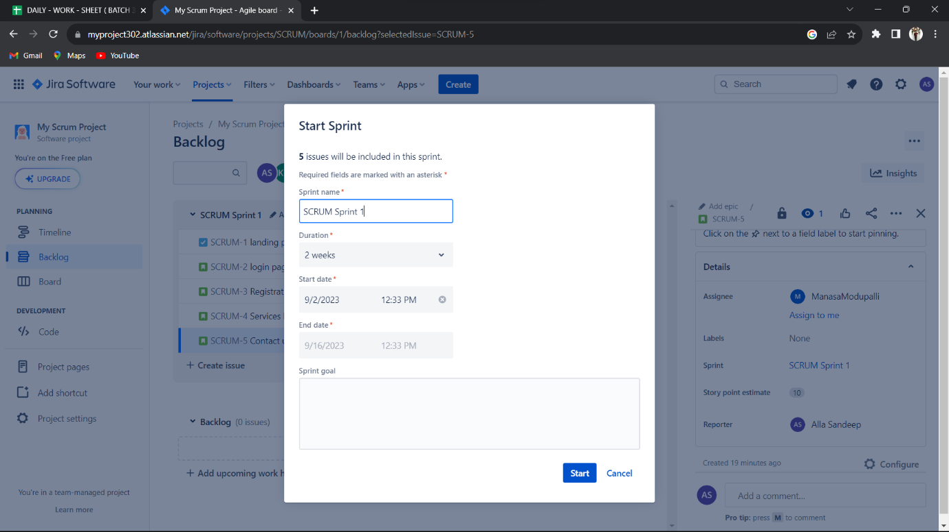

Step-6: Complete the sprint

* In first sprint two issues are in progress. These issues moves into another sprint means Sprint2

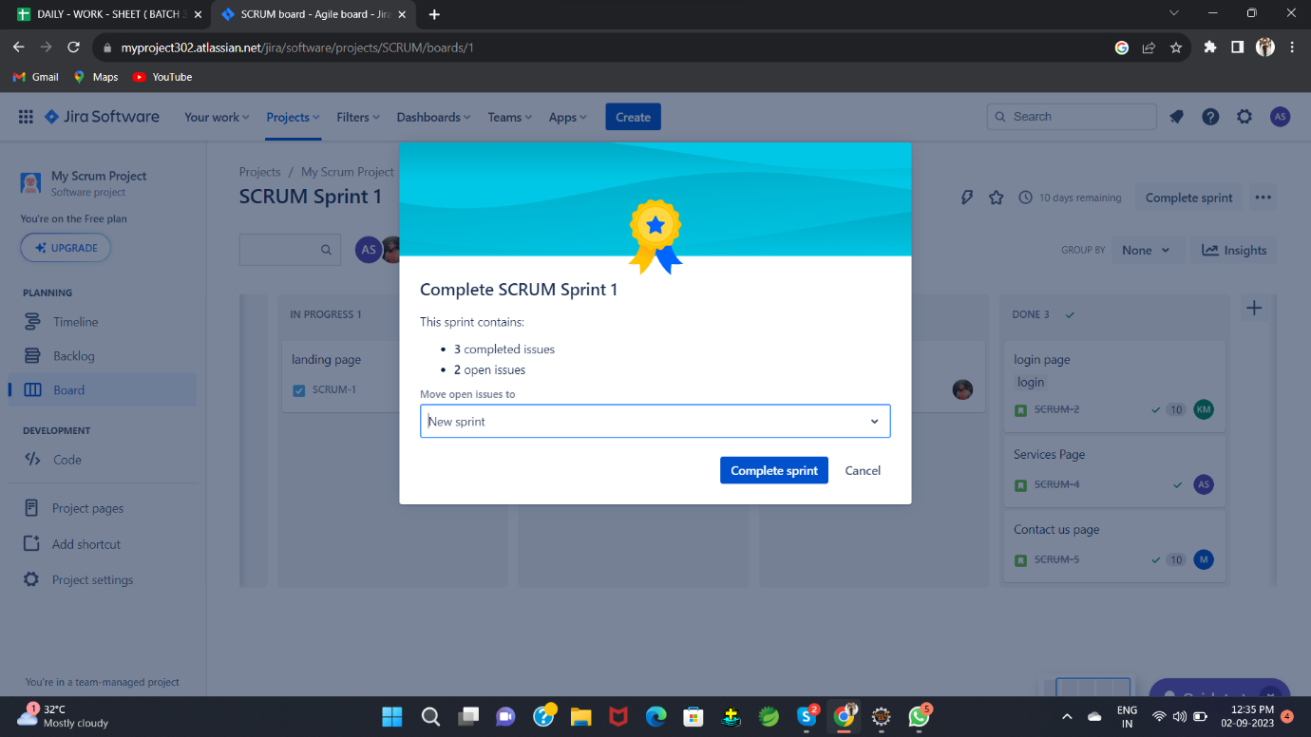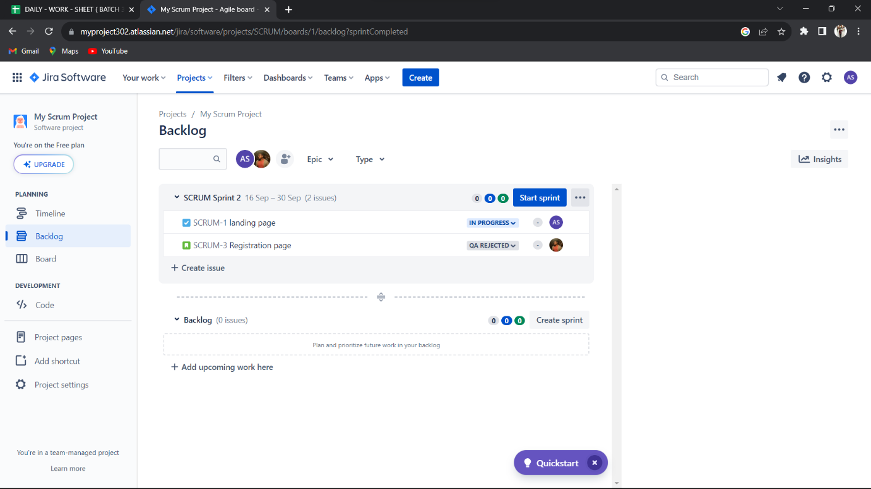

Step-7: Start the sprint and complete the sprint

In this we have two sprint. After completion of sprints the project will be completed.

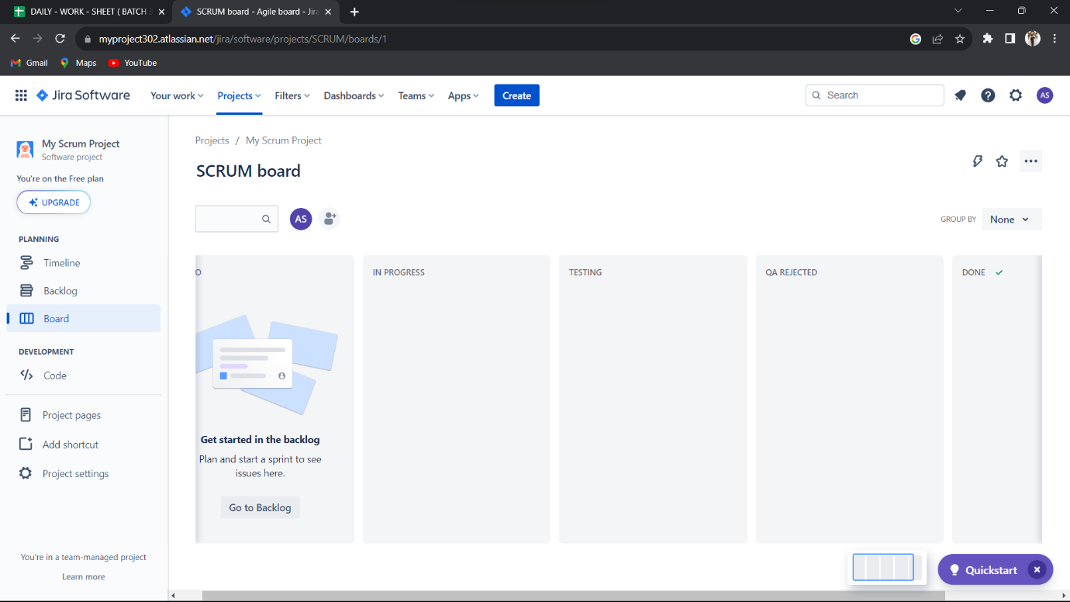

Conclusion:

Jira tool is very important in software industries to do the project more efficiently and time management purpose. We are taken requirements from the client (Project Owner), this project is designed under the scrum master. We are using scrum framework for this project and implemented project modules by team.