Title

Firstname Lastname1*, Firstname Lastname2 and Firstname Lastname2

1 Department, University/Institute, City, Country

2 Department, University/Institute, City, Country

**\* Corresponding Author’s email**: e-mail@e-mail.com

**Abstract:** A single paragraph of about 300 words maximum. Abstracts should give a pertinent overview of the work. Editorial board strongly encourages authors to use the following style of unstructured abstract without any subheadings. Preferably, the abstract should contain Background of the study (Place the questions addressed in a broad context and highlight the purpose of the study), Methods (briefly describe the main methods or treatments applied), Results (summarize the article’s main findings and Conclusions (indicate the main conclusions or interpretations). A line mentioning how your study aligns with the theme of the conference is recommended. The abstract should be an objective representation of the article and it must not contain results that are not presented and substantiated in the main text and should not exaggerate the main conclusions. Authors are advised to avoid equations/formula, abbreviations and references in the abstract.

**Keywords:** keyword 1; keyword 2; keyword 3 (List three to six pertinent keywords specific to the article yet reasonably common within the subject discipline.)

0. How to Use This Template

The template details the sections that can be used in a manuscript. Note that each section has a corresponding style, which can be found in the “Styles” menu of Word. Sections that are not mandatory are listed as such. The section titles given are for articles. Review papers and other article types have a more flexible structure.

**Remove this paragraph and start section numbering with 1**. For any questions, please contact the editorial office editorial.43inca@gmail.com.

1. Introduction

The introduction should briefly place the study in a broad context and highlight why it is important. It should define the purpose of the work and its significance. The current state of the research field should be carefully reviewed and key publications cited. Please highlight any scientific gaps pertaining to the field of this study and specify how your study will be useful to the scientific fraternity or further research. Finally, briefly mention the main objectives of the work. As far as possible, please keep the introduction comprehensible to readers outside your particular field of research. References should be in-text citation —e.g., (Smith, 2006) or (Guth et al., 2007) or (Geist & Lambin, 2002) or (Gupta, 2018; Faherty et al., 2020) or (Liu et al., 2021a; Liu et al., 2021b) or (Abhishire et al., 2018; Adams et al., 2018). See the end of the document for further details on references.

2. Materials and Methods

The section is intended to provide a description about study area (with subheading numbered 2.1), datasets/material (with subheading numbered 2.2, 2.2.1, etc.) and methodology (with appropriate subheading number). Outputs from the map compositions can used to depict the study area. Preferably, the figures should be of high quality (300 dpi) with all the map components like scale, north arrow, lables etc. Multiple figures can be clubbed as a single figure by designating with a separate labels - e.g., a, b, c, etc. at top left side of the image (refer to Figure 1). The Materials and Methods should be described with sufficient details to allow others to replicate and build on the published results. New methods and protocols should be described in detail while well-established methods can be briefly described and appropriately cited. It is recommended to include a flowchart diagram depicting the Methodology.

Research manuscripts reporting large datasets that are deposited in a publicly available database should specify where the data have been deposited and provide the relevant URL. – e.g., <https://github.com/github-linguist/linguist>

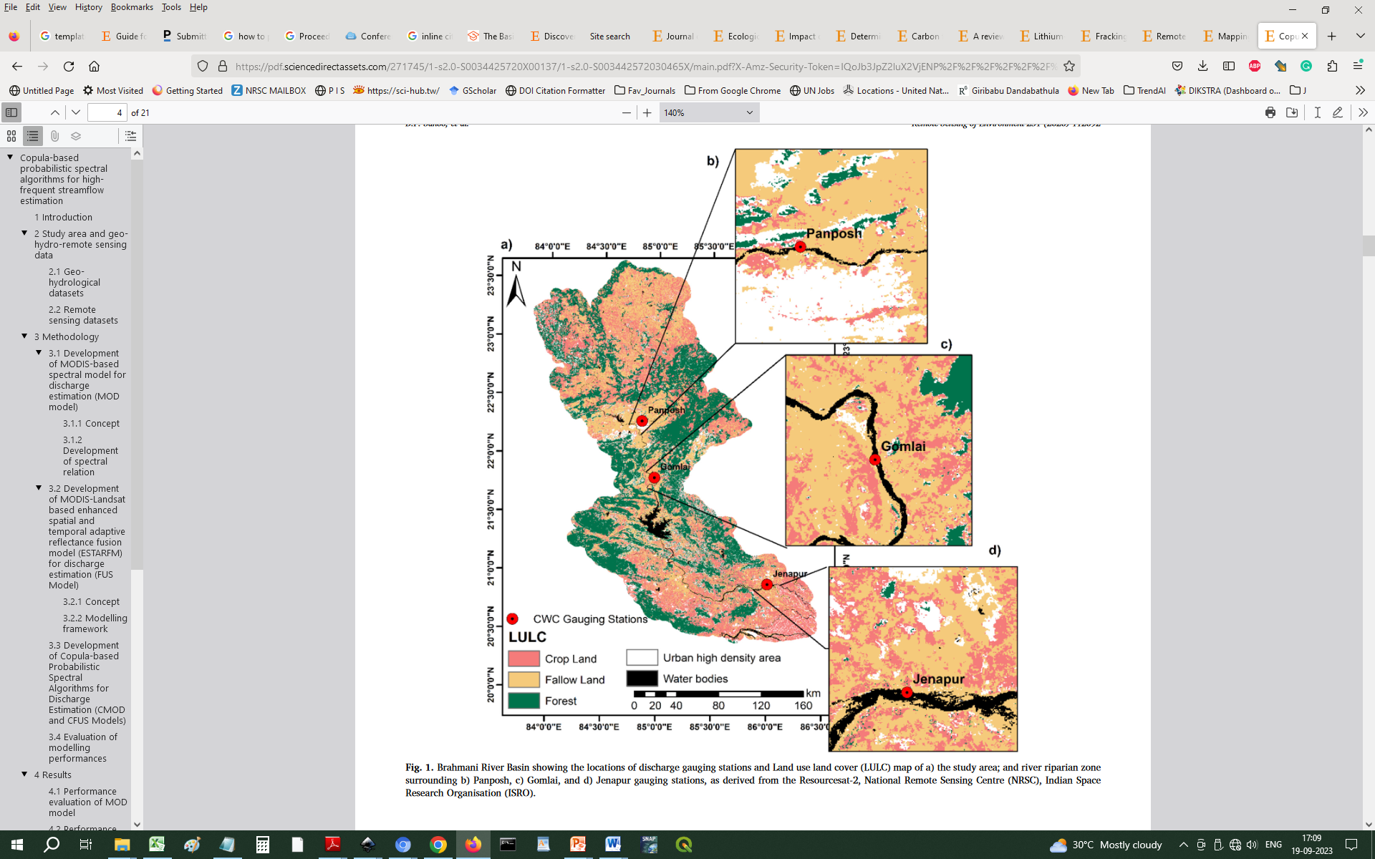

**Figure 1**. Brahmani River Basin showing the locations of discharge gauging stations and Land use land cover (LULC) map of a) the study area; and river riparian zone surrounding b) Panposh, c) Gomlai, and d) Jenapur gauging stations, as derived from the Resourcesat-2, National Remote Sensing Centre (NRSC), Indian Space Research Organisation (ISRO).

3. Results

This section may be divided by subheadings. It should provide a concise and precise description of the experimental results, their interpretation, as well as the experimental conclusions that can be drawn. *If needed ‘Discussion’ part can also come here under the section heading ‘Results and Discussions”.*

3.1. Subsection

3.1.1. Subsubsection

The text continues here.

3.2. Figures, Tables and Schemes

All figures and tables should be cited in the main text as Figure 1, Table 1, etc.

**Table 1.** This is a table. Tables should be placed in the main text near to the first time they are cited.

|  |  |  |
| --- | --- | --- |
| **Title 1** | **Title 2** | **Title 3** |
| entry 1 | data | data |
| entry 2 | data | data 1 |

1 Tables may have a footer.

The text continues here (Figure 2 and Table 1).

|  |  |
| --- | --- |
| C:\Users\martin\Downloads\testFigure.tif | C:\Users\martin\Downloads\testFigure.tif |
| (**a**) | (**b**) |

**Figure 2.** This is a figure. Schemes follow another format. If there are multiple panels, they should be listed as: (**a**) Description of what is contained in the first panel; (**b**) Description of what is contained in the second panel. Figures should be placed in the main text near to the first time they are cited.

3.3. Formatting of Mathematical Components

Please submit math equations as editable text and not as images. Present simple formulae in line with normal text where possible and use the solidus (/) instead of a horizontal line for small fractional terms, e.g., X/Y. In principle, variables are to be presented in italics. Powers of e are often more conveniently denoted by exp. Number consecutively any equations that have to be displayed separately from the text (if referred to explicitly in the text). This is example 1 of an equation:

|  |  |
| --- | --- |
| a = 1, | (1) |

4. Discussion

Authors should discuss the results and how they can be interpreted from the perspective of previous studies and of the working hypotheses. The findings and their implications should be discussed in the broadest context possible. Future research directions may also be highlighted.

5. Conclusions

Conclusions can be drawing and described here briefly along with scope for future studies. Also, how the study aligns with the theme of the conference can be mentioned.

Acknowledgements

Your research may have contributions from many people who have helped in some way to accomplish the task. This could be someone from a sponsoring institution, a funding body, other researchers, or even family, friends or colleagues who have helped in the preparation. This space can be used to mention the support provided by them.

References

References must be sorted alphabetically at the end of the manuscript.

Gautam, M. K., Tripathi, A. K., & Manhas, R. K. (2011). Assessment of critical loads in tropical sal (*Shorea robusta Gaertn. f.*) forests of Doon Valley Himalayas, India. Water, Air, & Soil Pollution, 218, 235-264. *(Example for Journal article)*

Hirt, C. (2016). Digital terrain models. In Encyclopedia of Geodesy. Springer, Berlin. *(Example for a Chapter in a Book)*

Merchant, C. (2020). The Anthropocene and the humanities: from climate change to a new age of sustainability. Yale University Press. *(example for a Book)*

Norman, X (1998) Advanced algorithm for discovering clusters in large spatial databases with noise. In Knowledge Discovery conference proceedings, 226-231, 02-04 January, Maryland, US. *(Example for an article in a conference proceedings)*

Sentinel-2 A/B. (2022). Copernicus Open Access Hub. https://scihub.copernicus.eu/Title of Site. (accessed on Day Month Year). *(Example for a website)*

Swamy, S. (2021). Enrichment of sustainability through flagship projects. Ph.D. Thesis. University of Toronto, Canada. *(Example for a thesis)*

UNICEF. (2022). The State of Food Security and Nutrition in the World. World Food Programme, Italy. *(Example for a technical report)*

**Disclaimer/Conference Note:** The statements, opinions and data contained in all publications are solely those of the individual author(s) and contributor(s) and not of INCA and/or the editor(s). The editor(s) disclaim responsibility for any injury to people or property resulting from any ideas, methods, instructions or products referred to in the content.