**Adaptive Image Contrast Enhancement Technique on CARTOSAT - 1 Stereo pair for DEM quality improvement**

**Y K Srivastava*, Arati Paul, VM Chowdary, A Jeyaram, Surajit Panda#**

*Regional Remote Sensing Centre - East, NRSC, ISRO, Kolkata*

*# Jharkhand Space Application Center (JSAC), Ranchi*

***[*email: srivastava_yk@yahoo.com]***

# Abstract

*Advancement in the acquisition of satellite images in stereo mode has added new dimension in generating DEM (Digital Elevation Model) and ortho-rectified images that helps in improved mapping. One of the most important factor that effects DEM quality is the image contrast of the stereo pair. Simple Histogram Equalization (HE) or Linear Stretch methods are effective, which improves the interpretability or perception of information for visual interpretation, or automated image processing. However, these methods are generally incapable of providing satisfactory enhancement on stereo pair as they act globally rather than locally causing over or under enhancement on certain regions in the image. -----------------------------------------------------------------------------------------------------------------------*

***Key words****: DEM, Histogram, enhancement, ortho-rectified, sun-synchronous, panchromatic*

**Introduction**

DEMs (Digital Elevation Model) are used in many cartographic and GIS applications (*Krishna Murthy et el., 2008).* Indian Space Research Organization (ISRO) realized the importance of DEMs and launched CARTOSAT-1 satellite into circular (altitude is 618 km) near-polar sun-synchronous orbit on May 5, 2005. CARTOSAT-1 is equipped with two panchromatic cameras capable of simultaneous acquisition of images of 2.5 meters spatial resolution. ----------------------------------------------------------------------------------------.

**Study Area**

Description about the study area

**Materials & Methods**

Satellite Data Used: Two Stereo pairs of CARTOSAT 1 covering high mountainous terrain of Sikkim State and moderate undulating terrain of Jharkhand State were considered for the present study. The details of satellite data along with their date of acquisition are given in the Table 1. ----

Methodology: Stereo pairs that are taken for this study have comparatively low contrast. CLAHE image enhancement technique is used for the enhancement of stereo pairs. The main advantages of the CLAHE transformation are its modest computational requirements, ease of use and excellent results on most of the images. This process allows ----------------------.

**Results and Discussion**

CLAHE based enhanced images appear to have 'better clarity' as compared to the images enhanced using Standard Deviation (SD) and Histogram Equalization (HE) algorithms (Figures 2a-d).

**Conclusions**

Concluding remarks by the author

**References**

1. Van der Geer, J., Hanraads, J. A. J., & Lupton, R. A. (2010). The art of writing a scientific article. *Journal of Scientific Communications, 163*, 51–59. https://doi.org/10.1016/j.sc.2010.00372.

2. Van der Geer, J., Hanraads, J. A. J., & Lupton, R. A. (2018). The art of writing a scientific article. *Heliyon*, *19*, Article e00205. <https://doi.org/10.1016/j.heliyon.2018.e00205>.

3. Strunk, W., Jr., & White, E. B. (2000). *The elements of style* (4th ed.). Longman (Chapter 4).

**Table 1**. Details of CARTOSAT 1 stereo pair used with present study

|  |  |  |  |  |
| --- | --- | --- | --- | --- |
| **Sl**  **No.** | **Path** | **Row** | **Date of Pass** | **Area of Interest** |
| 1 |  |  |  |  |
| 2 |  |  |  |  |

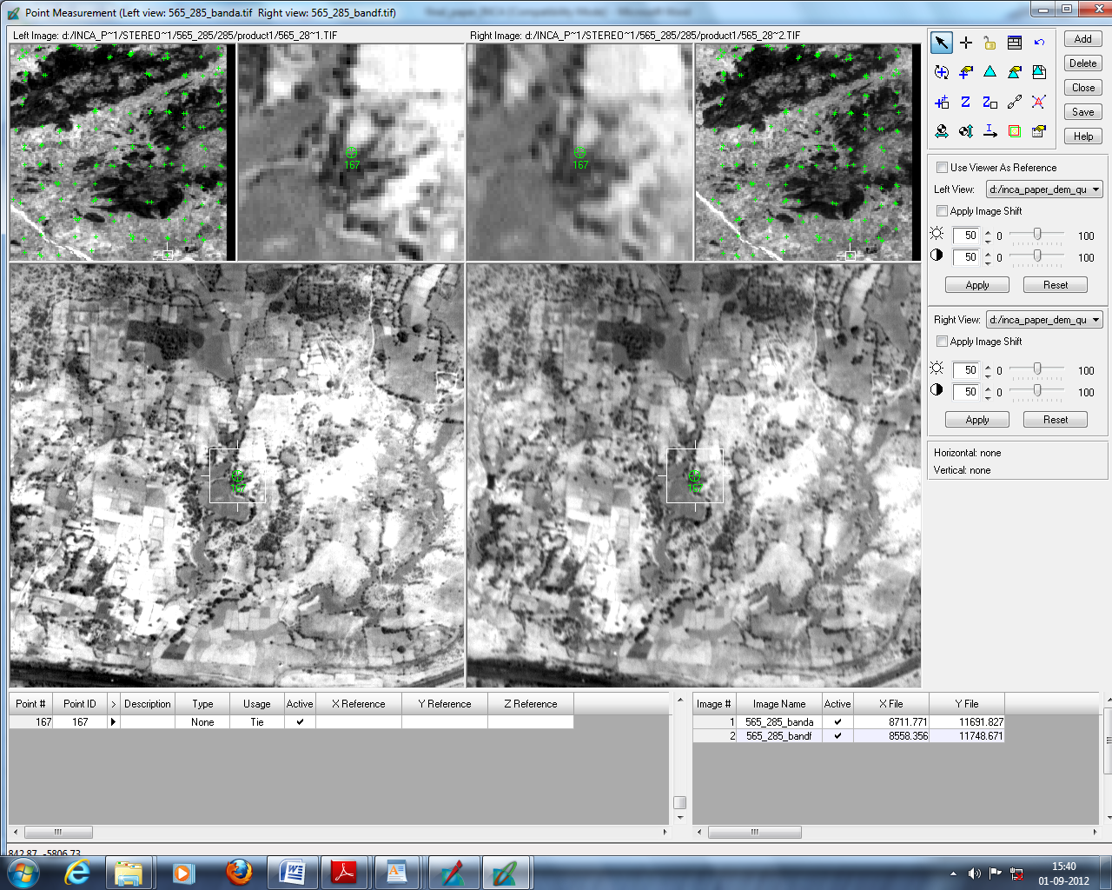

**Fig.1** Auto tie points distribution without enhancement (BAND A of 565-285)