## A REPORT OF SEMESTER INDUSTRIAL TRAINING

AT

HOPING MINDS

SUBMITTED IN PARTIAL FULFILLMENT OF THE REQUIREMENT FOR THE AWARD

OF THE DEGREE OF

## BACHELOR OF TECHNOLOGY

(Software Engineering)



JANUARY,2024 - MAY,2024

## SUBMITTED BY:

NAME: SANDEEP KUMAR UNIVERSITY ROLL NO: 2022915

DEPARTMENT OF COMPUTER SCIENCE AND ENGINEERING

I.K. GUJRAL PUNJAB TECHNICAL UNIVERSITY

**CERTIFICATE**

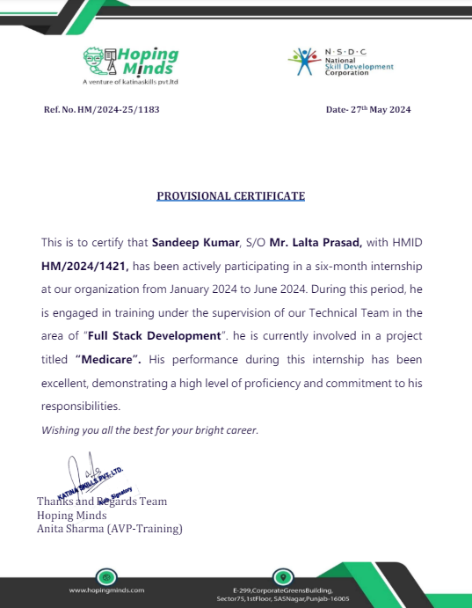

**CANDIDATE'S DECLARATION**

I “SANDEEP KUMAR’’ hereby declare that I have undertaken semester industrial training at “**HOPING MINDS**” during a period from FEB 2023 to JUNE 2023 in partial fulfillment of requirements for the award of degree of B.Tech (Computer Science and Engineering) at I.K.GUJRAL PUNJAB TECHNICAL UNIVERSITY**,** KAPURTHALA. The work which is

being presented in the training report submitted to Department of Computer Science and Engineering at I.K. GUJRAL PUNJAB TECHNICAL UNIVERSITY**,** KAPURTHALA is an

authentic record of training work.

Signature of the Student

The semester industrial training Viva–Voce Examination of has been held on and accepted.

Signature of Internal Examiner Signature of External Examiner

# ABSTRACT

The Doctor Appointment System is an innovative web-based solution designed to streamline and enhance the process of scheduling appointments between doctors and patients. This system aims to alleviate the administrative burdens associated with traditional appointment scheduling methods, offering a more efficient and user-friendly alternative. The core functionalities of the system include user registration and authentication, real-time availability management, appointment booking, rescheduling, and cancellation. Additionally, the system integrates an automated notification service that sends reminders to patients regarding their upcoming appointments, thereby reducing no-showates.

The project leverages modern web technologies, including a Reactjs, bootstrap frontend for a responsive and intuitive user interface, and a backend coupled with Express.js typescript prisma to handle server-side operations and API endpoints. Postgres is employed as the database management system to store and manage user data, appointments, and other relevant information. The system's architecture ensures scalability, security, and reliability, making it suitable for deployment in various healthcare settings. The development process involved comprehensive requirement analysis, meticulous system design, and thorough testing to ensure robustness and usability. Key challenges addressed during the development included ensuring data security and privacy, optimizing database performance, and creating a seamless user experience. The Doctor Appointment System not only simplifies the appointment scheduling process but also enhances patient satisfaction and operational efficiency in health

**Acknowledgement**

The Training opportunity I had with **Hoping Minds** was a great chance for learning and professional development. Therefore, I consider myself as a very lucky individual as I was provided with an opportunity to be a part of it. I am also grateful for having a chance to meet so many wonderful people and professionals who led me through this training period. Bearing in mind previous I am using this opportunity to express my deepest gratitude and special thanks to the founding Director and developers of excellence technology who in spite of being extraordinarily busy with his duties, took time out to hear, guide and keep me on the correct path and allowing me to carry out my project at their esteemed organization. I perceive this opportunity as a big milestone in my career development. I will strive to use my gained skills and knowledge in the best possible way, Hope to continue cooperation with all of you in the future.

Sincerely,

Sandeep Kumar

# TABLE OF CONTENT

|  |  |
| --- | --- |
| **Chapters** | **Topic** |
|  | Certificate |
|  | Candidate ‘s Declaration |
|  | Abstract |
|  | Acknowledgement |
|  | Table of Content |
|  | List of Tables |
|  | List of Figures |
| **1** | **INTRODUCTION** |
| **2** | **FIELD OF TRAINING** |
|  | **HTML** |
|  | CSS |
|  | BOOTSTRAP |
|  | JAVASCRIPT |
|  | REACTJS |
|  | POSTGRES |
|  | EXPRESS |
|  | Hardware and Software Requirements |
| **3** | **TRAINING WORK UNDERTAKEN** |
|  | Existing System |
|  | Proposed System |
|  | Feasibility Study | |

|  |  |
| --- | --- |
| **4** | **RESULT AND DISSCUSSION** |
|  | Program Coding |
| **5** | **CONCLUSION AND FUTURE SCOPE** |
| **6** | **REFERENCE** |

**LIST OF TABLES**

|  |  |
| --- | --- |
| **Table No.** | **Table Description** |
| 4.18 | APPOINTMENTS |
| 4.19 | AUTH |
| 4.20 | DOCTOR |
| 4.21 | DOCTOR TIME SLOT |
| 4.22 | FORGET PASSWORD |
| 4.23 | PAYMENT |
| 4.24 | SCHEDULE DAY |

**LIST OF FIGURES**

|  |  |
| --- | --- |
| **Figure No.** | **Figure Description** |
| 2.1 | HTML |
| 2.2 | CSS |
| 2.3 | JAVASCRIPT |
| 2.4 | BOOTSTRAP |
| 2.5 | REACT |
| 2.6 | NODEJS |
| 2.7 | POSTGRES |
| 2.8 | TYPESCRIPT |
| 2.9 | PRISMA |
| 3.0 | EXPRESS |
| 3.1 | HOME PAGE |
| 3.2 | ABOUT |
| 3.3 | SERVICES |
| 3.4 | DOCTORS |
| 3.5 | CONTACT |
| 3.6 | LOGIN |
| 3.7 | SIGNUP |
| 4.1 | APPOINTMENT |
| 4.2 | TRACK APPOINTMENT |
| 4.3 | DOCTOR DASHBOARD |
| 4.5 | PATIENT DASHBOARD |

|  |  |
| --- | --- |
| 4.6 | POSTGRES |

**LIST OF Abbreviations**

|  |  |
| --- | --- |
| DOM | Document Object Model. |
| W3C | World Wide Web Consortium. |
| ISO | International Organization for Standardization. |
| NPM | Node Package Manager. |
| API | Application Program Interface. |
| HTML | Hypertext Markup Language. |
| HTTP | Hypertext Transfer Protocol. |
| URL | Uniform Resource Locator. |
| JS | JavaScript. |
| JSON | Javascript Object Notation. |
| XML | Extensive Markup Language. |
| JSX | Javascript XML |
| TS | Typescript |
| API | Application Program interface |

**Chapter-1 Introduction**

The rapid advancements in technology have significantly transformed various sectors, including healthcare. One such transformative innovation is the development of an online doctor appointment system. This project aims to The online doctor appointment system is a comprehensive web-based application that allows patients to register, log in, and book appointment streamline the process of scheduling medical appointments by providing patients with a convenient, user-friendly, and efficient platform to book appointments with healthcare providers. The system is designed to address common challenges faced by patients and medical staff, such as long waiting times, scheduling conflicts, and the cumbersome nature of traditional appointment booking methods. The online doctor appointment system is a comprehensive web-based application that allows patients to register, log in, and book appointments with their preferred doctors. The system is built to ensure a seamless and hassle-free experience for users, from the initial sign-up process to the confirmation of their appointments. After logging in, patients are greeted with a dashboard that provides an overview of their upcoming appointments, past medical visits, and any notifications or messages from their healthcare providers. T One of the core features of the online doctor appointment system is the ability to search for doctors based on various criteria, such as specialization, After submitting the appointment request, patients receive a confirmation email or SMS with the details of their appointment, including the date, time. he development of this project involves a multi-tier architecture, with a front-end built using modern web technologies like HTML, CSS, and JavaScript, and a back-end powered by Node.js and Express.js. The database is managed using PostgreSQL, a powerful and reliable relational database system that ensures efficient data storage and retrieval. Prisma ORM is used to facilitate seamless interaction between the application and the database, providing a type-safe and intuitive query experience.

**CHAPTER - 2 FIELDS OF TRAINING**

## FRONT END

**HTML** (Hyper Text Markup Language) is the code that is used to structure a web page and its content. For example, content could be structured within a set of paragraphs, a list of bulleted points, or using images and data tables. As the title suggests, this article will give you a basic understanding of HTML and its functions.

HTML is a Mark language that defines the structure of your content. HTML consists of a series of elements, which you use to enclose, or wrap, different parts of the content to make it appear a certain way, or act a certain way. The enclosing tags can make a word or image hyperlink to somewhere else, can italicize words, can make the font bigger or smaller, and so on.



FIGURE 2.1 HTML

The main parts of our element are as follows:

1. The opening tag: This consists of the name of the element (in this case, p), wrapped in opening and closing angle brackets. This states where the element begins or starts to take effect — in this case where the paragraph begins.
2. The closing tag: This is the same as the opening tag, except that it includes a forward slash before the element name. This states where the element ends — in this case where the paragraph ends. Failing to add a closing tag is one of the standard beginner errors and can lead to strange results.
3. The content: This is the content of the element, which in this case, is just text.
4. The element: The opening tag, the closing tag, and the content together comprise the element.

**CSS** stands for Cascading Style Sheets. It is a style sheet language which is used to describe the look and formatting of a document written in markup language. It provides an additional feature to HTML. It is generally used with HTML to change the style of web pages and user interfaces. It can also be used with any kind of XML documents including plain XML, SVG and XUL.

CSS is used along with HTML and JavaScript in most websites to create user interfaces for web applications and user interfaces for many mobile applications.



FIGURE 2.2 CSS

There are three types of CSS which are given below:

* Inline CSS
* Internal or Embedded CSS
* External CSS

**Inline CSS:** Inline CSS contains the CSS property in the body section attached with element is known as inline CSS. This kind of style is specified within an HTML tag using the style attribute. **Internal or Embedded CSS:** This can be used when a single HTML document must be styled uniquely. The CSS rule set should be within the HTML file in the head section i.e the CSS is embedded within the HTML file.

**External CSS:** External CSS contains separate CSS file which contains only style property with the help of tag attributes (For example class, id, heading, … etc). CSS property written in a separate file with .css extension and should be linked to the HTML document using link tag. This means that for each element, style can be set only once and that will be applied across web pages.

**Bootstrap** is a free and open-source CSS framework directed at responsive, mobile-first front-end web development. It contains HTML, CSS and (optionally) JavaScript-based design templates for typography, forms, buttons, navigation, and other interface components.

Bootstrap is an HTML, CSS and JS library that focuses on simplifying the development of informative web pages (as opposed to web applications). The primary purpose of adding it to a web project is to apply Bootstrap's choices of color, size, font and layout to that project. As such, the primary factor is whether the developers in charge find those choices to their liking. Once added to a project, Bootstrap provides basic style definitions for all HTML elements.



FIGURE 2.4 BOOTSTRAP

The result is a uniform appearance for prose, tables and form elements across web browsers. In addition, developers can take advantage of CSS classes defined in Bootstrap to further customize the appearance of their contents. For example, Bootstrap has provisioned for light- and dark-

**JavaScript (JS)** is the most popular lightweight, interpreted compiled programming language. It can be used for both Client-side as well as Server-side developments. JavaScript also known as a scripting language for web pages. JavaScript is used by many developers (65% of the total development community), and the number is increasing day by day. JavaScript is one such programming language that has more than 1444231 libraries and increasing rapidly.

It is preferred over any other programming language by most developers. Also, major tech companies like Microsoft, Uber, Google, Netflix, and Meta use JavaScript in their projects.

JavaScript can be added to your HTML file in two ways:

* Internal JavaScript
* External JavaScript

**Internal JavaScript**: We can add JS code directly to our HTML file by writing the code inside the <script> & </script>. The <script> tag can either be placed inside the <head> or the <body> tag according to the requirement.

**External JavaScript:** We can create the file with a .js extension and paste the JS code inside of it. After creating the file, add this file in <script src=”file_name.js”> tag, and this <sctipt> can import inside <head> or <body> tag of the HTML file.



### JavaScript Used for :

FIGURE 2.3 JAVASCRIPT

It is mainly used to develop websites and web-based applications. JavaScript is a language that can be used as a front-end as well as a backend.

* Creating Interactive Websites: JavaScript is used to make web pages dynamic and interactive. It means using JavaScript, we can change the web page content and styles dynamically.
* Building Applications: JavaScript is used to make web and mobile applications. To build web and mobile apps, we can use the most popular JavaScript frameworks like – ReactJS, React Native, Node.js etc.
* Web Servers: We can make robust server applications using JavaScript. To be precise we use JavaScript frameworks like Node.js and Express.js to build these servers. • Game

Development: JavaSCript can be used to design Browser games. In JavaScript, lots of game engines are available that provide frameworks for building games.

## React JS

React is a declarative, efficient, and flexible JavaScript library for building user interfaces. It is an open-source, component-based front-end library that is responsible only for the view layer of the application. ReactJS is not a framework, it is just a library developed by Facebook to solve some problems that we were facing earlier.



## BACKEND

**Node.js** uses asynchronous programming!

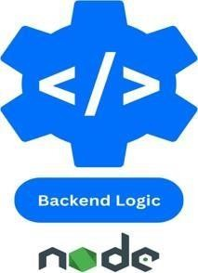

FIGURE 2.6 NODE JS

### Here is how Node.js handles a file request:

1. Sends the task to the computer's file system.
2. Ready to handle the next request.
3. When the file system has opened and read the file, the server returns the content to the client.

Node.js eliminates the waiting, and simply continues with the next request. Node.js runs single- threaded, non-blocking, asynchronous programming, which is very memory efficient.

**POSTGRES:**

Booking an appointment at [Your Clinic Name] is quick and easy with our online booking system, backed by a robust PostgreSQL database. This ensures your appointment details are stored securely and efficiently. Simply choose your desired service, select a doctor, and pick a convenient time slot. You can also call us at [Your Phone Number] for assistance. Our team of experienced doctors is ready to provide you with personalized, high-quality care. Schedule your appointment today and experience the convenience of a seamless, secure booking process!

A common task for a web server can be to open a file on the server and return the content to the PostgreSQL is renowned for its stability and reliability, making it an ideal choice for handling critical healthcare data. Its robust architecture ensures that data is consistently stored and retrieved without corruption. PostgreSQL offers advanced security features, including robust authentication methods, SSL encryption, and granular access control. This ensures that sensitive patient information is protected against unauthorized access..PostgreSQL can efficiently handle large volumes of data and high transaction loads, ensuring smooth performance even as our patient database grows. Its ability to scale horizontally and vertically makes it suitable for expanding healthcare needs. Support for Complex Queries: Functionality: With powerful query optimization and support for complex SQL queries, PostgreSQL enables efficient data retrieval and reporting. This is crucial for generating detailed patient records, appointment schedules, and medical reports. PostgreSQL’s extensible nature allows us to customize the database with additional modules and extensions tailored to our specific needs



FIGURE 2.7 POSTGRES

### Tools

The Postman platform includes a comprehensive set of tools that help accelerate the API lifecycle—from design, testing, documentation, and mocking to the sharing and discoverability of your APIs

The Postman API client is the foundational tool of Postman, and it enables you to easily explore, debug, and test your APIs while also enabling you to define complex API requests for HTTP, REST, SOAP, GraphQL, and WebSockets.

You can design your API specifications in Postman using OpenAPI, RAML, GraphQL, or SOAP formats. Postman's schema editor makes it easy to work with specification files of any size, and it validates specifications with a built-in linting engine

**EXPRESS**

Express is a fast, assertive, essential and moderate web framework of Node.js. You can assume express as a layer built on the top of the Node.js that helps manage a server and routes. It provides a robust set of features to develop web and mobile applications.

Let's see some of the core features of Express framework:

* + - It can be used to design single-page, multi-page and hybrid web applications.
    - It allows to setup middlewares to respond to HTTP Requests.
    - It defines a routing table which is used to perform different actions based on HTTP method and URL.
    - It allows to dynamically render HTML Pages based on passing arguments to templates.

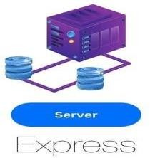

FIGURE 2.8 EXPRESS

**TYPESCRIPT:**

TypeScript is a statically typed superset of JavaScript, developed and maintained by Microsoft. It adds static types to JavaScript, enabling developers to catch errors during development rather than at runtime. TypeScript is designed for the development of large applications and transcompiles to JavaScript.

TypeScript introduces static typing to JavaScript, meaning you can define variable types (e.g., string, number, boolean). This allows the compiler to catch type errors during development. TypeScript is widely used in modern web development, especially for large-scale applications. It is the preferred language for many popular frameworks, such as Angular, and is increasingly used in React and Vue.js projects. Its ability to catch errors early, combined with powerful tooling and strong community support, makes it an excellent choice for developers looking to build robust, maintainable applications. TypeScript has a large and active community, with extensive resources, tutorials, and third-party libraries available. TypeScript has a large and active community, with extensive resources, tutorials, and third-party libraries available. Many popular frameworks and libraries, such as Angular and React, offer first-class TypeScript support, making it easier to use TypeScript in modern web development.

TypeScript offers excellent integration with popular IDEs, providing features like autocompletion, refactoring 

**PRISMA:**

Prisma is an open-source next-generation ORM (Object-Relational Mapping) tool for Node.js and TypeScript. It simplifies database management by providing a type-safe and intuitive API for database access, making it easier to interact with relational databases such as PostgreSQL, MySQL, SQLite, and SQL Server. A modern database toolkit for Node.js and TypeScript, used for database access and management. Prisma provides a modern and efficient way to handle database interactions in Node.js and TypeScript applications. Its emphasis on type safety, productivity, and consistency makes it a valuable tool for developers looking to build robust and maintainable backend systems. Prisma is particularly useful in modern backend development, where the combination of a type-safe ORM and powerful database migration tools can significantly streamline the development process. It is used in a variety of applications, from simple APIs to complex microservices architectures. 

**HARDWARE AND SOFTWARE REQUIRED:**

### Hardware :

|  |  |
| --- | --- |
| OS : | Windows/Linux/MacOS |
| Processor : | Minimum i3 or any above |
| Memory : | Minimum 8GB or any above |
| Storage : | Minimum 256 GB SSD/HDD or any above |
| CPU Cores : | 2 CPU Cores |

**Software :**

1. Visual Studio Code or Any Text Editor
2. Web Browser (Chrome/Firefox/Microsoft Edge)

# CHAPTER-4 RESULT AND DISCUSSION

# HOME PAGE

## ­­

FIGURE 3.1 Home page

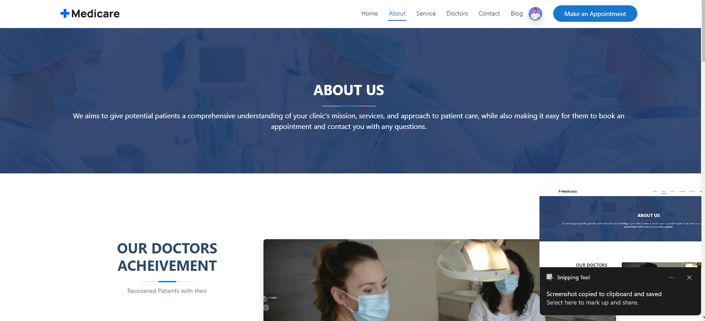

FIGURE 3.2 About

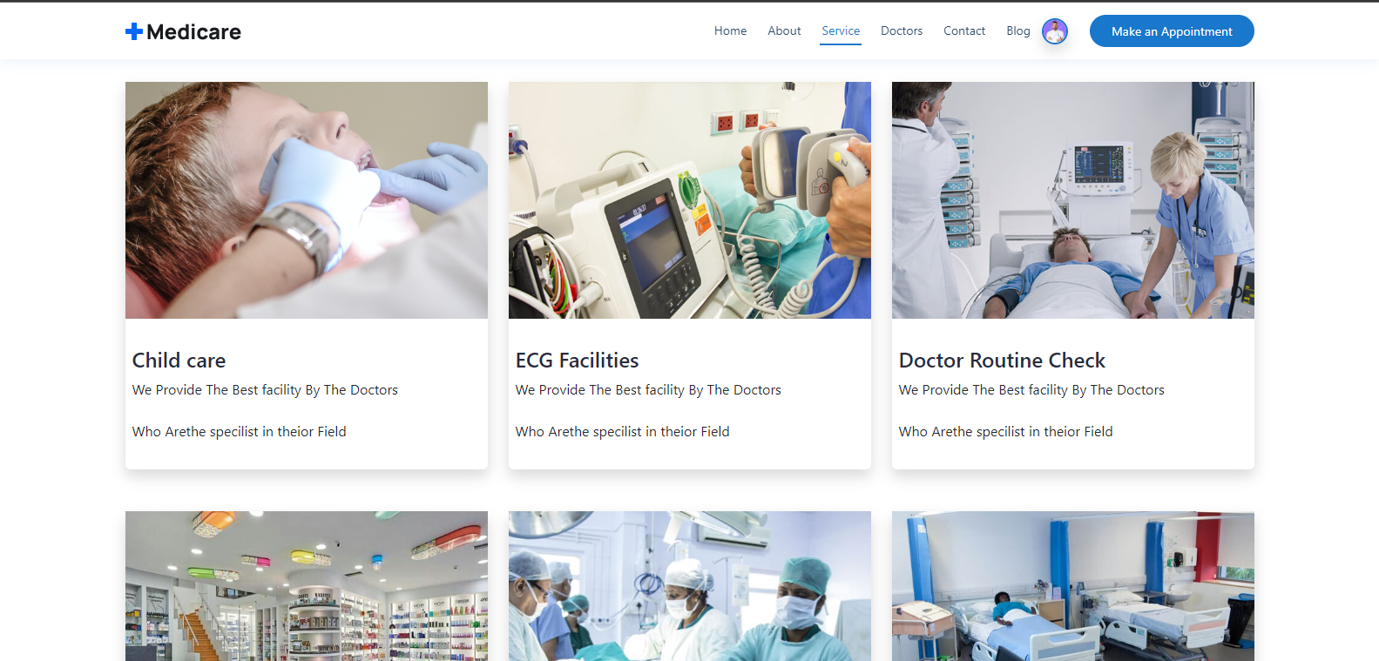

FIGURE 3.3 Services

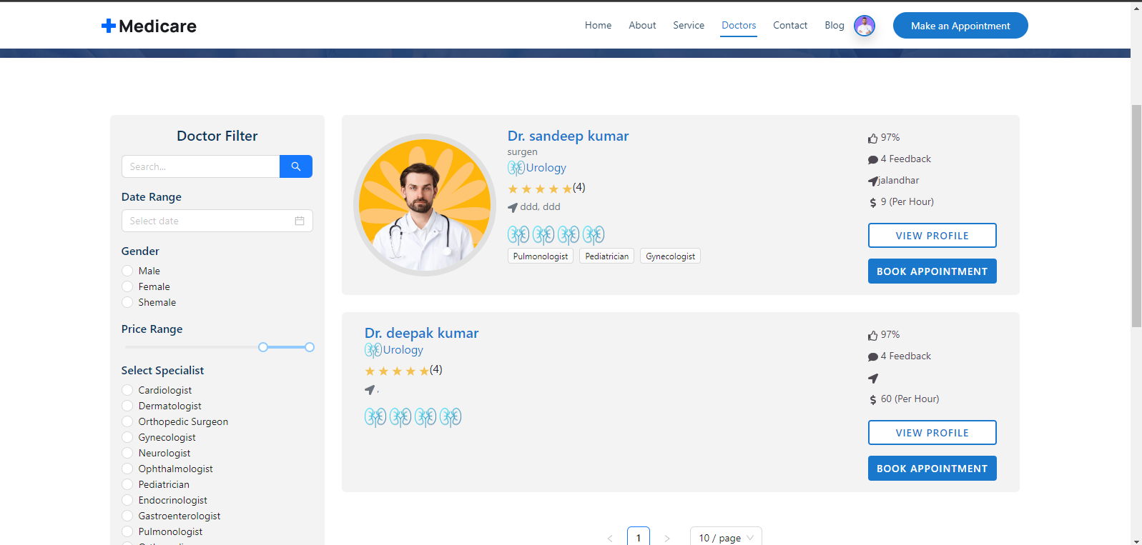

FIGURE 3.4 Doctors

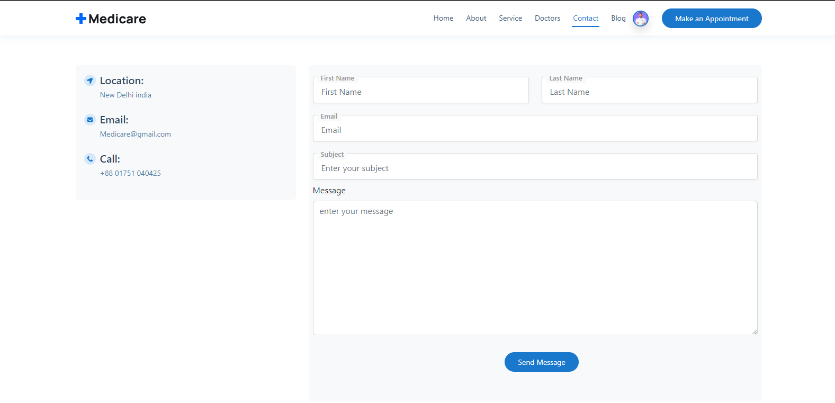

FIGURE 3.5 Contact

## 

**FIGURE 3.6 login**

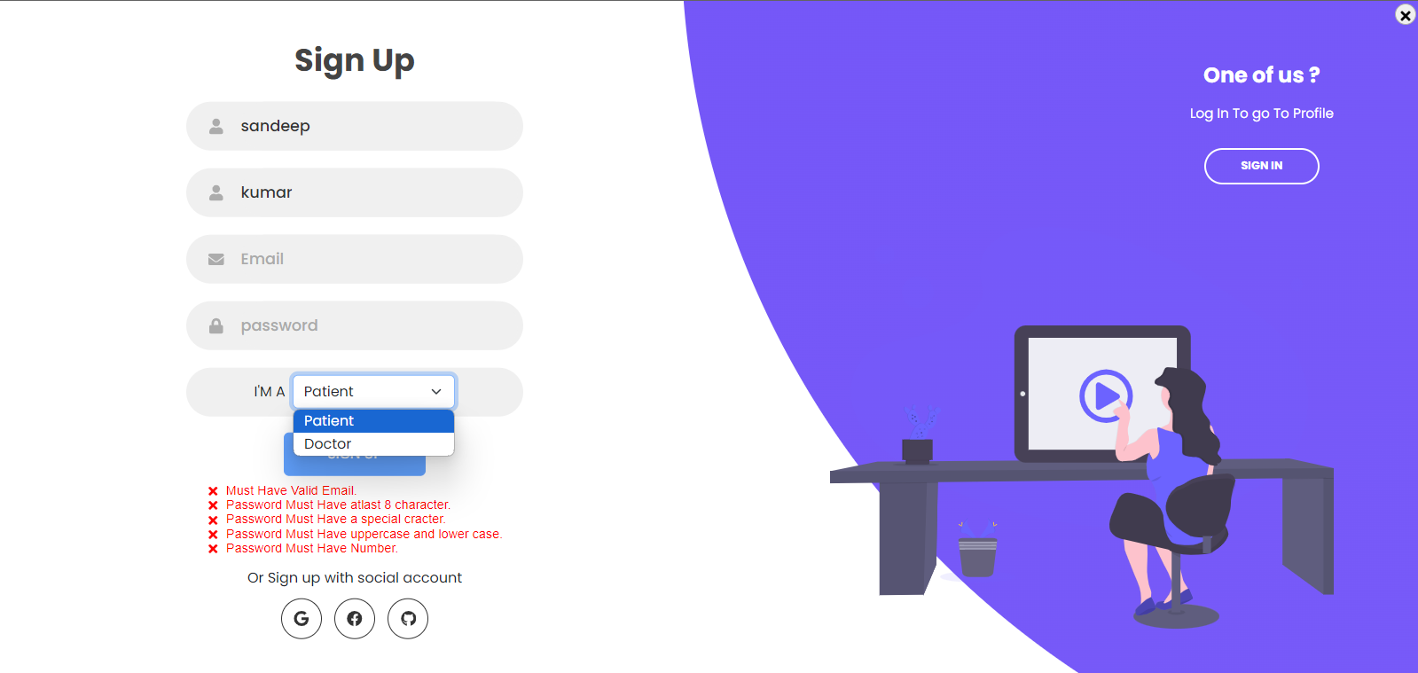

**FIGURE 3.7 SIGN UP**

## Appointments

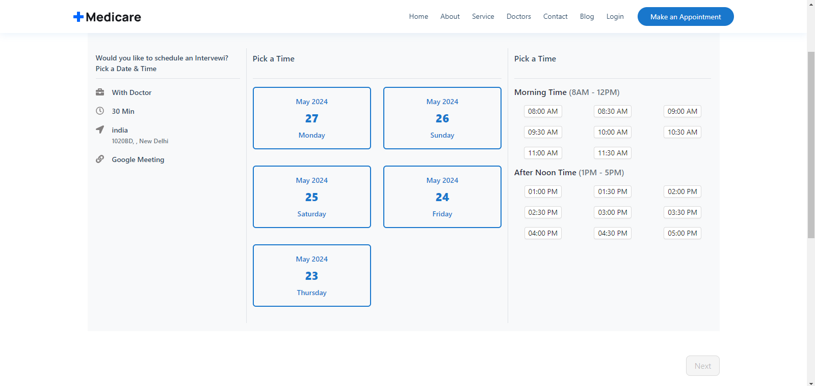

FIGURE 4.1 Appointments

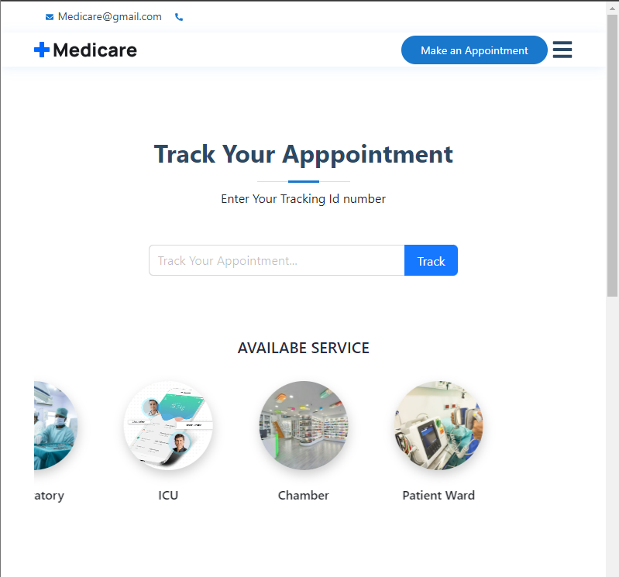

FIGURE 4.2 TRACK APPOINTMENT

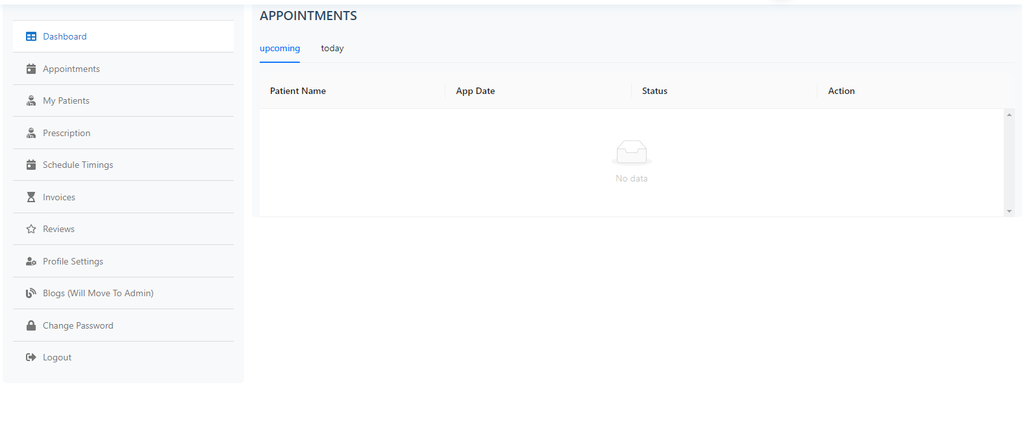

**FIGURE 4.3** DOCTOR DASHBOARD

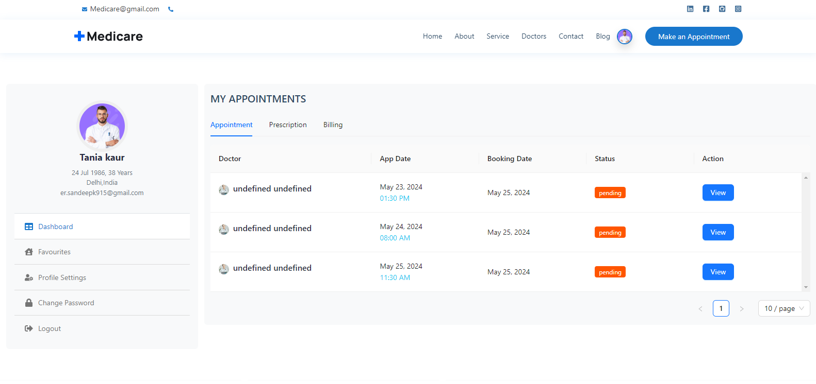

FIGURE 4.4 PATIENT DASHBOARD

**FIGURE 4.5 Postgres**

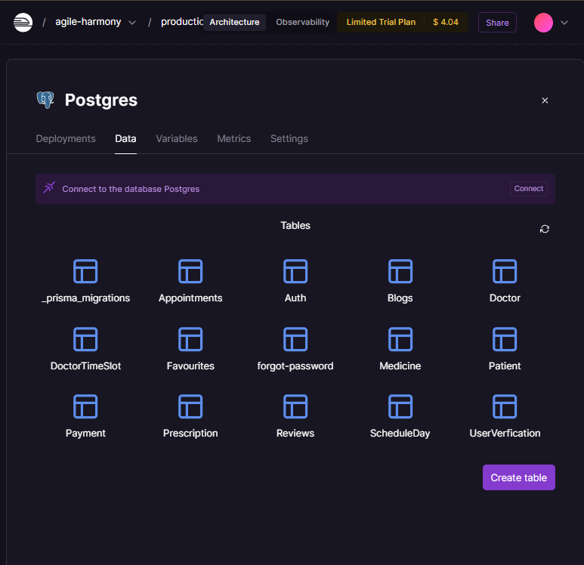

**Figure-4.18**

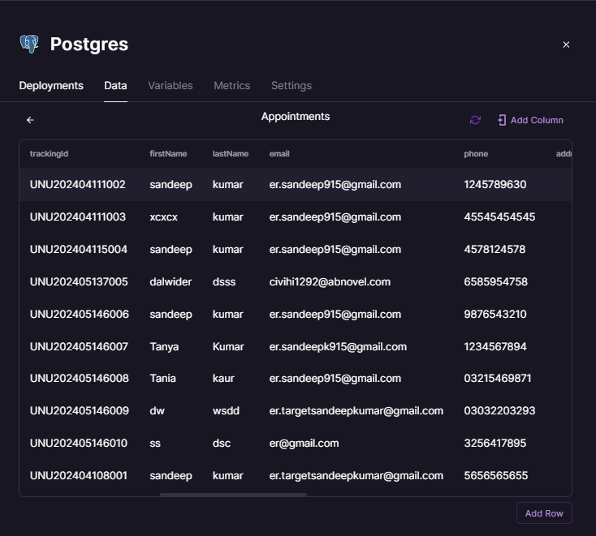

**Figure-4.19**

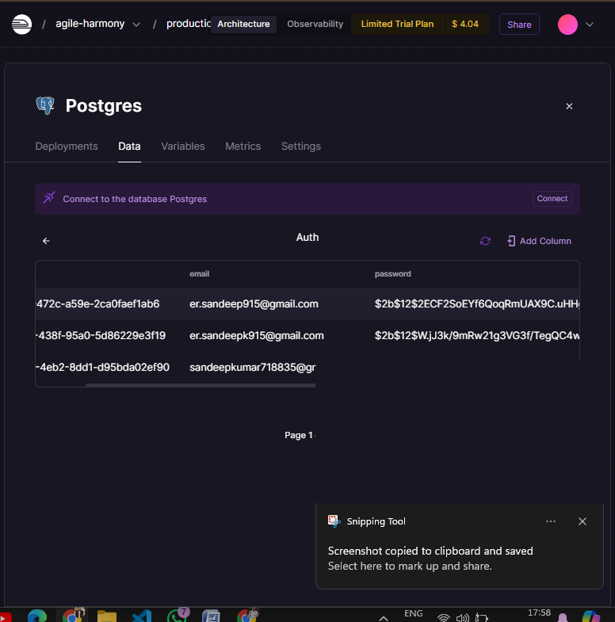

# Figure-4.20

# 

# Figure4.21

# 

# Figure4.22

# 

# Figure 4.23

# CONCULSION

# In conclusion, our project leverages modern technologies such as PostgreSQL, TypeScript, and Prisma to deliver a robust, scalable, and secure backend for [Your Clinic Name]'s online appointment booking system. PostgreSQL provides a reliable and high-performance database solution, ensuring that patient data is stored securely and accessed efficiently. TypeScript enhances our codebase with static typing, improving code quality and maintainability, while Prisma offers a type-safe and intuitive ORM, simplifying database interactions and migrations.Today's Web development, a good page design is essential. This combination of technologies not only meets our current needs but also positions us well for future growth and enhancements. We are committed to continuously improving our system to provide the best possible service to our patients and staff. Thank you for choosing [Your Clinic Name] as your trusted healthcare partner. We look forward to serving you with excellence and dedication. A bad design will lead to the loss of visitors and that can lead to a loss of business. In general, a good page layout has to satisfy the basic elements of a good page design. This includes color contrast, text organization, font selection, style of a page, page size, graphics used, and consistency. In order to create a well- designed page for a specific audience. The developer needs to organized and analyze the users' statistics and the background of the users. Although it can be hard to come up with a design that is well suited to all of the users, there will be a design that is appropriate for most of the audience. The better the page design, the more hits a page will get. That implies an increase in accessibility and a possible increase in business.

**5.2 FUTURE SCOPE**

The future scope of the doctor appointment system includes integrating telemedicine for virtual consultations, developing advanced analytics tools for patient demographics and trends, and creating a mobile app for convenient booking, reminders, telehealth, and access to medical records. Incorporating wearable device integration will allow real-time health data collection for better-informed healthcare decisions. Adding multi-language support will cater to a diverse patient population, enhancing accessibility. Enhanced security measures and compliance with global health regulations will ensure the protection of patient data. Integrating with pharmacy services will streamline the prescription process. Personalized health recommendations based on patient data will encourage healthy lifestyle choices. Continuous updates to ensure compatibility with new healthcare standards and technologies are anticipated. Additionally, exploring blockchain technology for secure, decentralized patient record management will ensure data integrity and seamless data sharing among healthcare providers.

# REFERENCE

* https://[www.geeksforgeeks.org/types-of-css-cascading-style-sheet/](http://www.geeksforgeeks.org/types-of-css-cascading-style-sheet/)
* <https://nodejs.org/en/>
* <https://www.prisma.io/>
* https://www.typescriptlang.org/
* https://[www.mongodb.com/cloud/atlas/lp/try4?utm_content=rlsavisitor&utm_sour](http://www.mongodb.com/cloud/atlas/lp/try4?utm_content=rlsavisitor&utm_sour)

ce=google&utm_campaign=search_gs_pl_evergreen_atlas_core_retarget- brand_gic- null_apac-all_ps- all_desktop_eng_lead&utm_term=mongodb&utm_medium=cpc_paid_search&ut m_ad=e&utm_ad_campaign_id=14412646476&adgroup=131761130812&cq_cm SSSSSp=14412646476&gclid=Cj0KCQiA6LyfBhC3ARIsAG4gkF-

gIqefPSM3Bd_n6oVl1go3nOhCcIT4sxC1NIhATjK2c9jGvCaY9H8aAolOEALw _wcB

* https://[www.w3schools.com/js/](http://www.w3schools.com/js/)