Programs :

1. Write a Python program to swap the values of two variables without using a temporary variable.

Logic:

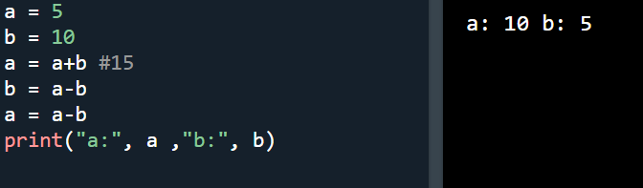

1. Create a function to check if a given number is prime.

Logic:

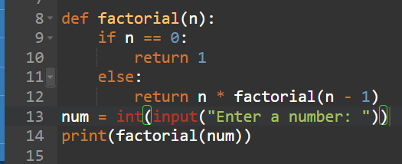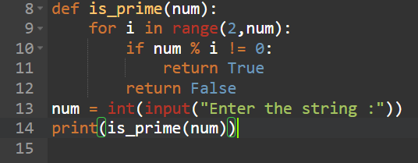

1. Write a program to find the factorial of a number using recursion.

Logic:



1. Implement a python program to check if a string is palindrome.

Logic:

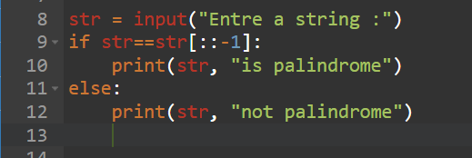 

1. Create a function to calculate the sum of digits in each number

Logic:

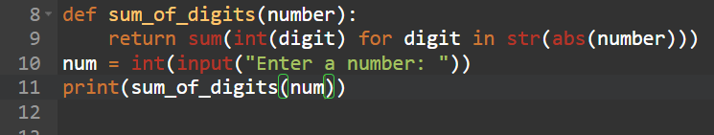 

1. Write a Python script to generate Fibonacci series up to n.

Logic:

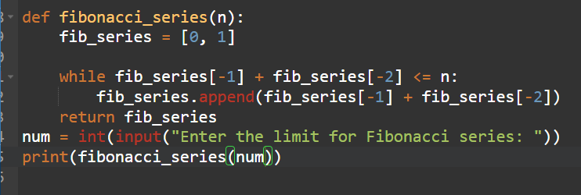

1. Implement a program to find the largest element in a list

Logic:

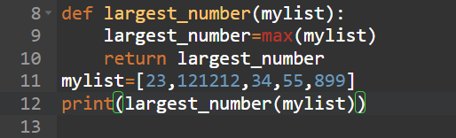 

1. Create a function to reverse a string without using slicing or reverse functions.

Logic:

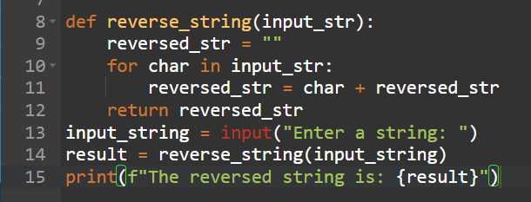



1. Write a program to find the intersection of two lists.

Logic:

1. Implement a function to remove duplicate elements from a list.