


V I S V E S V A R A Y A T E C H N O L O G I C A L U N I V E R S I T Y
“ J N A N A S A N G A M A ” B E L A G A V I – 5 9 0 0 1 8

A Synopsis Report on

“MULTI-MODEL AI APPROACH FOR CROP-ADVISOR AND DISEASE DETECTOR”
Submitted in the partial fulfillment of the requirements for the award of the degree of
BACHELOR OF ENGINEERING IN

COMPUTER SCIENCE AND ENGINEERING
(Accredited by NBA, New Delhi, Valid up to 30.06.2026)

SUBMITTED BY

Sandeep S K 4JD22CS092
Sanjay G M 4JD22CS095 Niranjan R M 4JD22CS077
Veeresh G S 4JD22CS118

UNDER THE GUIDANCE OF
Ms. Rashmi S P
Assistant Professor
Dept. of CS&E,
Jain Institute of Technology, Davangere

DEPARTMENT OF COMPUTER SCIENCE AND ENGINEERING
JAIN INSTITUTE OF TECHNOLOGY DAVANGERE – 577003
2024 - 2025

CONTENTS
 | Page No.
ABSTRACT | iii
LIST OF FIGURES | v
CHAPTER1: INTRODUCTION  1.1 Problem Statement | 1
1.2 Objectives of the Work | 1
1.3 Scopes | 2
CHAPTER2: LITERATURE SURVEY | 3-11
2.1 Description of each paper | 3-4
2.2 Literature survey Table | 5-6
2.3Related Work | 7-8
2.4 Gaps identified | 8-9
CHAPTER3: PROPOSED METHODOLOGY | 10-11
CHAPTER4: POSSIBLE OUTCOMES | 12
REFERENCES | 13

iv

LIST OF FIGURES

Figure No. | Title of the figure | Page No.
4.1 | Proposed Methodology and Architecture | 10

v

CHAPTER 1
INTRODUCTION

Problem Statement

Farmers often lack access to timely and accurate information related to crop selection, soil health, and disease management. Existing systems provide generalized recommendations that do not consider local soil parameters or specific crop conditions.Similarly, detecting plant diseases manually is slow, error-prone, and often leads to delayed treatment. There is a need for an intelligent, automated, and farmer-friendly system capable of providing real-time recommendations and detections.

This project addresses these challenges by developing AgriBot, an AI-powered chatbot using XGBoost and ResNet models to help farmers with personalized crop advisory and plant disease detection.

Objectives of the work

✔ To develop a chatbot capable of answering agricultural queries using NLP
✔ To recommend suitable crops using XGBoost based on soil parameters
✔ To detect plant diseases accurately using ResNet deep learning model
✔ To provide treatment suggestions and crop management tips
✔ To create a simple and user-friendly web interface for farmers
✔ To evaluate the accuracy, performance, and reliability of the AI models

Scopes

⚡ The project focuses on:
- Soil data collection (pH, NPK, moisture)
- Crop recommendation using machine learning
- Image-based disease detection
- Real-time chatbot to assist farmers
- Farm advisory through a responsive web application
- Integration of XGBoost, ResNet, and NLP models
- Providing fertilizer suggestions, prevention measures, and treatment steps

CHAPTER 2
LITERATURE SURVEY

Description of each paper

1. Detection and Classification of Diseases in Multi-Crop Leaves using LSTM and CNN Models
Authors: Srinivas Kanakala, Sneha Ningappa
Year: 2025
Description: This paper proposes a hybrid CNN + LSTM model for detecting diseases in multiple crop leaves. It uses a very large dataset with 38 disease classes and achieves high accuracy. It is useful for projects that focus on multi-crop disease identification.

2. Design and Implementation of FourCropNet: A CNN-Based System for Efficient Multi-Crop Disease Detection and Management
Authors: H. P. Khandagale, Sangram Patil, V. S. Gavali, S. V. Chavan, P. P. Halkarnikar, Prateek A. Meshram
Year: 2025
Description: Introduces FourCropNet, a deep learning architecture with residual and attention blocks. It is designed for crops like cotton, grape, soybean, and corn. It reports extremely high accuracy and is suitable for advanced disease-detection systems.

3. AI-IoT Based Smart Agriculture Pivot for Plant Diseases Detection and Treatment
Authors: A. S. Ibrahim, Mohammed S., I. M. Selim, and others
Year: 2025
Description: Focuses on combining AI with IoT sensors and UAV systems to detect plant diseases in real time. Useful if your crop advisor integrates sensors or remote monitoring along with image-based detection.

4. Advancing Plant Leaf Disease Detection Integrating Machine Learning and Deep Learning
Authors: R. Sujatha, S. Krishnan, J. M. Chatterjee, and team
Year: 2025
Description: Provides a comparative and hybrid approach using both ML and DL for leaf disease detection. This paper is relevant if you want to compare algorithms or design a hybrid detection pipeline.

5. Crop Disease Classification using Support Vector Machines with Green Chromatic Coordinate (GCC) and Attention-Based Feature Extraction for IoT-based Smart Agriculture Applications
Authors: Shashwat Jha, Vishvaditya Luhach, Gauri Shanker Gupta, Beependra Singh
Year: 2023
Description: Uses lightweight ML techniques (SVM + color/attention features) for crop disease detection, suitable for mobile and IoT devices. Good reference for low-power or real-time field applications

Literature Survey Table

 | Consensus  Algorithms in Vehicular  Networks.  Kim et al. |  | deep learning techniques to examine log data from vehicular networks, evaluating their role in blockchain-based security models. | application of ML in  blockchain security.  Demonstrates how deep learning  enhances  cybersecurity  decision- making. | network  applications, restricting  generalizability to other domains.
4 | Enhancing 5G Network Security with Blockchain and Machine Learning.  Salahdine et al. | 2018 | The study follows an experimental  research approach, conducting real- world tests on blockchain and ML applications in 5G networks. | Demonstrates practical  security  enhancements for 5G  networks.  Explores ML- driven threat detection for IoT-based  systems. | The study is focused on 5G networks,  limiting its applicability to other  cybersecurity fields.
5 | Research Trends in Blockchain and Machine Learning Integration.  Rodríguez-Correa et al | 2024 | The study employs a comparative analysis approach, reviewing research  contributions from different countries and analyzing  technology adoption trends. | Provides a global  perspective on blockchain and ML research. | Focuses on regional trends, limiting insights into industry- wide  implementations.

Related Work
In recent years, artificial intelligence has gained significant attention in agriculture due to the increasing need for automation, sustainability, and high-yield farming. Several studies have explored machine learning, deep learning, and chatbot-based advisory systems to assist farmers; however, most remain limited in scope or application.

Early research mainly focused on plant disease detection using image processing. Convolutional Neural Networks (CNNs) such as VGG16, InceptionNet, and Modified CNNs were employed to classify diseases from leaf images. While these systems achieved reasonable accuracy, they required high-quality datasets and lacked robustness when used in real-world farm environments. Furthermore, most studies focused on a single crop at a time, making it difficult to scale for diverse Indian farming conditions.

Subsequent research evolved into deep-learning-based plant disease diagnostic systems, where models like ResNet50, DenseNet, and MobileNet demonstrated improved classification performance. These works contributed significantly to the development of image-based disease detection; however, they did not integrate real-time recommendation systems or treatment suggestions.

Parallelly, several researchers explored crop recommendation systems using machine learning algorithms. Methods such as XGBoost, Random Forest, Naïve Bayes, and SVM analyzed soil parameters (pH, NPK levels, moisture, and temperature) to predict the most suitable crop. These systems enabled farmers to make informed decisions based on soil properties. Yet, they lacked the ability to automatically interpret farmer queries or integrate disease detection, limiting their practical usability.Recent advances introduced NLP-driven chatbots to support farmers by answering agricultural queries such as fertilizer usage, pest control, market prices, and crop planning. Although chatbot frameworks like BERT-based Q&A models and rule-based systems improved accessibility, they lacked integration with machine learning-based crop or disease prediction models. This made recommendations generic rather than personalized.

Integrated systems combining AI-based disease detection, ML-based crop advisory, and NLP chatbots are still rare. Most existing works focus on only one component (either crop recommendation, disease detection, or query answering) but not all three in a unified platform.The proposed system, AgriBot, builds upon these works and introduces a multi-model hybrid platform that brings together crop recommendation using XGBoost, disease detection using ResNet, and a conversational AI chatbot capable of answering context-aware agricultural queries. This unified platform intends to bridge the gaps left by earlier research and offer a farmer-friendly, intelligent, and practical advisory system.

Gaps identified

1. Lack of Unified Multi-Model Systems
Most existing solutions address only one problem — either crop recommendation OR disease detection OR chatbot-based advisory. Very few systems integrate all three functionalities into a single platform, leading to fragmented solutions that farmers find difficult to use practically.
2. Generic and Non-Personalized Recommendations
Many ML-based crop advisory systems use generalized datasets that do not reflect local soil variations. They ignore critical parameters like micro-nutrient levels, moisture content, and region-specific crop patterns. As a result, recommendations lack precision and real-world applicability.
3. Limited Image Accuracy Under Real Conditions
Disease detection models perform well under controlled datasets but struggle in real farm environments due to:
- poor lighting
- varying leaf positions
- presence of dust or water
- background noise
- low-quality mobile camera images
Existing models often fail to generalize these variations.
4. Poor Language and Query Understanding in Chatbots
Many agricultural chatbots are:
- rule-based,
- unable to understand complex farmer questions,
- not capable of handling multilingual inputs (Kannada, Hindi, etc.),
- and lack domain-specific knowledge integration.
This makes their responses generic and sometimes irrelevant.
5. No End-to-End Advisory — Only Detection
Even when systems detect diseases accurately, they often:
- do not provide treatment steps,
- do not offer pesticide/fertilizer suggestions,
- and lack preventive recommendations this reduces real-world usability.
6. Dataset Limitations
Existing datasets suffer from:
- insufficient disease variety,
- imbalanced classes,
- low-quality images,
- lack of real field data,
- regional soil data mismatch.
Thus, models trained on such datasets fail to perform reliably on diverse farming conditions.

7. Absence of Real-Time Decision Support
Most systems do not support real-time interaction or instant feedback. Farmers require immediate recommendations, but existing solutions require manual input or delay processing.
8. No Integration with Farmer-Friendly Platforms
Many research solutions do not provide:
- mobile-friendly UI,
- easy-to-use web dashboards,
- simple workflows suitable for farmers with limited technical experience.
Thus, deployment at scale becomes difficult.
9. Lack of Scalability
Existing models cannot handle:
- large volumes of queries,
- multiple image uploads,
- or integration with additional sensors/IoT.
Scalability is crucial for real-world adoption.

METHODOLOGY

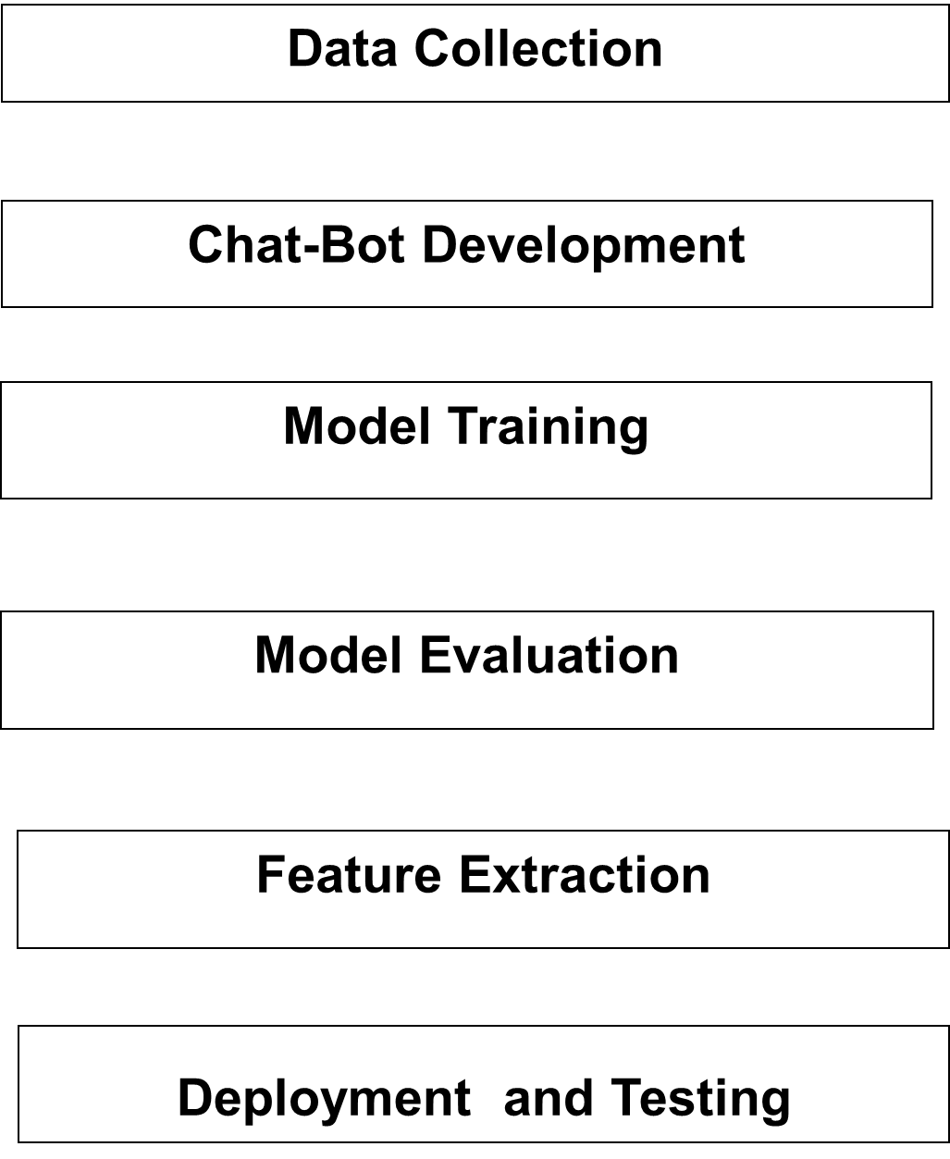

Figure 4.1: Proposed Methodology

1. Data Collection:

The Data Collection module forms the foundation of the system by gathering all essential inputs required for accurate prediction and analysis. It includes soil datasets containing parameters such as pH level, NPK (Nitrogen, Phosphorus, Potassium) composition, and moisture content. These soil attributes are crucial for determining crop suitability. Additionally, a plant leaf disease image dataset is collected, consisting of healthy and diseased leaf images across multiple crops. This dataset is used to train and validate the deep learning model for disease detection.

2. Chatbot Development (NLP):

The Chatbot Development module uses Natural Language Processing (NLP) techniques to create an intelligent conversational assistant for farmers. This chatbot can understand natural-language queries related to crops, soil, plant health, fertilizers, and cultivation practices. It responds with simple, clear, and helpful answers so that even non-technical users can easily understand the guidance. The chatbot acts as a support system, allowing farmers to interact with the platform in a natural and user-friendly manner.

3. Crop Recommendation (XGBoost):

The Crop Recommendation module uses the XGBoost algorithm, a high-performance machine learning model, to suggest the most suitable crop for a farmer based on soil parameters. Inputs such as soil pH, NPK levels, and moisture are processed by XGBoost to analyze crop adaptability. The system then outputs the best crop recommendation that fits the soil conditions, helping farmers make informed decisions that increase yield and reduce risks.

4. Disease Detection (ResNet):

The Disease Detection module uses a deep learning architecture based on ResNet to accurately identify diseases from plant leaf images. The user uploads a leaf image, and the model processes it to detect the presence of disease. Once identified, the system provides the disease name along with recommended treatment or preventive measures. This timely detection helps farmers take quick action and minimize crop loss.

5. Web Application (Django/Flask):

The Web Application module is developed using Django or Flask to provide an easy-to-use interface where all system features come together. It includes user login functionality, crop prediction, plant disease detection, and an integrated chatbot for instant support. The web app ensures smooth navigation and real-time interaction, allowing farmers to access recommendations and detection results anytime from a single platform.

CHAPTER 4
POSSIBLE OUTCOMES

The project “Multi-Model AI Approach for Crop-Advisor and Disease Detector (AgriBot)” is designed to improve agricultural decision-making, increase productivity, and support farmers with intelligent AI-based guidance. The key expected outcomes are as follows:

1. Accurate Crop Recommendation System
Using XGBoost, the system analyzes soil pH, NPK levels, moisture, and temperature to suggest the best crop for cultivation. It is expected to achieve around 90–95% accuracy, helping farmers improve yield and select suitable crops.

2. Reliable Plant Disease Detection
With a ResNet-based model, the system will detect plant leaf diseases accurately and provide the disease name, severity level, and treatment suggestions. This supports early action and reduces crop loss.

3. AI Chatbot for Farmer Assistance
An NLP-powered chatbot will respond to farmer queries in simple language, offering guidance on fertilizers, watering, pest control, soil improvement, and disease management. This ensures quick and reliable support.

4. Easy-to-Use Farmer Dashboard
A web interface will allow farmers to upload leaf images, enter soil parameters, view crop recommendations, check disease results, and chat with the AI assistant, making the system accessible even to non-technical users.

5. Early Disease Detection & Reduced Crop Loss
By providing timely alerts and treatment instructions, the system helps prevent major crop damage, reduces financial loss, and improves plant survival.

6. Better Soil Management & Resource Optimization
Data-driven insights will guide farmers in the proper use of fertilizers, irrigation, and nutrients, preventing waste and improving soil health.

7. Scalable AI Platform
The system is designed to be scalable and can be expanded to support more crops, additional soil types, multiple languages, and future IoT integration.

8. Support for Smart Agriculture
AgriBot promotes digital farming by enabling AI-driven advisories, automated disease prediction, and smart crop planning, contributing to modern agriculture initiatives.

9. Increased Farmer Productivity and Profitability
With accurate recommendations and timely guidance, the project helps farmers achieve higher yield, lower input cost, better crop quality, and improved overall income.

REFERENCES

• Mohanty, S. P., Hughes, D. P., & Salathé, M. (2016). “Using Deep Learning for Image-Based Plant Disease Detection.” Frontiers in Plant Science.
• Ferentinos, K. P. (2018). “Deep Learning Models for Plant Disease Detection and Diagnosis.” Computers and Electronics in Agriculture, Elsevier.
• Too, E. C., Yujian, L., Njuki, S., & Yingchun, L. (2019). “A Comparative Study of Fine-Tuning Deep Learning Models for Plant Disease Identification.” Computers and Electronics in Agriculture.
• Chlingaryan, A., Sukkarieh, S., & Whelan, B. (2018). “Machine Learning Approaches for Crop Yield Prediction.” Agricultural Systems, Elsevier.
• Kamilaris, A., & Prenafeta-Boldú, F. X. (2018). “Deep Learning in Agriculture: A Survey.” Computers and Electronics in Agriculture.
• Zhang, X., Zhang, F., Yan, R., & Li, Y. (2021). “Crop Recommendation System Using Machine Learning Algorithms.” International Journal of Advanced Computer Science.

Vision and Mission of the Institution

Vision of the Institute:

Technical manpower development to build professionally excellent, globally competitive, socially responsible engineers and entrepreneurs with human values.

Mission of the Institute:

M1 | To provide quality education through innovation in teaching to create technologically competent engineers.
M2 | To Achieve excellence in research and development to advance science and technology to the ever changing needs of society.
M3 | To create outstanding professionals by facilitating state of the art platform capable of working in multi-cultural environment.
M4 | To produce quality engineers with high ethical standards and professionalism.

Vision & Mission of the Program

Vision of the Department:
To develop socially responsible computer engineers and entrepreneurs with strong academic excellence, technical backgrounds, research and innovation, intellectual skills and creativity to cater the needs of IT Industry and society by adopting professional ethics

Mission of the Department:

M1 | To impart center of excellence by offering technical education and imbibing experiential learning skills to achieve teaching learning process.
M2 | Providing a Platform to discover and engage research and innovation strengths, talents, passions through collaborations, government, private  agencies and industries.
M3 | Creating an environment to inculcate moral principles, professionalism and  responsibilities towards the society.

PEOs, POs and PSOs Program Education Objectives
PEO 1 | Graduates of the program will be employed in the computing profession and be engaged in learning, understanding and applying new ideas and  technologies as the field evolves.
PEO 2 | Graduates will be able to conduct Research, Innovation, Design & Development aspects of varying complexities of software and scientific  systems.
PEO 3 | Graduates exhibit high professionalism with ethical and moral values in their  working environment.

Program Outcomes
Computer Science & Engineering Graduates will be able to:

POs | Program Outcomes
PO1 | Engineering knowledge: Apply the knowledge of mathematics, science, engineering fundamentals, and computer science and engineering to the solution of complex engineering problems.
PO2 | Problem analysis: Identify, formulate, review research literature, and analyze complex computer engineering problems reaching substantiated conclusions using first principles of mathematics, natural sciences, and engineering sciences.
PO3 | Design/development of solutions: Design solutions for complex computer engineering problems and design system components or processes that meet the specified needs with appropriate consideration for the public health and safety, and the cultural, societal, and environmental considerations.
PO4 | Conduct investigations of complex problems: Use research-based knowledge and research methods including design of experiments, analysis and interpretation of data, and synthesis of the information to provide valid conclusions.

PO5 | Modern tool usage: Create, select, and apply appropriate techniques, resources, and modern computer engineering and IT tools including prediction and modeling to complex computer engineering activities with an understanding of the limitations.
PO6 | The engineer and society: Apply reasoning informed by the contextual knowledge to assess societal, health, safety, legal and cultural issues and the consequent responsibilities relevant to the professional engineering practice.
PO7 | Environment and sustainability: Understand the impact of the professional computer engineering solutions in societal and environmental contexts, and demonstrate the knowledge of, and need for sustainable development.
PO8 | Ethics: Apply ethical principles and commit to professional ethics and responsibilities and norms of the computer engineering practice.
PO9 | Individual and team work: Function effectively as an individual, and as a member or leader in diverse teams, and in multidisciplinary settings.
PO10 | Communication: Communicate effectively on complex computer engineering activities with the engineering community and with society at large, such as, being able to comprehend and write effective reports and design documentation, make effective presentations, and give and receive clear instructions.
PO11 | Project management and finance: Demonstrate knowledge and understanding of the computer engineering and management principles and apply these to one’s own work, as a member and leader in a team, to manage projects and in multidisciplinary environments.
PO12 | Life-long learning: Recognize the need for, and have the preparation and ability to engage in independent and life-long learning in the broadest context of technological change.

Program Specific Outcomes

A graduate of the Computer Science and Engineering Program will demonstrate:

PSOs | Program Specific Outcomes
PSO1 | Professional Skills: The ability to understand, analyze and develop computer programs in the areas related to algorithms, system software, multimedia, web design, big data analytics, and networking for efficient design of computer-based systems of varying complexity
PSO2 | Standard Practices: The ability to apply standard practices and strategies in software project development using open-ended programming environments to deliver a quality product for business success.
PSO3 | Successful Career and Entrepreneurship: The ability to employ modern computer languages, environments, and platforms in creating innovative career paths to be an entrepreneur, and a zest for higher studies.

