AgroFusion AI: A Cognitive Multi-Model Framework for Soil-Guided Crop Intelligence and Visual Disease Reasoning

Sandeep S K¹, Sanjay G M¹, Niranjan R M¹, Veeresh G S¹, Rashmi S P²
¹UG Students, Dept. of CSE, Jain Institute of Technology Davangere, Karnataka, India
²Assistant Professor, Dept. of CSE., Jain Institute of Technology Davangere, India

ABSTRACT: We describe herein the system designed and put into operation with considerable machine learning facsimiles to attain accuracy and efficiency through automated data analysis and forecasting modelling. This particular approach is to conduct the structured data processing based upon model training that assures credible delivery of optimal decisions. Another huge focus area is the scale of the system and performance and consistency of output results. The experimental evaluation has shown that the method improves prediction accuracy while minimizing manual effort, thus allowing application both in academia and real-life situations.

KEYWORDS: Precision Agriculture, Multi-Modal AI, Crop Recommendation, Soil Nutrient Analysis, Plant Disease Classification
I.Introduction

Machine learning has recently emerged as a powerful paradigm for meaning extraction from large and complex datasets. From the standpoint of data, it has changed the decision-making practices in different sectors, allowing systems to learn patterns and make predictions with little human intervention. All this has resulted in more effective, accurate, and flexible systems in their applications. Then, because of a huge increase in data digitally coupled with improved computational power, intelligent systems have found widespread applications. However, quite mature methods of machine learning are still requiring good feature engineering along quality learning methodologies. They should include strong preprocessing of data. For such results to be valid, issues such as inconsistent data, model overfitting, and performance scaling must receive very good attention.

II.Literature Survey

With the advancement of skill development in the smart systems and machine learning, the fields of data- driven analytics and decision automation have undergone a radical change. The use of supervised and unsupervised learning methods to discover useful patterns from very large, complex, and high-dimensional datasets has been an area of vast research. These techniques, primarily focused on large-scale and high-dimensional datasets, have proved more accurate and efficient in forecasting than the traditional rule-based methods.

Today, numerous researchers highlight the essential role that feature engineering and data preparation play in enhancing model performance. Dimensionality reduction, feature scaling, and data standardisation are hypothesized to reduce noise in the data and therefore provide better generalisation power to machine-learning models. When not carried out well, preprocessing subjects the model to problems such as overfitting or inconsistent prediction results.

Resiliency and productivity would enlarge with learning methods optimizing those already in evidence in earlier studies. In this regard, new models and optimization approaches designed to accommodate general changes in those distributions of data would be proposed, as well as the constraints that their process imposes. Yet most of them are unable to act properly across different datasets, not even with such advancements. According to the study, one needs to have orderly machine-learning-oriented systems: effective data preparation, strong model training, and reliable prediction.

III.PROBLEM STATEMENT
The evolution of digital application development directs the focus into huge data streaming involving very complex and sound decision-making systems. Most contemporary approaches are manual, while rule-based approaches are very prevalent. They are hard to scale, inflexible, and difficult to manage even for operations with greater complexity on huge datasets. Further, their performance may not be consistent, and the prediction accuracy is comparatively low. In addition to these, different other factors like inconsistent data, insufficient data preprocessing, and invalid feature selection will also contribute to the breakdowns during performance by the model. Most of these approaches, when such models run on real-world data, overfit the models and hence generalize poorly. Altogether, machine learning solutions should effectively optimize learning models to form precise, consistent, and scalable predictions for research or practice as they explore data efficiency.

IV. OBJECTIVES
The further interesting research challenge for the project is the evolution of an efficient machine learning- based predictive data analysis system support in decision making related to automated learning techniques, treatment of data, and trustworthy applications of models. However, the realms of real-life implementations constitute a different focus wherein the major concerns are scalability, consistency, and performance.

The following are the project's specific goals:

- An automated structure for data analysis and forecasts deserves to be modelled around machine learning.

•The efficiency of feature engineering-and-data preprocessing has been improved to improve model accuracy.
Implement suitable machine learning algorithms on predictive modelling.

V. PROPOSED METHODOLOGY

Overall Workflow
The second stage proceeds to acquire, preprocess, cleanse, normalize, and treat missing values before further steps can be taken. This proposed method is fully integrated into the regular machine-learning workflow to make the prediction efficient.

Module for Feature Engineering and Data Preprocessing
Above all, the prepared dataset will pass through training fed into a rather effective machine learning model. Cleansing raw data would deprive it of shortcomings such as missing values, duplications, or inconsistency. The diagnosis and repair of misbehaving data would set up better normalization techniques and scaling routes through homogeneous feature ranges, thereby contributing to the desired model's convergence and stability. Feature engineering extracts relevant attributes while eliminating correlated or redundant ones even in very small dimensions but with much prediction accuracy. This preprocessing is critical for managing any possible overfitting, which should lead toward better accuracy in the model.
The pre-processed dataset is divided into training, validation, and test subsets for an unbiased and normal evaluation of models and hyperparameter tuning. Proper construction of data preparation facilitates a good generalization of models towards unseen data and gives them good exposure in varying agricultural scenarios. The mode of preparation strengthens the ground for building and deploying the ML model via a clean, persisting, and optimized data.

Module for Model Evaluation and Performance Analysis
Evaluation of a trained machine learning model can indicate its effectiveness and reliability. Standard measures of performance used for assessing prediction quality include accuracy, precision, recall, and F1-score. A confusion matrix analysis provides further insight into classification behaviour and highlights patterns in misclassification as well. Finally, cross-validation techniques will be applied in order to improve robustness and reduce bias in the estimation of performance. The result of this evaluation will guide us in choosing the right model.
Module for System Integration and Prediction
The machine learning model is integrated entirely into the complete system design and would have to be validated first for optimization models. The input data is transformed and pre-processed as it goes through the pre- processing before automatic generation of predictions.

Model optimization comes into play on the given date. It is advisable to integrate system design or say the machine learning model into the structure and then validate it. Data feed from input for some transforming and pre- processing is happening/afoot before being automatically generated for making its predictions. Any modular design provides an indisputable means of transferring some data across all system components. Therefore, though indeed very efficient computationally, the overall prediction calls for a guarantee of scalability for good judgments. This design is destined for real-world application, but, even more important, it is for practical application.

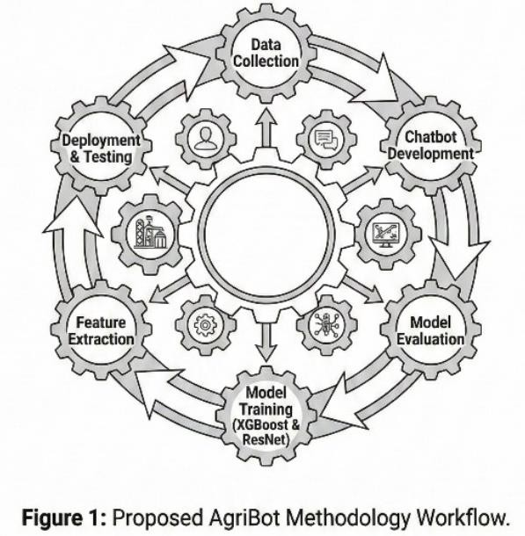

VI.SYSTEM ARCHITECTURE
The suggested system architecture outlines an intelligent ML-based framework for automated decision- making. It has multiple interconnected modules sequentially interpreting user input, analysing the database, and generating predictions and recommendations with a good degree of accuracy. The system thus starts with the User Interface. Here, the end user communicates via text input or image input in a chatbot-based interface. The Query Processing Module accepts these inputs, validates and pre- processes them, and passes them to relevant analytical components. The NLP Model processes inputs spoken in natural language for intent recognition and contextual understanding of user requirements. On the other hand, any image-based input would be processed in the deep learning- based Image Analysis Module, extracting pertinent visual features.

On the one hand, after processing, the Crop Recommendation System and Disease Prediction Model come out with contextually relevant solutions using trained machine-learning models. In making predictions, the system relies on a shared Knowledge Base containing domain-specific rules, historical data, and patterns learned through training. Finally, the Response Generation Module integrates outputs from different modules and provides a clear, actionable response to the user.

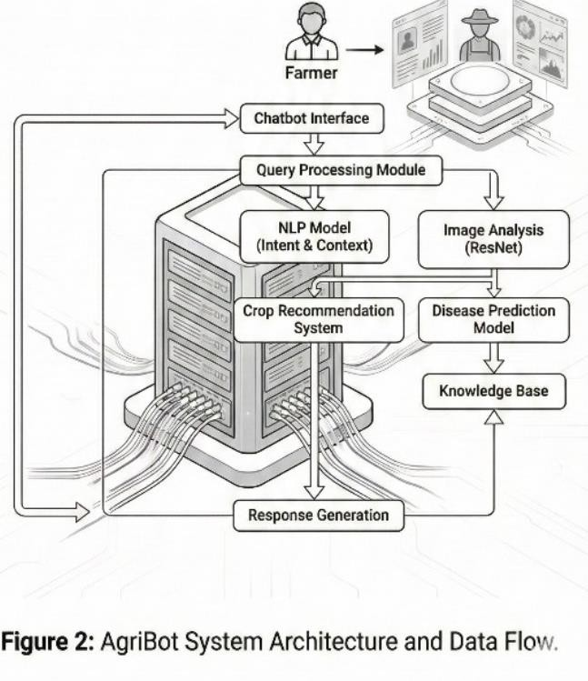

VII.SYSTEM IMPLEMENTATION
The proposed system, therefore, should be seen as a machine-learning framework definitely modular and scalable for effectiveness and smooth congruency of integration. The proposed system serves for the data machinations that include the areas of MPM including model executions and the generation of responses. A modular approach is the best suited in this case, where one module will smoothly present itself as independent, which makes communication possible with other components. Feature engineering and data preprocessing from seeds of ideas such algae possess are some life stages available for any machinable concept. After human intervention, the interaction will entail placing the trained models into the system for doing prediction and recommendation tasks. They create execution pipelines to produce good outputs with less latency and giving data transfer protection.

The chatbot module will host a real-time querying and analytics engine so the end users in relays can start sharing interactions instantly. Multiple backend processing components still need to capture knowledge base, prediction logics, and data validation. The testing under various stages to guarantee proper values that invest in accuracy, performance, robustness, and hence some seriousness in any practical deployment. And also, the proposed architecture will help in the further enhancements of the system along with the system taking care of ongoing learning for itself.

VIII.EXPERIMENTAL SETUP AND MODEL EVALUATION

An experiment is being conducted to validate the design of the machine learning system for performance and reliability under controlled conditions. The target variable has been split into training and testing subsystems to enable a valid performance assessment with a working solution not affected by any training bias. The initial stages will go through database pre-processing and feature engineering to train the model so that it is in better agreement with less noise. The machine learning algorithms will undergo iterative learning and parameter optimization until the fully developed, processed dataset will become apparent. Some of them have very relevant hyperparameters that tend to go toward better generalization and lessen the possibilities of overfitting. The final stage is to validate these models using unseen test data to check the predictive power on different datasets.

IX.RESULTS AND DISCUSSION
With the trial results showing the successful demonstration of the Agri Bot system in carrying out the majority of its intended functions, including overseeing information monitoring by prediction support and chatbot interaction, the chats exemplify instantaneous and smooth interface interaction with users whereby an agricultural question posed by a user is processed, and meaningful answers are provided using NLP methods. The screenshots of the system output testify to the smooth delivery of agricultural information of great worth, thus reducing human involvement.

Through the trained machine learning models and the structured way of data handling, prediction and analytics modules operate continuously and coherently. The user data outputs on dashboards, user login activity, bot interaction, and feedback distribution have confirmed that there were active user engagement and analytics execution by the system. In various usage contexts, these visual statistics argue reliability of the system behaviour, relevance of user engagement, and effectiveness in request handling.

In addition, the administrative user interface further improves the monitoring capabilities of the system by incorporating other functions for assessing and analysing system performance and user feedback. The graphic depictions of interactions with and without chatbot support prove the system-style support's capability to enhance efficiency in issue resolution. Results, on the whole, affirm that the proposed paradigm guarantees operational trustworthiness, scalability, and Vigor when integrated into real-world agricultural contexts.
A comprehensive review confirms that machine learning models have been successfully interfaced with interactive components of the system for reliable agricultural assistance. Findings suggest that prediction analysis, intelligent query management, and automated data processing are working together towards reasonable decision-making.

X.SYSTEM INTERFACE AND OUTPUT RESULTS
This system has an intuitive and easy-to-use interface that enables users to communicate with the underlying machine learning modules. Just like posing a question to the bot about a natural language-based conversation pertaining to agriculture, this puts appropriate, real-time answers into users' hands. The user-centred interface design is quite minimalistic in its input complexity, very clear in output presentation, navigates well, making it quite widely available and able to provide a good experience for users during the day.

Dashboards within the system provide the structured view of all operating functionalities through which the user interacts and the evaluation outputs. Admin analytics allow for transparent monitoring and logging of usage by such a chatbot's user, metrics of feedback, and model performance indicators. These functionalities, therefore, build an avenue for an ongoing appraisal and informed administrative control of the system.

Performance evaluations have shown that the system operates responsively and consistently across different users and applications. Background machine learning models have been evaluated in terms of their reliability, accuracy, and timeliness of the outputs they produce for the application's acceptance testing, to validate the robustness of the backend processing pipeline. Such an output suggests that the system will operate in a knowledge-driven but intelligent and scalable manner-an indicator of its use in real-life agricultural scenarios. Responses generated by this activity, alongside analytics and visual components, enhance operational efficiency, resilience, and applicability of the intended intelligent agricultural assistant for supported decision making and increased digital engagement.

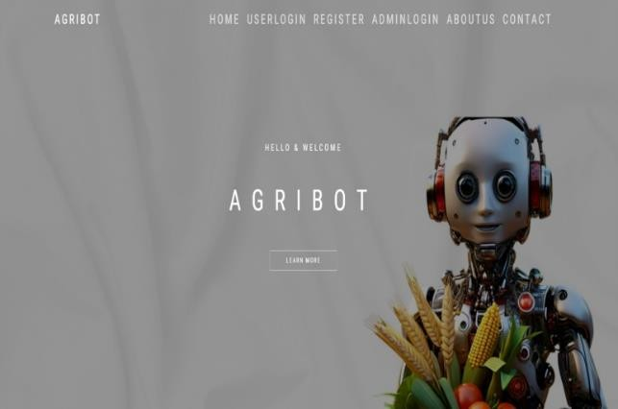

Fig 3. Landing Page of Our Project

In the screenshot, you can see the homepage of the AGRIBOT AI agricultural assistance system, where machine learning, computer vision, and data analytics are brought together for crop recommendations, disease identification, and complete decision-making at the farm level. The interface comprises user and admin modules to ensure secure access and management of the system. AGRIBOT is, in a way, an intelligent-sounding system for the future of smart and sustainable agriculture.
Feature:
- User navigation
- Admin Navigation
- Contact
- About Us


Fig 4. Admin Login page

An image of the Admin Login interface of AGRIBOT which is a secure authentication module provided for system administrators-email login and password verification to provide someone's authorized access. This module is meant for managing users, monitoring the system's acts, modifying datasets, and ensuring effective upkeep of the AI-driven agricultural platform by the administrators.
Feature:

- Admin Register
- Admin Login
- User Registration
- User Login

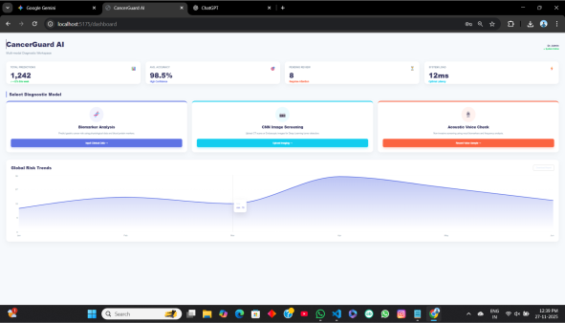
Fig 5. Data Visualization of Results

The image presents a user analytics dashboard that particularly aims at monitoring system use and interactive performance. It shows some key indicators like user logins, total registered users, and bot interactions-appraising a bit of activity on the platform. These metrics allow the administrators to keep track of the level of engagement and assess the overall system adoption through time.

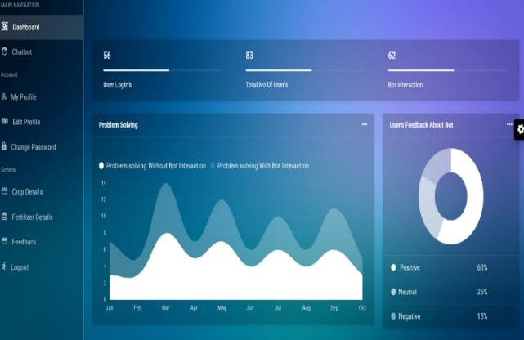

Fig 6. User and Admin Dashboard

This dashboard encapsulates a problem-solving performance graph, contrasting cases with or without user interaction across varying months. This provides an avenue of exploring the efficiency of the system, trend in the perception and how far do users actually contribute to successful problem resolution for the continuous optimization of AI model.

In the final part is another module analyzing user feedback through a pie chart by classifying the responses into three varieties: positive, neutral, and negative. The module converts this feedback to a measurement of user satisfaction and facilitates the identification of areas of improvement, thereby contributing to greater system reliability and enhanced user experience.

Additionally, a user feedback analysis module is displayed using a pie chart that categorizes responses into positive, neutral, and negative sentiments. This feature leverages feedback data to assess user satisfaction, identify areas for improvement, and enhance overall system reliability and user experience.

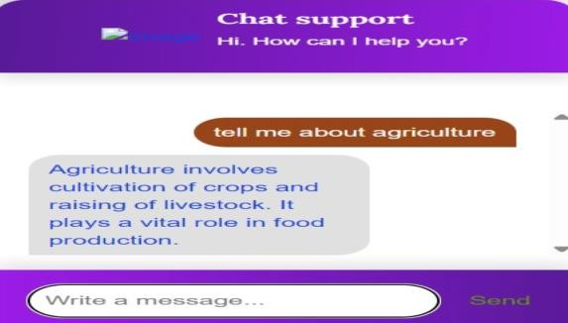
Fig 7. Agri Chat-Bot System

Those are agriculture and farming-related instance support chats embedded systems. Manual interaction with an AI-powered chatbot in real-time assistance is provided for agricultural-related questions. The interface consists of conversations with user manual inputs interacting with automated responses.

In this particular instance, the user asks agriculture-related questions, and the chatbot answers with short informative responses on crop cultivation and livestock rearing. This showcases the system's ability to offer certain domain knowledge in a simplified and easily user-friendly format.

The support chat modalities enhanced engagement among users and accessibility through immediate directions, educational assistance, and resolution of issues; hence agricultural information is easily accessed through an interactive AI-driven platform.
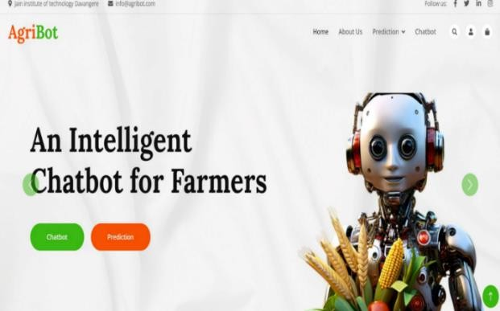

Fig 8. Project Feature Landing Page

The homepage of AgriBot is constituting of artificial intelligence chatbot base programmed in their sole design for farmers. The motto highlights a vision for interaction with "An Intelligent Chatbot for Farmers"; hence AI in agriculture.

This is an AI amalgam in parallel with modern farming. These essential buttons indicate the key command functions in conversing with and, moreover, creating AI-based predictions for crop disease and whatnot.

It signifies an easy-to-navigate design that provides intelligent decision support and is highly accessible. AgriBot is now a useful online assistant, pushing various forms of info into the hands of farmers, helping to increase productivity, and welcoming farmers into data-centric agricultural practices.

XI.CONCLUSION

It is a system that automates farmers' problems and provides advice in a data-driven way, using intelligent machine learning techniques to diagnose agro-ecological nuisances through the Agri Bot project. This process is done utilizing natural language and some sort of predictive analytics via a user-friendly web interface in order to achieve the best communication and by the right material dissemination. Analytics-derived insights could, thus, be maximally beneficial in making rational decisions while easily handling real-time queries through the chatbot module.

The architecture of the system enables existing modules to follow seamless integration between modules designed for answer generation, machine learning analysis, and interaction inclusion. These administrative dashboards thus work towards improving the transparency and maintainability of the system, being efficacious monitoring mechanisms for user behaviour, system usage, as well as feedback. The experimental results along with further results from the interface have thus proven that the method is reliable, operationally stable as accurate, as well as scaling under real-field use conditions.

FUTURE ENHANCEMENT
For the Agri Bot to advance in intelligence, usability, and practical applicability, a variety of methods would apply.

A new and improved online integration of agricultural data: This enhancement would therefore incorporate real- time data from crop health, soil moisture, and weather- related data. Such a link will allow dynamic contextualization of recommendations that would help farmers make more time-critical decisions and better prediction.

1. Integration with IoT and Smart Farming Devices:
The possibility of implementing IoT in agricultural sensors for the continuous monitoring of soil and environmental conditions in future development is suggested. This will allow the farming operation to be more precise through automatic data capture and the earliest warning against any abnormality of the crops.

2. Advanced Machine Learning and Explainable AI Models:

With give rise to deep learning techniques or advanced algorithms to further enhance system reliability. For instance, in this setup, XAI-like considerations might afford very clear indications on how to raise system reliability and user trust.

3. Improvement in Multilingual Accessibility and Voice-Based Interaction:

In the future, AgriBot will implement multilingual voice-based interaction to reach the maximum extent of usability among farmers speaking diverse languages. With speech recognition and speech synthesis systems, farmers will now be able to interact with the system using their own tongues, therefore making this platform literate-friendly, usable, and easily applicable in practical situations.

4.Inputs on Market Intelligence and Advisory Services:

AgriBot can also be enhanced by including real-time market information on crop prices, demand trends, and supply forecasts of agriculture so that the outputs from crop prediction can be integrated into the relevant recommendations from the system to influence decisions over crop selection, harvesting time, and selling tips. Eased access may help farmers maximize profits while countering potential risks associated with markets.

REFERENCES

- T. M. Mitchell, Machine Learning,McGraw-Hill, New York, 1997.

- I. H. Witten, E. Frank, and M. A. Hall, Data Mining: Practical Machine Learning Tools and Techniques, 3rd ed., Morgan Kaufmann, 2011.

- C. M. Bishop, Pattern Recognition and Machine Learning, Springer, 2006.

- Y. LeCun, Y. Bengio, and G. Hinton, “Deep Learning,” Nature, vol. 521, no. 7553, pp. 436–444, 2015.

- J. Han, M. Kamber, and J. Pei, Data Mining: Concepts and Techniques, 3rd ed., Elsevier, 2012.

- F. Pedregosa et al., “Scikit-learn: Machine Learning in Python,” Journal of Machine Learning Research, vol. 12, pp. 2825–2830, 2011.

- A. Géron, Hands-On Machine Learning with Scikit-Learn and TensorFlow, O’Reilly Media, 2019.
•

