Business Requirement Document

Project title: High-Value Transaction Automation
Author: Sandeep Chinta
Client: Banking Client

Executive Summary:
The project addresses the challenges faced by banking client due to significant increase in the volume of high value transactions post covid-19. The existing manual process managed by the operations team, could not handle the increased load, leading to SLA breaches, customer refunds, and reputational damage. This BRD outlines the proposed solution – automating the transaction interface between the online banking system and the legacy platform,

Business Objectives:
- Automate the high-value transaction flow to reduce manual intervention.
- Improved SLA compliance and reduce customer refund rates.
- Enable scalability and minimize human error in transaction processing.
- Enhance customer satisfaction by speeding up transaction execution

Background:
- Legacy System: Handles backend processing of high-value transactions.
- Online Platform: Allows customers to submit high-value transactions digitally.
- Current Flow: Operations team manually downloads and enters data from the online system
- Into the legacy system.
- Issue: Post Covid-19, transactions from 1000 to over 2500 annually. Manual entry could’nt scale, leading to delays, SLA failures, and rising refund costs.

Problem Statement:
Manual transaction entry is no longer sustainable. The operations team is overwhelmed, and the business is suffering from:
- Inability to meet processing SLAs
- High number of refunds
- Negative customer impact
- Operational inefficieny
Scope:
In Scope:
- Documenting AS-IS and TO-BE business processes.
- Autoating data flow from online system to legacy system.
- Error handling and audit trail logging.
- Testing support and business acceptance validation.
Out of Scope:
- Changes to legacy system core logic.
- Changes to customer-facing online portal UI.
- Non-high value transaction processes.

Stakeholders:
Role | Name/Team | Responsibility
Sponsor | Business Director | Approves project and funding.
Business Analyst | Sandeep Chinta | Requirements gathering and validation
Operations Team | Ops Manager | Provides AS-IS process input
Development Team | .NET Developers | Builds automation tool
Platform Engineering | API Integration Support | Online transaction data access
QA/Testing | QA Analyst | Validates solution meets needs

Assumptions:
- Existing APIs or data exports from online system are available.
- Legacy system has interfaces that can be accessed programmatically.
- Operations team will participate in UAT and provide feedback.
- No changes needed on customer front-end interface.

Constraints:
- Solution must be delivered within 6 weeks.
- Minimal downtime permitted during deployment.
- Legacy system cannot be modified extensively due to vendor limitations.
Requirements:
Functional Requirements:
ID | Requirement Description
FR1 | System shall fetch high-value transaction data from the online platform
FR2 | System shall validate transaction data for completeness and accuracy
FR3 | System shall automatically insert valid transactions into legacy system.
FR4 | System shall log all transactions processed (success/failure)
FR5 | Users shall be notified of any failed transactions.

Non-Functional Requirements:
ID | Requirement Description
NFR1 | System should process transactions within 30 seconds
NFR2 | Sytem should be available 99.9% of the time.
NFR3 | Data handling must comply with internal security and privacy policies
NFR4 | Logs should be retained for a minimum of 90 days

AS-IS PROCESS DIAGRAM:
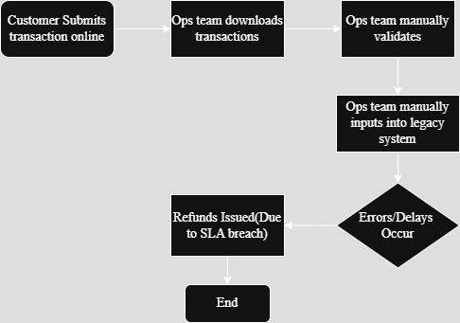

TO-BE PROCESS DIAGRAM:
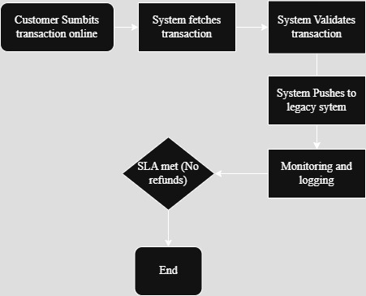

Business Rules:
- Only transactions above a certain threshold (e.g: £10,000) are considered “high-value.”
- Transactions must include mandatory fields (customer ID, amount, date, transaction type).
- Duplicate transaction entries must be flagged and blocked.

Success Metrics:
Metric | Target
SLA Compliance | >95%
Transaction Processing Time | < 30 seconds
Refund Volume Reduction | >90%
Manual Touchpoints | Reduced to zero

Impact Analysis:
Area Affected | Impact
Opeartions Team | Reduced workload, increased efficiency
Customer Experience | Faster transactions, fewer errors
IT Infrastructure | Need for automation hosting and monitoring
Business Risk | Reduced due to improved SLA adherence

Dependencies:
- Avaiabilty of online system APIs/data feeds
- Access credentials for legacy system
- Final sign-off from business stakeholders
- Development resources availability

Timeline (High-Level):
Phase | Duration
Requirement Gathering | 1 week
Design & Review | 1 week
Development | 2 weeks
Testing &UAT | 1 week
Deployment & Handover | 1 week

Risks & Mitigation:
Risk | Mitigation Strategy
API availabilty from online system | Early engagement with Platform Team
Legacy system errors | Conduct interface testing thoroughly
Ops team resistance | Conduct training and get buy-in early
Timeline slippage | Weekly check-ins and agile feedback loop

Appendices:
- Interview notes with stakeholders
- SLA and refund data (before automation)
- Access details for environments
- Glossary of Terms

