HTML TAG IDENTIFICATION USING FLEX
1. AIM
To write and execute a Flex program that scans an input stream or a text file, identifies HTML tags using a regular expression, and displays each matched HTML tag.
2. SOFTWARE REQUIRED
- Flex (Fast Lexical Analyzer Generator)
- GCC compiler
- Command Prompt/Terminal
3. PSEUDOCODE
BEGIN
IF a command-line filename is provided (argc > 1) THEN
OPEN the file argv[1] in read mode and assign it to yyin
IF yyin is NULL THEN
DISPLAY "Cannot open input file!"
RETURN 1
END IF
END IF

DISPLAY "HTML Tags:"
CALL yylex() to scan the input

FOR each sequence of input characters scanned by Flex:
IF the sequence matches the HTML-tag regular expression
(an opening or closing tag name beginning with a letter,
followed by permitted name characters and optional content)
DISPLAY "HTML Tag: " followed by the matched text (yytext)
ELSE
IGNORE the character or newline
END IF
END FOR

IF a command-line filename was provided THEN
CLOSE yyin
END IF

RETURN 0
END
4.OUTPUT
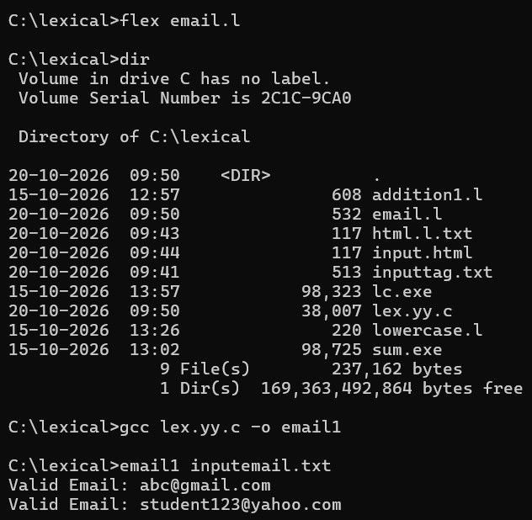

5.RESULT
The Flex program identifies and displays text matching the specified HTML-tag pattern. It can read from a file when a filename is supplied as a command-line argument; otherwise, it scans standard input.
Note: The regular expression recognizes tag-like strings according to the pattern provided. It is a basic pattern matcher and is not a complete HTML parser.

