Three Address Code into target machine

AIM
To write and execute a C program using Dev-C++ to convert Three Address Code (TAC) statements into simple target code instructions using register-based operations.

SOFTWARE REQUIRED
Software: Dev-C++
Programming Language: C

PSEUDOCODE
Step 1: Start the program.
Step 2: Declare variables to store the result, operands, operator, and input TAC statement. Initialize the register counter to zero.
Step 3: Prompt the user to enter Three Address Code statements, one statement per line. Enter END to finish input.
Step 4: Read each statement using fgets(). If the statement begins with END, terminate the input loop.
Step 5: Check whether the statement is an arithmetic instruction of the form result = operand1 operator operand2.
Step 6: If it is an arithmetic instruction, generate target code by moving operand1 into a register.
Step 7: Based on the operator, generate the corresponding ADD, SUB, MUL, or DIV instruction using operand2.
Step 8: Move the register result into the target variable.
Step 9: If the statement is a simple assignment of the form result = operand1, generate a MOV instruction.
Step 10: If the statement does not match either valid format, display an invalid Three Address Code message.
Step 11: Increment the register counter and continue reading statements until END is entered.
Step 12: Stop the program.

OUTPUT
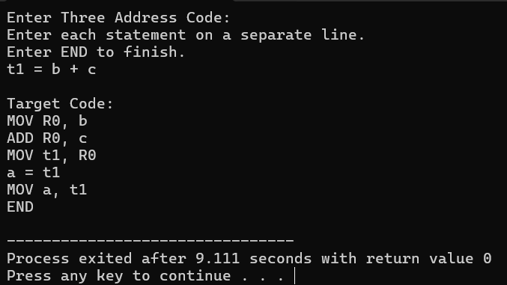

RESULT
Thus, the C program was successfully executed in Dev-C++ to translate Three Address Code (TAC) statements into corresponding target code instructions for arithmetic operations and simple assignments.

