COUNTING ALPHABETS AND DIGITS USING FLEX
1. AIM
To write and execute a Lex/Flex program that scans an input file and counts the total number of alphabetic characters and digits.
2. SOFTWARE REQUIRED
- Flex (Fast Lexical Analyzer Generator)
- GCC compiler
- Command Prompt/Terminal
3. PSEUDOCODE
BEGIN
INITIALIZE alphabet_count and digit_count to 0
OPEN the input file and check whether it was opened successfully
READ the file character by character using Flex rules
WHEN an alphabetic character is matched
INCREMENT alphabet_count by 1
WHEN a digit is matched
INCREMENT digit_count by 1
IGNORE all other characters
AFTER scanning the file, DISPLAY alphabet_count and digit_count
END
4.OUTPUT
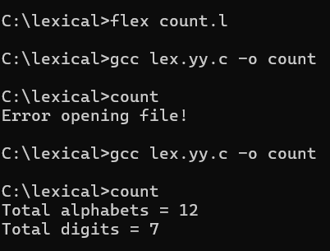

5. RESULT
Thus, the Lex/Flex program was executed successfully to count the total alphabets and digits in the input file.

