FIRST SET CALCULATION FOR A GRAMMAR
1. AIM
To write and execute a C program to calculate the FIRST sets of the non-terminals in a given context-free grammar.
2. SOFTWARE REQUIRED
- Dev-C++ or any C compiler
- GCC compiler
- Command Prompt/Terminal
3. PSEUDOCODE
BEGIN
DEFINE the grammar production rules
IDENTIFY all terminals and non-terminals
FOR each non-terminal in the grammar
EXAMINE each production of that non-terminal
IF the production begins with a terminal THEN
ADD that terminal to the FIRST set
ELSE IF the production begins with a non-terminal THEN
ADD the relevant symbols from that non-terminal's FIRST set
HANDLE epsilon/null productions if supported
REPEAT until the FIRST sets are determined
DISPLAY the grammar and the FIRST set of each non-terminal
END
4. OUTPUT
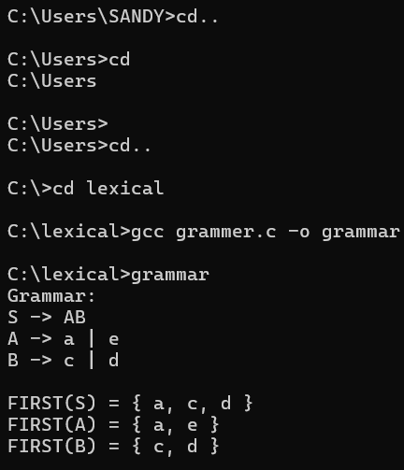

5. RESULT
Thus, the program was executed successfully to display the given grammar and calculate the FIRST sets of its non-terminals.

