COUNTING VOWELS, CONSONANTS, UPPERCASE AND LOWERCASE LETTERS USING FLEX
1. AIM
To write and execute a Lex/Flex program that reads an input file and counts vowels, consonants, uppercase letters, and lowercase letters separately, ignoring spaces and special characters.
2. SOFTWARE REQUIRED
- Flex (Fast Lexical Analyzer Generator)
- GCC compiler
- Command Prompt/Terminal
3. PSEUDOCODE
BEGIN
INITIALIZE vowel_count, consonant_count, uppercase_count and lowercase_count to 0
OPEN and scan the input file
FOR each character read
IF the character is a vowel (a, e, i, o, u, in either case)
INCREMENT vowel_count
ELSE IF the character is an alphabetic consonant
INCREMENT consonant_count
IF the character is uppercase
INCREMENT uppercase_count
ELSE IF the character is lowercase
INCREMENT lowercase_count
IGNORE spaces, digits and special characters for these letter counts
DISPLAY all four counts
END
4. OUTPUT

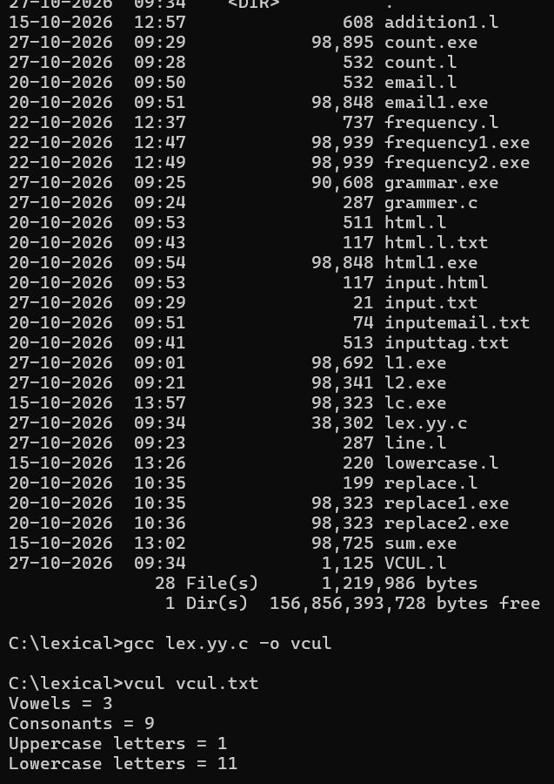

5. RESULT
Thus, the Lex/Flex program was executed successfully to count vowels, consonants, uppercase letters, and lowercase letters in the input file.

