LINE NUMBERING USING LEX/FLEX
1. AIM
To write and execute a Lex/Flex program that reads input text and displays each line with its corresponding line number.
2. SOFTWARE REQUIRED
- Flex (Fast Lexical Analyzer Generator)
- GCC compiler
- Command Prompt/Terminal
3. PSEUDOCODE
BEGIN
IF the input stream is available THEN
INITIALIZE the line counter to 0
DEFINE a Lex rule to match a complete line of text
WHEN a line is matched
INCREMENT the line counter by 1
DISPLAY the line counter, followed by the line text
CONTINUE scanning the input
WHEN the end of input is reached
STOP scanning
END
4. OUTPUT
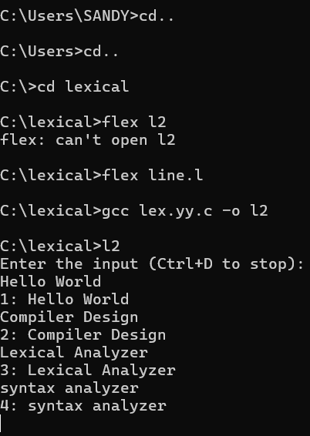

5.RESULT
Thus, the Lex/Flex program was executed successfully to read input text and display each line with its corresponding line number.

