STRING REPLACEMENT USING FLEX
1. AIM
To write and execute a Flex program that replaces each occurrence of the string "hello" with "hi" while copying all other input characters unchanged to the output.
2. SOFTWARE REQUIRED
- Operating System: Windows or Linux
- Flex (Fast Lexical Analyzer Generator)
- GCC compiler
- Command Prompt/Terminal
- Text editor or IDE (such as Notepad or Visual Studio Code)
3. PSEUDOCODE
BEGIN
CALL yylex() to read and process input

WHILE input is available:
IF the next input text matches "hello" THEN
DISPLAY "hi"
CONSUME the matched text "hello"
ELSE IF the next input character is a newline THEN
ECHO the newline to the output
ELSE
ECHO the current character to the output
END IF
END WHILE

yywrap() returns 1 to indicate that scanning is complete
RETURN 0 from main()
END

4.OUTPUT
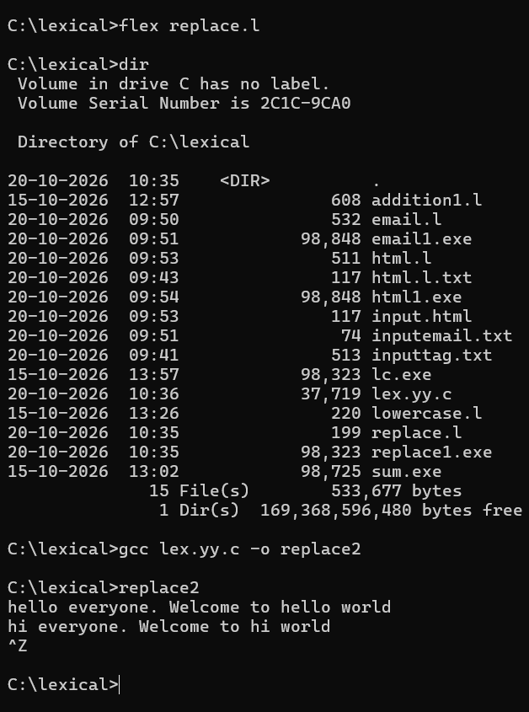

5.RESULT
The Flex program replaces every matched occurrence of "hello" with "hi" and echoes all other characters, including newline characters, unchanged.
Example: Input: hello world | Output: hi world

