**CSCI 551 Computer Networks**

**Project 1a – Report**

1. Screenshot of ping result from NEWY to SEAT

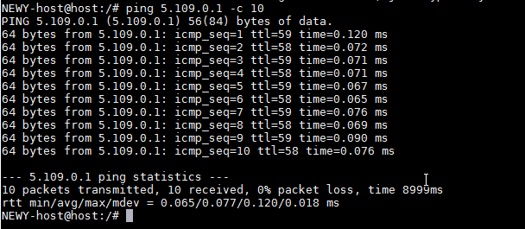

1. Traceroute results from NEWY to SEAT after OSPF is configured and weights are assigned

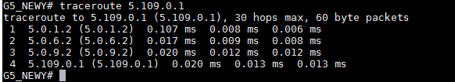

The path traversed is NEWY-CHIC-KANS-SALT-SEAT. This is because the cost of this path is (1000 + 690 + 1330 + 913 ) the least cost path in OSPF between the source NEWY and destination SEAT. Thus this is picked in favour of other paths.

1. I configured the links between NEWY-CHIC as cost of 20 and reminder path of CHIC-KANS-SALT-SEAT with an OSPF cost of 10 and the links between CHIC-WASH, CHIC-ATLA as 5000, between KANS-HOUS as 3000 and SALT-LOSA as 1500 and NEWY-WASH-ATLA-HOUS-LOSA-SEAT. So this created a path of NEWY-CHIC-KANS-SALT-SEAT of OSPF cost 50 and another equal cost path of NEWY-WASH-ATLA-HOUS-LOSA-SEAT. Thus the OSPF will load balance the traffic across the paths.

This is per packet load balance so OSPF forwards the entire traceroute packet first in one path and the next time in another path. Here’s the screenshot of the same:

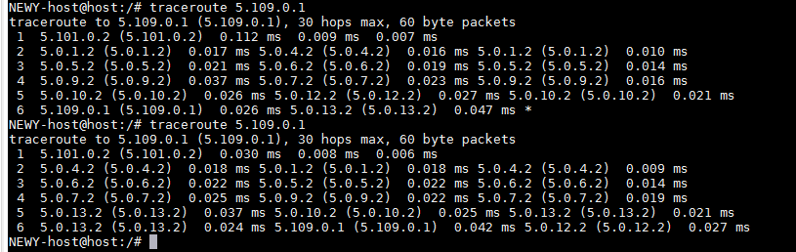

Notice: the difference in the hops is present starting from second hop.

1. iBGP – Internal BGP: The peers often use loopback (in our case the host interface) interface IP addresses for BGP peering to achieve higher availability.

The commands used in our case are:

**router bgp 5** ! Specifies the AS number our particular BGP is part of

**bgp router-id 5.101.0.1** !This uniquely identifies the router and the purpose of BGP Router-ID is to recover from TCP session collision.

**neighbor 5.102.0.1 remote-as 5** ! Checks if the remote Ip address is in the same as specified and peers if it is in the same AS

**neighbor 5.102.0.1 update-source host** ! To have higher availability the neighbors are defined are defined as part of loopback or host. Even if the link fails the routes arrive through redundant interface.

**neighbor 5.102.0.1 next-hop-self** ! This command actually puts the route learned from different AS on the routing table. Else, host from different AS can’t reach the host in our AS and vice-versa.

Below is the command as applied on NEWY router:

**!For NEWY**

**router bgp 5**

**bgp router-id 5.101.0.1**

**neighbor 5.102.0.2 remote-as 5**

**neighbor 5.102.0.2 update-source host**

**neighbor 5.102.0.2 next-hop-self**

**neighbor 5.103.0.2 remote-as 5**

**neighbor 5.103.0.2 update-source host**

**neighbor 5.103.0.2 next-hop-self**

**neighbor 5.104.0.2 remote-as 5**

**neighbor 5.104.0.2 update-source host**

**neighbor 5.104.0.2 next-hop-self**

**neighbor 5.105.0.2 remote-as 5**

**neighbor 5.105.0.2 update-source host**

**neighbor 5.105.0.2 next-hop-self**

**neighbor 5.106.0.2 remote-as 5**

**neighbor 5.106.0.2 update-source host**

**neighbor 5.106.0.2 next-hop-self**

**neighbor 5.107.0.2 remote-as 5**

**neighbor 5.107.0.2 update-source host**

**neighbor 5.107.0.2 next-hop-self**

**neighbor 5.108.0.2 remote-as 5**

**neighbor 5.108.0.2 update-source host**

**neighbor 5.108.0.2 next-hop-self**

**neighbor 5.109.0.2 remote-as 5**

**neighbor 5.109.0.2 update-source host**

**neighbor 5.109.0.2 next-hop-self**

**!**

The screenshot of **show ip bgp summary**

