PRODAPT
Pipeline Builder
Self-Service Pipeline Platform — Product Walkthrough
Prepared for Director review

What is Pipeline Builder?
A guided, self-service platform for designing, validating and monitoring data pipelines
────────────────────────────────────────
- Replaces hand-written Airflow DAGs and manual connection JSON with a guided wizard
- Template-driven: 8 pipeline templates across PostgreSQL, MySQL, Oracle, SQL Server, S3, Kafka, REST API, BigQuery
- Reusable connections: configure a source/target once, reuse across pipelines
- Schema discovery & drag-to-map column mapping
- Built-in Data Quality monitoring with AI-assisted failure analysis
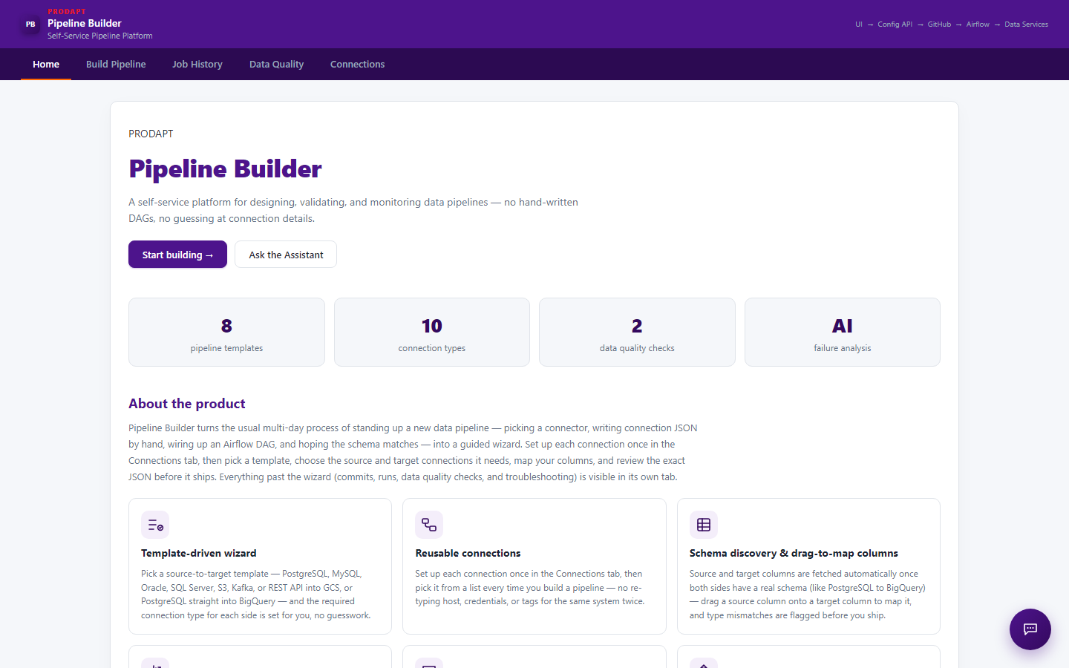

Build Pipeline
A 6-step guided wizard: Template → Source → Target → Mapping → Details → Review
────────────────────────────────────────
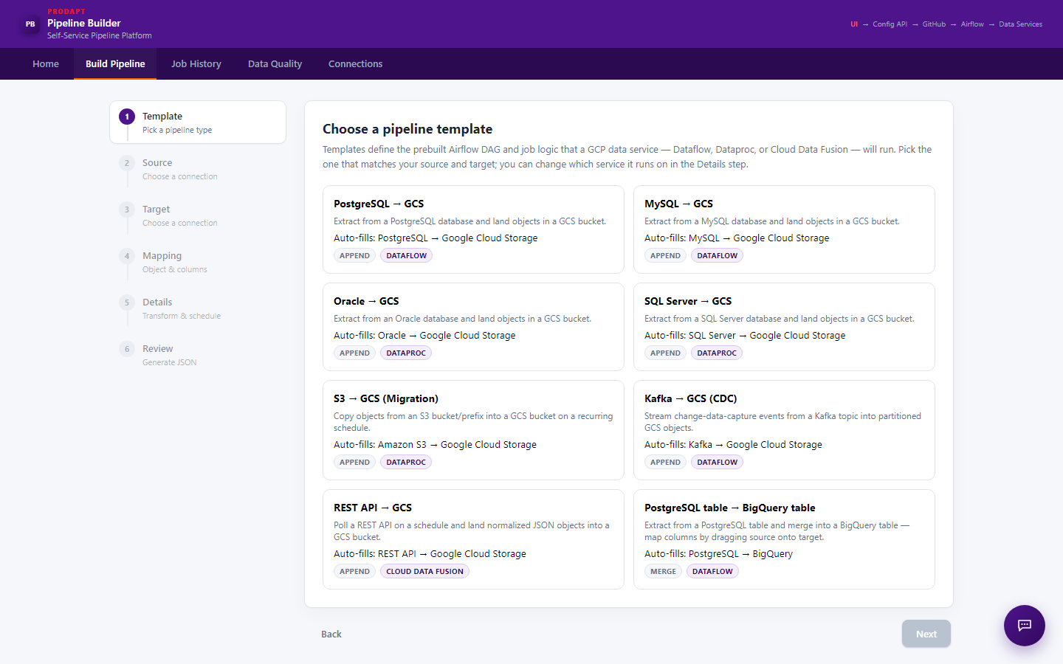

Job History
Run status and logs reported back from Airflow through the Config API for every generated pipeline
────────────────────────────────────────
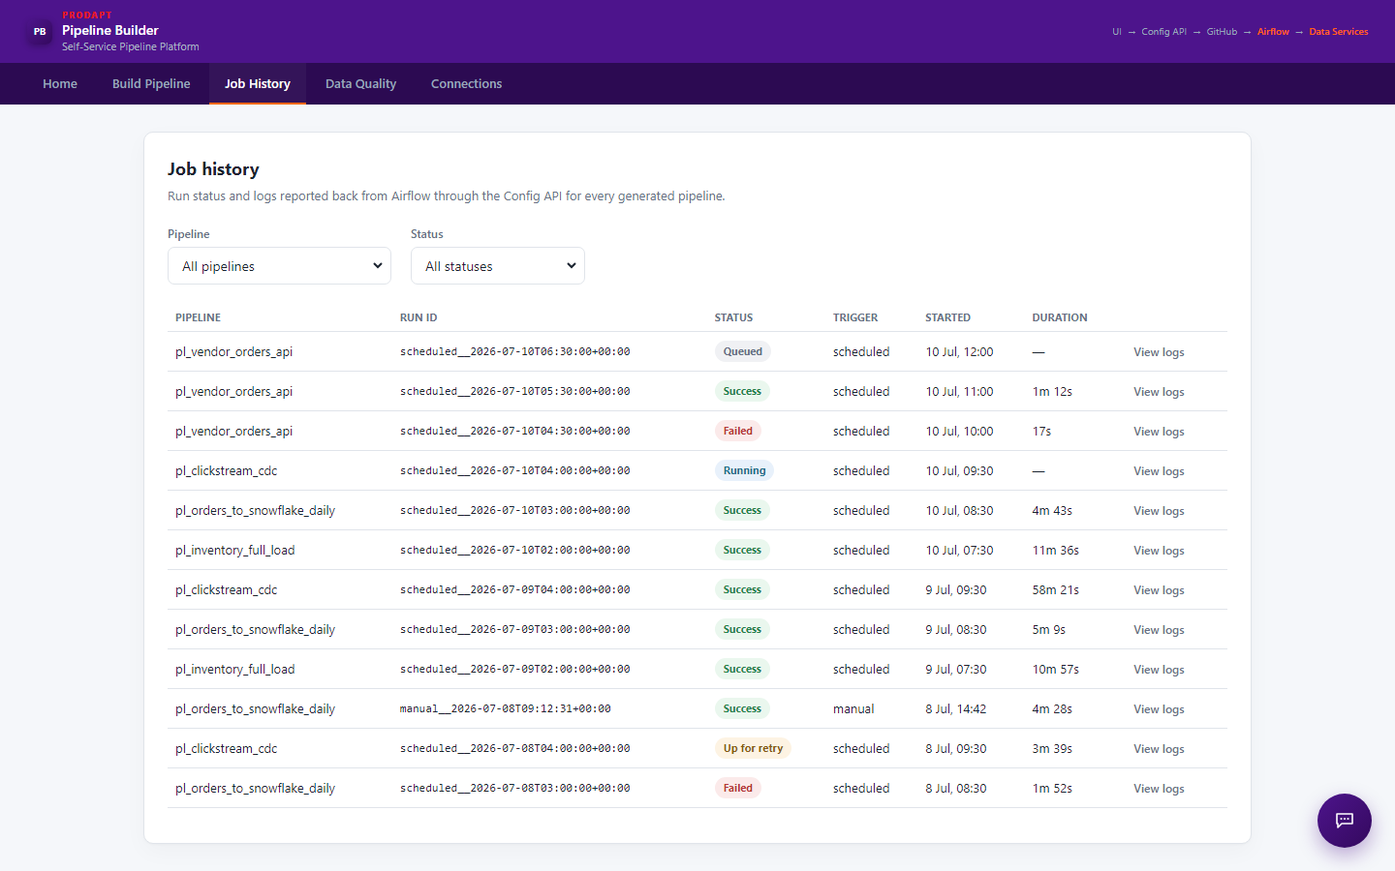

Data Quality — Improved Initial State
Fix: the pipeline dropdown no longer auto-selects a pipeline on load, so no check results are shown until the user chooses one
────────────────────────────────────────
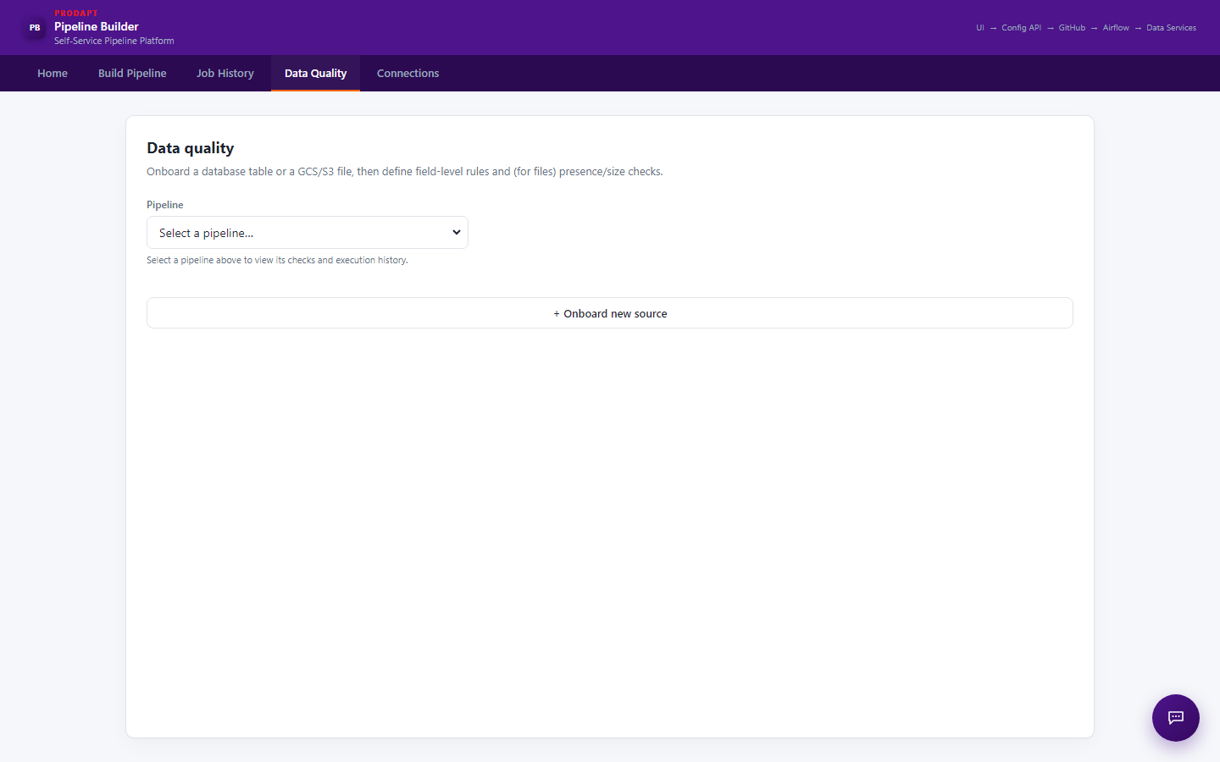

Data Quality — After Selecting a Pipeline
Once a pipeline is chosen from the dropdown, its checks, generated SQL, size trend and execution history appear
────────────────────────────────────────
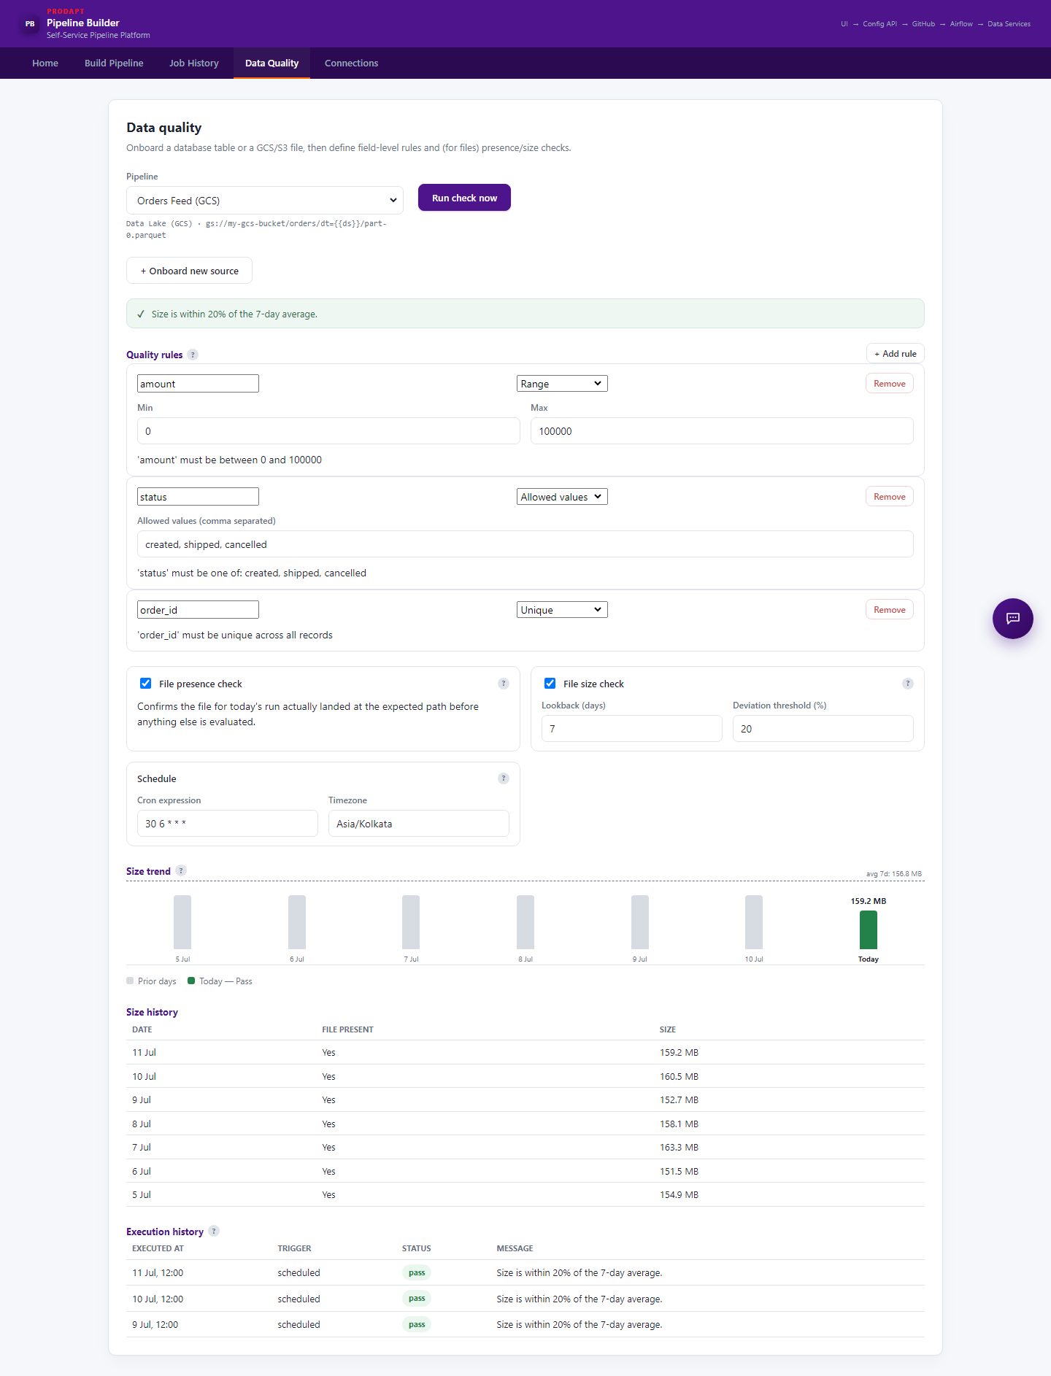

Connections
Set connection details up once, then reuse them from any pipeline's Source or Target step
────────────────────────────────────────
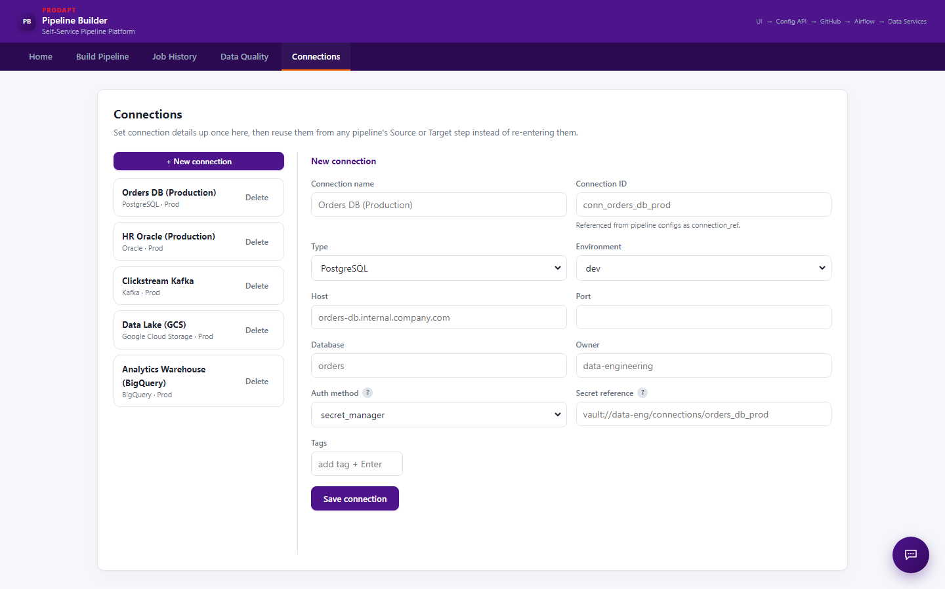

Summary
────────────────────────────────────────
- Home, Build Pipeline, Job History, Data Quality and Connections cover the full pipeline lifecycle in one UI
- Recent improvement: Data Quality tab no longer pre-selects a pipeline on load — users now explicitly choose a pipeline before seeing its checks, avoiding confusion with stale/default results
- Next: continue hardening Data Quality onboarding flow and expand AI-assisted failure analysis coverage

