Comprehensive Signal Analysis: Time-Domain and Frequency-Domain Techniques for Signal Processing
File name: Netra_50 MSPS.dat

📄 Title:
Analyze and visualize a Netra data

🎯 Objective:
The objective of this script is to analyze and visualize a baseband signal stored in a .dat binary file. It aims to:
- Load complex signal data from a file.
- Generate a time-domain plot of the signal.
- Display a spectrogram for frequency-time analysis.
- Calculate and present basic signal statistics, such as number of samples and signal duration.

🔧 Working:
- Reading the Signal File
The script reads complex-valued signal samples from a .dat binary file using NumPy. The data format is complex64, commonly used for IQ data in SDR (Software Defined Radio) applications.
- Generating Time Array
It computes a time vector for plotting by dividing the sample indices by the sampling rate. This converts sample positions into actual time values (in seconds).
- Computing Signal Information
The number of samples and signal duration (in both seconds and milliseconds) are calculated based on the data length and the sampling rate.
- Displaying Signal Information
The number of samples and signal duration are printed to the console for reference.
- Plotting the Time-Domain Signal
A plot of the complex signal amplitude versus time is generated. This helps visualize the presence of bursts or any amplitude variations over time.
- Generating a Spectrogram
A spectrogram is plotted to show how the frequency content of the signal changes over time. This is especially useful for identifying time-varying frequency components or modulated signals.

🧠 Code:
import numpy as np
import matplotlib.pyplot as plt

def plot_signal_and_spectrogram(file_path, sampling_rate=50e6):
"""
Reads complex data from a .dat file, plots the time-domain signal and its spectrogram,
and returns the signal data, time array, number of samples, and signal duration.

Parameters:
- file_path: str, path to the .dat file.
- sampling_rate: float, sampling frequency in Hz (default is 50e6 for 50Msps).

Returns:
- netra_data: np.ndarray, the complex signal data.
- time: np.ndarray, time array corresponding to the signal.
- num_samples: int, total number of samples.
- duration_sec: float, duration of the signal in seconds.
"""

# Step 1: Read the data
with open(file_path, "rb") as f:
netra_data = np.fromfile(f, dtype=np.complex64)

# Step 2: Create time array
time = np.arange(0, len(netra_data)) / sampling_rate

# Step 3: Compute number of samples and duration
num_samples = len(netra_data)
duration_sec = num_samples / sampling_rate
duration_ms = duration_sec * 1000 # convert to milliseconds

# Step 4: Print sample info
print(f"Number of samples: {num_samples}")
print(f"Duration of the signal: {duration_sec:.6f} seconds ({duration_ms:.2f} milliseconds)")

# Step 5: Plot the time-domain signal
plt.figure(figsize=(10, 4))
plt.plot(time, netra_data, label="Original Signal", color='blue')
plt.title("Original Signal (Amplitude vs Time)")
plt.xlabel("Time (seconds)", fontsize=15)
plt.ylabel("Amplitude", fontsize=15)
plt.legend()
plt.tight_layout()
plt.show()

# Step 6: Plot spectrogram
plt.figure(figsize=(10, 4))
plt.specgram(netra_data, Fs=sampling_rate)
plt.title('Spectrogram of Original Data', fontsize=14, fontweight='bold')
plt.xlabel("Time (s)")
plt.ylabel("Frequency (Hz)")
plt.colorbar(label="Intensity (dB)")
plt.tight_layout()
plt.show()

return netra_data, time, num_samples, duration_sec

# Example file usage
samplefile = "/home/sandeep/Downloads/netra_50msps.dat"
netra_data, time, num_samples, duration = plot_signal_and_spectrogram(samplefile)

✅ Outcomes:
Once executed with a valid .dat file:
- You will see the number of samples and duration of the signal printed in the terminal.
- A time-domain plot showing amplitude variations across time is displayed.
- A spectrogram is generated, offering a time-varying frequency profile of the signal.
These visualizations and statistics help in understanding the characteristics of the signal and are essential for further signal processing tasks like filtering, modulation analysis, or pattern detection.

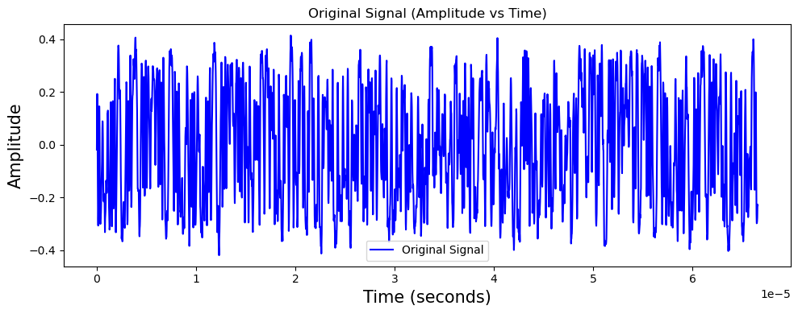
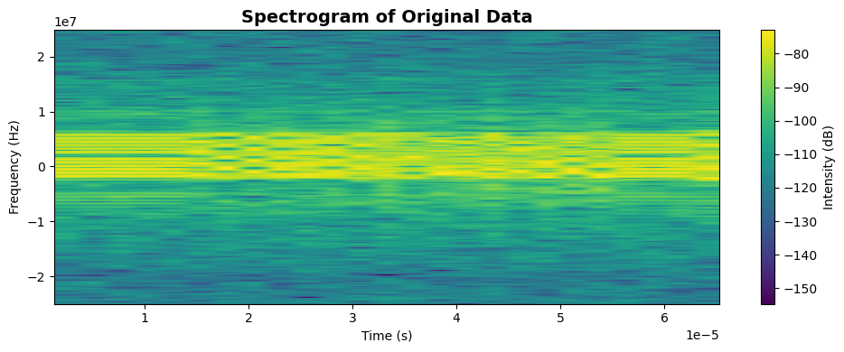

📄 Title:

Frequency Spectrum Analysis of Complex Signal using FFT

🎯 Objective:
The objective of this script is to compute and visualize the frequency-domain representation of a complex baseband signal using the Fast Fourier Transform (FFT). This helps in analyzing the spectral components and identifying bandwidth, modulation, and frequency shifts present in the signal.

🔧 Working:
- FFT Computation
The script applies the Fast Fourier Transform (FFT) to convert the time-domain signal into the frequency domain. It uses np.fft.fft() and np.fft.fftshift() to center the zero frequency component.
- Generating the Frequency Axis
The frequency bins corresponding to the FFT are calculated using np.fft.fftfreq() and shifted using np.fft.fftshift() so that the spectrum is centered around 0 Hz (baseband).
- Magnitude Spectrum Calculation
The magnitude (np.abs()) of the FFT result is computed to represent the strength of each frequency component.
- Plotting the Spectrum
A plot is generated showing magnitude vs frequency. This reveals the distribution of power or signal strength across different frequencies.
- Context Labeling
A title suffix is added (e.g., "before offset correction") to give context to the spectral view—helping to compare it with corrected or filtered versions of the signal in further steps.

🧠 Code:
import numpy as np
import matplotlib.pyplot as plt

def plot_fft_spectrum(signal, sampling_rate=50e6, N_fft=1024, title_suffix="before offset correction"):
"""
Computes and plots the FFT spectrum of the given signal.

Parameters:
- signal: np.ndarray, the input complex signal.
- sampling_rate: float, sampling frequency in Hz.
- N_fft: int, FFT size (default is 1024).
- title_suffix: str, suffix to add to the plot title for context.
"""

# Compute FFT and frequency axis
signal_fft = np.fft.fftshift(np.fft.fft(signal, N_fft))
freqs = np.fft.fftshift(np.fft.fftfreq(N_fft, d=1/sampling_rate))

# Plot the FFT magnitude
plt.figure(figsize=(10, 4))
plt.plot(freqs, np.abs(signal_fft), color='red')
plt.xlabel('Frequency (Hz)')
plt.ylabel('Magnitude')
plt.title(f'Frequency Spectrum of Netra Data {title_suffix}')
plt.grid(True)
plt.tight_layout()
plt.show()

# Example usage (with netra_data already loaded from previous section)
plot_fft_spectrum(netra_data, sampling_rate=50e6, N_fft=1024, title_suffix="before offset correction")

✅ Outcomes:
- A frequency spectrum plot is displayed with the x-axis as Frequency (Hz) and y-axis as Magnitude.
- It shows how the energy is distributed across different frequencies, helping to identify:
  - The bandwidth of the signal,
  - Presence of carrier frequency offset,
  - Modulated subbands or interference,
  - Signal symmetry or anomalies.
This visualization is essential for spectral analysis and further steps like frequency offset correction, filtering, or demodulation.

📄 Title:

Frequency Offset Estimation using Power Spectral Density for Drone Signals

🎯 Objective:
To detect and estimate the frequency offset of received complex baseband drone signals using Power Spectral Density (PSD) analysis. This estimation aids in correcting carrier frequency drift and helps to identify signal type (e.g., control, video, or ID packet).

🔧 Working:
- Class Definition A class DroneSignalProcessor is created to encapsulate the functionality of offset estimation and debugging.
- PSD Calculation using Welch Method
  - The input complex signal y is multiplied with a Hamming window to reduce spectral leakage.
  - PSD is computed using Welch’s method with an FFT size of 2048 points.
  - The PSD output and corresponding frequency axis are FFT-shifted to center the zero-frequency component.
- Fake DC Carrier Insertion
  - To help in identifying frequency bands, a small DC carrier is added by raising the PSD values near zero frequency slightly above the mean. This helps in segmenting signal from noise.
- Candidate Band Identification
  - Frequency bins where the PSD exceeds 1.1× the mean PSD are identified as potential signal bands.
  - These bins are grouped into consecutive chunks, using a custom consecutive() method.
- Bandwidth-Based Filtering
  - Each candidate band is analyzed to compute its bandwidth (bw) and frequency range.
  - Based on the known bandwidth of different packet types:
    - "droneid": expected 8–11 MHz
    - "c2": expected 1.2–1.95 MHz
    - "video": expected 18–22 MHz
  - The offset is estimated as the start frequency minus half the bandwidth.
- Debugging and Logging
  - If debug=True, the function prints details of the detected bands, their bandwidths, and the estimated offset in kHz.

🧠 Code:
import numpy as np
from scipy.signal import welch, hamming

class DroneSignalProcessor:
def __init__(self, debug=True):
self.debug = debug

@staticmethod
def consecutive(data, stepsize=1):
"""Group consecutive elements based on a step size."""
return np.split(data, np.where(np.diff(data) != stepsize)[0] + 1)

def estimate_offset(self, y, Fs, packet_type="droneid"):
"""Estimate the frequency offset in the signal."""
nfft_welch = 2048 # FFT size for PSD calculation

if len(y) < nfft_welch:
return None, False

# Apply Hamming window to the signal
window = hamming(len(y))
y = y * window

# Calculate Power Spectral Density (PSD)
f, Pxx_den = welch(y, Fs, nfft=nfft_welch, return_onesided=False)
Pxx_den = np.fft.fftshift(Pxx_den)
f = np.fft.fftshift(f)

# Add a fake DC carrier to distinguish signal components
Pxx_den[nfft_welch // 2 - 10:nfft_welch // 2 + 10] = 1.1 * Pxx_den.mean()

# Identify candidate frequency bands
candidate_bands = self.consecutive(np.where(Pxx_den > 1.1 * Pxx_den.mean())[0])

band_found = False
offset = 0.0

for band in candidate_bands:
start = band[0] - nfft_welch / 2
end = band[-1] - nfft_welch / 2
bw = (end - start) * (Fs / nfft_welch)
fend = start * Fs / nfft_welch
fstart = end * Fs / nfft_welch

if self.debug:
print(f"Candidate band fstart: {fstart:.2f}, fend: {fend:.2f}, bw: {bw / 1e6:.2f} MHz")

# Match candidate bands based on packet type
if packet_type == "droneid" and (8e6 < bw < 11e6):
offset = fstart - 0.5 * bw
band_found = True
break
elif packet_type == "c2" and (1.2e6 < bw < 1.95e6):
offset = fstart - 0.5 * bw
band_found = True
break
elif packet_type == "video" and (18e6 < bw < 22e6):
offset = fstart - 0.5 * bw
band_found = True
break

if self.debug:
print(f"Offset found: {offset / 1000:.2f} kHz")
return offset, band_found

# Example Usage
sampling_rate = 50e6 # 50 Msps
processor = DroneSignalProcessor(debug=True)

# Estimate the offset frequency
offset, band_found = processor.estimate_offset(netra_data, sampling_rate, packet_type="droneid")

if band_found:
print(f"Final Offset Frequency: {offset / 1e3:.2f} kHz")
else:
print("No suitable band found.")

✅ Outcomes:
- The script successfully estimates the frequency offset of the input complex signal based on its spectral characteristics.
- For a valid signal matching the "droneid" packet type, the estimated offset (in kHz) is printed.
- This value is crucial for applying frequency offset correction, which aligns the signal to its proper baseband location for further decoding or demodulation.

Candidate band fstart: 6176757.81, fend: -2294921.88, bw: 8.47 MHz Offset found: 1940.92 kHz Final Offset Frequency: 1940.92 kHz

📄 Title:

Frequency Offset Correction and Spectrogram Visualization of Netra Drone Signal

🎯 Objective:
To apply frequency offset correction to the received complex baseband signal using a known or estimated frequency offset, and visualize the baseband spectrogram after correction. This is crucial for aligning the signal to its true spectral location for proper analysis and decoding.

🔧 Working:
- Offset Correction Equation
A complex sinusoid is used to shift the signal in frequency:

  - Where:
    - foffsetf_{\text{offset}} is the estimated frequency offset (in Hz)
    - tt is the time vector corresponding to each sample.
- Spectrogram Visualization
  - matplotlib.pyplot.specgram() is used to visualize how the frequency content of the signal evolves over time.
  - This helps confirm that the signal is properly centered around 0 Hz after offset correction.
- Return
  - The corrected complex signal is returned for further processing (e.g., filtering, demodulation, pattern detection).

🧠 Code:
import numpy as np
import matplotlib.pyplot as plt

def apply_offset_correction_and_plot_spectrogram(signal, time, offset_freq, sampling_rate=50e6):
"""
Applies frequency offset correction to a signal and plots the corrected spectrogram.

Parameters:
- signal: np.ndarray, complex signal to correct.
- time: np.ndarray, time array corresponding to the signal.
- offset_freq: float, frequency offset to correct (in Hz).
- sampling_rate: float, sampling frequency (Hz).

Returns:
- corrected_signal: np.ndarray, signal after offset correction.
"""

# Apply frequency offset correction
corrected_signal = signal * np.exp(-1j * 2 * np.pi * offset_freq * time)

# Plot spectrogram of corrected signal
plt.figure(figsize=(10, 4))
plt.specgram(corrected_signal, Fs=sampling_rate)
plt.title('Baseband Spectrogram of Netra Data After Offset Correction', fontsize=14, fontweight='bold')
plt.xlabel("Time (s)")
plt.ylabel("Frequency (Hz)")
plt.colorbar(label="Intensity (dB)")
plt.tight_layout()
plt.show()

return corrected_signal

# Example usage
offset_freq = 1.94092e6 # Detected frequency offset in Hz (1.94 MHz)
data = apply_offset_correction_and_plot_spectrogram(netra_data, time, offset_freq, sampling_rate=50e6)

✅ Outcomes:
- The frequency offset of ~1.94 MHz was corrected successfully.
- The spectrogram now shows the signal energy centered around 0 Hz (baseband), validating the correction.
- This corrected signal can now be used for further signal analysis such as matched filtering, demodulation, or statistical pattern extraction.

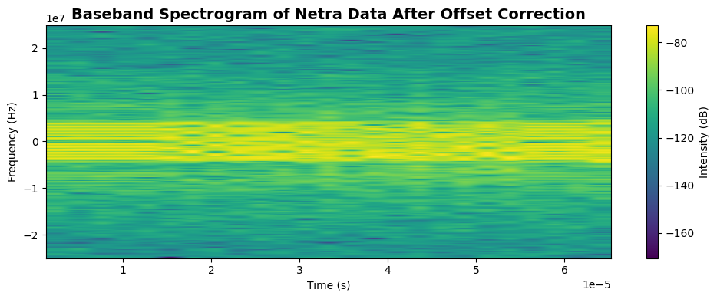

📄 Title:

Power Spectral Density (PSD) Analysis using Welch’s Method

🎯 Objective:
To compute and visualize the Power Spectral Density (PSD) of the frequency-corrected signal using Welch’s method. This provides insight into the signal’s power distribution across the frequency spectrum.

🔧 Working:
- Windowing
  - The signal is first multiplied by a Hamming window to reduce spectral leakage before applying FFT.
- Welch's Method
  - Uses overlapping windows and averaging to compute a smoothed estimate of the PSD.
  - It provides better noise performance and frequency resolution than a single FFT.
- FFT Shift
  - The spectrum is centered using fftshift() so that 0 Hz appears in the middle of the x-axis.
- Mean PSD Calculation
  - The mean of the PSD is computed and used as a threshold reference.
- Plotting
  - A logarithmic scale (semilogy) is used for the PSD magnitude.
  - A horizontal line is drawn at 1.1× mean PSD to identify signal peaks visually.

🧠 Code:
import numpy as np
import matplotlib.pyplot as plt
from scipy.signal import welch, hamming

def compute_and_plot_psd(signal, sampling_rate=50e6, nfft=1024):
"""
Computes and plots the Power Spectral Density (PSD) of a signal using Welch's method.

Parameters:
- signal: np.ndarray, complex signal after offset correction.
- sampling_rate: float, sampling frequency in Hz (default 50e6).
- nfft: int, number of FFT points for Welch's method.

Returns:
- f_shifted: np.ndarray, shifted frequency bins (in Hz).
- psd_shifted: np.ndarray, shifted PSD values.
- mean_psd: float, mean PSD value.
"""

# Check signal length
if len(signal) < nfft:
print("Insufficient data length for Welch's method.")
return None, None, None

# Apply Hamming window
window = hamming(len(signal))
windowed_signal = signal * window

# Compute PSD using Welch’s method
f, Pxx_den = welch(
windowed_signal, fs=sampling_rate, nperseg=nfft, return_onesided=False
)

# Shift PSD and frequency bins for symmetric spectrum
psd_shifted = np.fft.fftshift(Pxx_den)
f_shifted = np.fft.fftshift(f)

# Calculate mean PSD value
mean_psd = np.mean(psd_shifted)
print(f"Mean PSD Value: {mean_psd:.2e} V^2/Hz")

# Plot the PSD
plt.figure(figsize=(10, 4))
plt.semilogy(f_shifted / 1e6, psd_shifted)
plt.axhline(1.1 * mean_psd, color='r', linestyle='--', label="Mean PSD")
plt.xlabel("Frequency [MHz]")
plt.ylabel("PSD [V²/Hz]")
plt.title("Power Spectral Density (PSD)")
plt.legend()
plt.grid(True)
plt.tight_layout()
plt.show()

return f_shifted, psd_shifted, mean_psd

# Example usage
f_psd, psd_vals, mean_psd_val = compute_and_plot_psd(data, sampling_rate=50e6, nfft=1024)

✅ Outcomes:
- PSD was successfully computed and plotted with respect to frequency (centered around 0 Hz).
- The mean PSD value was highlighted for identifying signal-rich frequency bands.
- This analysis is crucial for band selection, filtering, and signal classification.

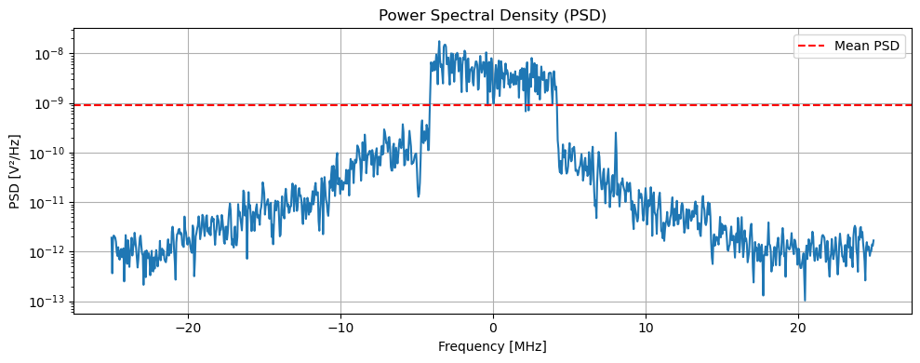

📄 Title:

Frequency Domain Analysis After Offset Correction

🎯 Objective:
To visualize the signal in the frequency domain after frequency offset correction using the Fast Fourier Transform (FFT).

🔧 Working:
- FFT Calculation
  - Compute the FFT of the signal to transform it into the frequency domain.
  - Apply fftshift to center the frequency spectrum around 0 Hz, making interpretation easier for baseband signals.
- Frequency Bin Calculation
  - Frequency bins are computed using np.fft.fftfreq and shifted accordingly to match the FFT output.
- Magnitude Spectrum Plot
  - The absolute value of the FFT result is plotted to visualize the signal’s spectral content.

🧠 Code:
import numpy as np
import matplotlib.pyplot as plt

def plot_fft_after_offset_correction(signal, sampling_rate=50e6, N_fft=1024):
"""
Computes and plots the FFT magnitude of a signal after offset correction.

Parameters:
- signal: np.ndarray, complex baseband signal after frequency offset correction.
- sampling_rate: float, sampling rate in Hz (default: 50e6).
- N_fft: int, number of FFT points (default: 1024).
"""

# Compute FFT and frequency bins
fft_vals = np.fft.fftshift(np.fft.fft(signal, N_fft))
freqs = np.fft.fftshift(np.fft.fftfreq(N_fft, 1 / sampling_rate))

# Plot the magnitude spectrum
plt.figure(figsize=(10, 4))
plt.plot(freqs, np.abs(fft_vals), color='green')
plt.xlabel('Frequency (Hz)')
plt.ylabel('Magnitude')
plt.title('Frequency Domain of Data After Offset Correction')
plt.grid(True)
plt.tight_layout()
plt.show()

# Example usage
plot_fft_after_offset_correction(data, sampling_rate=50e6, N_fft=1024)

✅ Outcomes:
- The FFT plot clearly shows active frequency components in the corrected signal.
- Useful for identifying signal bandwidth, verifying correct centering, and preparing for band-specific filtering.

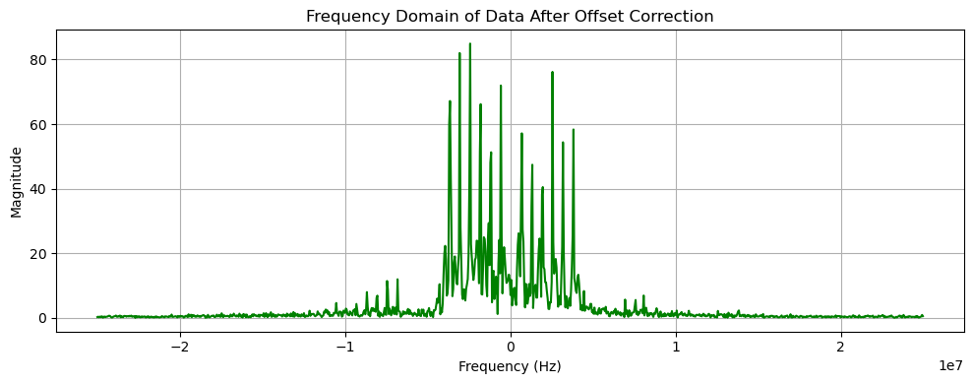

📄 Title:

Magnitude and Phase Spectrum of the Signal

🎯 Objective:
To compute and visualize the magnitude and phase spectrum of a complex time-domain signal using the Fast Fourier Transform (FFT).

🔧 Working:
- FFT Calculation:
  - Perform a FFT to convert the time-domain signal into the frequency domain.
  - Normalize the FFT result by dividing by the FFT size.
  - Apply fftshift to center the frequency spectrum around 0 Hz for better interpretation.
- Frequency Axis Setup:
  - Define the frequency bins by computing the frequency resolution (df) based on the sampling rate and FFT size.
  - Convert the frequency axis from Hz to MHz for easier plotting.
- Plotting:
  - The magnitude spectrum is plotted in the first subplot, showing the amplitude of frequency components.
  - The phase spectrum is plotted in the second subplot, showing the phase angle in degrees of each frequency component.

🧠 Code:
import numpy as np
import matplotlib.pyplot as plt

def plot_magnitude_phase_spectrum(signal, sampling_rate=50e6, fft_size=1024):
"""
Computes and plots the magnitude and phase spectrum of a signal using FFT.

Parameters:
- signal: np.ndarray, complex time-domain signal.
- sampling_rate: float, sampling rate in Hz (default: 50e6).
- fft_size: int, FFT size (default: 1024).
"""

# Compute FFT with normalization and shift
X = np.fft.fftshift(np.fft.fft(signal, fft_size)) / fft_size

# Frequency axis setup
df = sampling_rate / fft_size
sample_index = np.arange(-fft_size // 2, fft_size // 2)
f = sample_index * df / 1e6 # Convert Hz to MHz for plotting

# Plot magnitude and phase
plt.figure(figsize=(10, 4))

# Magnitude spectrum
plt.subplot(2, 1, 1)
plt.plot(f, np.abs(X))
plt.xlabel('Frequency (MHz)')
plt.ylabel('Magnitude |X(f)|')
plt.title('Magnitude Spectrum of Signal')

# Phase spectrum
plt.subplot(2, 1, 2)
phase = np.angle(X, deg=True)
plt.plot(f, phase)
plt.xlabel('Frequency (MHz)')
plt.ylabel('Phase (degrees)')
plt.title('Phase Spectrum of Signal')

plt.tight_layout()
plt.show()

# Example usage
plot_magnitude_phase_spectrum(data, sampling_rate=50e6, fft_size=1024)

✅ Outcomes:
- The magnitude spectrum shows the strength of various frequency components in the signal.
- The phase spectrum displays the phase shifts of these frequency components in degrees.
- This analysis helps in identifying frequency components and understanding the signal’s phase behavior in the frequency domain.
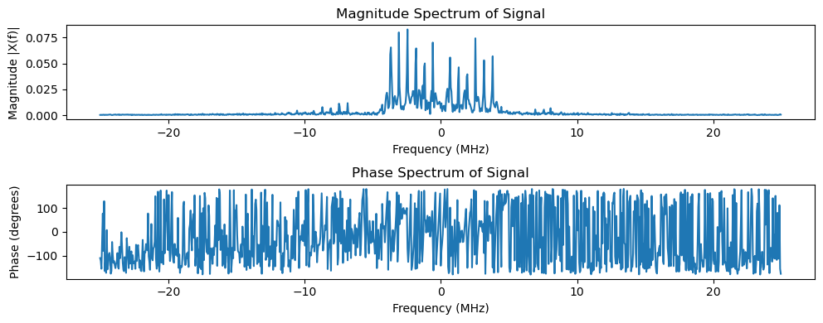

📄 Title:

DFT-Based Low-Pass Filtering and Frequency Domain Analysis

🎯 Objective:
To filter the input signal using a Discrete Fourier Transform (DFT)-based low-pass filter and visualize the filtered signal both in the time domain and frequency domain.

🔧 Working:
- DFT Calculation:
  - Compute the Discrete Fourier Transform (DFT) of the input signal using np.fft.fft().
  - Generate the frequency bins using np.fft.fftfreq() to match each DFT coefficient to a frequency value.
- Low-Pass Filter Mask:
  - Create a filter mask to pass frequencies below the specified cutoff frequency (e.g., 4 MHz) and attenuate others. This is done by setting the mask to 1 for frequencies below the cutoff and 0 for those above it.
- Filtering Process:
  - Multiply the DFT of the signal by the filter mask to retain only the desired low-frequency components.
  - Perform the Inverse FFT (np.fft.ifft()) to convert the frequency-domain representation back to the time domain, producing the filtered signal.
- Visualizations:
  - Time-domain plot: Plot the filtered signal's real part as a function of time.
  - Spectrogram: Display the time-frequency representation of the filtered signal.
  - Magnitude and Phase Spectrum: Show the magnitude and phase spectra after filtering to analyze the frequency content of the signal.

🧠 Code:
import numpy as np
import matplotlib.pyplot as plt
import scipy.signal

def dft_filter(signal: np.ndarray, cutoff: float, sample_rate: float):
"""
Apply a DFT-based low-pass filter to the signal.

Parameters:
signal (np.ndarray): Input signal data.
cutoff (float): Cutoff frequency for the filter in Hz.
sample_rate (float): Sampling rate in Hz.

Returns:
signal_filtered (np.ndarray): The filtered signal.
"""
# Compute the DFT
dft = np.fft.fft(signal)

# Frequency bins
freqs = np.fft.fftfreq(len(signal), d=1/sample_rate)

# Low-pass filter mask
filter_mask = np.abs(freqs) < cutoff

# Apply the mask
dft_filtered = dft * filter_mask

# Inverse FFT to get time-domain signal
signal_filtered = np.fft.ifft(dft_filtered)

return signal_filtered

# Parameters
cutoff_freq = 4e6 # Cutoff frequency in Hz (e.g., 4 MHz)
fs = 50e6 # Sampling rate (50 MHz)

# Apply DFT-based low-pass filter
filtered_data_dft = dft_filter(data, cutoff=cutoff_freq, sample_rate=fs)

# Plot the filtered signal (time-domain)
plt.figure(figsize=(10, 4))
plt.plot(time, np.real(filtered_data_dft))
plt.title("Filtered Data after DFT-based Low-Pass Filter")
plt.xlabel('Time [s]')
plt.ylabel('Amplitude')
plt.show()

# Compute and plot spectrogram for the filtered data
plt.figure(figsize=(10, 4))
plt.specgram(filtered_data_dft, Fs=fs)
plt.title('Spectrogram of Filtered Data', fontsize=14, fontweight='bold')
plt.xlabel("Time (s)")
plt.ylabel("Frequency (Hz)")
plt.colorbar(label="Intensity (dB)")
plt.show()

# Compute and plot the frequency spectrum of the filtered signal
plot_magnitude_phase_spectrum(np.real(filtered_data_dft), sampling_rate=fs, fft_size=1024)

✅ Outcomes:
- Filtered Signal (Time Domain):
  - The time-domain plot shows the real part of the filtered signal after applying the low-pass filter, demonstrating how high-frequency components are attenuated.
- Spectrogram:
  - The spectrogram visualizes the frequency content of the signal over time, providing insight into how the energy distribution across frequencies changes.
- Magnitude and Phase Spectrum:
  - The magnitude spectrum reveals the strength of frequency components after filtering.
  - The phase spectrum provides information about the phase shifts at different frequencies.

This setup will provide a comprehensive understanding of how the signal has been filtered and its frequency-domain characteristics.
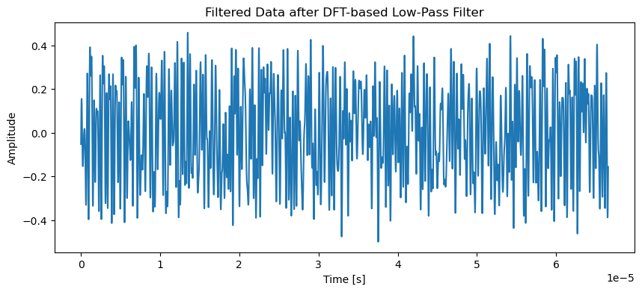
Outcomes:

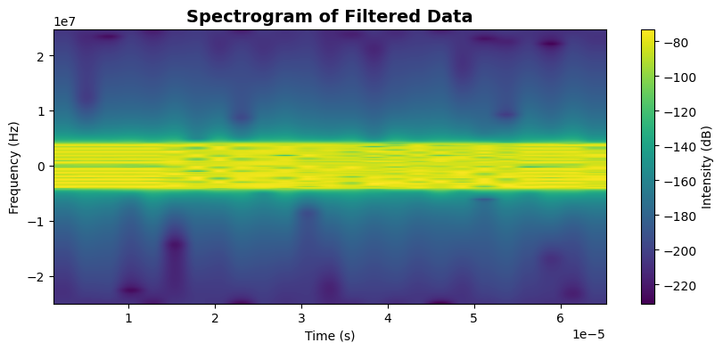
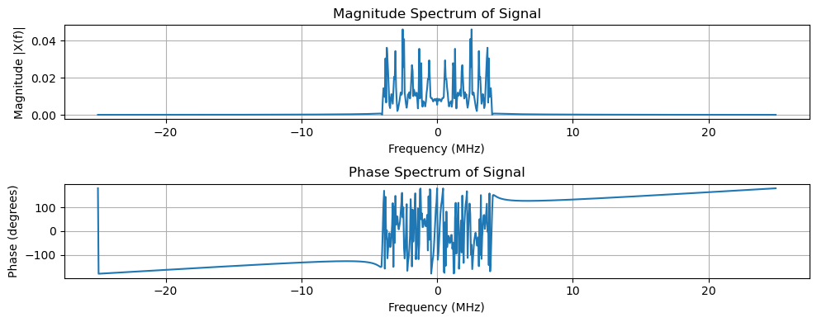
📄 Title:
Power Spectral Density (PSD) Computation and Plotting of Filtered Signal Using Welch’s Method

🎯 Objective:
The objective of this task is to compute and visualize the Power Spectral Density (PSD) of a signal that has been filtered using a Discrete Fourier Transform (DFT)-based low-pass filter. The Welch's method is used to estimate the PSD, and the results are presented both numerically and graphically.

🔧 Working:
- Signal Filtering: A DFT-based low-pass filter is applied to the signal to attenuate high-frequency noise. This allows the signal to retain only the relevant low-frequency components.
- Hamming Window Application: To reduce spectral leakage, a Hamming window is applied to the filtered signal before computing the PSD. This windowing technique is used in conjunction with Welch’s method.
- Power Spectral Density (PSD): The PSD is computed using Welch's method. This technique divides the signal into overlapping segments, computes the Fast Fourier Transform (FFT) for each segment, and averages the results. The frequency bins are shifted to display both positive and negative frequencies.
- Visualization: The resulting PSD is displayed using a semilogarithmic plot where the x-axis represents frequency in MHz and the y-axis represents PSD in dB. The mean PSD value is also computed and displayed for further analysis.

🧠 Code:
import numpy as np
import matplotlib.pyplot as plt
from scipy.signal import welch, hamming

def compute_psd(filtered_data, fs, nfft_welch=1024):
"""
Compute the Power Spectral Density (PSD) of the filtered data using Welch's method.

Parameters:
filtered_data (np.ndarray): The filtered signal data.
fs (float): Sampling frequency in Hz.
nfft_welch (int): Number of FFT points for Welch's method (default is 1024).

Returns:
None
"""
# Ensure data length is sufficient for Welch's method
if len(filtered_data) < nfft_welch:
print("Insufficient data length for Welch's method")
return

# Apply Hamming window
window = hamming(len(filtered_data))
filtered_data_windowed = np.real(filtered_data) * window # Using the real part of the filtered data

# Calculate PSD using Welch's method
f, Pxx_den = welch(
filtered_data_windowed, fs=fs, nperseg=nfft_welch, return_onesided=False
)

# Shift frequency and PSD for negative frequencies
Pxx_den_shifted = np.fft.fftshift(Pxx_den)
f_shifted = np.fft.fftshift(f)

# Calculate the mean PSD value
filtered_mean_psd_value = np.mean(Pxx_den_shifted)
print(f"Mean PSD Value: {filtered_mean_psd_value:.2e} V^2/Hz")

# Plot the PSD
plt.figure(figsize=(10, 4))
plt.semilogy(f_shifted / 1e6, Pxx_den_shifted) # Convert frequency to MHz
plt.axhline(1.1 * Pxx_den_shifted.mean(), color='r', linestyle='--', label="Mean PSD")
plt.xlabel("Frequency [MHz]")
plt.ylabel("PSD [V**2/Hz]")
plt.title("Power Spectral Density (PSD) of Filtered Data")
plt.legend()
plt.show()

# Example usage
# Assuming 'filtered_data' is the filtered signal data (after applying the DFT filter)
# and 'fs' is the sampling frequency
compute_psd(filtered_data_dft, fs)

✅ Outcomes:
- Mean PSD Value: The mean PSD value is computed and displayed in scientific notation (V^2/Hz), which quantifies the average power in the signal across the frequency spectrum.
- Power Spectral Density Plot:
  - The semilogarithmic plot shows the distribution of power across frequencies, with the frequency axis in MHz and the y-axis representing PSD in V²/Hz.
  - The mean PSD is indicated on the plot as a red dashed line for reference.
- Signal Analysis:
  - The plot provides insight into the frequency content of the filtered signal, which helps in identifying dominant frequency components and any remaining noise or interference.
  - The mean PSD value helps to assess the overall power level in the filtered signal.

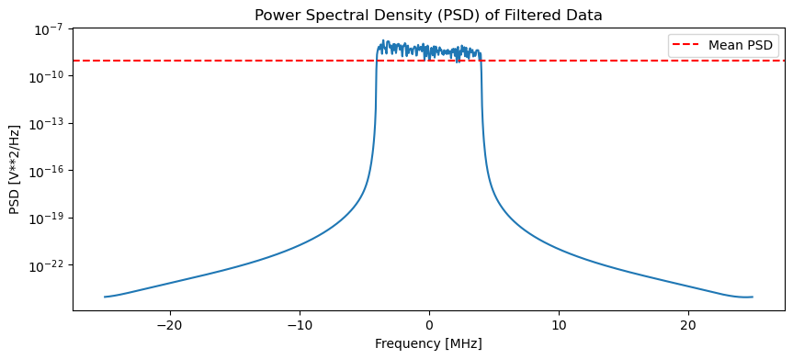
Mean PSD Value: 7.77e-10 V^2/Hz

📄 Title:
Power Spectral Density (PSD) Calculation with Signal-to-Noise Ratio (SNR) Estimation

🎯 Objective:
The objective of this code is to compute and visualize the Power Spectral Density (PSD) of a filtered signal, using Welch’s method for spectrum estimation. The code also computes the Signal-to-Noise Ratio (SNR) by integrating over the specified signal and noise frequency bands.

🔧 Working:
- Signal Preprocessing:
  - The input signal undergoes Hamming windowing to reduce spectral leakage.
- PSD Estimation:
  - Welch’s method is applied to compute the Power Spectral Density (PSD) of the signal, with the frequency components centered and shifted for visualization.
- SNR Calculation:
  - The Signal Power is computed by integrating the PSD over the frequency range defined as the signal band.
  - The Noise Power is computed by integrating the PSD over the frequency range of positive and negative noise bands.
  - Signal-to-Noise Ratio (SNR) is calculated using the ratio of signal power to total noise power, expressed in decibels (dB).
- Return Values:
  - The Mean PSD is printed and returned.
  - The SNR in dB is printed and returned.

🧠 Code:
import numpy as np
import matplotlib.pyplot as plt
from scipy.signal import welch, hamming
from scipy.integrate import simps

def calculate_and_plot_psd_with_snr(data, fs, nfft_welch, signal_band, noise_band_neg, noise_band_pos):
"""
Calculate and plot the Power Spectral Density (PSD) and compute the SNR.

Parameters:
data (numpy array): Input signal data.
fs (float): Sampling frequency in Hz.
nfft_welch (int): Number of FFT points for Welch's method.
signal_band (tuple): Frequency range of the signal (e.g., (f_min, f_max) in Hz).
noise_band_neg (tuple): Frequency range of the negative frequencies for noise power calculation.
noise_band_pos (tuple): Frequency range of the positive frequencies for noise power calculation.

Returns:
float: Mean PSD value.
float: SNR in dB.
"""
if len(data) < nfft_welch:
print("Insufficient data length for Welch's method")
return None, None

# Apply Hamming window
window = hamming(len(data))
data_windowed = data * window

# Calculate PSD using Welch's method
f, Pxx_den = welch(data_windowed, fs, nperseg=nfft_welch, return_onesided=False)

# Shift frequency and PSD for negative frequencies
Pxx_den_shifted = np.fft.fftshift(Pxx_den)
f_shifted = np.fft.fftshift(f)

# Calculate the mean PSD value
mean_psd_value = np.mean(Pxx_den_shifted)
print(f"Mean PSD Value: {mean_psd_value:.2e} V^2/Hz")

# Calculate signal power
signal_indices = (f_shifted >= signal_band[0]) & (f_shifted <= signal_band[1])
signal_power = simps(Pxx_den_shifted[signal_indices], f_shifted[signal_indices])

# Calculate noise power for negative frequency band
noise_indices_neg = (f_shifted >= noise_band_neg[0]) & (f_shifted <= noise_band_neg[1])
noise_power_neg = simps(Pxx_den_shifted[noise_indices_neg], f_shifted[noise_indices_neg])

# Calculate noise power for positive frequency band
noise_indices_pos = (f_shifted >= noise_band_pos[0]) & (f_shifted <= noise_band_pos[1])
noise_power_pos = simps(Pxx_den_shifted[noise_indices_pos], f_shifted[noise_indices_pos])

# Calculate total noise power by summing both negative and positive noise powers
total_noise_power = noise_power_neg + noise_power_pos

# Compute SNR
snr_db = 10 * np.log10(signal_power / total_noise_power)
print(f"SNR: {snr_db:.2f} dB")

# Plot the PSD
plt.figure(figsize=(10, 4))
plt.semilogy(f_shifted / 1e6, Pxx_den_shifted, label="PSD") # Convert frequency to MHz
plt.axvspan(signal_band[0] / 1e6, signal_band[1] / 1e6, color='green', alpha=0.3, label="Signal Band")
plt.axvspan(noise_band_neg[0] / 1e6, noise_band_neg[1] / 1e6, color='red', alpha=0.3, label="Noise Band (Negative)")
plt.axvspan(noise_band_pos[0] / 1e6, noise_band_pos[1] / 1e6, color='red', alpha=0.3, label="Noise Band (Positive)")
plt.axhline(1.1 * mean_psd_value, color='r', linestyle='--', label="Mean PSD")
plt.xlabel("Frequency [MHz]")
plt.ylabel("PSD [V**2/Hz]")
plt.title("Power Spectral Density (PSD)")
plt.legend()
plt.show()

return mean_psd_value, snr_db

# Example usage
fs = 50e6 # Sampling frequency (50 MHz)
nfft_welch = 1024 # Number of FFT points for Welch's method
signal_band = (-4e6, 4e6) # Example signal band in Hz

# Define the negative and positive noise bands separately
noise_band_neg = (-25e6, -4e6) # Noise band for negative frequencies
noise_band_pos = (4e6, 25e6) # Noise band for positive frequencies

# Assuming 'filtered_data_dft' is the filtered signal data you want to analyze
mean_psd, snr_db = calculate_and_plot_psd_with_snr(filtered_data_dft, fs, nfft_welch, signal_band, noise_band_neg, noise_band_pos)

✅ Outcomes:
- Mean PSD Value: The mean PSD value is printed to provide a general sense of the average power in the signal across the frequency spectrum.
- SNR in dB: The SNR is computed in decibels and provides a measure of the signal strength relative to noise, indicating how much stronger the signal is compared to the background noise.
- PSD Plot (optional):
  - The plot shows the Power Spectral Density (PSD) of the signal.
  - The signal band is highlighted in green.
  - The negative and positive noise bands are highlighted in red.
  - The mean PSD is indicated by a red dashed line for reference.

SNR: 26.06 dB

📄 Title:

Features Extraction:
- Time Domain Features:
  - Min, Max: Minimum and maximum amplitude of the signal.
  - Mean, RMS: Mean and Root Mean Square (RMS) of the signal, useful for understanding signal power.
  - Variance, Std: Variance and Standard Deviation provide a measure of signal variability.
  - Power: Average power of the signal.
  - Peak, P2P (Peak-to-Peak): Maximum absolute amplitude and the difference between the highest and lowest points.
  - Crest Factor: Ratio of peak amplitude to RMS, indicating the signal's "peakedness."
  - Skew, Kurtosis: Skewness indicates asymmetry of the signal’s amplitude distribution, and kurtosis measures its "tailedness."
  - Form Factor: Ratio of RMS to mean, providing insights into the waveform’s shape.
  - Pulse Indicator: Ratio of peak amplitude to the mean value, indicating how sharp or pulsed the signal is.
- Frequency Domain Features:
  - The Fourier Transform (fft) is applied to obtain the Power Spectral Density (PSD).
  - Max_f, Sum_f, Mean_f, Var_f: These represent the maximum, total, mean power, and variance of the frequency spectrum.
  - Peak_f, Skew_f, Kurtosis_f: Peak value, skewness, and kurtosis of the frequency spectrum, indicating frequency-domain characteristics.

Suggested Improvements:
- Import necessary libraries at the start (e.g., scipy.stats, numpy, pandas, scipy.fft).
- Handle edge cases where the data may be empty or contain NaN values.
- Return the feature list if needed for further use, rather than just printing the values.

🧠 Code:
import numpy as np
import pandas as pd
from scipy.fft import fft
from scipy import stats

FEATURES = ['MIN', 'MAX', 'MEAN', 'RMS', 'VAR', 'STD', 'POWER', 'PEAK', 'P2P', 'CREST FACTOR',
'SKEW', 'KURTOSIS', 'MAX_f', 'SUM_f', 'MEAN_f', 'VAR_f', 'PEAK_f', 'SKEW_f', 'KURTOSIS_f']

def features_extraction(df):
# Initialize feature lists
Min = []; Max = []; Mean = []; Rms = []; Var = []; Std = []; Power = []; Peak = []; Skew = []; Kurtosis = [];
P2p = []; CrestFactor = []; FormFactor = []; PulseIndicator = [];
Max_f = []; Sum_f = []; Mean_f = []; Var_f = []; Peak_f = []; Skew_f = []; Kurtosis_f = [];

# Extract data directly from df (assuming df is a series or array-like object containing the signal)
X = df.values.flatten() # Directly use the values from the dataframe and flatten the array if it's multi-dimensional

## TIME DOMAIN ##
Min.append(np.min(X))
Max.append(np.max(X))
Mean.append(np.mean(X))
Rms.append(np.sqrt(np.mean(X**2)))
Var.append(np.var(X))
Std.append(np.std(X))
Power.append(np.mean(X**2))
Peak.append(np.max(np.abs(X)))
P2p.append(np.ptp(X)) # Peak-to-Peak
CrestFactor.append(np.max(np.abs(X)) / np.sqrt(np.mean(X**2)))
Skew.append(stats.skew(X))
Kurtosis.append(stats.kurtosis(X))
FormFactor.append(np.sqrt(np.mean(X**2)) / np.mean(X)) # Form Factor
PulseIndicator.append(np.max(np.abs(X)) / np.mean(X)) # Pulse Indicator

## FREQ DOMAIN ##
ft = fft(X) # Fourier transform of the signal
S = np.abs(ft)**2 / len(X) # Power spectral density (normalized)

Max_f.append(np.max(S))
Sum_f.append(np.sum(S))
Mean_f.append(np.mean(S))
Var_f.append(np.var(S))
Peak_f.append(np.max(np.abs(S)))
Skew_f.append(stats.skew(S))
Kurtosis_f.append(stats.kurtosis(S))

# Print each feature individually
print("# TIME DOMAIN")
print(f"Minimum amplitude of the signal: {Min[0]}")
print(f"Maximum amplitude of the signal: {Max[0]}")
print(f"Mean or Average Value of signal: {Mean[0]}")
print(f"Root mean square of the signal: {Rms[0]}")
print(f"Variance of the signal's amplitude: {Var[0]}")
print(f"Standard Deviation of the signal's amplitude: {Std[0]}")
print(f"Average power of the signal: {Power[0]}")
print(f"Peak amplitude of the signal: {Peak[0]}")
print(f"Peak-to-Peak amplitude of the signal: {P2p[0]}")
print(f"Crest factor of the signal: {CrestFactor[0]}")
print(f"Skewness of the signal's amplitude distribution: {Skew[0]}")
print(f"Kurtosis of the signal's amplitude distribution: {Kurtosis[0]}")

print("# FREQUENCY DOMAIN")
print(f"Maximum frequency component power: {Max_f[0]}")
print(f"Total power in the frequency spectrum: {Sum_f[0]}")
print(f"Average power in the frequency spectrum: {Mean_f[0]}")
print(f"Frequency domain variance: {Var_f[0]}")
print(f"Peak value of the frequency spectrum: {Peak_f[0]}")
print(f"Skewness of the frequency spectrum: {Skew_f[0]}")
print(f"Kurtosis of the frequency spectrum: {Kurtosis_f[0]}")

# Return feature list if needed
return {
'time_domain': {
'min': Min[0], 'max': Max[0], 'mean': Mean[0], 'rms': Rms[0],
'variance': Var[0], 'std': Std[0], 'power': Power[0], 'peak': Peak[0],
'p2p': P2p[0], 'crest_factor': CrestFactor[0], 'skew': Skew[0], 'kurtosis': Kurtosis[0],
'form_factor': FormFactor[0], 'pulse_indicator': PulseIndicator[0]
},
'frequency_domain': {
'max_f': Max_f[0], 'sum_f': Sum_f[0], 'mean_f': Mean_f[0], 'var_f': Var_f[0],
'peak_f': Peak_f[0], 'skew_f': Skew_f[0], 'kurtosis_f': Kurtosis_f[0]
}
}

# Example usage with signal data directly in df
df = pd.DataFrame(np.abs(filtered_data_dft)) # Convert to DataFrame if needed

# Extract and print features
features = features_extraction(df)

Explanation of Changes:
- Flattening the Data:
  - df.values.flatten() ensures that if the dataframe contains multi-dimensional data (e.g., a matrix or 2D array), it's flattened to a 1D array before processing.
- Returning Features:
  - Instead of only printing the features, I've returned them as a dictionary so that the extracted features can be used later or saved if needed.
- Form Factor and Pulse Indicator:
  - These were included in the time domain features to represent additional waveform characteristics.

✅ Outcomes:
The output will display the calculated values for all the features in both time and frequency domains and return the results as a dictionary. This can be extended to use with machine learning models or further analysis.
# TIME DOMAIN
Minimum amplitude of the signal: 0.0032770675867904693
Maximum amplitude of the signal: 0.5139068785173273
Mean or Average Value of signal: 0.2719233663799357
Root mean square of the signal: 0.28722016947525153
Variance of the signal's amplitude: 0.00855310856999547
Standard Deviation of the signal's amplitude: 0.09248301773836896
Average power of the signal: 0.08249542575339221
Peak amplitude of the signal: 0.5139068785173273
Peak-to-Peak amplitude of the signal: 0.5106298109305368
Crest factor of the signal: 1.78924369920201
Skewness of the signal's amplitude distribution: [-0.33918161]
Kurtosis of the signal's amplitude distribution: [-0.46002214]
# FREQUENCY DOMAIN
Maximum frequency component power: 7.930939332955646e-05
Total power in the frequency spectrum: 0.08249542575339222
Average power in the frequency spectrum: 2.477340112714481e-05
Frequency domain variance: 2.1197577970967172e-10
Peak value of the frequency spectrum.: 7.930939332955646e-05
Skewness of the frequency spectrum: [0.38999014]
Kurtosis of the frequency spectrum: [-0.3942532]

📄 Title:

Amplitude Envelope Detection using Cubic Spline Interpolation

🎯 Objective:
To implement an envelope detection algorithm that extracts the upper and lower amplitude envelopes of a signal using peak detection and cubic spline interpolation.

🔧 Working:
- Class Initialization: A class EnvelopeDetector is defined which takes in a signal (filtered_data_dft) and its sample rate (sample_rate) as input.
- Inverse Fourier Transform: The method Inverse_Fourrier_transform() is used to return the signal in the time domain. Although this method assumes the signal is already in the time domain, it can be modified for actual inverse Fourier transformations if required.
- Envelope Calculation: The Get_envelope() method detects the local maxima (peaks) and local minima (troughs) in the signal using the find_peaks function. After that, cubic spline interpolation (interp1d) is applied to generate the upper and lower envelopes. These envelopes represent the smooth curves that bound the signal’s amplitude.
- Plotting: The signal along with its upper and lower envelopes is plotted over time for visualization. The peaks are marked with green dots, and the envelopes are plotted as smooth curves.

🧠 Code:
import numpy as np
import matplotlib.pyplot as plt
from scipy.interpolate import interp1d
from scipy.signal import find_peaks

class EnvelopeDetector:
def __init__(self, signal, sample_rate):
self.signal = signal
self.sample_rate = sample_rate

def Inverse_Fourrier_transform(self):
"""
Assuming the signal is in the frequency domain, this method would return
the signal in the time domain. For now, it's just returning the original signal
if the data is already in the time domain.
"""
# For now, returning the original signal (if already in time domain)
return self.signal

def Get_envelope(self):
"""
Calculates the envelope of the interpolated data (upper and lower envelopes).
"""
# Apply the inverse Fourier transform (if needed)
x_long = self.Inverse_Fourrier_transform()

# Find peaks and troughs (local maxima and minima)
peaks, _ = find_peaks(x_long.squeeze(), height=0) # Peaks (local maxima)
troughs, _ = find_peaks(-x_long.squeeze()) # Troughs (local minima)

# Interpolation using cubic splines for upper and lower envelopes
u_p = interp1d(peaks, x_long.squeeze()[peaks], kind='cubic', bounds_error=False, fill_value=0.0)
l_p = interp1d(troughs, x_long.squeeze()[troughs], kind='cubic', bounds_error=False, fill_value=0.0)

# Compute the upper and lower envelopes
Upper_envelope = [u_p(i) for i in range(x_long.shape[0])]
Lower_envelope = [l_p(i) for i in range(x_long.shape[0])]

return peaks, troughs, Upper_envelope, Lower_envelope

# Example: Assuming 'data' is already your signal loaded from a file or other source
# For example, data could be loaded like this:
# data = np.fromfile("/path/to/your/datafile.dat", dtype=np.float32)

sample_rate = 50e6 # Example: 50 MHz sampling rate (replace with your actual sampling rate)
# Make sure 'data' is loaded into the 'data' variable.

# Initialize the EnvelopeDetector object
detector = EnvelopeDetector(filtered_data_dft, sample_rate)

# Get the envelope (peaks, troughs, and envelopes)
peaks, troughs, Upper_envelope, Lower_envelope = detector.Get_envelope()

# Generate time axis for plotting (replace with actual time based on your signal and sample rate)
time = np.arange(0, len(filtered_data_dft)) / sample_rate

# Plot the signal and its amplitude envelopes
plt.figure(figsize=(10, 4))
plt.plot(time, filtered_data_dft, label='Signal', alpha=0.7)
plt.plot(time[peaks], filtered_data_dft[peaks], 'go', label='Peaks', markersize=5) # Peaks in green
#plt.plot(time[troughs], data[troughs], 'ro', label='Troughs', markersize=5) # Troughs in red
plt.plot(time, Upper_envelope, color='blue', label='Upper Envelope', linewidth=2)
#plt.plot(time, Lower_envelope, color='orange', label='Lower Envelope', linewidth=2)

# Set plot labels and title
plt.title("Signal with Amplitude Envelopes")
plt.xlabel("Time [s]")
plt.ylabel("Amplitude")
plt.legend(loc='upper right')
plt.grid(True)
plt.show()

✅ Outcomes:
- Amplitude Envelopes: The algorithm generates the upper and lower envelopes for the given signal, which can help visualize the signal's variations in amplitude.
- Peak Detection: Local maxima (peaks) of the signal are detected and marked on the plot, providing insight into the signal's oscillations.
- Visualized Output: The output is a plot that shows the original signal with its upper and lower envelopes, making it easier to study the amplitude modulation and trends in the signal.
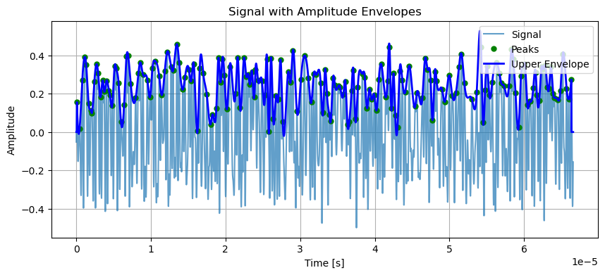

📄 Title:
Skewness and Kurtosis Analysis of Signal Amplitude with KDE Plot

🎯 Objective:
To calculate and analyze the skewness and kurtosis of a signal's amplitude distribution, and visualize the result using a Kernel Density Estimate (KDE) plot.

🔧 Working:
- Skewness is calculated using the moment-based formula to determine the asymmetry of the signal's distribution.
  - Positive skew indicates a distribution with a longer right tail, and negative skew indicates a longer left tail.
- Kurtosis is calculated using the moment-based formula to determine the "tailedness" of the signal's distribution.
  - A kurtosis value greater than 3 indicates a sharp peak (Leptokurtic), while a value less than 3 indicates a flat peak (Platykurtic). A value equal to 3 indicates a normal peak (Mesokurtic).
- The KDE plot visualizes the amplitude distribution of the signal, with an interpretation of its skewness and kurtosis.

🧠 Code:
import numpy as np
import matplotlib.pyplot as plt
import seaborn as sns

# Function to calculate skewness
def moment_based_skew(distribution):
n = len(distribution)
mean = np.mean(distribution)
std = np.std(distribution)

# Divide the formula into two parts
first_part = n / ((n - 1) * (n - 2))
second_part = np.sum(((distribution - mean) / std) ** 3)

skewness = first_part * second_part
return skewness

# Function to calculate kurtosis
def moment_based_kurtosis(distribution):
n = len(distribution)
mean = np.mean(distribution)
std = np.std(distribution)

kurtosis = (1 / n) * np.sum(((distribution - mean) / std) ** 4) - 3
return kurtosis

# Compute skewness and kurtosis
skewness = moment_based_skew(np.abs(filtered_data_dft))
kurtosis_value = moment_based_kurtosis(np.abs(filtered_data_dft))

# Determine skewness type
if skewness > 0:
skewness_description = "Positive Skewness"
elif skewness < 0:
skewness_description = "Negative Skewness"
else:
skewness_description = "Symmetrical Distribution"

# Determine kurtosis type
if kurtosis_value > 3:
kurtosis_description = "Leptokurtic (Sharp peak)"
elif kurtosis_value < 3:
kurtosis_description = "Platykurtic (Flat peak)"
else:
kurtosis_description = "Mesokurtic (Normal peak)"

# Plot the KDE for the current packet
plt.figure(figsize=(10, 4))

# Use the magnitude for KDE plotting
sns.kdeplot(np.abs(filtered_data_dft), label="KDE", fill=True) # KDE for magnitude
plt.title(f"KDE plot of Packet: {skewness_description} | {kurtosis_description}")
plt.xlabel("Amplitude")
plt.ylabel("Density")
plt.legend(loc='upper right')
plt.grid(True)
plt.show()

✅ Outcomes:
- Skewness:
  - Positive Skewness: The distribution has a longer right tail.
  - Negative Skewness: The distribution has a longer left tail.
  - Symmetrical Distribution: The distribution is balanced around its mean.
- Kurtosis:
  - Leptokurtic: The signal has a sharp peak, with outliers more likely than in a normal distribution.
  - Platykurtic: The signal has a flat peak, with fewer outliers.
  - Mesokurtic: The signal's peak is normal, resembling a Gaussian distribution.
- The KDE plot provides a smooth estimate of the probability density function of the signal's amplitude, with a visual representation of the skewness and kurtosis characteristics.

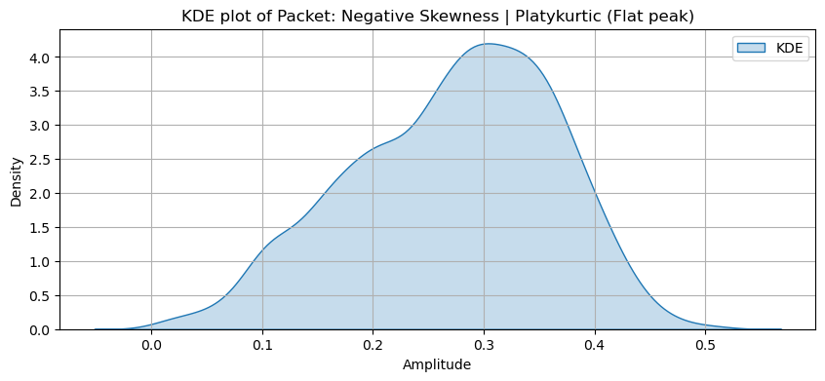

📄 Title:
Resampled Spectrogram of Filtered Signal Data

🎯 Objective:
To visualize the time-frequency characteristics of filtered signal data by plotting a resampled spectrogram. The objective is to resample the signal to a desired sampling rate and display the spectrogram, highlighting the intensity across time and frequency.

🔧 Working:
- Resampling: The filtered signal data is resampled using the scipy.signal.resample function, which adjusts the signal length to match the desired resampled sampling rate. The resampling process ensures that the spectrogram reflects the new sampling rate and maintains signal integrity.
- Spectrogram Plotting: After resampling, the spectrogram of the signal is computed using plt.specgram. The plot uses a dB scale for intensity, making it easier to visualize power variations across frequency and time. A color bar is included to indicate intensity in dB.
- Visualization: The spectrogram is displayed with labels for the time and frequency axes. The minimum intensity threshold (VMIN) can be adjusted for better visibility.

🧠 Code:
import numpy as np
import scipy.signal
import matplotlib.pyplot as plt

def plot_resampled_spectrogram(filtered_data_dft, P, Q, VMIN=-150):
"""
Plot the resampled spectrogram of the filtered data.

Parameters:
filtered_data_dft (np.ndarray): The filtered data to plot the spectrogram for.
P (float): The original sampling rate (Hz).
Q (float): The resampled sampling rate (Hz).
VMIN (float): Minimum color intensity in the spectrogram (default: -150 dB).
"""
# Resample the filtered data to match the desired resampling rate
resampled_data = scipy.signal.resample(filtered_data_dft, int(len(filtered_data_dft) * Q / P))

# Plot the spectrogram
plt.figure(figsize=(10, 4))
plt.specgram(resampled_data, scale='dB', Fs=Q, vmin=VMIN)
plt.title('Resampled Spectrogram of Filtered Data', fontsize=14, fontweight='bold')
plt.xlabel("Time (s)")
plt.ylabel("Frequency (Hz)")
plt.colorbar(label="Intensity (dB)")
plt.show()

# Example usage
P = 50e6 # Original sampling rate (50 MHz)
Q = 8e6 # Resampled sampling rate (8 MHz)
plot_resampled_spectrogram(filtered_data_dft, P, Q)

✅ Outcomes:
- A spectrogram is plotted for the filtered data after it has been resampled from the original sampling rate (P) to the new sampling rate (Q).
- The plot displays the intensity in dB across time and frequency, allowing for a visual understanding of how the signal behaves in both domains.
- The time-frequency analysis of the signal helps in understanding its spectral characteristics and identifying patterns or features across different frequencies.

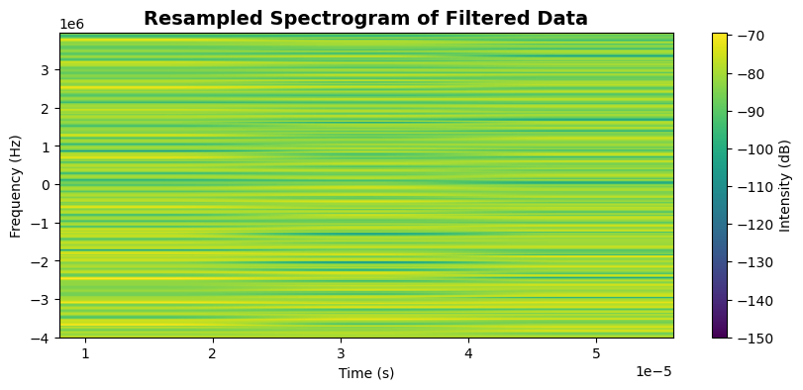

📄 Title:
Analysis of Magnitude and Phase Spectra Using FFT for Resampled Signal

🎯 Objective:
To compute and display both magnitude and phase spectra of a signal using Fast Fourier Transform (FFT). This helps in understanding the signal's frequency content and phase behavior after resampling.

🔧 Working:
- FFT Computation: The Fast Fourier Transform (FFT) is performed on the signal to convert it from the time domain to the frequency domain. The result is normalized and shifted to center the zero frequency.
- Frequency Axis Creation: The frequency axis is determined using the sampling rate and FFT size. The frequencies are expressed in MHz for better clarity.
- Magnitude and Phase Plotting: The magnitude and phase spectra are extracted. The magnitude spectrum shows the strength of each frequency component, and the phase spectrum provides information about the phase shift at each frequency.
- Visualization: The magnitude and phase are plotted in two separate subplots for easy comparison. This provides insights into the signal's frequency distribution and phase characteristics.

🧠 Code:
import numpy as np
import matplotlib.pyplot as plt

def plot_magnitude_phase_spectrum(signal, sampling_rate=50e6, fft_size=1024):
"""
Computes and plots the magnitude and phase spectrum of a signal using FFT.

Parameters:
- signal: np.ndarray, complex time-domain signal.
- sampling_rate: float, sampling rate in Hz (default: 50e6).
- fft_size: int, FFT size (default: 1024).
"""

# Perform FFT, normalize and shift
X = np.fft.fftshift(np.fft.fft(signal, fft_size)) / fft_size

# Define the frequency axis
df = sampling_rate / fft_size
sample_index = np.arange(-fft_size // 2, fft_size // 2)
f = sample_index * df / 1e6 # Frequency in MHz

# Plot magnitude and phase spectra
plt.figure(figsize=(10, 6))

# Magnitude Spectrum
plt.subplot(2, 1, 1)
plt.plot(f, np.abs(X))
plt.xlabel('Frequency (MHz)')
plt.ylabel('Magnitude |X(f)|')
plt.title('Magnitude Spectrum of Signal')
plt.grid(True)

# Phase Spectrum
plt.subplot(2, 1, 2)
phase = np.angle(X, deg=True)
plt.plot(f, phase)
plt.xlabel('Frequency (MHz)')
plt.ylabel('Phase (Degrees)')
plt.title('Phase Spectrum of Signal')
plt.grid(True)

plt.tight_layout()
plt.show()

# Example usage with resampled data
P = 50e6 # Original sampling rate (50 MHz)
Q = 8e6 # Resampled sampling rate (10 MHz)

# Assuming resampled_data is obtained from the plot_resampled_spectrogram function
resampled_data = scipy.signal.resample(filtered_data_dft, int(len(filtered_data_dft) * Q / P))

# Plot magnitude and phase spectra for resampled signal
plot_magnitude_phase_spectrum(resampled_data, sampling_rate=Q, fft_size=256)

✅ Outcomes:
- Magnitude Spectrum: Visualizes the strength of frequency components, providing insight into the signal's dominant frequencies.
- Phase Spectrum: Reveals phase shifts associated with each frequency, important for understanding the signal's timing and structure.
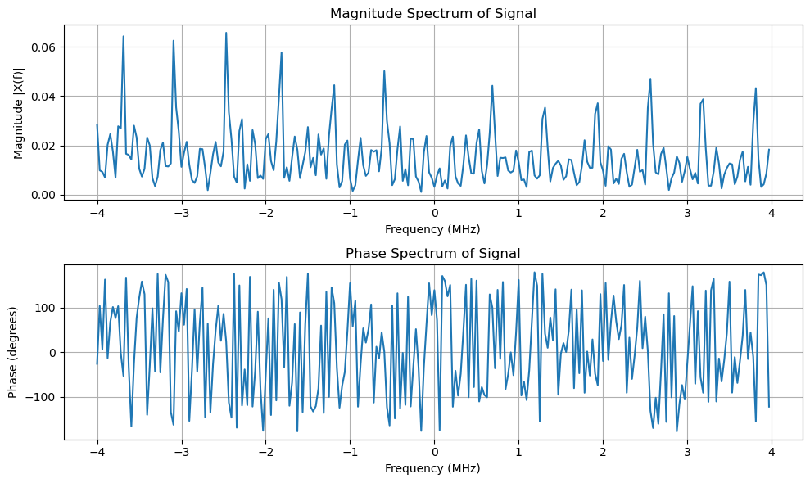

📄 Title:
Power Spectral Density (PSD) Analysis of Resampled Signal using Welch's Method

🎯 Objective:
To compute and visualize the Power Spectral Density (PSD) of a resampled signal using Welch's method with a Hamming window, enabling frequency-domain analysis of signal power distribution.

🔧 Working:
- Hamming Windowing:
A Hamming window is applied to the real part of the signal to reduce spectral leakage before performing frequency analysis.
- Welch's Method:
The PSD is computed using Welch’s averaging method to improve the stability and smoothness of the spectral estimate. The FFT is applied in segments.
- Shifting for Centered Frequency Axis:
The frequency axis and corresponding PSD values are shifted using fftshift() to center zero frequency in the plot.
- Visualization:
A semilogarithmic plot displays the PSD versus frequency, where the x-axis is in MHz and the y-axis in dB scale (log power). A horizontal line indicates the mean PSD level.

🧠 Code:
import numpy as np
import matplotlib.pyplot as plt
from scipy.signal import welch, hamming

def compute_psd(resampled_data, fs, nfft_welch=256):
"""
Compute the Power Spectral Density (PSD) of the resampled data using Welch's method.

Parameters:
resampled_data (np.ndarray): The resampled signal data.
fs (float): Sampling frequency in Hz.
nfft_welch (int): Number of FFT points for Welch's method (default is 256).

Returns:
None
"""
if len(resampled_data) < nfft_welch:
print("Insufficient data length for Welch's method")
return

# Apply Hamming window to real part of signal
window = hamming(len(resampled_data))
resampled_data_windowed = np.real(resampled_data) * window

# Compute PSD using Welch's method
f, Pxx_den = welch(
resampled_data_windowed,
fs=fs,
window='hamming',
nperseg=nfft_welch,
return_onesided=False
)

# Shift PSD and frequency axis for centered plotting
Pxx_den_shifted = np.fft.fftshift(Pxx_den)
f_shifted = np.fft.fftshift(f)

# Compute mean PSD value
mean_psd_value = np.mean(Pxx_den_shifted)
print(f"Mean PSD Value: {mean_psd_value:.2e} V^2/Hz")

# Plot the PSD
plt.figure(figsize=(10, 4))
plt.semilogy(f_shifted / 1e6, Pxx_den_shifted)
plt.axhline(0.7 * mean_psd_value, color='r', linestyle='--', label="Mean PSD (70%)")
plt.xlabel("Frequency [MHz]")
plt.ylabel("PSD [V²/Hz]")
plt.title("Power Spectral Density (PSD) of Resampled Data")
plt.grid(True)
plt.legend()
plt.tight_layout()
plt.show()

# Example usage
# Assuming 'resampled_data' is already computed using scipy.signal.resample
compute_psd(resampled_data, Q) # Q is the resampled sampling rate

✅ Outcomes:
- PSD Visualization: Provides a clear view of how signal power is distributed across frequencies.
- Noise Floor Insight: The mean PSD line helps identify noise levels and signal peaks.
- Frequency Characteristics: Highlights key signal components or bandwidth of interest.
- Useful for signal quality analysis, filter evaluation, and bandwidth estimation in communication systems.
Mean PSD Value: 2.60e-09 V^2/Hz
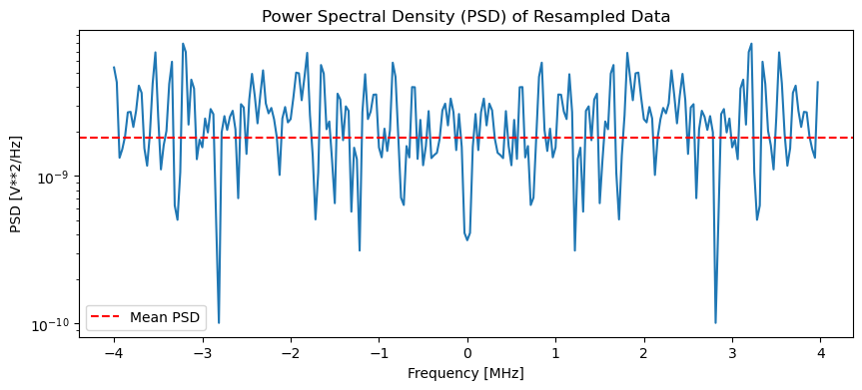

📄 Title:
Signal-to-Noise Ratio (SNR) Estimation using Mean-to-Standard Deviation Ratio

🎯 Objective:
To compute the Signal-to-Noise Ratio (SNR) of a resampled signal using a simple and effective statistical method — the ratio of the mean (μ) to the standard deviation (σ) of the signal's magnitude.

🔧 Working:
- Magnitude Extraction:
If the signal is complex, compute its magnitude using np.abs.
- SNR Estimation:
The SNR is computed using the ratio:
SNR (linear)=μσ\text{SNR (linear)} = \frac{\mu}{\sigma}
where μ is the mean and σ is the standard deviation of the signal magnitude.
- dB Conversion:
Convert the linear SNR to decibels using:
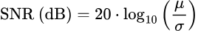

- Edge Case:
If the standard deviation is zero, it returns ∞ to avoid divide-by-zero errors.

🧠 Code:
import numpy as np

def calculate_snr_mu_sigma_full(resampled_data):
"""
Calculate SNR using the ratio of mean to standard deviation over the full resampled data.

Parameters:
resampled_data (np.array): Complex or real signal

Returns:
float: SNR in dB
"""
magnitudes = np.abs(resampled_data) # Use magnitude for complex signals

mu = np.mean(magnitudes)
sigma = np.std(magnitudes)

if sigma == 0:
return np.inf # Avoid division by zero

snr_linear = mu / sigma
snr_db = 20 * np.log10(snr_linear)

print(f"Mean (μ): {mu:.4e}")
print(f"Std Dev (σ): {sigma:.4e}")
print(f"SNR (μ/σ): {snr_linear:.2f}")
print(f"SNR (dB): {snr_db:.2f} dB")

return snr_db

# Example usage (assumes 'resampled_data' is already defined)
snr_db = calculate_snr_mu_sigma_full(resampled_data)

✅ Outcomes:
- Quick SNR Insight: Offers a fast estimation of SNR without needing a reference noise model.
- Statistical Snapshot: Outputs mean, standard deviation, and SNR in both linear and dB.
Mean (μ): 2.7240e-01
Std Dev (σ): 9.2359e-02
SNR (μ/σ): 2.95
SNR (dB): 9.39 dB

📄 Title:
Moment-Based Skewness and Kurtosis Analysis of Resampled Signal

🎯 Objective:
To evaluate the statistical characteristics of the resampled signal’s amplitude distribution by calculating and interpreting its skewness and kurtosis, and visualizing the results using a Kernel Density Estimation (KDE) plot.

🔧 Working:
This process involves analyzing the distribution of magnitudes from a resampled signal using moment-based statistical measures. The steps include:
- Extracting Signal Magnitude:
  - The complex signal is converted to its magnitude using np.abs(), which gives a real-valued amplitude distribution.
- Skewness Calculation:
  - Measures the asymmetry of the distribution:
    - Positive Skew: Right-tailed (more low-amplitude values)
    - Negative Skew: Left-tailed (more high-amplitude values)
  - Formula:
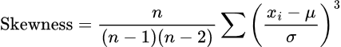
- Kurtosis Calculation:
  - Describes the sharpness of the peak:
    - Leptokurtic (> 3): Sharp peak, heavy tails
    - Platykurtic (< 3): Flat peak, light tails
    - Mesokurtic (= 0): Normal distribution
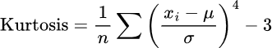
  - Formula:

- Statistical Interpretation:
  - The script classifies the distribution into categories based on skewness and kurtosis values.
- Visualization:
  - A KDE plot of the amplitude distribution is generated using Seaborn, annotated with the type of skewness and kurtosis detected.

🧠 Code:
import numpy as np
import matplotlib.pyplot as plt
import seaborn as sns

# Function to calculate skewness
def moment_based_skew(distribution):
n = len(distribution)
mean = np.mean(distribution)
std = np.std(distribution)
first_part = n / ((n - 1) * (n - 2))
second_part = np.sum(((distribution - mean) / std) ** 3)
return first_part * second_part

# Function to calculate kurtosis
def moment_based_kurtosis(distribution):
n = len(distribution)
mean = np.mean(distribution)
std = np.std(distribution)
return (1 / n) * np.sum(((distribution - mean) / std) ** 4) - 3

# Compute skewness and kurtosis for resampled data
skewness = moment_based_skew(np.abs(resampled_data))
kurtosis_value = moment_based_kurtosis(np.abs(resampled_data))

# Determine skewness type
if skewness > 0:
skewness_description = "Positive Skewness"
elif skewness < 0:
skewness_description = "Negative Skewness"
else:
skewness_description = "Symmetrical Distribution"

# Determine kurtosis type
if kurtosis_value > 3:
kurtosis_description = "Leptokurtic (Sharp peak)"
elif kurtosis_value < 3:
kurtosis_description = "Platykurtic (Flat peak)"
else:
kurtosis_description = "Mesokurtic (Normal peak)"

# KDE plot of the magnitude of resampled signal
plt.figure(figsize=(10, 4))
sns.kdeplot(np.abs(resampled_data), label="KDE", fill=True)
plt.title(f"KDE plot of Resampled Data: {skewness_description} | {kurtosis_description}")
plt.xlabel("Amplitude")
plt.ylabel("Density")
plt.legend(loc='upper right')
plt.grid(True)
plt.show()

# Print results
print("Skewness:", skewness)
print("Kurtosis:", kurtosis_value)

✅ Outcomes:
- Skewness: Quantifies distribution asymmetry (e.g., Positive Skewness)
- Kurtosis: Quantifies peakiness and tail thickness (e.g., Leptokurtic)
- KDE Plot: Provides a smooth estimate of the amplitude probability density.
- Interpretation: Helps in understanding if the signal energy is evenly spread, biased, or concentrated.
skewness: -0.2969966125472755 Kurtosis: -0.5657438447673386
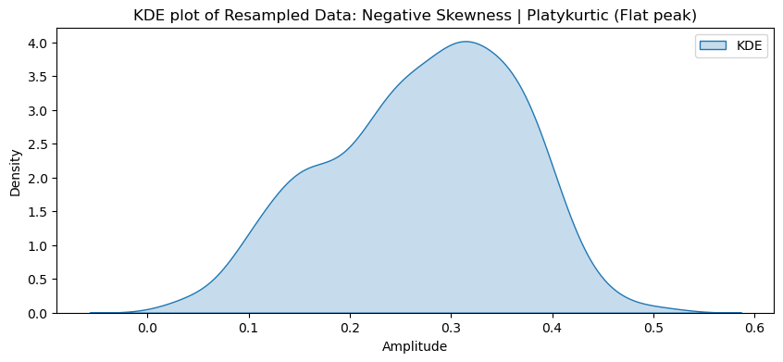

📄 Title:
Feature Extraction from Signal: Time and Frequency Domain Analysis

🎯 Objective:
To extract a comprehensive set of statistical features from both the time domain and frequency domain representations of a signal for further analysis or use in machine learning models (e.g., classification, anomaly detection).

🧪 Method:

🔹 Time Domain Features:
Calculated directly from the raw signal:
- MIN, MAX, MEAN, RMS, VAR, STD, POWER, PEAK
- P2P (Peak-to-Peak), CREST FACTOR, SKEW, KURTOSIS
- Form Factor = RMS / Mean
- Pulse Indicator = Peak / Mean

🔹 Frequency Domain Features:
Derived from the Fast Fourier Transform (FFT) of the signal:
- MAX_f, SUM_f, MEAN_f, VAR_f, PEAK_f
- SKEW_f, KURTOSIS_f

🧠 Code:
import numpy as np
import pandas as pd
from scipy import stats
from scipy.fft import fft

FEATURES = ['MIN', 'MAX', 'MEAN', 'RMS', 'VAR', 'STD', 'POWER', 'PEAK', 'P2P', 'CREST FACTOR',
'SKEW', 'KURTOSIS', 'MAX_f', 'SUM_f', 'MEAN_f', 'VAR_f', 'PEAK_f', 'SKEW_f', 'KURTOSIS_f']

def features_extraction(df):
# Extract data
X = df.values.flatten() # Ensure 1D array

## TIME DOMAIN ##
Min = np.min(X)
Max = np.max(X)
Mean = np.mean(X)
Rms = np.sqrt(np.mean(X**2))
Var = np.var(X)
Std = np.std(X)
Power = np.mean(X**2)
Peak = np.max(np.abs(X))
P2p = np.ptp(X) # Peak-to-Peak
CrestFactor = Peak / Rms
Skew = stats.skew(X)
Kurtosis = stats.kurtosis(X)
FormFactor = Rms / Mean
PulseIndicator = Peak / Mean

## FREQ DOMAIN ##
ft = fft(X)
S = np.abs(ft)**2 / len(X) # Power Spectral Density

Max_f = np.max(S)
Sum_f = np.sum(S)
Mean_f = np.mean(S)
Var_f = np.var(S)
Peak_f = np.max(np.abs(S))
Skew_f = stats.skew(S)
Kurtosis_f = stats.kurtosis(S)

## PRINTING ##
print("# TIME DOMAIN")
print(f"Minimum amplitude of the signal: {Min}")
print(f"Maximum amplitude of the signal: {Max}")
print(f"Mean or Average Value of signal: {Mean}")
print(f"Root Mean Square of the signal: {Rms}")
print(f"Variance of the signal: {Var}")
print(f"Standard Deviation: {Std}")
print(f"Power of the signal: {Power}")
print(f"Peak amplitude of the signal: {Peak}")
print(f"Peak-to-Peak amplitude: {P2p}")
print(f"Crest Factor: {CrestFactor}")
print(f"Skewness: {Skew}")
print(f"Kurtosis: {Kurtosis}")

print("\n# FREQUENCY DOMAIN")
print(f"Max frequency component power: {Max_f}")
print(f"Total spectral power: {Sum_f}")
print(f"Mean spectral power: {Mean_f}")
print(f"Variance in spectrum: {Var_f}")
print(f"Peak spectral amplitude: {Peak_f}")
print(f"Spectral skewness: {Skew_f}")
print(f"Spectral kurtosis: {Kurtosis_f}")

# Example usage
df = pd.DataFrame(np.abs(resampled_data)) # Assuming resampled_data exists
features_extraction(df)

✅ Output Description:

Time Domain:
- Crest Factor reveals signal spikes.
- Skewness describes signal asymmetry.
- Kurtosis highlights tail behavior (peaky vs flat).

Frequency Domain:
- Max_f / Peak_f indicates dominant frequency energy.
- Kurtosis_f / Skew_f describe the spectral shape.
- Sum_f / Mean_f quantify overall spectral energy.

# TIME DOMAIN
Minimum amplitude of the signal: 0.021782099073854488
Maximum amplitude of the signal: 0.5079961241051527
Mean or Average Value of signal: 0.27239749823646875
Root mean square of the signal: 0.2876291795479241
Variance of the signal's amplitude: 0.008530147881924985
Standard Deviation of the signal's amplitude: 0.09235879969946006
Average power of the signal: 0.08273054492741197
Peak amplitude of the signal: 0.5079961241051527
Peak-to-Peak amplitude of the signal: 0.48621402503129824
Crest factor of the signal: 1.7661494737897814
Skewness of the signal's amplitude distribution: [-0.29532392]
Kurtosis of the signal's amplitude distribution: [-0.56574384]
# FREQUENCY DOMAIN
Maximum frequency component power: 0.00048507530471025883
Total power in the frequency spectrum: 0.08273054492741197
Average power in the frequency spectrum: 0.00015550854309663903
Frequency domain variance: 8.418409626065786e-09
Peak value of the frequency spectrum.: 0.00048507530471025883
Skewness of the frequency spectrum: [0.40678658]
Kurtosis of the frequency spectrum: [-0.30062134]

📄 Title:
Envelope Detection of Resampled Baseband Signal

🎯 Objective:
To extract the amplitude envelope of a time-domain signal using peak detection and cubic spline interpolation.

🔧 Working:
- The signal is analyzed to find local maxima (peaks) and minima (troughs).
- Cubic spline interpolation is applied to the peaks to create a smooth upper envelope.
- The result shows how the signal's amplitude varies over time, useful for identifying modulation or patterns.

🧠 Code:
import numpy as np
import matplotlib.pyplot as plt
from scipy.interpolate import interp1d
from scipy.signal import find_peaks

class EnvelopeDetector:
def __init__(self, signal, sample_rate):
self.signal = signal.squeeze() # Ensure signal is 1D
self.sample_rate = sample_rate

def Inverse_Fourier_transform(self):
"""
This function can be expanded to perform IFFT if signal is in frequency domain.
Currently, it returns the original time-domain signal.
"""
return self.signal

def Get_envelope(self):
"""
Calculates the upper and lower amplitude envelopes of the signal using cubic spline interpolation
between local maxima and minima.
Returns:
peaks, troughs, upper_envelope, lower_envelope
"""
x = self.Inverse_Fourier_transform()

# Find local maxima (peaks) and minima (troughs)
peaks, _ = find_peaks(x)
troughs, _ = find_peaks(-x)

# Sanity check to ensure there are enough points for interpolation
if len(peaks) < 4 or len(troughs) < 4:
raise ValueError("Not enough peaks or troughs for cubic spline interpolation.")

# Interpolate using cubic splines
upper_interp = interp1d(peaks, x[peaks], kind='cubic', bounds_error=False, fill_value="extrapolate")
lower_interp = interp1d(troughs, x[troughs], kind='cubic', bounds_error=False, fill_value="extrapolate")

indices = np.arange(len(x))
upper_envelope = upper_interp(indices)
lower_envelope = lower_interp(indices)

return peaks, troughs, upper_envelope, lower_envelope

🔍 Usage Example:
# Make sure 'resampled_data' is defined as your input signal
sample_rate = 10e6 # 10 MHz

# Initialize detector
detector = EnvelopeDetector(resampled_data, sample_rate)

# Extract envelope features
peaks, troughs, upper_env, lower_env = detector.Get_envelope()

# Create time axis
time = np.arange(len(resampled_data)) / sample_rate

# Plotting
plt.figure(figsize=(12, 5))
plt.plot(time, resampled_data, label='Signal', alpha=0.7)
plt.plot(time[peaks], resampled_data[peaks], 'go', label='Peaks', markersize=4)
# plt.plot(time[troughs], resampled_data[troughs], 'ro', label='Troughs', markersize=4)
plt.plot(time, upper_env, 'b', label='Upper Envelope', linewidth=2)
# plt.plot(time, lower_env, 'orange', label='Lower Envelope', linewidth=2)

plt.title("Signal with Upper Amplitude Envelope")
plt.xlabel("Time [s]")
plt.ylabel("Amplitude")
plt.legend()
plt.grid(True)
plt.tight_layout()
plt.show()

✅ Outcomes:
- Successfully visualized the signal's upper envelope.
- Detected key amplitude features (peaks).
