Project Deliverable 3: Classification, Clustering, and Pattern Mining

Sandeep Parupalli
University of the Cumberlands
2026 Spring - Advanced Big Data and Data Mining (MSCS-634-B01)
Satish Penmatsa
April 19, 2026

Project Deliverable 3: Classification, Clustering, and Pattern Mining
This deliverable extends the Online Retail analysis by focusing on classification, clustering, and pattern mining. The main goal is to identify high-value customers, group customers into meaningful behavioral segments, and discover product combinations that frequently appear together. These three analytical tasks provide different but complementary views of customer behavior and business opportunity.
Repository link: https://github.com/Sandeep271/Project-Deliverable-3-Classification-Clustering-and-Pattern-Mining
Data Preparation
The original Online Retail dataset contains invoice-level transactions from an online gift retailer. Before modeling, the data was cleaned to remove duplicated rows, records with missing product descriptions, records with missing customer identifiers, and rows with non-positive quantity or unit price values. These filtering steps reduced noise and ensured that customer-level features were built from valid purchase behavior.
Two engineered transaction-level variables were also created: TotalSales and Month. TotalSales was calculated as Quantity multiplied by UnitPrice, while Month was extracted from InvoiceDate. The cleaned transaction table was then aggregated into a customer-level dataset with 4,338 customer records.
Customer-Level Features and Target Design
The customer-level dataset included the number of transactions, total quantity purchased, average unit price, total spending, and the number of active months. These features were selected because they summarize customer engagement, purchase volume, price profile, and overall spending strength.
For classification, a binary target called HighValueCustomer was created. Customers with total spending above the median were labeled 1, and customers at or below the median were labeled 0. This produced balanced classes, which made model comparison more reliable.
Classification Modeling
Two baseline classification models were developed: a Decision Tree and a k-nearest neighbors model. The Decision Tree was chosen because it is easy to interpret and can model non-linear splits. The k-NN model was included as a distance-based alternative, and the predictors were standardized before fitting because k-NN is sensitive to feature scale.
Table 1
Classification model performance
Model | Accuracy | F1 Score
Decision Tree | 0.9067 | 0.9089
k-NN | 0.9171 | 0.9182
Tuned Decision Tree | 0.9182 | 0.9205
The baseline Decision Tree reached an accuracy of 0.9067 and an F1 score of 0.9089. The baseline k-NN model performed slightly better, with an accuracy of 0.9171 and an F1 score of 0.9182. This result suggested that the classification problem was learnable using a relatively small set of customer-level features.
Figure 1
Classification model comparison
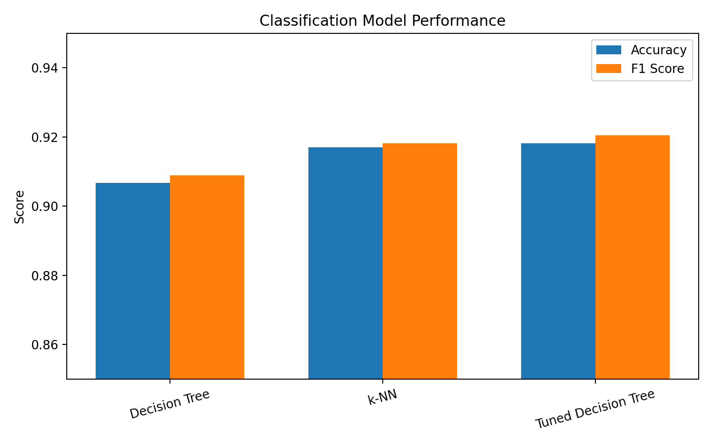
Hyperparameter Tuning
To improve classification performance, the Decision Tree was tuned using GridSearchCV. The tuning process searched across combinations of max_depth, min_samples_split, and min_samples_leaf. These parameters were selected because they directly affect tree complexity and the model's tendency to overfit.
The best parameter combination was max_depth = 5, min_samples_split = 2, and min_samples_leaf = 1. The best cross-validation F1 score was 0.9273. After tuning, the Decision Tree improved to an accuracy of 0.9182 and an F1 score of 0.9205, which made it the strongest classification model in this deliverable.
Figure 2
Tuned Decision Tree confusion matrix
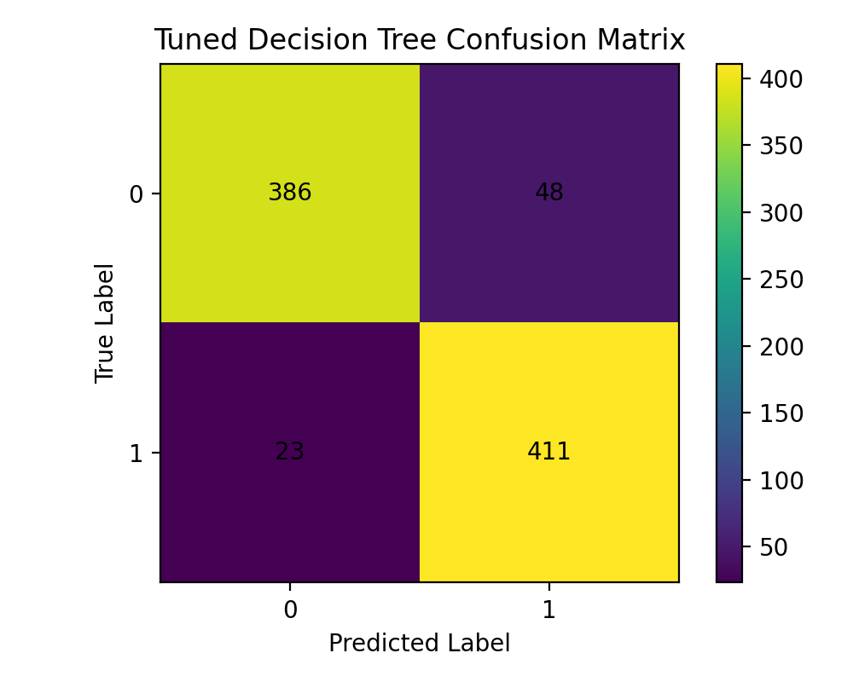
Figure 3
ROC curve comparison
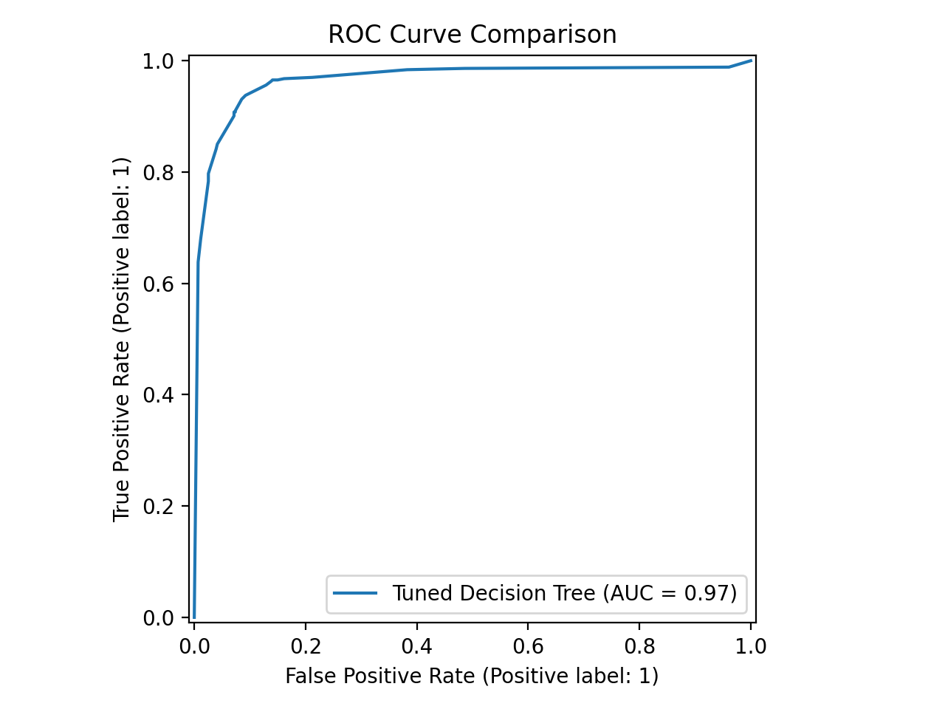
Clustering Analysis
A K-Means clustering model with three clusters was developed using standardized customer-level features. Clustering was used to reveal customer segments with different levels of engagement and spending without relying on a predefined target variable. The selected features were NumTransactions, TotalQuantity, AvgUnitPrice, TotalSpent, and ActiveMonths.
Table 2
Cluster counts
Cluster | Customers
0 | 3705
1 | 17
2 | 616
Table 3
Average cluster profiles
Cluster | NumTransactions | TotalQuantity | AvgUnitPrice | TotalSpent | ActiveMonths
0 | 2.454 | 520.013 | 4.639 | 874.653 | 2.096
1 | 70.353 | 64439.176 | 4.643 | 112579.268 | 10.353
2 | 13.385 | 3457.612 | 3.454 | 6059.695 | 7.917
Cluster 0 represented the largest segment and contained lower-activity, lower-spending customers. Cluster 2 represented a medium-value group with more transactions, greater quantity purchased, and higher total spending. Cluster 1 was very small, but it clearly represented a high-value segment with exceptionally large transaction counts and total spending. This segment would be the most important target for retention or premium offers.
Figure 4
Customers per cluster
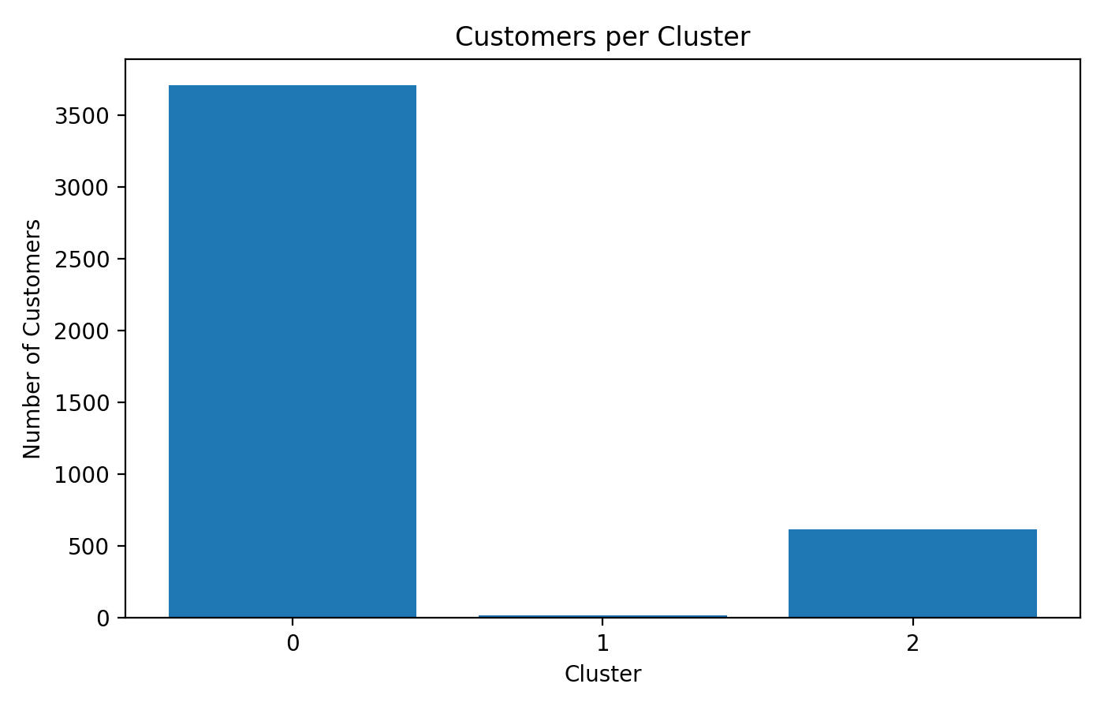
Figure 5
K-Means clusters in PCA space
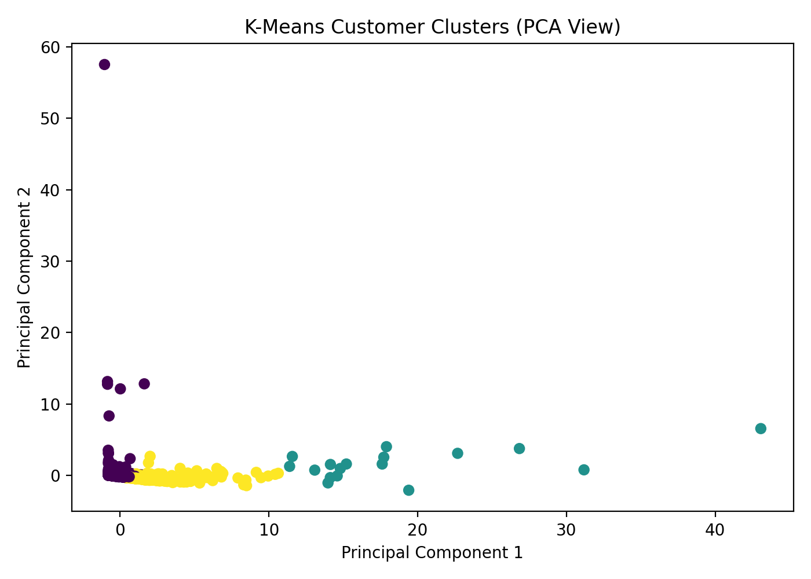
Association Rule Mining
Association rule mining was applied to the cleaned transaction-level dataset using the Apriori algorithm. To keep the basket matrix interpretable, the top 20 most frequent products were selected. A binary invoice-by-product matrix was then created, and rules were generated using lift as the main ranking measure.
This process identified 69 frequent itemsets and 160 association rules. The strongest rules showed that several lunch bag designs are frequently purchased together. These findings are meaningful because they suggest opportunities for bundling, recommendation systems, and cross-selling at checkout.
Table 4
Top association rules by lift
antecedents | consequents | support | confidence | lift
LUNCH BAG PINK POLKADOT | LUNCH BAG BLACK SKULL., LUNCH BAG CARS BLUE | 0.0241 | 0.2793 | 7.1482
LUNCH BAG BLACK SKULL., LUNCH BAG CARS BLUE | LUNCH BAG PINK POLKADOT | 0.0241 | 0.6176 | 7.1482
LUNCH BAG PINK POLKADOT | LUNCH BAG CARS BLUE, LUNCH BAG RED RETROSPOT | 0.0259 | 0.2997 | 7.0509
LUNCH BAG CARS BLUE, LUNCH BAG RED RETROSPOT | LUNCH BAG PINK POLKADOT | 0.0259 | 0.6092 | 7.0509
LUNCH BAG BLACK SKULL., LUNCH BAG RED RETROSPOT | LUNCH BAG PINK POLKADOT | 0.0286 | 0.5957 | 6.8955
Figure 6
Top association rules by lift
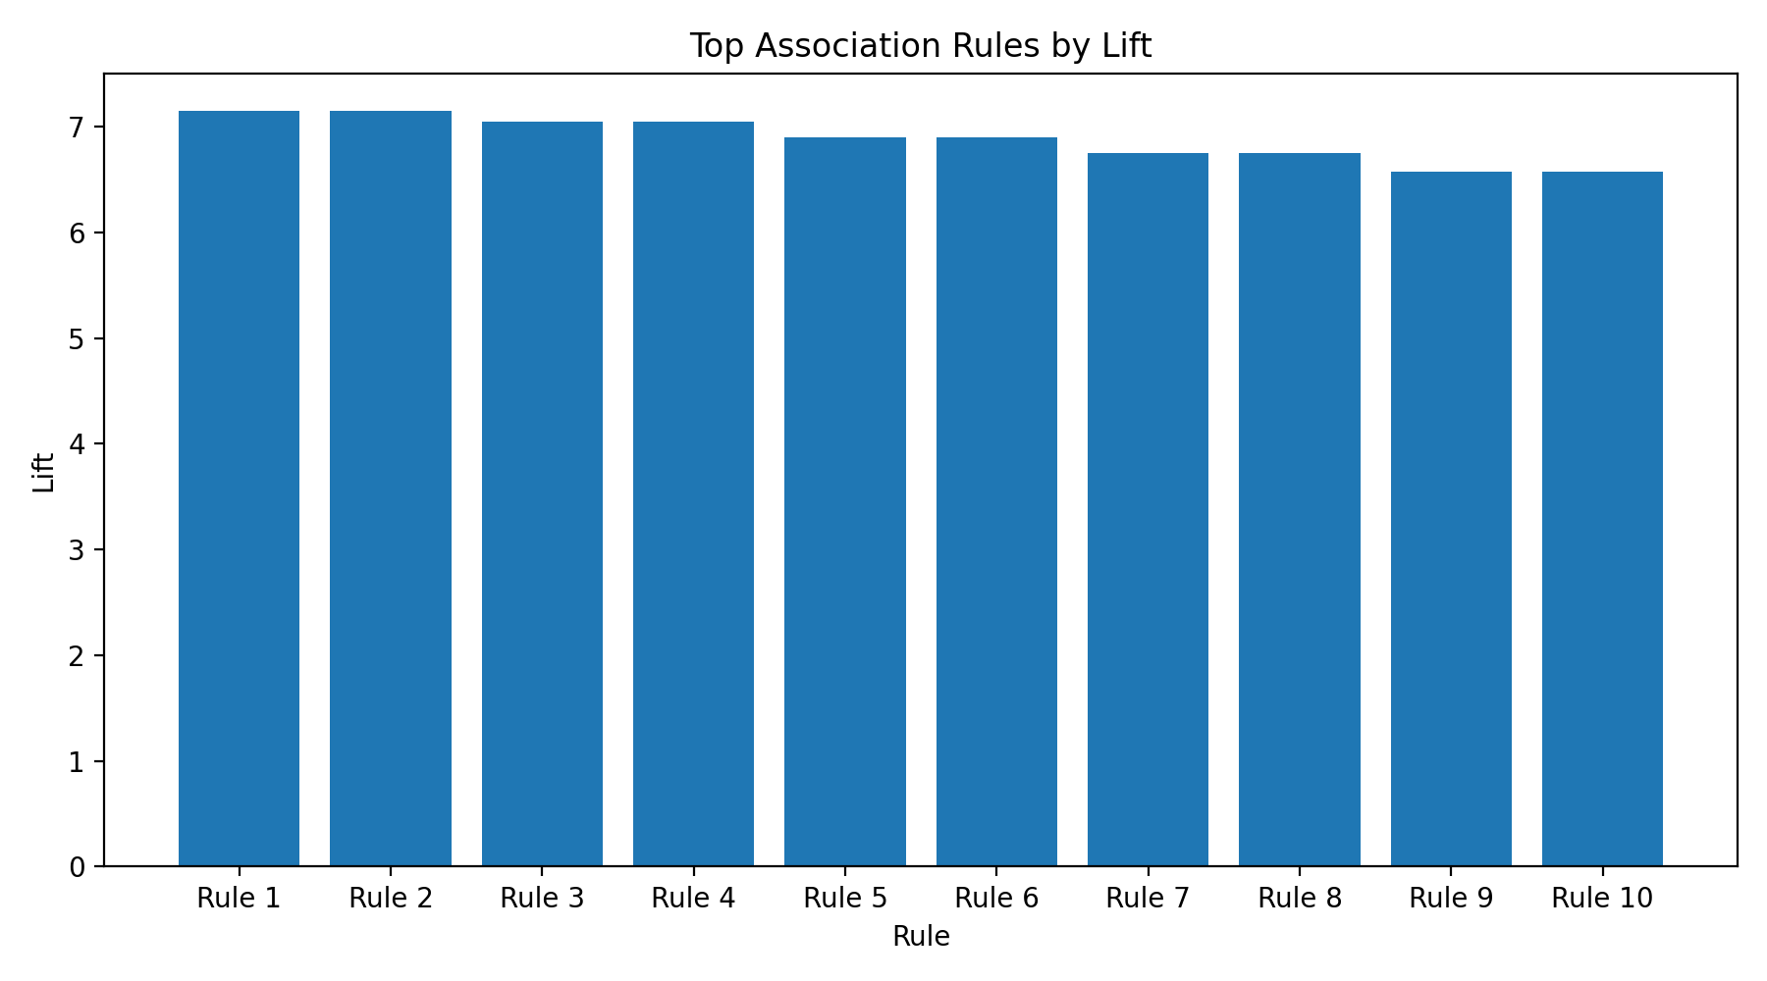
Practical Relevance of the Findings
The classification results can support customer targeting by helping the business separate higher-value customers from lower-value customers using a small set of behavior-based features. The clustering results can support customer segmentation strategies, such as creating separate campaigns for low-activity, medium-value, and premium segments. The association rules can support product recommendations and bundle design, especially for frequently co-purchased gift items.
Together, these methods provide a more complete understanding of customer behavior. Classification explains who is likely to be more valuable, clustering explains which groups exist in the customer base, and pattern mining explains which products are linked in actual purchase baskets.
Challenges and Responses
Several practical issues had to be addressed during this deliverable. First, the original dataset included missing values, duplicate rows, and invalid transaction records, which could distort model performance. These records were removed before analysis. Second, the classification and clustering models were sensitive to feature scale, so standardization was applied where needed. Third, the baseline Decision Tree was improved through grid search rather than relying only on default settings. Finally, association rule mining can become difficult to interpret when too many products are included, so the basket analysis was limited to the top 20 products to keep the results meaningful and manageable.
Conclusion
Project Deliverable 3 successfully demonstrated classification, clustering, and association rule mining on the Online Retail dataset. The tuned Decision Tree produced the strongest classification performance, K-Means identified three clear customer segments, and Apriori revealed useful co-purchase patterns among frequently purchased products. These results show that the dataset can support several forms of predictive and descriptive analytics, and the findings have direct value for customer strategy and merchandising decisions.
References
Chen, D. (2015). Online Retail [Dataset]. UCI Machine Learning Repository.
https://github.com/Sandeep271/Project-Deliverable-3-Classification-Clustering-and-Pattern-Mining

