Employee Schedule Manager Assignment
Submission package with Python and Java source code
Student Name | Sandeep Parupalli
Languages Chosen | Python and Java
GitHub Repository | https://github.com/Sandeep271/employee-scheduler-control-structures
Included Screenshot | Embedded on pages 2–3 (Python + Java)

What this solution demonstrates
- Input and storage using dictionaries/maps, lists, and nested control structures.
- Scheduling rules that prevent more than one shift per day and cap employees at five days per week.
- Conflict handling that prefers same-day reassignment and can move an employee to the next day when needed.
- Readable weekly schedule output plus a conflict/auto-assignment log.
- Bonus support for ranked shift preferences.
Files included in this package
File | Purpose
employee_scheduler.py | Python implementation
EmployeeScheduler.java | Java implementation
final_schedule_compact.png | Sample schedule screenshot
java_schedule_output.png | Sample schedule screenshot (Java)

Sample Final Schedule Output (Python)
The screenshot below was generated from the Python version using the provided sample employee preferences.
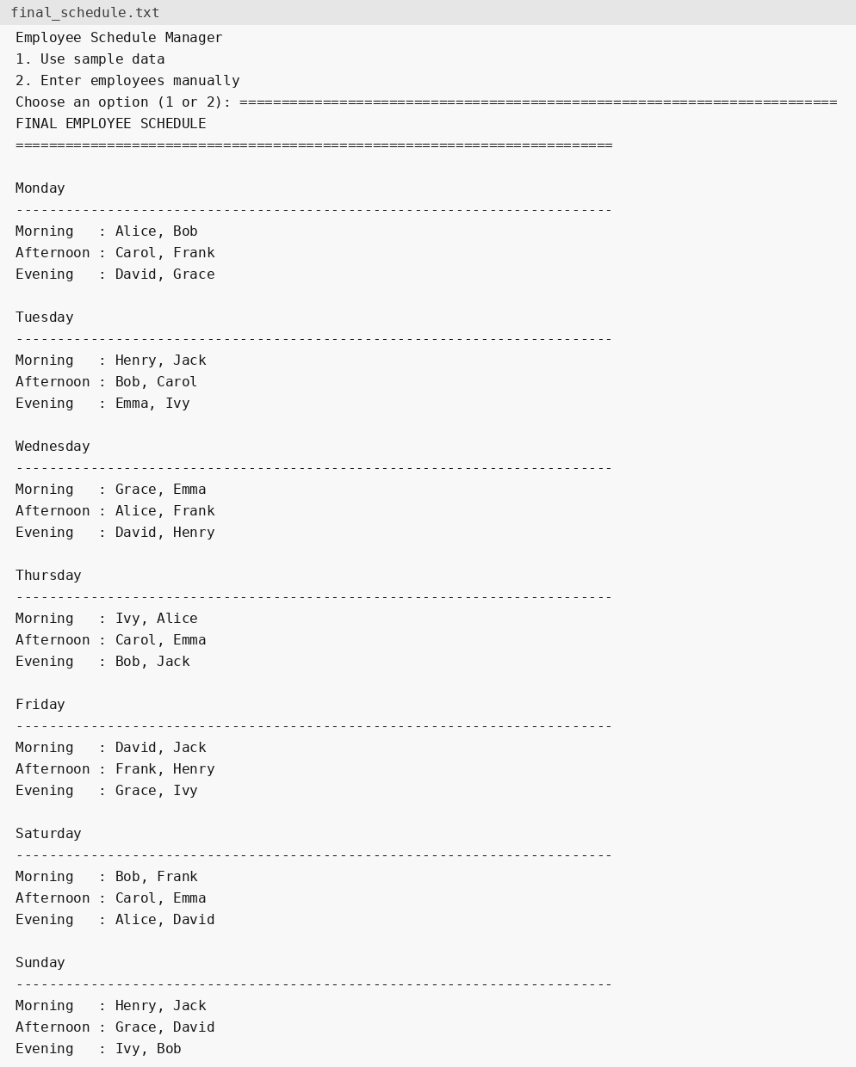

Sample Final Schedule Output (Java)
The screenshot below was generated from the Java version using the same sample employee preferences.
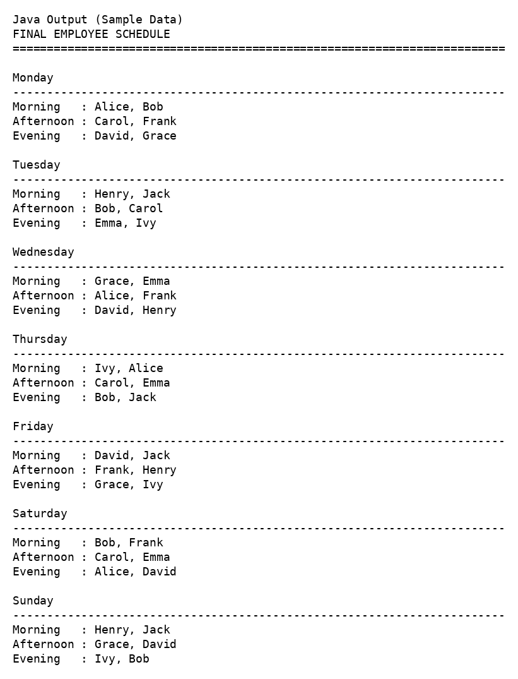
Student name and GitHub repository link are provided on page 1, and the sample schedule screenshots are included on pages 2–3.

