//StudentName -: Sandeep Sandeep

//Student Id -: 25461

//Student Email -: 25461@student.dorset-college.ie  
Answer A or B  
  
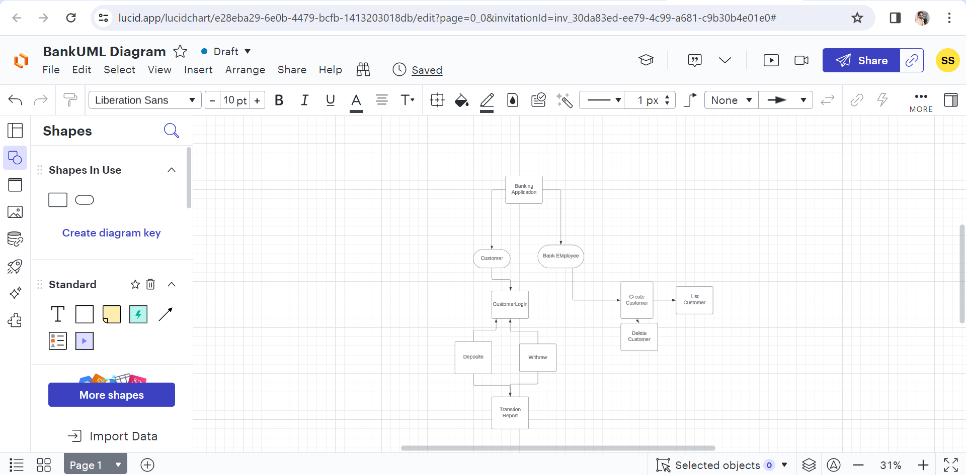

Answer C:

UML Diagram of Banking Application where   
First is Customer or Bank Employee  
When choose Bank Employee then two option open

1:Create Customer  
2:List of Customer

When employee click on Create customer it will show multiple text box and save button then employee fill all required field and press save button after that customer created   
employee can show new customer in list of customer

If employee try to delete customer it will show option for delete any customer

Second option menu is CUSTOMER

When employee create customer then it will ask firstname ,lastname ,email or pin then accountnumber create automatic using its fill required validate  
  
after that employee share customer detail to customer eg firstname lastname accountNumber or Pin which is required field for login customer   
after login   
Customer show accountnumber or both saving or current account and amount which have save in both account  
after that customer can show deposite withraw or transition report where it can deposite amount in both account withraw or show till transition in both account