PROJECT SYNOPSIS ON

AyuScan: An Intelligent System for Disease Detection via Facial Cues

BACHELOR OF TECHNOLOGY IN COMPUTER SCIENCE & ENGINEERING

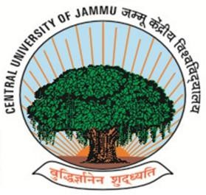

Submitted By:

Name: | Riya Kumari | Suman Kumar | Nenawath Pavani
Roll No. | 22BECSE33 | 22BECSE43 | 22BECSE25

Group No. – 24
Under the supervision of

Dr. Jasvinder Pal Singh
(Assistant Professor)

DEPARTMENT OF COMPUTER SCIENCE & ENGINEERING CENTRAL UNIVERSITY OF JAMMU
Rahya-Suchani (Bagla), District Samba-181143, Jammu (J&K)

Project Overview
Project Overview Imagine a world where your face can reveal hidden health conditions before symptoms appear. For centuries, Ayurveda and Vedic sciences have emphasized facial diagnosis through Varna Pariksha (skin tone), Mukha Pariksha (facial features), and Netra Pariksha (eye analysis) [4][6]. This project aims to blend these ancient methods with modern artificial intelligence to create AyuScan, a smart health assistant. By using deep learning models, particularly Convolutional Neural Networks (CNNs), our system will analyze facial features to detect early-stage health issues. The project aspires to make preventive healthcare accessible to all, particularly in rural areas, through a simple facial scan using a mobile or web-based interface.
In today’s digital era, where health diagnostics increasingly depend on costly tests and infrastructure, there is a dire need for low-cost, non-invasive, and accessible diagnostic tools. AyuScan addresses this need by utilizing facial recognition and deep learning, empowering users to receive real-time health analysis from the comfort of their homes. Our vision is to create an AI-powered system that mimics the diagnostic capabilities of ancient Ayurvedic practitioners, making it highly interpretable, accurate, and personalized [5].
According to the World Health Organization, nearly half of the global population lacks access to essential healthcare services [1]. Meanwhile, studies have shown that facial expressions and features can reflect underlying health conditions such as neurological diseases and emotional states [2][3]. Integrating this understanding with Ayurvedic practices enhances the model’s ability to offer holistic insights into physical and mental well-being.
Thus, AyuScan not only aims to revolutionize preventive healthcare but also serves as a cultural and technological bridge—preserving and validating traditional Ayurvedic practices using the precision of artificial intelligence.

Existing System
Modern artificial intelligence has shown considerable promise in diagnosing diseases using imaging data. Various deep learning-based models, such as Convolutional Neural Networks (CNNs), are already being applied to medical image analysis to detect skin diseases, emotional states, and neurological disorders [1][2][3]. For example, Esteva et al. [3] demonstrated dermatologist-level accuracy in detecting skin cancer through deep neural networks, while emotion recognition systems are used to evaluate stress and depression through facial cues [2].
Despite these advancements, existing AI diagnostic systems have several shortcomings:
Lack of Holistic Health View: Most AI models focus on specific diseases and symptoms, lacking a comprehensive view of a person’s well-being.
No Integration of Ayurvedic Insights: Thousands of years of Ayurvedic knowledge, including facial diagnosis techniques like Varna Pariksha, Mukha Pariksha, and Netra Pariksha, are not leveraged in current systems [4][6].
Limited Accessibility: These models often rely on high-end hardware and medical imaging devices, making them inaccessible to people in rural and under-resourced communities.
Opaque Decision-Making: Users and clinicians may not understand how AI arrives at its conclusions, leading to a lack of trust in predictions.
Therefore, there is a significant research gap in combining traditional diagnostic practices with explainable AI models that are easily deployable on mobile and web platforms. This project seeks to address that gap by building a hybrid model that combines CNNs with Ayurvedic principles for early disease detection based on facial features.

Proposed System
AyuScan is a next-generation diagnostic tool that blends ancient Ayurvedic facial analysis with modern AI capabilities, specifically Convolutional Neural Networks (CNNs). The proposed system is designed to be explainable, accessible, and effective in delivering preventive health assessments through facial image analysis. This section outlines the conceptual framework and core functionalities of AyuScan.
Core Concept: The system operates by capturing a user's facial image through a camera- enabled device. The face is segmented into Ayurvedic zones—forehead, cheeks, lips, and eyes—to conduct Varna Pariksha (skin tone analysis), Mukha Pariksha (facial structure analysis), and Netra Pariksha (eye characteristic evaluation) [4][6]. The extracted features are then processed using a trained CNN model that correlates visual cues with potential health conditions [1][3].

System Workflow:
- Image Acquisition: Facial image is captured through a mobile or web-based interface.
- Preprocessing: Image normalization, cropping, and segmentation into Ayurvedic diagnostic zones.
- Feature Extraction: CNN model identifies patterns corresponding to health conditions such as stress, nutrient deficiencies, skin diseases, or early signs of neurological disorders [2][8].
- Prediction Layer: Hybrid logic integrates CNN predictions with a rule-based Ayurvedic inference engine to generate personalized health alerts.
- Output Module: The system provides users with a diagnostic summary, potential risk areas, and lifestyle or dietary suggestions rooted in Ayurvedic science.
- Deployment Model: The system is designed for low-resource settings and is accessible through smartphones and web browsers. A lightweight model is optimized for real-time performance, even with limited processing power.

Innovative Aspects:
- Holistic Health Analysis: Rather than focusing on a single disease, the system evaluates general well-being.
- Explainable AI: Provides reasoning behind every prediction, thereby increasing trust and transparency.
- User Accessibility: Designed for both tech-savvy and rural users, with an intuitive interface and vernacular language support planned for future versions.
By integrating time-tested Ayurvedic principles with the analytical power of deep learning, AyuScan has the potential to redefine how we perceive preventive healthcare in the digital age.

Problem Formulation
Despite significant advances in health technology, early and accessible diagnosis remains a major challenge—especially in rural and underprivileged areas. Conventional healthcare systems often rely on expensive equipment, in-person consultations, and symptom-based diagnosis that typically occurs after the disease has progressed. Simultaneously, traditional Ayurvedic wisdom, which emphasizes facial cues as early indicators of internal health imbalances, remains largely unexplored in modern AI-driven diagnostics.
Problem Statement: To create a facial diagnosis system based on deep learning that combines Ayurvedic principles with image processing and CNN-based models for early detection of health risks through facial analysis.

Key Challenges Addressed:
Lack of integration between traditional and modern healthcare systems Inaccessibility of diagnostic tools to rural populations
Limited explainability and trust in current AI-based medical predictions

Objectives
The primary aim of the project is to develop an AI-based facial diagnostic system that incorporates ancient Ayurvedic knowledge with modern computer vision techniques to provide a non-invasive, early-stage health assessment.

The main objectives are:
To build a CNN-based AI model capable of detecting health markers from facial images.
To integrate Ayurvedic diagnostic zones (Varna, Mukha, Netra) into image preprocessing and labeling.
To construct a hybrid framework combining rule-based Ayurvedic inference with learned AI predictions.
To develop a user-friendly application deployable on mobile and web platforms for accessible health insights.
To enhance system explainability and promote user trust through transparent diagnostic reasoning.

Features of the Project
AyuScan introduces several novel features that distinguish it from existing diagnostic systems by fusing traditional Ayurvedic insights with modern AI technologies:
Facial Health Mapping: Utilizes advanced CNN algorithms to detect subtle cues from facial features, such as skin texture, color changes, eye clarity, and structural symmetry.
Integration of Ayurvedic Principles: Combines three classical diagnostic techniques— Varna Pariksha, Mukha Pariksha, and Netra Pariksha—for a multi-dimensional health assessment [4][6].
Non-Invasive & Real-Time Assessment: Offers quick and contactless diagnosis using only a facial image, without requiring clinical tests or physical examination.
Personalized Recommendations: Provides lifestyle tips and Ayurvedic guidance based on individual analysis results, promoting user engagement and preventive care.
Cross-Platform Accessibility: Designed for both web and mobile platforms to ensure ease of use and wide accessibility, especially for under-resourced communities.
Explainable & Transparent: Users receive a breakdown of predictions and associated Ayurvedic markers, increasing clarity and trust in system outputs.
These features not only make the project technologically innovative but also culturally relevant, providing users with a familiar, credible, and data-driven health companion.

Proposed Methodology

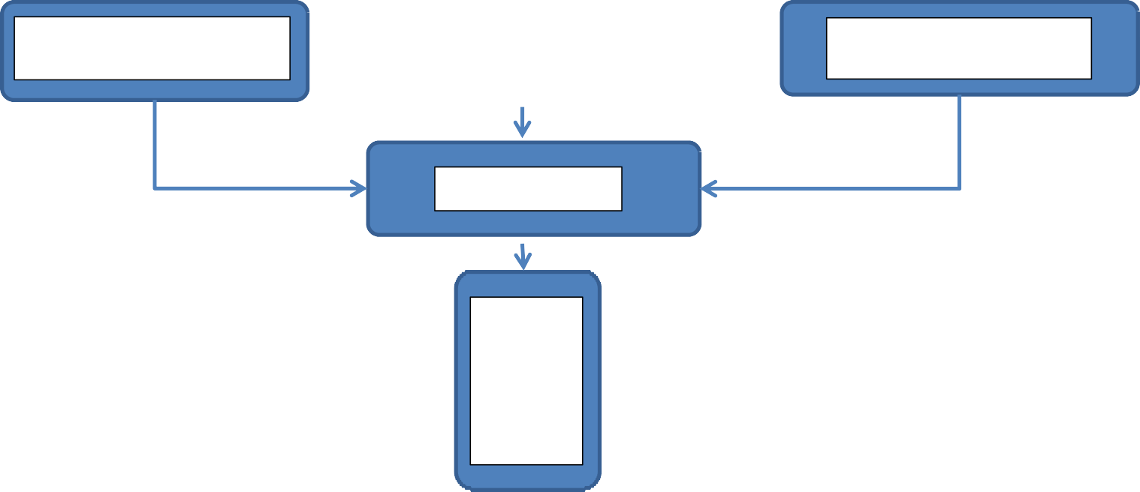
Gather medical & Ayurvedic facial datasets and Facial Images(Testing)
Preprocess Images (Cleaning…..etc)
Varna Parikasha, Mukha Pariksha, Netra Pariksha
Train CNN Model on health conditions and vedic markers
Evaluation & Refinement
Predictions
Web and Mobile interface

To bring this idea to life, we begin by collecting facial images from both medical datasets and Ayurvedic observations. This allows our system to learn how visible facial features—like skin tone, eye color, and facial expressions—can reflect early signs of health issues. After cleaning and preparing these images using tools like OpenCV, we use Convolutional Neural Networks (CNNs) to train the model to detect conditions such as jaundice, fever, stress- related symptoms, and skin issues [1][3][6]. At the same time, the model learns to interpret subtle imbalances as described in traditional diagnostic practices like Varna Pariksha, Mukha Pariksha, and Netra Pariksha [4][10]. Once trained, the model is tested and optimized for accuracy across diverse facial types. We then integrate Ayurvedic knowledge to provide holistic, personalized insights [6][7], combining ancient wisdom with scientific precision.
Finally, everything is packaged into a simple, user-friendly mobile and web app, where users can scan their face and receive early alerts, health advice, and natural recommendations—all accessible from their phone [5].

6.0 Project Planning

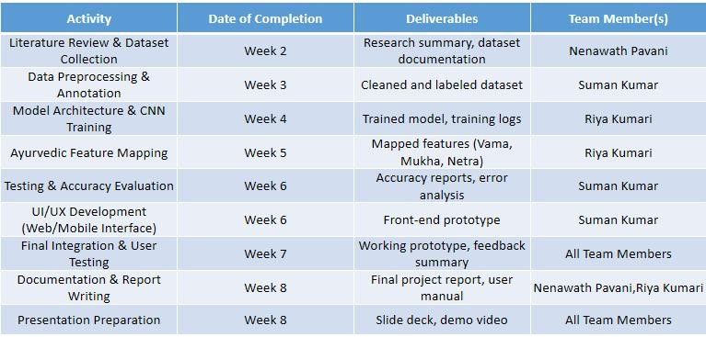

Refrences

- Patil, S. A., & Kalbande, D. R. (2018).Prediction of skin disease using machine learning techniques. International Journal of Engineering Research and Technology.
- Albahri, N., et al. (2021).Facial emotion recognition: A review. IEEE Access.
- Esteva, A., Kuprel, B., Novoa, R. A., Ko, J., Swetter, S. M., Blau, H. M., & Thrun, S. (2017).Dermatologist-level classification of skin cancer with deep neural networks.
- Rajalakshmi, P., & Ramya, S. (2020).An Ayurvedic face diagnosis system. International Journal of Computer Applications.
- Zainuddin, N. A. M., & Hussain, A. (2015).Human health prediction using facial features. Procedia Computer Science.
- Dwivedi, R. R. (1998).Ayurvedic diagnosis and treatment. Journal of Research in Ayurvedic Sciences.
- Patwardhan, B., & Mashelkar, R. A. (2009).Traditional medicine- inspired approaches. Drug Discovery Today.
- Joyce, T. (2021).Using computer vision for Parkinson’s detection: A review. Frontiers in Aging Neuroscience.
- Redmon, J., Divvala, S., Girshick, R., & Farhadi, A. (2016, June).You only look once: Unified, real-time object detection. In Proceedings of the IEEE Conference on Computer Vision and Pattern Recognition.
[10] Charaka Samhita; Vaidya, J., & Trikamji, A. (n.d.).Chaukhambha Orientalia.

(Suman Kumar) (Dr, Jasvinder Pal Singh)
Team Leader (Project Guide)

Date:

