**Ques 1:**

Create your own new custom VPC

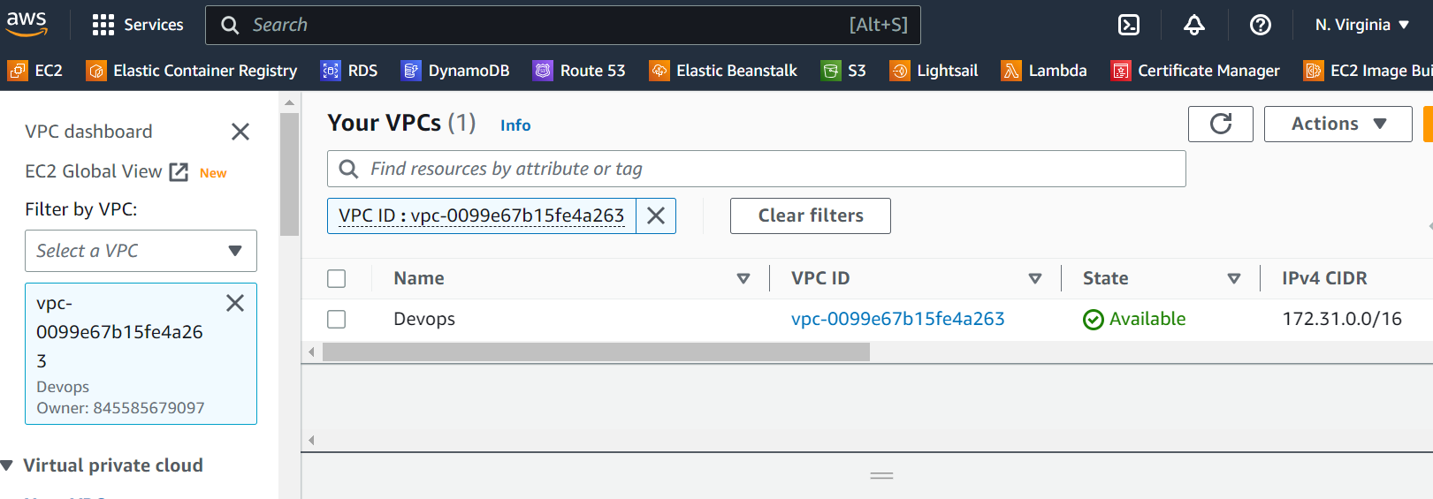

- And configure your EC2 linux instance inside your custom VPC - and then create 3 subnets of that VPC

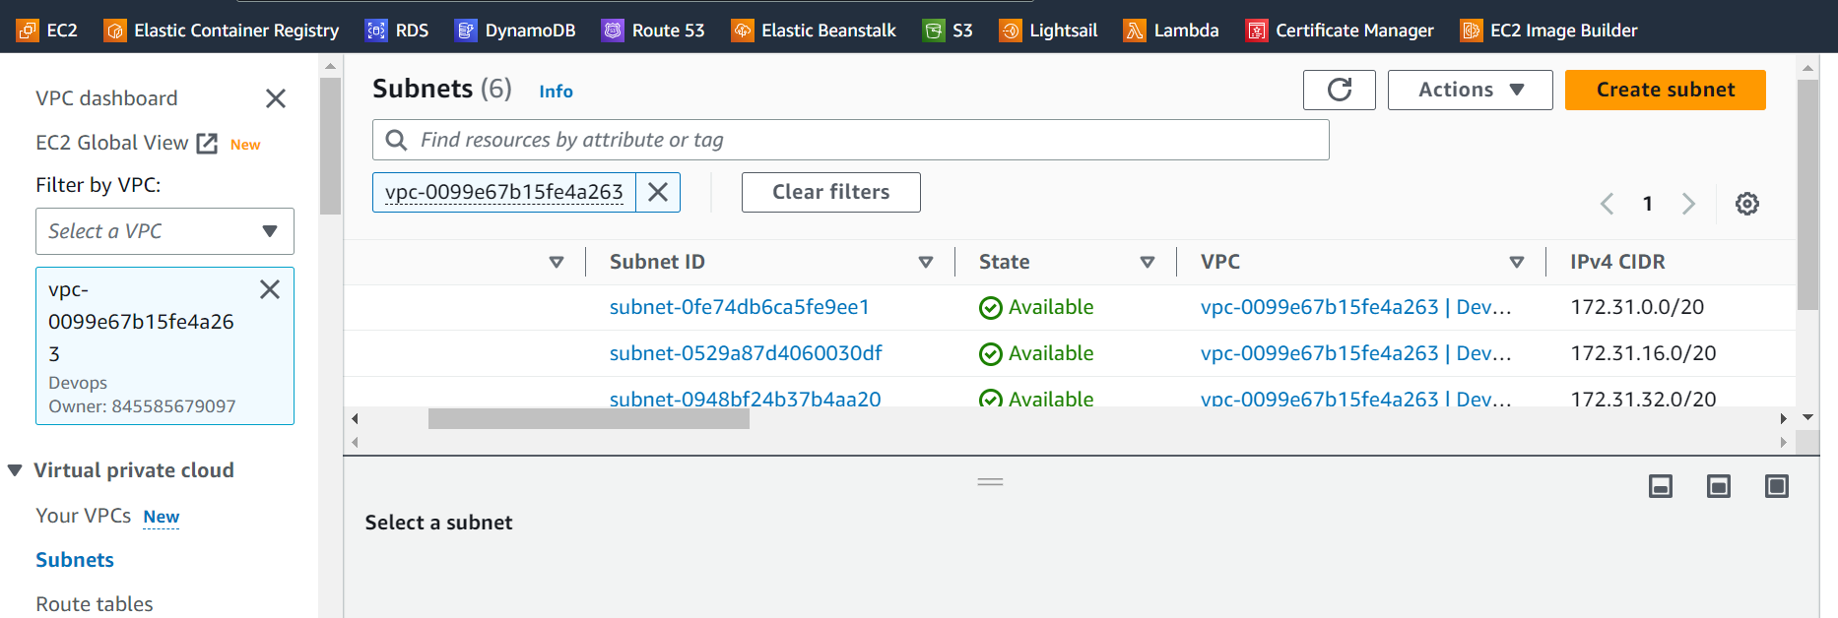

- Attach an internet gateway to your custom VPC

