

**Basic Linux Commands Assignments**

Assignment-1

Connect and disconnect with login Access

* What happens when you login a non-existent users or username?

**Message prompt as “sorry, that didn’t work. Please try again”**

* + Provide Screenshot and What you understand, explain in short brief?

**Screenshot attached below, It means user has no valid credentials to login, without correct login credentials user can’t access to account.**

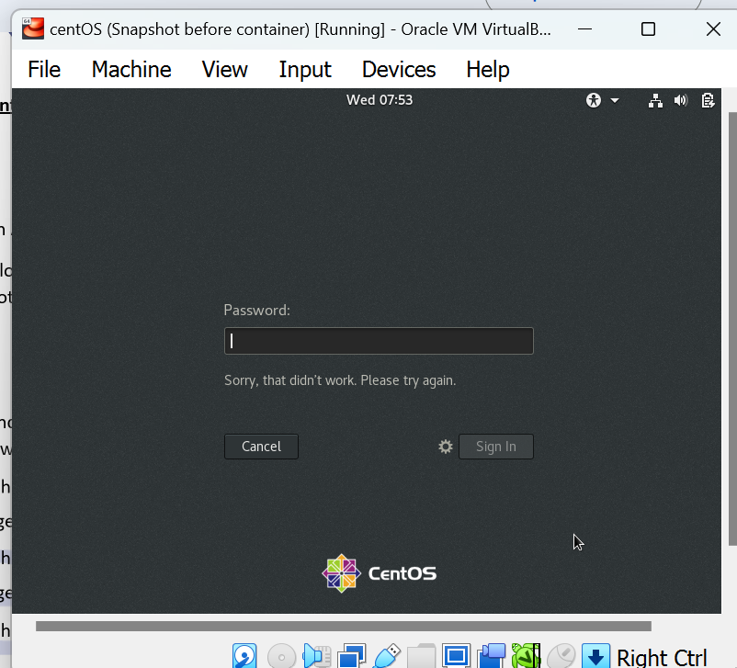

Assignment-2

Password changing

* Login into your account and then change password?
  + Change your password into **IneuR0n#42** and hit the **Enter** key
    - Explain what happen and give screenshot? Screenshot attached below, after resetting the password, all tokens updated successfully, now we can login by using **IneuR0n#42** password

* + Try again to change password but use like password ***1234*** or ***abcd***
    - Explain what happen and give screenshot?

**Password must be 8 characters and it should be common/guessable like 1234 or abcd**

* + Try again to change password but now don’t use any password just hit **Enter** key
    - Explain what happen and give screenshot?

**Its showing bad password, no password supplied. After that “Authentication Token manipulation error” which means no character input as password.**

Assignment-3

Working with Directories

* Enter the command **cd /** and then **ls** and then hit **Enter** key
  + Take screenshot and explain what output we got?

**Screenshot is attached below, after going to base directory I have run the ls command, all the directory and file are showing.**

* Enter the command now **cd /home** and then hit **Enter** key
  + Do **ls,** provide screenshot and explain what is **/home** directory used for?

**Home directory used to store the file, personal information, login scripts, and user information.**

* Enter **cd ..** and hit **Enter** key [ *Note: here we have space after cd then use double dot*]
  + Check what happen and give screenshot?

**Once we enter the cd .. , It goes a directory back basically change the directory.**

* Now enter **cd /var/www/html** and then type **cd** and hit **Enter** key
  + Explain what happen and give screenshot?

**No such file or directory found after entering the cd/var/www/html, when I enter the cd directory got changed**

* Now type **cd /root** and then hit **Enter** key
  + Do **ls,** check any output we have on screen if yes then take screenshot?

**Screenshot is attached below, after typing the cd /root, getting the msg access denied. But once typed ls then directories and files shown.**

Assignment-4

Working with File Listing

* Go to **cd /etc** and type **ls**
  + Take screenshot and explain what files you have seeing?

**/etc directory contains system configuration information such as several files and subdirectories changed, removed, and added.**

* + Take screenshot and explain what different output you found compare to previous command you used?

**In the previous command, only I can get the directory/files but can’t the details about the added, removed, or changed the subdirectories or files. It’s more detailed about all subdirectories and files.**

* Then type **ls -al** and hit **Enter** key
  + Take screenshot and explain what new file or directory you found?

**First thing, I can see clearly which on is directory and which one is not. Second thing, I can see which file/directory has read/write permission and who is owner of directory or file when it was created with date and time.**

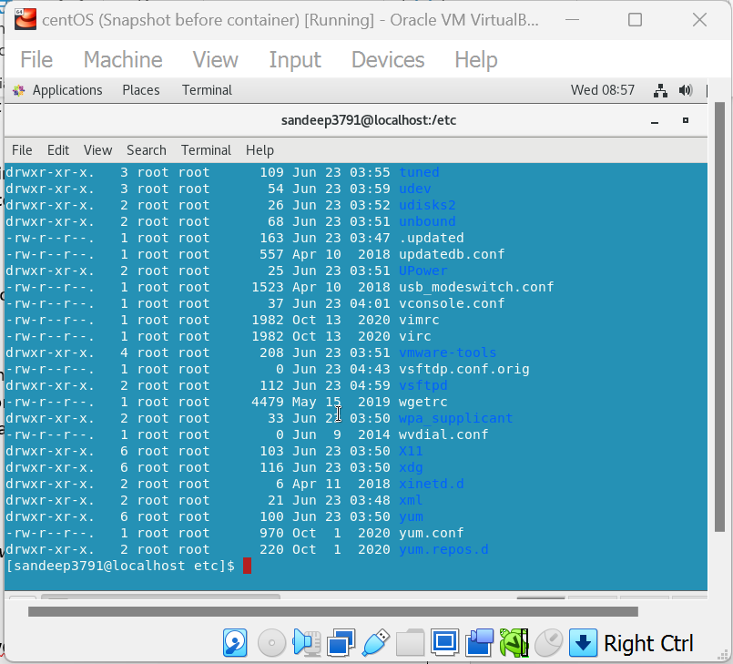

* Then use **ls -i** and hit **Enter** key
  + Now see what different output its shows and take screenshot?

**After running the command ls -I, we find all directories/files size in byte.**

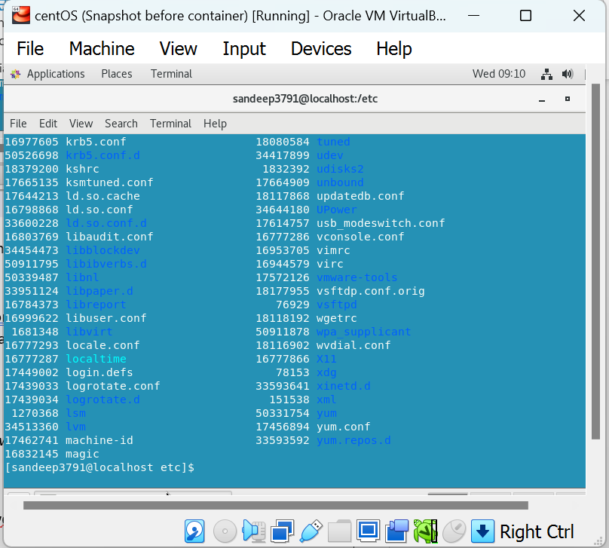

* Then use **ls –help** and see other options about **ls** command
  + Explore it and try with other attribute we can use with **ls** command

Assignment-5

Know where you are and where you working

*Here we use* ***pwd, cd and ls*** *as combine task to understand where you working on terminal and how you can switch from one directory to another one.*

* Open terminal after restart the linux
  + Check which location you working, type **pwd** and take screenshot

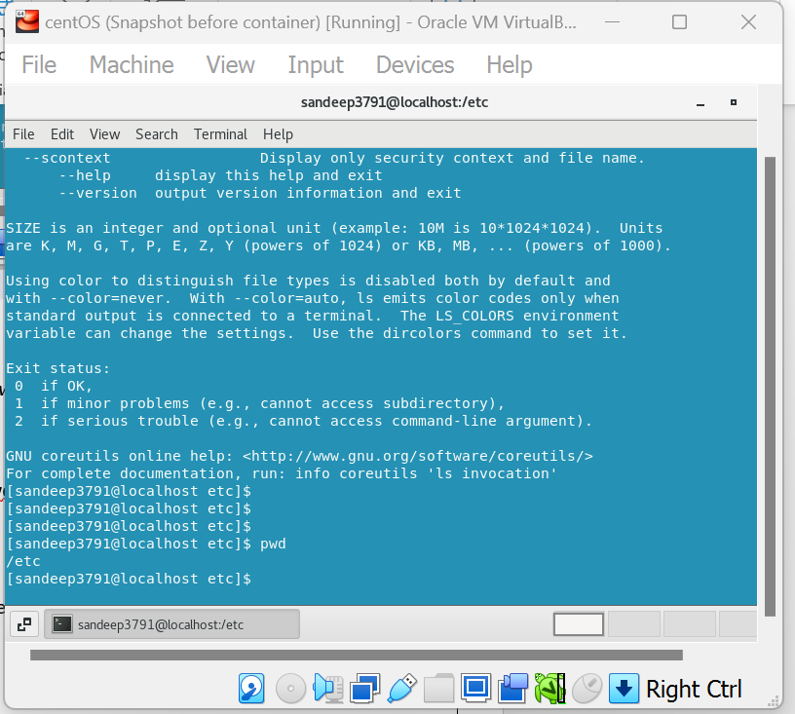

* Now use **cd /var** and hit **Enter** key
  + Do **ls,** and see what output comes, give screenshot?

**Screenshot attached below**

* Do explore other help options of each command to learn more other things we can do with these commands