

**Linux Basic Commands Assignment**

***Assignment Part-3***

Playing with files

1. Create a file like **nano file1.txt**

o Edit some data and then save the file

2. Now we will copy date from file1 to new file2 **cp file1.txt file2.txt**

o Then see the output of file2.txt, **cat file2.txt**

o Give screenshot

**Screenshot is attached below:**

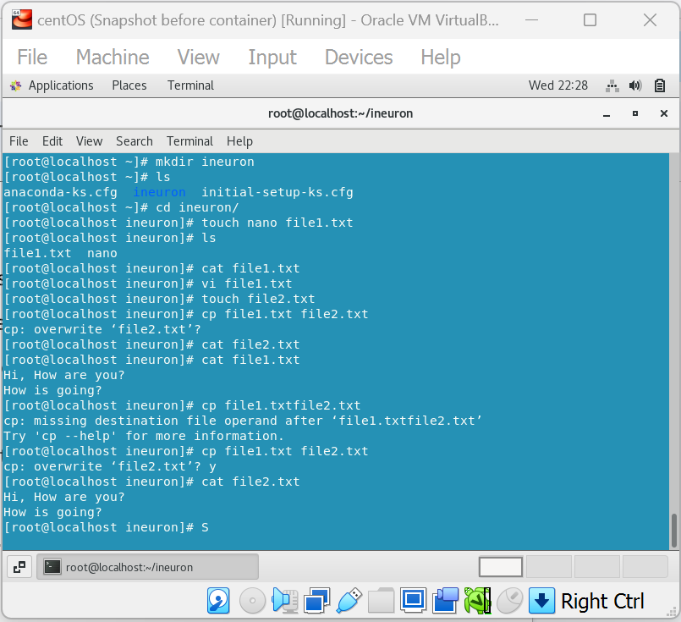

3. Now we will move the file2.txt to new folder **/home**

o **mv file2.txt /home**

o Then go to the homedirectory and check **ls,** file exists or not? **Yes File Exists**

o Given screenshot

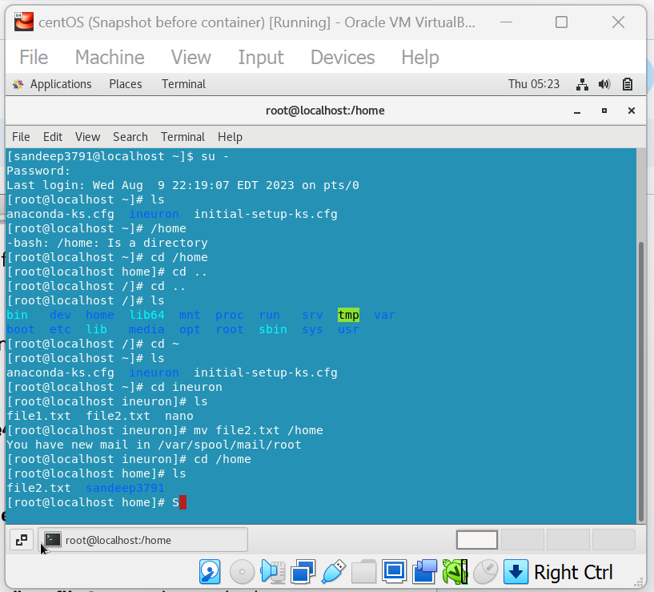

4. Then we create a new **file3.txt and file4.txt** in the home **directory** and add content in it.

o Now do **echo “Hello I am newline” > file3.txt** and provide the output of file3.txt

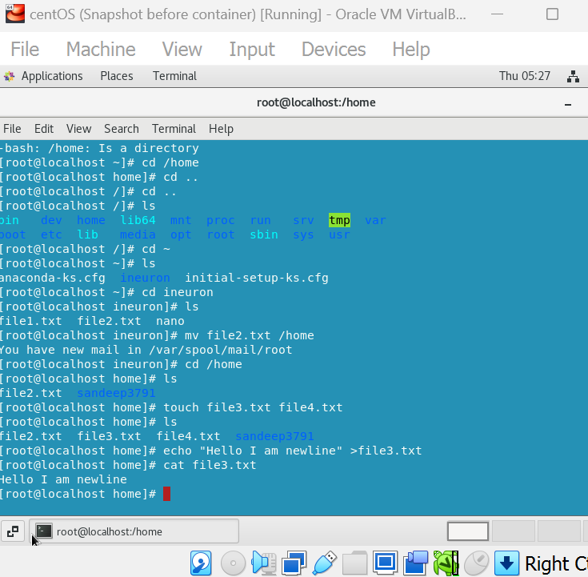

o Now do **echo “Hello I am newline” >> file4.txt** and provide the output of file4.txt

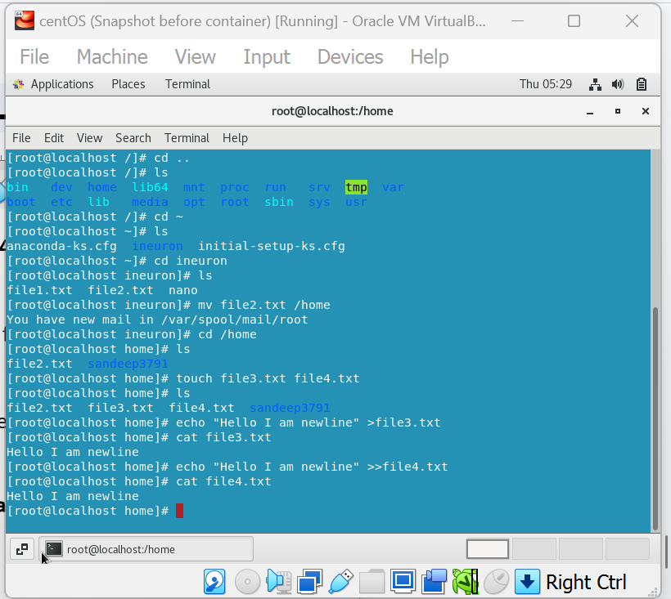

o Tell the difference between both step you follow and the reason behind it

**The major difference is when we use “>” then it overwrites the file if it exists or creates it if it doesn't. And when we use “>>” then it appends to the file if it exists or creates it if it doesn't.**

5. For remove a file or directory you can use the below two commands **o** To delete a file – **rm <any_filename>**

**o**Todeleteadirectory-**rmdir<any_directoryname>**