**CSC 244 – Database System Design**

California State University, Sacramento (CSUS)

Computer Science Department

Fall-2023

**Project Proposal – Phase 2**

**Project Team - 7**

**Instructor – Ying Jin**

|  |  |
| --- | --- |
| ***Team Members*** | ***Contribution (%)*** |
| *Rajasekhar Reddy Kolagotla* | *34* |
| *Chanakya Rudhra Baluguri* | *33* |
| *Sandeep Reddy Yeruva* | *33* |

**Tools and Frameworks:**

* Oracle Apex is the primary tool that we use to design, develop and deploy the applications/projects.
* Oracle Autonomous DB – It’s a preconfigured database environment, where it supports both transaction processing and data warehousing applications.
* SQL Developer Web – We are using the web-based version of SQL Developer, which is integrated into Oracle Autonomous Database. Using SQL Developer Web, we will run SQL queries, manage database, and perform Database Related tasks.
* Oracle REST Data Services (ORDS) – With the help of Oracle REST data service, we will be able to develop the relational data in oracle database and with the help of these services and Apex tool, we will build our applications.
* Apex Inbuilt Plugins – Oracle Apex tools contains various built-in plugins, where we can display the data or perform analysis and present them in the form of charts, graphs etc.

**Where to Retrieve Real World Data:**

* In order to design an application using Oracle Apex, we need to input a dataset into Oracle Autonomous DB. In our project, we are making use of a Brazilian e-commerce public dataset by Olist (largest department store in Brazil marketplaces) available on the Kaggle website. This dataset has the data of 100k orders from 2016 to 2018 made at multiple market places in Brazil. Below is the link to access the dataset.

Link: <https://www.kaggle.com/datasets/olistbr/brazilian-ecommerce>

**Architectural Design and Design Flow:**

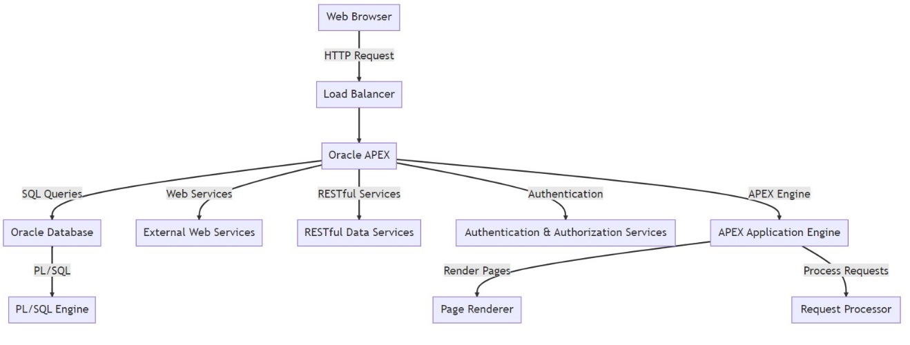

The flow chart gives a visual picture of the interactions and architecture of the oracle apex applications. An HTTP request is first performed to reach the APEX application via the user’s web browser. The load balancer, which effectively distributes incoming traffic, receives this request first. The Oracle system platform receives the requests once it has been processed. Requests processing page rendering, and application logic all takes place here. Apex communicates with the Oracle Autonomous DB, which holds all application data and metadata, in order to perform data operations. Additionally, an Oracle SQL Engine for running procedural code is present in the database. For further functionality, APEX can also interface with external web services including RESTful Data services. To maintain security, separate services are in charge of managing user authentication and authorization.

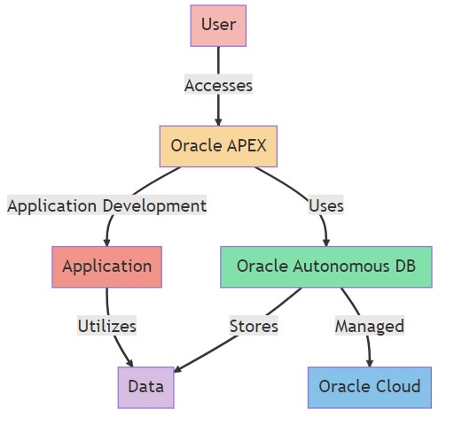

* End-users’ interaction with Oracle APEX, the user interacts with an application that is built using oracle APEX.
* Oracle APEX is a low-code development platform that allows user to build scalable and secure application, when building or running applications, APEX uses Oracle Autonomous Database to store and retrieve data.
* Application represents the software or system being developed or operated; this application uses data from Oracle Autonomous DB to perform the functions.
* Oracle Autonomous DB is Oracle’s cloud native database service, which uses machine learning and automation to store data and provide self-driving, self-repairing and self-securing capabilities.
* Data represents the raw information or records that the application and the database handle.
* Oracle Cloud provides servers, storages, and other functionalities that allows businesses to run their applications in the cloud.

**Preliminary Implementation:**

Create an Oracle Autonomous DB Instance from Oracle Cloud Infrastructure (OCI). We have created a free tier database instance service.

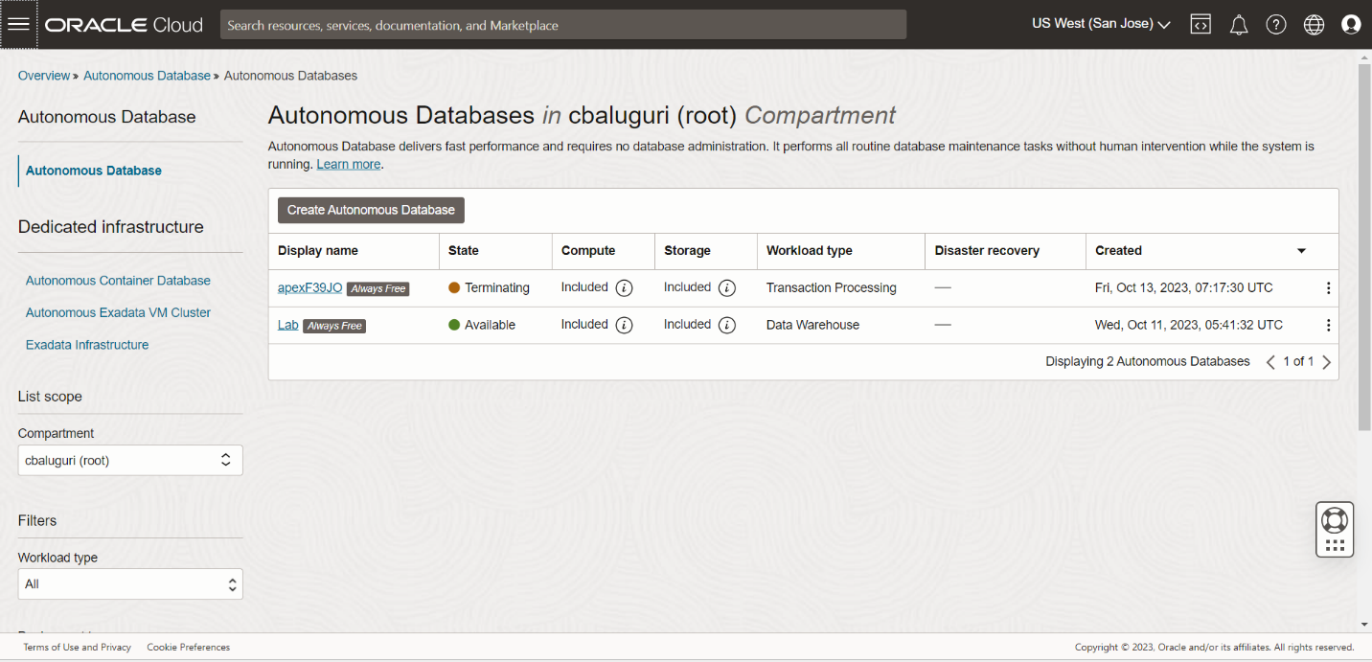

We can change the display and database name from default settings to user defined names.

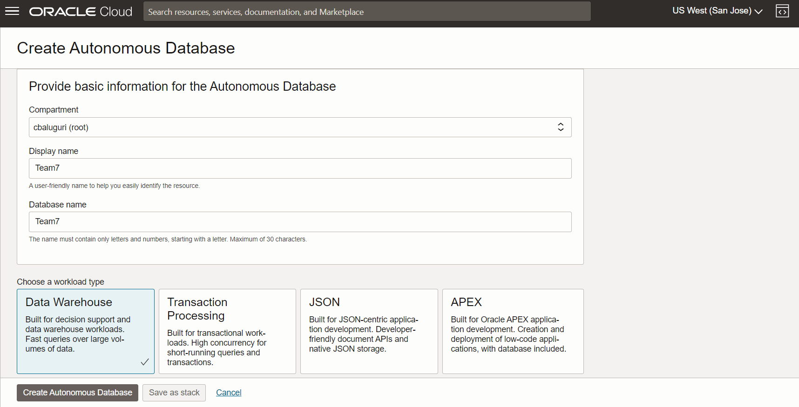

Once the details are provided, its firsts provision the database. During the provision, the database instance shows in orange color and wait until the instance turns into green color to use the database actions.

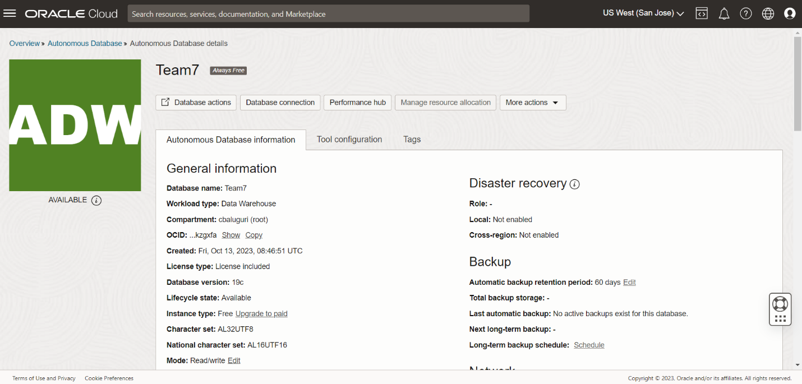

Once the database is available, you can find the database connections, where we can download the Instance wallet details, which contains the connection strings and keys needed for database connection or Oracle Apex connection.

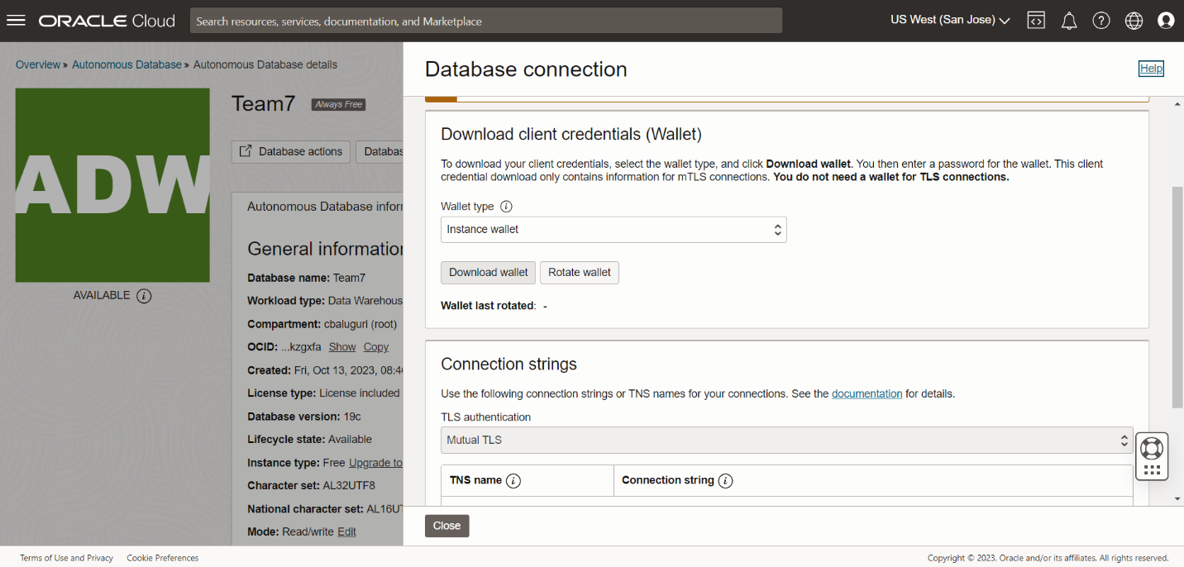

We can also navigate to Oracle Database actions and access SQL and Apex directly from the OCI.

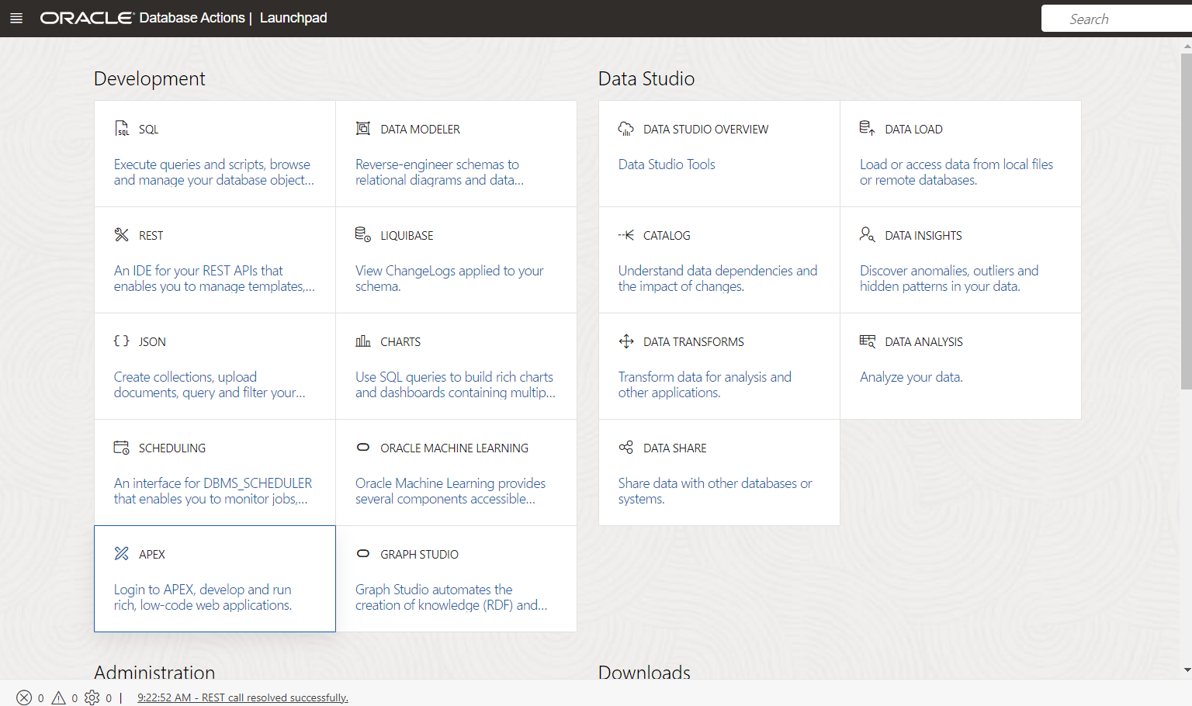

Below is the Oracle Apex Welcome page and we need to create a workspace in order to develop the applications.

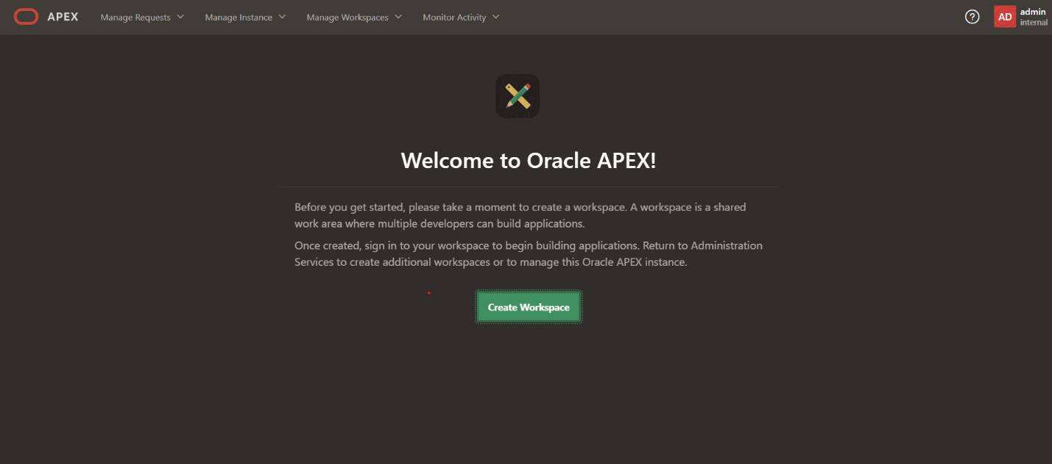

By providing the Apex Workspace name, Username and Password, we can create a workspace.

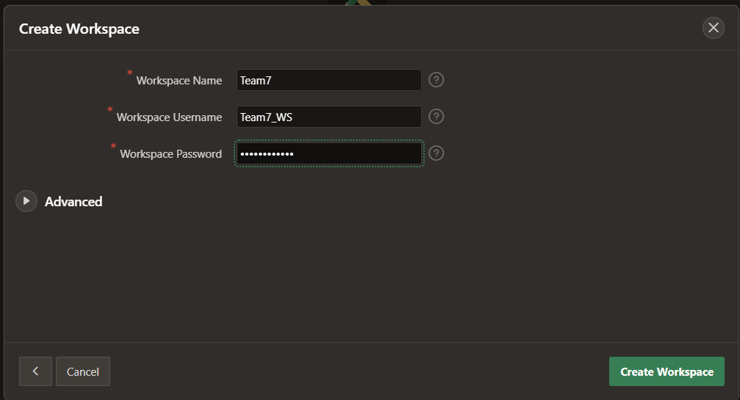

Once, the Workspace is created, we will be redirected to Oracle Apex home page, where we can access App Builder to create the apps, SQL workshop to run the SQL queries and code development.

