**CSC 244 – Database System Design**

**Fall 2023**



**Oracle Apex using Oracle Autonomous Database**

|  |  |
| --- | --- |
| ***Team Members*** | ***Contribution (%)*** |
| *Rajasekhar Reddy Kolagotla* | *34* |
| *Chanakya Rudhra Baluguri* | *33* |
| *Sandeep Reddy Yeruva* | *33* |

# Abstract:

The goal of this project is to create a dynamic, data-driven e-commerce application by utilizing the powerful features of Oracle Application Express (APEX) in combination with Oracle Autonomous Database. By utilizing a real-world dataset from Olist, a well-known Brazilian e-commerce site.

The core objective is to develop a responsive web application schema for e-commerce that can handle orders, products, sales information, and customer data with ease. Important tasks include Configuring Oracle Autonomous DB in Oracle Cloud Infrastructure, Configuring Oracle Apex in OCI, and using it for front-end application development and data visualization.

Our strategy uses an architectural framework to enable effective data handling and application logic processing by allowing Oracle APEX to communicate with the Oracle Autonomous DB. The utilization of Oracle REST Data Services (ORDS) will allow for advanced application functionalities. The project emphasizes the incorporation of Oracle's strong database administration with a low-code application development platform to create a scalable, safe, and operative e-commerce application.

Table of Contents:

Abstract: 2

Table of Figures: 3

1. Introduction: 4

2. Dataset Used: 5

3. Oracle Apex Architecture in Oracle Autonomous DB: 5

3.1 Architectural Design: 5

3.2 Design Flow: 6

3.3 Data Import Methods in Oracle APEX: 7

4. Ecommerce Application Using Oracle APEX 7

4.1 Defining the ER Diagram & Schema. 7

4.2 Populating the Database: 8

4.3 SQL Workshop: 9

4.4 Building the Oracle APEX application: 9

5. Future Work: 14

6. Conclusion: 15

7. References: 15

# Table of Figures:

Figure 1: Oracle Apex Architecture diagram 6

Figure 2: Oracle Apex design flow 7

Figure 3: ER diagram 8

Figure 4: SQL Workshop 9

Figure 5: App Builder 10

Figure 6:E-commerce Application Login Page 10

Figure 7:Dashboard Page 11

Figure 8:Navigation Page 11

Figure 9: Customer Order Product Details View Page 12

Figure 10: Data Visualization Page 13

Figure 11:Data Load Page 13

Figure 12:Customer Edit Report Page 14

# Introduction:

In the Rapidly developing landscape of web application development, the incorporation of Oracle Application Express (APEX) and Oracle Autonomous Database (ADB) is a extremely effective combination. In order to produce a composite e-commerce web application, this project proposes to combine the abilities of Oracle ADB, a highly automated and effective database management system, with the strengths of premier low-code development platform Oracle APEX.

Offering a low-code environment that facilitates the quick creation and deployment of sophisticated web applications, Oracle APEX makes web application development simpler and is therefore a great option for companies trying to optimize their application development procedures.

The Oracle Autonomous Database is a self-managing database that repeatedly performs routine tasks like security maintenance, backups, upgrades, and performance tuning. This automation lessens the load on database administrators while enhancing the database's performance, security, and uptime.

The collaboration between Oracle APEX and Oracle ADB delivers a dynamic framework for developing and handling powerful web applications. This project will leverage Oracle APEX for the front-end application development and Oracle ADB for backend database management. By using a real-world e-commerce dataset from Olist, the largest department store in Brazilian marketplaces, we purpose to demonstrate the effectiveness of this integration in handling complex database operations and providing insightful data visualization.

The objectives of this project are to create a comprehensive e-commerce website schema, perform CRUD (Create, Read, Update, Delete) operations on the dataset, and showcase the data through various visualization techniques using Oracle APEX. This involves setting up the Oracle Autonomous Database in Oracle Cloud Infrastructure, understanding the real-world data model, and implementing it efficiently using Oracle APEX’s robust features.

# Dataset Used:

In order to design an application using Oracle Apex, we need to input a dataset into Oracle Autonomous DB. In our project, we are making use of a Brazilian e-commerce public dataset by Olist (largest department store in Brazil marketplaces) available on the Kaggle website. This dataset has the data of 100k orders from 2016 to 2018 made at multiple market places in Brazil.  
Link to the dataset: <https://www.kaggle.com/datasets/olistbr/brazilian-ecommerce>

# Oracle Apex Architecture in Oracle Autonomous DB:

## Architectural Design:

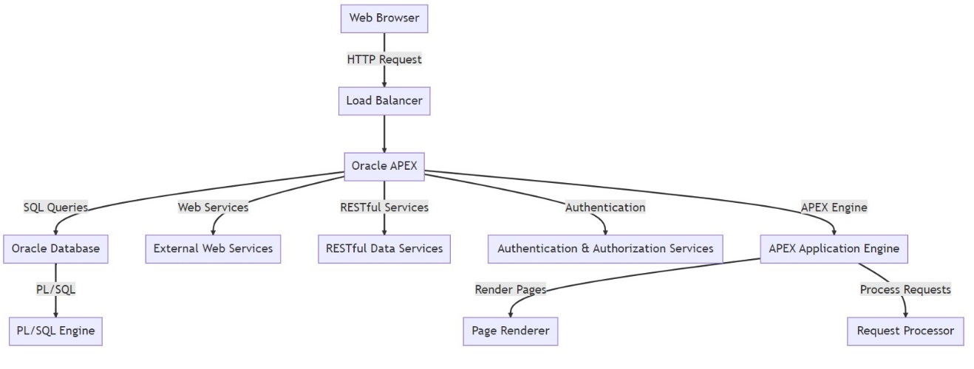

Figure 1: Oracle Apex Architecture diagram

The flow chart gives a visual picture of the interactions and architecture of the oracle apex applications. An HTTP request is first performed to reach the APEX application via the user’s web browser. The load balancer, which effectively distributes incoming traffic, receives this request first. The Oracle system platform receives the requests once it has been processed. Requests processing page rendering, and application logic all takes place here. Apex communicates with the Oracle Autonomous DB, which holds all application data and metadata, in order to perform data operations. Additionally, an Oracle SQL Engine for running procedural code is present in the database. For further functionality, APEX can also interface with external web services including RESTful Data services. To maintain security, separate services are in charge of managing user authentication and authorization.

## Design Flow:

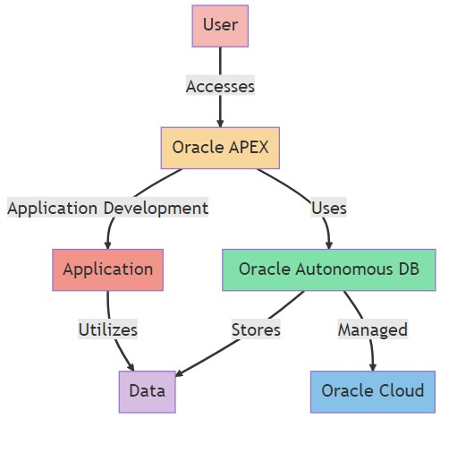

Figure 2: Oracle Apex design flow

Oracle APEX enables end-users to interact with applications built on this system. These applications are highly scalable and secure, utilizing the Oracle Autonomous Database for data storage and retrieval. The Autonomous Database, a cloud-native service from Oracle, leverages machine learning and automation to provide self-driving, self-repairing, and self-securing capabilities. This integration allows the applications developed in APEX to effectively use data from the Autonomous Database, facilitating the handling and processing of raw information or records. In essence, Oracle APEX offers a streamlined and efficient environment for building and operating data-driven applications, leveraging the advanced features of the Oracle Autonomous Database. Oracle Cloud provides servers, storages, and other functionalities that allows businesses to run their applications in the cloud.

## Data Import Methods in Oracle APEX:

There are multiple ways to upload data into Oracle Autonomous DB. Depending upon the business requirements and data volumes, formats, sources the methods are used by the users. Some of the key ways to upload the data are SQL Developer Data Import, Data Pump, SQL*Loader, DBMS_CLOUD package, APEX Data Upload Wizard, RESTful Services, External Tables. In this Project, we are using Oracle APEX Data Upload Wizard to upload the data.

# Ecommerce Application Using Oracle APEX

## Defining the ER Diagram & Schema.

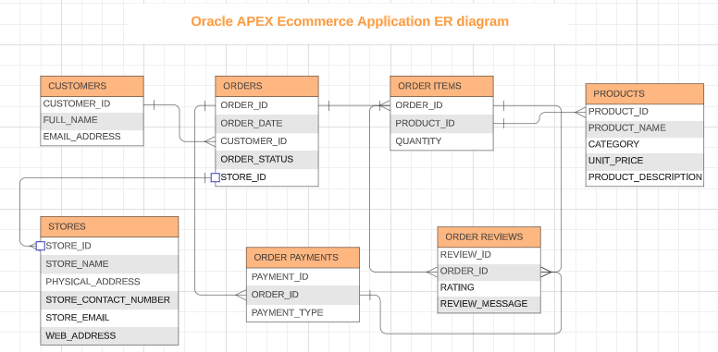

Figure 3: ER diagram

The ER diagram provided represents the data structure for an Oracle APEX eCommerce application. It visually outlines the key entities and their relationships within the application's database.

**Database Schema:**

**Customers** (Customer ID, Full Name, Email Address)

**Stores** (Store ID, Store Name, Physical Address, Store Contact Number, Store Email, Web Address)

**Products** (Product ID, Product Name, Category, Unit Price, Product Description)

**Orders** (Order ID, Order Date, Customer ID, Order Status, Store ID)

**Order Items** (Order ID, Product ID, Quantity)

**Order Payments** (Payment ID, Order ID, Payment Type)

**Order Reviews** (Review ID, Order ID, Rating, Review Message)

## Populating the Database:

Dataset is required to build an Oracle APEX application. We have used the dataset of an e-commerce application available from Kaggle website. The dataset consists of different tables that are required for an e-commerce website. With the help of Oracle APEX Data Upload Wizard, we have uploaded the data into Oracle Autonomous Database. Once the data is loaded, the primary and foreign keys relationships are mapped according to the schema diagram.

## SQL Workshop:

Using SQL workshop, we browse the objects that are pre-installed in the system or the functions, procedures, views, triggers, tables created using the SQL commands through Object Browser. We can even develop the scripts and run them whenever we needed.

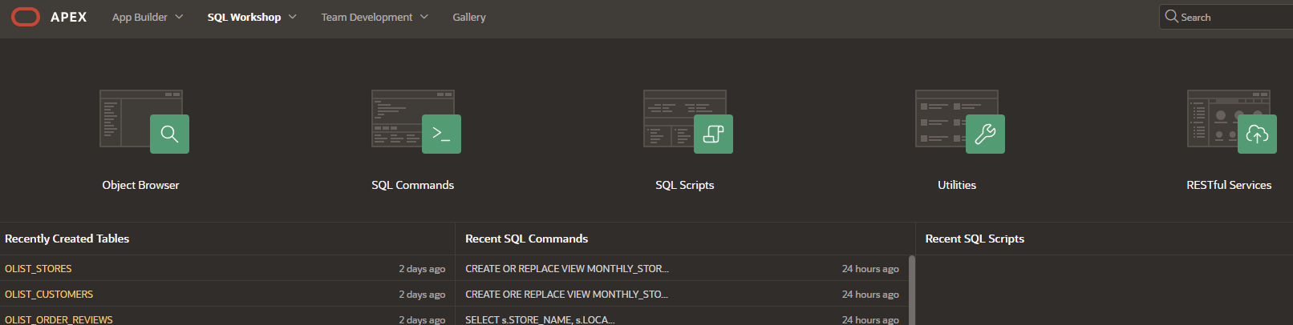

Figure 4: SQL Workshop

## Building the Oracle APEX application:

Using App Builder Function in Oracle apex, we can create the New Application or import the application from external sources. We can add multiple pages to the application, and can even perform data visualization techniques using the data.

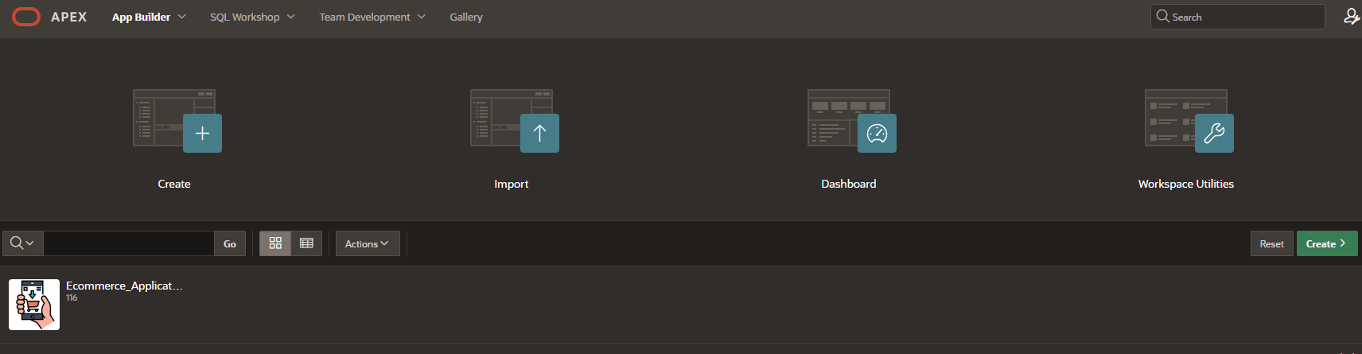

Figure 5: App Builder

**Application Login Page:**

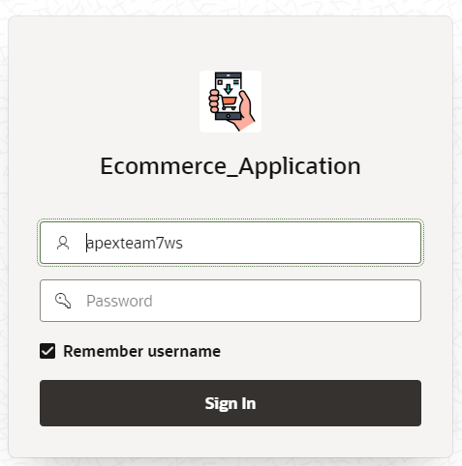

Figure 6:E-commerce Application Login Page

Once the application is created and run, it asks the users to login with the workspace details that are created while configuring the Oracle Apex in Oracle Cloud Infrastructure.

**Dashboard Page**:

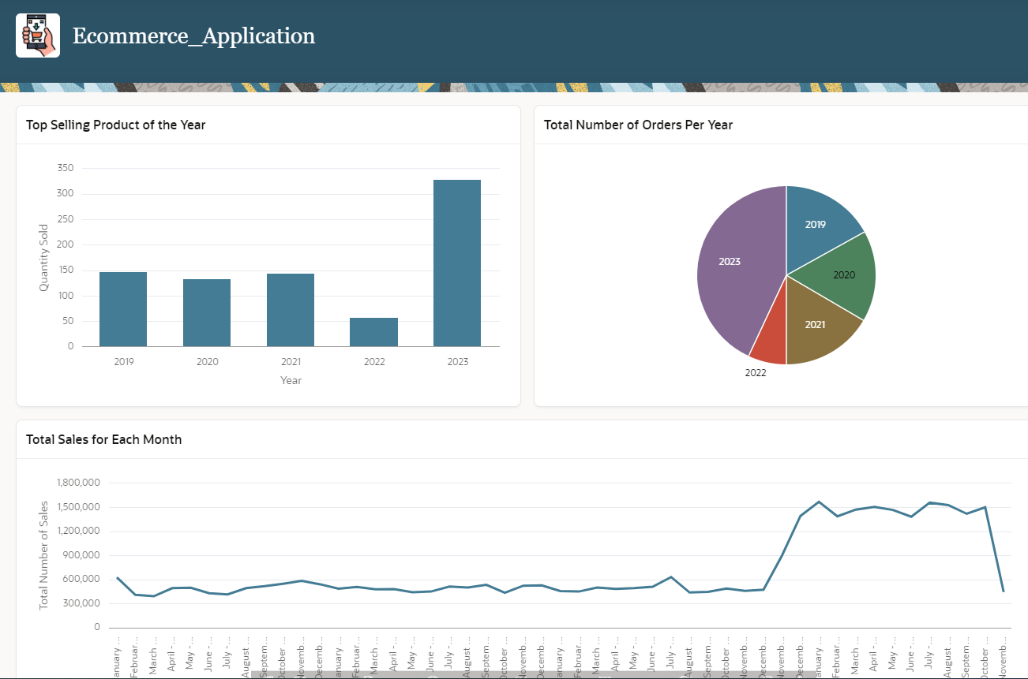

Figure 7:Dashboard Page

Once the User has logged in, it goes the dashboard/home page. The dashboard displays the various charts like bar graphs, pie charts and line charts. We can customize the dashboard page based on the user/customer requirement. The users can navigate to other pages based on their interest.

**Navigation Menu:**

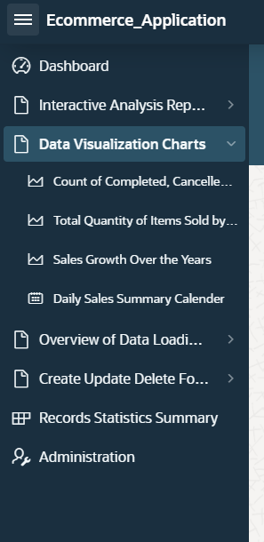

Figure 8:Navigation Page

With the help of Navigation menu on the left, users can go to other pages and explore the features of Oracle Apex. The Interactive Analysis Reports contains the reports, Data visualization charts depicts various charts developed for data analysis, Data Loading Pages (users can load the data to the oracle autonomous database with the help of these pages), Create Read Update Delete Page performs the CRUD operations (where users can read the data available in database and even insert, update and delete the records).

**Customer Order Product Details View Page:**

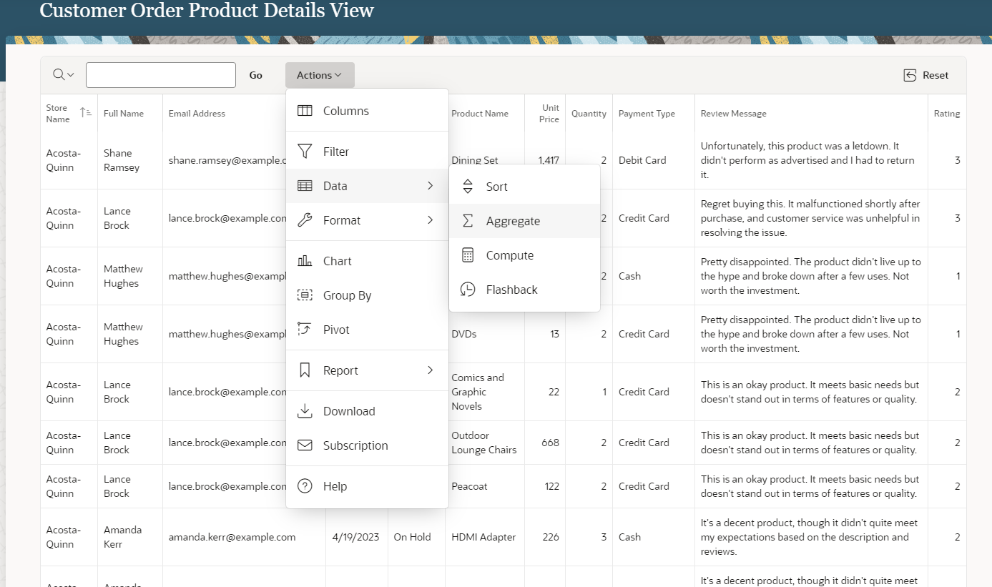

Figure 9: Customer Order Product Details View Page

This report is built based on a view. It displays all the necessary information about the customer details, products purchased, total amount paid, payment type used, and ratings if provided. We can even search the customer’s name and perform some aggregate functions to find the total amount paid by that customer over the years. We can even download the data into an excel, csv, html, pdf formats. There are some other features, where we can build the charts as required by the business needs.

**Data Visualization Page:**

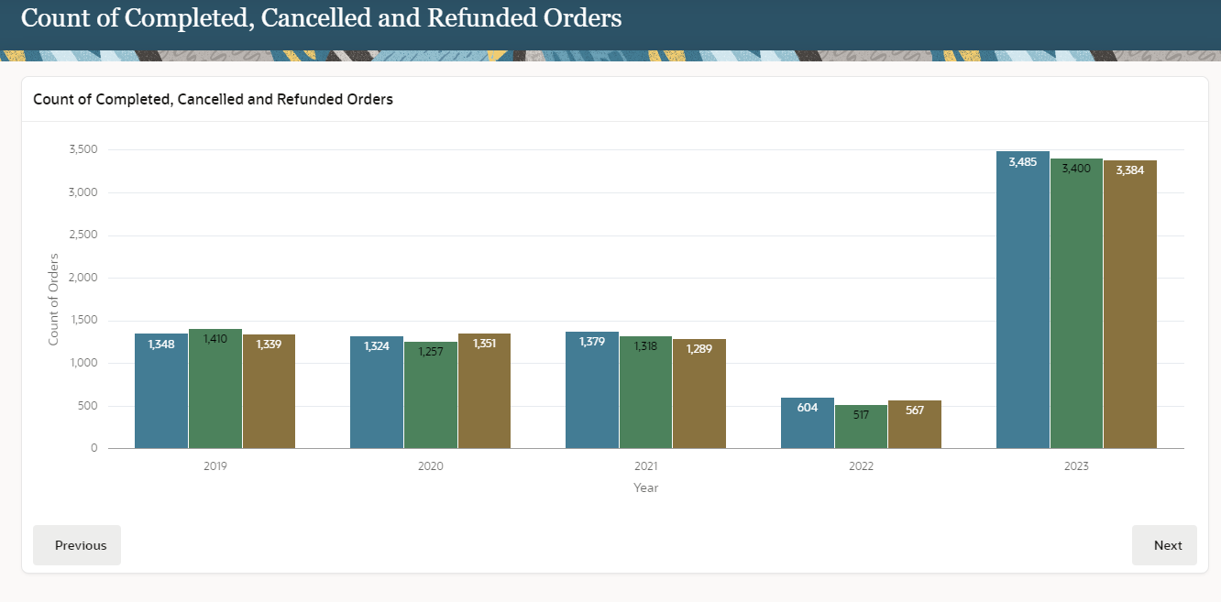

Figure 10: Data Visualization Page

This is one of the data visualization pages, which displays the total number of orders completed, cancelled and refunded over the years.

**Customers Data Load Page:**

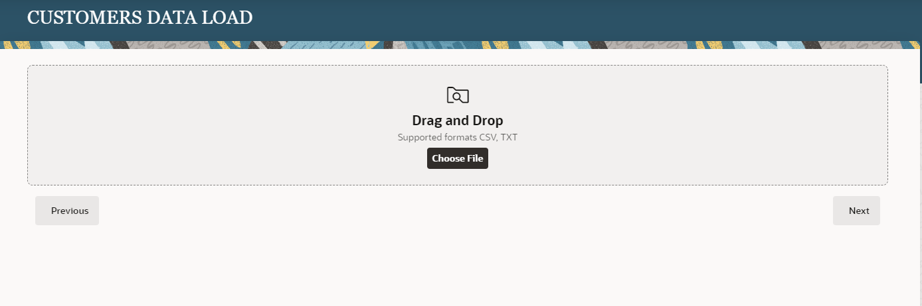

Figure 11:Data Load Page

Oracle APEX provides a feature where the users can create a data load page, where users can upload the data/datasets into the oracle autonomous DB by uploading the file. In this project, we have created the data load pages to upload the data for all the tables.

**Customer Edit Report Page:**

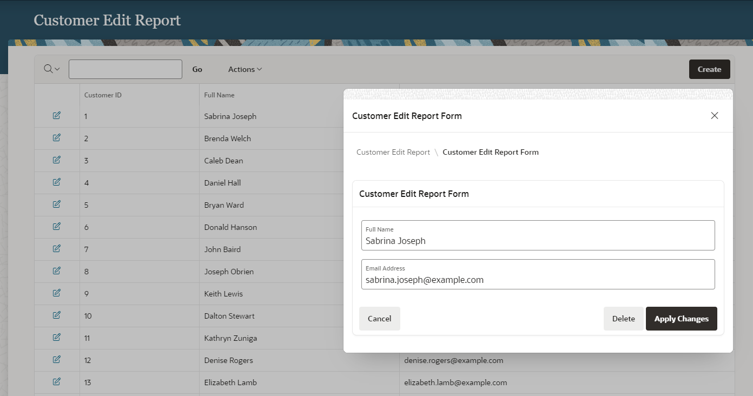

Figure 12:Customer Edit Report Page

This is an Interactive Report where it displays the customer details. Using Oracle Apex forms, we can make changes/edit the customer details and save them. The changes will be directly reflected in the Oracle database. Similarly, we have developed the other reports for all the available tables.

# Future Work:

By leveraging predictive modeling and advanced data analytics, businesses can greatly enhance their sales forecasting and gain insights into customer behavior. This involves analyzing historical data with the help of machine learning algorithms to identify patterns and trends in customer interactions and purchases. By optimizing inventory management, personalizing marketing strategies and improving customer engagement through accurate forecasting of sales trends and customer preferences, businesses can achieve higher sales and customer satisfaction. This approach makes use of data to support strategic decision-making.

# Conclusion:

This project underscores the effectiveness of Oracle Application Express (APEX) in conjunction with Oracle Autonomous Database in creating a sophisticated e-commerce application. By harnessing the real-world Olist dataset, the project vividly demonstrates the practical application of these robust Oracle tools in managing and visualizing complex data. The end product is a testament to the power of a low-code development environment, enabling rapid deployment of a web application that is not only user-friendly but also rich in features. The seamless execution of CRUD operations and the implementation of dynamic data visualization techniques illustrate the capabilities of Oracle APEX and the Oracle Autonomous Database to work in harmony. The project not only achieves its initial objectives but also sets the stage for future enhancement, such as the integration of advanced analytics for deeper business insights. It stands as a prime example of leveraging modern technology solutions to build efficient, responsive, and data-driven applications in today's competitive e-commerce landscape.

# References:

[1] Oracle Corporation. (2023). Getting Started with Oracle Application Express. Oracle Help Center. <https://docs.oracle.com/en/database/oracle/application-express/index.html>

[2] Oracle Corporation. (2023). Overview of Oracle Autonomous Database. Oracle Help Center. <https://docs.oracle.com/en/cloud/paas/autonomous-database/index.html>

[3] de Souza, R. M., Jersak, F., & Pereira, S. (2018). Brazilian E-Commerce Public Dataset by Olist. Kaggle. <https://www.kaggle.com/datasets/olistbr/brazilian-ecommerce>

[4] Oracle Corporation. (2023). Utilizing SQL Developer Web for Database Management. Oracle Help Center. <https://docs.oracle.com/en/database/oracle/sql-developer-web/index.html>

[5] Oracle Corporation. (2023). Oracle APEX Application Development Guide. Oracle Help Center. <https://apex.oracle.com/en/platform/>