Project Submitted by- Sandeep P
Project Description
This project implements a custom SQL UPDATE statement parser using LEX and YACC. The Lex scanner is responsible for tokenizing SQL input by identifying keywords, identifiers, operators, numbers, strings, and special constructs such as IN, IS NULL, and arithmetic expressions. The YACC parser then validates the syntactic structure of the input based on defined grammar rules for the SQL UPDATE command, including SET assignments, complex WHERE conditions and logical operators.

Update Statement Syntax
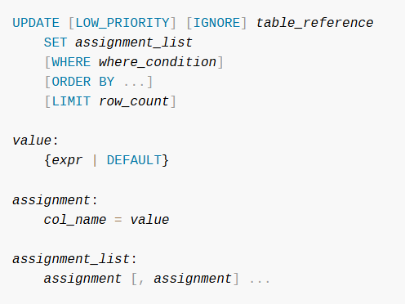
This is the MySQL syntax for UPDATE statement.

What UPDATE statements my Project covers?
1. Basic UPDATE Statements
- Updating one or more columns:
- UPDATE tableName SET column = value;
2. Multiple Column Assignments
- Using commas to update several columns in a single statement:
- UPDATE student SET name = "Alice", age = 20, marks = 95;
3. Arithmetic Expressions in SET Clause
- Supporting expressions using +, -, *, /:
- UPDATE employee SET salary = salary + 5000;
- UPDATE product SET price = price * 1.2;
4. WHERE Clause Filtering
- Conditional updates using comparison operators:
- UPDATE student SET marks = 90 WHERE id = 10;
- UPDATE product SET price = 100 WHERE stock >= 50;
5. Logical Operators (AND / OR)
- Combining multiple conditions:
- UPDATE user SET status = "active" WHERE role = "admin" AND login_count > 5;
- UPDATE student SET grade = "A" WHERE marks > 90 OR attendance > 95;
6. Assignment-Based Conditions
- Conditions using = in comparisons:
- UPDATE student SET section = "B" WHERE class = "10A";
7. IN Clause (List-Based Filtering)
- Matching a value against a list:
- UPDATE student SET status = "passed" WHERE id IN (1, 2, 3, 4);
- UPDATE employee SET role = "Manager" WHERE name IN ("Alice", "Bob");
8. IS / IS NOT NULL Conditions
- Checking for missing or empty values:
- UPDATE records SET flag = 1 WHERE description IS NULL;
- UPDATE user SET active = 0 WHERE last_login IS NOT NULL;
9. String, Number, and Identifier Values
- The parser supports:
  - Numbers (integer and floating-point)
  - Strings in single or double quotes
  - Identifiers (column names, table names)
10. BETWEEN, LIKE, NOT LIKE.

Unsupported UPDATE Statements in the Project
- UPDATE Statements with ORDER BY and LIMIT
The project does not include this because of the limited usage of these statements. These keywords are rarely used with UPDATE statements unlike SELECT statement
- Subqueries in SET or WHERE Clauses
Due to the complexity of subqueries, these are excluded.
- UPDATE Multiple Tables
- Complex Boolean Expressions.
Eg UPDATE logs SET flag = 1 WHERE (level = "high" OR level = "medium") AND active = 1;
- Function Calls such as UPPER LOWER CONCAT etc are excluded.
- Alias Usage in UPDATE or WHERE.

TEST CASES
1) Basic single-column UPDATE
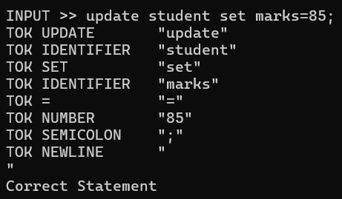
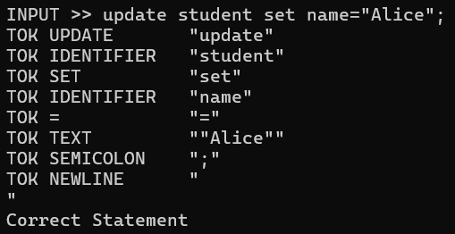
2) Multiple-column assignments
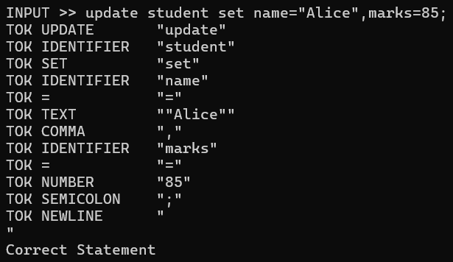
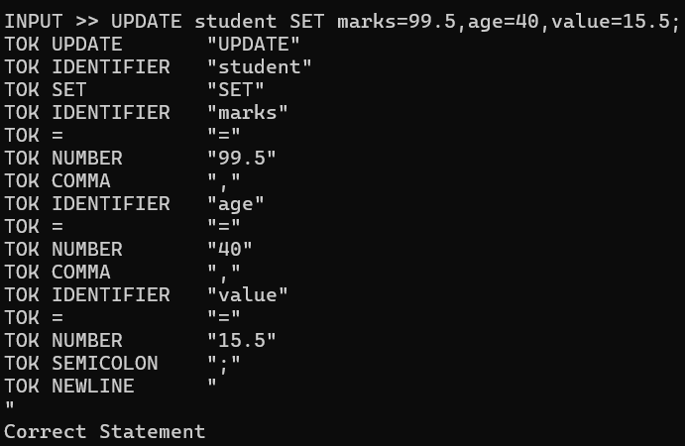
3) Arithmetic expressions in SET
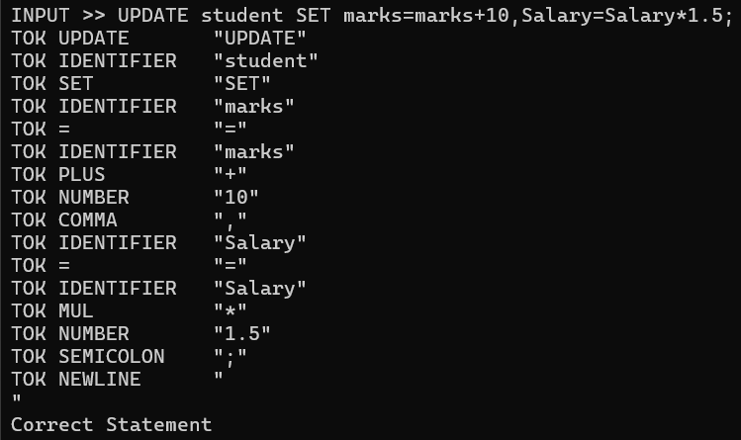
4) Floating point / scientific numeric tests
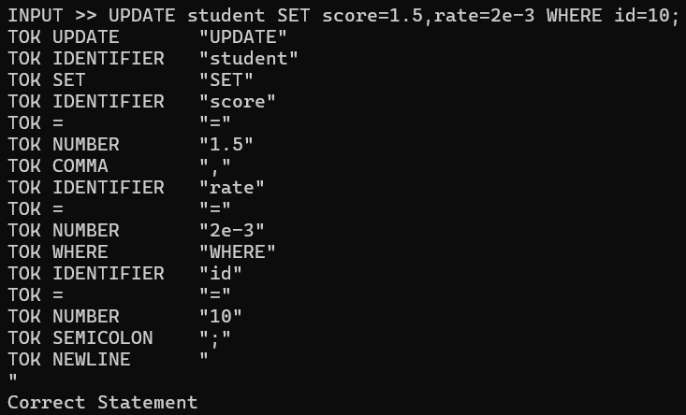
5) WHERE — numeric comparisons
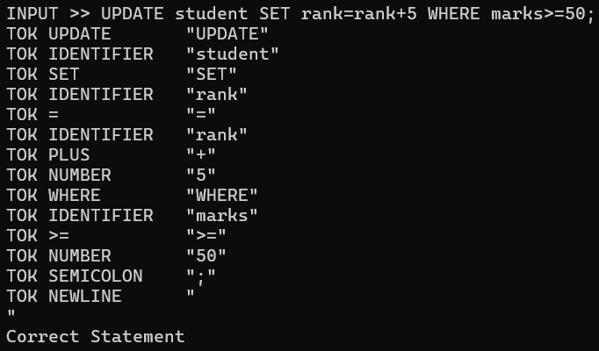
6) WHERE — text comparisons (quoted strings)
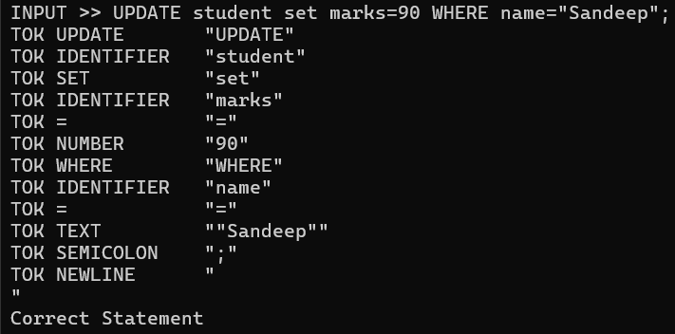
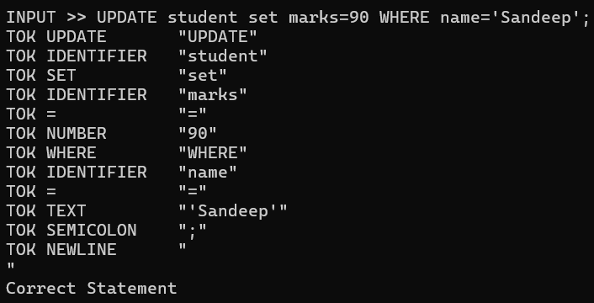
7) Logical operators (AND / OR)
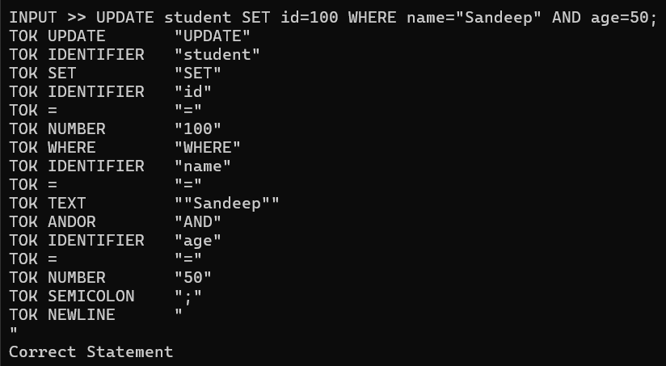
8) IN clause — numeric list
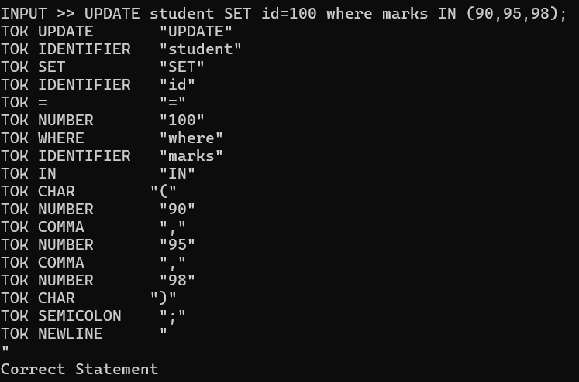

9) IN clause — text list
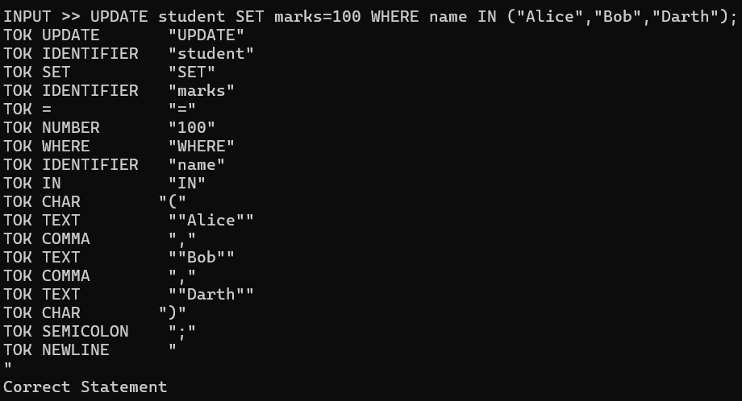
10) NOT IN variants
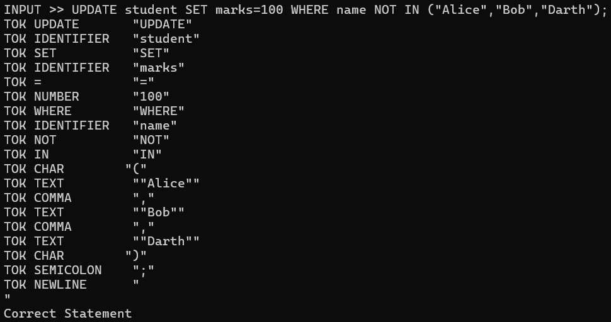
11) IS NULL and IS NOT NULL
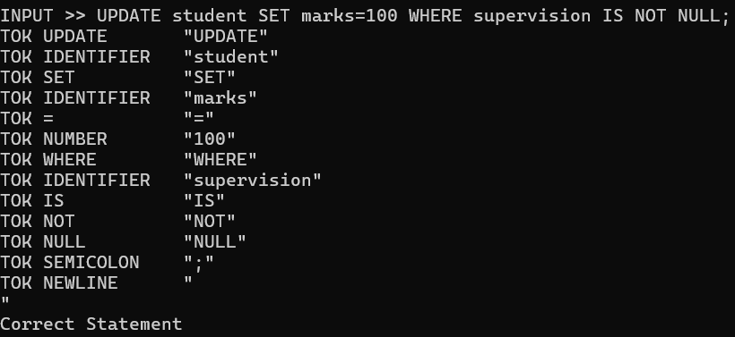
12) LIKE and NOT LIKE
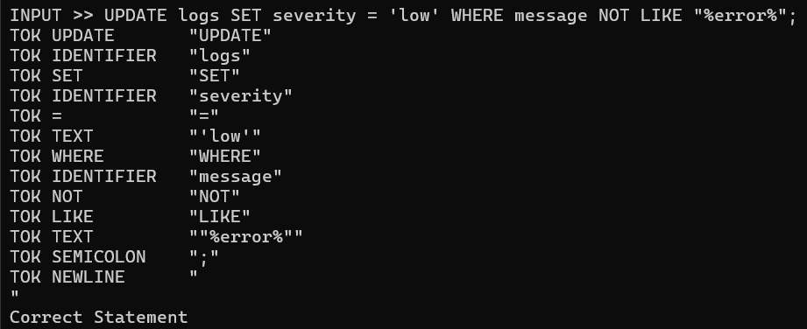
13) BETWEEN and NOT BETWEEN
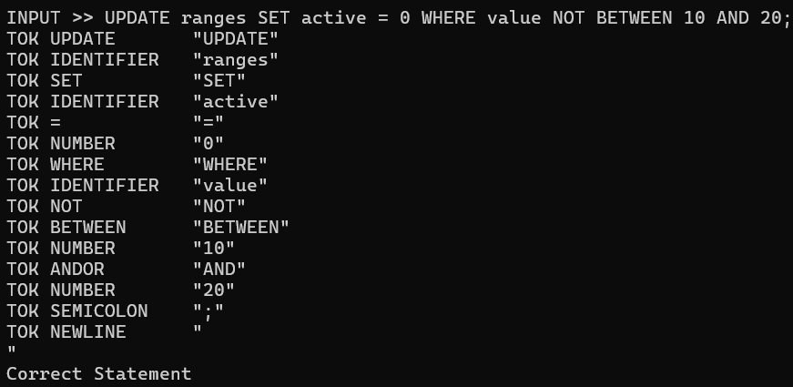
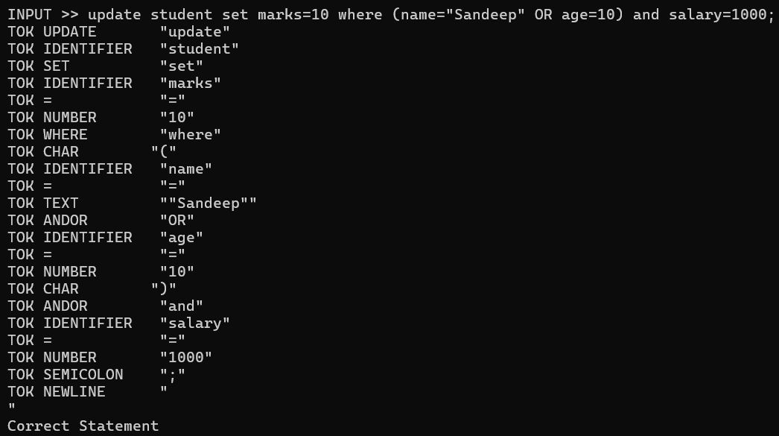
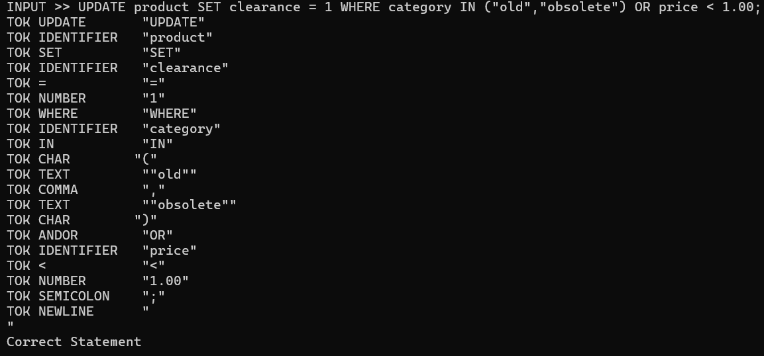

SYNTAX ERROR CASES
