**Case1) For rmax=8000** **maximum number of rounds**  **in I sep**

**xm=100;**

**ym=100;**

**n=100;**

**b=0.5** in an intermediate energy level lets say , the energy is β times more than normal ones, and less than the advanced nodes energy (α ) where β = α/2.

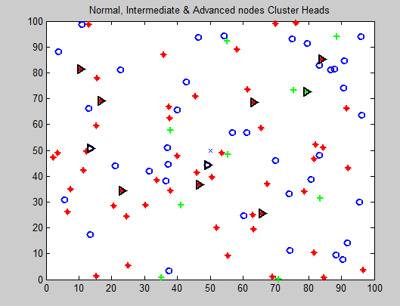

**Blue : Normal Nodes**

**Red : Intermediate Nodes**

**Green : Advanced Nodes**

**Black Triangle: Cluster head**

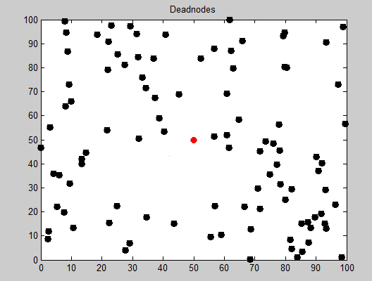

**Black: Dead nodes**

more energy is supplied to the active or the sensing nodes and the others that are non sensing nodes act as dead nodes as there is no energy passed. So in this way we can preserve energy. basically, the highest energy level is supplied to advanced nodes, the number of dead nodes is less as compared to intermediate and normal nodes. With time, the normal nodes tend to die out at a faster rate. so, the intermediate and advanced nodes get elected as CH that stretches the lifetime to a greater number of rounds and increases the CH count

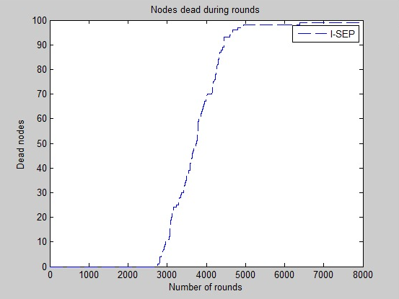

**Throughput**: in order to maximize throughput we introduce a threshold level in the CH selection process. So that the number of packets sent to the base station is more.

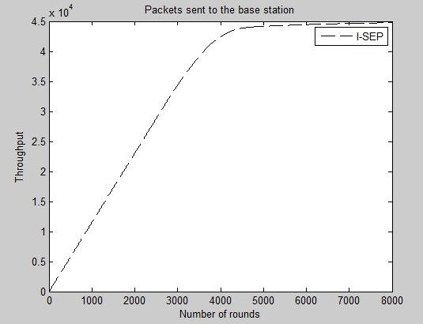

N=50

X=y=100

R=rmax=4000

At once all the nodes became dead at r=1300 since we limited the ability of the advanced nodes become a CH if E<0.5

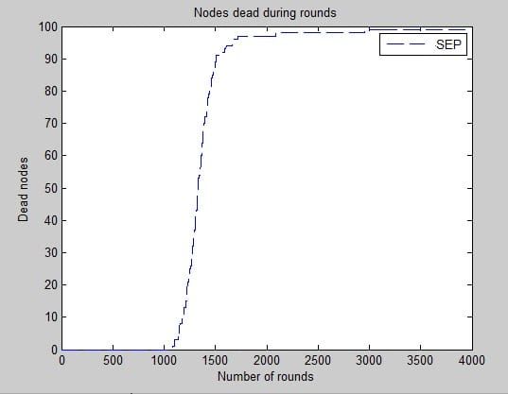

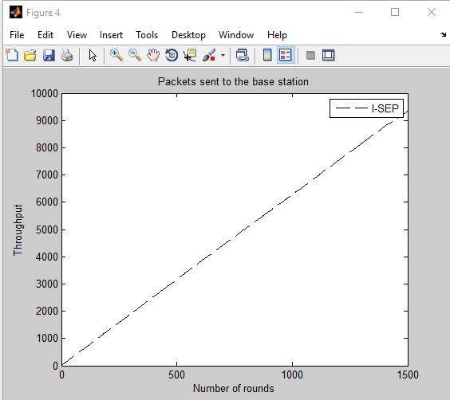

**Case 2)**

**In I-sep , for n=100**

**X=y=100**

**B=0.3**

**A=1**

**R=rmax=4000**

**By calculating the residual energy and** if the cluster head is there with the residual energy greater than the threshold value, then the same cluster head is continued to remain as the cluster head thereby we energy consumption is reduced.so when compared to the previous values, the dead nodes are seen at the round 2900. Which makes our network stable.

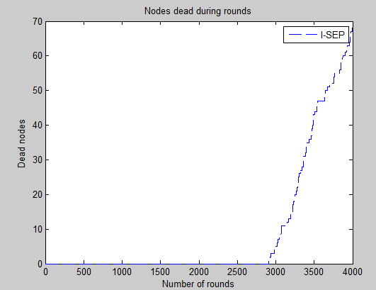

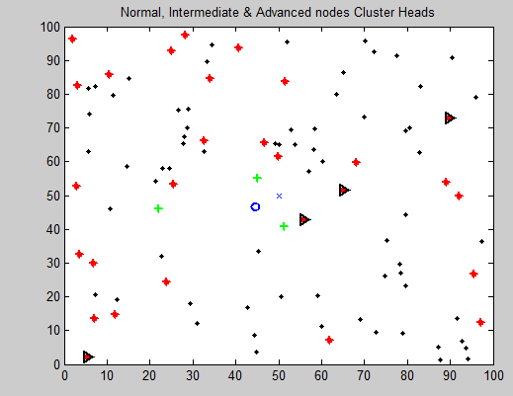

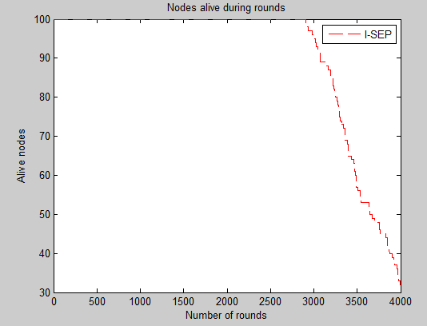

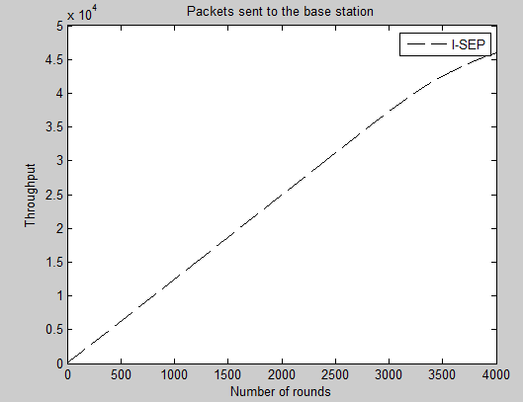

**Case 3) I-SEP for rmax=4000: (maximum number of rounds)**

**xm=100;**

**ym=100;**

**n=100;**

**b=0.5**

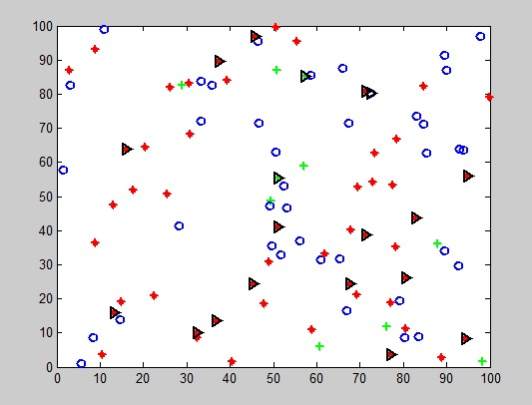

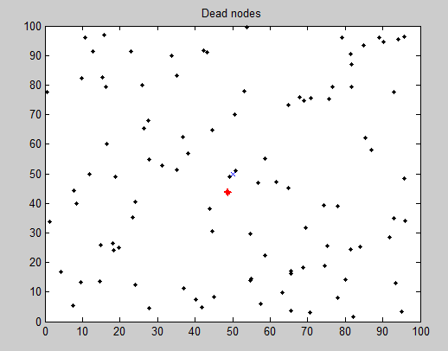

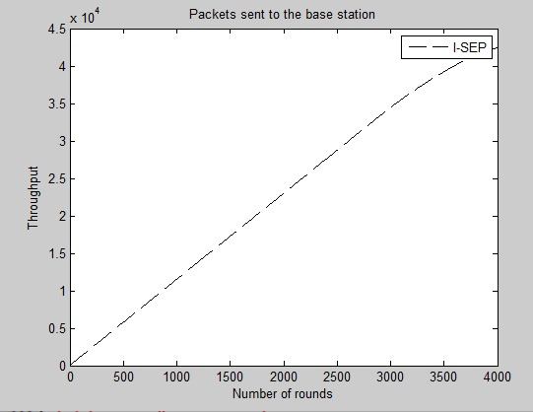

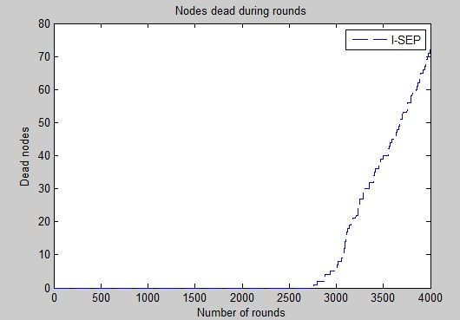

**Case 4) N=100**

**Rmax=r=1000**

**I-sep**

If we take the number of rounds less that is 1000, the graph is as below where, the dead nodes are not available,

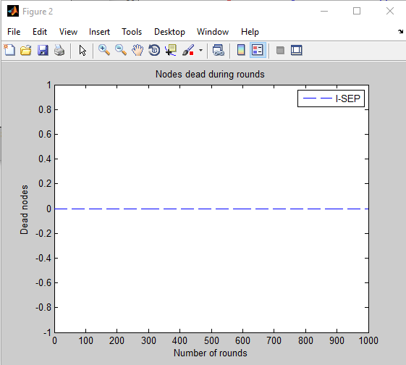

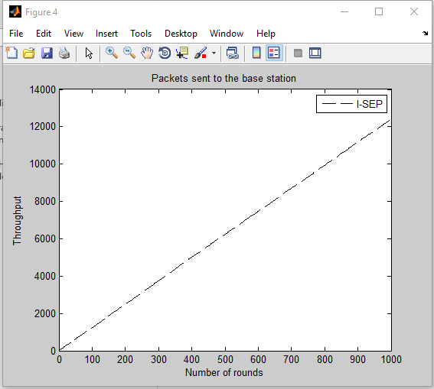

**Case 5) Comparison of SEP with I-SEP results.**

**For rmax=4000 in sep**

**xm=100;**

**ym=100;**

**n=100;**

**b=0.5**

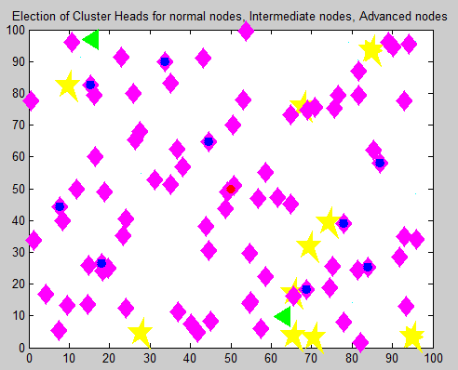

**Pink : normal**

**Blue advanced nodes.**

**Yellow: dead nodes.**

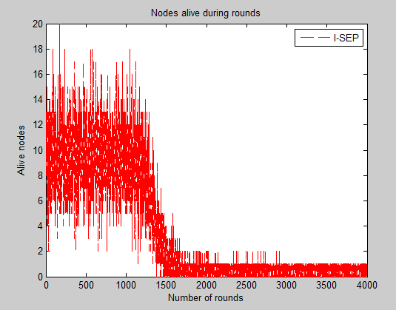



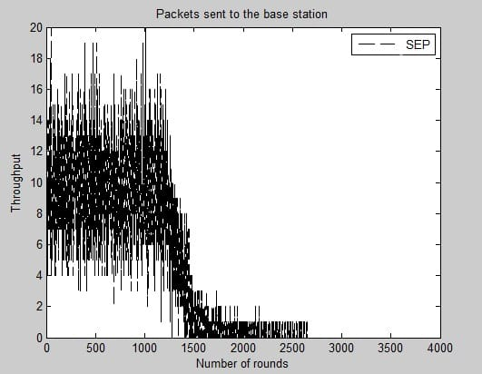

**Case 6) R=rmax=4000; in I-sep**

**N=150**

**Alpha =3**

**B=0.2**

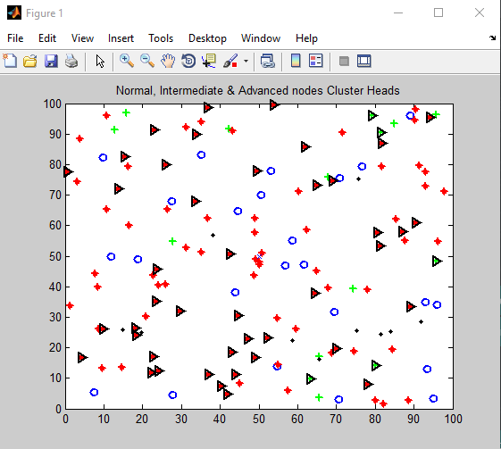

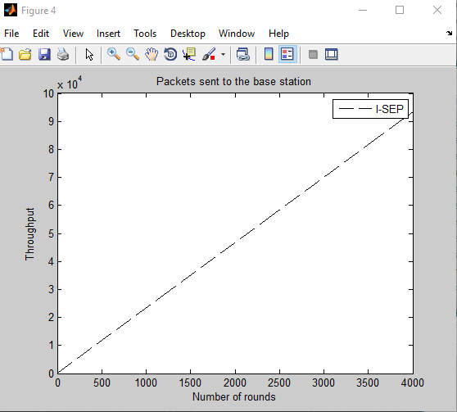

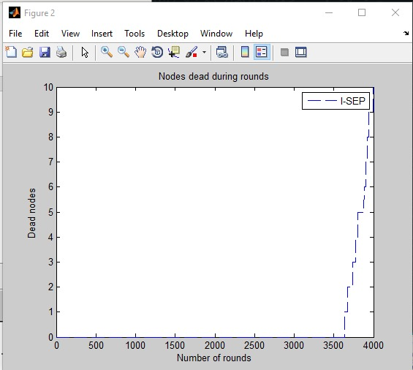

**For rmax=8000** **maximum number of rounds**  **in I sep**

**xm=100;**

**ym=100;**

**n=100;**

**b=0.3**





