Druid
Druid is a distributed, column-oriented, real-time analytics data store that is commonly used to power exploratory dashboards in multi-tenant environments.
Druid excels as a data warehousing solution for fast aggregate queries on petabyte sized data sets. Druid supports a variety of flexible filters, exact calculations, approximate algorithms, and other useful calculations.
Druid can load both streaming and batch data and integrates with Samza, Kafka, Storm, Spark, and Hadoop.
Druid is commonly used in business intelligence/OLAP applications to analyze high volumes of real-time and historical data

The Data
This data set is composed of three distinct components
- Timestamp column: We treat timestamp separately because all of our queries center around the time axis.
- Dimension columns: Dimensions are string attributes of an event, and the columns most commonly used in filtering the data. We have four dimensions in our example data set: publisher, advertiser, gender, and country. They each represent an axis of the data that we’ve chosen to slice across.
- Metric columns: Metrics are columns used in aggregations and computations. In our example, the metrics are clicks and price. Metrics are usually numeric values, and computations include operations such as count, sum, and mean. Also known as measures in standard OLAP terminology.

Sharding the Data
Druid shards are called segments and Druid always first shards data by time.Segments are self-contained containers for the time interval of data they hold. Segments contain data stored in compressed column orientations, along with the indexes for those columns. Druid queries only understand how to scan segments.

Indexing the Data
Druid gets its speed in part from how it stores data. Borrowing ideas from search infrastructure, Druid creates immutable snapshots of data, stored in data structures highly optimized for analytic queries.
Druid is a column store, which means each individual column is stored separately. Only the columns that pertain to a query are used in that query, and Druid is pretty good about only scanning exactly what it needs for a query. Different columns can also employ different compression methods. Different columns can also have different indexes associated with them.
Druid indexes data on a per-shard (segment) level.

Loading the Data
Druid has two means of ingestion, real-time and batch. Real-time ingestion in Druid is best effort. Exactly once semantics are not guaranteed with real-time ingestion in Druid, although we have it on our roadmap to support this. Batch ingestion provides exactly once guarantees and segments created via batch processing will accurately reflect the ingested data. One common approach to operating Druid is to have a real-time pipeline for recent insights, and a batch pipeline for the accurate copy of the data.

ARCHITECTURE
The Druid Cluster
A Druid Cluster is composed of several different types of nodes. Each node is designed to do a small set of things very well.
- Historical Nodes Historical nodes commonly form the backbone of a Druid cluster. Historical nodes download immutable segments locally and serve queries over those segments. The nodes have a shared nothing architecture and know how to load segments, drop segments, and serve queries on segments.
- Broker Nodes Broker nodes are what clients and applications query to get data from Druid. Broker nodes are responsible for scattering queries and gathering and merging results. Broker nodes know what segments live where.
- Coordinator Nodes Coordinator nodes manage segments on historical nodes in a cluster. Coordinator nodes tell historical nodes to load new segments, drop old segments, and move segments to load balance.
- Real-time Processing Real-time processing in Druid can currently be done using standalone realtime nodes or using the indexing service. The real-time logic is common between these two services. Real-time processing involves ingesting data, indexing the data (creating segments), and handing segments off to historical nodes. Data is queryable as soon as it is ingested by the realtime processing logic. The hand-off process is also lossless; data remains queryable throughout the entire process.
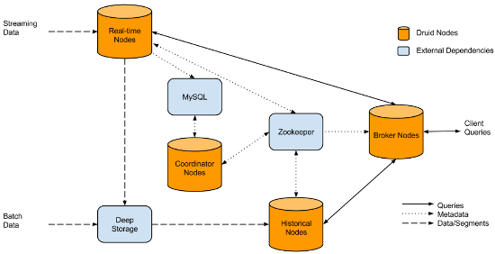

Figure 1: An overview of a Druid cluster and the flow of data through the cluster

External Dependencies
Druid has a couple of external dependencies for cluster operations.
- Zookeeper Druid relies on Zookeeper for intra-cluster communication.
- Metadata Storage Druid relies on a metadata storage to store metadata about segments and configuration. Services that create segments write new entries to the metadata store and the coordinator nodes monitor the metadata store to know when new data needs to be loaded or old data needs to be dropped. The metadata store is not involved in the query path. MySQL and PostgreSQL are popular metadata stores for production, but Derby can be used for experimentation when you are running all druid nodes on a single machine.
- Deep Storage Deep storage acts as a permanent backup of segments. Services that create segments upload segments to deep storage and historical nodes download segments from deep storage. Deep storage is not involved in the query path. S3 and HDFS are popular deep storages.

