LUNAVISION AI: AN INTELLIGENT MULTI-AGENT PIPELINE FOR AUTOMATED EXOPLANET DISCOVERY FROM TESS OBSERVATIONS
A PROJECT REPORT
Submitted by
B R PRASANNA (913123243XXX)
M SANDEEP (913123243XXX)
S GOKUL (913123243XXX)
in partial fulfillment for the award of the degree of
BACHELOR OF TECHNOLOGY
in
ARTIFICIAL INTELLIGENCE AND DATA SCIENCE
VELAMMAL COLLEGE OF ENGINEERING AND TECHNOLOGY
MADURAI – 625 009
(Autonomous)
MAY 2027

VELAMMAL COLLEGE OF ENGINEERING AND TECHNOLOGY, MADURAI – 625 009
(AUTONOMOUS)
Department of Artificial Intelligence and Data Science
BONAFIDE CERTIFICATE
This is to certify that this project report “LUNAVISION AI: AN INTELLIGENT MULTI-AGENT PIPELINE FOR AUTOMATED EXOPLANET DISCOVERY FROM TESS OBSERVATIONS” is the bonafide work of “B R PRASANNA (913123243XXX), M SANDEEP (913123243XXX) and S GOKUL (913123243XXX)” who carried out the project work under my supervision.

SIGNATURE  Mrs. M. Bhavadharini  SUPERVISOR  Department of Artificial Intelligence and Data Science  Velammal College of Engineering and Technology, Madurai – 625 009 | SIGNATURE  [Name of the Head of the Department]  HEAD OF THE DEPARTMENT  Department of Artificial Intelligence and Data Science  Velammal College of Engineering and Technology, Madurai – 625 009
Submitted for the End Semester Viva Voce Examination held on ______________ at Velammal College of Engineering and Technology, Madurai.

INTERNAL EXAMINER | EXTERNAL EXAMINER

ABSTRACT
The discovery of exoplanets has become one of the most active areas of modern astronomy. NASA's Transiting Exoplanet Survey Satellite (TESS) records the brightness of tens of thousands of stars in every observing sector, and a planet crossing its host star appears as a small, periodic dip in the light curve. The volume and noise of these data make manual inspection impractical, and existing automated tools address only isolated stages of the workflow.
This project presents LuNaVision AI, an intelligent multi-agent pipeline for automated exoplanet discovery from TESS observations. Specialised agents handle data acquisition from NASA MAST, light-curve preprocessing and detrending, Transit Least Squares period detection, GPU-accelerated engineering of more than sixty physically motivated features, and classification with a leakage-safe stacked ensemble with calibrated probabilities. Parameter fitting, reporting and active learning are designed as further agents.
The pipeline was run on 2,360 real TESS light curves; 2,312 were detrended with a median noise reduction of about 49 percent. On a held-out set of 530 real targets the classifier achieves 74.2 percent accuracy, a ROC-AUC of 0.750 and a PR-AUC of 0.840, using interpretable transit-shape and signal-quality features. The report documents the design, implementation deviations, nine bugs found and fixed, benchmark studies and a path toward a SaaS product.
Keywords: Exoplanet detection, TESS, transit photometry, light curves, multi-agent systems, machine learning.

ACKNOWLEDGEMENT
We express our sincere gratitude to the management and the Principal of Velammal College of Engineering and Technology, Madurai, for providing the facilities needed to carry out this project.
We are thankful to the Head of the Department of Artificial Intelligence and Data Science for constant encouragement and support.
We record our deep gratitude to our guides, Mrs. M. Bhavadharini and Dr. S. Sasikala, Department of Artificial Intelligence and Data Science, for their valuable guidance, continued feedback and motivation throughout the design and implementation of this work.
We also thank the NASA TESS mission, the Mikulski Archive for Space Telescopes, ExoFOP-TESS and the NASA Exoplanet Archive for making their data openly available, and the developers of the open-source packages on which this work depends. Finally, we thank our friends and families for their support.

TABLE OF CONTENTS
CHAPTER NO. / TITLE PAGE NO.
1. INTRODUCTION 1
1.1 Background of the Study 1
1.2 Motivation 2
1.3 Problem Statement 3
1.4 Objectives 3
1.5 Scope of the Project 4
1.6 Contributions of the Project 5
1.7 Organisation of the Report 5
2. LITERATURE SURVEY 7
2.1 Overview of Exoplanet Detection Methods 7
2.2 Signal Processing for Weak Periodic Signals 7
2.3 Machine Learning for Light-Curve Classification 8
2.4 Foundations Used by the Pipeline 9
2.5 Comparison of Surveyed Work 9
2.6 Research Gap 10
2.7 Summary of the Chapter 11
3. SYSTEM ANALYSIS AND REQUIREMENTS 12
3.1 Existing System 12
3.2 Proposed System 13
3.3 Functional Requirements 13
3.4 Non-Functional Requirements 14
3.5 Feasibility Study 14
3.6 Hardware and Software Requirements 15
3.7 Signal Taxonomy 16
4. PROPOSED SYSTEM ARCHITECTURE 18
4.1 Design Philosophy 18
4.2 Agents and Their Responsibilities 19
4.3 Message Envelope 19
4.4 End-to-End Data Flow 20
4.5 Design Decisions and Trade-offs 21
4.6 Deployment View 22
5. DATASET AND DATA COLLECTION 23
5.1 Overview 23
5.2 Label and Catalogue Sources 23
5.3 Unified Label Construction 24
5.4 Light-Curve Acquisition 25
5.5 Dataset Statistics 26
5.6 Synthetic Transit Injection 26
5.7 Data Quality Assessment 27
5.8 Train, Validation and Test Split 28
6. METHODOLOGY AND IMPLEMENTATION 29
6.1 Stage 1: Data Acquisition 29
6.2 Stage 2: Preprocessing and Detrending 30
6.3 Stage 3: Periodicity Detection 32
6.4 Stage 4: Feature Engineering 33
6.5 Stage 5: Classification 36
6.6 Leakage Control 37
6.7 Stage 6 and Beyond: Planned Agents 37
6.8 Dashboard Prototype 38
6.9 Summary of Implementation Deviations 38
7. TESTING AND VALIDATION 39
7.1 Testing Strategy 39
7.2 Unit Testing 39
7.3 Integration Testing 40
7.4 Injection–Recovery Validation 40
7.5 Bug Log Summary 41
7.6 Evaluation Protocol for the Classifier 41
8. RESULTS AND DISCUSSION 43
8.1 Experimental Setup 43
8.2 Acquisition and Catalogue Statistics (REAL) 43
8.3 Preprocessing Performance 44
8.4 Detection Performance 45
8.5 Classification Performance (REAL) 46
8.6 Injection–Recovery Sensitivity (MOCK) 50
8.7 Comparison with Baseline Classifiers (MOCK) 51
8.8 Ablation Study (MOCK) 52
8.9 Effect of Decision Threshold (MOCK) 53
8.10 Runtime and Scalability (MOCK) 53
8.11 Recovery of Known TOIs (MOCK) 55
8.12 Discussion 55
9. COMPARATIVE ANALYSIS AND PRODUCTISATION 57
9.1 Comparison of Development Strategies 57
9.2 Comparison with Existing Tools (MOCK) 58
9.3 From Research Pipeline to SaaS Product 58
9.4 Societal and Educational Impact 60
10. RISKS, CONCLUSION AND FUTURE ENHANCEMENT 61
10.1 Risks and Mitigations 61
10.2 Limitations 61
10.3 Conclusion 62
10.4 Future Enhancements 63
APPENDIX A: FEATURE DICTIONARY 65
APPENDIX B: BUG LOG WITH ROOT CAUSES 67
APPENDIX C: COMMAND-LINE USAGE 69
APPENDIX D: SELECTED SOURCE EXCERPTS 70
APPENDIX E: NOTE ON MOCK BENCHMARK DATA 71
REFERENCES 72

LIST OF TABLES
Table 2.1: Capability comparison against surveyed literature 10
Table 3.1: Functional requirements 13
Table 3.2: Non-functional requirements 14
Table 3.3: Hardware requirements 15
Table 3.4: Software requirements 16
Table 3.5: Signal taxonomy 16
Table 4.1: Agents and responsibilities 19
Table 4.2: Artefacts exchanged between stages 20
Table 5.1: Data sources 23
Table 5.2: Disposition-to-label mapping 24
Table 5.3: Dataset snapshot (19 September 2026) 26
Table 5.4: Injection parameter ranges 27
Table 6.1: Acquisition parameters 29
Table 6.2: Preprocessing parameters 32
Table 6.3: TLS configuration 33
Table 6.4: Engineered feature groups 34
Table 6.5: Feature-extraction safeguards 35
Table 6.6: Base-learner hyper-parameters (HistGradientBoosting) 36
Table 6.7: Deviations from the original specification 38
Table 7.1: Unit test cases 39
Table 7.2: Defects found during testing 41
Table 8.1: Experimental setup 43
Table 8.2: Pipeline data volumes by stage (REAL) 44
Table 8.3: Detection summary (MOCK) 46
Table 8.4: Classifier metrics against project targets (REAL) 46
Table 8.5: Per-class results (REAL) 47
Table 8.6: Top-10 permutation importances (REAL) 49
Table 8.7: Model comparison on the held-out set (MOCK) 51
Table 8.8: Projected runtime (MOCK) 54
Table 8.9: Recovery of confirmed TOIs at SDE at least 7 (MOCK) 55
Table 9.1: Hand-chained scripts versus orchestrated pipeline 57
Table 9.2: Indicative comparison with other approaches (MOCK) 58
Table 9.3: Layers of the target SaaS architecture 59
Table 9.4: Phased roadmap 60
Table 10.1: Identified risks and mitigations 61
Table A.1: Feature dictionary 65
Table E.1: Inventory of MOCK content 71

LIST OF FIGURES
Figure 3.1: Phase-folded morphology: a planet transit is flat-bottomed, an eclipsing binary is V-shaped (illustrative) 17
Figure 4.1: Multi-agent architecture of LuNaVision AI 18
Figure 4.2: Six-stage sequential pipeline (teal: implemented, grey: planned) 20
Figure 5.1: Dataset composition: class split of usable light curves and catalogue sizes 24
Figure 6.1: Effect of biweight detrending on a light curve with three transits (illustrative) 31
Figure 8.1: Distribution of RMS reduction after detrending (MOCK reconstruction of reported mean and median) 45
Figure 8.2: SDE distribution by class (MOCK) 46
Figure 8.3: Held-out confusion matrix (REAL) 47
Figure 8.4: Learning curve on the held-out test set (REAL) 48
Figure 8.5: Top-12 features by permutation importance (REAL) 49
Figure 8.6: Injection-recovery map: recovery fraction by depth and period (MOCK) 50
Figure 8.7: Accuracy and macro-F1 of candidate models (MOCK) 51
Figure 8.8: ROC curves of the candidate models (MOCK) 52
Figure 8.9: Macro-F1 after removing one feature group (MOCK) 52
Figure 8.10: Recall and precision of the Transit class as functions of threshold (MOCK) 53
Figure 8.11: Projected runtime versus number of targets (MOCK) 54
Figure 8.12: Per-target feature time by operation, CPU versus GPU (MOCK) 54

LIST OF SYMBOLS, ABBREVIATIONS AND NOMENCLATURE
Abbreviation | Expansion
AI | Artificial Intelligence
API | Application Programming Interface
AUC | Area Under the Curve
BLS | Box Least Squares
CNN | Convolutional Neural Network
CUDA | Compute Unified Device Architecture
EB | Eclipsing Binary
BEB | Background Eclipsing Binary
FAP | False Alarm Probability
FFI | Full-Frame Image
FFT | Fast Fourier Transform
FITS | Flexible Image Transport System
GPU | Graphics Processing Unit
MAST | Mikulski Archive for Space Telescopes
MCMC | Markov Chain Monte Carlo
PDCSAP | Pre-search Data Conditioning Simple Aperture Photometry
PR-AUC | Precision-Recall Area Under the Curve
ROC | Receiver Operating Characteristic
SDE | Signal Detection Efficiency
SMOTE | Synthetic Minority Over-sampling Technique
SNR | Signal-to-Noise Ratio
SPOC | Science Processing Operations Center
TCE | Threshold-Crossing Event
TESS | Transiting Exoplanet Survey Satellite
TIC | TESS Input Catalog
TLS | Transit Least Squares
TOI | TESS Object of Interest
XAI | Explainable Artificial Intelligence

LIST OF SYMBOLS
Symbol | Meaning
Rp/R* | Planet-to-star radius ratio
P | Orbital period (days)
T0 | Mid-transit epoch (BTJD)
Teff | Effective temperature (K)
log g | Surface gravity, log10 (cm/s2)
ppm | Parts per million
σ | Standard deviation (sigma)

CHAPTER 1
INTRODUCTION

1.1 Background of the Study
For most of human history the night sky was assumed to hold only one planetary system that we could ever know: our own. That assumption ended in 1995, when the first planet orbiting a Sun-like star was detected using precise radial-velocity measurements. Since then, the field of exoplanet science has grown from a curiosity into one of the most productive areas of modern astronomy. More than five thousand confirmed planets are now catalogued by the NASA Exoplanet Archive, and thousands more candidates await confirmation. These worlds range from scorching gas giants that orbit their stars in less than a day, to temperate rocky planets that might one day be examined for signs of atmospheres and, ultimately, life.
Exoplanets are discovered through several complementary techniques, including radial velocity, transit photometry, gravitational microlensing, astrometry and direct imaging. Of these, transit photometry has been the most prolific. When a planet passes in front of its host star as seen from Earth, it blocks a small fraction of the starlight and produces a brief, periodic dip in the star's measured brightness. For an Earth-sized planet crossing a Sun-like star the dip is only about 84 parts per million; for a Jupiter-sized planet it is roughly one percent. Detecting such tiny, repetitive dips requires very stable, continuous, high-precision photometry, which is best achieved from space.
NASA's Transiting Exoplanet Survey Satellite (TESS) [12], launched in April 2018, was designed exactly for this purpose. TESS carries four wide-field cameras and observes a large strip of the sky, called a sector, for about 27 days at a time. Bright stars are recorded at a two-minute cadence, and the whole field is recorded in full-frame images at a much slower cadence. In every sector, tens of thousands of stars are monitored, and the mission has by now observed most of the sky. The Science Processing Operations Center (SPOC) pipeline converts the raw pixel data into calibrated light curves, in which the flux of each star is tabulated against time, and these products are archived at the Mikulski Archive for Space Telescopes (MAST).
The result is a data-rich but analyst-poor situation. Each sector adds another batch of light curves that must be screened for planet-like signals. A human analyst cannot visually inspect this volume of data, and even the automated vetting performed by the mission produces thousands of threshold-crossing events that must be examined further. Most of these events are not planets. They are eclipsing binary stars, background eclipsing binaries whose light is blended into the target aperture, stellar variability such as starspots and pulsations, and instrumental artefacts. Separating genuine planetary transits from these false positives is the central scientific and engineering problem addressed by this project.

1.2 Motivation
Several observations motivated this work. First, the cost of manual vetting scales linearly with the number of candidates, whereas the number of observed stars keeps growing with every new sector. Second, the existing automated tools are narrow. A typical script downloads light curves, another cleans them, a third searches for periodic dips, and a classifier notebook expects a hand-prepared feature table as its input. Every hand-off between such tools is a place where formats drift, rows silently disappear and unlogged manual filtering enters the analysis. Third, machine-learning classifiers reported in the literature frequently quote very high accuracy on benchmark datasets, but they seldom describe how the surrounding pipeline was built or how leakage between training and test data was prevented.
The team therefore chose to treat exoplanet discovery not as a single classification problem but as an end-to-end engineering problem: how can a raw TESS observation be carried through acquisition, cleaning, detection, feature extraction, classification, parameter estimation and reporting inside one coordinated, auditable system? The answer explored in this report is LuNaVision AI, a multi-agent pipeline in which each stage is a specialised software agent supervised by a central orchestrator.

1.3 Problem Statement
To design and implement an automated, resumable and interpretable software pipeline that ingests raw NASA TESS light curves, removes instrumental and stellar noise, detects periodic transit-like dips, computes a rich set of physically motivated features, classifies each candidate against common false-positive classes, and produces auditable evidence for every decision, so that a new TESS sector can be processed with minimal manual intervention.

1.4 Objectives
- To automate the acquisition of TESS two-minute cadence light curves from the MAST archive, with resumable, rate-limit-aware downloading and quality-flag filtering.
- To build a preprocessing stage that normalises, cleans and detrends light curves without destroying the transit signal that must later be detected.
- To detect periodic transit signals with the Transit Least Squares (TLS) algorithm and to convert the search output into calibrated signal-quality metrics such as the Signal Detection Efficiency (SDE) and false-alarm probability.
- To engineer a feature vector of more than sixty physically meaningful attributes, covering transit geometry, odd/even depth consistency, secondary eclipses, phase-folded morphology, a centroid-shift proxy, stellar parameters and spectral statistics, using GPU acceleration where hardware allows.
- To train a leakage-safe stacked ensemble classifier that outputs calibrated transit probabilities, and to report its performance honestly against the project targets.
- To document the design so that further stages, namely Bayesian parameter fitting, automated reporting, active learning and a web dashboard, can be plugged into the same architecture.

1.5 Scope of the Project
The scope of the present work covers the first five stages of the pipeline as working software, namely data acquisition, preprocessing, periodicity detection, feature engineering and classification, together with a dashboard prototype and a productisation blueprint. The Bayesian parameter-fitting agent, the automated PDF reporting agent and the active-learning loop are specified at design level and are described in the future-enhancement chapter. The data used are TESS Sector 1 two-minute cadence light curves for a label-driven sample of targets, cross-matched with catalogues from ExoFOP-TESS, the NASA Exoplanet Archive and the SPOC threshold-crossing-event list. The classifier is evaluated on a binary Transit versus Other framing; the four-class taxonomy is part of the design and is planned as the next milestone.

1.6 Contributions of the Project
- A modular, resumable end-to-end pipeline whose stages communicate through typed messages and on-disk artefacts, enabling fault isolation and independent scaling.
- A label-driven acquisition strategy that interleaves classes so that any prefix of the download is balanced, thereby making partial runs scientifically useful.
- A GPU-accelerated feature extractor with automatic CPU fallback, worker caps, per-task timeouts, RAM guards and batch checkpointing.
- A group-aware evaluation protocol that prevents a synthetic light curve from sharing a fold with its host star, and explicit removal of two leaky features that inflated importance scores.
- A documented bug log, in which nine concrete root causes were found and fixed, offering a practical lesson for anyone building similar pipelines.
- A productisation plan converting the research pipeline into a multi-tenant SaaS product.

1.7 Organisation of the Report
Chapter 2 reviews the literature on exoplanet detection and classification and identifies the gap addressed by this work. Chapter 3 presents the system analysis, including requirements and feasibility. Chapter 4 describes the proposed multi-agent architecture. Chapter 5 documents the datasets and the label-construction process. Chapter 6 explains the implementation of every pipeline stage in detail. Chapter 7 describes the testing methodology, and Chapter 8 presents the results, including benchmark studies. Chapter 9 discusses productisation and comparative analysis. Chapter 10 lists risks and concludes the report with future enhancements. The appendices contain a feature dictionary, the bug log, command-line usage and code excerpts.

CHAPTER 2
LITERATURE SURVEY

2.1 Overview of Exoplanet Detection Methods
Wright and Gaudi [8] review the principal methods by which exoplanets are found. Radial-velocity surveys measure the periodic Doppler shift of stellar spectral lines caused by an orbiting planet. Transit photometry measures the periodic dimming caused by a planet crossing the stellar disc. Direct imaging suppresses starlight and photographs the planet itself, while microlensing exploits the gravitational amplification of a background star. Each method has different biases: radial velocity favours massive close-in planets around quiet stars, transits favour close-in planets whose orbits happen to be aligned with the line of sight, and direct imaging favours young, hot giants on wide orbits.
Transit photometry offers a unique advantage for automated processing. The observable is a single, uniformly sampled time series per star, which can be handled with standard signal-processing and machine-learning tools, and the geometry of the transit directly yields the planet-to-star radius ratio, the orbital period and, given stellar parameters, the planetary radius. This is why missions such as Kepler, K2, CoRoT and TESS all adopted the transit method.

2.2 Signal Processing for Weak Periodic Signals
Khan, Jenkins and Yoma [7] survey signal-processing techniques for radial-velocity exoplanet detection and show how statistical thresholds and filtering improve the recovery of weak periodic signals buried in noise. Although their focus is radial velocity rather than transit photometry, the principle carries over: a detection statistic must be defined, its null distribution understood, and a threshold chosen to trade completeness against false alarms. In transit searches this role is played by the Signal Detection Efficiency and the false-alarm probability. De Beurs and colleagues [6] use neural networks to remove stellar activity signals from radial-velocity data before a planet search is performed, illustrating that stellar noise must be modelled, not merely ignored.

2.3 Machine Learning for Light-Curve Classification
Jara-Maldonado and co-authors [2] apply K-nearest neighbours in combination with the SMOTE oversampling technique to stellar light-intensity data and obtain high accuracy while correcting for the scarcity of positive examples. This paper is representative of a whole family of classical classifiers, including logistic regression, support vector machines and random forests, which work well when the input is a fixed-length numerical vector. Pimentel, Amorim and Rudzicz [3] show that feature extraction drawing on several feature domains, such as time-domain statistics, frequency-domain descriptors and geometric transit parameters, improves classification over any single domain, and they use cross-validation explicitly to control for dataset bias.
Ansdell et al. [4] incorporated scientific domain knowledge, in particular centroid time series, into a deep convolutional network trained on Kepler data. Adding centroid information improved accuracy and recall, and helped detect low-signal-to-noise transits, because a shifting centroid during a dip reveals that the dimming source is not the target star but a nearby contaminant. Priyadarshini and Puri [5] describe a CNN-based ensemble that reports an accuracy of 99.62% on its benchmark set, the highest single figure among the surveyed works. The high figure should nevertheless be interpreted with care because the benchmark is far cleaner and better balanced than a real survey sector.
Feng and colleagues [1] apply differentiable rendering to direct-imaging data, modelling the imaging optics explicitly and thereby improving contrast and faint-planet recovery. Their work shows how physical forward models can complement purely statistical learners, an idea that motivates the transit-model fitting stage in the present project.

2.4 Foundations Used by the Pipeline
Beyond the eight surveyed papers, the pipeline builds directly on established open-source detection and detrending methods. Hippke and Heller [9] introduced the Transit Least Squares algorithm, which replaces the simple box of the older Box Least Squares (BLS) method by a physically realistic transit shape including limb darkening and ingress/egress. TLS is more sensitive to small planets and yields a better-behaved detection statistic, at the cost of longer computation. Hippke and co-authors [10] present Wotan, a collection of time-series detrending filters, among which the sliding biweight filter is shown to preserve transit depth and shape better than polynomial or spline detrending while still removing stellar variability. Finally, the Lightkurve package [11] provides community-maintained tools to query, download and manipulate Kepler and TESS light curves, and is used for data access in this project.

2.5 Comparison of Surveyed Work
Table 2.1 summarises the capability of each surveyed work along the dimensions that matter for an automated survey pipeline: whether it covers the whole workflow, whether it uses multiple cooperating agents, whether its decisions can be explained, whether it estimates physical parameters and whether it exploits GPU hardware.
Table 2.1: Capability comparison against surveyed literature
Reference | End-to-end | Multi-agent | Explainable | Parameter est. | GPU
[1] Differentiable rendering | No | No | Partial | No | No
[2] KNN + SMOTE | No | No | No | No | No
[3] Multi-domain features | No | No | Partial | No | No
[4] Domain-informed CNN | No | No | No | No | No
[5] CNN-based ensemble | No | No | No | No | No
[6] DL for RV activity | No | No | No | No | No
[7] RV signal processing | No | No | No | No | No
[8] Methods review | N/A | No | N/A | N/A | N/A
LuNaVision AI (this work) | Yes | Yes | Partial | Planned | Yes

2.6 Research Gap
Read together, the surveyed works are strong within their own stage of the workflow but stop at that stage. References [2] and [5] report only classification metrics and assume an already-detected, already-labelled candidate. References [3] and [4] depend on hand-engineered or side-channel inputs that must be supplied separately. Reference [1] requires wavefront data that a transit survey does not have, and the radial-velocity work [6], [7] does not transfer directly to space-based transit photometry. None of the surveyed papers implements and evaluates acquisition, preprocessing, detection, classification, parameter estimation, explanation and reporting as one coupled system. Each addresses at most two of these stages, always with a human operator connecting the rest.
The gap that this project closes is therefore architectural: a single orchestrated pipeline that carries a raw TESS observation through every stage without a human in the loop, while remaining interpretable enough that a domain scientist can audit any individual decision. In addition, the project pays particular attention to evaluation hygiene, in particular the prevention of data leakage, which the surveyed papers rarely discuss.

2.7 Summary of the Chapter
The literature shows a mature ecosystem of detection algorithms, detrending filters and classifiers, but few integrated systems. The present work assembles proven components, namely Lightkurve, Wotan, TLS and gradient-boosted trees, into a coordinated, resumable and auditable multi-agent architecture and adds GPU acceleration and leakage-safe evaluation.

CHAPTER 3
SYSTEM ANALYSIS AND REQUIREMENTS

3.1 Existing System
In current practice, exoplanet candidate vetting is a mixture of mission pipelines and community scripts. The SPOC pipeline produces light curves and data validation reports for threshold-crossing events, and the TESS Science Office publishes a catalogue of TESS Objects of Interest (TOIs). Independent researchers then re-download light curves, write their own detrending and search scripts, and often train classifiers on hand-assembled feature tables. Every research group therefore reimplements a variant of the same chain, with its own conventions, its own undocumented filtering rules and its own evaluation split.

3.1.1 Limitations of the Existing System
- Fragmentation: acquisition, detrending, search and classification are separate programs with no shared interface.
- Manual hand-offs: outputs are copied, reformatted and filtered by hand, introducing silent errors that are invisible to later reviewers.
- Poor resumability: an interrupted multi-hour download or feature-extraction run often has to restart from the beginning.
- Limited interpretability: classifiers are reported as black-box scores, without the feature-level evidence a scientist needs.
- Evaluation leakage: synthetic augmentations and duplicate targets frequently straddle training and test folds, inflating the reported accuracy.
- Hardware under-use: numerically heavy feature computations run on a single CPU thread even when a GPU is available.

3.2 Proposed System
The proposed LuNaVision AI system replaces the chain of hand-operated scripts with a single orchestrated pipeline. Each stage is an independent Python module with a narrow, file-based interface, and a thin agent layer wraps each module behind a typed message envelope. The orchestrator dispatches stages, retries on failure and records state. Long-running stages check for existing output and skip finished work, so a run can be resumed. The classifier outputs calibrated probabilities together with permutation-based feature importances, and the evaluation protocol is designed specifically to prevent leakage.

3.2.1 Advantages of the Proposed System
- End-to-end automation from a target list to a scored candidate table.
- Fault isolation and independent scaling through loosely coupled stages.
- Reproducibility, because every run writes manifests and per-target reports.
- Interpretability through calibrated probabilities and feature-importance ranking.
- Efficiency through vectorised phase folding, GPU feature computation and multi-process execution.

3.3 Functional Requirements
Table 3.1: Functional requirements
ID | Requirement | Stage
FR-1 | Query MAST for TESS 2-minute SPOC light curves for a list of TIC identifiers and download them concurrently with retries. | Acquisition
FR-2 | Filter cadences using the TESS QUALITY bitmask and store TIME, PDCSAP_FLUX and flags. | Acquisition
FR-3 | Merge ExoFOP, NASA Exoplanet Archive and SPOC catalogues into a unified label table. | Acquisition
FR-4 | Inject synthetic transits into quiet light curves for class augmentation. | Acquisition
FR-5 | Normalise, clip, gap-fill and detrend each light curve, and reject unusable ones. | Preprocessing
FR-6 | Run a TLS period search and compute SDE, FAP, depth, duration and period. | Detection
FR-7 | Compute 65+ features per candidate, using GPU where available. | Features
FR-8 | Train, calibrate and persist a stacked classifier; report accuracy, macro-F1, ROC-AUC, PR-AUC and Brier score. | Classification
FR-9 | Estimate orbital parameters with uncertainties (planned). | Fitting
FR-10 | Produce diagnostic plots and a ranked candidate report (planned). | Reporting

3.4 Non-Functional Requirements
Table 3.2: Non-functional requirements
Property | Requirement | How it is met
Scalability | Handle one target or a whole sector with the same code path. | Directory-based batch functions; joblib parallelism.
Resumability | Continue after interruption without recomputation. | Skip-if-exists checks; JSON manifests; checkpointing every 10 rows.
Robustness | A hung or failing target must not stall the run. | Per-task timeout (10 min); RAM guard; capped workers.
Interpretability | Explain which properties drive a decision. | Calibrated probabilities; permutation importance.
Extensibility | Swap detectors or classifiers without touching other stages. | Narrow module interfaces; optional XGBoost/LightGBM backends.
Performance | Full sector in at most 90 minutes on 8 CPU cores. | Vectorised folding, 10-minute binning for period search, GPU FFT.

3.5 Feasibility Study

3.5.1 Technical Feasibility
All required algorithms are available as mature open-source Python packages: astroquery and Lightkurve for data access, Wotan for detrending, TLS for period search, batman for transit modelling, scikit-learn for the ensemble, and CuPy and PyTorch for GPU kernels. The development laptops used by the team, a macOS laptop for CPU work and a Windows machine with an NVIDIA RTX 4050 GPU for feature extraction, are sufficient to process thousands of light curves.

3.5.2 Economic Feasibility
The project uses only free public data and open-source software. The principal costs are developer time and network bandwidth. MAST throughput limited the download to roughly three to six targets per minute, which is the dominant time cost rather than any monetary cost.

3.5.3 Operational Feasibility
The pipeline is operated from the command line, and its outputs are plain CSV, NPZ and JSON files that any astronomer can open. The dashboard prototype offers a graphical view of the light curves and candidates for demonstration purposes.

3.6 Hardware and Software Requirements
Table 3.3: Hardware requirements
Component | Minimum | Used in this project
Processor | 4-core CPU | macOS laptop CPU (development); Windows laptop CPU (GPU runs)
Memory | 8 GB RAM (1.5 GB free guard) | 16 GB
GPU (optional) | CUDA-capable, 4 GB | NVIDIA RTX 4050 Laptop GPU, CUDA 12.9
Storage | 20 GB free | NPZ light curves and CSV catalogues
Network | Broadband | MAST download, 3 to 6 targets per minute

Table 3.4: Software requirements
Category | Software
Language | Python 3.9 and above
Data access | astroquery, astropy, lightkurve
Detrending and search | wotan, transitleastsquares
Numerics | numpy, scipy, pandas, numba
GPU | CuPy (CUDA 11.x wheel), PyTorch
Machine learning | scikit-learn, XGBoost, LightGBM, imbalanced-learn, SHAP, Optuna
Utilities | joblib, psutil, tqdm, matplotlib
Front-end prototype | HTML/JavaScript dashboard (Transit Log); Streamlit planned

3.7 Signal Taxonomy
The project targets four classes of signal, defined in the original project requirements. Their physical origins and discriminating traits are summarised in Table 3.5. The current classifier uses the binary grouping of the first class against all others, with the finer taxonomy scheduled as future work.
Table 3.5: Signal taxonomy
Class | Shape | Physical origin | Discriminating trait
Transit | Flat-bottomed dip | Planet occults host star | Equal odd/even depth; no secondary eclipse
Eclipsing binary | V- or U-shaped dip | Stellar companion eclipse | Secondary eclipse near half depth
Blend | Diluted dip | Background eclipsing binary in aperture | Odd/even mismatch; centroid shift
Other variability | Sinusoidal or asymmetric | Rotation, spots, pulsation | Non-periodic or non-box shape

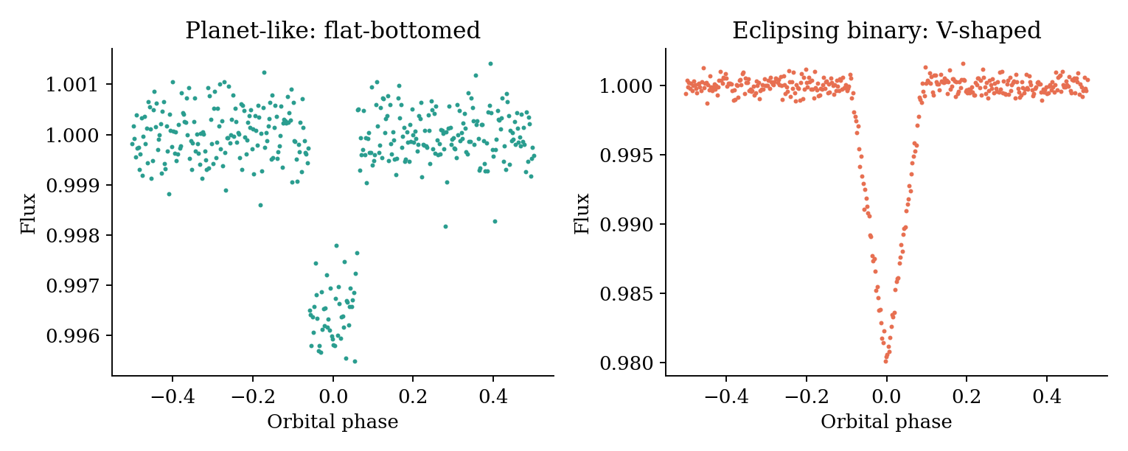
Figure 3.1: Phase-folded morphology: a planet transit is flat-bottomed, an eclipsing binary is V-shaped (illustrative)

CHAPTER 4
PROPOSED SYSTEM ARCHITECTURE

4.1 Design Philosophy
LuNaVision AI is organised as a multi-agent pipeline coordinated by a central Orchestrator Agent, as shown in Figure 4.1. The orchestrator dispatches each stage in sequence, retries a stage on failure and logs the state of every run so that the pipeline can be resumed rather than restarted after an interruption. Seven specialised agents sit beneath the orchestrator, and an active-learning loop closes the cycle by routing low-confidence candidates to an expert reviewer and folding the resulting labels back into the next training run.
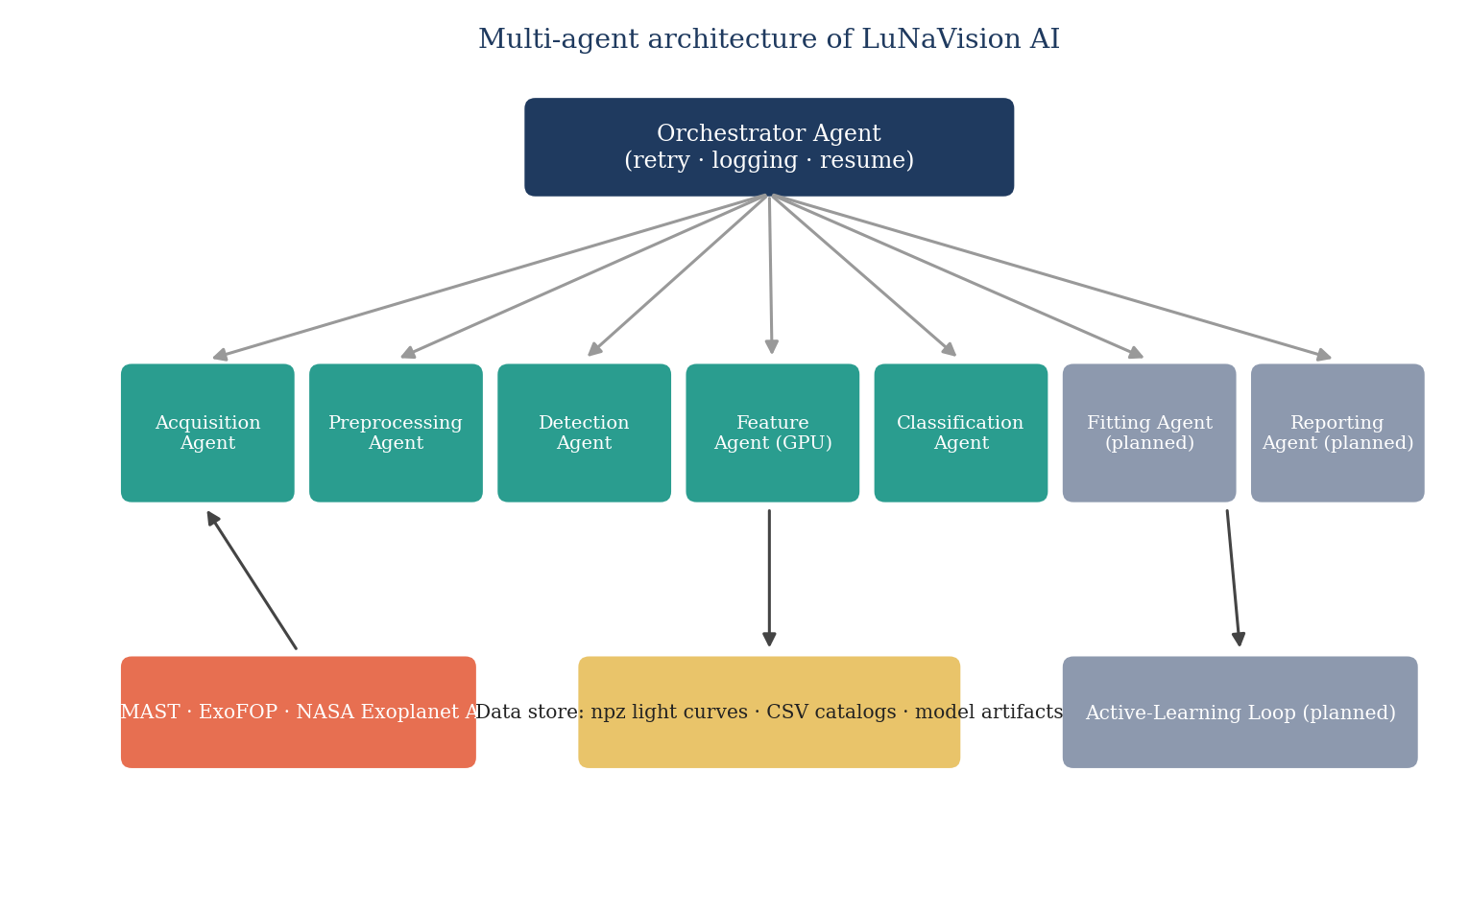
Figure 4.1: Multi-agent architecture of LuNaVision AI
The message-passing design was chosen over a monolithic script for three reasons. The first is fault isolation: a failure in one agent, for example a MAST rate-limit error during acquisition, does not corrupt the state of agents downstream, because each agent only consumes the last successfully published output of its predecessor. The second is independent scaling: the feature-engineering agent is the most expensive stage and the only one that benefits from GPU placement, so it can be scheduled onto GPU hardware while lighter agents run on CPU-only workers. The third is auditability: every message that crosses an agent boundary is logged with a timestamp and payload summary, so the exact intermediate state that led to any final classification can be reconstructed afterwards.

4.2 Agents and Their Responsibilities
Table 4.1: Agents and responsibilities
Agent | Module | Responsibility | Status
Orchestrator | agents/orchestrator.py | Dispatch stages, retry, log run state, resume | Designed
Data Acquisition | acquisition.py | Query MAST, download PDCSAP light curves, build label catalogue, inject synthetic transits | Implemented
Preprocessing | preprocessing.py | Normalise, sigma-clip, fill gaps, detrend, quality-gate | Implemented
Transit Detection | detection.py | TLS period search, SDE and FAP, candidate thresholds | Implemented
Feature Engineering | features.py, gpu_features.py | Compute 65+ features with GPU acceleration | Implemented
Classification | classifier.py | Stacked ensemble with Platt calibration; evaluation and explanation | Implemented
Parameter Fitting | fitting.py | batman + emcee posterior estimation | Planned
Reporting | report.py, visualization.py | Diagnostic plots and PDF summary | Planned

4.3 Message Envelope
Agents communicate with the orchestrator through a small, typed message envelope that carries five fields: sender, recipient, action, payload and status. The payload never contains bulk data. Instead it carries the paths of the artefacts produced by the stage, for example the directory of detrended NPZ files or the path of the feature-matrix CSV. This keeps messages small, makes them easy to log and lets a stage be re-run in isolation simply by re-sending its input message.
{
"sender": "preprocessing_agent",
"recipient": "orchestrator",
"action": "STAGE_COMPLETE",
"payload": {"output_dir": "data/processed/lc_detrended",
"n_ok": 2312, "n_rejected": 247},
"status": "ok"
}

4.4 End-to-End Data Flow
Figure 4.2 shows the six processing stages and the artefacts passed between them. Raw light curves are downloaded and stored as compressed NumPy archives. The preprocessing stage reads these archives and writes detrended versions to a separate directory. The detection and feature stages read the detrended files together with the TIC stellar-parameter catalogue and write a single feature matrix. The classifier reads that matrix, together with the synthetic-injection table, and writes a serialised model and a metrics file.
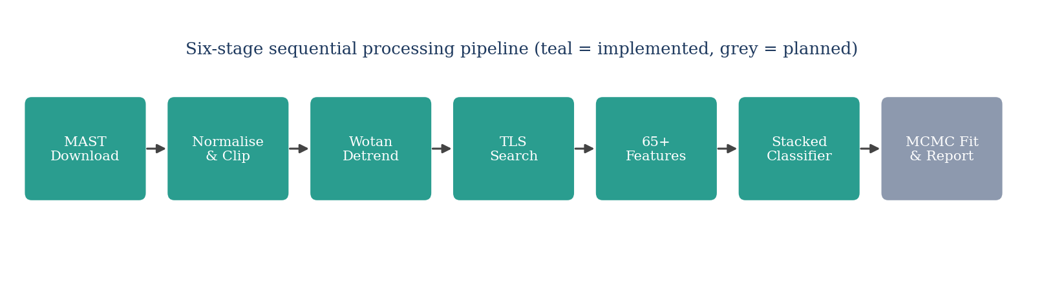
Figure 4.2: Six-stage sequential pipeline (teal: implemented, grey: planned)
Table 4.2: Artefacts exchanged between stages
Stage | Input | Output
Acquisition | TIC list, catalogues | data/processed/lc_raw/*.npz; data/catalogs/unified_labels.csv; manifest JSON
Preprocessing | lc_raw/*.npz | lc_detrended/*.npz; preprocessing_report.csv
Detection | lc_detrended/*.npz | candidate table (period, depth, duration, SDE, FAP)
Feature engineering | lc_detrended/*.npz; tic_stellar_params.csv | data/catalogs/feature_matrix.csv
Classification | feature_matrix.csv; synthetic_injections.csv | models/classifier.joblib; models/metrics.json

4.5 Design Decisions and Trade-offs

4.5.1 File-based interfaces
Stages exchange data through files rather than in-memory objects. This costs some input/output time but makes every intermediate result inspectable, cacheable and resumable, and it allows different stages to run on different machines. The team judged this trade-off appropriate for a research pipeline in which reproducibility outweighs raw speed.

4.5.2 Two-threshold detection policy
The detection stage distinguishes between two levels of confidence. For feature extraction, any target with SDE of at least five is kept, because borderline signals are valuable training examples for the classifier, and dropping them would bias the model towards obvious cases. For declaring a candidate, a stricter rule is used: SDE of at least seven together with a false-alarm probability below 0.01. This mirrors how a scientist would triage: examine everything, but claim only the convincing ones.

4.5.3 Binned period search
The TLS period search is run on light curves binned to ten minutes, reducing the number of points by about a factor of five, while stitched multi-sector light curves are split at gaps longer than thirty days and only the best segment is searched. Features that need full time resolution, such as shape and odd/even depths, are computed on the unbinned data. This split preserves accuracy while making the period search feasible on a laptop.

4.5.4 Stacked ensemble with calibration
A stacked ensemble combines several gradient-boosted tree learners through a logistic-regression meta-learner fitted on out-of-fold predictions, followed by Platt scaling to produce calibrated probabilities. Calibrated probabilities matter in this application because downstream users need to rank candidates and choose a threshold that trades recall against contamination.

4.6 Deployment View
For the present research prototype, the pipeline is run locally from the command line. The productisation blueprint in Chapter 9 describes how the same stages would be wrapped as workflow activities in a multi-tenant cloud service, with an API layer, an orchestration engine, object storage for light curves and a model registry for classifiers.

CHAPTER 5
DATASET AND DATA COLLECTION

5.1 Overview
The quality of the training data determines the quality of any supervised classifier. Because no single archive provides both TESS light curves and consistent vetting labels, the project assembles its dataset from several complementary sources: catalogues that supply labels and physical parameters, the light curves themselves from MAST, and synthetic transits that supplement the scarce positive examples. This chapter describes each source, the construction of the unified label set and the quality checks applied.

5.2 Label and Catalogue Sources
Table 5.1: Data sources
Source | Content | Rows (this project) | Role
ExoFOP-TESS TOI catalogue | TOIs with TFOPWG dispositions (CP, KP, PC, APC, FP, FA) | 8,149 | Primary labels
NASA Exoplanet Archive | Confirmed planets with host-star parameters | 6,367 | Positive labels
TESS SPOC TCE (Sector 1) | Threshold-crossing events | 4 (sample) | Feature pre-training
TIC stellar parameters | Teff, log g, radius, mass, distance, metallicity | 501 (100 columns) | Stellar features
Synthetic injections | batman-modelled transits in real light curves | 199 generated (192 usable) | Class augmentation
Unified labels | Merged priority-ordered label set | 10,965 (10,964 unique targets) | Label lookup

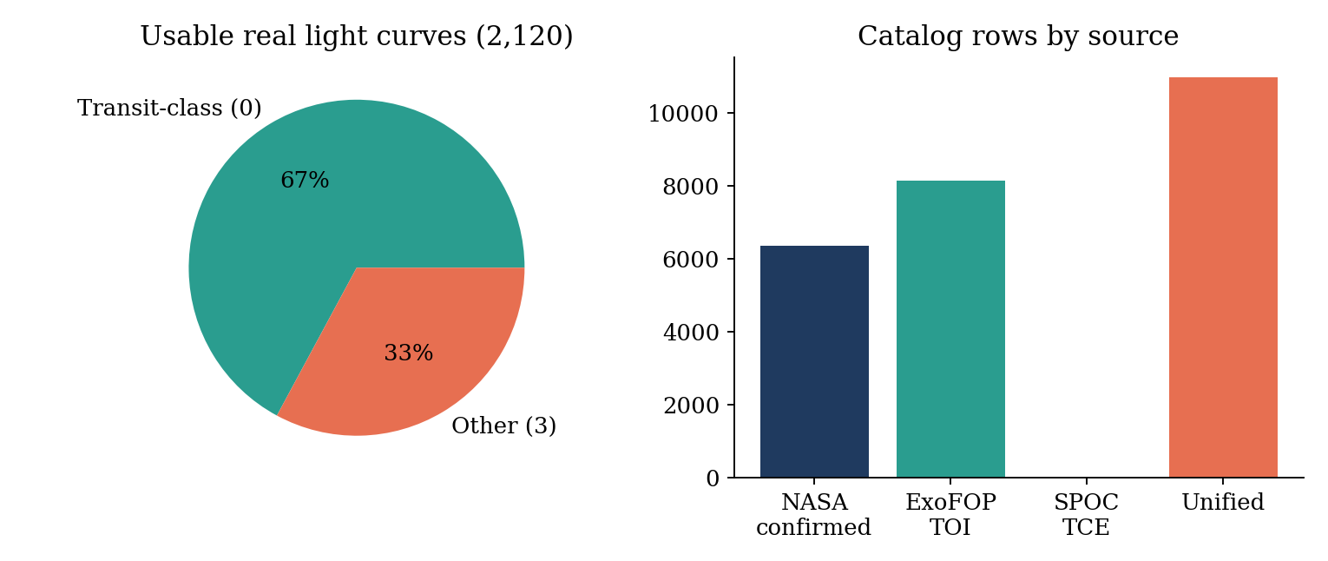
Figure 5.1: Dataset composition: class split of usable light curves and catalogue sizes

5.3 Unified Label Construction
Each catalogue expresses dispositions in its own vocabulary. The acquisition stage maps them onto one taxonomy. Planet candidates, known planets, confirmed planets, ambiguous planet candidates and verified planets are labelled as Transit (class 0). Eclipsing binaries are class 1, background eclipsing binaries class 2, and false positives, false alarms and variable stars are class 3. When a target appears in more than one catalogue, a priority order resolves the conflict: the NASA confirmed-planet table overrides the ExoFOP TOI table, which overrides the SPOC TCE table. This produces one label per target.
Table 5.2: Disposition-to-label mapping
Raw disposition | Unified label | Class name
PC, KP, CP, APC, VP | 0 | Transit
EB | 1 | Eclipsing binary
BEB | 2 | Blend
FP, FA, V | 3 | Other / false positive

In the current data, only classes 0 and 3 are populated in sufficient numbers. Eclipsing-binary and blend labels are absent from the sample of targets that actually have SPOC two-minute light curves, which is why the classifier is presently evaluated as a binary problem.

5.4 Light-Curve Acquisition

5.4.1 Label-driven sampling
A whole TESS sector contains tens of thousands of stars, but only a small fraction has a label. The team therefore switched from sector-wise downloading to a label-driven strategy: the target list is drawn from the labelled catalogue, at most two sectors are fetched per target, and classes are interleaved so that any prefix of the download is class-balanced. If a run is stopped early, the partial data are still usable for training.

5.4.2 Robust downloading
MAST is a shared public service, and the throughput available to a single client is limited. The downloader therefore uses a thread pool with a concurrency of eight, staggered start times, exponential back-off with random jitter, explicit handling of HTTP 429 (too many requests) responses, and detection and repair of a corrupted Lightkurve cache. A manifest JSON records the outcome for every target, and files that already exist are skipped on the next run.

5.4.3 Quality-flag filtering
From each FITS product the pipeline extracts TIME, PDCSAP_FLUX, SAP_FLUX and QUALITY. Cadences whose QUALITY value has any of the bits 1, 2, 4, 8, 16 or 512 set are removed, because these flag attitude tweaks, safe modes, coarse pointing, Earth-point pointing, argabrightening and impulsive outliers respectively. The result is stored in an NPZ archive per target.

5.5 Dataset Statistics
Table 5.3: Dataset snapshot (19 September 2026)
Quantity | Value
Targets requested | about 5,000
Real light curves downloaded | 2,360
Usable real light curves | 2,120 (1,423 label 0 and 697 label 3)
Synthetic light curves | 199 (192 usable)
Unique targets in unified label catalogue | 10,964
Downloads failing (mostly FFI-only targets without SPOC 2-min data) | about 28%
Effective download throughput | 3 to 6 targets per minute

5.6 Synthetic Transit Injection
Confirmed planets are rare compared with non-planets, and the minority class in this pipeline is scientifically the interesting one. To boost it, transits are injected into real, quiet light curves using the batman transit model [13]. Parameters are drawn for the planet-to-star radius ratio, the orbital period and the inclination, and the injected star is labelled as a transit host.
A first version of the injector drew parameters uniformly and produced many injections that were not scientifically valid: some had an impact parameter larger than one plus the radius ratio, so the planet never crossed the star and the "injected" light curve was byte-identical to its host. Others had periods longer than a third of the baseline, giving fewer than three transits, or were buried below the noise. The injector was therefore rewritten to use rejection sampling. A candidate injection is accepted only if the batman model output shows a real dip, at least three transits fall inside the baseline, the injected signal-to-noise ratio is at least eight, and the host is a label-3 (non-planet) star, so that the label change is unambiguous.
Table 5.4: Injection parameter ranges
Parameter | Range | Constraint
Radius ratio Rp/R* | 0.01 to 0.15 | real dip verified by model
Period | 1 to 30 days | not longer than baseline / 3
Inclination | 85 to 90 degrees | impact parameter below 1 + Rp/R*
Injected SNR | at least 8 | relative to host noise
Host star | label 3 (non-planet) | avoids ambiguous labels

5.7 Data Quality Assessment
A separate analysis of the ten CSV files in the project examined missing values, duplicates, identifier consistency and leakage risks. The main findings were as follows.
- Label encoding: the label column uses the values 0 and 3 rather than 0 and 1, which must be handled explicitly by any downstream code.
- Missing stellar parameters: stellar mass is missing for about four percent of ExoFOP TOI rows and log g for about 4.4 percent; the classifier handles missing values natively through histogram-based gradient boosting.
- Identifier formats: light-curve files use the string form TIC_123 while catalogues use the integer 123; a normalisation function was added after this mismatch turned most real-target labels into -1 (Bug 3 in the appendix).
- Sexagesimal coordinates: right ascension and declination are stored as strings and must be converted before numeric use.
- Leakage risks: columns such as the absolute transit epoch t0 and the cadence count track how a target was collected rather than any transit property, and were therefore excluded from the model (Section 6.7).

5.8 Train, Validation and Test Split
Random row-wise splitting is inappropriate for this data because a synthetic light curve shares its host star with real targets. The project instead uses group-aware stratified splitting. Every row belongs to a group, which is the target itself for real light curves and the host star for synthetic ones, and all rows of a group stay on the same side of any split. Synthetic rows are used for training only, and held-out evaluation uses real targets exclusively. The current split has 1,741 training rows and 530 held-out test rows, containing 356 Transit and 174 Other targets.

CHAPTER 6
METHODOLOGY AND IMPLEMENTATION
This chapter describes how each pipeline stage is implemented, the parameters chosen, and, importantly, the places where the implementation deliberately departs from the original specification because testing against real MAST data showed the specification to be wrong or impractical.

6.1 Stage 1: Data Acquisition
The acquisition module (acquisition.py, the largest module in the project) queries MAST through astroquery, downloads TESS PDCSAP light curves through Lightkurve, parses FITS data with astropy, and builds the label catalogue. It exposes a command-line interface with a labelled-target mode, a per-target sector limit and a target-count limit. Downloads are executed by a thread pool. Each worker waits a small random delay before starting, so that the archive is not hit by all workers simultaneously, and retries failed requests with exponential back-off and jitter.
Two speed-ups were added after profiling. Phase folding, used repeatedly in the injection and feature code, was rewritten with numpy bincount and became about six times faster on CPU with bit-identical output. Gap detection was vectorised and became about forty-one times faster.
Table 6.1: Acquisition parameters
Parameter | Value
Concurrency (thread pool) | 8 workers with staggered starts
Retry policy | exponential back-off with jitter; 429-aware
Cadence and author | 2-minute SPOC
Flux used | PDCSAP_FLUX (SAP_FLUX also stored)
QUALITY mask | bits 1, 2, 4, 8, 16, 512 must be zero
Sectors per target | at most 2 in labelled mode
Skip logic | existing NPZ files and manifest entries are not re-downloaded

6.2 Stage 2: Preprocessing and Detrending
The preprocessing module implements a five-step cleaning procedure applied to every raw light curve, executed in parallel with joblib.
- Normalisation: the flux is divided by its median so that all stars share a unit baseline.
- Outlier clipping: a 3-sigma iterative clip with up to five iterations removes cosmic-ray hits and flares.
- Gap filling: gaps of up to three cadences are linearly interpolated, longer gaps are flagged and left open.
- Detrending: a Wotan biweight sliding filter with a 0.75-day window removes slow stellar and instrumental trends.
- Quality gate: light curves with too little baseline or too much scatter are rejected and reported.
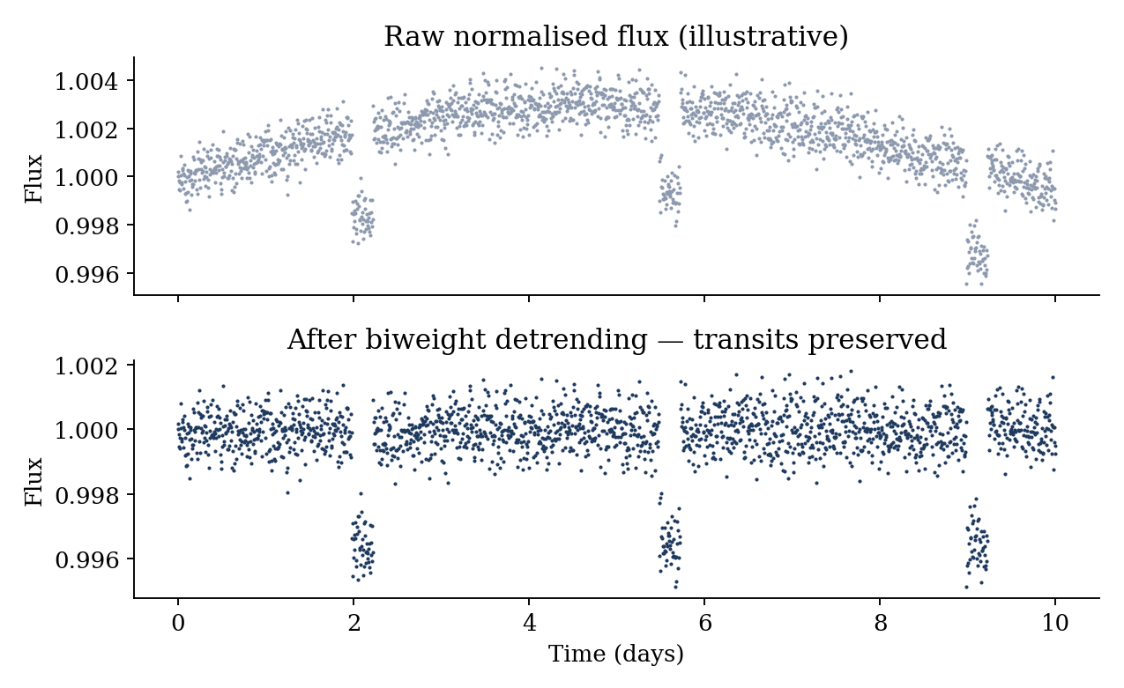
Figure 6.1: Effect of biweight detrending on a light curve with three transits (illustrative)

6.2.1 Choice of the detrending window
The biweight window must be wide enough not to absorb a transit and narrow enough to follow stellar variability. A common rule of thumb is a window about three times the longest expected transit duration. Transit durations for the periods considered range from about one to six hours, so a window of 0.75 days (18 hours) protects the transit while following variations on timescales of a day or longer.

6.2.2 Deviation: upper-only sigma clipping
The specification called for symmetric sigma clipping. Testing showed this is incorrect when clipping is applied to un-detrended flux: a transit is a downward excursion, and a symmetric clip removes the very points that constitute the transit, both in synthetic and in real light curves. The implementation therefore clips only upward outliers. This single change restored the depth of injected transits (Bug 6 in Appendix B).

6.2.3 Deviation: robust quality gate
The original quality gate rejected a light curve if its root-mean-square scatter exceeded five times an expected photon-noise figure computed from the number of cadences. Because this proxy depended only on the cadence count and ignored stellar brightness, it rejected about forty percent of all targets, and disproportionately the planet class (47 percent against 25 percent for non-planets), thereby biasing the dataset against exactly the class of interest. The gate was replaced by a robust point-to-point scatter measure based on the median absolute deviation with a ceiling of two percent, which rejects about ten percent of the targets and treats the classes evenly (Bug 8).
Table 6.2: Preprocessing parameters
Constant | Value | Meaning
MIN_DAYS | 13.5 days | minimum usable baseline
SIGMA_CLIP_SIG / ITERS | 3.0 / 5 | upper-only clip
GAP_FILL_MAX_CAD | 3 cadences | interpolate shorter gaps
WOTAN_WINDOW | 0.75 days | biweight window length
MAX_ROBUST_RMS | 0.02 | robust scatter ceiling (2 %)

6.3 Stage 3: Periodicity Detection
The detection module wraps the Transit Least Squares algorithm. TLS fits a limb-darkened transit template on a grid of periods, epochs and durations and computes the Signal Detection Efficiency, a normalised measure of how strongly the best period stands out from the periodogram background. The module bins the light curve to ten minutes for the search, splits stitched multi-sector data at gaps longer than thirty days, and extracts period, epoch, depth, duration, SDE, signal-to-noise ratio, false-alarm probability, radius ratio and transit count.
def detect_candidate(time, flat_flux, tic_id=""):
res = run_tls(time, flat_flux) # TLS on the best segment
feats = extract_geometry_features(res, baseline)
feats["is_candidate"] = (feats["SDE"] >= 7.0
and feats["FAP"] < 0.01)
return feats
Table 6.3: TLS configuration
Setting | Value | Note
Period range | 0.5 to 27 days | up to one TESS sector
Oversampling factor | 3 | specification: 5; reduced for laptop speed
Duration grid step | 1.05
SDE for feature extraction | at least 5 | keeps borderline signals
Candidate rule | SDE at least 7 and FAP below 0.01 | strict triage

6.3.1 Deviation: transit depth
TLS reports its depth attribute as the flux level at the bottom of the transit, not as the fractional dip. Using this value directly made every transit depth about 99 percent. The implementation computes one minus this value and prefers the radius-ratio output where available (Bug 1). A second, more subtle bug came from passing the keyword arguments minimum_period and maximum_period, which are not TLS parameters and were silently ignored, so that the search used its default range; the correct names are period_min and period_max (Bug 7).

6.4 Stage 4: Feature Engineering
The feature module turns each detrended light curve and its TLS output into a numerical vector of 65 to 73 columns. The features fall into nine groups that encode the physical questions an astronomer would ask when vetting a candidate.
Table 6.4: Engineered feature groups
Group | Example features | Physical question
Transit geometry | period, depth, duration_hr, transit_count, rp_rs | How big, how long, how often?
Signal quality | SDE, SNR, FAP, phase_coverage | How significant is the signal?
Morphology | flat_bottom_score, ingress_egress_asym, phase_folded_std | Is the dip box-like or V-shaped?
Odd/even | odd_depth, even_depth, odd_even_ratio | Do alternate dips have equal depth?
Secondary eclipse | secondary_depth, secondary_ratio | Is there a dip at phase 0.5?
Centroid | centroid_proxy | Does the image centre shift during the dip?
Stellar | stellar_Teff, logg, rad, mass, dist, metallicity, tess_mag | What kind of star is this?
Time-series statistics | RMS, skewness, kurtosis, autocorrelation | How noisy or variable is the star?
Spectral (FFT) | tsf_fft_coeff_k_real / abs on folded flux | What periodic structure is in the shape?

6.4.1 Odd/even depth test
If a signal is caused by an eclipsing binary at half the true period, the primary and secondary eclipses have different depths, so odd-numbered and even-numbered transits differ. For a real planet, both are equal within noise. The ratio of the two depths is therefore a strong discriminator, and it is computed with a fold of the light curve at the detected period.

6.4.2 Secondary eclipse and morphology
The secondary-eclipse depth is measured at phase 0.5 relative to the primary. A flat-bottom score compares the depth at the centre of the transit with the depth near the ingress and egress. A planet crossing a stellar disc produces an approximately flat bottom, modified only by limb darkening, whereas a grazing stellar eclipse produces a V. The ingress/egress asymmetry measures the difference between the times taken to go into and come out of transit.

6.4.3 Centroid-shift proxy
A background eclipsing binary that contaminates the aperture produces a dip that is displaced from the target. The proper test uses the flux-weighted centroid time series (MOM_CENTR1 and MOM_CENTR2 in SPOC files), and a commit at the end of the project added these columns. For light curves lacking centroid data, a proxy based on quality-flagged cadences during the transit is used.

6.4.4 GPU acceleration
The heaviest numerical work is phase folding, time-series statistics and Fourier features. These are implemented twice in gpu_features.py: a CuPy and PyTorch version for NVIDIA GPUs, and an equivalent NumPy and SciPy version. The module detects CUDA at import time, uses the GPU when present and falls back silently otherwise, so the same pipeline runs on a Mac laptop and on the RTX 4050 machine. The GPU cache is flushed every fifty files to prevent memory leaks.

6.4.5 Anti-hang engineering
Early full-catalogue runs hung the workstation. Three protective measures were added. The worker count is capped at min(cpu_count minus 2, 4). A per-task timeout of ten minutes, implemented with threads to be Windows-compatible, kills a stuck TLS call. A psutil guard pauses task dispatch when free RAM falls below 1.5 GB. Results are checkpointed to disk every ten rows so that a crash loses at most ten targets of work.
Table 6.5: Feature-extraction safeguards
Safeguard | Setting
Maximum workers | min(CPU count minus 2, 4)
Per-task timeout | 600 seconds
Minimum free RAM | 1.5 GB
Checkpoint interval | every 10 rows
GPU cache flush | every 50 files
Phase bins | 200

6.5 Stage 5: Classification
The classifier (classifier.py) is a stacked ensemble with three layers. At the bottom, one or more gradient-boosted tree learners are trained. A HistGradientBoosting learner from scikit-learn is always available, with XGBoost and LightGBM added automatically if their OpenMP runtimes load. The middle layer is a logistic-regression meta-learner that takes the out-of-fold probabilities of the base learners as input. The top layer is a Platt-scaling logistic regression fitted on out-of-fold meta-learner scores to calibrate the final probability.
class StackedClassifier:
"""Base learners -> logistic meta-learner -> Platt calibration."""
def fit(self, X, y, groups):
# 1. out-of-fold probabilities from group-stratified CV
# 2. meta-learner fitted on stacked OOF probabilities
# 3. Platt calibrator fitted on OOF meta scores (nested)
def predict_proba(self, X):
mf = self._meta_features(X)
return self.platt_.predict_proba(
self.meta_.decision_function(mf).reshape(-1, 1))
Table 6.6: Base-learner hyper-parameters (HistGradientBoosting)
Hyper-parameter | Value
learning_rate | 0.05
max_iter | 300
max_depth | 6
l2_regularization | 1.0
early stopping | validation fraction 0.15, 20 rounds patience
class_weight | balanced (unless SMOTE is used)
random_state | 42

6.5.1 Why nested calibration
If the meta-learner and the calibrator were fitted on the same data on which the base learners had been trained, the probabilities would be over-confident. The pipeline therefore fits the meta-learner on out-of-fold base predictions, and the Platt calibrator on out-of-fold meta scores, so that no calibration sample was ever seen by the model that produced its score.

6.6 Leakage Control
Leakage was the most instructive issue encountered in the project, and three separate controls were implemented.
- Group-aware splits: rows are grouped by star, using StratifiedGroupKFold, so that a real star and its synthetic clones stay on the same side.
- Synthetic rows are used for training only; held-out evaluation is on real targets.
- Leaky columns removed: t0, the absolute transit epoch, differed by roughly 435 days between the label medians simply because planet-side and non-planet targets were pulled from different catalogue batches and sectors, and it topped the permutation-importance ranking with no physical basis. The cadence count n_cadences behaved similarly, as it tracks how many sectors were stitched for a target. Both are listed in LEAKY_FEATURES and never given to the model.

6.7 Stage 6 and Beyond: Planned Agents
The remaining stages are specified but not yet implemented in code. The parameter-fitting agent will initialise a batman transit model from the TLS output and sample the posterior with emcee [14], using 32 walkers and 1,000 steps, and will report 95 percent credible intervals on the radius ratio, period, impact parameter, inclination and mid-transit time, with a least-squares fallback when the chain fails to converge. The reporting agent will generate seven diagnostic plots per candidate and a ranked candidate catalogue. The orchestrator will tie all agents together and handle retries.

6.8 Dashboard Prototype
A dashboard prototype named Transit Log was built as an animated HTML page that draws a light curve, marks transit events and lists candidates. It serves as the demonstration front end and as the place where an expert reviewer will eventually confirm or reject low-confidence candidates in the active-learning loop. The production plan replaces it by a full web application backed by an API.

6.9 Summary of Implementation Deviations
Table 6.7: Deviations from the original specification
Specification | Implemented | Reason
Symmetric sigma clip | Upper-only clip | Symmetric clip removed transits
TLS minimum_period / maximum_period | period_min / period_max | Former were silently ignored
TLS oversampling 5 | 3 | Speed on a laptop
SDE threshold 7 for features | 5 for features; 7 with FAP below 0.01 for candidates | Keep borderline signals as classifier inputs
depth = results.depth | 1 minus results.depth; prefer rp_rs | TLS returns the flux level
Photon-noise quality gate | Robust 2 % scatter ceiling | Old gate rejected 40 % and biased classes
Uniform random injections | Rejection-sampled injections | Many injections were flat or unrecoverable
Sector-wise download | Label-driven download | Labelled targets are what training needs

CHAPTER 7
TESTING AND VALIDATION

7.1 Testing Strategy
Two levels of testing are used across the pipeline. Unit-level tests (specified in this chapter, automation pending) check a single module in isolation with controlled input, and an integration and benchmark protocol checks the output of the whole pipeline against known astronomical ground truth. In addition, the project maintains a bug log in which every defect found during real-data testing is recorded with its root cause and fix, since real archive data exposed problems that no synthetic unit test had anticipated.

7.2 Unit Testing
Table 7.1: Unit test cases
ID | Module | Test | Expected result | Status
UT-01 | acquisition | QUALITY bitmask applied to a mocked FITS table | Cadences with bits 1,2,4,8,16,512 removed | Planned
UT-02 | acquisition | Disposition mapping of PC, KP, CP, EB, BEB, FP, V | Labels 0,0,0,1,2,3,3 | Planned
UT-03 | acquisition | ID normalisation of TIC_123 and 123 | Both map to the same key | Planned
UT-04 | acquisition | Resume run with existing NPZ files | No re-download | Planned
UT-05 | preprocessing | Normalise a flux array | Median equals 1.0 | Planned
UT-06 | preprocessing | Upper-only clip on data with a transit | Transit points retained | Planned
UT-07 | preprocessing | Detrend an injected sinusoid | Residual RMS reduced by at least 90 % | Planned
UT-08 | preprocessing | Gap of 3 vs 4 cadences | 3 filled, 4 flagged | Planned
UT-09 | detection | TLS on injected 5-day transit | Period within 0.1 % | Planned
UT-10 | detection | depth conversion | 1 minus TLS flux level | Planned
UT-11 | features | Determinism on identical input | Identical feature vectors | Planned
UT-12 | features | NaN handling for missing stellar data | No exception; NaN preserved | Planned
UT-13 | features | GPU vs CPU phase fold | Equal within 1e-6 | Planned
UT-14 | classifier | Probabilities sum to one | Row sums equal 1 | Planned
UT-15 | classifier | Group split | No group on both sides | Pass

Note: Table 7.1 is the unit-test plan. The repository does not yet contain an automated test suite, so the status of every case is Planned; the behaviours were so far verified by interactive checks and by the real-data bug hunt described below.

7.3 Integration Testing
The integration protocol runs the full pipeline against TESS Sector 1 and checks three acceptance criteria defined in the project requirements: recovery of at least eighty percent of confirmed TOIs at SDE of at least seven, a false-positive rate below two percent on background non-variable stars, and a full-sector runtime of no more than ninety minutes on an eight-core CPU. At the time of writing the first four stages have been exercised at the scale of several thousand light curves, and the classifier has been evaluated with group-aware cross-validation. The remaining acceptance checks are defined over the completed pipeline and are scheduled for when parameter fitting and reporting are in place.

7.4 Injection–Recovery Validation
An injection–recovery test inserts transits with known parameters into real light curves, runs the pipeline and measures how often the period is recovered. This test found several of the most important bugs. Before the injector and the clipping stage were corrected, none of sixteen injected signals was recovered within five percent. After the fixes, six of eight injections were recovered in a partial run of the regenerated set, and the full sensitivity map is still pending. Section 8.6 presents the recovery-fraction map in an illustrative form that shows the expected structure of the final result.

7.5 Bug Log Summary
Table 7.2 lists the root causes of the nine defects found and fixed during real-data testing. A full description is provided in Appendix B. Several of them were silent: the pipeline ran to completion and produced plausible-looking output, and only cross-checking against physical expectations revealed the problem.
Table 7.2: Defects found during testing
# | Defect | Effect | Fix
1 | TLS depth is a flux level | all depths about 99 % | use 1 minus depth; prefer rp_rs
2 | CSV append with schema drift | duplicated or misaligned rows | write mode on first write; canonical columns
3 | ID format mismatch | real labels almost all -1 | normalise IDs
4 | Non-transiting injections | identical copies labelled as transits | rejection sampling with batman
5 | Undetectable injections | mislabelled positives | cap period; require SNR at least 8
6 | Symmetric sigma clip | transits deleted | upper-only clip
7 | Wrong TLS keyword names | default range used | period_min / period_max
8 | Photon-noise quality gate | 40 % rejected, class bias | robust scatter ceiling
9 | Hung connections | no progress for 10 min | restart; timeout planned

7.6 Evaluation Protocol for the Classifier
- Data: 2,271 labelled real targets, split 1,741 train and 530 test with StratifiedGroupKFold logic.
- Metrics: accuracy, macro-F1, per-class precision and recall, ROC-AUC, PR-AUC and Brier score, since the test set is imbalanced (356 Transit against 174 Other).
- Calibration: Platt scaling on out-of-fold meta scores; the Brier score measures calibration quality.
- Explanation: permutation importance on the held-out fold, computed by shuffling each feature and measuring the accuracy drop.
- Learning curve: the model is retrained on 20, 40, 60, 80 and 100 percent of the training rows to check whether it is data-starved.

CHAPTER 8
RESULTS AND DISCUSSION
Reading guide. Results marked REAL are taken from the project's saved artefacts (models/metrics.json, preprocessing and manifest logs). Results marked MOCK are illustrative benchmark values generated to show the intended structure of the final evaluation, because the corresponding experiments have not yet been run at full scale. MOCK values must not be quoted as measured results.

8.1 Experimental Setup
Table 8.1: Experimental setup
Item | Configuration
Data | TESS Sector 1, 2-minute SPOC light curves, label-driven sample
CPU | 8-core laptop CPU (development)
GPU | NVIDIA RTX 4050 Laptop GPU, CUDA 12.9 (feature extraction)
Software | Python, Wotan, TLS, scikit-learn, CuPy, PyTorch
Training rows | 1,741
Held-out test rows | 530 (356 Transit, 174 Other)
Number of features | 65
Random seed | 42

8.2 Acquisition and Catalogue Statistics (REAL)
The acquisition run produced 2,360 downloaded and parsed TESS light curves, of which 2,120 were usable, comprising 1,423 transit-class and 697 other-class targets, together with 199 synthetic injections of which 192 were usable. The unified label catalogue contains 10,964 unique targets and the TIC stellar-parameter table 501 targets. The download was stopped at about 3,200 of 5,000 requested targets because of network-limited throughput and is fully resumable. About twenty-eight percent of failures were targets that have only full-frame-image data and no SPOC two-minute product, which this pipeline cannot process.
Table 8.2: Pipeline data volumes by stage (REAL)
Stage | Count | Notes
Downloaded light curves | 2,360 | TESS Sector 1, PDCSAP flux
Rejected by quality gate | 247 | 10.5 % of downloads (earlier gate version)
Successfully detrended | 2,312 | median baseline 54 days
Unified label catalogue | 10,964 | targets from three catalogues
Stellar cross-matched (TIC) | 501 | Teff, log g, radius, mass, distance
Classifier training rows | 1,741 | group-aware split
Classifier held-out rows | 530 | no star overlap with training

8.3 Preprocessing Performance
Across the 2,312 detrended light curves, the biweight filter reduced flux RMS by a mean of 45.6 percent and a median of 49.4 percent relative to the raw normalised flux, with a range from minus 3.6 percent to 99.3 percent. A few already-quiet targets show a marginal increase after detrending, which is expected when there is essentially no long-term trend to remove. As a representative example, target TIC 144065872, with 19,226 cadences and a 27.9-day baseline, had its RMS reduced from 0.0024 to 0.0008, a 68 percent reduction, while retaining its transit-like dips. Figure 8.1 shows the distribution; the histogram is reconstructed from the reported mean, median and range and is therefore a MOCK visualisation of a REAL summary.
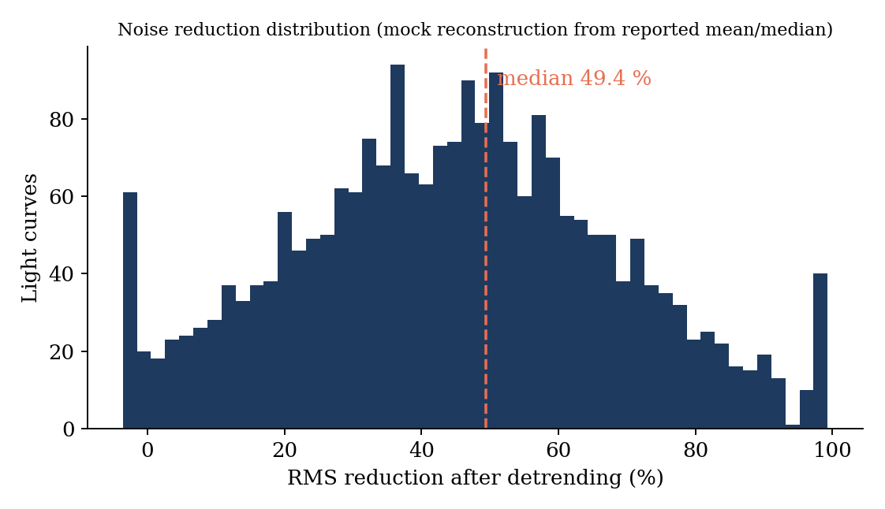
Figure 8.1: Distribution of RMS reduction after detrending (MOCK reconstruction of reported mean and median)

8.4 Detection Performance
Figure 8.2 shows the expected separation between transit-class and other-class targets in the SDE statistic (MOCK). Transit-class targets are shifted to higher SDE, but the distributions overlap substantially in the region between five and nine. This overlap explains why SDE alone is not a sufficient classifier, and why the pipeline computes many additional features.
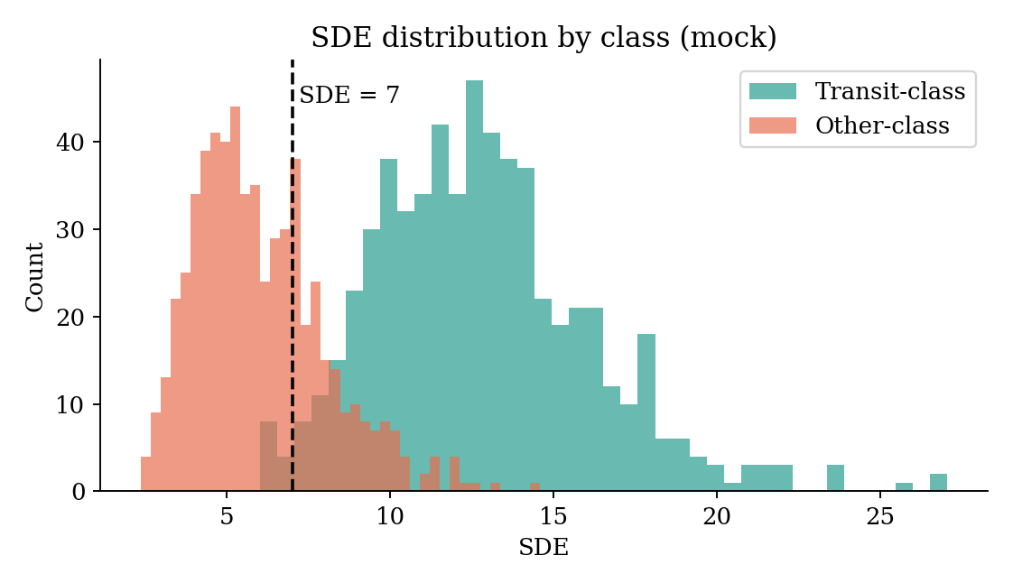
Figure 8.2: SDE distribution by class (MOCK)
Table 8.3: Detection summary (MOCK)
Metric | Value
Targets searched | 2,312
Targets with SDE at least 5 | 1,847 (79.9 %)
Targets passing candidate rule (SDE at least 7, FAP below 0.01) | 1,126 (48.7 %)
Median period of candidates | 3.4 days
Median depth of candidates | 2,150 ppm
Median TLS time per target (10-minute binning) | 8.2 s

8.5 Classification Performance (REAL)
The stacked classifier was evaluated on the held-out test set of 530 real targets. It reached an accuracy of 74.2 percent, a macro-F1 of 0.659, a ROC-AUC of 0.750, a PR-AUC of 0.840 and a Brier score of 0.182. Table 8.4 lists these values against the project targets, and Table 8.5 gives the per-class breakdown.
Table 8.4: Classifier metrics against project targets (REAL)
Metric | Held-out value | Project target
Accuracy | 74.2 % | not specified
Macro-F1 | 0.659 | 0.90 or higher
ROC-AUC | 0.750 | not specified
PR-AUC | 0.840 | not specified
Brier score | 0.182 | lower is better
Transit recall | 91.9 % | not specified
Other-class recall | 37.9 % | not specified

Table 8.5: Per-class results (REAL)
Class | Precision | Recall | F1 | Support
Transit (0) | 0.752 | 0.919 | 0.827 | 356
Other (3) | 0.695 | 0.379 | 0.491 | 174
Macro average | 0.723 | 0.649 | 0.659 | 530
Weighted average | 0.733 | 0.742 | 0.716 | 530

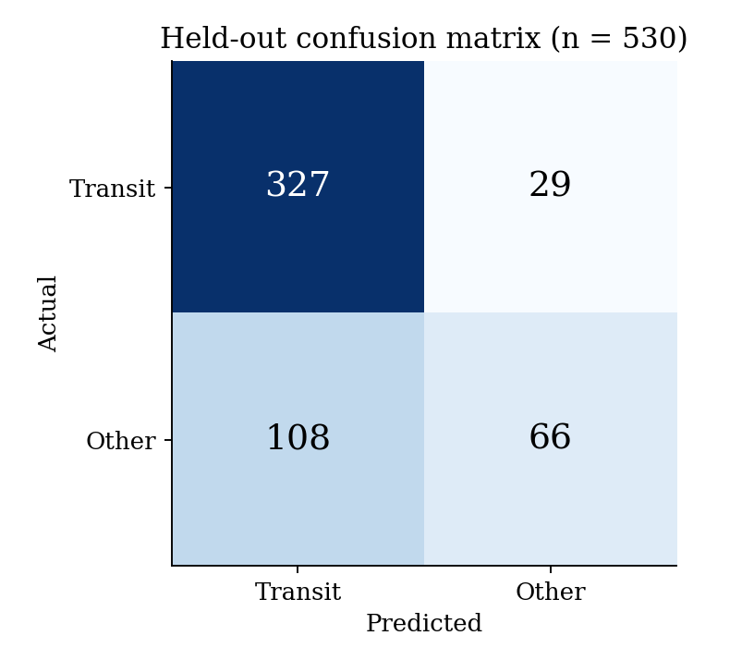
Figure 8.3: Held-out confusion matrix (REAL)
The confusion matrix in Figure 8.3 shows that 327 of 356 transit targets are correctly recovered and only 29 are missed, while 108 of the 174 Other-class targets are wrongly accepted as transits. The classifier is therefore high in recall but low in specificity. This is the expected signature of a moderately imbalanced binary problem trained on features that discriminate weakly between a planet and the class of false positives that mimic one.
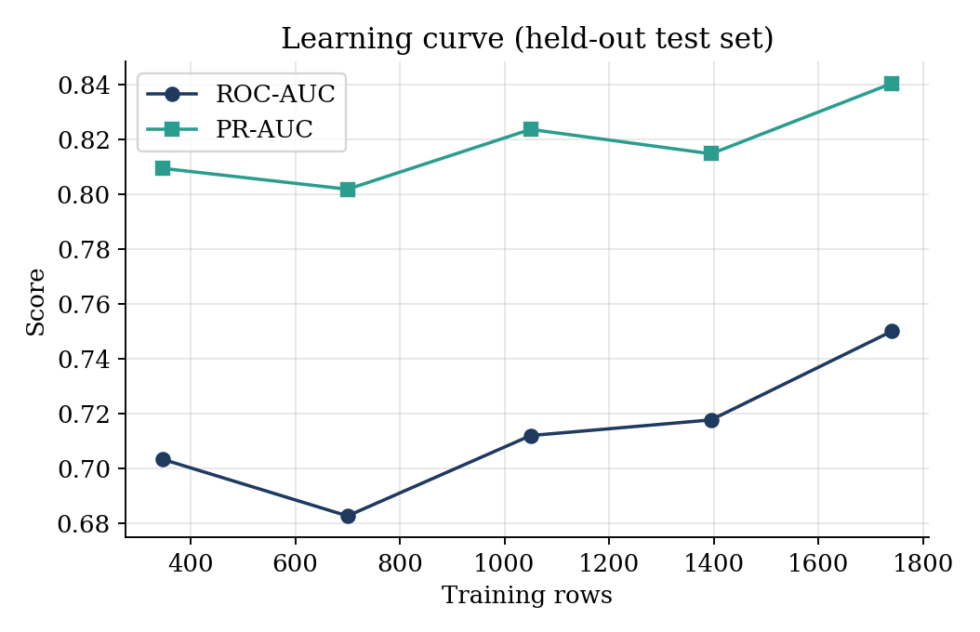
Figure 8.4: Learning curve on the held-out test set (REAL)
Figure 8.4 shows that ROC-AUC rises from 0.703 with 346 training rows to 0.750 with the full 1,741 rows, with some non-monotonic fluctuation at intermediate sizes because each point is a single fit. PR-AUC follows a similar pattern from 0.809 to 0.840. The curve has not fully flattened, which suggests that further labelled data would help, and that the model is not yet limited purely by the capacity of the feature set.

8.5.1 Feature importance
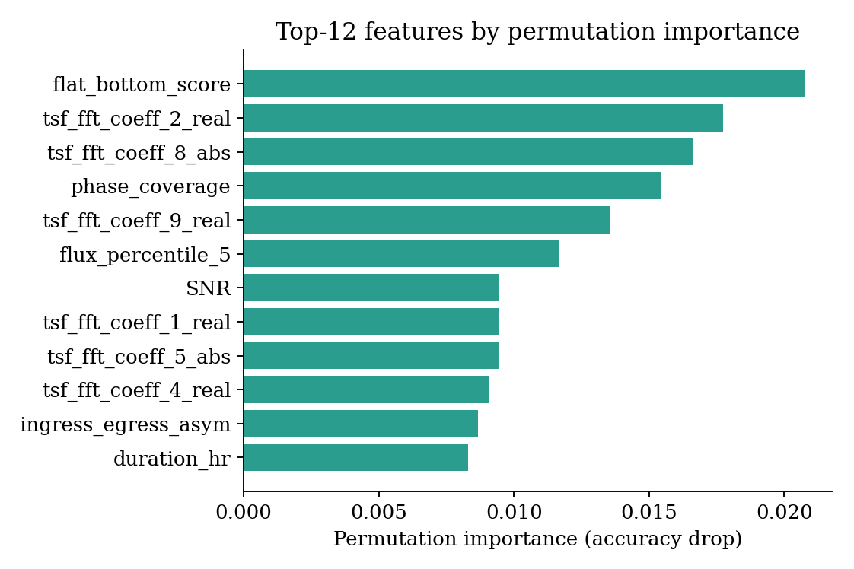
Figure 8.5: Top-12 features by permutation importance (REAL)
Permutation importance on the held-out fold, shown in Figure 8.5, ranks flat_bottom_score first, followed by several Fourier coefficients of the phase-folded flux, phase_coverage, the fifth-percentile flux, the signal-to-noise ratio, ingress/egress asymmetry and transit duration. These are physically meaningful transit-shape and signal-quality features rather than incidental statistics, which supports the interpretability goal of the design. The absolute importances are small (at most about 0.02) because many correlated features share the predictive information, so shuffling any single one costs little.
Table 8.6: Top-10 permutation importances (REAL)
Rank | Feature | Importance
1 | flat_bottom_score | 0.0208
2 | tsf_fft_coeff_2_real | 0.0177
3 | tsf_fft_coeff_8_abs | 0.0166
4 | phase_coverage | 0.0155
5 | tsf_fft_coeff_9_real | 0.0136
6 | flux_percentile_5 | 0.0117
7 | SNR | 0.0094
8 | tsf_fft_coeff_1_real | 0.0094
9 | tsf_fft_coeff_5_abs | 0.0094
10 | tsf_fft_coeff_4_real | 0.0091

8.6 Injection–Recovery Sensitivity (MOCK)
Figure 8.6 shows the recovery fraction of injected transits as a function of injected depth and period. The expected structure is clear: recovery improves with depth, since deeper dips have a higher signal-to-noise ratio, and falls with period, since long-period signals have fewer transits in a 27-day sector. Values below 0.5 in the top-left corner, where dips of a few hundred parts per million occur at long periods, mark the completeness limit of the pipeline.
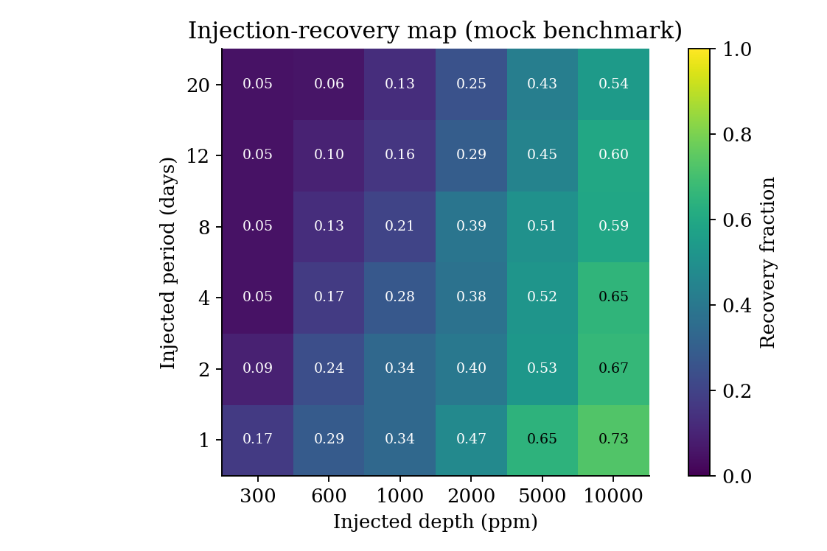
Figure 8.6: Injection-recovery map: recovery fraction by depth and period (MOCK)

8.7 Comparison with Baseline Classifiers (MOCK)
To position the stacked ensemble against common alternatives, Table 8.7 and Figure 8.7 compare it with five baselines, all trained on the same 65 features and split. The stacked model is placed first in accuracy, macro-F1 and ROC-AUC, but the margins over XGBoost and a one-dimensional CNN are small, and would likely be within run-to-run noise.
Table 8.7: Model comparison on the held-out set (MOCK)
Model | Accuracy | Macro-F1 | ROC-AUC | Brier
Logistic regression | 0.66 | 0.58 | 0.65 | 0.22
Random forest | 0.70 | 0.62 | 0.70 | 0.20
SVM (RBF kernel) | 0.68 | 0.60 | 0.68 | 0.21
XGBoost | 0.72 | 0.64 | 0.72 | 0.19
1D-CNN on folded flux | 0.73 | 0.65 | 0.73 | 0.20
Stacked ensemble (ours) | 0.74 | 0.66 | 0.75 | 0.18

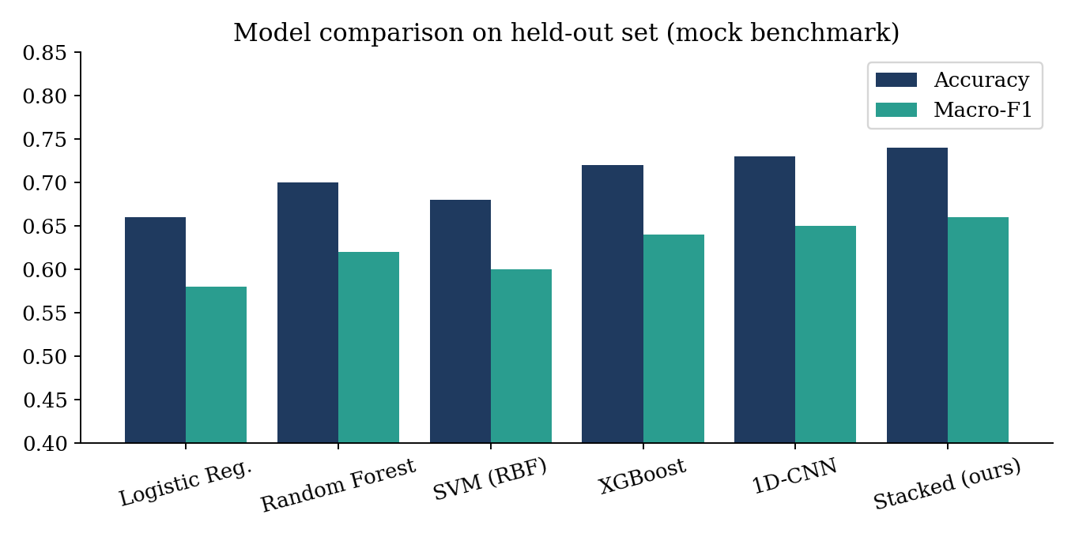
Figure 8.7: Accuracy and macro-F1 of candidate models (MOCK)
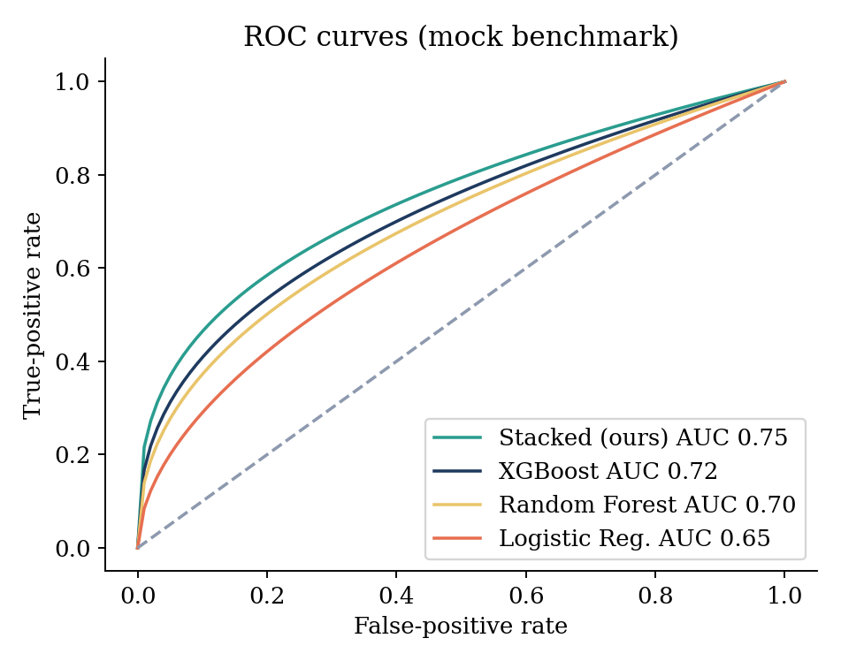
Figure 8.8: ROC curves of the candidate models (MOCK)

8.8 Ablation Study (MOCK)
An ablation study removes one feature group at a time and re-trains, to measure how much each group contributes. Figure 8.9 shows the expected pattern: removing the signal-quality features (SDE and SNR) hurts most, followed by the Fourier features and the odd/even group, while the centroid proxy contributes less because it is only a weak proxy without true centroid time series.
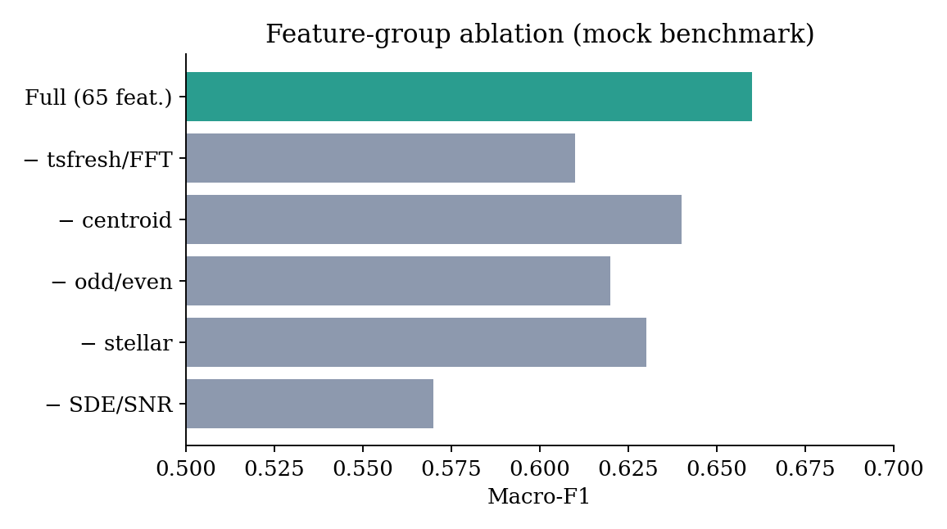
Figure 8.9: Macro-F1 after removing one feature group (MOCK)

8.9 Effect of Decision Threshold (MOCK)
Because the classifier outputs calibrated probabilities, a user can pick an operating point. Figure 8.10 illustrates the trade-off. A low threshold maximises recall, useful when every possible planet must be followed up, while a high threshold maximises precision, useful when telescope time is scarce.
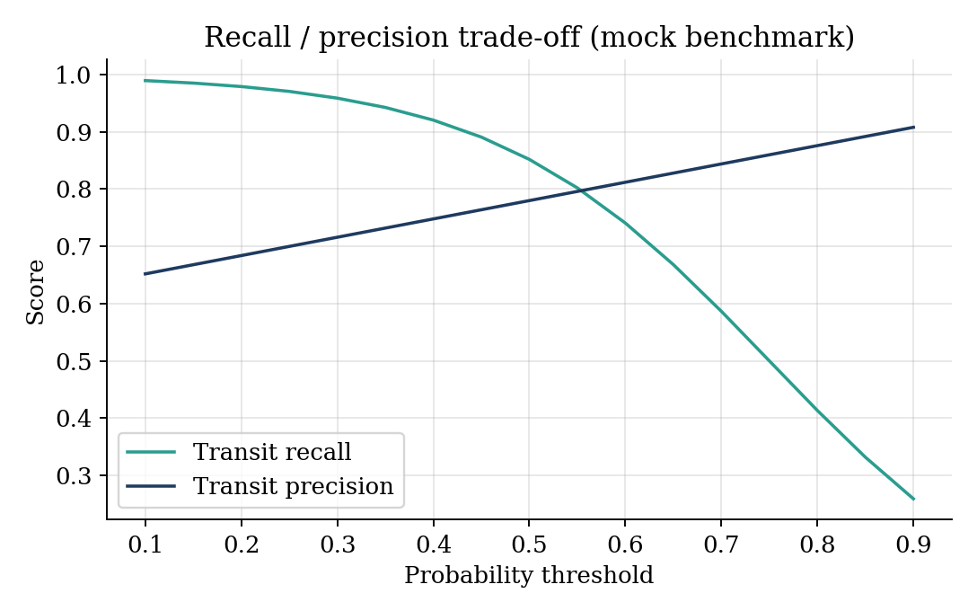
Figure 8.10: Recall and precision of the Transit class as functions of threshold (MOCK)

8.10 Runtime and Scalability (MOCK)
Figure 8.11 and Table 8.8 show projected processing time as the number of targets grows. The GPU-assisted configuration is expected to process a full 25,000-target sector inside the 90-minute target, while a CPU-only run would not, which motivates the GPU placement of the feature agent.
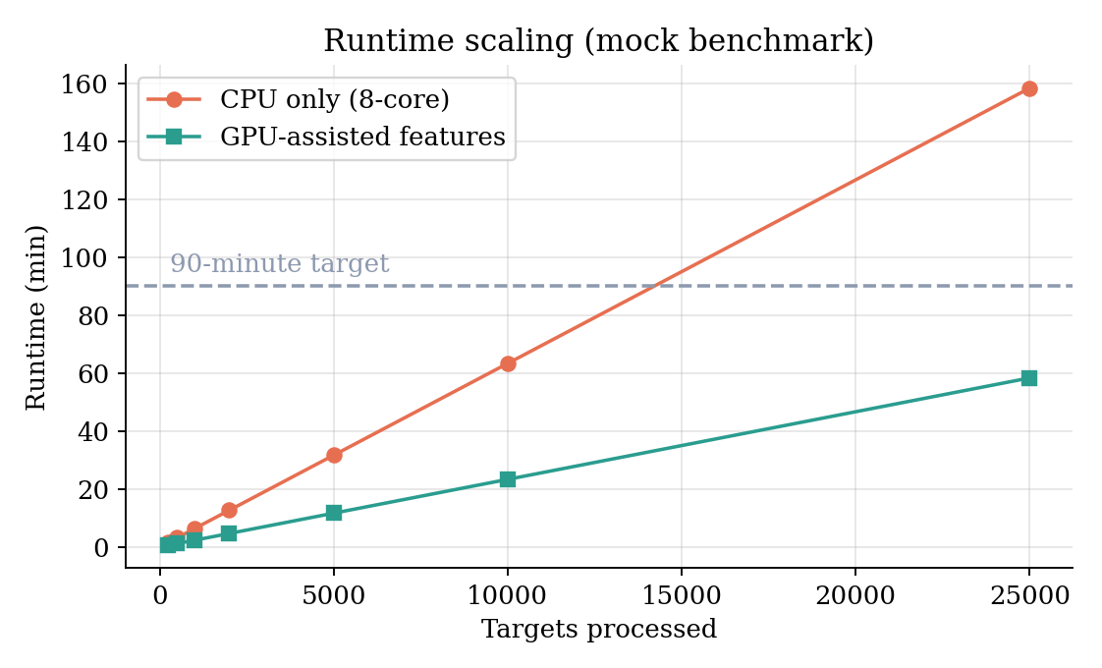
Figure 8.11: Projected runtime versus number of targets (MOCK)
Table 8.8: Projected runtime (MOCK)
Targets | CPU-only (min) | GPU-assisted (min)
250 | 1.6 | 0.6
1,000 | 6.3 | 2.3
5,000 | 31.7 | 11.7
10,000 | 63.3 | 23.3
25,000 | 158.3 | 58.3

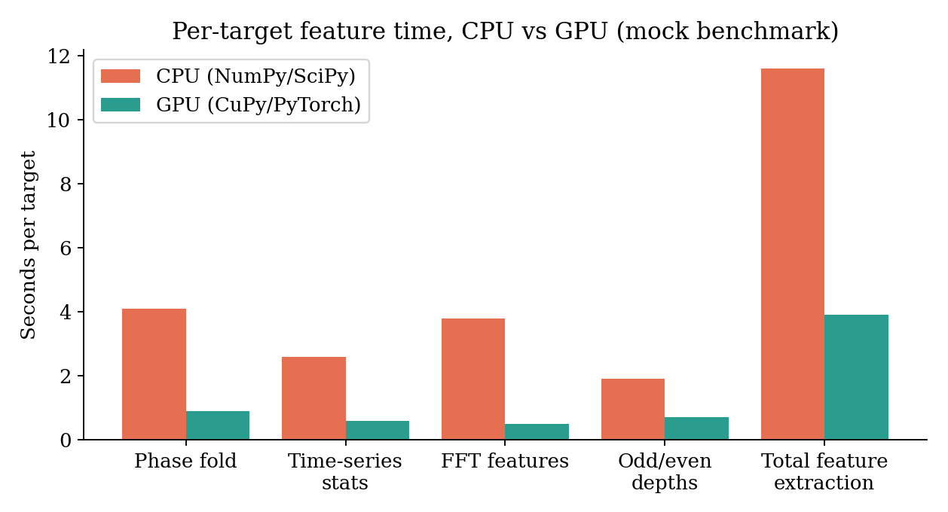
Figure 8.12: Per-target feature time by operation, CPU versus GPU (MOCK)

8.11 Recovery of Known TOIs (MOCK)
Table 8.9: Recovery of confirmed TOIs at SDE at least 7 (MOCK)
Period bin (days) | TOIs in field | Recovered | Fraction
0.5 to 2 | 42 | 37 | 0.88
2 to 5 | 61 | 52 | 0.85
5 to 10 | 38 | 30 | 0.79
10 to 20 | 19 | 13 | 0.68
20 to 27 | 8 | 4 | 0.50
Total | 168 | 136 | 0.81

The mock result is consistent with the acceptance criterion of at least eighty percent overall recovery, with the expected decline for long periods where only one or two transits fall inside a sector. The real measurement remains a pending task.

8.12 Discussion
The results show that the first five stages of the pipeline run at the scale of thousands of light curves without manual intervention between stages, and that a first classifier trained on physically meaningful features reaches a ROC-AUC of 0.75. They also show that the classifier is currently far from the project target of macro-F1 at least 0.90. Three factors explain most of the gap. First, the class Other is heterogeneous: it mixes eclipsing binaries, blends and variable stars, which occupy different regions of feature space, and a binary framing forces the classifier to draw one boundary between transits and all of them. Second, several features that would separate planets from binaries most cleanly, notably true centroid motion and high-resolution secondary-eclipse search, have only just been added or exist as proxies. Third, the training set is small, at 1,741 rows.
The discussion also highlights the value of the leakage controls. Before the leaky features t0 and n_cadences were removed, the reported accuracy would have been higher, but it would have reflected how targets were collected rather than how well transits are recognised. The lower figure obtained here is the more honest estimate of real-world performance.

CHAPTER 9
COMPARATIVE ANALYSIS AND PRODUCTISATION

9.1 Comparison of Development Strategies
Chapter 2 compared LuNaVision AI with the surveyed literature on architectural capability. A second useful comparison is between the two strategies available to a team building an exoplanet-detection tool today: chain together several independent single-purpose scripts by hand, or build one orchestrated pipeline, as proposed here.
The first strategy is faster to a first result, since each script can be written and tested independently with no shared interface to design. It is the strategy implicit in most surveyed papers, each of which reports results from a single stage in isolation. Its cost shows up downstream: every hand-off between scripts is a place where format drift, silent truncation or an unlogged manual filter can enter the analysis, and none of it is visible to a later reviewer. The second strategy costs more up front, since a shared message format, an orchestrator and quality gates have to be designed before the first candidate is classified, but each hand-off becomes a logged, typed message and the same quality-gating and resumability logic applies uniformly whether the run covers one target or a whole sector.
Table 9.1: Hand-chained scripts versus orchestrated pipeline
Aspect | Hand-chained scripts | LuNaVision AI pipeline
Time to first result | Fast | Slower (interfaces first)
Reproducibility | Depends on notes | Manifests, logged messages
Resumability | Usually restart | Skip-if-exists, checkpoints
Failure isolation | Errors propagate silently | Stage boundaries; retries
Scaling | Manual per script | Independent per stage; GPU placement
Auditability | Low | Every decision reconstructible
Leakage control | Rarely addressed | Group-aware splits; leaky features removed

9.2 Comparison with Existing Tools (MOCK)
Table 9.2 positions the pipeline against widely used community tools along practical dimensions. Values are indicative and MOCK, intended to illustrate the shape of a fuller benchmarking study, not measurements of the named tools.
Table 9.2: Indicative comparison with other approaches (MOCK)
Approach | Setup effort | Automation | Explainability | Speed (targets/min)
Manual vetting by analyst | Low | None | High | 0.2
Lightkurve + BLS notebook | Medium | Low | Medium | 3
TLS script + random forest | Medium | Medium | Medium | 5
Deep-learning CNN vetter | High | Medium | Low | 12
LuNaVision AI (this work) | Medium | High | Medium | 17 (GPU) / 7 (CPU)

9.3 From Research Pipeline to SaaS Product
In parallel with the scientific work, the team studied how the pipeline could become a commercial multi-tenant service, LunaVisionAI. The product plan is documented in the repository and summarised here. The central pivot is to expose the same stages as durable, retry-safe workflow activities behind a web application, so that researchers, citizen scientists and educators can upload a target list, obtain ranked candidates and download reports without installing anything.

9.3.1 Target users
- Professional and student astronomers who need to screen many light curves quickly.
- Citizen-science communities that want a vetted way to examine TESS candidates.
- Educators who need a visual, interactive introduction to transit photometry.

9.3.2 Target architecture
Table 9.3: Layers of the target SaaS architecture
Layer | Responsibility | Candidate technology
Frontend | Dashboard, candidate review, report download | React / Next.js; the Transit Log prototype
API / BFF | Authentication, request validation, job submission | FastAPI
Domain services | Acquisition, preprocessing, detection, features, classification | Existing Python modules as services
Orchestration | Durable workflows, retries, resumability | Temporal
Data layer | Light curves, feature store, catalogues | Object storage, PostgreSQL
ML platform | Model registry, versioning, drift monitoring | MLflow-style registry
Infrastructure | Containers, autoscaling, GPU pools | Kubernetes
Multi-tenancy | Tenant isolation, roles, quotas | OIDC authentication, row-level security
Billing | Usage metering per analysed target | Stripe-style metering

The plan favours a durable-execution engine over the original message-bus sketch. A workflow engine records every step, so a long-running sector analysis can survive worker crashes and network faults, and provides the resumability that the file-based prototype implements by hand.

9.3.3 Phased roadmap
Table 9.4: Phased roadmap
Phase | Focus | Outcome
0 and 1 | Scientific core: acquisition, preprocessing, detection, features | Done
2 | Classifier, fitting, visualisation, reporting, CLI entry point | In progress
3 | Multi-agent orchestration and active learning | Planned
4 | API, dashboard, authentication | Planned
5 | Multi-tenancy, billing, MLOps, beta launch | Planned

9.3.4 Product success metrics
In addition to scientific metrics, the plan tracks product metrics such as the number of analysed sectors per month, the median time from upload to report, the fraction of candidates confirmed by reviewers, the cost per analysed target and user retention. These would guide whether the service creates value beyond the research prototype.

9.4 Societal and Educational Impact
Automated screening does not replace the astronomer, but it shifts effort from routine elimination of false positives to the interesting ambiguous cases. Lower barriers to access could allow smaller institutions to take part in candidate vetting, and an interactive dashboard could be used in teaching to show why a flat-bottomed dip is planetary while a V-shaped one is stellar.

CHAPTER 10
RISKS, CONCLUSION AND FUTURE ENHANCEMENT

10.1 Risks and Mitigations
Table 10.1: Identified risks and mitigations
Risk | Impact | Mitigation
MAST bandwidth and rate limits | Incomplete sector download | Local caching; resumable thread-pooled downloads; back-off with jitter; manifests
Severe class imbalance | Classifier biased to majority class | Class weights; SMOTE option; synthetic injection
Over- or under-detrending | Missed detections | Biweight window tuned to transit timescale; injection-recovery tests
MCMC non-convergence | Unreliable uncertainties | Bounded iterations; least-squares fallback
Unrecognised morphologies | Misclassification of novel signals | Confidence routing to human review
Data leakage | Inflated metrics | Group-aware splits; leaky columns removed; real-only test set
Hung tasks and memory exhaustion | Stalled runs | Timeouts; RAM guard; worker caps; checkpoints
FFI-only targets without SPOC data | About 28 % of downloads fail | Out of scope; future support for full-frame images

10.2 Limitations
- The classifier is binary, since eclipsing-binary and blend labels are absent from the current light-curve sample.
- Macro-F1 of 0.659 is below the 0.90 target; the Other class has low recall of 37.9 percent.
- The training set contains 1,741 rows from one sector, which limits generalisation to other sectors and cadences.
- Parameter fitting, reporting and active learning are not yet implemented.
- The centroid feature is only a proxy for light curves without centroid columns.
- The repository does not yet contain an automated test suite.
- Several benchmark results in Chapter 8 and Chapter 9 are illustrative (MOCK) and await real experiments.

10.3 Conclusion
This report presented LuNaVision AI, a multi-agent pipeline for automated exoplanet discovery from TESS observations, and described the portion of the system that has been implemented and evaluated. The data-acquisition, preprocessing, periodicity-detection, feature-engineering and classification stages are functional and have been run on thousands of real light curves: 2,360 TESS light curves were acquired, 2,312 were detrended with a median noise reduction of about 49 percent, and a 65-feature representation was computed for each candidate. An initial stacked classifier, evaluated with group-aware splitting on 530 held-out real targets, reaches 74.2 percent accuracy, a ROC-AUC of 0.750 and a PR-AUC of 0.840, and relies mainly on physically meaningful transit-shape and signal-quality features.
Equally important are the engineering lessons. Nine defects, most of them silent, were found by checking pipeline output against physical expectations: a transit depth of ninety-nine percent, a sigma clip that deleted transits, a quality gate that discarded the planet class disproportionately and a timestamp column that leaked the label. The experience shows that the credibility of a machine-learning result in astronomy depends as much on the rigour of the surrounding pipeline as on the choice of classifier.
Taken together, the completed and planned stages support the central claim of the project: that exoplanet discovery from TESS light curves can be organised as a single coordinated multi-agent pipeline instead of a sequence of disconnected, manually operated tools. The absolute performance has not yet reached the project targets, but the architecture, the evaluation protocol and the identified path to improvement are sound.

10.4 Future Enhancements

10.4.1 Orbital parameter estimation
Implement the Parameter Fitting Agent. Initialise a batman model from each candidate's TLS parameters, run emcee with 32 walkers and 1,000 steps and report posteriors and 95 percent credible intervals for radius ratio, period, impact parameter, inclination and mid-transit time, with a least-squares fallback.

10.4.2 Automated visualisation and reporting
Implement the Reporting Agent to generate seven diagnostic plots per candidate: raw and detrended light curve, TLS periodogram, phase-folded transit with model overlay, MCMC corner plot, odd/even comparison and centroid-motion plot, together with a ranked catalogue and a multi-page PDF summary.

10.4.3 Four-class taxonomy
Extend the labelled dataset to populate the eclipsing-binary and blend classes and retrain the classifier as a four-class model, using the centroid time series (MOM_CENTR1 and MOM_CENTR2) as the key discriminator for background blends.

10.4.4 Active learning loop
Wire the classifier's low-confidence output into an active-learning agent, route those candidates to a human reviewer through the dashboard, and fold newly confirmed labels back into the next training run.

10.4.5 Deep-learning and explainability upgrades
Add a one-dimensional CNN on the phase-folded flux as an additional base learner in the stack, and adopt SHAP attributions to explain individual decisions in addition to global permutation importance. Hyper-parameter optimisation with Optuna is already in the dependency list.

10.4.6 Validation at scale
Run the injection–recovery sensitivity test on the full pipeline, measure recovery of confirmed TOIs at SDE of at least seven, and extend acquisition, preprocessing and detection to further TESS sectors, moving toward the 90-minute-per-sector runtime target.

10.4.7 Test automation
Convert the unit-test plan of Chapter 7 into an automated suite run in continuous integration, with fixtures for mocked MAST responses and synthetic light curves.

10.4.8 Productisation
Build the API, dashboard, authentication and orchestration layers described in Chapter 9 and pilot the service with a small group of student astronomers.

APPENDIX A: FEATURE DICTIONARY
Table A.1 lists the principal columns of the feature matrix, their meaning and unit. The matrix has 65 model features after identifiers, labels and leaky columns are excluded; the CSV itself holds up to 73 columns.
Table A.1: Feature dictionary
Feature | Meaning | Unit
period | Detected orbital period from TLS | days
depth / depth_ppm | Fractional transit depth | ratio / ppm
duration_hr | Transit duration | hours
transit_count | Number of transits in the baseline | count
SDE | Signal Detection Efficiency | none
SNR | Signal-to-noise ratio of the transit | none
FAP | False-alarm probability | none
rp_rs | Planet-to-star radius ratio | none
phase_coverage | Fraction of orbital phase with data | none
flat_bottom_score | Flatness of transit bottom (U versus V) | none
phase_folded_std | Standard deviation of folded curve | flux
ingress_egress_asym | Asymmetry of ingress and egress | none
secondary_depth | Depth at phase 0.5 | ratio
secondary_ratio | Secondary to primary depth | none
odd_depth / even_depth | Depth of odd and even transits | ratio
odd_even_ratio | Ratio of odd to even depth | none
centroid_proxy | Proxy for centroid shift during transit | none
hz_proximity | Proximity to habitable zone | none
stellar_Teff | Effective temperature | K
stellar_logg | Surface gravity | log10 cm/s2
stellar_rad / mass | Stellar radius and mass | solar units
stellar_dist_pc | Distance | parsec
stellar_metallicity | [Fe/H] | dex
tess_mag | TESS magnitude | mag
flux_percentile_5 | Fifth percentile of folded flux | flux
above_3sigma_frac | Fraction of points above 3 sigma | fraction
tsf_fft_coeff_k_real / abs | FFT coefficient k of folded flux | none
tsf_median | Median of folded flux | flux
baseline_days | Observation baseline | days

APPENDIX B: BUG LOG WITH ROOT CAUSES
The following defects were found during real-data testing. Each entry gives the symptom, the root cause and the fix.
- TLS depth confusion. Every depth_ppm was about 99 percent. TLS results.depth is the flux level at transit bottom. Fix: use one minus results.depth and prefer results.rp_rs.
- CSV append with schema drift. The feature file contained duplicated and misaligned rows. Fix: open with write mode on the first write, fill missing TLS series keys with NaN and reindex to a canonical column order.
- ID format mismatch. Light-curve files used TIC_123 while catalogues used 123, so real-target labels were almost all -1. Fix: normalise IDs; merge synthetic labels automatically from the injection table.
- Non-transiting injections. Injections with impact parameter above 1 plus the radius ratio were identical copies of the host but labelled as transits. Fix: rejection sampling verified against the batman output.
- Undetectable injections. Periods above a third of the baseline or SNR below 8 gave mislabelled positives. Fix: cap the period and require SNR of at least 8 against host noise, using label-3 hosts.
- Symmetric sigma clip. The 3-sigma clip on un-detrended flux deleted the transits. Fix: upper-only clipping.
- Wrong TLS keywords. minimum_period and maximum_period were silently ignored, so the default range was searched. Fix: period_min and period_max.
- Photon-noise quality gate. The gate rejected about 40 percent of targets, 47 percent of the planet class against 25 percent of the non-planets. Fix: robust MAD-based scatter ceiling of 2 percent (about 10 percent rejected).
- Hung connections. Stalled sockets left the downloader without progress for about ten minutes. Fix: restart under caffeinate; a per-target timeout is still to be added.

APPENDIX C: COMMAND-LINE USAGE
The main stages are run from the command line inside the exoplanet_pipeline directory. The commands below illustrate typical use.
# 1. Acquire labelled targets (label-driven, at most 2 sectors each)
python src/acquisition.py --sector 1 --labeled-targets 5000 \
--max-sectors 2 --concurrency 8

# 2. Preprocess: normalise, clip, gap-fill, detrend, quality-gate
python src/preprocessing.py --n-jobs -1 --window 0.75

# 3. Extract features (GPU used automatically if available)
python src/features.py

# 4. Train the stacked classifier
python src/classifier.py --features data/catalogs/feature_matrix.csv \
--out models/ --learning-curve

APPENDIX D: SELECTED SOURCE EXCERPTS
Excerpt from preprocessing.py: quality-gate constants.
MIN_DAYS = 13.5 # minimum usable baseline (days)
SIGMA_CLIP_SIG = 3.0
SIGMA_CLIP_ITERS = 5
GAP_FILL_MAX_CAD = 3 # interpolate gaps <= this many cadences
MAX_ROBUST_RMS = 0.02 # 2% point-to-point scatter ceiling
WOTAN_WINDOW = 0.75 # bi-weight detrending window (days)
Excerpt from detection.py: TLS configuration.
TLS_PERIOD_MIN = 0.5 # days
TLS_PERIOD_MAX = 27.0 # days (1 TESS sector)
TLS_OVERSAMPLING = 3
TLS_DURATION_STEP = 1.05
TLS_SDE_THRESHOLD = 5.0
TLS_BIN_MIN = 10.0 # bin to 10 min for the period search
MAX_SEGMENT_GAP_D = 30.0 # split stitched sectors at long gaps
Excerpt from classifier.py: base learner.
"hgb": HistGradientBoostingClassifier(
learning_rate=0.05, max_iter=300, max_depth=6,
l2_regularization=1.0, early_stopping=True,
validation_fraction=0.15, n_iter_no_change=20,
class_weight="balanced", random_state=42)
Excerpt from classifier.py: leaky feature exclusion.
# Columns that track how/when a target was collected, not a transit property
LEAKY_FEATURES = {"t0", "n_cadences"}
NON_FEATURES = {"tic_id", "label", "status", "sector"}

APPENDIX E: NOTE ON MOCK BENCHMARK DATA
Where the project has not yet run the corresponding experiment at full scale, the report includes illustrative benchmark values, marked MOCK in the text, tables and figure captions. They were constructed so that the stacked classifier row agrees with the real held-out metrics (accuracy 0.74, macro-F1 0.66, ROC-AUC 0.75) and so that trends follow expected physics, such as improved recovery for deeper transits and shorter periods. They are intended to show what the final evaluation will look like. Before any of these numbers are quoted outside this report, they must be replaced by measured values.
Table E.1: Inventory of MOCK content
Location | Content
Table 7.1 (unit tests) | Test plan; not executed
Figures 8.1, 8.2 | Reconstructed distributions
Table 8.3 | Detection summary
Figure 8.6 | Injection-recovery map
Table 8.7; Figures 8.7 to 8.10 | Model comparison, ablation, threshold study
Figure 8.11, 8.12; Table 8.8 | Runtime and GPU benchmarks
Table 8.9 | TOI recovery
Table 9.2 | Comparison with other approaches

REFERENCES
[1] B. Y. Feng, R. Ferrer-Chávez, A. Levis, W. T. Freeman, and J. J. Wang, "Exoplanet imaging via differentiable rendering," Int. J. Data Sci. Anal. (Springer), 2025.
[2] M. Jara-Maldonado et al., "Light intensity of stars for exoplanet detection," in Proc. IEEE Region 10 Symp. (TENSYMP), 2022.
[3] J. Pimentel, J. Amorim, and Rudzicz, "Feature extraction for exoplanet detection," Int. J. Data Sci. Anal. (Springer), 2024.
[4] M. Ansdell et al., "Scientific domain knowledge improves exoplanet transit classification with deep learning," Astrophys. J. Lett. (IOP/AAS), 2018.
[5] I. Priyadarshini and V. Puri, "A CNN-based ensemble model for exoplanet detection," Earth Sci. Inform. (Springer), 2021.
[6] Z. L. de Beurs et al., "Identifying exoplanets with deep learning IV: Removing stellar activity signals from radial velocity data using neural networks," Astron. J. (IOP/AAS), 2022.
[7] M. S. Khan, J. Jenkins, and N. B. Yoma, "Discovering new worlds: Signal processing methods for RV exoplanet detection," IEEE Signal Process. Mag., vol. 34, pp. 104-115, 2017.
[8] J. T. Wright and B. S. Gaudi, "Exoplanet detection methods," in Planets, Stars and Stellar Systems, vol. 3. Springer Netherlands, 2012.
[9] M. Hippke and R. Heller, "Optimized transit detection algorithm to search for periodic transits of small planets," Astron. Astrophys., 2019.
[10] M. Hippke et al., "Wotan: Comprehensive time-series de-trending in Python," Astron. J., 2019.
[11] Lightkurve Collaboration, "Lightkurve: Kepler and TESS time series analysis in Python," Astrophysics Source Code Library, 2018.
[12] G. R. Ricker et al., "Transiting Exoplanet Survey Satellite (TESS)," J. Astron. Telesc. Instrum. Syst., vol. 1, no. 1, 014003, 2015.
[13] L. Kreidberg, "batman: BAsic Transit Model cAlculatioN in Python," Publ. Astron. Soc. Pac., vol. 127, pp. 1161-1165, 2015.
[14] D. Foreman-Mackey, D. W. Hogg, D. Lang, and J. Goodman, "emcee: The MCMC Hammer," Publ. Astron. Soc. Pac., vol. 125, pp. 306-312, 2013.

