MULTI-DOMAIN DIGITAL ASSESSMENT AND PERFORMANCE MONITORING PLATFORM

Dr. S. Sasikala
Department of Artificial Intelligence and Data Science
Velammal College of Engineering and Technology
Madurai, India
ssk@vcet.ac.in

Mrs. A. Thiruniraiselvi
Department of Artificial Intelligence and Data Science
Velammal College of Engineering and Technology
Madurai, India
@gmail.com
Ms. Kennet Sheela J
Department of Artificial Intelligence and Data Science
Velammal College of Engineering and Technology
Madurai, India
kennetsheela@gmail.com
Ms. Chaaru Pavadaarani K
Department of Artificial Intelligence and Data Science
Velammal College of Engineering and Technology
Madurai, India
chaarupavadaarini@gmail.com

Ms. Jeya Sri S
Department of Artificial Intelligence and Data Science
Velammal College of Engineering and Technology
Madurai, India
jeyasrisivaananth@gmail.com

ABSTRACT:
Traditional assessment methods in educational institutions rely heavily on manual processes for question preparation, examination management, and evaluation, limiting scalability and increasing administrative overhead. This challenge was amplified during the COVID-19 pandemic, which highlighted the need for secure, centralized remote assessment solutions. This paper presents AptioGen, a multi-tenant, role-based SaaS assessment platform supporting Super Administrators, Institution Administrators, Heads of Department, and students while ensuring complete institutional data isolation. The platform provides automated assessment creation, centralized question bank management, document-based question import, configurable proctoring, real-time analytics, and performance reporting. Security is enforced through role-based access control, tenant isolation, rate limiting, input sanitization, and server-side score evaluation to preserve academic integrity. The platform further offers self-practice modules, custom quiz generation, and AI integration capabilities to enhance student learning. Results demonstrate that AptioGen reduces administrative workload and enables scalable, secure, data-driven assessment across institutions. Future work includes AI-driven performance prediction, adaptive assessments, advanced webcam-based proctoring, mobile application support, and integration with Learning Management Systems (LMS).

Keywords—digital assessment; multi-tenant architecture; role-based access control; online examination; performance monitoring; SaaS; academic integrity

1. INTRODUCTION:

Online education has become an integral part of modern life, driven by the rapid pace of technological advancement across every sector of society. As digital learning platforms continue to reshape how knowledge is delivered and consumed, traditional methods of assessment and examination are increasingly proving inadequate for the demands of contemporary education. Conventional, paper-based examination systems require significant institutional resources — faculty coordination, \physical infrastructure, and manual paper arrangement — making them difficult to scale and manage, particularly for large or geographically distributed student populations.
While many institutions have begun adopting online assessment systems to address these logistical challenges, existing solutions often provide only limited security mechanisms. This gap leaves online examinations vulnerable to academic dishonesty, with cheating remaining the most persistent and critical drawback of current digital assessment platforms. Without robust safeguards, the integrity and credibility of online evaluation are difficult to guarantee, undermining the very purpose of assessment as a measure of genuine student learning.
To address these limitations, this paper proposes a secure online assessment system designed to strengthen the reliability of digital examinations. The key contributions of our work are as follows:
- Secure performance evaluation – ensuring that assessment results accurately and reliably reflect student performance.
- Cheating prevention mechanisms – incorporating techniques to detect and deter dishonest practices during online examinations.
- Effective time management – enabling structured, time-bound assessments that mirror the rigor of traditional exams.
By integrating these features, the proposed system aims to overcome the security and integrity challenges faced by existing online assessment platforms. Our approach not only enhances trust in the evaluation process but also benefits a wide range of stakeholders, including students, faculty, and academic institutions, by reducing administrative overhead while maintaining examination integrity. This work is motivated by the growing need for scalable, secure, and trustworthy digital assessment solutions in an increasingly online-first educational landscape

2. LITERATURE SURVEY:

The development of online assessment systems has focused on improving accessibility, automated evaluation, examination management, and security. Traditional computer-based examination systems primarily concentrate on presenting questions to candidates, collecting responses, and generating results. Although these systems reduce manual evaluation effort, they may provide limited support for advanced examination security, multi-level institutional administration, and automated question-bank generation. Online examination platforms have also introduced browser-based proctoring mechanisms to improve examination integrity.

Features such as fullscreen enforcement, tab-switch detection, focus monitoring, and restriction of copying and pasting can help reduce unauthorized activities during examinations. However, a comprehensive assessment platform needs to integrate these security mechanisms with centralized examination management and server-side enforcement rather than relying only on client-side controls.

Another important area is the management of large question repositories. Conventional question-bank systems generally require administrators or faculty members to manually enter questions, options, answers, and difficulty levels.

This process can become time-consuming when question papers are available in existing document formats. The integration of document parsing and Generative AI provides an opportunity to automatically extract unstructured examination content and convert it into structured question data. Artificial Intelligence-based natural language processing can therefore be used to assist in question extraction and organization.

In AptioGen, document files are processed using appropriate parsers and the extracted text is passed to Google Gemini AI.

The generated question objects are validated for the required structure, including four options and a valid correct-option index, before being inserted into the centralized question bank. From the above areas, it can be observed that an effective online assessment platform should combine automated question management, secure examination delivery, role-based administration, institutional data separation, automated evaluation, and analytics.

AptioGen integrates these requirements into a single platform by combining AI-assisted question ingestion, browser-based proctoring, server-side randomization, RBAC, and centralized examination management.

3. PROBLEM STATEMENT:
Educational institutions and training organizations require reliable online examination systems that can efficiently manage large numbers of students, question banks, examinations, and academic departments. Existing examination processes may involve manual question preparation, limited question-bank automation, insufficient examination monitoring, and fragmented administrative operations. The manual preparation of question banks is particularly time-consuming when questions are already available in documents such as Word files, PDF files, or text files. Administrators or faculty members may need to manually extract questions, enter answer options, identify correct answers, and organize them into categories. Security is another major challenge in online examinations. Candidates may attempt to switch browser tabs, copy examination content, or access external resources during an assessment. Therefore, an online examination platform requires mechanisms for detecting violations and enforcing examination rules. Furthermore, institutions have different administrative levels and organizational structures. A platform must distinguish the privileges of platform administrators, institution administrators, department heads, and students while ensuring that institutional data remains properly isolated. Examination results also need to be securely evaluated without exposing answer keys to candidates. Hence, there is a need for an integrated online assessment platform that can automate question ingestion, provide secure proctored examinations, support multiple institutional roles, randomize questions and options, perform server-side evaluation, and provide practice and analytical capabilities within a unified system. AptioGen addresses this problem by providing a multi-tenant assessment platform with AI-assisted question ingestion, Role-Based Access Control, browser-based examination monitoring, server-side randomization, secure answer-key isolation, automated evaluation, and self-paced practice modules.

4. PROPOSED SYSTEM ARCHITECTURE:
The proposed AptioGen system follows a full-stack, multi-tenant web architecture consisting of a frontend interface, backend application server, database layer, authentication layer, AI processing layer, and security middleware.
The architecture is designed to support different categories of users while maintaining controlled access to institutional resources. The frontend layer provides role-specific interfaces for Super Admins, Institution Admins, HODs/Department Staff, and Students.
Students can access scheduled examinations, scorecards, self-paced practice modules, and coding assessments, while administrative users receive dashboards for institutional, departmental, question-bank, event, and analytics management. The backend layer is implemented using Node.js and Express.js.

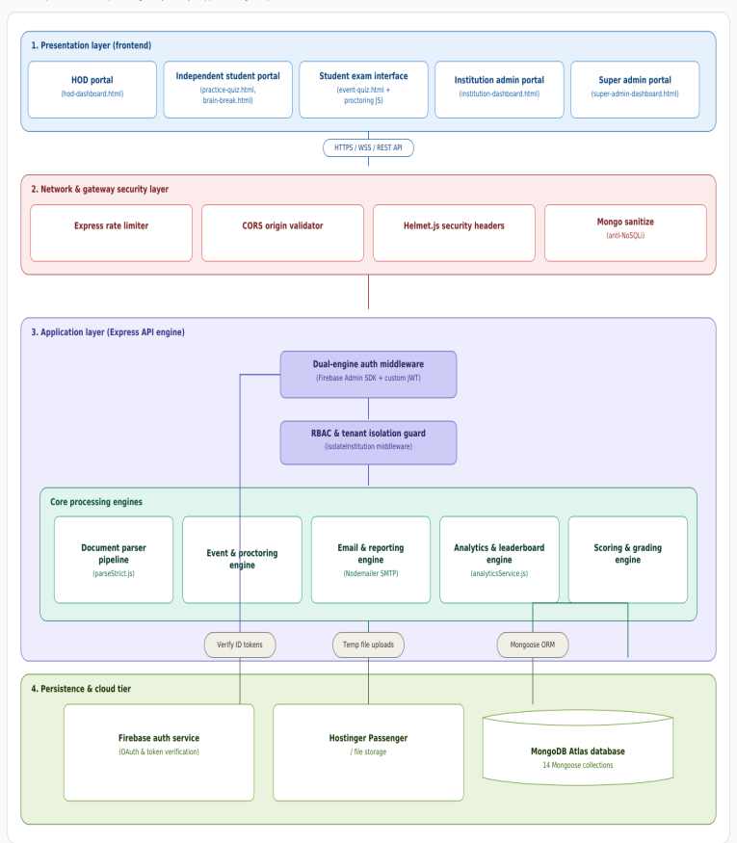 Figure 1. Overall System Architecture
It provides RESTful APIs responsible for authentication, institution setup, examination-event creation, question management, student examination execution, violation logging, submission, analytics, and report generation. The backend also contains controllers, services, middleware, models, and route modules for separating application responsibilities. The database layer uses MongoDB Atlas with Mongoose ORM. It stores institutional information, departments, batches, users, question banks, examination events, participant records, practice progress, analytics data, and examination results. The multi-tenant structure allows institutional and departmental information to be associated with the appropriate entities. The AI question-ingestion layer accepts .docx, .pdf, and .txt documents. Uploaded files are processed using Multer and document-specific parsers such as Mammoth and PDF-Parse. The extracted text is sent to Google Gemini AI, which converts the unstructured content into structured question objects. These objects are validated before being stored in the QuestionBank collection.
The authentication and authorization layer uses Firebase Authentication together with backend-generated JWT tokens stored in secure HTTP-only cookies. RBAC middleware verifies whether the authenticated user has the required role before allowing access to protected resources. The examination and proctoring layer provides fullscreen enforcement, tab-switch monitoring, violation logging, clipboard and context-menu restrictions, timer management, and automatic disqualification based on configured limits. Questions and options are randomized on the server using the Fisher-Yates algorithm, while correct answers are removed from the payload sent to the student browser. The architecture also incorporates security middleware including Helmet, CORS protection, rate limiting, MongoDB sanitization, JWT-based authentication, and role-based authorization. Answer keys remain on the backend and are used for server-side evaluation after examination submission.

5. SYSTEM DESIGN:
The AptioGen system is designed as a modular web-based assessment platform in which each major functionality is implemented as a separate subsystem. The system design consists of user management, institution management, question-bank management, AI-assisted question ingestion, examination management, proctoring, practice modules, evaluation, and analytics.
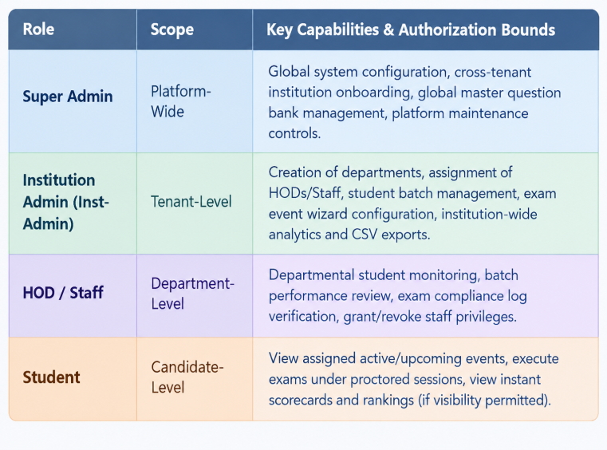Figure 2. System Design and Functional Modules
The User Management Module manages authentication and authorization for the four system roles: Super Admin, Institution Admin,HOD/Department Staff, and Student. Role-Based Access Control ensures that each user can access only the functions permitted for their role. The Institution Management Module allows Institution Admins to configure campus information, create departments and batches, and provision HOD accounts. The setup process establishes relationships between institutions, departments, batches, and users, supporting institutional data isolation. The Question Management Module maintains the centralized question bank. Questions can be categorized and organized for use in different assessments. The system also supports AI-assisted ingestion from DOCX, PDF, and TXT files. Extracted content is converted into structured JSON by Gemini AI and validated before bulk insertion into MongoDB. The Examination Management Module enables Institution Admins to create examination events using a configurable wizard. The administrator can specify basic examination details, select questions, configure proctoring and scoring rules, and define the target departments or batches. Negative marking and ranking visibility can also be configured. The Proctored Examination Module provides a controlled environment for students. When an examination begins, fullscreen mode can be enforced and browser activity is monitored. Tab switches and focus loss are recorded as violations. If the configured maximum number of violations is exceeded, the system can automatically disqualify the candidate. The Evaluation Module performs answer evaluation on the server after submission. The student's responses are compared with the master answer keys stored in the database. If negative marking is enabled, the configured penalty is applied. The final score, examination status, timestamp, and ranking information are then stored and returned according to the event's visibility settings. The Practice and Coding Module provides self-paced learning activities in Quantitative Aptitude, Logical Reasoning, Technical MCQs, and coding challenges. The coding assessment interface uses Monaco Editor to provide an integrated browser-based coding environment. The Analytics and Reporting Module provides examination and departmental performance information. HODs can review student registration information, examination completion rates, average scores, scorecards, and leaderboard rankings. Administrators can also obtain event analytics and export examination results. Overall, the modular design of AptioGen enables the platform to combine examination administration, AI-assisted question management, secure proctoring, automated evaluation, practice, and analytics while maintaining role-based access and backend security.
6. IMPLEMENTATION:
The implementation of the platform follows the architecture shown in Fig. 1, consisting of a role-based input layer, a centralized security gateway, an orchestrator-managed agent pipeline for assessment processing, and a defined technology stack supporting each layer
A. User Roles and Inputs
The platform supports four user roles: Student, Head of Department (HOD), Institution Admin, and Super Admin. Administrative roles (HOD, Institution Admin, Super Admin) provide the primary inputs to the system, including uploaded question sets and assessment parameters such as duration, category, and scoring rules. These inputs initiate the downstream assessment workflow.
B. Security and Gateway Interface
All incoming API requests are processed through a centralized security and gateway interface before reaching application logic. This layer performs JWT cookie-based authentication, verifies the requesting user's role through RBAC checks, and enforces CORS policy along with input sanitization to guard against malformed or malicious requests. This ensures that no request bypasses authentication or authorization checks before reaching downstream services.
C. Quiz Engine Orchestrator
The Quiz Engine Orchestrator functions as the central controller for the assessment lifecycle. It manages state transitions across the workflow, coordinates the countdown timer, and enforces proctoring locks, ensuring that each stage of the assessment pipeline executes in the correct sequence and that session state remains consistent throughout the exam.
D. Assessment Workflow (Agent Pipeline)
The core assessment process is implemented as a pipeline of specialized agents, each handling a distinct stage of the workflow:
- Question Bank Agent — parses uploaded documents (PDF, DOCX, TXT) and assembles the question pool for use in assessments.
- Randomizer Agent — performs server-side shuffling of question order and answer options on a per-candidate basis, reducing the effectiveness of collusion between concurrent test-takers.
- Proctor Guard Agent — enforces fullscreen locking and monitors tab-switch telemetry throughout the exam session, flagging violations in real time.
- Exam Execution — renders the interactive test workspace through which students view and respond to questions.
- Auto-Scoring Agent — computes grading immediately upon submission, applying negative marking rules where configured, without exposing scoring logic to the client.
- Analytics Agent — calculates departmental leaderboards and ranking metrics from scored results, incorporating score, speed, and accuracy.
- Compliance Audit Agent — analyzes proctoring logs generated during the exam session and flags potential cheating behavior for administrative review.
A feedback loop connects HOD/Admin review back into the Analytics Agent stage, allowing manual verification and approval before results are finalized and released to students.
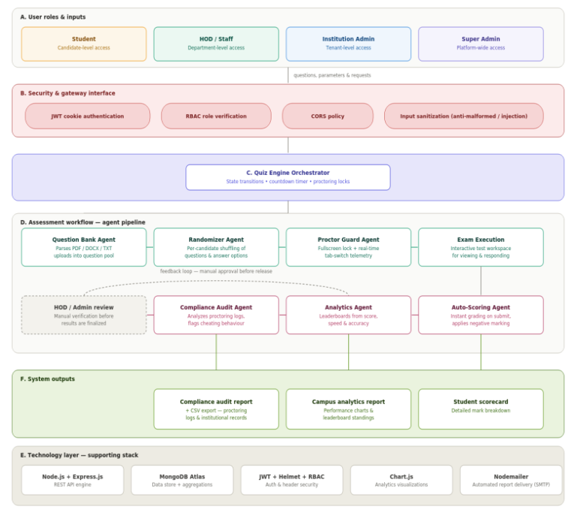
Figure 3. Assessment Workflow and Agent-Based
Processing Pipeline

E. Technology Layer
The platform is built on Node.js and Express.js, which together form the REST API engine handling routing and request processing. MongoDB Atlas serves as the primary data store, supporting the aggregation queries used for leaderboard and analytics computation. Security is enforced through JWT-based authentication combined with Helmet for HTTP header protection and RBAC for role verification. Chart.js powers analytics visualizations, while Nodemailer handles automated report delivery via SMTP.
F. System Outputs
The pipeline produces three categories of output. Students receive a processed scorecard with a detailed mark breakdown. Administrators receive a campus analytics report containing performance charts and leaderboard standings. Additionally, a compliance audit report combined with CSV export data is generated, containing proctoring logs and exportable records for institutional record-keeping.

7. RESULTS:

Testing of AptioGen confirmed that the implemented pipeline meets its core design goals across five areas: real-time result generation, self-practice functionality, role-specific dashboards, security and privacy enforcement, and system responsiveness under active use.
A. Instant Result Generation
Upon quiz submission, the Auto-Scoring Agent computes grading immediately, without dependency on batch processing or manual intervention. Scored results are passed directly to the Analytics Agent, which updates departmental leaderboards and ranking metrics in real time. Students received their scorecards immediately after submission, with no observed delay between quiz completion and result availability, confirming that the agent pipeline supports true instant evaluation rather than deferred or queued scoring.
B. Self-Practice Sessions
In addition to formally scheduled assessments, the platform supports self-practice sessions that allow students to attempt questions independently for skill-building. Practice sessions draw from the same centralized question bank and pass through the same scoring pipeline, giving students immediate feedback on performance without affecting official leaderboards or departmental records. Testing confirmed that practice attempts were correctly isolated from graded assessment data while still delivering instant, accurate scoring.
C. Role-Specific Dashboards
Each user role is served a distinct dashboard tailored to its scope of visibility. Super Admins access a global analytics dashboard summarizing platform-wide usage and system load. Institution Admins receive an executive dashboard displaying institution-level metrics, including total students, active events, departments, and average pass rates. HODs and Staff are presented a departmental performance dashboard limited to their own department's engagement and scores. Students access a personal dashboard showing their scorecards, answer breakdowns, and leaderboard rank. Testing confirmed that each dashboard correctly displayed data scoped to its corresponding role, with no leakage of data belonging to other roles, departments, or institutions.
D. Security and Privacy
The combination of the Security and Gateway Interface, JWT-based authentication, and the Proctor Guard Agent was effective in preventing unauthorized access and academic dishonesty during testing. No instance of successful cheating was observed across test sessions: fullscreen exit attempts were consistently detected and flagged by the Proctor Guard Agent, tab-switch attempts were logged accurately by the telemetry system, and clipboard restrictions prevented copying of question content. Because scoring logic and answer keys are never transmitted to the client, no answer leakage was possible through client-side inspection. Role-based access control correctly restricted each user type to its intended scope, with no cross-role or cross-tenant data access observed during testing.
E. System Responsiveness
The platform maintained stable performance under active quiz sessions, with no observable lag during question navigation, timer countdown, or answer submission. The server-synchronized timer remained accurate and consistent across concurrent sessions, and the Randomizer Agent's per-candidate shuffling introduced no perceptible delay in question loading. Overall, the system sustained smooth operation throughout active assessment periods, indicating that the agent-based pipeline architecture scales effectively without degrading the candidate experience.

8. FUTURE ENHANCEMENT:

While the current implementation of AptioGen satisfies its core assessment and monitoring requirements, several enhancements are planned to extend its capability and robustness.
A. AI-Driven Performance Prediction
Future versions aim to incorporate machine learning models trained on historical student performance data to predict outcomes and identify at-risk students early, enabling timely academic intervention by departments and institutions.
B. Adaptive Assessments
The platform will be extended to support adaptive testing, where question difficulty dynamically adjusts based on a candidate's real-time performance during the assessment, providing a more precise measure of ability than fixed-difficulty question sets.
C. Advanced Webcam-Based Proctoring
The current Proctor Guard Agent relies on browser-level signals such as fullscreen exit and tab-switch detection. A planned enhancement introduces webcam-based monitoring, including face detection and gaze tracking, to strengthen identity verification and detect proctoring violations that browser-level signals alone cannot capture.
D. Mobile Application Support
A dedicated mobile application is planned to extend access to the platform beyond desktop and browser-based interfaces, allowing students and administrators to interact with assessments, dashboards, and notifications directly from mobile devices.
E. Integration with Learning Management Systems (LMS)
Future work includes integrating AptioGen with widely used Learning Management Systems, enabling seamless synchronization of student records, course structures, and assessment results between platforms, and reducing administrative duplication for institutions already using an LMS.

9. CONCLUSION:

This paper presented AptioGen, a multi-tenant, role-based SaaS platform designed to automate and secure the complete assessment lifecycle for educational institutions. Through its agent-based pipeline architecture, the platform enables centralized question bank management, automated assessment creation, secure proctored examinations, and real-time analytics, while maintaining strict data isolation across institutions.
The implementation demonstrates that a layered security gateway combined with role-specific access control can effectively prevent unauthorized access and cheating, while server-side scoring and answer-key isolation preserve academic integrity throughout the assessment process.
Testing confirmed instant result generation, accurate role-based dashboards, and stable performance under active use, validating the platform's core design goals. By reducing administrative workload and enabling scalable, data-driven evaluation, AptioGen offers a practical solution to the limitations of traditional, manual assessment methods. Planned enhancements — including AI-driven performance prediction, adaptive assessments, webcam-based proctoring, mobile application support, and LMS integration — are expected to further strengthen the platform's capability and extend its applicability across a wider range of educational contexts.

References:

- J. Deborah, Y. Wang, B. Rawal, and P. Vijayakumar, "Secure online examination system for e-learning," in Proc. IEEE Conf., 2019.
- G. F. Fragulis, L. Lazaridis, M. Papatsimouli, and I. A. Skordas, "O.D.E.S.: An online dynamic examination system based on a CMS WordPress plugin," in Proc. 2018 South-Eastern European Design Automation, Computer Engineering, Computer Networks and Society Media Conf. (SEEDA-CECNSM), Kastoria, Greece, 2018, pp. 1–8, doi: 10.23919/SEEDA-CECNSM.2018.8544928.
- O. Gervasi, D. Perri, and M. Simonetti, "Strategies and system implementations for secure electronic written exams," IEEE Access, vol. 10, pp. 20559–20570, 2022, doi: 10.1109/ACCESS.2022.3150860.
- R. Balamurugan, G. S., A. V., and A. K. B., "Design and implementation of online learning and evaluation system for competitive examinations," in Proc. 2026 Int. Conf. Computer Networks and Inventive Communication Technologies (ICCNCT), Erode, India, 2026, pp. 779–785, doi: 10.1109/ICCNCT68477.2026.11590170.
- N. Gupta and M. Sharma, "An assessment of smart technologies in education ensuing COVID-19," in Proc. 2024 Int. Conf. Augmented Reality, Intelligent Systems, and Industrial Automation (ARIIA), Manipal, India, 2024, pp. 1–5, doi10.1109/ARIIA63345.2024.11051862.
- Martin, F., Kim, S., Bolliger, D. U., & DeLarm, J. (2025). Assessment types, strategies, and feedback in online higher education courses in the age of artificial intelligence: Perspectives of instructional designers. TechTrends, 69, 1330–1346.
- Heil, J., & Ifenthaler, D. (2023). Online assessment in higher education: A systematic review. Online Learning, 27(1).
- S. Gadkar, B. Vora, K. Chotai, S. Lakhani and P. Katudia, "Online Examination Auto-Proctoring System," 2023 International Conference on Advanced Computing Technologies and Applications (ICACTA), Mumbai, India, 2023, pp. 1-7, doi: 10.1109/ICACTA58201.2023.10392679.
- B. M. Aller, C. Phillips, E. Tsang, A. A. Kline and R. Aravamuthan, "An online assessment system to enhance teaching and learning in engineering," 33rd Annual Frontiers in Education, 2003. FIE 2003., Westminster, CO, USA, 2003, pp. T2B_10-T2B_16, doi: 10.1109/FIE.2003.1263292.
- H. Kumar Dandage, D. S. Uplaonkar, A. Shete, A. Shete, L. Bodele and S. Jadhav, "Online Examination and Evaluation System," 2022 IEEE Pune Section International Conference (PuneCon), Pune, India, 2022, pp. 1-5, doi: 10.1109/PuneCon55413.2022.10014912.

