Launching EC2

>> login to aws console if you already have account/if not create one

>> search ec2 in search bar

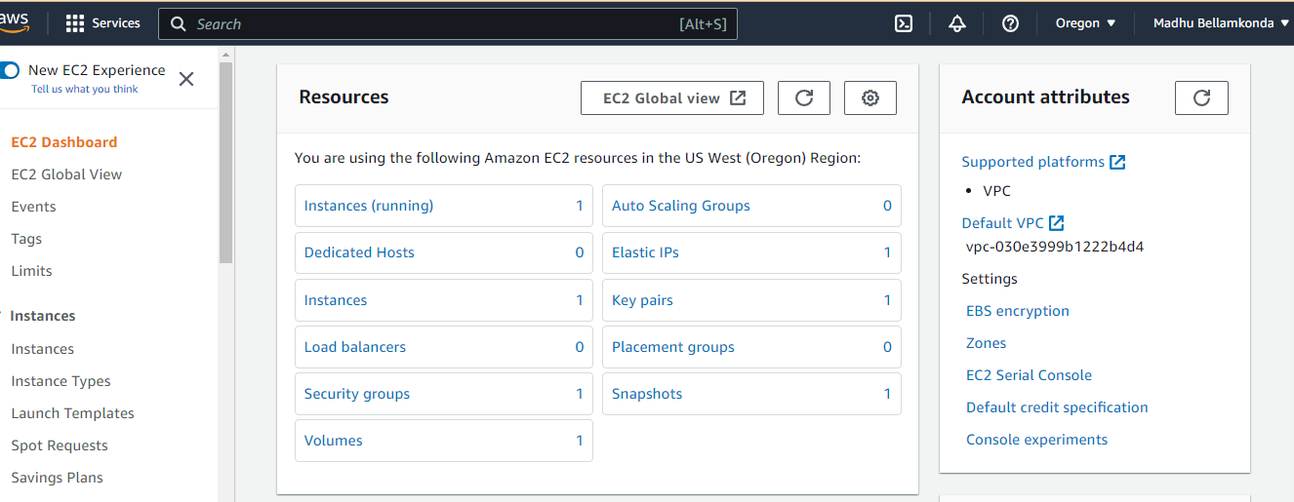

>> click on instances

>> click on launch instances

>> give name choose OS linux/ubuntu ..

>>choose instance type acc to your requirement

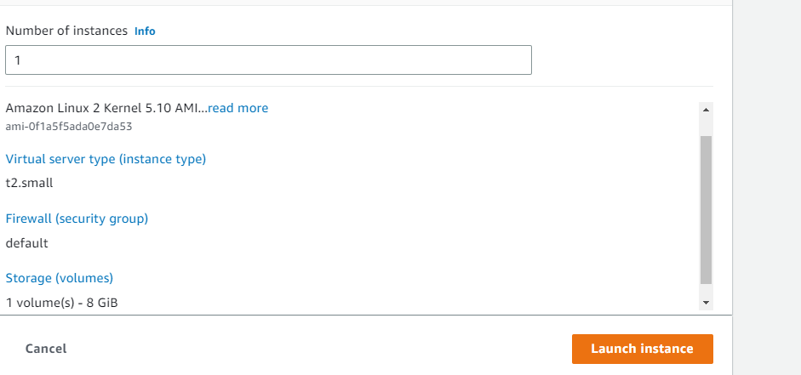

>>>click on launch instance

>>>once instance is up and running connect to cli whatever you use

>>>installing docker

# sudo yum install –y docker

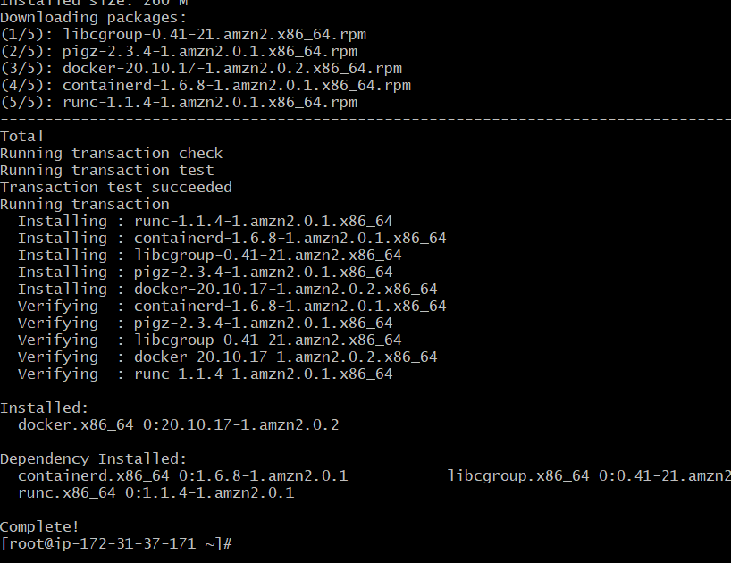

>>> once installed start docker

# sudo systemctl start docker

>>>check the status

# sudo systemctl status docker

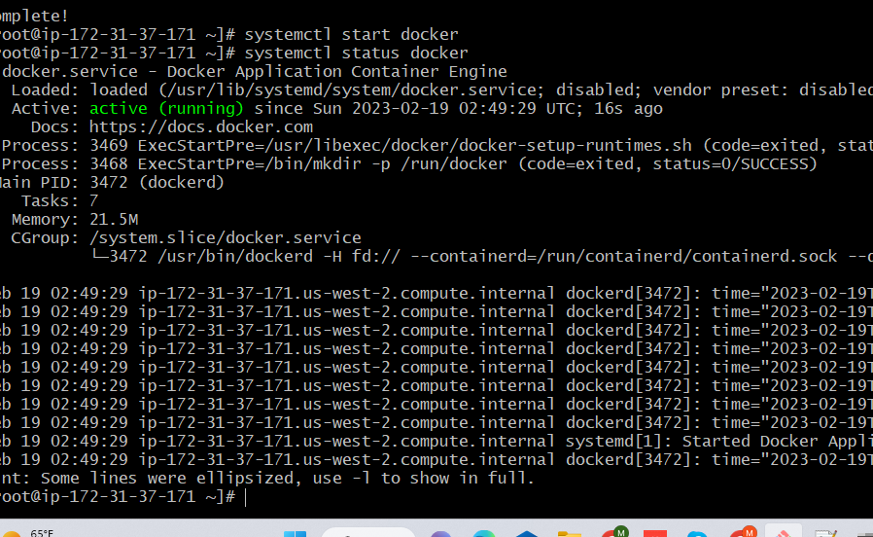

Now run

# docker run -itd --name db -e MYSQL_ROOT_PASSWORD=redhat -e\



After this popup come use the command below

# MYSQL_DATABASE=mydb -e MYSQL_USER=dev -e MYSQL_PASSWORD=123 mysql:latest

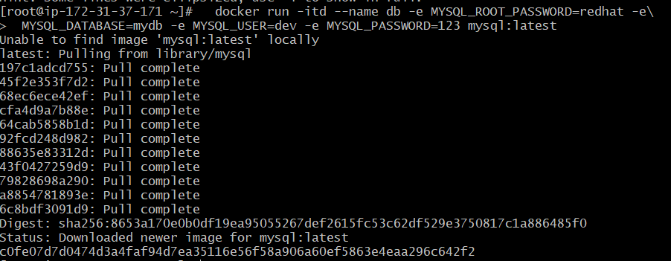

Then run this

# docker run -itd --name mywp -p 8080:80 wordpress:latest

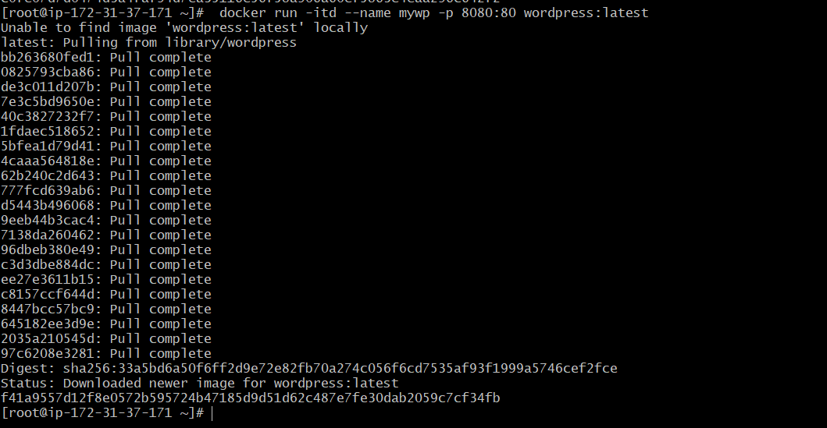

Edit inbound rules to all traffic

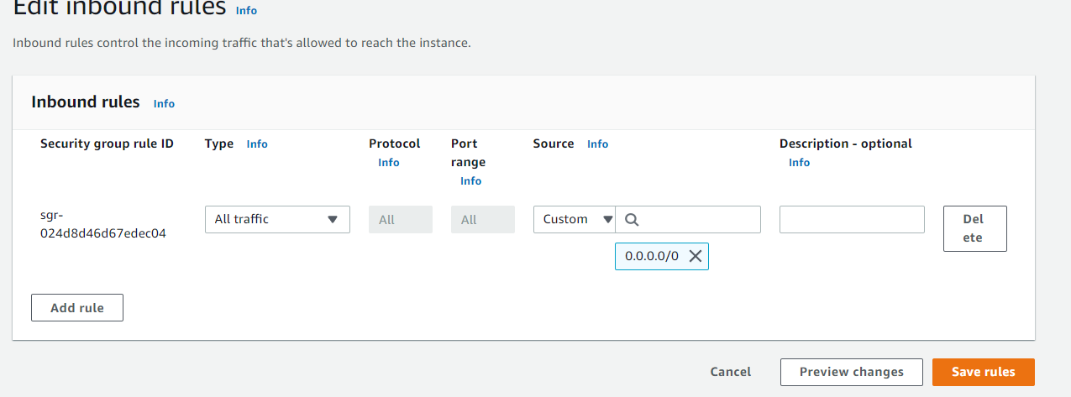

Then run below command to get pub ip

# curl ident.me



Then open any browser

Paste public ip :8080

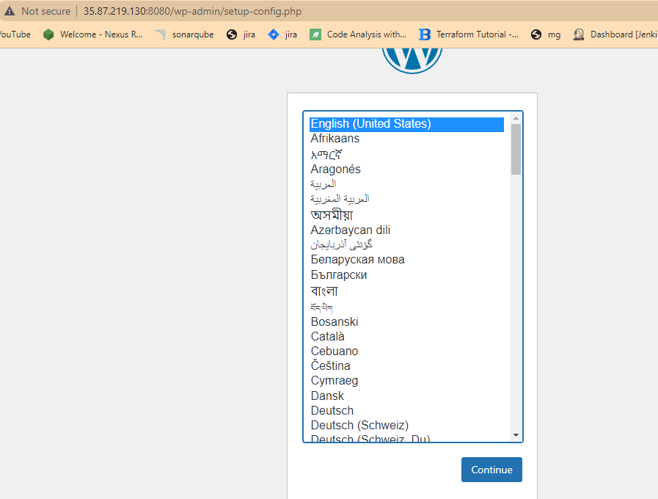

Go to cli enter below command

#docker inspect db

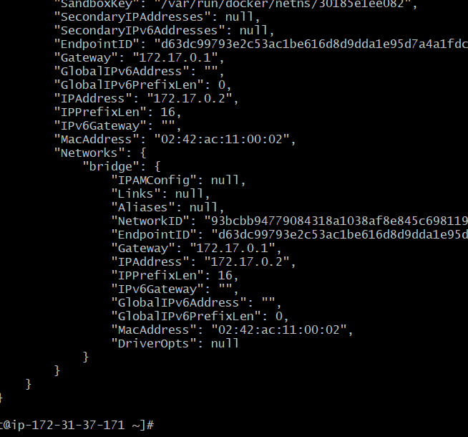

Copy this ip “172.17.0.2”

Enter in browser these details

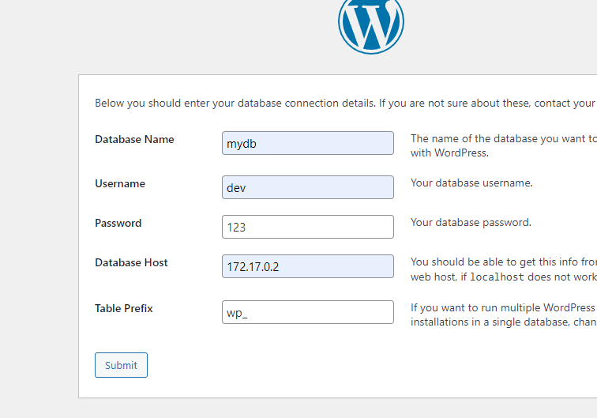

Then do next step and do configure

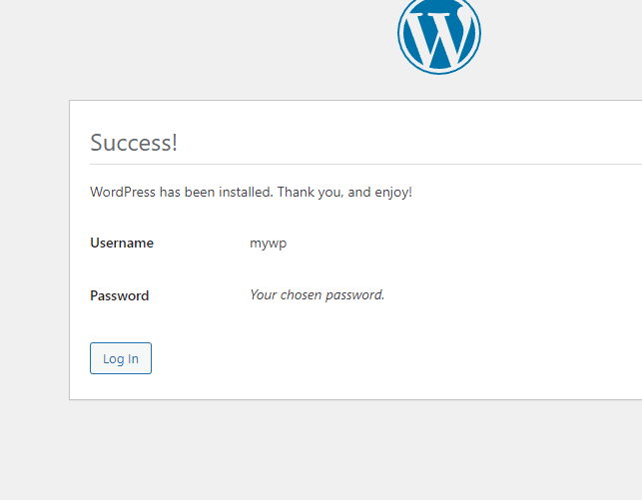

Now three tier is set up

Now upload image to ECR do follow these steps

Go to console

>>on top right click on account

Then security credentials

#create access key and secret key

Note them down on notepad

Now comeback to AWS CLI

# aws configure

Enter access key & secret key

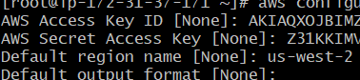

Go to AWS CONSOLE

Search ECR



Click on get started

Create repo

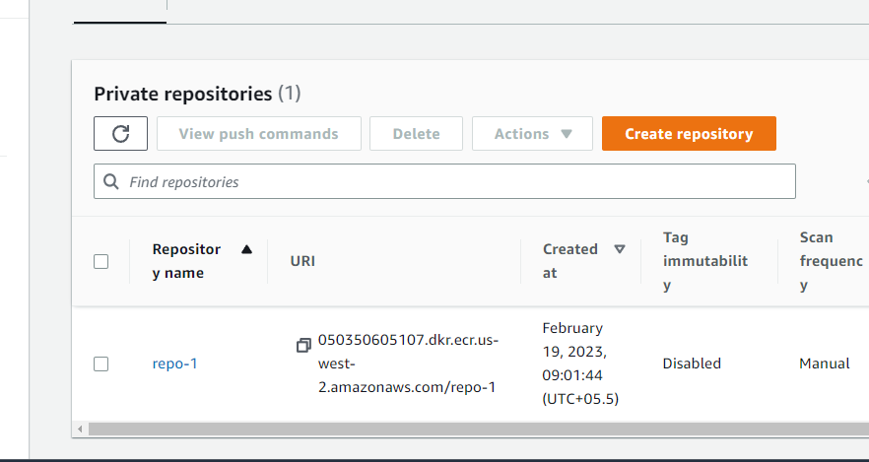

Now we need to login to ECR Through cli so that we can push images to ecr repository

Click on repo go to view push commands

Run the below command

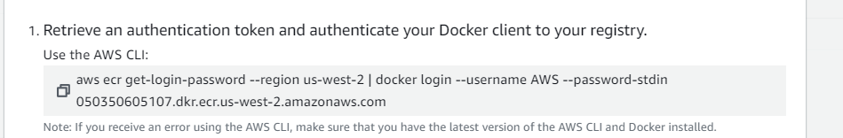

Now we successfully logged into ecr

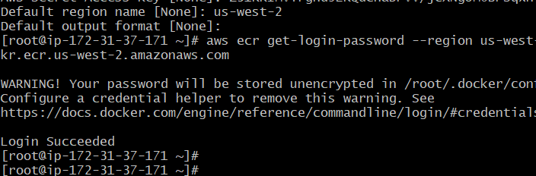

#docker image ls

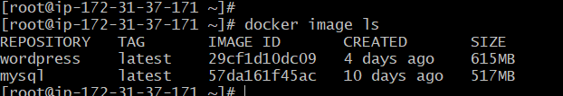

#doccker tag image:tag uri of ecr



Next push image

#docker push uri

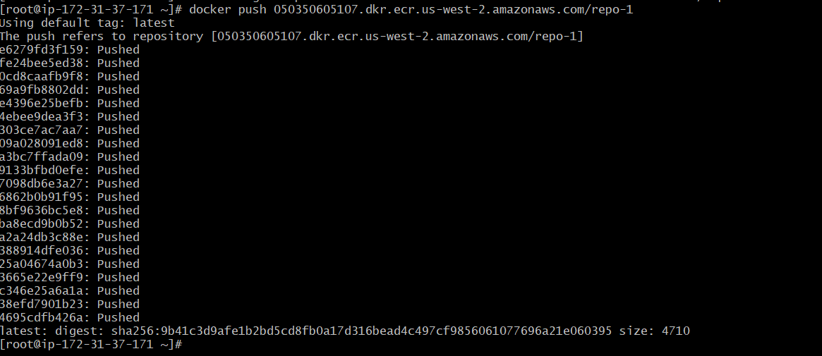

Now refresh repository

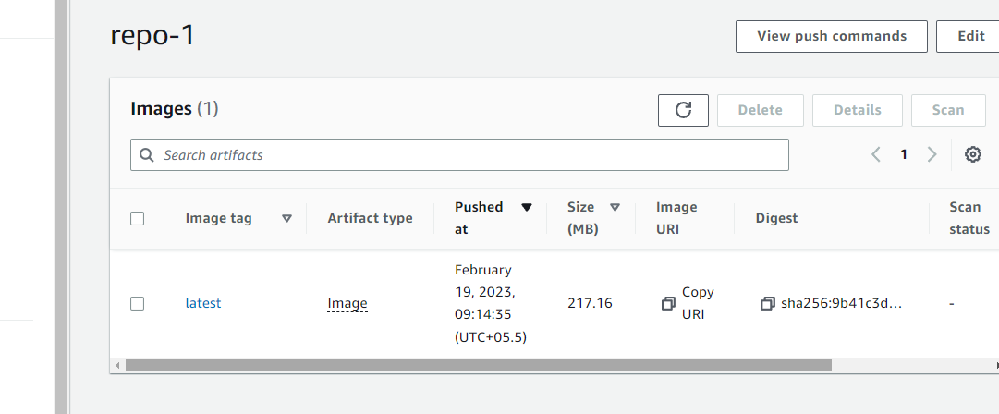

We got image just now we pushed

Do it for db image

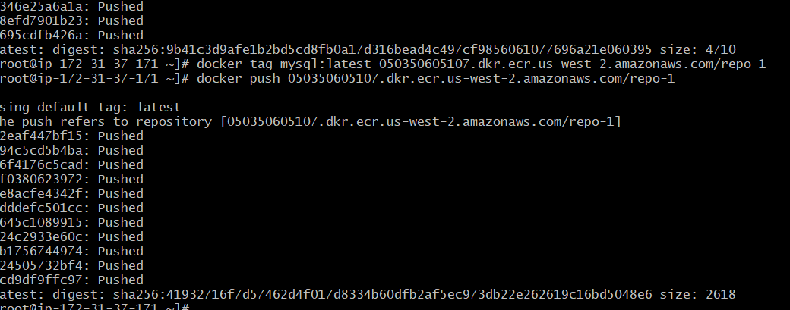

Now refresh ecr

