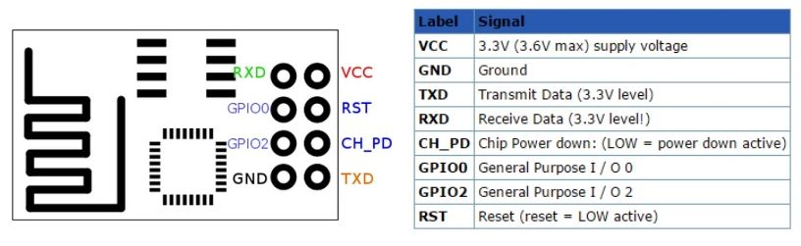

Fig 1: ESP 8266 – (WifI enabled micro controller) – Pin diagram

In order to transfer data/command from Arduino IDE to ESP 8266 we need “FT232RL USB TO TTL 5V 3.3V Download Cable To Serial Adapter”

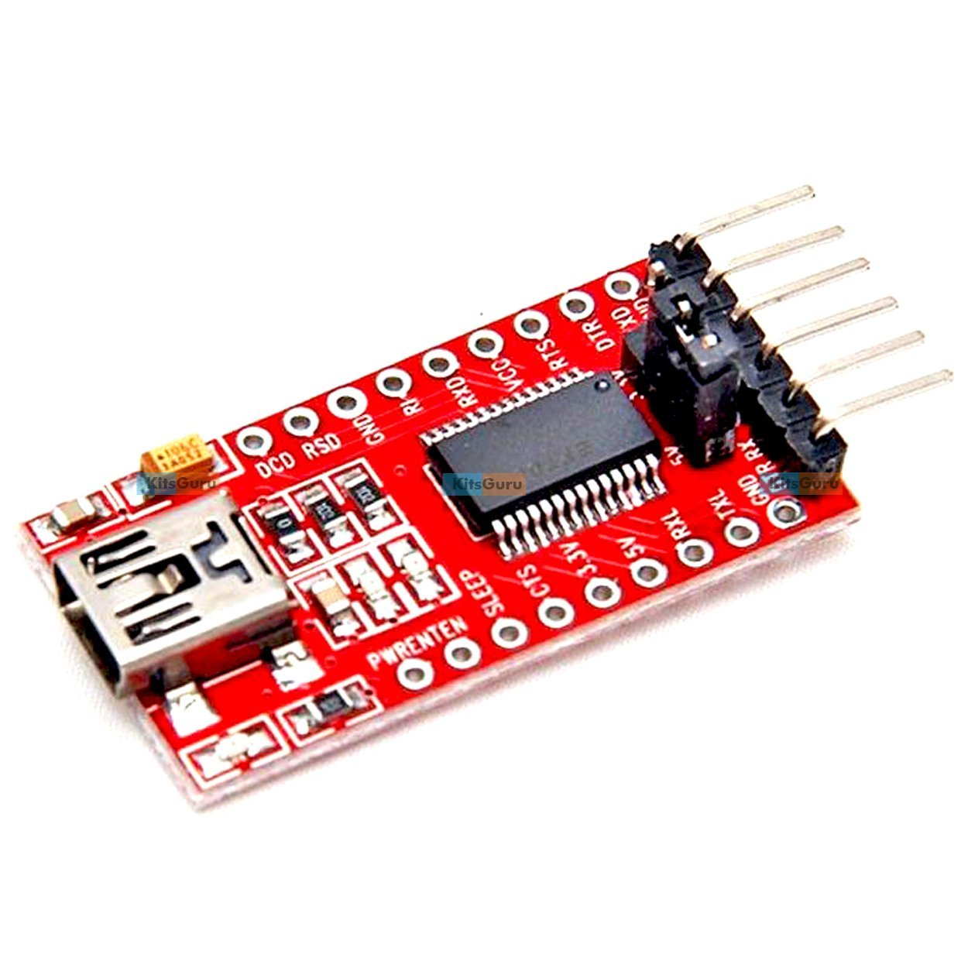

Fig2: FT232RL

ESP 8266 needs 3.3 volt power supply and only 3.3 volt to its Rx (receive input) pin.

**Connect the ESP 8266 as below (except) GIPO(0) – should be grounded**

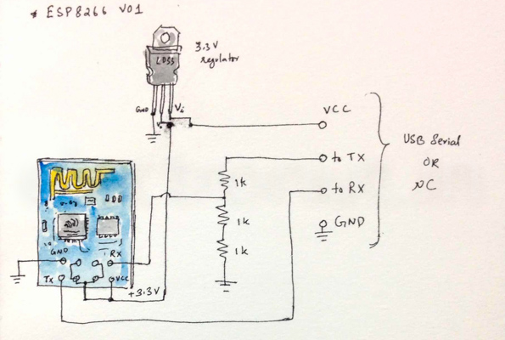

Here USB serial Or Nc is FT232RL. It operates on 5 volt.

Open Arduino IDE.

Download and install ESP8266wifi-master, ArduinoJson-v5.6.4 library for Arduino



Change upload speed, Board, CPU, Programmer as per below screen shot.

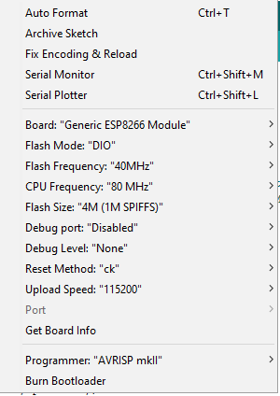

Open the console of Ardrino and run the below commands

1. AT : It is a test command
2. AT+CWMODE? : It list CWMODE
3. AT+CWMODE=3 : it sets CWMODE
4. AT+CWLAP : List near by wifi
5. AT+CWJAP="GREEN","NOTTELLINGMYPASSWD" : Connects to GREEN

Program to connect to WIFI from Arduino and send/Receive HTTP commands. Transfer this program to ESP8266 via FT232RL. It may fail some time, retry by switching off and on the ESP8266.Here is the ardunino sketch



Once done pit the GIPO of ESP8266 to high. In the abobe code we have used GIPO 2 as output. So connect that to LED that you want to controls

Here is the java program to connect to goggle app cloud and than mongo db (mlab.com)

Mlab.com: sonu.hooda/Sandeep#1234

<https://console.cloud.google.com/appengine?project=sandeephoodaiot>



Eclipse pluging for google cloud : <https://dl.google.com/eclipse/plugin/4.6>