Smart
IoT-Based
Antenna Position and
Monitoring
System
CONTENTS
- INTRODUCTION

  - Introduction to Internet of Things 1
    - Applications 1
    - Advantages of IoT 4
    - Introduction To Blynk 5
  - Introduction to Smart IoT-Based Antenna Position
and Monitoring System 14
    - Introduction to Arduino 15
    - Why Arduino? 16
    - ESP32 17
    - Pin configuration of ESP32 18
    - LED And Siren 19
    - Antenna 20
    - Servo Motor’s 21
    - Jumper Wires 22
    - DHT11 Temperature And Humidity Sensor 23
1.3.0 16x2 LCD Display 24

- LITERATURE SURVEY
  - Introduction 25
  - History 26
  - Survey 27
  - Problem Statement 28
  - Existing System 28
  - Proposed System 29
  - Requirement Analysis 30
    - Functional Requirements 31
    - Non-Functional Requirements 32
- UML MODELING
  - Introduction to UML 33
  - Goals of UML 34
  - UML Standard Diagrams 35
    - Structural Diagrams 36
    - Behavioral Diagrams 37
      - Use case Diagram 38
      - Sequence Diagram 39
      - Activity Diagram 40
- DESIGN 41
  - Design Goals 42
  - Algorithm 43
  - What Makes Up An Arduino? 45
    - Download the IDE 46
- CODING 48
  - Coding Approach 49
  - Information Handling 49
  - Programming Style 50
  - Verification and Validation 50
  - Form level Validation 50
  - Source Code 51
- TESTING 63
  - Testing Activities 64
  - Types of Testing 64
  - Testing Plan 67
  - Test Cases 68
- SCREENS 72
- CONCLUSION 78
- FUTURE SCOPE 81
- REFERENCE
  - Academic Papers and Journals 83
  - Web References 84
- APPENDIX
  - List of Figure 87
  - List of Tables 89

ABSTRACT

ABSTRACT

The IoT-Based Antenna Positioning System is a smart and automated system designed to optimize wireless signal reception by dynamically adjusting the orientation of a directional antenna. In many real-world scenarios, signal strength varies depending on antenna alignment and environmental conditions. Manual adjustment is inefficient and inaccurate, especially in remote or dynamic environments.
This project uses an ESP32 microcontroller integrated with WiFi connectivity to monitor signal strength (RSSI – Received Signal Strength Indicator) and control two 180-degree servo motors that adjust the antenna in both horizontal (X-axis) and vertical (Y-axis) directions. The system operates in both manual and automatic modes through the Blynk IoT cloud platform.
In automatic mode, the system scans different angles, measures the WiFi signal strength, identifies the position with the strongest RSSI value, and aligns the antenna accordingly. In manual mode, users can directly control antenna positioning using a mobile dashboard. A 16x2 LCD display provides real-time information such as current angle and signal strength.
This system improves signal optimization, reduces manual effort, and demonstrates practical implementation of IoT, embedded systems, and automation concepts.

INTRODUCTION

INTRODUCTION
`

Introduction to Internet of Things
The Internet of things (IoT) refers to the concept of extending Internet connectivity beyond conventional computing platforms such as personal computers and mobile devices, and into any range of traditionally “dumb” or non-internet-enabled physical devices and everyday objects. Embedded with electronics, Internet connectivity, and other forms of hardware (such as sensors), these devices can communicate and interact with others over the Internet, and they can be remotely monitored and controlled. The definition of the Internet of things has evolved due to convergence of multiple technologies, real-time analytics, machine learning, commodity sensors, and embedded systems. Traditional fields of embedded systems, wireless sensor networks, control systems, automation (including home and building automation), and others all contribute to enabling the Internet of things. In the consumer market, IoT technology is most synonymous with products pertaining to the concept of the “smart home”, covering devices and appliances (such as lighting fixtures, thermostats, home security systems and cameras, and other home appliances) that support one or more common ecosystems, and can be controlled via devices associated with that ecosystem, such as smart phones and smart speakers.

Applications

The extensive set of applications for IoT devices is often divided into consumer, commercial, industrial, and infrastructure spaces.

Consumer Applications

A growing portion of IoT devices are created for consumer use, including connected vehicles, home automation, wearable technology (as part of Internet of Wearable Things (IoT), connected health, and appliances with remote monitoring capabilities.

Smart Home: IoT devices are a part of the larger concept of home automation, which can include lighting, heating and air conditioning, media and security systems. Long term benefits could include energy savings by automatically ensuring lights and electronics are turned off. A smart home or automated home could be based on a platform or hubs that

Control smart devices and appliances. There are also dedicated smart home hubs that aSre offered as standalone platforms to connect different smart home products and these include Amazon Echo, Google Home.

Commercial Applications

Building and Home Automation: IoT devices can be used to monitor and control the mechanical electrical and electronic systems used in various types of buildings (e.g., public and private, industrial, institutions, or residential) in home automation and building automation systems. In this context, three main areas are being covered in literature:
  - The integration of the Internet with building energy management systems in ordertocreate energy efficient and IOT-driven “smart buildings”
  - The possible means of real-time monitoring for reducing energy consumptionandmonitoring occupant behavior.
  - The integration of smart devices in the built environment and how they might toknow how to use in further applications

Industrial Applications

Manufacturing: The IoT can realize the seamless integration of various manufacturing devices equipped with sensing, identification, processing, communication, actuation, and networking capabilities. Based on such a highly integrated smart cyber physical space, it opens the door to create whole new business and market opportunities for manufacturing. Network control and management of manufacturing equipment, asset and situation management, or manufacturing process control bring the IoT within the realm of industrial applications and smart manufacturing as well. The IoT intelligent systems enable rapid manufacturing of new products, dynamic response to product demands, and real-time optimization of manufacturing production and supply chain networks, by networking machinery, sensors and control systems together. Digital control systems to automate process controls, operator tools and service information systems to optimize plant safety and security are within the purview of the IoT. But it also extends itself to asset management via predictive maintenance, statistical evaluation,and measurements to maximize reliability. Smart industrial management systems can also be integrated with the Smart Grid, thereby enabling real-time energy optimization. Measurements,

Automated controls, plant optimization, health and safety management, and other functions are provided by a large number of networked sensors. The term industrial Internet of things (IoT) is often encountered in the manufacturing industries, referring to the industrial subset of the IoT. IoT in manufacturing could generate so much business value thatit will eventually lead to the Fourth Industrial Revolution, so the so- called Industry 4.0. It is estimated that in the future, successful companies will be able to increase their revenuethrough Internet of things by creating new business models and improve productivity, exploit analytics for innovation, and transform workforce. The potential of growth by implementing IoT may generate $12 trillion of global GDP by 2030.

- Agriculture: There are numerous IoT applications in farming such as collecting data on temperature, rainfall, humidity, wind speed, pest infestation, and soil content. This data can be used to automate farming techniques, take informed decisions to improve quality and quantity, minimize risk and waste, and reduce effort required to manage crops.For example, farmers can now monitor soil temperature and moisture from afar, and evenapply IoT-acquired data to precision fertilization programs.

- Infrastructure Applications: Monitoring and controlling operations of sustainable urban and rural infrastructures like bridges, railway tracks and on- and offshore wind- farms is a key application of the IoT. The IoT infrastructure can be used for monitoring any events or changes in structural conditions that can compromise safety and increase risk. The IoT can benefit the construction industry by cost saving, time reduction, better quality workday, paperless workflow and increase in productivity. It can help in taking faster decisions and save money with Real-Time Data Analytics. It can also be used for scheduling repair and maintenance activities in an efficient manner, by coordinating tasks between different service providers and users of these facilities. IoT devices can also be used to control critical infrastructure like bridges to provide access to ships. Usage of IoT devices for monitoring and operating infrastructure is likely to improve incident management and emergency response coordination, and quality of service, uptimes and reduce costs of operation in all infrastructure related areas.

Advantages of IoT:
- It can assist in the smarter control of homes and cities via mobile phones. It enhances security and offers personal protection.
- By automating activities, it saves us a lot of time.

- Information is easily accessible, even if we are far away from our actual location, and it is updated frequently in real time.
  - Electric Devices are directly connected and communicate with a controller computer, such as a cell phone, resulting in efficient electricity use. As a result, there will be no unnecessary use of electricity equipment.
  - Personal assistance can be provided by IoT apps, which can alert you to your regular plans.
  - It is useful for safety because it senses any potential danger and warns users. For example, GM On Star, is a integrated device that system which identifies a car crash or accident on road. It immediately makes a call if an accident or crash is found.
  - It minimizes human effort because IoT devices connect and communicate with one another and perform a variety of tasks without the need for human intervention.
  - Patient care can be performed more effectively in real time without the need for a doctor’s visit. It gives them the ability to make choices as well as provide evidence- based care.
  - Asset tracking, traffic or transportation tracking, inventory control, delivery, surveillance, individual order tracking, and customer management can all be Made more cost-effective with the right tracking system.

Introduction to Blynk – A Powerful IoT Platform:
Blynk is a powerful Internet of Things (IoT) platform designed to help developers and hobbyists build applications that can control and monitor hardware devices remotely using smartphones. It allows easy interaction between physical devices such as microcontrollers (ESP32, Arduino, NodeMCU, etc.) and the Blynk mobile app, providing a seamless interface for real-time control and data visualization. The main advantage of Blynk lies in its user-friendly mobile app, which lets users design custom dashboards using widgets like buttons, sliders, charts, and gauges without writing any complex UI code..

The architecture of Blynk consists of three major components: the Blynk app (user interface), the Blynk server (cloud or local), and the Blynk library that runs on the hardware. When a user interacts with the mobile app, commands are sent to the server, which in turn communicates with the connected device through the internet. Each device is identified using a unique Auth Token generated by the app, which ensures secure communication between the cloud and hardware. Blynk also supports virtual pins, which allow you to assign specific functions or data streams within your code for smoother widget-device interaction.

One of Blynk's key strengths is its wide compatibility with different hardware platforms and connectivity methods (Wi-Fi, Ethernet, GSM), allowing it to fit into various applications including smart farming, home automation, environmental monitoring, and robotics. It also supports integration with other services such as IFTTT, Google Sheets, and HTTP APIs, enabling users to trigger cloud-based actions or store data externally. Developers can use the Blynk Console (web dashboard) to manage devices, users, and data from a central place. With built-in features for real-time notifications, automation, geofencing, and device sharing, Blynk makes it easy to scale from a small prototype to a large deployment. Its support for secure SSL connections, customizable apps, and graphical analytics adds to its robustness. Overall, Blynk provides a simple yet comprehensive platform to bring IoT ideas to life without the need for developing custom applications from scratch.

Introduction to Smart IoT-Based Antenna Position and Monitoring System
The Smart IoT-Based Antenna Position and Monitoring System is an intelligent solution designed to optimize wireless signal reception through automated antenna alignment. In wireless communication systems, proper antenna orientation plays a critical role in maintaining strong and stable signal strength. Traditional manual alignment methods are often time-consuming, inaccurate, and unsuitable for dynamic or remote environments.
This project utilizes an ESP32 microcontroller with built-in WiFi capability to monitor signal strength using RSSI (Received Signal Strength Indicator) values. Two servo motors enable precise movement of the antenna in horizontal and vertical directions. The system supports both manual and automatic modes through the Blynk IoT cloud platform, allowing remote monitoring and control. In automatic mode, the antenna scans multiple angles and locks onto the position with the strongest signal. A 16x2 LCD display provides real-time system feedback.
This system demonstrates practical implementation of IoT, embedded systems, and wireless communication optimization.

Key Features

  - Smart Sensor Integration
Uses ultrasonic, infrared, or magnetic sensors to detect vehicle presence and parking space occupancy accurately.
  - Real-Time Data Collection
Sensors continuously transmit parking availability data to a centralized cloud platform for live updates.
  - Cloud-Based Management
Processes and stores parking data in the cloud for monitoring, analytics, and administrative control.
  - Mobile Application Integration
Allows users to view real-time parking availability and locate empty spaces via a mobile application.
  - Dynamic Pricing and Reservation
Supports demand-based pricing models and advance parking slot reservations.
  - Navigation and Guidance System
Provides electronic signboards or in-app directions to guide drivers directly to available parking spaces.
  - Analytics and Insights
Uses data analytics to study parking trends, optimize resource allocation, and assist urban planning decisions.
  - Scalability and Flexibility
Designed to adapt to different parking lot sizes and integrate seamlessly with existing infrastructure.
  - Security and Privacy Protection
Implements secure data transmission and storage protocols to protect user and system information.
  - Environmental Sustainability
Reduces traffic congestion and fuel consumption by minimizing time spent searching for parking, contributing to a greener environment.

Introduction to Arduino
Arduino is an open-source electronics platform based on easy-to-use hardware and software. Arduino boards are able to read inputs - light on a sensor, a finger on a button, or a Twitter message - and turn it into an output - activating a motor, turning on an LED,
publishing something online. You can tell your board what to do by sending a set of instructions to the microcontroller on the board. To do so you use the Arduino programming language (based on Wiring), and the Arduino Software (IDE), based on Processing. Over the years Arduino has been the brain of thousands of projects, from everyday objects to complex scientific instruments. A worldwide community of makers-

students, hobbyists, artists, programmers, and professionals - has gathered around this open-source platform, their contributions have added up to an incredible amount of accessible knowledge that can be of great help to novices and experts alike.

Arduino was born at the Ivrea Interaction Design Institute as an easy tool for fast prototyping, aimed at students without a background in electronics and programming. As soon as it reached a wider community, the Arduino board started changing to adapt to new needs and challenges, differentiating its offer from simple 8-bit boards to products for IoT applications, wearable, 3D printing, and embedded environments.

Why Arduino?

Thanks to its simple and accessible user experience, Arduino has been used in thousands of different projects and applications. The Arduino software is easy-to-use forbeginners, yet flexible enough for advanced users. It runs on Mac, Windows, and Linux.Teachers and students use it to build low cost scientific instruments, to prove chemistry and physics principles, or to get started with programming and robotics Designers and architects build interactive prototypes, musicians and artists use it for installations andto experiment with new musical instruments. Makers, of course, use it to build many of the projects exhibited at the Maker Faire, for example. Arduino is a key tool to learn newthings. Anyone - children, hobbyists, artists, programmers - can start tinkering just following the step-by-step instructions of a kit, or sharing ideas online with other members of the Arduino community. There are many other microcontrollers and microcontroller platforms available for physical computing. Parallax Basic Stamp, Net media's BX-24, Phid gets, MIT's Handy board, and many others offer similar functionality. All of these tools take the messy details of microcontroller programming and wrap it up in an easy-to- use package. Arduino also simplifies the process of working with microcontrollers, but it offers some advantage forteachers, students, and interested amateurs over other systems:
- Inexpensive - Arduino boards are relatively inexpensive compared to other microcontroller platforms. The least expensive version of the Arduino module can be assembled by hand, and even the pre-assembled Arduino modules cost less than $50

- Cross-platform - The Arduino Software (IDE) runs on Windows, Macintosh OSX,

and Linux operating systems. Most microcontroller systems are limited to Windows.

- Simple, clear programming environment - The Arduino Software (IDE) is easy-to- use for beginners, yet flexible enough for advanced users to take advantage of as well. For teachers, it's conveniently based on the Processing programming environment, so students learning to program in that environment will be familiar with how the Arduino IDE works.

ESP32

The ESP32 microcontroller has emerged as a cornerstone in the realm of embedded systems and IoT applications. Boasting a dual-core processor and robust wireless connectivity via Wi-Fi and Bluetooth, it offers a powerful platform for developers to create innovative solutions. Its extensive array of peripherals—including GPIO pins, UART, SPI, I2C, ADC, DAC, and more—facilitates versatile interfacing with various sensors, actuators, and other components. This versatility, coupled with low power consumption and advanced security features, makes the ESP32 well-suited for applications ranging from smart home devices and industrial automation to wearable technology and sensor networks. Supported by a vibrant development ecosystem that includes Express if's ESP-IDF and Arduino IDE, the ESP32 continues to drive advancements in connectivity, efficiency, and functionality across diverse industries.

- Different ESP32 modules
- ESP32-WROOM-DA
- ESP32-WROOM-32E
- ESP32-WROOM-32UE
- ESP32-WROOM-32D
- ESP32-WROOM-32U
- ESP32-SOLO-1
- ESP32-WROVER-E
- ESP32-WROVER-IE

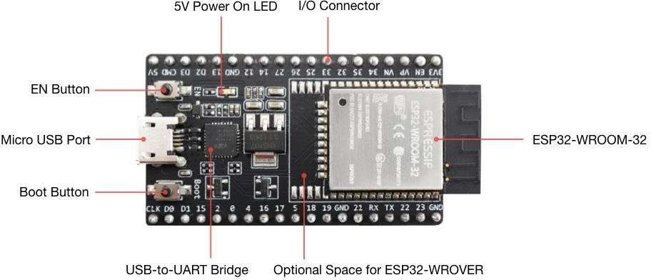

Figure 1.1: ESP32

Pin Configuration of ESP32

- Power Pins:

- VIN: Input voltage range is 5V. Used to power the ESP32 module.
- 3V3: Output 3.3V voltage regulator. Used to power external components.
- GND: Ground pins for power and signal ground.

Analog Pins (ADC):

- ADC1_0 to ADC1_8: Analog input pins with 12-bit resolution.
- ADC2_0 to ADC2_10: Additional analog input pins with 12-bit resolution.

Digital GPIO Pins:

- GPIO0 to GPIO39: General purpose digital input/output pins. These can be configured as input or output, with support for internal pull-up or pull-down resistors.

Special Function Pins:

- UART Pins (TX, RX): Typically GPIO1 and GPIO3 or GPIO17 and GPIO16.
- SPI Pins (SCK, MOSI, MISO, CS): Typically GPIO18, GPIO23, GPIO19, and
GPIO5 respectively.
- I2C Pins (SDA, SCL): Typically GPIO21 (SDA) and GPIO22 (SCL).
- PWM Output Pins: Available on GPIO0, GPIO2, GPIO4, GPIO12, GPIO13, GPIO14, GPIO15, GPIO25, GPIO26, GPIO27, etc.
- Touch Sensor Pins: Capacitive touch sensor inputs on GPIO4, GPIO0, GPIO2,

GPIO15, GPIO13, GPIO12, GPIO14, GPIO27, GPIO33, GPIO32.

Other Pins:

- EN: Enable pin to power on the ESP32 module.
- BOOT: Boot mode selection pin.
- IO0: Input/output pin used for programming and boot mode selection.
- IO33, IO32: Additional digital input/output pins.

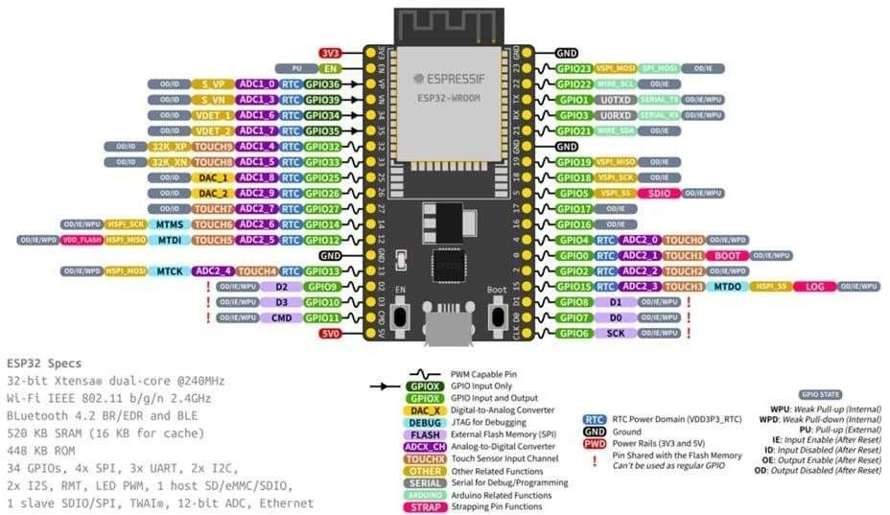

Figure 1.2: Pin Configuration ESP32

Jumper Wires

Jumper wires are simply wires that have connector pins at each end, allowing them to be used to connect two points to each other without soldering. Jumper wires are typically used with breadboards and other prototyping tools in order to make it easy to change a circuit as need though jumper wires come in a variety of colors, the colors don’t actually mean anything. This means that a red jumper wire is technically the same as a

black one. But the colors can be used to your advantage in order to differentiate between types of connections, such as ground or power.
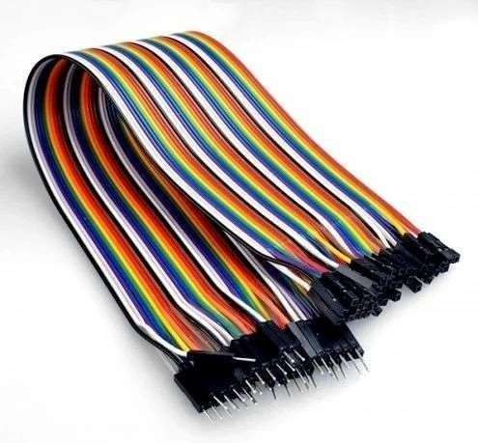

Figure 1.9: Jumper Wires

DHT11 Temperature and Humidity Sensor:
The DHT11 is a widely used digital sensor that measures both ambient temperature and relative humidity. It’s cost-effective, compact, and ideal for weather monitoring, greenhouse control, and smart agriculture systems.

Working Principle:
The sensor uses a thermistor to measure temperature and a capacitive humidity sensor to detect moisture in the air. The data is then transmitted digitally to a microcontroller like the ESP32.

Pin Configuration (Typical 3-Pin Version of DHT11):

VCC – Power Supply (3.3V to 5V)
DATA – Serial Data Output (connect to a digital pin on ESP32) GND – Ground
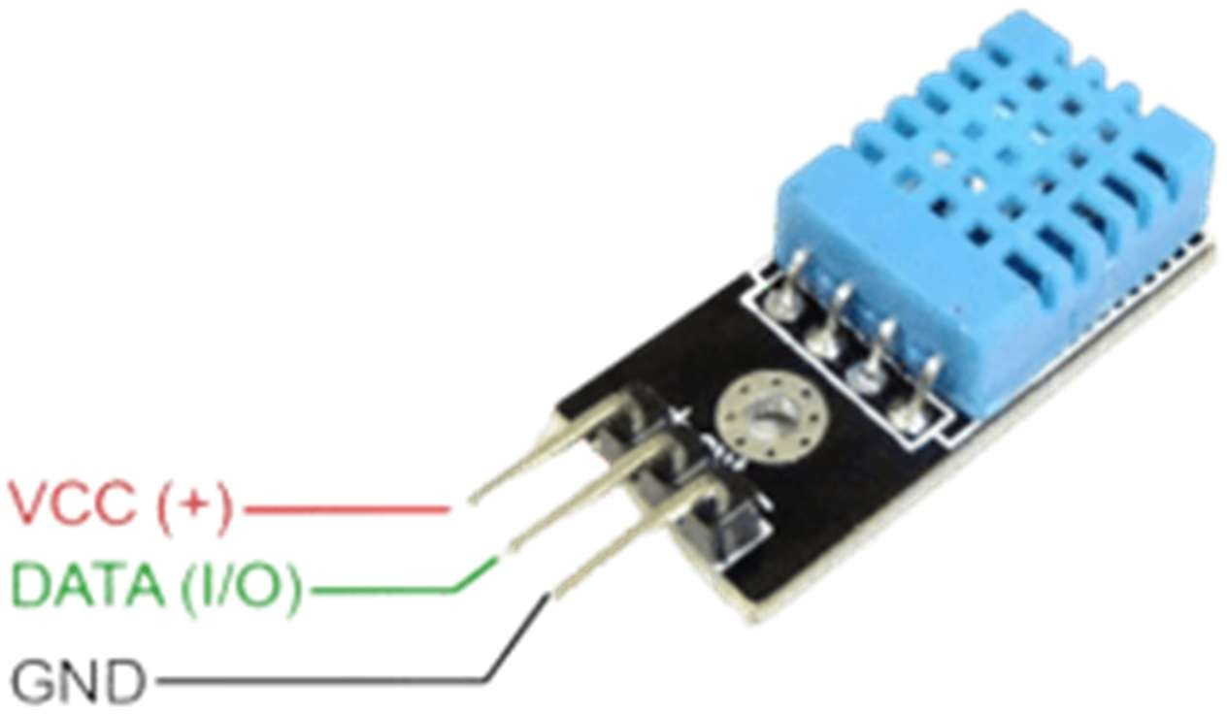

Figure 1.10: DHT11

Features and Advantages:

Measures temperature: 0–50 °C (±2 °C accuracy) Measures humidity: 20–90% RH (±5% accuracy) Digital output – no need for ADC
Low power consumption
Simple to integrate with libraries like DHT.h in Arduino

In an IoT-based agriculture system, the DHT11 can monitor environmental conditions that affect plant health. You can log data to the cloud or use it to control irrigation and ventilation automatically.

16x2 LCD Display (I2C Module):
A 16x2 LCD display is used in IoT-based systems to provide real-time visual feedback such as system status, sensor readings, signal strength, or angle positions. When integrated with an I2C module, it reduces the number of required GPIO pins from 6–8 pins to only 2 communication pins.

Working Principle:
The ESP32 communicates with the LCD using the I2C protocol, sending data through SDA and synchronized by SCL. The display can show two rows of 16 characters each. It is used to display parameters such as system mode, signal strength (RSSI), motor angles, soil moisture values, or pump status. The I2C interface simplifies wiring and improves system efficiency..

Pin Configuration (Typical 3-Pin Version of DHT11):

VCC – Power Supply (3.3V to 5V)
SDA (Serial Data): Connects to ESP32 SDA pin (commonly GPIO 21).
SCL (Serial Clock): Connects to ESP32 SCL pin (commonly GPIO 22).
GND – Ground

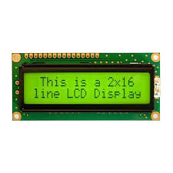

Figure 1.10: 16x2 LCD Display

Servo Motor:

A servo motor in IoT-based automation projects is used for precise angular movement and position control. Unlike DC motors, servo motors can rotate to a specific angle (0°–180°) based on PWM (Pulse Width Modulation) signals from a microcontroller like the ESP32. In this project, servo motors are used for controlled movement such as antenna positioning or directional actuation.

Pin Configuration (when used with a relay module):
VCC: Connects to 5V external power supply (recommended) to ensure stable operation.
GND: Ground connection to complete the circuit.
Signal (PWM Pin): Connected to any PWM-enabled GPIO pin of ESP32 (e.g., D18, D19, D21) to control angle position.

Working:
The ESP32 generates PWM signals to control the servo motor's shaft position. The pulse width determines the angle of rotation (e.g., 1ms ≈ 0°, 1.5ms ≈ 90°, 2ms ≈ 180°). The servo moves precisely to the commanded angle and holds that position. This enables accurate directional control in automation systems. An external power supply is recommended to prevent voltage drops and ensure stable performance..

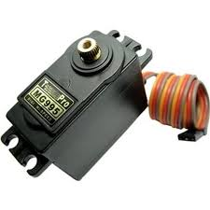

Figure 1.11: Servo Motor

LITERATURE SURVEY

LITERATURE SURVEY

INTRODUCTION:

Wireless communication systems rely heavily on proper antenna alignment to ensure strong and stable signal transmission. In many applications such as rural internet connectivity, remote monitoring stations, surveillance systems, and communication towers, signal strength varies depending on antenna orientation and environmental conditions. Traditional antenna alignment methods involve manual adjustments, which are time-consuming, inaccurate, and inefficient, especially in dynamic environments where signal conditions frequently change.
Recent advancements in the Internet of Things (IoT) and embedded systems have enabled the development of intelligent antenna positioning systems. Microcontrollers like the ESP32 provide built-in WiFi capability, allowing real-time monitoring of signal strength using RSSI (Received Signal Strength Indicator) values. IoT cloud platforms such as Blynk support remote monitoring and control through mobile dashboards.
Automated positioning mechanisms using servo motors allow precise horizontal and vertical antenna movement. By integrating real-time signal monitoring with motorized adjustment, the system can automatically scan different angles and align the antenna to the position with maximum signal strength.
This approach reduces manual effort, improves communication reliability, and provides a scalable and cost-effective solution for modern wireless optimization systems.

Circuit Diagram:

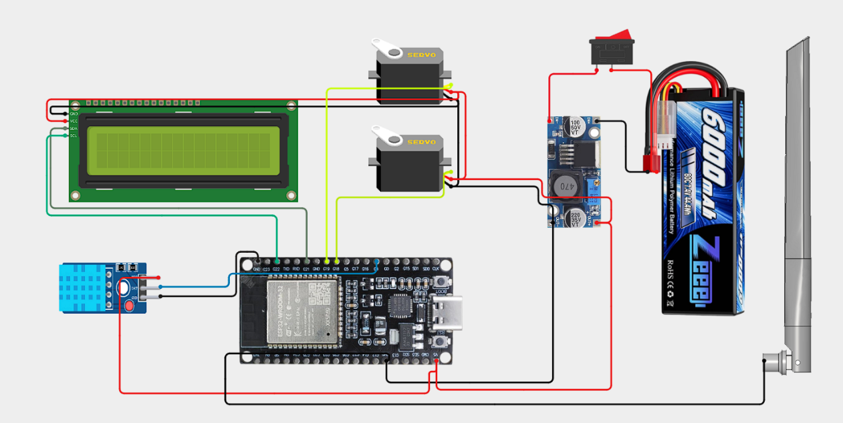

Figure 2.1: Circuit Diagram

History

The development of antenna positioning systems has evolved alongside advancements in wireless communication technology. In earlier communication setups, antenna alignment was performed manually using signal meters and trial-and-error methods. Technicians physically rotated antennas until acceptable signal strength was achieved. While effective to some extent, this process was time-consuming and lacked precision.
With the rise of digital communication systems in the 2000s, automated signal monitoring tools were introduced. However, these systems were often expensive and limited to large-scale communication towers. Around the mid-2010s, the growth of IoT-enabled microcontrollers enabled low-cost wireless monitoring solutions. Devices such as the ESP32 provided built-in WiFi capabilities and real-time RSSI monitoring, making signal-based automation feasible.
Simultaneously, IoT cloud platforms like Blynk simplified remote monitoring and control through mobile applications. Servo motor-based positioning systems also became affordable and precise.
This project integrates these technological advancements into a compact, cost-effective, automated antenna positioning system suitable for both small-scale and remote applications.

Survey

Several research works have explored automated antenna alignment using signal strength analysis. Some systems use high-end spectrum analyzers and motorized mounts to optimize antenna direction. Although accurate, these solutions are expensive and mainly used in commercial telecom industries.
Other prototypes implemented microcontroller-based signal monitoring with motor drivers to adjust antenna position. However, many lacked cloud integration for remote monitoring. Some systems relied on external computers for processing, increasing cost and power consumption.
IoT-based monitoring platforms improved accessibility by allowing users to view signal data remotely. However, most systems focused only on monitoring and did not include automatic scanning and repositioning mechanisms.
Commercial motorized antenna rotators are available in the market, but they are costly and not easily customizable.
This project addresses these limitations by providing a low-cost, ESP32-based automated antenna positioning system with both manual and automatic modes, along with real-time IoT monitoring.

Problem Statement

Traditional Wireless communication performance depends heavily on accurate antenna alignment. Traditional antenna positioning methods:
- Require manual adjustment
- Lack precision
- Cannot dynamically respond to signal fluctuations
- Are unsuitable for remote or unmanned installations
Signal strength often varies due to environmental changes, obstacles, and interference. Without automatic adjustment, communication quality may degrade significantly.
There is a need for a smart, cost-effective system that:
- Continuously monitors signal strength (RSSI)
- Automatically adjusts antenna orientation
- Allows remote monitoring and manual control
- Operates efficiently in remote areas

Existing System

Current antenna alignment systems are either manual or expensive industrial solutions. Manual alignment requires technicians to physically adjust the antenna while monitoring signal levels.
Some commercial motorized rotators allow remote movement but lack intelligent signal-based optimization. Advanced telecom systems use automatic alignment tools, but they are expensive and complex.

Limitations:

High Cost and Commercial Automatic Rotators:
Industrial-grade antenna rotators and automatic alignment systems are expensive and primarily designed for telecom towers or professional communication setups, making them unaffordable for small users.
Manual Effort Required in Basic Systems:
Traditional antenna alignment requires physical adjustment by technicians, which is time-consuming and inconvenient, especially in rooftop or remote installations.
No Intelligent RSSI-Based Optimization in Low-Cost Setups:
Most affordable systems lack automated signal strength comparison and decision-making mechanisms. They do not dynamically scan and select the optimal signal direction.
Lack of Dual-Axis Precision Control:
Some systems support only horizontal rotation and do not provide vertical tilt adjustment, limiting precise antenna positioning.
Poor Scalability for IoT Integration:
Many traditional systems are not designed to integrate easily with IoT platforms or smart automation frameworks.
Delayed Response to Signal Fluctuations:
Without continuous monitoring and automatic adjustment, signal degradation may persist until manually corrected..

Proposed System

The proposed system introduces a Smart IoT-Based Antenna Position and Monitoring System using the ESP32 for real-time WiFi RSSI monitoring and control. Two 180° servo motors enable horizontal and vertical antenna movement.
In automatic mode, the system:
- Scans multiple angles
- Measures RSSI at each position
- Compares signal values
- Locks the antenna at the strongest signal direction
In manual mode, users can adjust antenna orientation via the Blynk mobile dashboard.
A 16x2 LCD provides real-time display of signal strength and angle position. The system operates on a battery-powered setup with voltage regulation for stability.

Advantages:

- Automatic signal optimization
- Reduced manual effort
- Low-cost and scalable solution
- Remote monitoring and control
- Suitable for rural and remote installations

Requirement analysis

The system design requires careful analysis of both hardware and software components to ensure stable and accurate antenna positioning. At the core of the system, the ESP32 monitors WiFi signal strength (RSSI) and controls antenna movement. Two 180-degree servo motors are used for horizontal (X-axis) and vertical (Y-axis) positioning.
The system supports both automatic and manual modes. In automatic mode, the ESP32 scans different angular positions, records RSSI values, and determines the strongest signal direction. In manual mode, users can control antenna angles remotely using the Blynk dashboard.
A 16x2 LCD (I2C) is used for real-time display of signal strength, angle position, and system status. Stable power regulation using a 2S lithium-ion battery and buck converter is required to ensure uninterrupted operation. The system must also withstand outdoor conditions such as heat, dust, and wind exposure.

Functional Requirements
The functional requirements for the project outline the specific behaviour and functionalities that the system will exhibit to meet user needs and achieveits intended purpose. These requirements focus on what the system should do, describing the interactions between the system and its users, as well as the system’s operations.

INPUT:

- Wi-Fi Signal Strength (RSSI) Data : The ESP32 continuously scans and reads the Received Signal Strength Indicator (RSSI) from the connected WiFi network.. The RSSI readings are collected at different angular positions during scanning to compare signal quality.
- Automatic Mode Activation Command: A user-triggered command (via Blynk dashboard button) or system-defined condition initiates the automatic scanning process. This input enables the ESP32 to begin rotating the antenna step-by-step across predefined horizontal and vertical angles.
- Manual Position Control Input : Users can manually adjust the antenna’s horizontal (X-axis) and vertical (Y-axis) angles through slider widgets in the Blynk mobile application. These inputs allow precise angle selection without enabling automatic scanning..
- Mode Selection Input (Auto/Manual): The system receives user input to switch between automatic optimization mode and manual control mode, ensuring flexible operation.
- System Reset or Initialization Input: On startup or reset, the system initializes default antenna angles and begins signal monitoring to ensure consistent operation.
- User Control via Blynk App: Optional user commands via the Blynk mobile app to view system status, override actions, or initiate manual watering/spraying.

OUTPUT:

- Optimal Signal Angle Determination: After scanning multiple angular positions, the system compares RSSI values and determines the direction that provides the strongest signal strength. This calculated optimal angle becomes the final alignment position.
- Servo Motor Control Signals (PWM Output): The ESP32 generates PWM signals to control two servo motors, adjusting the antenna’s horizontal and vertical orientation accurately according to manual or automatic inputs.
- Real-Time LCD Display Output: The 16x2 I2C LCD displays live system information including current X-axis angle, Y-axis angle, RSSI value, system mode (Auto/Manual), and scan status. This provides immediate local feedback to the user.
- Real-time Notifications via Blynk: Updates and alerts about plant status, disease detection, pump operation, and system faults sent to the user’s mobile device.
- Data Logging to Cloud: Sensor readings, classification results, and device actions are uploaded to the Blynk cloud for remote monitoring and future analysis.

Hardware Requirements:
  - ESP32 Microcontroller – Used for WiFi RSSI monitoring, servo motor
control, and IoT communication.
  - Servo Motors (2 Nos., 180°) – Used for horizontal (X-axis) and vertical
(Y-axis) antenna positioning.
  - 16x2 LCD Display (I2C Module) – Displays real-time RSSI values
  - Buck Converter (Voltage Regulator)
  - 2S Lithium-Ion Battery Pack (7.4V)Fertilizer & Water Pumps
  - Limit Switches
  - Antenna Mounting Frame
  - Connecting Wires and PCB

Software Requirements:
  - Arduino IDE for firmware development
  - Blynk IoT Platform for remote monitoring
  - Embedded C/C++ for ESP32 firmware
  - ESP32 WiFi Libraries – For RSSI monitoring and network communication.
  - I2C LCD Library – For displaying system parameters.

Non-Functional Requirements
Non-functional requirements describe the overall qualities and attributes of the Smart Pill Reminder system, focusing on how the system performs its functions rather than what specific functions it performs. These requirements ensure the system is usable, reliable, and efficient.
- Performance: The system should respond to manual control inputs within 1–2 seconds. During automatic scanning mode, RSSI readings should be updated with minimal delay to ensure accurate optimization.
- Scalability: The system architecture should allow integration with additional antennas or monitoring nodes without major hardware redesign. Cloud dashboard expansion should support multiple device monitoring..
- Reliability: Ensure 99.9% system uptime. Implement failover and redundancy mechanisms to handle server failures and ensure continuous operation.

- Security: Use end-to-end encryption for all data transmissions. Implement multi- factor authentication for user accounts.
- Usability: The user interface should be intuitive and user-friendly for both web and mobile applicatio

UMLMODELING

UML MODELING

Introduction to UML

UML is a standard language for specifying, visualizing, constructing, and documenting the artifacts of software system. UML was created by the Object Management Group (OMG) and UML 1.0specification drift was proposed to the OMG in January 1997.OMG is continuously making efforts to create a truly industry standard.
- UML stands for Unified Modeling Language.

- UML is different from the other common programming language such as C++, java, etc.
- UML is a pictorial language used to make software blueprints.

- UML can be described as a general-purpose visual modeling language to visualize, specify, construct and document software system.
- Although UML is generally used to model software system, it is not limited within this boundary. It is generally used to model software system as well. For example, the process flows in a manufacturing unit, etc.
- UML is not a programming language, but tools can be used to generate code in various language using UML diagrams. UML has a direct relation with object- oriented analysis and design. After some standardization, UML has become an OMG standard.

Goals of UML
- UML aimed to create a universal modeling language for all types of systems, emphasizing simplicity and widespread applicability.
- UML diagrams cater not only to developers but also to business users, general audiences, and anyone interested in understanding complex systems.
- UML integrates with development processes rather than being a standalone methodology, enhancing system development and understanding.
- UML provides a straightforward approach to model and visualize both software and non-software systems in modern, intricate environments.

UML Standard Diagrams:
The elements are like components which can be associated in diverse ways to make a complete UML picture, which is known as diagram. Thus, it is very important to understand the different diagrams to implement the knowledge in real-life system. Any complex system is best understood by making some kind of diagrams or pictures. These diagrams have a better impact on our understanding. If we look around, we will realize that the diagram is not a new concept but it is used widely in different forms in different industries. We prepare UML diagram to understand the system in a better and simple way. A single diagram is not enoughto cover all the aspects of the system. UML defines various kinds of diagrams to cover most of the aspects of a system. You can also create your own set of diagrams to meet your requirements. Diagrams are generally made in an incremental and iterative way. There are two broad categories of diagram and they are again divided into subcategories:
- Structural Diagrams

- Behavioral Diagrams

Structural Diagrams
The structural diagram represents the static aspect of the system. These static aspects represent those parts of a diagram, which forms the main structure and are therefore stable. These static parts are represented by classes, interfaces, object, components, and nodes. The four structural diagrams are:
- Class Diagram
- Object Diagram
- Component Diagram
- Deployment Diagram

Behavioral Diagrams
Any system can have two aspects, static and dynamic. So, a model is considered as complete when both the aspects are fully covered. Behavioral diagram captures the dynamic aspect of a system. Dynamic aspect can be further described as the changing/moving parts ofa system. UML has the following five types of behavioral diagrams:

- Use case Diagram

- Sequence Diagram

- Activity Diagram

3.3.3.1 Use Case Diagram:

Use case describes the behavior of the system as seen from the actor’s point of view. A use case diagram can portray then different types of users of a system and the many ways that they interact with system. This type of diagram is typically used in conjunction with the textual use case and will often be accompanied by other types of diagrams as well. Actors initiate the use cases for accessing system’s functionality. When actors and use cases exchange information, they are said to Communicate. To describe a use case, we use a template composed of six fields:
- Use Case Name: The name of the use case.
- Participating Actors: The actors participating in the particular use case.
- Entry Condition: Condition for initiating the use case.
- Flow of events: Sequence of steps describing the functioning of Use case.
- Exit Condition: Condition for terminating the use case.
- Quality Requirements: Requirements that do not belong to the use case but constraint the functionality of the system.

Use Case Diagram:
Use Case Diagram for Smart IoT-Based Antenna Position and Monitoring System
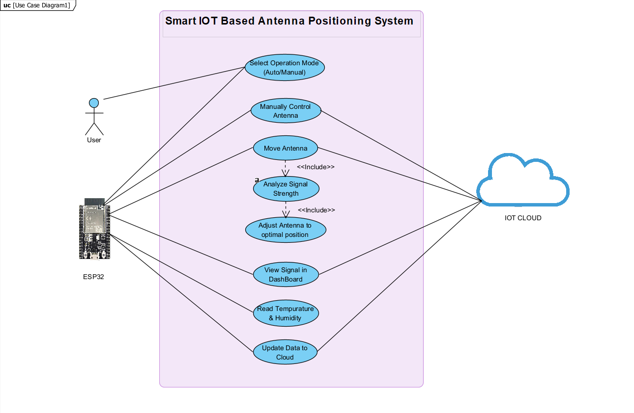

Figure 3.1: Use Case Diagram

Description:

The Smart IoT-Based Antenna Position and Monitoring System is designed to automate the identification and treatment of diseased plants. Using an ESP32-CAM module trained with an Edge Impulse TinyML model, the system captures images of plant leaves, analyzes them for signs of disease, and communicates results to a main ESP32 controller. The CoreXY mechanism then navigates the fertilizer nozzle to the affected plant location for precise spraying. A soil moisture sensor further enables irrigation control. Real-time updates are sent to the Blynk IoT cloud, providing users with live monitoring via a dashboard..

Actors:
The main actors are the User and the IoT System (comprising the ESP32 and the Blynk Cloud platform). The User interacts with the system through a mobile dashboard to initiate automatic antenna scanning, manually adjust antenna angles, and monitor real-time signal strength (RSSI) values.
The IoT System handles continuous WiFi signal monitoring, processes RSSI data, controls the servo motors for horizontal and vertical antenna movement, and manages automatic optimization logic. It also ensures real-time data transmission to the Blynk cloud platform, providing the user with remote monitoring capability and an intuitive control interface.
+There are two main actors:
- User
- IoT Cloud (Blynk platform)
  - User: The User initiates automatic signal scanning or manually adjusts antenna position through the Blynk mobile application. The User monitors real-time RSSI values, antenna angles (X and Y axes), and system mode (Auto/Manual). The User also receives updates when optimal signal alignment is achieved.
  - IoT Cloud: The Blynk IoT platform acts as a cloud-based dashboard to monitor system activity. It receives RSSI readings and antenna position data from the ESP32, displays real-time updates, logs signal performance, and enables remote interaction and control of the antenna positioning system.

Use Case for Monitor Signal Strength

Use Case ID | UC001
Use case Name | Monitor RSSI
Participating Actors | ESP32, IoT Cloud
Entry Condition | System powered ON and connected to WiFi
Flow of Events | - ESP32 connects to WiFi network.  - RSSI value is read continuously.  - Signal strength is displayed on LCD.  - Data is sent to Blynk cloud.
Exit Condition | RSSI value is successfully displayed and logged.
Table 3.1: Monitor Signal Strength

Use case for Automatic Signal Optimization:

Use Case ID | UC002
Use case Name | Auto Scan & Align Antenna
Participating Actors | ESP32-CAM, User
Entry Condition | User activates Auto Mode via mobile app
Flow of Events | • ESP32 rotates antenna step-by-step horizontally.  • RSSI is recorded at each angle.  • Vertical adjustment is performed if required.  • System compares all RSSI values.  • Antenna moves to position with strongest signal.
Exit Condition | Antenna is aligned to optimal signal direction.

Table 3.2: Automatic Signal Optimization
Use case for Manual Antenna Control:

Use Case ID | UC003
Use case Name | Manual Position Control
Participating Actors | User, IoT Cloud
Entry Condition | User selects Manual Mode
Flow of Events | - User adjusts X-axis and Y-axis sliders.  • Commands sent from Blynk cloud to ESP32.  • Servo motors rotate to specified angles.  • LCD updates new angle positions.
Exit Condition | Antenna reaches user-defined position.

Table 3.3: Manual Antenna Control

Use case for Display System Status:

Use Case ID | UC004
Use case Name | Display System Information
Participating Actors | ESP32
Entry Condition | System running
Flow of Events | • LCD displays RSSI value.  • Current X & Y angles are shown.  • Mode status (Auto/Manual) is displayed.  • Scan completion message appears when finished.
Exit Condition | Updated system data is shown to user.

Table 3.4: Display System Status

Use case for Remote Monitoring & Logging :

Use Case ID | UC005
Use case Name | Cloud Monitoring & Logging
Participating Actors | User, IoT Cloud, ESP32
Entry Condition | System connected to internet
Flow of Events | • RSSI and angle data uploaded to cloud.  • Dashboard updates in real-time.  • User monitors signal performance remotely.
Exit Condition | Data stored and visible in dashboard interface.

Table 3.5: Remote Monitoring & Logging

3.3.2.2 Sequence Diagram:

Sequence diagrams depict interactions between objects in a system through a timeline of messages exchanged. Each message triggers operations within receiving objects, influencing their behavior and interactions with other objects. Arguments accompanying messages provide data necessary for executing operations, binding parameters to the receiving object's functions. These diagrams help visualize the flow of operations and communication paths, aiding in the understanding and design of complex system behaviors. Sequence diagrams are invaluable for clarifying the order of operations, dependencies between objects, and the overall dynamics of object-oriented systems during development and analysis phases.

Sequence diagram for Smart IoT-Based Antenna Position and Monitoring System
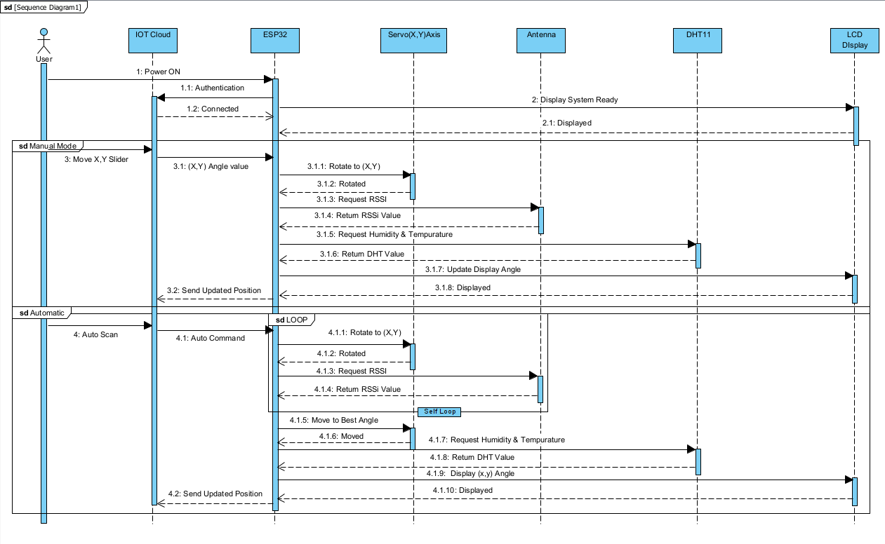

Figure 3.2: Sequence Diagram

Description:
The sequence diagram illustrates the real-time interaction flow within the Smart IoT-Based Antenna Position and Monitoring System. The process begins when the user powers on the system. The ESP32 initializes and connects to the WiFi network. Once connected, it begins monitoring the RSSI (Received Signal Strength Indicator) value of the connected network.
If the user selects Automatic Mode via the Blynk mobile dashboard, a command is sent from the cloud to the ESP32. The ESP32 then rotates the horizontal servo motor step-by-step, measuring RSSI at each angular position. If vertical optimization is required, the vertical servo motor is adjusted accordingly. All RSSI values are compared internally.
After completing the scan, the ESP32 identifies the angle with the strongest signal and moves both servo motors to that optimal position. The final RSSI value and antenna angles are displayed on the 16x2 LCD and uploaded to the Blynk cloud dashboard.
If the user selects Manual Mode, slider inputs from the mobile application are transmitted through the cloud to the ESP32, which directly adjusts the servo motors to the specified angles and updates the display accordingly.
This automated sequence ensures continuous signal optimization, reduces manual intervention, and provides remote monitoring capability through IoT integration.
Activity Diagram:

An Activity Diagram in UML (Unified Modeling Language) is a type of behavioral diagram that represents the dynamic aspects of a system by showing the flow of control or data from one activity to another. It is widely used to model the workflow of a system, business process, or algorithm. The diagram begins with an initial node and proceeds through various actions or activities connected by control flows, ending at a final node. Activity diagrams often include decision nodes, merge nodes, forks, and joins to illustrate branching and parallel processes. In the context of an IoT-based plant disease detection system, an activity diagram helps visualize the sequence of tasks—such as capturing images, analyzing them, detecting disease, and activating actuators. It allows developers and stakeholders to understand how the system behaves in response to different inputs and states. Swim lanes can be used to assign responsibilities to different hardware or software components. This makes activity diagrams useful for both system design and debugging. Overall, they offer a clear visual representation of the system’s logic and workflow.

3.3.2.4 Activity diagram:

Activity Diagram for Smart IoT-Based Antenna Position and Monitoring System

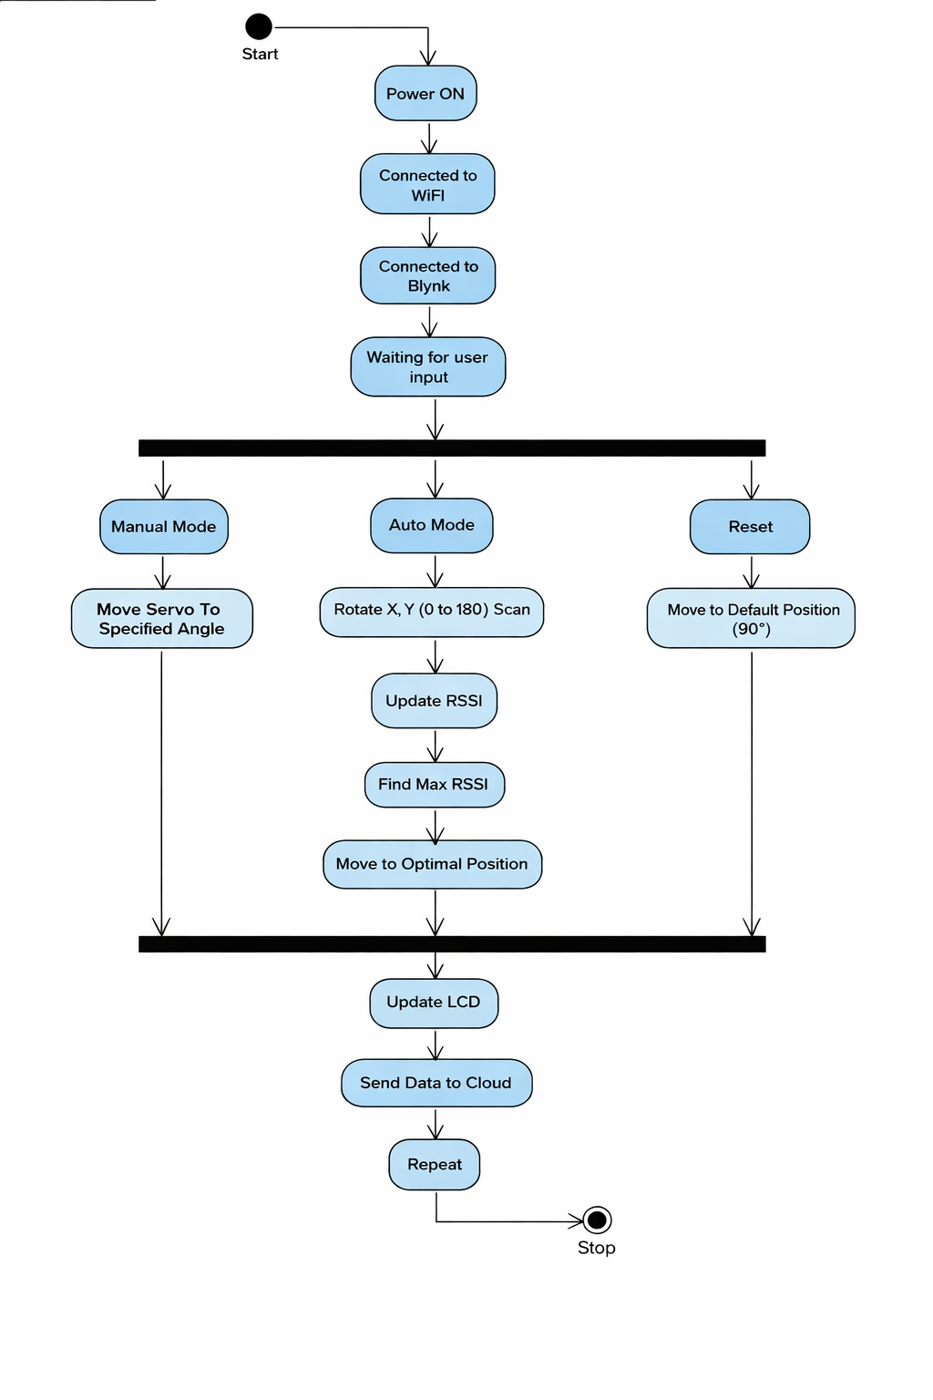

Figure 3.3: Activity Diagram

Description:
The activity diagram for the Smart IoT-Based Antenna Position and Monitoring System illustrates the complete operational workflow of the system from initialization to signal optimization and monitoring.
The process begins with powering on the system. The ESP32 initializes all peripherals, including WiFi connectivity, servo motors, and the LCD display. Once connected to the network, the system starts monitoring the WiFi signal strength (RSSI).
The next step involves checking the selected mode. If the user activates Automatic Mode via the Blynk dashboard, the system begins scanning different horizontal and vertical angles. At each position, RSSI values are measured and recorded. After completing the scan, the system compares all readings and identifies the angle with the strongest signal. The servo motors then reposition the antenna to the optimal alignment.
If Manual Mode is selected, the system directly adjusts antenna angles based on user input from the mobile dashboard.
Finally, the optimized RSSI value and antenna position are displayed on the LCD and uploaded to the IoT cloud platform for remote monitoring and logging. This diagram clearly represents the automated decision-making, control flow, and IoT communication process within the system.

DESIGN

DESIGN

System Design is the process of defining the architecture, components, modules, interfaces, and data flow of a system to meet specified requirements. In the Smart IoT-Based Antenna Position and Monitoring System, the design focuses on achieving intelligent signal optimization through automation and IoT integration. Define design goals of the project

- Decompose the system into smaller sub systems
- Define the design goals of the project
- Decompose the system into smaller subsystems
- Design hardware and software interaction strategies
- Design data communication and cloud monitoring strategies
- Define global control flow for automatic and manual modes
- Establish secure IoT access control mechanisms
- Plan strategies to handle boundary conditions such as weak
signal or power fluctuations

System design is not purely algorithmic; it involves structuring the system into manageable components and defining how they interact. The result is a structured model describing subsystem decomposition and operational strategies.

Design Goals

Design goals are the qualities that the system should focus on. Many design goals can be inferred from the non-functional requirements or from the application domain.

  - Readable: The mobile dashboard and LCD display should present RSSI values, antenna angles, and system status clearly and understandably..
  - Usability: The system should provide an intuitive interface for switching between Auto and Manual modes and adjusting antenna angles easily.
  - Reliable: The system must continuously monitor signal strength and accurately position the antenna without frequent resets or failures.
  - ReusableHardware components such as ESP32 and servo motors should be adaptable for other IoT automation projects.
  - Extendable: The design should allow integration of additional antennas, improved scanning algorithms, or advanced signal analytics..
  - Flexible: The system should support both automatic optimization and manual control without architectural changes.
  - Efficient: The system must optimize signal strength quickly while minimizing power consumption and processing delay.
  - Scalable: The architecture should allow multiple antenna nodes to be monitored via the cloud platform.

Algorithm:

Step 1: Power on the system and initialize all hardware components:
- ESP32 (Main controller)
- Servo motors (X-axis and Y-axis rotation)
- LCD display
- WiFi module (inbuilt in ESP32)
- IoT dashboard on Blynk
Step 2: System moves the antenna to the HOME (default) position and connects to the configured WiFi network.
Step 3: The system continuously reads the RSSI (Received Signal Strength Indicator) value of the connected WiFi network.
Step 4: If the system is in Automatic Mode, it begins the signal optimization cycle.

Step 5: The ESP32 rotates the antenna horizontally (X-axis) in small angle increments and
records RSSI values at each position.
Step 6: For each horizontal angle, the antenna adjusts vertically (Y-axis) and records
corresponding RSSI values.
Step 7: The system compares all measured RSSI values and identifies the position with the
strongest signal (maximum RSSI).
Step 8: The antenna automatically moves to the optimal angle where the best signal strength
is detected.
Step 9: The optimized RSSI value and antenna angles are displayed on the LCD and updated
to the Blynk cloud dashboard for remote monitoring.
Step 10: If the system is switched to Manual Mode, users can adjust X and Y angles directly
from the Blynk mobile application.
Step 11: The system continuously monitors signal strength.
- If signal strength drops below a predefined threshold, automatic optimization restarts.
- Otherwise, the system remains in monitoring mode.
Step 12: The system remains in STANDBY mode until powered off or reconfigured.

Overview Screen of Smart IoT-Based Antenna Position and Monitoring System
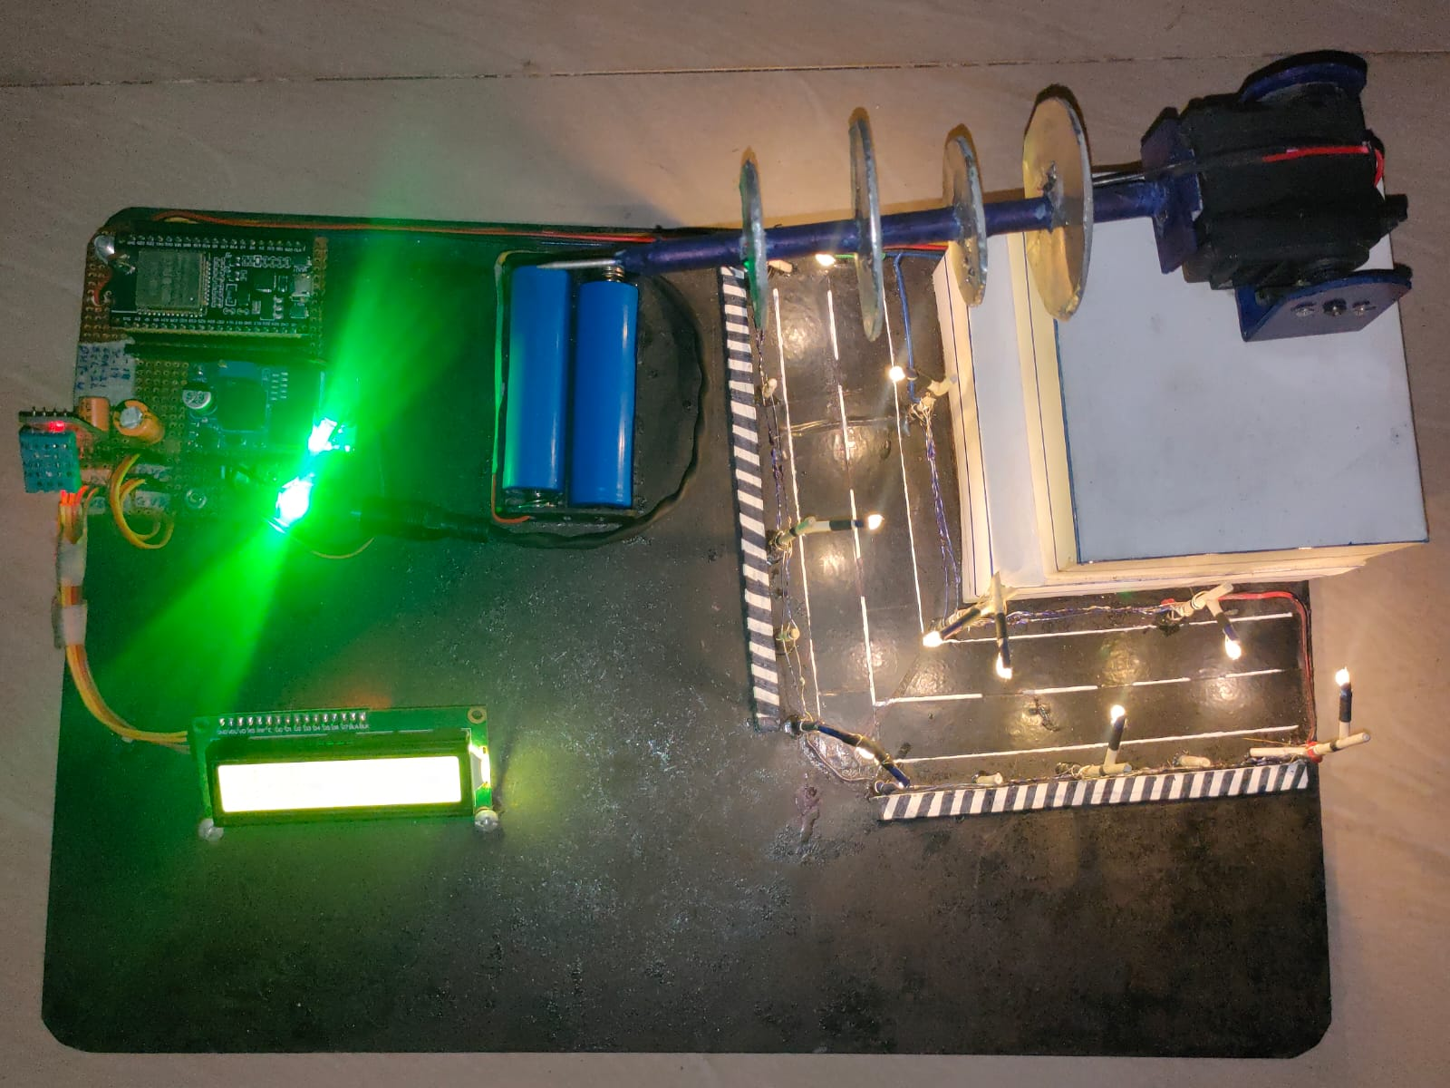

Figure 4.1: Overview

What makes up an Arduino? ARDUINO IDE
You decided to go and buy yourself an Arduino, but once it arrived, you realized you have no idea what to do with it. Do not panic, for help is at hand! In this how-to, we will look at how to get started with Arduino microcontroller boards. We’ll cover software.
installation, as well as connecting and configuring the Arduino IDE. You Will Need

- USB B Cable
- Windows 10, Windows 8, Windows 7, Mac, or Linux OS
- Arduino IDE

Download the IDE
First, you must download the IDE and install it. Start by visiting Arduino’s software page .The IDE is available for most common operating systems, including Windows, Mac OS X, and Linux, so be sure to download the correct version for your OS. If you are using Windows 7 or older, do not download the Windows app version, as this requires Windows
  - Or Windows 10.
Once the installer has downloaded, go ahead and install the IDE. Chances are you will want to enable all options on the installer, including any USB drivers and libraries, but do make sure to read the EULA!

The Arduino IDE
The Arduino IDE is incredibly minimalistic, yet it provides a near-complete environment for most Arduino-based projects. The top menu bar has the standard options, including “File” (new, load save, etc.), “Edit” (font, copy, paste, etc.), “Sketch” (for compiling and programming), “Tools” (useful options for testing projects), and “Help”. The middle section of the IDE is a simple text editor that where you can enter the program code. The bottom section of the IDE is dedicated to an output window that is used to see the status of the compilation, how much memory has been used, any errors that were found in the program, and various other useful messages.
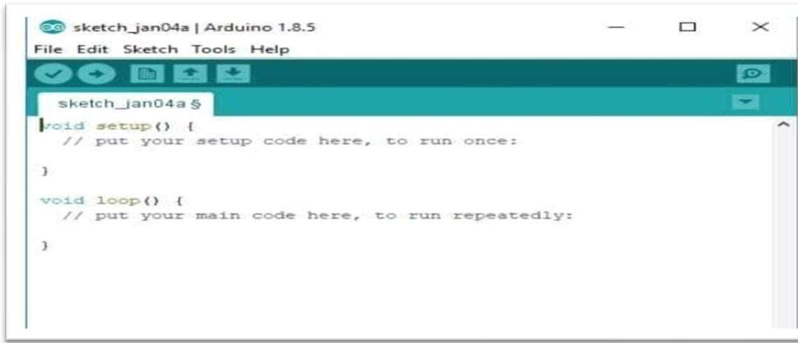
Figure 4.2: Arduino IDE

The Arduino IDE in its default state.

Projects made using the Arduino are called sketches, and such sketches are usually written ina cut-down version of C++ (a number of C++ features are not included). Because programming a microcontroller is somewhat different from programming a computer, there are a number of device-specific libraries (e.g., changing pin modes, output data on pins, reading analog values, and timers). This sometimes confuses users who think Arduino is programmed in an “Arduino language.” However, the Arduino is, in fact, programmed in C++.It just uses unique libraries for the device. The 6 Buttons while more advanced projects will take advantage of the built-in tools in the IDE, most projects will rely on the six buttons found below the menu bar.

The button bar
The check mark is used to verify your code. Click this once you have written your code.
- The arrow uploads your code to the Arduino to run.

- The dotted paper will create a new file.
- The upward arrow is used to open an existing Arduino project.

- The downward arrow is used to save the current file.

- The far right button is a serial monitor, which is useful for sending data from the Arduino to the PC for debugging purposes.
There are plenty of other features available to consider on the IDE. But, having used many different types of microcontrollers and having been involved in multiple programming environments, it is shocking how simple the Arduino and its IDE is! In less than two minutes, you can get a simple C++ program uploaded onto the Arduino and have it.

CODING

CODING
The goal of coding or programming phase is to translate the design of the system produced during the phase into code in a given programming language, which can be executed by a computer and the performs the computation specified by the design.
The coding phase affects both testing and maintenance. The goal of coding is not to reduce the implementation cost, but the goal should be to reduce the cost of later phase. Inother words, the goal is not to simplify the job of programmer. Rather the goal should be to simplify the job of the tester and maintainer.

Coding Approach:

There are two major approaches for coding any software system. They are top-Down approach and bottom-up approach.
Bottom-up approach can suit for developing the object-oriented systems. During system design phase of reduce the complexity. We decompose the system into appropriate number of subsystems, for which objects can be modelled independently. These objects exhibit the way the subsystems perform their operations.
Once object have been modeled they are implemented by means of coding. Even though related to the same system as the objects are implemented of each other the Bottom-Up approach is more suitable for coding these objects.
In this approach, we first do the coding of objects independently and then we integrate these modules into one system to which they belong. In this project, top-Down approach is followed. For registration and Login. User will click and stores the intruder information intensely.

Information Handling:
Any software system requires some amount of information during its operation selection of appropriate data structures can help us to produce the code so that objects of the system can better operate with the available information decreased complexity.
In this project, Encryption and decryption will not be possible if the image fields are vacant. System will not have any default values. User must specify each secret file name in encryption and locate all required operations in decryption.

Programming Style:

Programming style deals with act of rules that a programmer must follow so that the characteristics of coding such as Traceability, Understands the ability, Modifiability, and Extensibility can be satisfied.
In the current system, we followed the coding rules for naming the variables and methods. The system is developed in a very interactive and users friendly manner.

Verification and Validation:

Verification is the process of checking the product built is right. Validation is the process of checking whether the right product is built. During the Development of the system coding for the object as been thoroughly verified from various aspects regarding their design,in the way they are integrated and etc. The various techniques that have been followed for validation discussed in testing the current system. Validations applied to the entire system at two levels.

Form level validation:

Validations of all the inputs given to the system at various points in the forms are validated while navigating to the next form. System raises appropriate custom and predefined exceptions to alert the user about the errors occurred or likely to occur.
Validations at the level of individual controls are also applied whenever necessary. System pops up appropriate and sensuous dialogs whenever necessary.

SOURCE CODE:

#define BLYNK_TEMPLATE_ID "TMPL3D4ZKP5Lo"
#define BLYNK_TEMPLATE_NAME "SmartAntenna"
#define BLYNK_AUTH_TOKEN "MQzyObHnhPBUsEIo6yJQbYAe-N9BTAjB"

#include <WiFi.h>
#include <BlynkSimpleEsp32.h>
#include <Wire.h>
#include <LiquidCrystal_I2C.h>
#include <ESP32Servo.h>
#include "DHT.h"

// -------- WiFi --------
char ssid[] = "A";
char pass[] = "12345678";

// -------- LCD --------
LiquidCrystal_I2C lcd(0x27, 16, 2);

// -------- Servo --------
Servo servoX, servoY;
#define SERVO_X_PIN 18
#define SERVO_Y_PIN 19

// -------- DHT --------
#define DHTPIN 4
#define DHTTYPE DHT11
DHT dht(DHTPIN, DHTTYPE);

// -------- Variables --------
int xAngle = 90;
int yAngle = 90;

bool autoMode = false;
bool scanning = false;

// -------- BLYNK CONTROL --------

// X Slider (Manual)
BLYNK_WRITE(V0)
{
if(!autoMode)
{
xAngle = param.asInt();
servoX.write(xAngle);
}
}

// Y Slider (Manual)
BLYNK_WRITE(V1)
{
if(!autoMode)
{
yAngle = param.asInt();
servoY.write(yAngle);
}
}

// Mode Switch
BLYNK_WRITE(V2)
{
autoMode = param.asInt();

if(autoMode)
{
scanning = true; // start scan
}
}

// -------- RSSI --------
int getStableRSSI()
{
int total = 0;
for(int i=0;i<3;i++)
{
total += WiFi.RSSI();
delay(100);
}
return total/3;
}

// -------- LCD UPDATE (YOUR FINAL UI) --------
void updateLCD(int rssi, float temp, float hum, char mode)
{
if(isnan(temp) || isnan(hum))
{
temp = 0;
hum = 0;
}

lcd.setCursor(0,0);
lcd.print("X:");
if(xAngle < 100) lcd.print(" ");
if(xAngle < 10) lcd.print(" ");
lcd.print(xAngle);

lcd.print(" Y:");
if(yAngle < 100) lcd.print(" ");
if(yAngle < 10) lcd.print(" ");
lcd.print(yAngle);

lcd.print(" T:");
lcd.print((int)temp);
lcd.print(" ");

lcd.setCursor(0,1);
lcd.print("R:");
lcd.print(rssi);
lcd.print(" ");

lcd.setCursor(9,1);
lcd.print("H:");
lcd.print((int)hum);

lcd.setCursor(15,1);
lcd.print(mode);
}

// -------- SEND DATA TO BLYNK --------
void sendToBlynk(int rssi, float temp, float hum)
{
// X Y display
Blynk.virtualWrite(V7, xAngle);
Blynk.virtualWrite(V8, yAngle);

// Sensors
Blynk.virtualWrite(V4, temp);
Blynk.virtualWrite(V5, hum);

// RSSI Graph
Blynk.virtualWrite(V3, rssi);
}

// -------- AUTO SCAN --------
void autoScan()
{
int bestRSSI = -1000;
int bestX = 90, bestY = 90;

for(int x=0; x<=180; x+=30)
{
for(int y=0; y<=180; y+=30)
{
servoX.write(x);
servoY.write(y);

xAngle = x;
yAngle = y;

delay(300);

int rssi = getStableRSSI();
float temp = dht.readTemperature();
float hum = dht.readHumidity();

updateLCD(rssi, temp, hum, 'S');
sendToBlynk(rssi, temp, hum);

if(rssi > bestRSSI)
{
bestRSSI = rssi;
bestX = x;
bestY = y;
}
}
}

// Move to best position
servoX.write(bestX);
servoY.write(bestY);

xAngle = bestX;
yAngle = bestY;

scanning = false;
}

// -------- SETUP --------
void setup()
{
Serial.begin(115200);

lcd.init();
lcd.backlight();

lcd.print("Connecting WiFi");

WiFi.begin(ssid, pass);

while(WiFi.status() != WL_CONNECTED)
{
delay(500);
}

lcd.clear();
lcd.print("WiFi Connected");
delay(1500);

Blynk.begin(BLYNK_AUTH_TOKEN, ssid, pass);

lcd.clear();
lcd.print("Blynk Ready");
delay(1500);
lcd.clear();

servoX.attach(SERVO_X_PIN);
servoY.attach(SERVO_Y_PIN);

dht.begin();
}

// -------- LOOP --------
void loop()
{
Blynk.run();

float temp = dht.readTemperature();
float hum = dht.readHumidity();
int rssi = getStableRSSI();

if(autoMode && scanning)
{
autoScan();
}

char mode;
if(scanning) mode = 'S';
else if(autoMode) mode = 'A';
else mode = 'M';

updateLCD(rssi, temp, hum, mode);
sendToBlynk(rssi, temp, hum);

delay(1000);
}

TESTING

.TESTING

Testing is the process of finding differences between the expected behavior specifiedby system models and the observed behavior of the system. Testing is a critical role in quality assurance and ensuring the reliability of development and these errors will be reflected in the codes the application should be thoroughly tested and validated.
Unit testing finds the differences between the object design model and its corresponding components. Structural testing finds differences between the system design model and asubset of integrated subsystems. Functional testing finds differences between the use case model and the system.
Finally, performance testing, finds differences between non-functional requirements and actual system performances. Form modeling point of view, testing is the attempt of falsification of the system with respect to the system models. The goal of testing is to design tests that exercise defects in the system and to reveal problems.

Testing Activities

Testing a large system is a complex system is a complex activity and like any complex activity. It must be breaking into smaller activities. Thus, incremental testing was performed on the project i.e., components and subsystems of the system were tested separately before integrating them to from the subsystem for system testing.

Types of testing

Unit Testing:
Unit testing is essential to ensure reliability and accuracy. First, each parking sensor's connectivity to the IoT network must be verified to confirm proper integration. Next, the sensors should be tested for data accuracy to ensure they correctly detect and report vehicle presence or absence. It is also crucial to validate the communication protocol, ensuring that data transmission from the sensors to the central server is both reliable and consistent. Additionally, the system must be checked for database integrity to confirm that the server correctly updates and stores parking status data. Lastly, the user interface should be tested to ensure that the app accurately displays real-time parking availability to users.

Integration Testing:
Integration testing using IoT involves several critical steps to ensure seamless operation. First, the end-to-end data flow must be verified, ensuring data is transmitted smoothly from parking sensors to the central server and subsequently to the user app. Next, the interaction and synchronization between the parking sensors, server, and database need to be tested to confirm they work together correctly. Real-time updates are also crucial; therefore, it's essential to ensure that any changes in parking status are accurately reflected across all system components. Finally, the system's ability to handle errors must be tested, ensuring it can effectively manage issues like sensor disconnections or network failures, and recover gracefully from such disruptions.

Functional Testing:
Functional testing focuses on verifying that all system features work as intended. This includes ensuring that parking sensors accurately detect vehicle presence and absence, and that this data is correctly processed and displayed in the user app. The system's reservation functionality must be tested to confirm that users can book parking spaces and that these reservations are properly reflected in the system. Additionally, payment processing should be tested to ensure transactions are secure and correctly recorded. Overall, functional testing ensures that each feature of the smart parking system operates correctly and provides a seamless user experience.

Performance Testing:
Performance testing is essential to ensure the system operates efficiently under various conditions. This involves evaluating the system's response time to detect and report vehicle presence, and ensuring the central server can handle large volumes of data from numerous sensors without delays. The system's scalability is tested to verify it can support an increasing number of users and parking spots without performance degradation. Additionally, stress tests are conducted to assess the system's stability and reliability under peak load conditions, ensuring that it maintains functionality during high traffic periods.

Accuracy Testing:
Accuracy testing focuses on verifying that parking sensors correctly detect vehicle presence and absence. This involves comparing sensor data against actual parking occupancy to ensure high detection precision. The test also checks for false positives and negatives to minimize errors. Ensuring accurate data transmission to the central server and user app is crucial for reliable real-time parking availability information.

Usability Testing:
Usability testing ensures the system is user-friendly and intuitive. This involves evaluating the user interface of the app for ease of navigation, clarity of information, and efficiency in booking and paying for parking spots. Feedback from real users is collected to identify any issues and improve overall user experience, ensuring the system meets users' needs effectively.

Security Testing:
Security testing involves ensuring the protection of data and system integrity. This includes verifying secure communication between sensors, servers, and user applications to prevent data breaches. Tests are conducted to identify vulnerabilities in the system, such as unauthorized access, data tampering, and potential cyber-attacks. Ensuring robust authentication and encryption mechanisms is critical to safeguarding user data and maintaining the overall security of the smart parking system.

Black box Testing:

Black box testing involves evaluating the system's functionality without examining its internal code or structure. Testers focus on verifying that the system correctly handles input data, such as vehicle detection and parking reservations, and produces the expected output, like accurate parking availability and booking confirmations. The goal is to ensure that the system meets functional requirements and performs as intended from a user's perspective.

Whitebox Testing:

White box testing involves examining the internal logic and code of the system. This includes testing algorithms for vehicle detection, data processing, and communication protocols to ensure they function correctly and efficiently. The aim is to identify and fix potential issues within the code, such as logical errors or security vulnerabilities, ensuring the system operates as intended at a technical level.

Testing Plan:

A comprehensive testing plan for the Smart IoT-Based Antenna Position and Monitoring System ensures reliable performance, accurate signal optimization, and stable IoT communication. Unit testing is conducted on individual components such as the ESP32, servo motors, LCD display, and power supply module to verify proper functionality. Integration testing validates coordination between RSSI signal monitoring, antenna movement, and cloud communication through the Blynk. Functional testing ensures both Automatic and Manual modes operate correctly, including real-time RSSI updates and remote control features. Performance testing evaluates scanning speed, response time, and system stability during continuous operation. Accuracy testing confirms correct identification of the strongest signal direction. Usability testing ensures the IoT dashboard is intuitive and easy to operate. Security testing verifies safe WiFi communication and protected cloud access, while regression testing ensures firmware updates do not disrupt existing features. Finally, acceptance testing confirms the system meets all operational requirements.

Test Cases
Test Case for RSSI Signal Detection and Reporting:

Test Case ID | TC001
Description | Validate that the ESP32 correctly measures WiFi RSSI values and processes them for optimization.
Steps: | • Power on the system.  • Connect ESP32 to a WiFi network.  • Rotate antenna to different angles.  • Monitor RSSI values on Serial Monitor and LCD.  • Verify that RSSI data is updated to the Blynk dashboard.
ExpectedResult | The system accurately reads RSSI values at different angles and updates them locally and on the cloud dashboard.

Table 6.1: RSSI Signal Detection and Reporting

Test Case for Antenna Movement to Target Angle:

Test Case ID | TC002
Description | Validate that the servo motors rotate the antenna to specified X and Y angles.
Steps | • Provide target angle through automatic scan or manual input.  • Observe servo motor movement.  • Verify final angle position using display values.
Expected Results | Antenna rotates precisely to the specified angle without jitter or positioning error.

Table 6.2: Antenna Movement to Target Angle

Test case for Automatic Signal Optimization

Test Case ID | TC003
Description | Validate that the system automatically finds and locks onto the strongest signal direction.
Steps: | - Simulate disease detection.  - Allow system to move to target.  - Confirm relay activates the correct pump.
Expected Results | The correct pump is activated and fertilizer is sprayed over diseased plant.

Table 6.3: Automatic Signal Optimization

Test case for Continuous Signal Monitoring

Test Case ID | TC004
Description | Validate that the system re-optimizes when signal strength drops below threshold.
Steps | • Reduce WiFi signal strength artificially.  • Observe RSSI value drop.  • Check if system restarts optimization cycle.
Expected Result | System automatically rescans and repositions antenna to restore optimal signal strength.
Table 6.4 : Continuous Signal Monitoring

Test case for Cloud Data Update:

Test Case ID | TC005
Description | Validate that antenna angles and RSSI values are updated to IoT cloud in real time.
Steps | • Run automatic optimization.  • Open Blynk dashboard.  • Check for updated RSSI values and angle data.
Expected Result | Real-time signal strength and antenna position are accurately reflected on the cloud dashboard.

Table 6.5: Cloud Data Update

Test case for Manual Control via Blynk

Test Case ID | TC006
Description | Validate that the user can manually adjust antenna angles via Blynk dashboard.
Steps | • Open Blynk dashboard.  • Move X and Y angle sliders.  • Observe servo motor response.
Expected Result | Manual commands are executed correctly and antenna moves to selected positions without error.

Table 6.6: Manual Control via Blynk

SCREENS

7.SCREENS

The below screens show the initial position and operation of the Smart IoT-Based Antenna Position and Monitoring System.
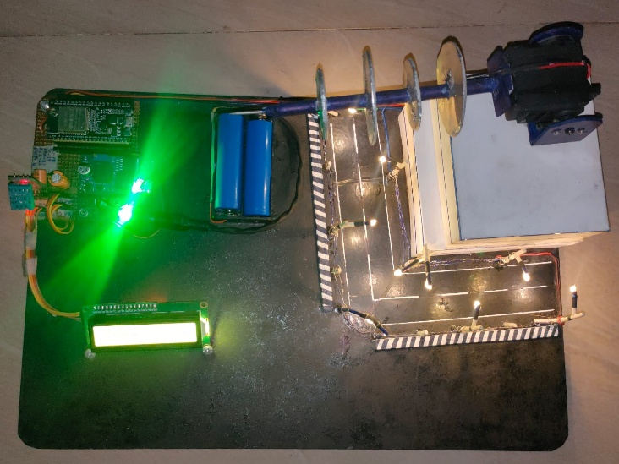

Figure 7.1: Home Position of Antenna

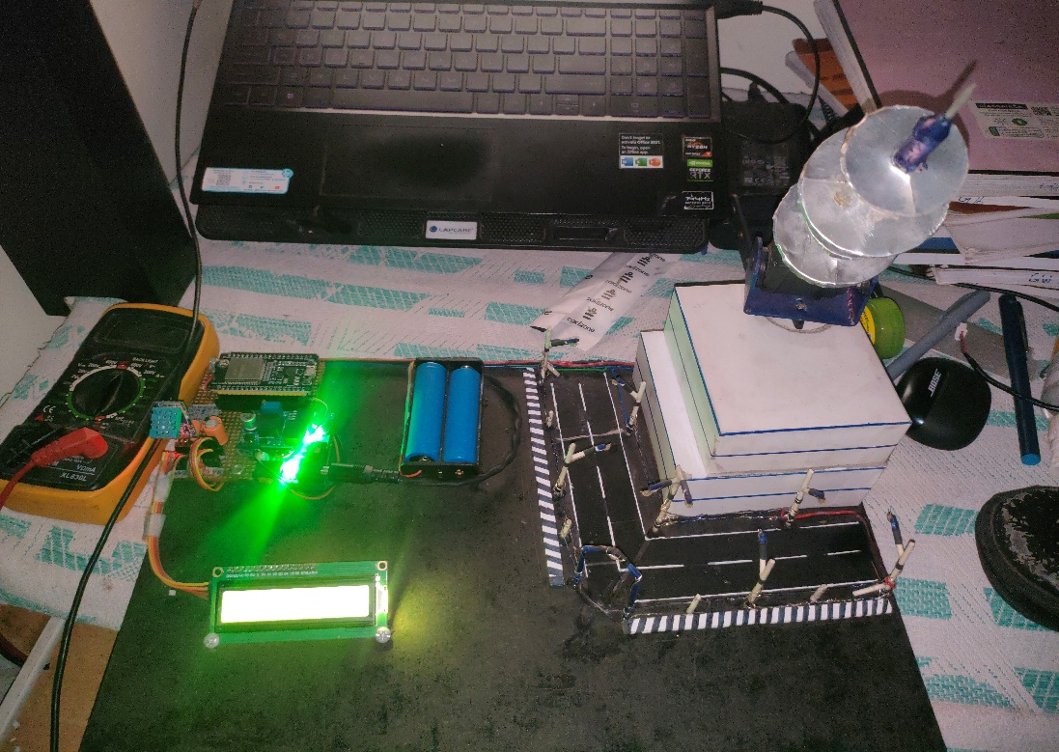

Figure 7.2: Antenna Moved to Different Position

Description:
The directional antenna is mounted on a dual-axis servo motor mechanism that allows precise horizontal (X-axis) and vertical (Y-axis) movement. Initially, the antenna remains at the HOME position after system startup. During operation, the ESP32 controls the servo motors to rotate the antenna toward different angular positions for signal scanning and optimization. This flexible movement enables efficient monitoring of wireless signal strength from multiple directions.

The below screens show RSSI Signal Monitoring

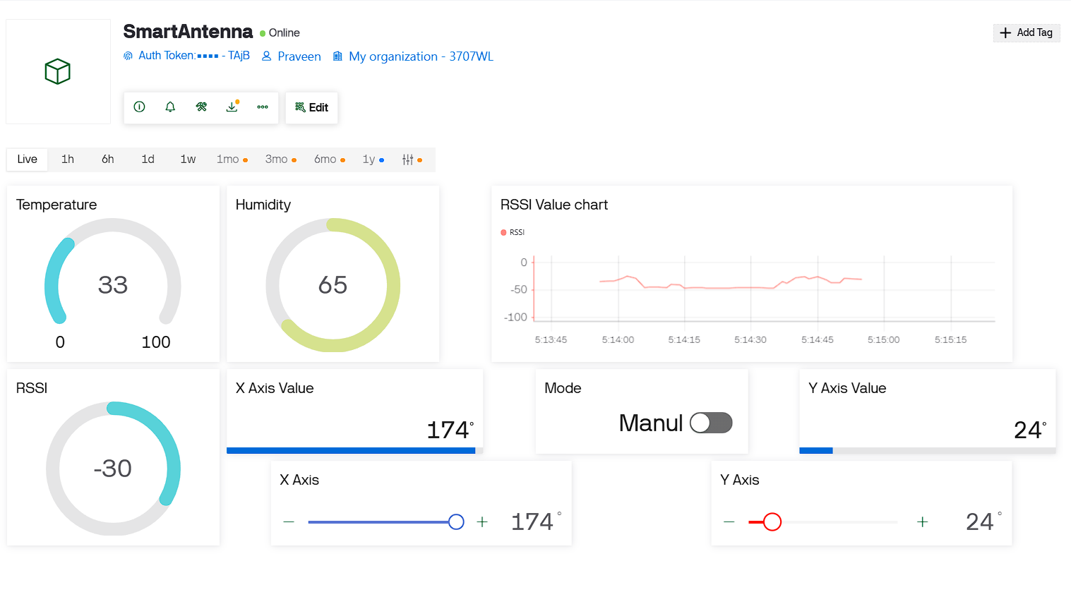

Figure 7.3: Strong Signal Detection

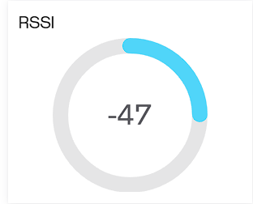

Figure 7.4: Weak Signal Detection

Description:
The system continuously measures WiFi signal strength using RSSI (Received Signal Strength Indicator) values. During scanning, the ESP32 compares RSSI readings at different antenna angles. Strong signal conditions are displayed when the antenna aligns toward the optimal direction, while weaker signal values appear when alignment is less effective. These signal values are updated in real time on both the LCD display and the Blynk dashboard, enabling remote monitoring of antenna performance.
The below screen shows Automatic Signal Optimization
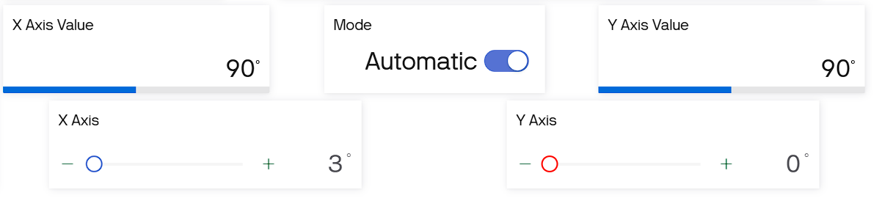
Figure 7.5 Automatic Antenna Alignment

Description:

The system automatically scans multiple horizontal and vertical angles to determine the strongest WiFi signal direction. Based on the collected RSSI values, the ESP32 identifies the optimal alignment and rotates the antenna accordingly using servo motors. After positioning is completed, the optimized RSSI value and final antenna angles are updated to the IoT cloud platform for monitoring and logging purposes.

The below screen shows Blynk Dashboards
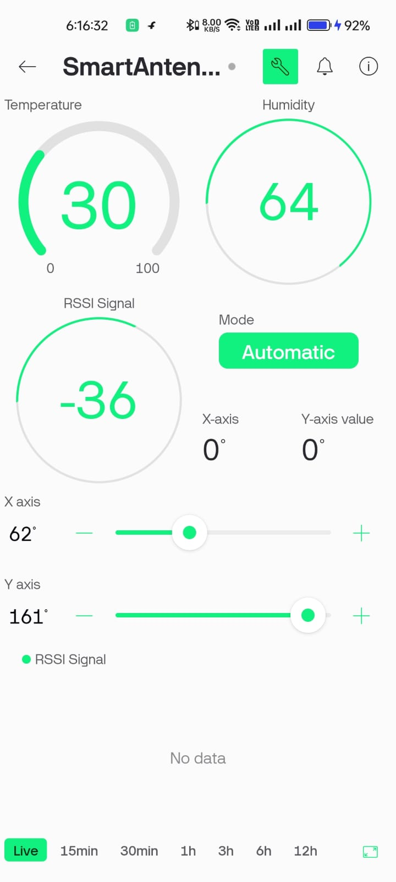
Figure 7.6 Blynk Dashboard in mobile


Figure 7.7 Blynk Dashboard in Web

Description:
The Blynk dashboard, available on both mobile and web platforms, displays real-time RSSI values, antenna angles, and system operating mode. Users can switch between Automatic and Manual modes directly from the dashboard. In Manual Mode, users can control horizontal and vertical antenna movement using sliders. The dashboard also provides real-time updates on signal optimization status and antenna position, enabling centralized remote monitoring and control of the system.

The below screen shows Real-Time System Monitoring



Figure 7.8 RSSI and Angle Display

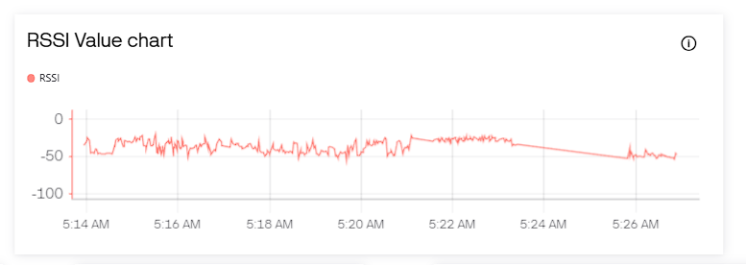

Figure 7.9 RSSI Value Chart

Description:

The LCD display and IoT dashboard continuously monitor and display important system parameters such as RSSI signal strength, X-axis angle, Y-axis angle, and current operating mode. Real-time updates allow users to analyze antenna performance and observe signal variations during scanning and optimization. This live monitoring capability improves usability and ensures accurate antenna positioning for stable wireless communication.

The below screen shows DHT11

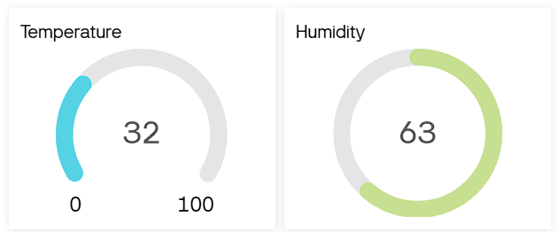
Figure 7.10 Temperature and Humidity

Description:

The DHT sensor in the system accurately measures and displays temperature and humidity data in real time on the Blynk dashboard. In this case, the temperature is shown as 30.1°C, indicating warm ambient conditions. The humidity level is recorded at 82%, reflecting a high-moisture environment suitable for plant growth. These readings help monitor the climate around the plants to ensure optimal growing conditions. The live display allows users to make timely decisions on ventilation or irrigation based on environmental changes.

CONCLUSION

CONCLUSION

The Smart IoT-Based Antenna Position and Monitoring System provides an intelligent solution for automatic signal optimization and remote monitoring using IoT technology. By continuously measuring RSSI values through the ESP32 and automatically adjusting antenna orientation using servo motors, the system ensures improved wireless signal strength and stable connectivity. Integration with the Blynk enables real-time monitoring, remote control, and data visualization, reducing manual effort and enhancing operational efficiency.
The system offers a cost-effective alternative to expensive commercial antenna rotators while maintaining reliability and flexibility. Future improvements may include AI-based signal prediction algorithms, support for multiple network bands, GPS-based automatic alignment, and scalability for large communication infrastructures. By leveraging IoT and automation, this project contributes toward smarter, more efficient wireless communication management systems.

FUTURE SCOPE

FUTURE SCOPE

- AI-Based Signal Prediction: Advanced machine learning models can be integrated to predict signal fluctuations based on historical RSSI trends, environmental conditions, and time patterns, enabling proactive antenna adjustments.
- Multi-Band Support: The system can be upgraded to support dual-band (2.4 GHz and 5 GHz) or even multi-frequency communication for improved compatibility with modern routers and communication systems.
- 360° Continuous Rotation Mechanism: Replacing standard servo motors with stepper motors or slip-ring-based rotators can allow full 360-degree continuous antenna rotation for enhanced scanning accuracy.
- GPS-Based Auto Alignment: Integration of GPS modules can enable automatic antenna alignment toward specific communication towers or predefined geographic coordinates.
- Mobile App Expansion: Advanced mobile dashboards beyond the Blynk can be developed with custom analytics, graphical signal history, and performance reports.
- Predictive Network Optimization: Cloud-stored signal data can be analyzed to predict weak signal periods and automatically optimize antenna orientation before signal degradation occurs.
- Solar-Powered Deployment: Incorporating solar panels and smart power management can make the system energy-efficient and suitable for remote or rural installations.
- Integration with Communication Infrastructure: The system can be expanded for use in rural broadband setups, disaster management communication units, and temporary field communication networks.
- Industrial-Grade Rotator Upgrade: The use of high-torque motors and weather proof
enclosures can make the system suitable for outdoor and large-scale industrial applications
- Open API and Scalable Architecture: Providing open APIs will allow integration with
larger network management systems, enabling centralized monitoring of multiple antenna nodes.

REFERENCE

REFERENCES

Academic Papers and Journals

    - A. Goldsmith, “Wireless Communications,” Wireless Communications, Cambridge University Press, 2005.

    - T. S. Rappaport, “Wireless Communications: Principles and Practice,” Wireless Communications: Principles and Practice, 2nd Edition, Prentice Hall, 2002..

    - K. Pahlavan and P. Krishnamurthy, “Principles of Wireless Networks,” Principles of Wireless Networks, Prentice Hall, 2002.

    - Y. Zeng, R. Zhang, and T. J. Lim, “Wireless Communications with UAVs: Opportunities and Challenges,” Wireless Communications with UAVs, IEEE Communications Magazine, 2016.

    - J. Mitola, “Cognitive Radio: An Integrated Agent Architecture for Software Defined Radio,” Cognitive Radio, Royal Institute of Technology (KTH), 2000.

    - M. B. Srivastava, R. Muntz, and M. Potkonjak, “Smart Wireless Sensor Networks and Applications,” Smart Wireless Sensor Networks, IEEE Computer, 2001.

    - Espressif Systems, “ESP32 Technical Reference Manual,” ESP32 Documentation, 2023

Web References

- Espressif Systems Official Documentation – https://docs.espressif.com
- Blynk Official IoT Platform Documentation – https://docs.blynk.io
- Arduino Servo Motor Control Tutorials – https://www.arduino.cc
- WiFi RSSI Monitoring Guide – https://randomnerdtutorials.com
- IoT Cloud Integration Resources – https://iotdesignpro.com
- Antenna Alignment and Signal Optimization Articles – https://electronicsforu.com

APPENDIX

APPENDIX

List of Figures

Figure No. | Figure Name | Page No.
Figure 1.1 | ESP32 | 19
Figure 1.2 | Pin Configuration of ESP32 | 20
Figure 1.3 | Servo Motor | 21
Figure 1.4 | 16x2 LCD Display with I2C Module | 22
Figure 1.5 | Servo Motor Connections | 23
Figure 1.6 | 2S Lithium-Ion Battery Pack | 24
Figure 1.7 | Buck Converter Module | 25
Figure 1.8 | Antenna Positioning Mechanism | 26
Figure 1.9 | Jumper Wires | 27
Figure 2.1 | Circuit Diagram | 33
Figure 3.1 | Use Case Diagram | 45
Figure 3.2 | Sequence Diagram | 49
Figure 3.3 | Activity Diagram | 51
Figure 4.1 | System Overview | 55
Figure 4.2 | Arduino IDE | 56
Figure 7.1 | Home Position of Antenna | 82
Figure 7.2 | Antenna Moved to Different Position | 82
Figure 7.3 | Strong Signal Detection | 83
Figure 7.4 | Weak Signal Detection | 83
Figure 7.5 | Automatic Antenna Alignment | 84
Figure 7.6 | Blynk Dashboard in Mobile | 85
Figure 7.7 | Blynk Dashboard in Web | 85
Figure 7.8 | RSSI and Angle Display | 86
Figure 7.9 | RSSI Value Chart | 86
Figure 7.10 | Temperature and Humidity | 87

List of Tables

Table No. | Table Name | Page No.
Table 3.1 | Monitor RSSI Signal Strength | 46
Table 3.2 | Automatic Signal Optimization | 47
Table 3.3 | Manual Antenna Control | 47
Table 3.4 | Display System Information | 48
Table 3.5 | Remote Monitoring and Logging | 48
Table 6.1 | RSSI Signal Detection and Reporting | 78
Table 6.2 | Antenna Movement to Target Angle | 78
Table 6.3 | Automatic Signal Optimization | 79
Table 6.4 | Continuous Signal Monitoring | 79
Table 6.5 | Cloud Data Update | 80
Table 6.6 | Manual Override via Blynk | 80

