Enums: .Net Adapter Manual TPS
TestStand Version: 2016

Author: Jed Beach
Feature Spec: There is no current spec for this.
Dependencies: None
Estimated Completion Time: 60 minutes (120 minutes for TS 2016)

Test Category: Functional

Description
This is a manual test plan for how the .Net Adapter handles enums.

Preparation
Sync to //TestStand/WebPages/TestCases/DotNetModulePanel/

Validation
Open

//TestStand/WebPages/TestCases/DotNetModulePanel/Media/DotNetEnums/DotNetEnums.seq

Validate: Run the MainSequence. It should pass.

This is a semi-automated test of the adapter’s runtime behavior. You can also look to it for inspiration later.

Open the “Errors” sequence. Each step’s name is a brief description of the error along with whether the error should occur at edit time, runtime, or both.

Validate: Run the Sequence Analzyer. Verify that there are no errors other than those associated with the steps in the “Errors” sequence that deliberately cause errors. Verify there are no warnings besides a couple for things like unused sequences and enabled watch expressions. Verify that all of the steps in the “Errors” sequence that produce edit time errors cause analyzer errors.

Validate: Examine each step in the Sequence Editor. Make sure the appropriate error (or no error) is show. In most error cases, the error argument should be in red and there should be a tool tip with appropriate details. For the errors specific to enums that describe the differences between the TestStand and .Net versions of the enums, verify the given info is correct.

Validate: Run the sequence. Verify that all steps that are supposed to give a runtime error do, and that the details of the errors are correct. The easiest way to do this is to choose the “ignore” option in the runtime error dialog. (Please note CAR 574619 though.)

Validate: Look at the Standard Test for Adapters. We do not need to test the entire adapter because that gets covered elsewhere. However, perform the following items specifically for methods with enums:
- Create code.
- Edit code.
- Step into.
- Test any applicable code templates.

Validate: Make sure that all possible ways of specifying enums as arguments work correctly at edit time. Enums can be specified in the .Net adapter in several ways:
- Using a TestStand number.
- Using a TestStand string
  - String can be selected from the drop-down.
  - String can be the result of an expression, for example a string variable “Locals.MyString” or something.
- Using an appropriate TestStand enum.
  - Enums.<TYPE>.Enumerator syntax
  - Enum(“<TYPE>”, “<ENUMERATOR>”) expression function
  - Using a variable or expression that evaluates to an enum, perhaps Locals.MyEnum

Make sure that all of these method work correctly, and assuming the TestStand enum is compatible with the parameter type, the panel does not show an error.

Create/UpdateTestStand Enums
- Select the step Pass Blue as String.
- Click the button to create a custom data type for the color parameter.
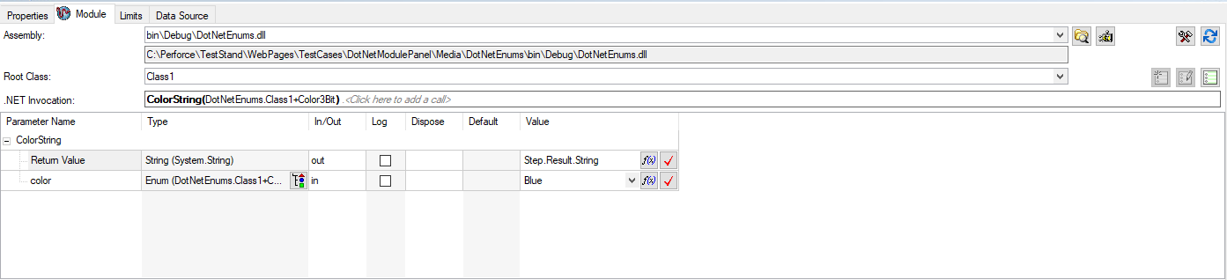
- On the Create tab, click the help button and verify a relevant help topic is shown.
- Close the Help dialog.
- Verify that the ‘Type Name’ matches the enumeration type name from the DLL. To do that open “//TestStand/WebPages/TestCases/DotNetModulePanel/Media/DotNetEnums/Class1.cs” file in notepad.
- Verify that the enumerator names and values are correct. As shown below 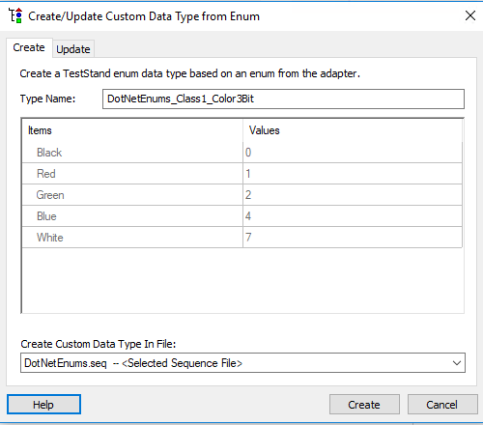
- Click on the Update tab.
- Click on the Help button and verify a relevant help topic is shown.
- Close the help dialog.
- Click cancel. Verify no type was created and that no types were modified.
- On the Create tab, click Create.
- Verify that you will get the message box stating that type has been created. See below
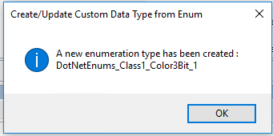
- Verify the type was properly created. It should have the correct enumerators.
- Click the Undo button and verify the type is removed.
- Click the Redo button and verify the type has been added again.
- Open Create/Update Custom Data from Enum dialog (Same as step2). Go to Update tab.
- Check that the Update tab shows all the types that were previously created.
- Select an existing Type and click on update.
- Verify that you will get the message box stating that type has been updated.
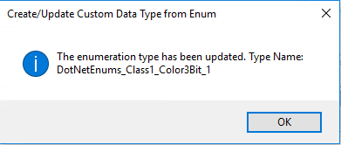
- Verify the type was properly update. It should have the correct enumerators.
- Repeat above steps with multiple steps.
- Open Create/Update Custom Data from Enum dialog (Same as step2). Go to Create tab.
- Give Type name which already exist in the sequence file and click on create.
- Verify that you get the Invalid Name error. As show below
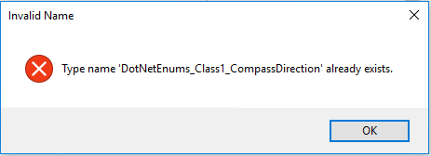
- Change Create Custom Data Type in File filed to MyTypes.ini and click on create.
- Verify that new type is create in MyTypes.ini and It should have the correct enumerators. As shown below
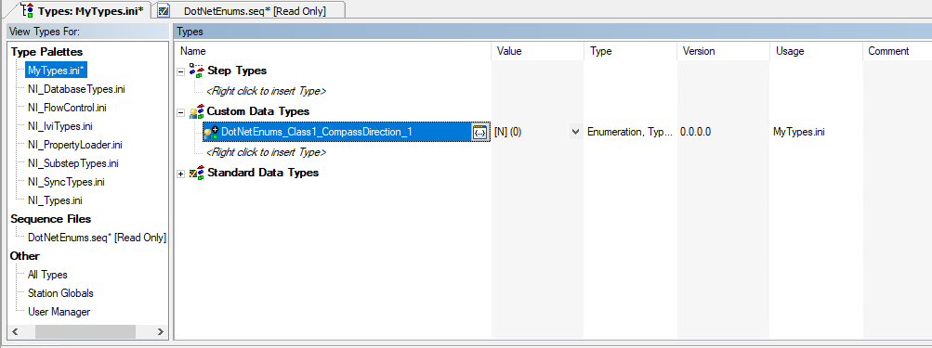
- Verify that all Enum that we create/update from this dialog will have Strict Enumeration check box checked. To verify this, go to Types plate (Ctrl+T) and click on Edit Enumerator button.
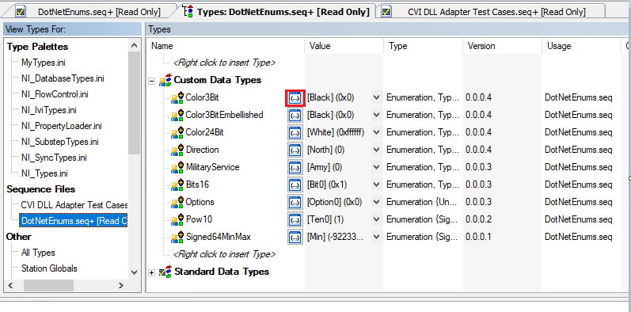

Free Form Testing (TS 2016 R1 and R2 Only)
Do about one hour of free-form testing. Create a .Net code module that takes different types of enums. The automated test already does a reasonable sampling of these, but it is always good to try some different ones. Try things with arrays and containers.

National Instruments Confidential
Copyright © 2005 National Instruments Corporation

